 |  |  |  | UNITED STATES
 |  |  | SECURITIES AND EXCHANGE COMMISSION
 |  |  |  | WASHINGTON, D. C. 20549
(MARK ONE) |  |  |  | FORM 10-K
☒ | ANNUAL REPORT PURSUANT TO SECTION 13 OR 15(d) OF THE SECURITIES EXCHANGE ACT OF 1934
For the fiscal year ended December 31, 2025
☐ |  |  |  | OR
☐ | TRANSITION REPORT PURSUANT TO SECTION 13 OR 15(d) OF THE SECURITIES EXCHANGE ACT OF 1934
For the transition period from |  | to
 |  |  |  | Commission file number 001-35565
 |  |  |  | AbbVie Inc.
 |  |  | (Exact name of registrant as specified in its charter)
 | Delaware |  |  |  | 32-0375147
 | (State or other jurisdiction of |  |  |  | (I.R.S. employer
 | incorporation or organization) |  |  |  | identification number)
 |  |  |  | 1 North Waukegan Road
 |  |  |  | North Chicago, Illinois 60064-6400
 | (847) 932-7900
 |  |  | (Address, including zip code, and telephone number of principal executive offices)

Securities Registered Pursuant to Section 12(b) of the Act:
Title of Each Class |  | Trading Symbol(s) |  | Name of Each Exchange on Which Registered
Common Stock, par value $0.01 per share |  | ABBV |  | New York Stock Exchange
 |  |  |  | NYSE Texas
0.750% Senior Notes due 2027 |  | ABBV27 |  | New York Stock Exchange
2.125% Senior Notes due 2028 |  | ABBV28 |  | New York Stock Exchange
2.625% Senior Notes due 2028 |  | ABBV28B |  | New York Stock Exchange
2.125% Senior Notes due 2029 |  | ABBV29 |  | New York Stock Exchange
1.250% Senior Notes due 2031 |  | ABBV31 |  | New York Stock Exchange

Securities Registered Pursuant to Section 12(g) of the Act: None

Indicate by check mark if the registrant is a well-known seasoned issuer, as defined in Rule 405 of the Securities Act.

Yes ☒ No ☐

Indicate by check mark if the registrant is not required to file reports pursuant to Section 13 or 15(d) of the Act.

Yes ☐ No ☒

Indicate by check mark whether the registrant (1) has filed all reports required to be filed by Section 13 or 15(d) of the Securities Exchange Act of 1934 during the preceding 12 months (or for such shorter period that the registrant was required to file such reports) and (2) has been subject to such filing requirements for the past 90 days.

Yes ☒ No ☐

Indicate by check mark whether the registrant has submitted electronically every Interactive Data File required to be submitted pursuant to Rule 405 of Regulation S-T during the preceding 12 months (or for such shorter period that the registrant was required to submit such files).

Yes ☒ No ☐

Indicate by check mark whether the registrant is a large accelerated filer, an accelerated filer, a non -accelerated filer, a smaller reporting company, or an emerging growth company. See the definitions of "large accelerated filer," "accelerated filer", "smaller reporting company" and "emerging growth company" in Rule 12b-2 of the Exchange Act.
Large Accelerated Filer ☒ | Accelerated Filer ☐
Non-Accelerated Filer ☐ | Smaller reporting company ☐
 | Emerging growth company ☐

If an emerging growth company, indicate by check mark if the registrant has elected not to use the extended transition period for complying with any new or revised financial accounting standards provided pursuant to Section 13(a) of the Exchange Act. ☐

Indicate by check mark whether the registrant has filed a report on and attestation to its management’s assessment of the effectiveness of its internal control over financial reporting under Section 404(b) of the Sarbanes-Oxley Act (15 U.S.C. 7262(b)) by the registered public accounting firm that prepared or issued its audit report. ☒

If securities are registered pursuant to Section 12(b) of the Act, indicate by checkmark whether the financial statements of the registrant included in the filing reflect the correction of an error to previously issued financial statements. ☐

Indicate by check mark whether any of those error corrections are restatements that required a recovery analysis of incentive-based compensation received by any of the registrant’s executive officers during the relevant recovery period pursuant to §240.10D-1(b). ☐

Indicate by check mark whether the registrant is a shell company (as defined in Rule 12b-2 of the Act).

Yes ☐ No ☒

The aggregate market value of the 1,751,219,130 shares of voting stock held by non-affiliates of the registrant, computed by reference to the closing price as reported on the New York Stock Exchange, as of the last business day of AbbVie Inc.'s most recently completed second fiscal quarter (June 30, 2025), was $325,061,294,916. AbbVie has no non-voting common equity.

Number of common shares outstanding as of February 10, 2026: 1,768,169,012

DOCUMENTS INCORPORATED BY REFERENCE

Portions of the 2026 AbbVie Inc. Proxy Statement are incorporated by reference into Part III. The Definitive Proxy Statement will be filed on or about March 23, 2026.

 |  |  |  |  |  |  |  |  |  |  |  |  |  |  |  |  | ABBVIE INC.
 |  |  |  |  |  |  |  |  |  |  |  |  |  |  |  |  | FORM 10-K
 |  |  |  |  |  |  |  |  |  |  |  |  |  | FOR THE YEAR ENDED DECEMBER 31, 2025
 |  |  |  |  |  |  |  |  |  |  |  |  |  |  | TABLE OF CONTENTS |  |  |  |  |  |  |  |  |  |  | Page
 | PART I
 | Item 1. |  |  |  | BUSINESS |  |  |  |  |  |  |  |  |  |  |  |  |  |  |  |  |  |  |  |  | 1
 | Item 1A. |  |  |  | RISK FACTORS |  |  |  |  |  |  |  |  |  |  |  |  |  |  |  |  |  |  |  |  | 14
 | Item 1B. |  |  |  | UNRESOLVED STAFF COMMENTS |  |  |  |  |  |  |  |  |  |  |  |  |  |  |  |  |  |  |  |  | 27
 | Item 1C |  |  |  | CYBERSECURITY |  |  |  |  |  |  |  |  |  |  |  |  |  |  |  |  |  |  |  |  | 27
 | Item 2. |  |  |  | PROPERTIES |  |  |  |  |  |  |  |  |  |  |  |  |  |  |  |  |  |  |  |  | 29
 | Item 3. |  |  |  | LEGAL PROCEEDINGS |  |  |  |  |  |  |  |  |  |  |  |  |  |  |  |  |  |  |  |  | 29
 | Item 4. |  |  |  | MINE SAFETY DISCLOSURES |  |  |  |  |  |  |  |  |  |  |  |  |  |  |  |  |  |  |  |  | 29
 |  |  |  |  | INFORMATION ABOUT OUR EXECUTIVE OFFICERS |  |  |  |  |  |  |  |  |  |  |  |  |  |  |  |  |  |  |  |  | 30
 | PART II
 | Item 5. |  |  |  | MARKET FOR REGISTRANT’S COMMON EQUITY, RELATED STOCKHOLDER MATTERS AND ISSUER PURCHASES OF EQUITY SECURITIES |  |  |  |  |  |  |  |  |  |  |  |  |  |  |  |  |  |  |  |  | 32
 | Item 6. |  |  |  | [RESERVED] |  |  |  |  |  |  |  |  |  |  |  |  |  |  |  |  |  |  |  |  | 33
 | Item 7. |  |  |  | MANAGEMENT’S DISCUSSION AND ANALYSIS OF FINANCIAL CONDITION AND RESULTS OF OPERATIONS |  |  |  |  |  |  |  |  |  |  |  |  |  |  |  |  |  |  |  |  | 34
 | Item 7A. |  |  |  | QUANTITATIVE AND QUALITATIVE DISCLOSURES ABOUT MARKET RISK |  |  |  |  |  |  |  |  |  |  |  |  |  |  |  |  |  |  |  |  | 50
 | Item 8. |  |  |  | FINANCIAL STATEMENTS AND SUPPLEMENTARY DATA |  |  |  |  |  |  |  |  |  |  |  |  |  |  |  |  |  |  |  |  | 51
 | Item 9. |  |  |  | CHANGES IN AND DISAGREEMENTS WITH ACCOUNTANTS ON ACCOUNTING AND FINANCIAL DISCLOSURE |  |  |  |  |  |  |  |  |  |  |  |  |  |  |  |  |  |  |  |  | 102
 | Item 9A. |  |  |  | CONTROLS AND PROCEDURES |  |  |  |  |  |  |  |  |  |  |  |  |  |  |  |  |  |  |  |  | 102
 | Item 9B. |  |  |  | OTHER INFORMATION |  |  |  |  |  |  |  |  |  |  |  |  |  |  |  |  |  |  |  |  | 104
 | Item 9C. |  |  |  | DISCLOSURE REGARDING FOREIGN JURISDICTIONS THAT PREVENT INSPECTIONS |  |  |  |  |  |  |  |  |  |  |  |  |  |  |  |  |  |  |  |  | 104
 | PART III
 | Item 10. |  |  |  | DIRECTORS, EXECUTIVE OFFICERS AND CORPORATE GOVERNANCE |  |  |  |  |  |  |  |  |  |  |  |  |  |  |  |  |  |  |  |  | 105
 | Item 11. |  |  |  | EXECUTIVE COMPENSATION |  |  |  |  |  |  |  |  |  |  |  |  |  |  |  |  |  |  |  |  | 105
 | Item 12. |  |  |  | SECURITY OWNERSHIP OF CERTAIN BENEFICIAL OWNERS AND MANAGEMENT AND RELATED STOCKHOLDER MATTERS |  |  |  |  |  |  |  |  |  |  |  |  |  |  |  |  |  |  |  |  | 106
 | Item 13. |  |  |  | CERTAIN RELATIONSHIPS AND RELATED TRANSACTIONS, AND DIRECTOR INDEPENDENCE |  |  |  |  |  |  |  |  |  |  |  |  |  |  |  |  |  |  |  |  | 106
 | Item 14. |  |  |  | PRINCIPAL ACCOUNTING FEES AND SERVICES |  |  |  |  |  |  |  |  |  |  |  |  |  |  |  |  |  |  |  |  | 106
 | PART IV
 | Item 15. |  |  |  | EXHIBITS, FINANCIAL STATEMENT SCHEDULES |  |  |  |  |  |  |  |  |  |  |  |  |  |  |  |  |  |  |  |  | 107
 | Item 16. |  |  |  | FORM 10-K SUMMARY |  |  |  |  |  |  |  |  |  |  |  |  |  |  |  |  |  |  |  |  | 111
 |  |  |  |  | SIGNATURES |  |  |  |  |  |  |  |  |  |  |  |  |  |  |  |  |  |  |  |  | 112

PART I

ITEM 1. BUSINESS

Overview

AbbVie or "the company" refer to AbbVie Inc., or AbbVie Inc. and its consolidated subsidiaries, as the context requires. AbbVie is a global, diversified research-based biopharmaceutical company positioned for success with a comprehensive product portfolio that has leadership positions across immunology, neuroscience, oncology and aesthetics. AbbVie uses its expertise, dedicated people and unique approach to innovation to develop and market advanced therapies that address some of the world’s most complex and serious diseases. AbbVie was incorporated in Delaware on April 10, 2012. On January 1, 2013, AbbVie became an independent, publicly-traded company as a result of the distribution by Abbott Laboratories (Abbott) of 100% of the outstanding common stock of AbbVie to Abbott's shareholders.

Segments

AbbVie operates as a single global business segment dedicated to the research and development, manufacturing, commercialization and sale of innovative medicines and therapies. This operating structure enables the Chief Executive Officer, as Chief Operating Decision Maker (CODM), to allocate resources and assess business performance on a global basis in order to achieve established long-term strategic goals. Consistent with this structure, a global research and development and supply chain organization is responsible for the discovery, development, manufacturing and supply of products. Commercial efforts that coordinate the marketing, sales and distribution of these products are organized by geographic region or therapeutic area. All of these activities are supported by a global corporate administrative staff. The determination of a single business segment is consistent with the consolidated financial information regularly reviewed by the CODM for purposes of assessing performance, allocating resources and planning and forecasting future periods. See Note 16, "Segment and Geographic Area Information" to the Consolidated Financial Statements included under Item 8, "Financial Statements and Supplementary Data" and the sales information related to AbbVie's key products and geographies included under Item 7, "Management's Discussion and Analysis of Financial Condition and Results of Operations."

Products

AbbVie's portfolio of products includes a broad line of therapies that address some of the world's most complex and serious diseases.

Immunology products. AbbVie maintains an extensive immunology portfolio across rheumatology, dermatology and gastroenterology. AbbVie's immunology products address unmet needs for patients with autoimmune diseases. These products are:

Skyrizi. Skyrizi (risankizumab) is an interleukin-23 (IL-23) inhibitor that selectively blocks IL-23 by binding to its p19 subunit. It is a biologic therapy approved to treat the following autoimmune diseases in the

United States, Canada and Mexico (collectively, North America), the European Union and Japan:

Condition | Principal Markets
Plaque psoriasis (moderate to severe) | North America, European Union, Japan
Psoriatic arthritis | North America, European Union, Japan
Crohn's disease (moderate to severe) | North America, European Union, Japan
Ulcerative colitis (moderate to severe) | North America, European Union, Japan

In psoriatic disease (plaque psoriasis or psoriatic arthritis), Skyrizi is administered as a quarterly subcutaneous injection following two induction doses. When administered for Crohn’s disease and ulcerative colitis, Skyrizi is given as three induction doses via IV infusion, followed by subcutaneous injection via an on-body injector every eight weeks. Skyrizi is sold in numerous other markets worldwide.

1 | 2025 Form 10-K

Rinvoq. Rinvoq (upadacitinib) is an oral, once-daily selective and reversible JAK inhibitor that is approved to treat the following inflammatory diseases in North America, the European Union and Japan:

Condition | Principal Markets
Rheumatoid arthritis (moderate to severe) | North America, European Union, Japan
Psoriatic arthritis | North America, European Union, Japan
Ankylosing spondylitis | North America, European Union, Japan
Atopic dermatitis (moderate to severe) | North America, European Union, Japan
Non-radiographic axial spondyloarthritis | North America, European Union, Japan
Ulcerative colitis (moderate to severe) | North America, European Union, Japan
Crohn's disease (moderate to severe) | U.S., Canada, European Union, Japan
Giant cell arteritis | U.S., Canada, European Union, Japan
Active polyarticular juvenile idiopathic arthritis | U.S.

In the United States, Rinvoq is indicated for the treatment of moderate to severe active rheumatoid arthritis, active ankylosing spondylitis, active non-radiographic axial spondyloarthritis, moderate to severe ulcerative colitis and moderate to severe active Crohn's disease in adult patients who have an inadequate response or intolerance to one or more tumor necrosis factor (TNF) blockers. For Crohn's disease and ulcerative colitis, it is additionally approved prior to the use of TNF blockers in patients for whom the use of these treatments is clinically inadvisable and who have received at least one approved systemic therapy. It is also indicated for the treatment of adult and pediatric patients two years of age and older with active psoriatic arthritis and for the treatment of patients two years of age and older with active polyarticular juvenile idiopathic arthritis who have had an inadequate response or intolerance to one or more TNF blockers. It is also indicated for the treatment of adults and adolescents 12 years of age and older with moderate to severe atopic dermatitis whose disease is not adequately controlled with other systemic drug products, including biologics, or when use of those therapies are inadvisable.

In the European Union, Rinvoq is indicated for the treatment of moderate to severe active rheumatoid arthritis and active psoriatic arthritis in adult patients who have an inadequate response or intolerance to disease-modifying anti-rheumatic medicines (DMARDs). It is also indicated for the treatment of moderate to severe active ulcerative colitis and Crohn's disease in adult patients who have an inadequate response or were intolerant to either conventional therapy or a biologic agent. It is also indicated for the treatment of active non-radiographic axial spondyloarthritis in adult patients who have responded inadequately to nonsteroidal anti-inflammatory drugs (NSAIDs) and for ankylosing spondylitis in adult patients who have responded inadequately to conventional therapy. Additionally, it is indicated for the treatment of moderate to severe atopic dermatitis in adults and adolescents 12 years of age and older who are candidates for systemic therapy.

Rinvoq is sold in numerous other markets worldwide.

2025 Form 10-K | | 2

Humira. Humira (adalimumab) is a biologic therapy administered as a subcutaneous injection. It is approved to treat the following autoimmune diseases in North America and in the European Union:

Condition | Principal Markets
Rheumatoid arthritis (moderate to severe) | North America, European Union
Psoriatic arthritis | North America, European Union
Ankylosing spondylitis | North America, European Union
Crohn's disease (moderate to severe) | North America, European Union
Plaque psoriasis (moderate to severe chronic) | North America, European Union
Juvenile idiopathic arthritis (moderate to severe polyarticular) | North America, European Union
Ulcerative colitis (moderate to severe) | North America, European Union
Non-radiographic axial spondyloarthritis | European Union
Pediatric Crohn's disease (moderate to severe) | North America, European Union
Hidradenitis suppurativa (moderate to severe) | North America, European Union
Pediatric enthesitis-related arthritis | European Union
Non-infectious intermediate, posterior and panuveitis | North America, European Union
Pediatric ulcerative colitis (moderate to severe) | North America, European Union
Pediatric uveitis | North America, European Union

Neuroscience products. AbbVie’s neuroscience products address some of the most difficult-to-treat neurologic diseases. These products are:

Vraylar. Vraylar (cariprazine) is a dopamine D3-preferring D3/D2 receptor partial agonist and a 5-HT1A receptor partial agonist. Vraylar is indicated for acute and maintenance treatment of schizophrenia in adults, acute treatment of manic or mixed episodes associated with bipolar disorder in adults, acute treatment of depressive episodes associated with bipolar I disorder in adults and as an adjunctive treatment in major depressive disorder.

Botox Therapeutic. Botox Therapeutic (onabotulinumtoxinA) is an injectable product, an acetylcholine release inhibitor and a neuromuscular blocking agent. In the United States, it is approved to treat numerous indications, including chronic migraine, overactive bladder in adults who have an inadequate response to an anticholinergic medication and urinary incontinence due to detrusor overactivity associated with a neurologic condition in adults who have an inadequate response to an anticholinergic medication. In addition, Botox Therapeutic is approved to treat spasticity in patients two years of age and older, cervical dystonia in adults as well as other conditions. Botox is marketed in other countries around the world and licenses will vary. Botox Therapeutic is marketed by GSK in Japan.

Ubrelvy. Ubrelvy (ubrogepant) is a calcitonin gene-related peptide receptor antagonist indicated for the acute treatment of migraine with or without aura in adults. Ubrelvy is commercialized in the United States, Israel, Saudi Arabia, United Arab Emirates and Canada.

Qulipta. Qulipta (atogepant) is a calcitonin gene-related peptide receptor antagonist indicated for the preventive treatment of episodic and chronic migraine in adults. Qulipta is commercialized in the United States and Canada and is approved in the European Union under the brand name Aquipta.

Vyalev. Vyalev (foscarbidopa and foslevodopa) is a subcutaneous 24-hour infusion of levodopa-based therapy for the treatment of motor fluctuations in adults with advanced Parkinson's disease. Vyalev is commercialized in the United States and in many other markets primarily as Produodopa though brand names vary by region.

Duodopa. Duodopa (carbidopa and levodopa) is a levodopa-carbidopa intestinal gel for the treatment of advanced Parkinson's disease is marketed as Duopa in the United States and primarily as Duodopa outside of the United States.

3 | 2025 Form 10-K

Oncology products. AbbVie’s oncology products target some of the most complex and difficult-to-treat cancers. These products are:

Imbruvica. Imbruvica (ibrutinib) is an oral, once-daily therapy that inhibits a protein called Bruton's tyrosine kinase. Imbruvica was one of the first medicines to receive a United States Food and Drug Administration (FDA) approval after being granted a Breakthrough Therapy Designation and is one of the few therapies to receive four separate designations. Imbruvica currently is approved for the treatment of adult patients with blood cancers such as chronic lymphocytic leukemia (CLL), as well as certain forms of non-Hodgkin lymphoma. Imbruvica is approved in adult and pediatric patients one year and older with chronic graft versus host disease after failure of one or more lines of systemic therapy.

Venclexta. Venclexta (venetoclax) is a B-cell lymphoma 2 (BCL-2) inhibitor used to treat blood cancers. Venclexta is approved by the FDA for adults with CLL or small lymphocytic lymphoma. In addition, Venclexta is approved in combination with azacitidine, or decitabine, or low-dose cytarabine to treat adults with newly-diagnosed acute myeloid leukemia who are 75 years of age or older or have other medical conditions that prevent the use of standard chemotherapy. It is marketed as Venclexta in the United States and primarily as Venclyxto outside of the United States.

Elahere. Elahere (mirvetuximab soravtansine-gynx) is an antibody-drug conjugate (ADC) used to treat certain types of cancer. Elahere is approved in both the United States and the European Union for the treatment of adult patients with FRα positive, platinum-resistant epithelial ovarian, fallopian tube, or primary peritoneal cancer, who have received one to three prior systemic treatment regimens.

Epkinly. Epkinly (epcoritamab) is a product used to treat adults with certain types of diffuse large B-cell lymphoma (DLBCL) and high-grade B-cell lymphoma that has recurred or that does not respond to previous treatment after receiving two or more treatments. Epkinly is administered as a subcutaneous injection. Epkinly is also approved to treat adults with relapsed or refractory follicular lymphoma. It is marketed as Epkinly in the United States and primarily as Tepkinly outside of the United States.

Other oncology. Other oncology products include Emrelis, an ADC used for the treatment of adult patients with locally advanced or metastatic, non-squamous non-small cell lung cancer with high c-Met protein overexpression who have received prior systemic therapy.

Aesthetics products. AbbVie’s Aesthetics portfolio consists of facial injectables, plastics and regenerative medicine, body contouring and skincare products, which hold market-leading positions in the United States and in key markets around the world. These products are:

Botox Cosmetic. Botox Cosmetic (onabotulinumtoxinA) is an acetylcholine release inhibitor and a neuromuscular blocking agent indicated for treatment in four areas: temporary improvement in the appearance of moderate to severe glabellar lines (frown lines between the eyebrows), moderate to severe crow's feet, moderate to severe forehead lines in adults and moderate to severe platysma bands. Botox Cosmetic is approved for use in all major markets around the world and is approved for the treatment of masseter muscle prominence in China.

Juvederm Collection. Juvederm Collection is a portfolio of hyaluronic acid-based dermal fillers with a variety of approved indications in the U.S. and in other major markets around the world to augment or treat volume loss in the temples, undereye, cheeks, chin, lips and lower face.

Other aesthetics. Other aesthetics products include, but are not limited to, Alloderm regenerative dermal tissue, CoolSculpting body contouring technology, Natrelle breast implants, the SkinMedica skincare line, Latisse eyelash solution and DiamondGlow dermabrasion technology.

Eye care products. AbbVie’s eye care products address unmet needs and new approaches to help preserve and protect patients’ vision. These products are:

Ozurdex. Ozurdex (dexamethasone intravitreal implant) is a corticosteroid implant that slowly releases medication over time. Injected directly into the back of the eye, it dissolves naturally and does not need to be removed. Ozurdex is indicated for the treatment of adult patients with visual impairment due to diabetic macular oedema (DME), adult patients with macular oedema following either Branch Retinal Vein Occlusion (BRVO) or Central Retinal Vein Occlusion (CRVO) and patients with inflammation of the posterior segment of the eye presenting as non-infectious uveitis. Ozurdex is commercially available in the United States and numerous markets around the world.

Lumigan/Ganfort. Lumigan (bimatoprost ophthalmic solution) 0.01% is a once daily, topical prostaglandin analog indicated for the reduction of elevated intraocular pressure (IOP) in patients with open angle glaucoma (OAG) or ocular hypertension (OHT). Ganfort is a once daily topical fixed combination of bimatoprost 0.03% and timolol 0.5% for the reduction

2025 Form 10-K | | 4

of IOP in adult patients with OAG or OHT. Lumigan is sold in the United States and numerous markets around the world, while Ganfort is approved in the European Union and some markets in South America, the Middle East and Asia.

Alphagan/Combigan. Alphagan (brimonidine tartrate ophthalmic solution) is an alpha-adrenergic receptor agonist indicated for the reduction of elevated IOP in patients with open-angle glaucoma or ocular hypertension. Combigan (brimonidine tartrate/timolol maleate ophthalmic solution) is approved for reducing elevated IOP in patients with glaucoma who require additional or adjunctive IOP-lowering therapy. Both Alphagan and Combigan are available for sale in the United States and numerous markets around the world.

Other eye care. Other eye care products include Refresh/Optive, Xen, Durysta and Restasis.

Other key products. AbbVie’s other key products include, among other things, treatments for patients with hepatitis C virus (HCV), exocrine pancreatic insufficiency, hypothyroidism, irritable bowel syndrome with constipation and chronic idiopathic constipation. These products are:

Mavyret. Mavyret (glecaprevir/pibrentasvir) is approved in the United States and European Union (Maviret) for the treatment of adult and pediatric patients (12 years and older or weighing at least 45 kilograms) with chronic HCV genotype 1-6 infection without cirrhosis and with compensated cirrhosis (Child-Pugh A). It is also indicated for the treatment of adult and pediatric patients (12 years and older or weighing at least 45 kilograms) with HCV genotype 1 infection, who previously have been treated with a regimen containing an HCV NS5A inhibitor or an NS3/4A protease inhibitor, but not both. Mavyret is also approved in the United States for the treatment of adults and pediatric patients 3 years and older with acute or chronic hepatitis C virus infection. It is marketed as Mavyret in the United States and primarily as Maviret outside of the United States.

Creon. Creon (pancrelipase) is a pancreatic enzyme therapy for exocrine pancreatic insufficiency, a condition that occurs in patients with cystic fibrosis, chronic pancreatitis and several other conditions.

AbbVie has the rights to sell Creon only in the United States.

Linzess/Constella. Linzess (linaclotide) is a once-daily guanylate cyclase-C agonist used in adults to treat irritable bowel syndrome with constipation (IBS‑C) and chronic idiopathic constipation. The product is marketed as Linzess in the United States and as Constella outside of the United States.

Marketing, Sales and Distribution Capabilities

AbbVie utilizes a combination of dedicated commercial resources, regional commercial resources and distributorships to market, sell and distribute its products worldwide. AbbVie directs its primary marketing efforts toward securing the prescription, or recommendation, of its brand of products by physicians, external experts and other health care providers. Managed care providers (for example, health maintenance organizations and pharmacy benefit managers), hospitals and state and federal government agencies (for example, State Medicaid programs, the United States Department of Veterans Affairs and the United States Department of Defense) are also important customers. AbbVie also markets directly to consumers themselves, although in the United States many of the company's products must be sold pursuant to a prescription. Outside of the United States, AbbVie focuses its promotional and market access efforts on external experts, payers, physicians and health systems. AbbVie also provides patient support programs closely related to its products.

AbbVie's products are generally sold worldwide directly to wholesalers, distributors, government agencies, health care facilities, specialty pharmacies and independent retailers from AbbVie-owned distribution centers and public warehouses. Certain products (including aesthetic products and devices) are also sold directly to physicians and other licensed healthcare providers. Although AbbVie's business does not have significant seasonality, AbbVie's product revenues may be affected by end customer and retail buying patterns, fluctuations in wholesaler inventory levels and other factors.

In the United States, AbbVie distributes pharmaceutical products principally through independent wholesale distributors, with some sales directly to retailers, pharmacies, patients or other customers. In 2025, three wholesale distributors (McKesson Corporation, Cardinal Health, Inc. and Cencora, Inc.) accounted for substantially all of AbbVie's pharmaceutical product sales in the United States. No individual wholesaler accounted for greater than 43% of AbbVie's 2025 gross revenues in the United States. Outside the United States, AbbVie sells products primarily to wholesalers or through distributors, and depending on the market, works through largely centralized national payers systems to agree on reimbursement terms.

Certain products are co-marketed or co-promoted with other companies. AbbVie has no single customer that, if the customer were lost, would have a material adverse effect on the company's business.

Orders are generally filled on a current basis and order backlog is not material to AbbVie's business.

5 | 2025 Form 10-K

Competition

The markets for AbbVie's products are highly competitive. AbbVie competes with other research-based pharmaceuticals and biotechnology companies that discover, manufacture, market and sell proprietary pharmaceutical products, therapies and biologics. For example, AbbVie's immunology products compete with IL-23 inhibitors, IL-17 inhibitors, JAK inhibitors, biosimilars and other competitive products intended to treat a number of disease states, and AbbVie's oncology products compete with targeted therapies including BTK inhibitors, ADCs, cell therapies and other competitive products intended to treat certain cancers. In addition, a number of other companies have successfully developed and market products that are being positioned as competitors to Botox. The search for technological innovations in pharmaceutical products is a significant aspect of competition. The introduction of new products by competitors and changes in medical practices and procedures can result in product obsolescence. Price is also a competitive factor. In addition, the substitution of generic and biosimilar pharmaceutical products for branded pharmaceutical products creates competitive pressures on AbbVie's products that do not have patent protection. New products or treatments brought to market by AbbVie’s competitors could cause revenues for AbbVie’s products to decrease due to price reductions and sales volume decreases.

Biosimilars. Competition for AbbVie’s biologic products is affected by the approval of follow-on biologics, also known as “biosimilars.” Biologics have added major therapeutic options for the treatment of many diseases, including some for which therapies were unavailable or inadequate. The cost of developing and producing biologic therapies is typically dramatically higher than for small molecule medications, and many biologic medications are used for ongoing treatment of chronic diseases, such as rheumatoid arthritis or inflammatory bowel disease, or for the treatment of previously untreatable cancer. Significant investments in biologics infrastructure and manufacturing are necessary to produce biologic products.

Humira faces direct biosimilar competition globally and AbbVie will continue to face competitive pressure from these biologics and from orally administered products.

In the United States, the FDA regulates biologics under the Federal Food, Drug, and Cosmetic Act (FFDCA), the Public Health Service Act (PHSA) and the regulations implementing these statutes. The enactment of federal health care reform legislation in March 2010 provided a pathway for approval of biosimilars under the PHSA, but the approval process for, and science behind, biosimilars is complex. Approval by the FDA is dependent upon many factors, including a showing that the biosimilar is "highly similar" to the original product and has no clinically meaningful differences from the original product in terms of safety, purity and potency. The types of data that could ordinarily be required in an application to show similarity may include analytical data, bioequivalence studies and studies to demonstrate chemical similarity, animal studies (including toxicity studies) and clinical studies.

Furthermore, the law provides that only a biosimilar product that is determined to be "interchangeable" will be considered by the FDA as substitutable for the original biologic product without the intervention of the health care provider who prescribed the original biologic product. To prove that a biosimilar product is interchangeable, the applicant must demonstrate that the product can be expected to produce the same clinical results as the original biologic product in any given patient, and if the product is administered more than once in a patient, that safety risks and potential for diminished efficacy of alternating or switching between the use of the interchangeable biosimilar biologic product and the original biologic product is no greater than the risk of using the original biologic product without switching. The law continues to be interpreted and implemented by the FDA. As a result, its full ultimate impact, implementation and meaning remains subject to uncertainty.

Intellectual Property Protection and Regulatory Exclusivity

Generally, upon approval, products may be entitled to certain kinds of exclusivity under applicable intellectual property and regulatory regimes. AbbVie’s intellectual property is materially valuable to the company, and AbbVie seeks patent protection, where available, in all significant markets and/or countries for each product in development. In the United States, the expiration date for patents is 20 years after the filing date. Given that patents relating to pharmaceutical products are often obtained early in the development process and given the amount of time needed to complete clinical trials and other development activities required for regulatory approval, the length of time between product launch and patent expiration is significantly less than 20 years. The Drug Price Competition and Patent Term Restoration Act of 1984 (commonly known as the Hatch-Waxman Act) permits a patent holder to seek a patent extension, commonly called a “patent term restoration,” for patents on products (or processes for making the product) regulated by the FFDCA. The length of the patent extension is roughly based on 50% of the period of time from the filing of an Investigational New Drug Application (NDA) for a compound to the submission of the NDA for such compound, plus 100% of the time period from NDA submission to regulatory approval. The extension, however, cannot exceed five years and the patent term remaining after regulatory approval cannot exceed 14 years. Biological products licensed under the PHSA are similarly eligible for terms of patent restoration.

2025 Form 10-K | | 6

Pharmaceutical products may be entitled to other forms of legal or regulatory exclusivity upon approval. The scope, length and requirements for each of these exclusivities vary both in the United States and in other jurisdictions. In the United States, if the FDA approves a conventional drug product that contains an active ingredient not previously approved, the product is typically entitled to five years of non-patent regulatory exclusivity. Specific conditions of use approved for individual products may also be entitled to three years of exclusivity if approval was based on the FDA’s reliance on new clinical studies essential to approval submitted by the NDA applicant. If the NDA applicant studies the product for use by children, the FDA may grant pediatric exclusivity, which extends by 180 days all existing exclusivities (patent and regulatory) related to the product. For products that are either used to treat conditions that afflict a relatively small population or for which there is not a reasonable expectation that the research and development costs will be recovered, the FDA may designate the pharmaceutical as an orphan drug and grant it seven years of exclusivity. Other types of regulatory exclusivity may also be available, such as Generating New Antibiotic Incentives Now (GAIN) exclusivity, which can provide new antibiotic or new antifungal drugs an additional five years of exclusivity to be added to certain exclusivities already provided for by law.

Applicable laws and regulations dictate the scope of any exclusivity to which a product or particular characteristics of a product is entitled upon approval in any particular country. In certain instances, regulatory exclusivity may offer protection where patent protection is no longer available or for a period of time in excess of patent protection. It is not possible to estimate for each product in development the total period and scope of exclusivity to which it may become entitled until regulatory approval is obtained or sometimes even later. However, given the length of time required to complete clinical development of a pharmaceutical product, the periods of exclusivity that might be achieved in any individual case would not generally be expected to exceed a minimum of three years and a maximum of 14 years. These estimates do not consider other factors, such as the difficulty of recreating the manufacturing process for a particular product or other proprietary knowledge that may delay the introduction of a generic or other follow-on product after the expiration of applicable patent and other regulatory exclusivity periods.

Biologics may be entitled to exclusivity under the Biologics Price Competition and Innovation Act, which was passed on March 23, 2010 as Title VII to the Patient Protection and Affordable Care Act. The law provides a pathway for approval of biosimilars following the expiration of 12 years of regulatory exclusivity for the innovator biologic and a potential additional 180 day-extension term for conducting pediatric studies. Biologics are also eligible for orphan drug exclusivity, as discussed above. The law also includes an extensive process for the innovator biologic and biosimilar manufacturer to litigate patent infringement, validity and enforceability. The European Union has also created a pathway for approval of biosimilars and has published guidelines for approval of certain biosimilar products. The more complex nature of biologics and biosimilar products has led to close regulatory scrutiny over follow-on biosimilar products, which can reduce the effect of biosimilars on sales of the innovator biologic as compared to the sales erosion caused by generic versions of small molecule pharmaceutical products.

AbbVie owns or has licensed rights to a substantial number of patents and patent applications. AbbVie licenses or owns a patent portfolio of thousands of patent families, each of which includes United States patent applications and/or issued patents and may also contain the non-United States counterparts to these patents and applications. These patents and applications, including various patents that expire during the period 2026 to the mid 2040s, in aggregate are believed to be of material importance in the operation of AbbVie’s business.

The following patents, licenses and trademarks are significant: those related to risankizumab (which is sold under the trademark Skyrizi) and those related to upadacitinib (which is sold under the trademark Rinvoq). The United States composition of matter patents covering risankizumab and upadacitinib are expected to expire in 2033. In September 2025, AbbVie settled litigation with all generic manufacturers that filed abbreviated new drug applications with the U.S. FDA for generic versions of upadacitinib tablets. Given the settlement and license agreements, which are subject to standard acceleration provisions, assuming pediatric exclusivity is granted, no generic entry for Rinvoq tablets is expected prior to April 2037 in the United States. AbbVie believes that no other single patent, license, trademark (or related group of patents, licenses, or trademarks), is material in relation to the company’s business as a whole.

AbbVie may rely, in some circumstances, on trade secrets to protect its technology. AbbVie seeks to protect its technology and product candidates, in part, by confidentiality agreements with its employees, consultants, advisors, contractors and collaborators. These agreements may be breached, and AbbVie may not have adequate remedies for any breach. In addition, AbbVie’s trade secrets may otherwise become known or be independently discovered by competitors. To the extent that AbbVie’s employees, consultants, advisors, contractors and collaborators use intellectual property owned by others in their work for the company, disputes may arise as to the rights in related or resulting know-how and inventions.

Licensing, Acquisitions and Other Arrangements

In addition to its independent efforts to develop and market products, AbbVie enters into arrangements such as acquisitions, option-to-acquire agreements, licensing arrangements, option-to-license arrangements, strategic alliances, co-

7 | 2025 Form 10-K

promotion arrangements, co-development and co-marketing agreements and joint ventures. The acquisitions and option-to-acquire agreements typically include, among other terms and conditions, upfront purchase price payments or option fees, option exercise payments, milestones or earn-outs and other customary terms and obligations. The licensing and other arrangements typically include, among other terms and conditions, upfront license fees, option fees and option exercise payments, milestone payments and royalty and/or profit sharing obligations. See Note 5, "Licensing, Acquisitions and Other Arrangements— Other Licensing & Acquisitions Activity," to the Consolidated Financial Statements included under Item 8, "Financial Statements and Supplementary Data."

Third Party Agreements

AbbVie has agreements with third parties for process development, product distribution, analytical services and manufacturing of certain products. AbbVie procures certain products and services from a limited number of suppliers and, in some cases, a single supply source. In addition, AbbVie has agreements with third parties for active pharmaceutical ingredient and product manufacturing, formulation and development services, fill, finish and packaging services, transportation and distribution and logistics services for certain products. AbbVie does not believe that these manufacturing-related agreements are material because AbbVie's business is not substantially dependent on any individual agreement. In most cases, AbbVie maintains alternate supply relationships that it can utilize without undue disruption of its manufacturing processes if a third party fails to perform its contractual obligations. AbbVie seeks to maintain sufficient inventory of product to minimize the impact of any supply disruption.

AbbVie is also party to certain collaborations and other arrangements, as discussed in Note 5, "Licensing, Acquisitions and Other Arrangements—Other Licensing & Acquisitions Activity," to the Consolidated Financial Statements included under Item 8, "Financial Statements and Supplementary Data."

Sources and Availability of Raw Materials

AbbVie purchases, in the ordinary course of business, raw materials and supplies essential to its operations from numerous suppliers around the world. In addition, certain medical devices and components necessary for the manufacture of AbbVie products are provided by unaffiliated third party suppliers. AbbVie has robust business continuity and supplier monitoring programs.

Research and Development Activities

AbbVie makes a significant investment in research and development and has numerous compounds (and complementary devices) in clinical development, including potential treatments for complex, life-threatening diseases. AbbVie's ability to discover and develop new compounds is enhanced by the company's use of integrated discovery and development project teams, which include chemists, biologists, physicians and pharmacologists who work on the same compounds as a team. AbbVie also partners with third parties, such as biotechnology companies, other pharmaceutical companies and academic institutions to identify and prioritize promising new treatments that complement and enhance AbbVie’s existing portfolio. AbbVie also supplements its research and development efforts with acquisitions.

The research and development process generally begins with discovery research which focuses on the identification of a molecule that has a desired effect against a given disease. If preclinical testing of an identified compound proves successful, the compound moves into clinical development which generally includes the following phases:

- Phase 1— involves the first human tests in a small number of healthy volunteers or patients to assess safety, tolerability and doses for later phases.

- Phase 2— tests different doses of the drug in a disease state in order to assess efficacy.

- Phase 3— tests a drug that demonstrates favorable results in the earlier phases in a significantly larger patient population to further demonstrate efficacy and safety in order to meet regulatory requirements to enable global approval.

Preclinical data and clinical trials from all of the development phases provide the data required to prepare and submit an NDA, a Biological License Application (BLA) or other submission for regulatory approval to the FDA or similar government agencies outside the United States. The specific requirements (e.g., scope of clinical trials) for obtaining regulatory approval vary across different countries and geographic regions.

The research and development process from discovery through a new drug launch typically takes 8 to 12 years and can be even longer. The research and development of new pharmaceutical products has a significant amount of inherent uncertainty. There is no guarantee when, or if, a molecule will receive the regulatory approval required to launch a new drug or indication.

2025 Form 10-K | | 8

In addition to the development of new products, delivery devices and new formulations, research and development projects also may include Phase 4 trials, sometimes called post-marketing studies. For such projects, clinical trials are designed and conducted to collect additional data regarding, among other parameters, the benefits and risks of an approved drug.

Regulation—Discovery and Clinical Development

United States. Securing approval to market a new pharmaceutical product in the United States requires substantial effort and financial resources and takes several years to complete. The applicant must complete preclinical tests and submit protocols to the FDA before commencing clinical trials. Clinical trials are intended to establish the safety and efficacy of the pharmaceutical product and typically are conducted in sequential phases, although the phases may overlap or be combined. If the required clinical testing is successful, the results are submitted to the FDA in the form of an NDA or BLA requesting approval to market the product for one or more indications. The FDA reviews an NDA or BLA to determine whether a product is safe and effective for its intended use and whether its manufacturing is compliant with current Good Manufacturing Practices (cGMP).

Compliance with regulatory requirements is assured through periodic, announced or unannounced inspections by the FDA and other regulatory authorities, and these inspections associated with clinical development may include the sponsor, investigator sites, laboratories, hospitals and manufacturing facilities of AbbVie's subcontractors or other third-party manufacturers. Failure to comply with applicable regulatory requirements can result in enforcement action by the FDA, including rejection of an NDA or BLA.

Even if an NDA or a BLA receives approval, the applicant must comply with post-approval requirements. For example, holders of an approval must report adverse reactions, provide updated safety and efficacy information and comply with requirements concerning advertising and promotional materials and activities. Also, quality control and manufacturing procedures must continue to conform to cGMP after approval, and certain changes to the manufacturing procedures and finished product must be submitted and approved by the FDA prior to implementation. The FDA periodically inspects manufacturing facilities to assess compliance with cGMP, which imposes extensive procedural and record keeping requirements. In addition, as a condition of approval, the FDA may require post-marketing testing and surveillance to further assess and monitor the product's safety or efficacy after commercialization, which may require additional clinical trials, patient registries, observational data or additional work on chemistry, manufacturing and controls. Any post-approval regulatory obligations, and the cost of complying with such obligations, could expand in the future. Further, the FDA continues to regulate product labeling and prohibits the promotion of products for unapproved or “off-label” uses along with other labeling restrictions.

Outside the United States. AbbVie is subject to similar regulatory requirements outside the United States for approval and marketing of pharmaceutical products. AbbVie must obtain approval of a clinical trial application or product from applicable supervising regulatory authorities before it can commence clinical trials or marketing of the product in target markets. The approval requirements and process for each country can vary and the time required to obtain approval may be longer or shorter than that required for FDA approval in the United States. For example, AbbVie may submit marketing authorizations in the European Union under either a centralized or decentralized procedure. The centralized procedure is mandatory for the approval of biotechnology products and many pharmaceutical products and provides for a single marketing authorization that is valid for all European Union member states. Under the centralized procedure, a single marketing authorization application is submitted to the European Medicines Agency. After the agency evaluates the application, it makes a recommendation to the European Commission, which then makes the final determination on whether to approve the application. The decentralized procedure provides for mutual recognition of individual national approval decisions and is available for products that are not subject to the centralized procedure.

In Japan, applications for approval of a new product are made through the Pharmaceutical and Medical Devices Agency (PMDA). Japan-specific trials and/or bridging studies to demonstrate that the non-Japanese clinical data applies to Japanese patients are usually required. After completing a comprehensive review, the PMDA reports to the Ministry of Health, Labour and Welfare, which then approves or denies the application.

Similarly, applications for a new product in China are submitted to the Center for Drug Evaluation of the National Medical Products Administration for technical review and approval of a product for marketing in China. Clinical data in Chinese subjects are usually required to support approval in China, requiring the inclusion of China in global pivotal studies, or a separate China/Asian clinical trial.

The regulatory process in many emerging markets continues to evolve. Many emerging markets, including those in Asia, generally require regulatory approval to have been obtained in a large developed market (such as the United States or Europe) before the country will begin or complete its regulatory review process. Similar to the requirements in Japan and

9 | 2025 Form 10-K

China, certain countries (notably South Korea, Taiwan, India and Russia) also generally require that clinical studies that include data from patients in those countries be conducted in order to support local regulatory approval.

The requirements governing the conduct of clinical trials and product licensing also vary. In addition, post-approval regulatory obligations such as adverse event reporting and cGMP compliance generally apply and may vary by country. For example, after a marketing authorization has been granted in the European Union, periodic safety reports must be submitted and other pharmacovigilance measures may be required (such as Risk Management Plans).

Regulation—Commercialization, Distribution and Manufacturing

The manufacturing, marketing, sale, promotion and distribution of AbbVie's products are subject to comprehensive government regulation. Government regulation by various national, regional, federal, state and local agencies, both in the United States and other countries, addresses (among other matters) inspection of, and controls over, research and laboratory procedures, clinical investigations, product approvals and manufacturing, labeling, packaging, marketing and promotion, pricing and reimbursement, sampling, distribution, quality control, post-marketing surveillance, record keeping, storage and disposal practices.

AbbVie's operations are also affected by trade regulations in many countries that limit the import of raw materials and finished products and by laws and regulations that seek to prevent corruption and bribery in the marketplace (including the United States Foreign Corrupt Practices Act and the United Kingdom Bribery Act, which provide guidance on corporate interactions with government officials) and require safeguards for the protection of personal data. In addition, AbbVie is subject to laws and regulations pertaining to health care fraud and abuse, including state and federal anti-kickback and false claims laws in the United States. Prescription drug manufacturers such as AbbVie are also subject to taxes, as well as application, product, user and other fees.

Compliance with these laws and regulations is costly and materially affects AbbVie's business. Among other effects, health care regulations substantially increase the time, difficulty and costs incurred in obtaining and maintaining approval to market newly developed and existing products. AbbVie expects compliance with these regulations to continue to require significant technical expertise and capital investment to ensure compliance. Failure to comply can delay the release of a new product or result in regulatory and enforcement actions, the seizure or recall of a product, the suspension or revocation of the authority necessary for a product's production and sale and other civil or criminal sanctions, including fines and penalties.

In addition to regulatory initiatives, AbbVie's business can be affected by ongoing studies of the utilization, safety, efficacy and outcomes of health care products and their components that are regularly conducted by industry participants, government agencies and others. These studies can lead to updates to the data regarding utilization, safety and efficacy of previously marketed products. In some cases, these studies have resulted, and may in the future result, in the discontinuance of, or limitations on, marketing of such products domestically or worldwide, and may give rise to claims for damages from persons who believe they have been injured as a result of their use.

Access to human health care products continues to be a subject of oversight, investigation and action by governmental agencies, legislative bodies and private organizations in the United States and other countries. A major focus is cost containment. Efforts to reduce health care costs are also being made in the private sector, notably by health care payers and providers, which have instituted various cost reduction and containment measures. AbbVie expects insurers and providers to continue attempts to reduce the cost of health care products. Outside the United States, many countries control the price of health care products directly or indirectly, through reimbursement, payment, pricing, coverage limitations, or compulsory licensing. Political and budgetary pressures in the United States and in other countries may also heighten the scope and severity of pricing pressures on AbbVie's products for the foreseeable future.

United States. Specifically, U.S. federal laws require pharmaceutical manufacturers to pay certain statutorily-prescribed rebates to state Medicaid programs on prescription drugs reimbursed under state Medicaid plans and the efforts by states to seek additional rebates may affect AbbVie's business. Similarly, the Veterans Health Care Act of 1992, as a prerequisite to participation in Medicaid and other federal health care programs, requires that manufacturers extend additional discounts on pharmaceutical products to various federal agencies, including the United States Department of Veterans Affairs, Department of Defense and Public Health Service entities and institutions. In addition, recent legislative changes would require similarly discounted prices to be offered to TRICARE program beneficiaries. The Veterans Health Care Act of 1992 also established the 340B drug discount program, which requires pharmaceutical manufacturers to provide products at reduced prices to various designated health care entities and facilities.

In the United States, most states also have generic substitution legislation requiring or permitting a dispensing pharmacist to substitute a different manufacturer's generic version of a pharmaceutical product for the one prescribed. In addition, the federal government follows a diagnosis-related group (DRG) payment system for certain institutional services provided under Medicare or Medicaid and has implemented a prospective payment system (PPS) for services delivered in hospital outpatient, nursing home and home health settings. DRG and PPS entitle a health care facility to a fixed

2025 Form 10-K | | 10

reimbursement based on the diagnosis and/or procedure rather than actual costs incurred in patient treatment, thereby increasing the incentive for the facility to limit or control expenditures for many health care products. Medicare reimburses Part B drugs based on average sales price plus a certain percentage to account for physician administration costs, which have been reduced in the hospital outpatient setting. Medicare enters into contracts with private plans to negotiate prices for most patient-administered medicine delivered under Part D.

Under the Patient Protection and Affordable Care Act and the Health Care and Education Reconciliation Act (together, the Affordable Care Act), AbbVie pays a fee related to its pharmaceuticals sales to government programs. In addition, through the end of 2024 AbbVie provided a discount of 70% for branded prescription drugs sold to patients who fell into the Medicare Part D coverage gap, or "donut hole."

The Affordable Care Act also includes provisions known as the Physician Payments Sunshine Act, which require manufacturers of drugs and biologics covered under Medicare and Medicaid to record any transfers of value to physicians and teaching hospitals and to report this data to the Centers for Medicare and Medicaid Services (CMS) for subsequent public disclosure. Similar reporting requirements have also been enacted on the state level in the United States, and an increasing number of countries worldwide either have adopted or are considering similar laws requiring disclosure of interactions with health care professionals. Failure to report appropriate data may result in civil or criminal fines and/or penalties.

The Inflation Reduction Act of 2022 (IRA) requires: (i) the government to set prices for select high expenditure Medicare Part D drugs (prices effective beginning in 2026) and Part B drugs (prices effective

beginning in 2028) that are more than nine years (for small-molecule drugs) or 13 years (for biological products) from their FDA approval, (ii) manufacturers to pay a rebate for Medicare Part B and Part D drugs

when prices for those drugs increase faster than inflation beginning in 2022 for Part D and 2023 for Part B and (iii) a Medicare Part D redesign replacing the current coverage gap provisions and establishing a

$2,000 cap for out-of-pocket costs for Medicare beneficiaries beginning in 2025, with manufacturers being responsible for 10% of costs up to the $2,000 cap and 20% after that cap is reached. In August 2023, the

U.S. Department of Health and Human Services (HHS), through CMS, selected Imbruvica as one of 10 medicines subject to government-set prices in Medicare Part D beginning January 1, 2026, and in January

2025, selected Vraylar and Linzess as two of 15 medicines subject to government-set prices in Medicare Part D beginning January 1, 2027. In January 2026, Botox was selected as one of 15 medicines subject to

government-set prices in Medicare Parts B and D beginning January 1, 2028. It is possible that more of our products, including products that generate substantial revenues, could be selected in future years, which

could, among other things, accelerate revenue erosion prior to expiration of intellectual property protections. The effect of reducing prices and reimbursement could significantly impact revenues for certain of our

products.

European Union. The European Union has adopted directives and other legislation governing labeling, advertising, distribution, supply, pharmacovigilance and marketing of pharmaceutical products. Such legislation provides mandatory standards throughout the European Union and permits member states to supplement these standards with additional regulations. European governments also regulate pharmaceutical product prices through their control of national health care systems that fund a large part of the cost of such products to consumers. As a result, patients are unlikely to use a pharmaceutical product that is not reimbursed by the government. In many European countries, the government either regulates the pricing of a new product at launch or subsequent launch through direct price controls or reference pricing. In recent years, many countries have also imposed new or additional cost containment measures on pharmaceutical products. Differences between national pricing regimes create price differentials within the European Union that can lead to significant parallel trade in pharmaceutical products.

Most governments also promote generic substitution by mandating or permitting a pharmacist to substitute a different manufacturer's generic version of a pharmaceutical product for the one prescribed and by permitting or mandating that health care professionals prescribe generic versions in certain circumstances. Many governments are also following a similar path for biosimilar therapies. In addition, governments use reimbursement lists to limit the pharmaceutical products that are eligible for reimbursement by national health care systems.

Japan. In Japan, the National Health Insurance system maintains a Drug Price List specifying which pharmaceutical products are eligible for reimbursement and the Ministry of Health, Labour and Welfare sets the prices of the products on this list. The government generally introduces price cut rounds every other year and also mandates price decreases for specific products. New products judged innovative or useful, that are indicated for pediatric use, or that target orphan or small population diseases, however, may be eligible for a pricing premium. The government has also promoted the use of generics, where available.

Emerging Markets. Many emerging markets take steps to reduce pharmaceutical product prices, in some cases through direct price controls and in others through the promotion of generic/biosimilar alternatives to branded pharmaceuticals.

11 | 2025 Form 10-K

Since AbbVie markets its products worldwide, certain products of a local nature and variations of product lines must also meet other local regulatory requirements. Certain additional risks are inherent in conducting business outside the United States, including price and currency exchange controls, changes in currency exchange rates, limitations on participation in local enterprises, expropriation, nationalization and other governmental action.

Regulation – Medical Devices

Medical devices are subject to regulation by the FDA, state agencies and foreign government health authorities. FDA regulations, as well as various U.S. federal and state laws, govern the development, clinical testing, manufacturing, labeling, record keeping and marketing of medical device products agencies in the United States. AbbVie’s medical device product candidates, including AbbVie’s breast implants, must undergo rigorous clinical testing and an extensive government regulatory clearance or approval process prior to sale in the United States and other countries. The lengthy process of clinical development and submissions for clearance or approval, and the continuing need for compliance with applicable laws and regulations, require the expenditure of substantial resources. Regulatory clearance or approval, when and if obtained, may be limited in scope, and may significantly limit the indicated uses for which a product may be marketed. Cleared or approved products and their manufacturers are subject to ongoing review and discovery of previously unknown problems with products may result in restrictions on their manufacture, sale and/or use or require their withdrawal from the market.

United States. AbbVie’s medical device products are subject to extensive regulation by the FDA in the United States. Unless an exemption applies, each medical device AbbVie markets in the United States must have a 510(k) clearance or a Premarket Approval Application (PMA) in accordance with the FFDCA and its implementing regulations. The FDA classifies medical devices into one of three classes, depending on the degree of risk associated with each medical device and the extent of controls that are needed to ensure safety and effectiveness. Devices deemed to pose a lower risk are placed in either Class I or Class II, and devices deemed by the FDA to pose the greatest risk, such as life-sustaining, life-supporting or implantable devices, or a device deemed to be not substantially equivalent to a previously cleared 510(k) device, are placed in Class III. In general, a Class III device cannot be marketed in the United States unless the FDA approves the device after submission of a PMA, and any changes to the device subsequent to initial FDA approval must also be reviewed and approved by the FDA. The majority of AbbVie’s medical device products, including AbbVie’s breast implants, are regulated as Class III medical devices. A Class III device may have significant additional obligations imposed in its conditions of approval, and the time in which it takes to obtain approval can be long. Compliance with regulatory requirements is assured through periodic, unannounced facility inspections by the FDA and other regulatory authorities, and these inspections may include the manufacturing facilities of AbbVie’s subcontractors or other third-party manufacturers. Failure to comply with applicable regulatory requirements can result in enforcement action by the FDA, which may include any of the following sanctions: warning letters or untitled letters; fines, injunctions and civil penalties; recall or seizure of AbbVie’ products; operating restrictions, partial suspension or total shutdown of production; refusing AbbVie’ request for 510(k) clearance or PMA approval of new products; withdrawing 510(k) clearance or PMA approvals that are already granted; and criminal prosecution.

A clinical trial is almost always required to support a PMA application and is sometimes required for a 510(k) premarket notification. Clinical trials generally require submission of an application for an investigational device exemption (IDE), which must be supported by appropriate data, such as animal and laboratory testing results, showing that it is safe to test the device in humans and that the testing protocol is scientifically sound. A study sponsor must obtain approval for its IDE from the FDA, and it must also obtain approval of its study from the Institutional Review Board overseeing the trial. The results of clinical testing may not be sufficient to obtain approval of the investigational device.

Once a device is approved, the manufacture and distribution of the device remains subject to continuing regulation by the FDA, including Quality System Regulation requirements, which involve design, testing, control, documentation and other quality assurance procedures during the manufacturing process. Medical device manufacturers and their subcontractors are required to register their establishments and list their manufactured devices with the FDA and are subject to periodic unannounced inspections by the FDA and certain state agencies for compliance with regulatory requirements. Manufacturers must also report to the FDA if their devices may have caused or contributed to a death or serious injury or malfunctioned in a way that could likely cause or contribute to a death or serious injury, or if the manufacturer conducts a field correction or product recall or removal to reduce a risk to health posed by a device or to remedy a violation of the FFDCA that may present a health risk. Further, the FDA continues to regulate device labeling and prohibits the promotion of products for unapproved or “off-label” uses along with other labeling restrictions.

European Union. Medical device products that are marketed in the European Union must comply with the requirements of the Medical Device Regulation (MDR), which came into effect in May 2021. The MDR provides for regulatory oversight with respect to the design, manufacture, clinical trials, labeling and adverse event reporting for medical devices to ensure that medical devices marketed in the European Union are safe and effective for their intended uses. Medical devices that comply with the MDR are entitled to bear a Conformité Européenne marking evidencing such compliance and may be

2025 Form 10-K | | 12

marketed in the European Union. Failure to comply with these domestic and international regulatory requirements could affect AbbVie’s ability to market and sell AbbVie’s products in these countries.

Environmental Matters

AbbVie believes that its operations comply in all material respects with applicable laws and regulations concerning environmental protection. Regulations under federal and state environmental laws impose stringent limitations on emissions and discharges to the environment from various manufacturing operations. AbbVie's capital expenditures for pollution control in 2025 were approximately $17 million and operating expenditures were approximately $44 million. In 2026, capital expenditures for pollution control are estimated to be approximately $21 million and operating expenditures are estimated to be approximately $46 million.

Abbott was identified as one of many potentially responsible parties in investigations and/or remediations at several locations in the United States, including Puerto Rico, under the Comprehensive Environmental Response, Compensation and Liability Act, commonly known as Superfund. Some of these locations were transferred to AbbVie in connection with the separation and distribution, and AbbVie has become a party to these investigations and remediations. Abbott was also engaged in remediation at several other sites, some of which have been transferred to AbbVie in connection with the separation and distribution, in cooperation with the Environmental Protection Agency or similar agencies. While it is not feasible to predict with certainty the final costs related to those investigations and remediation activities, AbbVie believes that such costs, together with other expenditures to maintain compliance with applicable laws and regulations concerning environmental protection, should not have a material adverse effect on the company's financial position, cash flows, or results of operations.

Employees

AbbVie employed approximately 57,000 employees in over 70 countries as of December 31, 2025. Outside the United States, some of AbbVie's employees are represented by unions or works councils.

AbbVie believes that it has good relations with its employees.

Human Capital Management

Attracting, retaining and providing meaningful growth and development opportunities to AbbVie's employees is critical to the company's success in making a remarkable impact on people’s lives around the world. AbbVie leverages numerous resources to identify and enhance strategic and leadership capability, foster employee engagement and create a culture where talent is productive and engaged. AbbVie invests in its employees through competitive compensation, benefits and employee support programs and offers best-in-class development and leadership opportunities. AbbVie has developed a deep talent base through ongoing investment in functional and leadership training and by sourcing world-class external talent, ensuring a sustainable talent pipeline.

Attracting and Developing Talent. Attracting and developing high-performing talent is essential to AbbVie’s continued success. AbbVie implements detailed talent attraction strategies, with an emphasis on STEM skill sets and other critical skill sets, including drug discovery, clinical development, market access and business development. AbbVie seeks candidates with diverse backgrounds, experiences, and perspectives to enhance innovation and problem-solving. AbbVie also invests in competitive compensation and benefits programs. In addition to offering a comprehensive suite of benefits ranging from medical and dental coverage to retirement, disability and life insurance programs, AbbVie also provides health promotion programs, mental health awareness campaigns and employee assistance programs in several countries, financial wellness support, on-site health screenings and immunizations in several countries and on-site fitness and rehabilitation centers. AbbVie has on-site health care clinics at certain locations, offering convenient and affordable access to quality healthcare, flu shots and vaccines. In addition, the AbbVie Employee Assistance Fund (a part of the AbbVie Foundation) supports two programs for global employees: the AbbVie Possibilities Scholarship for children of employees, which is an annual merit-based scholarship for use at accredited colleges, universities or vocational-technical schools; and the Employee Relief Program, which is financial assistance to support short term needs of employees when faced with large-scale disasters (e.g., a hurricane), individual disasters (e.g., a home fire) or financial hardship (e.g., the death of a spouse). Finally, AbbVie empowers managers and their teams with tools, tips and guidelines on effectively managing workloads and managing teams from a distance.

New AbbVie employees are given a tailored onboarding experience for faster integration and to support performance. One of AbbVie's mentorship programs allows employees to self-nominate as mentors or mentees and facilitates meaningful relationships supporting employees’ career and development goals.

AbbVie also provides structured, broad-based development opportunities, focusing on high-performance skills and leadership training. AbbVie has invested significantly in equipping employees with foundational artificial intelligence (AI) skills,

13 | 2025 Form 10-K

reflecting both the opportunities AI presents and its commitment to supporting employees as work evolves. AbbVie's talent philosophy holds leaders accountable for building a high-performing organization, and the company provides development opportunities for all levels of leadership. AbbVie's Learn, Develop, Perform program offers year-long, self-directed leadership education, supplemented with tools and resources, and leverages leaders as role models and teachers. In addition, a foundational success factor to AbbVie's leadership pipeline is the company's Professional Development Programs, which attract graduates, postgraduates and post-doctoral talent to participate in formal development programs lasting up to three years, with the objective of strengthening functional and leadership capabilities.

Culture. AbbVie’s shared principles of transforming lives, acting with integrity, driving innovation, embracing diversity and inclusion, and serving the community form the core of the company's culture. AbbVie articulates the behaviors associated with these values in the Ways We Work, a core set of working behaviors that emphasize how the company achieves results is equally as important as achieving them. The Ways We Work are designed to ensure that every AbbVie employee is aware of the company's cultural expectations. AbbVie integrates the Ways We Work into all talent processes, forming the basis for assessing performance, prioritizing development and ultimately rewarding employees. AbbVie believes its culture creates strong engagement, which is measured regularly through a confidential, third-party all-employee survey. Employee engagement consistently remains strong, with survey results holding steady or improving across all measured categories. AbbVie continues to be recognized among the world’s top places to work. This engagement supports AbbVie’s mission of making a remarkable impact on people’s lives.

Diversity & Inclusion. A cornerstone of AbbVie’s human capital management approach is to prioritize fostering an inclusive workforce where all employees have equal opportunity to succeed. AbbVie is committed to equal employment opportunity and non-discrimination in all aspects of employment. Further, AbbVie is committed to pay equity and conducts pay equity analyses annually. A critical component of AbbVie's strategy is to instill an inclusive mindset in all AbbVie leaders and employees, so the company continues to realize the full value of its workforce from recruitment through retirement. AbbVie's Employee Resource Groups also help the company nurture an inclusive culture for all by building community and creating connections.

Internet Information

Copies of AbbVie's Annual Reports on Form 10-K, Quarterly Reports on Form 10-Q, Current Reports on Form 8-K and amendments to those reports filed or furnished pursuant to Section 13(a) or 15(d) of the Securities Exchange Act of 1934 are available free of charge through AbbVie's investor relations website (investors.abbvie.com) as soon as reasonably practicable after AbbVie electronically files the material with, or furnishes it to, the Securities and Exchange Commission (SEC).

AbbVie's corporate governance guidelines, outline of directorship qualifications, code of business conduct and the charters of AbbVie's audit committee, compensation committee, nominations and governance committee and public policy and sustainability committee are all available on AbbVie's investor relations website (investors.abbvie.com).

ITEM 1A. RISK FACTORS

You should carefully consider the following risks and other information in this Form 10-K in evaluating AbbVie and AbbVie's common stock. Any of the following risks could materially and adversely affect AbbVie's results of operations, financial condition or cash flows. The risk factors generally have been separated into two groups: risks related to AbbVie's business and risks related to AbbVie's common stock. Based on the information currently known to it, AbbVie believes that the following information identifies the most significant risk factors affecting it in each of these categories of risks. However, the risks and uncertainties AbbVie faces are not limited to those set forth in the risk factors described below and may not be in order of importance or probability of occurrence. Additional risks and uncertainties not presently known to AbbVie or that AbbVie currently believes to be immaterial may also adversely affect its business. In addition, past financial performance may not be a reliable indicator of future performance and historical trends should not be used to anticipate results or trends in future periods.

If any of the following risks and uncertainties develops into actual events, these events could have a material adverse effect on AbbVie's business, results of operations, financial condition or cash flows. In such case, the trading price of AbbVie's common stock could decline.

2025 Form 10-K | | 14

Risks Related to AbbVie's Business

The expiration or loss of patent protection and licenses, including the loss of exclusivity for any of our products and increased competition from generics and biosimilars, may adversely affect AbbVie's revenues and operating earnings.

AbbVie relies on patent, trademark and other intellectual property protection in the discovery, development, manufacturing and sale of its products. In particular, patent protection is, in the aggregate, important in AbbVie's marketing of pharmaceutical products in the United States and most major markets outside of the United States. Patents covering AbbVie products normally provide market exclusivity, which is important for the profitability of many of AbbVie's products.

As patents for certain of its products expire, AbbVie could face competition from lower priced generic or biosimilar products. The expiration or loss of patent protection for a product typically is followed promptly by substitutes that may significantly reduce sales for that product in a short amount of time. If AbbVie's competitive position is compromised because of generics, biosimilars or otherwise, it could have a material adverse effect on AbbVie's business and results of operations. In addition, proposals emerge from time to time for legislation to further encourage the early and rapid approval of generic drugs or biosimilars. Any such proposals that are enacted into law could increase the impact of generic or biosimilar competition.

Large pharmaceutical companies and generics manufacturers of pharmaceutical products continue to expand into the biotechnology field and form partnerships to pursue biosimilars. Companies have developed and are developing biosimilars that compete with AbbVie’s biologic products. As competitors obtain marketing approval for biosimilars referencing AbbVie’s biologic products, AbbVie’s products may become subject to competition from such biosimilars, with the attendant competitive pressure and consequences. Expiration of or successful challenges to AbbVie’s applicable patent rights could also trigger competition from other products, assuming any relevant exclusivity period has expired. As a result, AbbVie could face increased litigation and administrative proceedings with respect to the validity and/or scope of patents relating to its biologic products.

A significant portion of AbbVie's revenues and operating earnings are derived from two major products. Specifically, Skyrizi and Rinvoq each represented greater than 10% of AbbVie's total net revenues and, in aggregate, these products accounted for approximately 42% of total net revenues in 2025.

AbbVie's principal patents and trademarks are described in greater detail in Item 1, "Business—Intellectual Property Protection and Regulatory Exclusivity" and Item 7, "Management's Discussion and Analysis of Financial Condition and Results of Operations—Results of Operations," and litigation regarding these patents is described in Item 3, "Legal Proceedings."

AbbVie's major products could lose patent protection earlier than expected, which could adversely affect AbbVie's revenues and operating earnings.

Third parties or government authorities may challenge or seek to invalidate or circumvent AbbVie's patents and patent applications. For example, manufacturers of generic pharmaceutical products file, and may continue to file, Abbreviated New Drug Applications with the FDA seeking to market generic forms of AbbVie's products prior to the expiration of relevant patents owned or licensed by AbbVie by asserting that the patents are invalid, unenforceable and/or not infringed. In addition, petitioners have filed, and may continue to file, challenges to the validity of AbbVie's patents under the 2011 Leahy-Smith America Invents Act, which created inter partes review and post grant review procedures for challenging patent validity in administrative proceedings at the United States Patent and Trademark Office.

Although most of the challenges to AbbVie's intellectual property have come from other businesses, governments have and are expected to also challenge intellectual property rights. For example, court decisions and potential legislation relating to patents, such as legislation regarding biosimilars, and other regulatory initiatives may result in further erosion of intellectual property protection. In addition, certain governments outside the United States have indicated that compulsory licenses to patents may be sought to further their domestic policies or on the basis of national emergencies, such as HIV/AIDS. If triggered, compulsory licenses may diminish or eliminate sales and profits from those jurisdictions and negatively affect AbbVie's results of operations.

AbbVie normally responds to challenges by vigorously defending its patents, including by filing patent infringement lawsuits. Patent litigation, administrative proceedings and other challenges to AbbVie's patents are costly and unpredictable and may deprive AbbVie of market exclusivity for a patented product. To the extent AbbVie's intellectual property is successfully challenged, circumvented or weakened, or to the extent such intellectual property does not allow AbbVie to compete effectively, AbbVie's business will suffer. To the extent that countries do not enforce AbbVie's intellectual property rights or require compulsory licensing of AbbVie's intellectual property, AbbVie's revenues and operating earnings will be reduced.

15 | 2025 Form 10-K

A third party's intellectual property may prevent AbbVie from selling its products or have a material adverse effect on AbbVie's profitability and financial condition.

Third parties may claim that an AbbVie product infringes upon their intellectual property. In addition, in its pursuit of valid business opportunities, AbbVie may be required to challenge intellectual property rights held by others that it believes were improperly granted. Resolving an intellectual property infringement or other claim can be costly and time consuming and may require AbbVie to enter into license agreements. AbbVie cannot guarantee that it would be able to obtain license agreements on commercially reasonable terms. A successful claim of patent or other intellectual property infringement could subject AbbVie to significant damages or an injunction preventing the manufacture, sale, or use of the affected AbbVie product or products. Any of these events could have a material adverse effect on AbbVie's profitability and financial condition.

AbbVie's research and development efforts may not succeed in developing products and technologies that can be successfully commercialized, which may cause its revenues and profitability to decline.

To remain competitive, AbbVie must continue to launch new products and new indications and/or brand extensions for existing products. Such launches must generate revenue sufficient both to cover its substantial research and development costs and to replace revenues of profitable products that are lost to or displaced by competing products or therapies. Failure to do so would have a material adverse effect on AbbVie's revenue and profitability. Accordingly, AbbVie commits substantial effort, funds and other resources to research and development and must make ongoing substantial expenditures without any assurance that its efforts will be commercially successful. A high rate of failure in the biopharmaceutical industry is inherent in the research and development of new products, and failure can occur at any point in the research and development process, including after significant resources have been invested. Products that appear promising in development may fail to reach the market for numerous reasons, including, but not limited to, failure to demonstrate effectiveness, safety concerns, superior safety or efficacy of competing therapies, failure to achieve positive clinical or pre-clinical outcomes beyond the current standards of care, inability to obtain necessary regulatory approvals or delays in the approval of new products and new indications, limited scope of approved uses, excessive costs to manufacture or the failure to obtain or maintain intellectual property rights, or infringement of the intellectual property rights of others.

Decisions about research studies made early in the development process of a pharmaceutical product candidate can affect the marketing strategy once such candidate receives regulatory approval. More detailed studies may demonstrate additional benefits that can help in the marketing, but they also consume time and resources and may delay submitting the pharmaceutical product candidate for regulatory approval. AbbVie cannot guarantee that a proper balance of speed and testing will be made with respect to each pharmaceutical product candidate or that decisions in this area would not adversely affect AbbVie's results of operations.

Even if AbbVie successfully develops and markets new products or enhancements to its existing products, they may be quickly rendered obsolete by changing clinical preferences, changing industry standards, or competitors' innovations. AbbVie's innovations may not be accepted quickly in the marketplace because of existing clinical practices or uncertainty over third-party reimbursement. AbbVie cannot state with certainty when or whether any of its products under development will be launched, whether it will be able to develop, license, or otherwise acquire compounds or products, or whether any products will be commercially successful. Failure to launch successful new products or new indications for existing products may cause AbbVie's products to become obsolete, causing AbbVie's revenues and operating results to suffer.

AbbVie is subject to cost-containment efforts and pricing pressures that could cause a reduction in revenues and operating earnings, and changes in the terms of rebate and chargeback programs, which are common in the pharmaceuticals industry, could have a material adverse effect on AbbVie's operations.

Cost-containment efforts by governments and private organizations are described in greater detail in Item 1, "Business—Regulation—Commercialization, Distribution and Manufacturing." To the extent these cost containment efforts are not offset by greater demand, increased patient access to health care, or other factors, AbbVie's revenues and operating earnings will be reduced. In the United States, European Union member states and other countries, AbbVie's business has experienced downward pressure on product pricing, and this pressure could increase in the future.

AbbVie is subject to increasing public and legislative pressure with respect to pharmaceutical pricing. In the United States, practices of managed care organizations, and institutional and governmental purchasers, as well as federal laws and regulations related to Medicare and Medicaid, contribute to pricing pressures. In particular, the IRA will have the effect of reducing prices and reimbursements for certain of our products, which could significantly impact AbbVie’s results of operations. Under the IRA, HHS can effectively set prices for certain single-source drugs and biologics reimbursed under Medicare Part B and Part D. Generally, these government prices can apply as soon as nine years (for small-molecule drugs) or 13 years (for biological products) from their FDA approval and will be capped at a statutory ceiling price that is likely to represent a significant discount from average prices to wholesalers and direct purchasers. In August 2023, HHS, through CMS,

2025 Form 10-K | | 16

selected Imbruvica as one of 10 medicines subject to government-set prices in Medicare Part D beginning January 1, 2026, and in January 2025, selected Vraylar and Linzess as two of 15 medicines subject to government-set prices in Medicare Part D beginning January 1, 2027. In January 2026, Botox was selected as one of 15 medicines subject to government-set prices in Medicare Parts B and D beginning January 1, 2028. It is possible that more of our products, including products that generate substantial revenues, could be selected in future years, which could, among other things, accelerate revenue erosion prior to expiration of intellectual property protections. In addition, beginning in January 2025, under the IRA, the 70% coverage gap discount program was replaced by a 10% manufacturer discount for all Medicare Part D beneficiaries that have met their deductible and incurred out of pocket drug costs below a $2,000 threshold and a 20% discount for beneficiaries that have incurred out of pocket drug costs above the $2,000 threshold under the new Part D benefit redesign. Manufacturers that fail to comply with the IRA may be subject to various penalties, including civil monetary penalties, which could be significant. The IRA has and will continue to meaningfully impact AbbVie’s business strategies and those of others in the pharmaceutical industry. The full impact of the IRA on AbbVie’s business and the pharmaceutical industry, including the implications to us of our or a competitor's product being selected for price setting, remains uncertain.

In addition to the pricing mechanisms established under the IRA, governments and other payers may pursue or implement additional approaches intended to reduce pharmaceutical costs, including arrangements or frameworks that reference international prices, most-favored-nation (MFN) concepts, or other comparative pricing methodologies. Such approaches may be implemented through legislation, regulation, administrative action, negotiated arrangements, or other means, and their scope, structure, and application may continue to evolve. In January 2026, AbbVie entered into a voluntary agreement with the United States government to provide certain pricing concessions and U.S.-based research and development and capital investments in exchange for exemptions from tariffs and future pricing mandates during the three-year agreement period. In addition, our pricing concessions and expansion of direct-to-patient offerings may subject AbbVie to new pricing or reimbursement policies that could affect our commercial performance.

Where pricing arrangements incorporate MFN, reference pricing, or similar concepts, AbbVie’s realized pricing, revenues, or commercial flexibility could be affected by factors outside of AbbVie’s control, including changes in applicable policies, methodologies, guidance, or related pricing regimes, as well as interactions with other governmental or private-sector pricing and reimbursement programs. Such arrangements could also influence pricing expectations or negotiations in other markets or with other payers.

AbbVie continues to evaluate the impact that pricing and cost-containment related policy developments may have on the company. The potential for continuing changes to the health care system in the United States and the increased purchasing power of entities that negotiate on behalf of Medicare, Medicaid and private sector beneficiaries, including pharmacy benefit managers (PBMs) and managed care organizations may result in additional pricing pressures and formulary restrictions that limit patient access to our products. For further discussion of PBM formulary practices and their impact on pricing and patient access, see "Pharmacy benefit managers and other supply chain intermediaries exert significant influence over pricing and patient access to our products" below.

In major markets worldwide, governments play a significant role in funding health care services and determining the pricing and reimbursement of pharmaceutical products. Consequently, in those markets, AbbVie is subject to government decision-making and budgetary actions with respect to its products. In particular, many European countries have ongoing government-mandated price reductions for many pharmaceutical products, and AbbVie anticipates continuing pricing pressures in Europe. Differences between countries' pricing regulations could lead to third-party cross-border trading in AbbVie's products that results in a reduction in revenues and operating earnings.

Rebates related to government programs, such as fee-for-service Medicaid or Medicaid managed care programs, arise from laws and regulations. AbbVie cannot predict with certainty whether additional government initiatives to contain health care costs or other factors could lead to new or modified regulatory or contractual requirements that include higher or incremental rebates, discounts or other price concessions. Other rebate and discount programs arise from contractual agreements with private payers, including PBMs and managed care organizations. Various factors, including market factors, consolidation among PBMs and the ability of private payers to control patient access to products, including through formulary management and utilization controls, may provide payers the leverage to negotiate higher or additional rebates or discounts that could have a material adverse effect on AbbVie's operations.

Pharmacy benefit managers and other supply chain intermediaries exert significant influence over pricing and patient access to our products, which could adversely affect our revenues and results of operations.

Consolidation and vertical integration among PBMs, managed care organizations and other supply chain intermediaries has increased their purchasing power and ability to influence formulary placement and reimbursement levels. A limited number of these entities negotiate pricing, rebates and patient access terms on behalf of health plans and government programs that cover a significant portion of insured patients in the United States.

17 | 2025 Form 10-K

These entities employ formulary management and utilization tools, including formulary exclusions, step therapy requirements, prior authorization protocols and tiered placement decisions, that could limit or delay patient access to our products, potentially increase patient cost-sharing and/or shift utilization to competing therapies. Unfavorable formulary decisions and increased utilization management restrictions could reduce prescription volumes and adversely affect our revenues. Further changes in formulary placement or access restrictions implemented by these intermediaries could occur with limited advance notice and may be difficult to predict or mitigate.

PBM business practices, rebate structures and pricing arrangements are also subject to change as a result of enforcement actions, regulatory settlements, legislation or other government actions. Government-mandated changes to PBM rebate methodologies, formulary design or pricing transparency practices could affect our contractual arrangements with PBMs, alter manufacturer-PBM economic relationships or shift costs to manufacturers. Additionally, these entities may negotiate higher or additional rebates, discounts, administrative fees or other price concessions that could adversely affect our revenues and results of operations.

A portion of AbbVie's near-term pharmaceutical pipeline relies on collaborations with third parties, which may adversely affect the development and sale of its products.

AbbVie depends on alliances and joint ventures with pharmaceutical and biotechnology companies for a portion of the products in its near-term pharmaceutical pipeline. Failures by these parties to meet their contractual, regulatory, or other obligations to AbbVie, or any disruption in the relationships between AbbVie and these third parties, could have an adverse effect on AbbVie's pharmaceutical pipeline and business. In addition, AbbVie's collaborative relationships for research and development extend for many years and may give rise to disputes regarding the relative rights, obligations and revenues of AbbVie and its collaboration partners, including the ownership of intellectual property and associated rights and obligations. Such disputes could result in AbbVie's loss of intellectual property rights or protection, delay the development and sale of potential pharmaceutical products, affect the effective sale and delivery of AbbVie's commercialized products and lead to lengthy and expensive litigation, administrative proceedings or arbitration.

Biologics carry unique risks and uncertainties, which could have a negative impact on AbbVie's business and results of operations.

The successful discovery, development, manufacturing and sale of biologics is a long, expensive and uncertain process. There are unique risks and uncertainties with biologics. For example, access to and supply of necessary biological materials, such as cell lines, may be limited and current governmental regulations restrict access to and regulate the transport and use of such materials. In addition, the development, manufacturing and sale of biologics is subject to regulations that are often more complex and extensive than the regulations applicable to other pharmaceutical products. As a result, manufacturing biologics, especially in large quantities, is often complex and may require the use of innovative technologies. Such manufacturing also requires facilities specifically designed and validated for this purpose and sophisticated quality assurance and quality control procedures. Biologics are also frequently costly to manufacture because production inputs are derived from living animal or plant material, and some biologics cannot be made synthetically. Failure to successfully discover, develop, manufacture and sell biologics—including Skyrizi, Botox, Humira and Creon —could have a negative impact on AbbVie's business and results of operations.

Trade restrictions, tariffs, and other changes in global trade policy could increase costs, disrupt supply chains, and adversely affect AbbVie’s business and results of operations.

AbbVie operates in a global environment and relies on complex international supply chains for the development, manufacture, and distribution of its products, including the sourcing of active pharmaceutical ingredients and key materials. Changes in global trade policy, including the potential imposition of import or export tariffs, trade restrictions, or other measures affecting pharmaceutical products or related inputs, could increase manufacturing and procurement costs, reduce margins or disrupt supply continuity. If AbbVie is unable to substantially mitigate or offset increased costs or disruptions resulting from such measures through pricing adjustments, operational changes, or alternative sourcing arrangements, it may have an adverse effect on AbbVie’s business and results of operations.

New products and technological advances by AbbVie's competitors may negatively affect AbbVie's results of operations.

AbbVie competes with other research-based pharmaceutical and biotechnology companies that research, develop, manufacture, market and sell proprietary pharmaceutical products and biologics. All of these competitors may introduce new products or develop technological advances that compete with AbbVie’s products in therapeutic areas such as immunology, neuroscience, oncology and aesthetics. In addition, as AbbVie products lose exclusivity, competition surrounding such products will increase and generic and biosimilar products will increasingly penetrate the markets. Furthermore, consolidation

2025 Form 10-K | | 18

among certain pharmaceutical and biotechnology companies can enhance such advantages. These advantages may make it difficult for us to compete with them successfully to discover, develop and market new products and for our current products to compete with new products or indications they may bring to market. AbbVie cannot predict with certainty the timing or impact of the introduction by competitors of new products or technological advances. Such competing products may be safer, more effective, more effectively marketed or sold, have lower prices or better insurance coverage or reimbursement levels, or have superior performance features than AbbVie’s products, and this may negatively impact AbbVie’s business and results of operations.

The manufacture of many of AbbVie's products is a highly exacting and complex process requiring critical environmental controls, and if AbbVie or one of its suppliers encounters problems manufacturing AbbVie's products, AbbVie's business could suffer.

The manufacture of many of AbbVie's products is a highly exacting and complex process, due in part to strict regulatory requirements. Problems may arise during manufacturing for a variety of reasons, including equipment malfunction, failure to follow specific protocols and procedures, problems with raw materials, delays related to the construction of new facilities or the expansion of existing facilities, including those intended to support future demand for AbbVie's products, changes in manufacturing production sites and limits to manufacturing capacity due to regulatory requirements, changes in the types of products produced, physical limitations that could inhibit continuous supply, labor shortages, supply chain disruption, pandemics, man-made or natural disasters and environmental factors. If problems arise during the production of a batch of product, such batch of product may have to be discarded, and AbbVie may experience product shortages or incur added expenses. This could, among other things, lead to increased costs, lost revenue, damage to customer relations, time and expense spent investigating the cause and, depending on the cause, similar losses with respect to other batches or products. If problems are not discovered before the product is released to the market, recall and product liability costs may also be incurred.

AbbVie uses raw materials and components in its pharmaceutical and biologic manufacturing processes, including those sourced from single suppliers around the world, and an interruption in the supply of those raw materials and components could adversely affect AbbVie's business and results of operations.

AbbVie uses raw materials and components in its pharmaceutical and biologic manufacturing processes that may be sourced from single suppliers. The failure of AbbVie's suppliers, and particularly its single-source suppliers, to fulfill their contractual obligations in a timely manner or as a result of regulatory noncompliance or physical disruption at a manufacturing site may impair AbbVie's ability to deliver its products to customers on a timely and competitive basis, which could adversely affect AbbVie's business and results of operations. Increases in demand on any of AbbVie's suppliers could result in delays and disruptions in the manufacturing, distribution and sale of its products and/or product shortages, leading to lost revenue. Finding an alternative supplier could take a significant amount of time and involve significant expense due to the nature of the products and the need to obtain regulatory approvals. AbbVie cannot guarantee that it will be able to reach agreement with alternative providers or that regulatory authorities would approve AbbVie's use of such alternatives. Business interruption insurance may not provide adequate compensation in the case of a failure by a supplier.

Certain aspects of AbbVie’s operations are highly dependent upon third party service providers.

AbbVie relies on suppliers, vendors and other third party service providers to research, develop, manufacture, commercialize, promote and sell its products. In addition, AbbVie relies on third party service providers for support of its information technology services. Reliance on third party manufacturers reduces AbbVie’s oversight and control of the manufacturing process. Some of these third party providers are subject to legal and regulatory requirements, privacy and security risks and market risks of their own. The failure of a critical third party service provider to meet its obligations could have a material adverse impact on AbbVie’s operations and results. If any third party service providers have violated or are alleged to have violated any laws or regulations during the performance of their obligations to AbbVie, it is possible that AbbVie could suffer financial and reputational harm or other negative outcomes, including possible legal consequences.

Significant safety or efficacy issues could arise for AbbVie's products, which could have a material adverse effect on AbbVie's revenues and financial condition.

Pharmaceutical products receive regulatory approval based on data obtained in controlled clinical trials of limited duration. Following regulatory approval, these products will be used over longer periods of time in many patients. Additional, and perhaps more extensive, studies may also be conducted, which may be sponsored by AbbVie but could also be sponsored by competitors, insurance companies, government institutions, scientists, investigators or other interested parties. If new safety or efficacy issues are reported or if new scientific information becomes available (including results of post-marketing Phase 4 trials), or if governments change standards regarding safety, efficacy or labeling, AbbVie may be required to amend the conditions of use for a product. For example, AbbVie may voluntarily provide or be required to provide updated

19 | 2025 Form 10-K

information on a product's label or narrow its approved indication, either of which could reduce the product's market acceptance. If safety or efficacy issues with an AbbVie product arise, sales of the product could be halted by AbbVie or by regulatory authorities and regulatory action could be taken by such regulatory authorities. Safety or efficacy issues affecting suppliers' or competitors' products also may reduce the market acceptance of similar AbbVie products.

New data about AbbVie's products, or products similar to its products, could negatively impact demand for AbbVie's products due to actual or perceived safety issues or uncertainty regarding efficacy and, in some cases, could result in product withdrawal. Furthermore, new data and information, including information about product misuse, may lead government agencies, professional societies, practice management groups or organizations involved with various diseases to publish guidelines or recommendations related to the use of AbbVie's products or the use of related therapies or place restrictions on sales. Such guidelines or recommendations may lead to lower sales of AbbVie's products.

AbbVie is subject to product liability claims and other lawsuits that may adversely affect its business, results of operations and reputation.

In the ordinary course of business, AbbVie is the subject of product liability claims and lawsuits alleging that AbbVie's current or historical products or the products of other companies that it promotes have resulted or could result in an unsafe condition for or injury to patients. Product liability claims and lawsuits and safety alerts or product recalls, regardless of their ultimate outcome, may have a material adverse effect on AbbVie's business, results of operations and reputation and on its ability to attract and retain customers. Consequences may also include additional costs, a decrease in market share for the product in question, lower revenue and exposure to other claims. Additionally, some of these matters involve numerous plaintiffs and parties seeking large or indeterminate financial claims and may remain unresolved for several years. AbbVie evaluates its risks and has determined that the cost of obtaining product liability insurance outweighs the likely benefits of the coverage that is available and, as such, AbbVie's product liability losses are self-insured.

AbbVie is also the subject of other claims, legal proceedings and investigations in the ordinary course of business, which relate to intellectual property, commercial, securities and other matters. Adverse outcomes in such claims, legal proceedings and investigations may also adversely affect AbbVie’s business, results of operations and reputation. See Note 15, "Legal Proceedings and Contingencies" to the Consolidated Financial Statements included under Item 8, "Financial Statements and Supplementary Data." AbbVie cannot predict with certainty the outcome of these proceedings.

AbbVie is subject to governmental regulations, and it can be costly to comply with these regulations and to develop compliant products and processes.

AbbVie's products are subject to rigorous regulation by numerous international, supranational, federal and state authorities, as described in Item 1, "Business—Regulation—Discovery and Clinical Development,” “Business—Regulation—Commercialization, Distribution and Manufacturing,” and “Business—Regulation—Medical Devices.” The process of obtaining regulatory approvals to market a pharmaceutical product can be costly and time consuming, and approvals may not be granted for future products, or additional indications or uses of existing products, on a timely basis, if at all. Delays in the receipt of, or failure to obtain approvals for, future products, or new indications and uses, could result in delayed realization of product revenues, reduction in revenues and substantial additional costs.

The U.S. healthcare industry, in particular, is highly regulated and subject to frequent and substantial regulatory changes. It is expected that the U.S. healthcare industry will continue to be subject to increasing regulation as well as political and legal action, as future proposals to reform the healthcare system are considered by federal, state and local governments. Changes in healthcare policy may introduce additional and significant changes to healthcare regulation and the healthcare industry. AbbVie cannot predict with certainty when additional changes in the healthcare industry in general, or the pharmaceutical industry in particular, will occur, or what the impact of such changes may be.

In addition, AbbVie cannot guarantee that it will remain compliant with applicable regulatory requirements once approval has been obtained for a product. These requirements include, among other things, regulations regarding manufacturing practices, product labeling and advertising and post-marketing reporting, including adverse event reports and field alerts due to manufacturing quality concerns. AbbVie must incur expense and spend time and effort to ensure compliance with these complex regulations.

Possible regulatory actions could result in substantial modifications to AbbVie's business practices and operations; refunds, recalls or seizures of AbbVie's products; a total or partial shutdown of production in one or more of AbbVie's or its suppliers' facilities while AbbVie or its supplier remedies the alleged violation; the inability to obtain future approvals; and withdrawals or suspensions of current products from the market. Any of these events could disrupt AbbVie's business and have a material adverse effect on its business and results of operations.

2025 Form 10-K | | 20

Laws and regulations affecting government benefit programs could impose new obligations on AbbVie, require it to change its business practices, and restrict its operations.

The health care industry is subject to federal, state and international laws and regulations pertaining to government benefit program reimbursements, rebates, price reporting and regulation and health care fraud and abuse. In the United States, these laws include anti-kickback and false claims laws, the Medicaid Rebate Statute, the Veterans Health Care Act, the U.S. Physician Payments Sunshine Act, the TRICARE program, the government pricing rules applicable to the Medicaid, Medicare Part B, 340B Drug Pricing Program and individual state laws relating to pricing and sales and marketing practices. The 340B Drug Pricing Program requires participating manufacturers to offer discounts to covered entities and growth in entities claiming entitlement to 340B pricing has increased the portion of our sales subject to such discounts. Manufacturer policies designed to improve program integrity have been subject to enforcement actions and legal challenges under federal and state laws. Adverse outcomes in 340B-related litigation or significant changes to our 340B approach could adversely affect our revenues and results of operations.

Violations of such laws and regulations may be punishable by criminal and/or civil sanctions, including, in some instances, substantial fines, imprisonment and exclusion from participation in federal and state health care programs, including Medicare, Medicaid and Veterans Administration health programs. Such violations may also lead to product recalls and seizures, interruption of production leading to product shortages, import bans or denials of import certifications, delays or denials in the approvals of new products or supplemental approvals of current products pending resolution of the issues, and reputational harm, any of which would adversely affect AbbVie's business. These laws and regulations are broad in scope and are subject to change and evolving interpretations, which could require AbbVie to incur substantial costs associated with compliance or to alter one or more of its sales or marketing practices. In addition, violations of these laws and regulations, or allegations of such violations, could impose new obligations on AbbVie, require it to change its business practices and restrict its operations.

The international nature of AbbVie's business subjects it to additional business risks that may cause its revenue and profitability to decline.

AbbVie's business is subject to risks associated with doing business internationally, including in emerging markets. Net revenues outside of the United States made up approximately 24% of AbbVie's total net revenues in 2025. The risks associated with AbbVie's operations outside the United States include:

- fluctuations in currency exchange rates;

- changes in medical reimbursement policies and programs and pricing restrictions;

- multiple legal and regulatory requirements that are subject to change and that could restrict AbbVie's ability to manufacture, market and sell its products;

- differing local product preferences and product requirements;

- import or export licensing requirements;

- international trade disruptions or disputes;

- difficulty in establishing, staffing and managing operations;

- differing labor regulations;

- potentially negative consequences from changes in or interpretations of tax laws;

- political and economic instability;

- conflicts or crises in individual countries or regions, including terrorist activities or wars;

- sovereign debt issues;

- price and currency exchange controls, limitations on participation in local enterprises, expropriation, nationalization and other governmental action and regulation;

- inflation, recession and fluctuations in interest rates;

- restrictions on transfers of funds;

- potential deterioration in the economic position and credit quality of certain non-U.S. countries; and

21 | 2025 Form 10-K

- potential penalties or other adverse consequences for violations of anti-corruption, anti-bribery and other similar laws and regulations, including the United States Foreign Corrupt Practices Act and the United Kingdom Bribery Act.

If AbbVie does not effectively and profitably commercialize its products, AbbVie's revenues and financial condition could be adversely affected.

AbbVie must effectively and profitably commercialize its principal products by creating and meeting continued market demand; achieving market acceptance and generating product sales; ensuring that the active pharmaceutical ingredient(s) for a product and the finished product are manufactured in sufficient quantities and in compliance with requirements of the FDA and similar foreign regulatory agencies and with acceptable quality and pricing to meet commercial demand; and ensuring that the entire supply chain efficiently and consistently delivers AbbVie's products to its customers. The commercialization of AbbVie products may not be successful due to, among other things, unexpected challenges from competitors, new safety issues or concerns being reported that may impact or narrow approved indications, the relative price of AbbVie's product as compared to alternative treatment options and changes to a product's label that further restrict its marketing. If the commercialization of AbbVie's principal products is unsuccessful, AbbVie's revenues and financial condition could be adversely affected.

AbbVie may acquire other businesses, license rights to technologies or products, form alliances, or dispose of assets, which could cause it to incur significant expenses and could negatively affect profitability.

AbbVie from time to time pursues acquisitions, technology licensing arrangements, joint ventures and strategic alliances, and/or disposes of some of its assets, as part of its business strategy. AbbVie may not complete these transactions in a timely manner, on a cost-effective basis, or at all, and may not realize the expected benefits. If AbbVie is successful in making an acquisition, the products and technologies that are acquired may not be successful or may require significantly greater resources and investments than originally anticipated. AbbVie may not be able to integrate acquisitions successfully into its existing business and could incur or assume significant debt and unknown or contingent liabilities. AbbVie could also experience negative effects on its reported results of operations from acquisition or disposition-related charges, amortization of expenses related to intangibles and charges for impairment of long-term assets. These effects could cause a deterioration of AbbVie's credit rating and result in increased borrowing costs and interest expense.

Additionally, changes in AbbVie's structure, operations, revenues, costs, or efficiency resulting from major transactions such as acquisitions, divestitures, mergers, alliances, joint ventures, restructurings or other strategic initiatives, may result in greater than expected costs, may take longer than expected to complete or encounter other difficulties, including the need for regulatory approval where appropriate.

AbbVie is dependent on wholesale distributors for distribution of its products in the United States and, accordingly, its business and results of operations could be adversely affected if they encounter financial or other difficulties.

In 2025, three wholesale distributors (McKesson Corporation, Cardinal Health, Inc. and Cencora, Inc.) accounted for substantially all of AbbVie's pharmaceutical product sales in the United States. If one of its significant wholesale distributors encounters financial or other difficulties, such distributor may decrease the amount of business that it does with AbbVie, and AbbVie may be unable to collect all the amounts that the distributor owes it on a timely basis or at all, which could adversely affect AbbVie's business and results of operations.

AbbVie has debt obligations that could adversely affect its business and its ability to meet its obligations.

The amount of debt that AbbVie has incurred and intends to incur could have important consequences to AbbVie and its investors. These consequences include, among other things, requiring a portion of AbbVie's cash flow from operations to make interest payments on this debt and reducing the cash flow available to fund capital expenditures and other corporate purposes and to grow AbbVie's business. To the extent AbbVie incurs additional indebtedness or interest rates increase, these risks could increase further. In addition, AbbVie's cash flow from operations may not be sufficient to repay all of the outstanding debt as it becomes due, and AbbVie may not be able to borrow money, sell assets, or otherwise raise funds on acceptable terms, or at all, to refinance its debt.

AbbVie may need additional financing in the future to meet its capital needs or to make opportunistic acquisitions, and such financing may not be available on favorable terms, if at all.

AbbVie may need additional financing in the future to meet its capital needs or to make opportunistic acquisitions. For example, it may need to increase its investment in research and development activities. The capital and credit markets may experience extreme volatility and disruption, which may lead to uncertainty and liquidity issues for both borrowers and investors, and AbbVie may be unable to obtain any desired additional financing on terms favorable to it, if at all. If AbbVie

2025 Form 10-K | | 22

loses its investment grade credit rating or adequate funds are not available on acceptable terms, AbbVie may be unable to fund its expansion, successfully develop or enhance products, or respond to competitive pressures, any of which could negatively affect AbbVie's business. If AbbVie raises additional funds by issuing debt or entering into credit facilities, it may be subject to limitations on its operations due to restrictive covenants. Failure to comply with these covenants could adversely affect AbbVie's business.

AbbVie depends on information technology and a failure of, or significant disruption to, those systems, or a failure to adequately adopt emerging technologies such as artificial intelligence, could have a material adverse effect on AbbVie's business.

AbbVie relies on sophisticated software applications and complex information technology systems (including cloud services) to operate its business, which are inherently vulnerable to malicious intrusion, random attack, loss of data privacy, disruption, degradation or breakdown. Certain of these applications and systems are managed, hosted, provided or used by third parties. Data privacy or security breaches of our internal systems or those of our information technology vendors may in the future result in the failure of critical business operations. Such breaches may cause sensitive data, including intellectual property, trade secrets or personal information belonging to AbbVie, its patients, customers, employees or business partners, to be exposed to unauthorized persons or to the public. The healthcare and biopharmaceutical industries remain targets of cybersecurity threats due to the value and sensitivity of the data they hold. Cybersecurity attacks and incidents are increasing in their frequency, sophistication and intensity and, due to the nature of some of these attacks, there is a risk that they may remain undetected for a period of time. AbbVie’s investments in the protection of its data and information technology and its efforts to monitor its systems on an ongoing basis may be insufficient to prevent compromises in AbbVie's information technology systems that could have a material adverse effect on AbbVie's business. Such adverse consequences could include loss of revenue or the loss of critical or sensitive information from AbbVie’s or third-party providers’ databases or information technology systems and could also result in legal, financial, reputational or business harm to AbbVie and potentially substantial remediation costs. In addition, AbbVie’s cyber insurance may not be sufficient to cover the financial, legal, business or reputational losses that may result from an interruption or breach of AbbVie systems or those of our third-party vendors.

Additionally, AbbVie utilizes AI and other emerging technologies in select applications to support its operations. These technologies may present opportunities for AbbVie's business but may also entail risks, including that AI-generated analyses utilized by AbbVie could be deficient or exacerbate regulatory, cybersecurity or other significant risks. Further, our failure to effectively implement these technologies could hinder our ability to compete, as competitors' advancements in AI may lead to more efficient operations.

AbbVie’s balances of intangible assets, including developed product rights and goodwill acquired, are subject to impairment testing and may result in impairment charges, which may adversely affect AbbVie’s results of operations and financial condition.

A significant amount of AbbVie’s total assets is related to acquired intangibles and goodwill. As of December 31, 2025, the carrying value of AbbVie’s developed product rights and other intangible assets was $52.6 billion and the carrying value of AbbVie’s goodwill was $35.6 billion.

AbbVie’s developed product rights are stated at cost, less accumulated amortization. AbbVie determines original fair value and amortization periods for developed product rights based on its assessment of various factors impacting estimated useful lives and cash flows of the acquired products. Significant adverse changes to any of these factors require AbbVie to perform an impairment test on the affected asset and, if evidence of impairment exists, require AbbVie to take an impairment charge with respect to the asset. For assets that are not impaired, AbbVie may adjust the remaining useful lives. Such a charge could adversely affect AbbVie’s results of operations and financial condition.

AbbVie’s other significant intangible assets include in-process research and development (IPR&D) intangible projects, acquired in recent business combinations, which are indefinite-lived intangible assets. For IPR&D assets, the risk of failure is significant, and there can be no certainty that these assets ultimately will yield successful products. AbbVie's ability to realize value on these significant investments is often contingent upon, among other things, regulatory approvals and market conditions. As such, IPR&D assets may become impaired and/or be written off at some point in the future if the associated research and development effort is abandoned or is curtailed.

Goodwill and AbbVie’s IPR&D intangible assets are tested for impairment annually, or when events occur, or circumstances change that could potentially reduce the fair value of the reporting unit or intangible asset. Impairment testing compares the fair value of the reporting unit or intangible asset to its carrying amount. A goodwill or IPR&D impairment, if any, would be recorded in operating income and could have a material adverse effect on AbbVie’s results of operations and financial condition.

23 | 2025 Form 10-K

Failure to attract, develop and retain highly qualified personnel could affect AbbVie’s ability to successfully develop and commercialize products.

AbbVie’s success is largely dependent on its continued ability to attract, develop and retain diverse, highly qualified scientific, technical and management personnel, as well as personnel with expertise in clinical research and development, governmental regulation and commercialization. Competition for qualified personnel in the biopharmaceutical field is intense and increasing. AbbVie cannot be sure that it will be able to attract and retain quality personnel or that the costs of doing so will not materially increase.

The illegal distribution and sale by third parties of counterfeit or unregistered versions of AbbVie products could have a material adverse impact on its reputation, business and results of operations.

Third parties may illegally obtain, distribute, and sell counterfeit or illegally diverted from their intended market versions of AbbVie products. These versions of product would not meet AbbVie's rigorous manufacturing, testing, distribution and quality standards. A patient who receives a counterfeit, stolen, or diverted drug may be at risk for a number of dangerous health consequences. The prevalence of counterfeit/diverted medicines is an industry-wide issue due to a variety of factors, including the adoption of e-commerce, greatly enhancing consumers' ability to obtain prescriptions and other medical treatments via the internet in lieu of traditional brick and mortar pharmacies. This can expose patients to greater risks as the internet is a preferred vehicle for dangerous counterfeit/diverted product offers and scams because of the anonymity it affords. AbbVie's reputation and business could suffer harm as a result of counterfeit or diverted drugs sold under its brand name which may also result in reduced revenues that could negatively affect our results of operation.

Other factors can have a material adverse effect on AbbVie's profitability and financial condition.

Many other factors can affect AbbVie's results of operations, cash flows and financial condition, including:

- changes in or interpretations of laws and regulations, including changes in accounting standards, taxation requirements, product marketing application standards, data privacy laws, particularly in the European Union and the United States and environmental laws;

- differences between the fair value measurement of assets and liabilities and their actual value, particularly for pension and post-employment benefits, stock-based compensation, intangibles and goodwill; and for contingent liabilities such as litigation and contingent consideration, the absence of a recorded amount, or an amount recorded at the minimum, compared to the actual amount;

- changes in the rate of inflation (including the cost of raw materials, commodities and supplies), interest rates, market value of AbbVie's equity investments and the performance of investments held by it or its employee benefit trusts;

- changes in the creditworthiness of counterparties that transact business with or provide services to AbbVie or its employee benefit trusts;

- environmental liabilities in connection with AbbVie’s manufacturing processes and distribution logistics, including the handling of hazardous materials;

- changes in the ability of third parties that provide information technology, accounting, human resources, payroll and other outsourced services to AbbVie to meet their contractual obligations to AbbVie;

- the failure, perceived failure, or pursuit of achieving environmental, social and governance objectives;

- information loss or damage to AbbVie's reputation, brand, image or goodwill due to increased use of social media platforms;

- business interruptions stemming from natural disasters, such as climate change, earthquakes, hurricanes, flooding, fires, or efforts taken by third parties to prevent or mitigate such disasters; and

- changes in business, economic and political conditions, including: war, political instability, terrorist attacks, the threat of future terrorist activity and related military action; natural disasters; pandemics and epidemics, the cost and availability of insurance due to any of the foregoing events; labor disputes, strikes, slow-downs, or other forms of labor or union activity; and pressure from third-party interest groups.

2025 Form 10-K | | 24

Risks Related to AbbVie's Common Stock

AbbVie cannot guarantee the timing, amount, or payment of dividends on its common stock or the repurchase of its common stock.

Although AbbVie expects to pay regular cash dividends, the timing, declaration, amount and payment of future dividends to stockholders will fall within the discretion of AbbVie's board of directors. The board's decisions regarding the payment of dividends will depend on many factors, such as AbbVie's financial condition, earnings, capital requirements, debt service obligations, industry practice, legal requirements, regulatory constraints and other factors that the board deems relevant. For more information, see Item 5, "Market for Registrant's Common Equity, Related Stockholder Matters and Issuer Purchases of Equity Securities." AbbVie's ability to pay dividends and repurchase shares under its stock repurchase program will depend on its ongoing ability to generate cash from operations and access capital markets. AbbVie cannot guarantee that it will continue to pay a dividend in the future.

An AbbVie stockholder's percentage of ownership in AbbVie may be diluted in the future.

In the future, a stockholder's percentage ownership in AbbVie may be diluted because of equity issuances for capital market transactions, equity awards that AbbVie will be granting to AbbVie's directors, officers and employees, acquisitions or other purposes. AbbVie anticipates its compensation committee will grant additional stock options or other stock-based awards to its employees. Such awards will have a dilutive effect on AbbVie's earnings per share, which could adversely affect the market price of AbbVie's common stock. From time to time, AbbVie will issue additional options or other stock-based awards to its employees under AbbVie's employee benefits plans.

In addition, AbbVie's amended and restated certificate of incorporation authorizes AbbVie to issue, without the approval of AbbVie's stockholders, one or more classes or series of preferred stock having such designation, powers, preferences and relative, participating, optional and other special rights, including preferences over AbbVie's common stock respecting dividends and distributions, as AbbVie's board of directors generally may determine. The terms of one or more classes or series of preferred stock could dilute the voting power or reduce the value of AbbVie's common stock. For example, AbbVie could grant the holders of preferred stock the right to elect some number of AbbVie's directors in all events or on the happening of specified events or the right to veto specified transactions. Similarly, the repurchase or redemption rights or liquidation preferences AbbVie could assign to holders of preferred stock could affect the residual value of the common stock.

Certain provisions in AbbVie's amended and restated certificate of incorporation and amended and restated by-laws, and of Delaware law, may prevent or delay an acquisition of AbbVie, which could decrease the trading price of AbbVie's common stock.

AbbVie's amended and restated certificate of incorporation and amended and restated by-laws contain, and Delaware law contains, provisions that are intended to deter coercive takeover practices and inadequate takeover bids by encouraging prospective acquirors to negotiate with AbbVie's board of directors rather than to attempt a hostile takeover. These provisions include, among others:

- the inability of AbbVie's stockholders to call a special meeting;

- the division of AbbVie's board of directors into three classes of directors, with each class serving a staggered three-year term;

- a provision that stockholders may only remove directors for cause;

- the ability of AbbVie's directors, and not stockholders, to fill vacancies on AbbVie's board of directors; and

- the requirement that the affirmative vote of stockholders holding at least 80% of AbbVie's voting stock is required to amend certain provisions in AbbVie's amended and restated certificate of incorporation and AbbVie's amended and restated by-laws relating to the number, term and election of AbbVie's directors, the filling of board vacancies, the calling of special meetings of stockholders and director and officer indemnification provisions.

In addition, Section 203 of the Delaware General Corporation Law provides that, subject to limited exceptions, persons that acquire, or are affiliated with a person that acquires, more than 15% of the outstanding voting stock of a Delaware corporation shall not engage in any business combination with that corporation, including by merger, consolidation or acquisitions of additional shares, for a three-year period following the date on which that person or its affiliates becomes the holder of more than 15% of the corporation's outstanding voting stock.

25 | 2025 Form 10-K

AbbVie believes these provisions protect its stockholders from coercive or otherwise unfair takeover tactics by requiring potential acquirors to negotiate with AbbVie's board of directors and by providing AbbVie's board of directors with more time to assess any acquisition proposal. These provisions are not intended to make the company immune from takeovers. However, these provisions apply even if the offer may be considered beneficial by some stockholders and could delay or prevent an acquisition that AbbVie's board of directors determines is not in the best interests of AbbVie and AbbVie's stockholders. These provisions may also prevent or discourage attempts to remove and replace incumbent directors.

2025 Form 10-K | | 26

CAUTIONARY STATEMENT REGARDING FORWARD-LOOKING STATEMENTS

This Annual Report on Form 10-K contains certain forward-looking statements regarding business strategies, market potential, future financial performance and other matters. The words "believe," "expect," "anticipate," "project" and similar expressions and uses of future or conditional verbs, generally identify "forward looking statements," which speak only as of the date the statements were made. The matters discussed in these forward-looking statements are subject to risks, uncertainties and other factors that could cause actual results to differ materially from those expressed or implied in the forward-looking statements. In particular, information included under Item 1, "Business," Item 1A, "Risk Factors," and Item 7, "Management's Discussion and Analysis of Financial Condition and Results of Operations" contain forward looking statements. Where, in any forward looking statement, an expectation or belief as to future results or events is expressed or implied, such expectation or belief is based on the current plans and expectations of AbbVie management and expressed in good faith and believed to have a reasonable basis, but there can be no assurance that the expectation or belief will result or be achieved or accomplished. Factors that could cause actual results or events to differ materially from those anticipated include, but are not limited to, the matters described under Item 1A, "Risk Factors" and Item 7, "Management's Discussion and Analysis of Financial Condition and Results of Operations." AbbVie does not undertake, and specifically declines, any obligation to update the forward-looking statements included in this Annual Report on Form 10-K to reflect events or circumstances after the date hereof, unless AbbVie is required by applicable securities law to do so.

ITEM 1B. UNRESOLVED STAFF COMMENTS

None.

ITEM 1C. CYBERSECURITY

We rely on complex information technology systems and various software applications to operate our business. We have developed a comprehensive cybersecurity program designed to protect our systems and the confidentiality, integrity and availability of our data.

We have implemented processes that are intended to govern, manage and reduce cybersecurity risks. We maintain a global incident response plan and disaster recovery management plan, each designed to protect against, identify, detect, respond to and recover from an incident. These plans anticipate an array of potential scenarios and provide for the assembly of a cybersecurity incident response team in the event of a cyber incident. The incident response team is a cross-functional group that may be composed of both company personnel and external service providers, and which is tailored to a particular incident so that individuals with appropriate experience and expertise are available. We regularly conduct exercises to help ensure the plans’ effectiveness and our overall preparedness.

We also have invested in tools and technologies to protect our and our patients' and customers' data and information technology, and we regularly monitor our information technology systems and infrastructure to identify and assess cybersecurity risks. We have designed a Threat Intelligence function that actively looks for emerging threats and risks that target the pharmaceutical industry generally or AbbVie specifically. We rely in part on third parties (including assessors, consultants, advisors and others) in connection with our processes for assessing, identifying, managing and reducing cyber risks.

In addition, we have implemented a cybersecurity awareness program designed to educate and train our entire workforce on how to identify and report cybersecurity threats. Training programs are conducted on a periodic basis and are focused on giving employees information to manage and defend against the most relevant and prevalent cybersecurity risks to AbbVie. We also provide specialized training for employees in specialized information technology roles and for business functions who may be impacted by a cyber incident. We conduct regular drills, such as tabletop exercises, to help with our overall preparedness.

We take measures to regularly update and improve our cybersecurity program, including conducting independent program assessments, penetration testing and scanning of our systems for vulnerabilities. We follow the National Institute of Standards and Technology (NIST) Cybersecurity Framework and undergo a third-party assessment every two years to measure the maturity of our cybersecurity program against the NIST Cybersecurity Framework. In addition, we periodically engage third-party advisors to assess the effectiveness and capabilities of our cybersecurity program, strengthen our cybersecurity policies and practices and identify potential vulnerabilities of our systems.

With respect to third-party service providers, our information security program includes conducting due diligence of relevant service providers’ information security programs prior to onboarding. We also contractually require third-party

27 | 2025 Form 10-K

service providers with access to our information technology systems, sensitive business data or personally identifiable information to implement and maintain appropriate security controls and contractually restrict their ability to use our data, including personally identifiable information, for purposes other than to provide services to us, except as required by law. To oversee the risks associated with these service providers, we work with them to help ensure that their cybersecurity protocols are appropriate to the risk presented by their access to or use of our systems and/or data, including notification and coordination concerning incidents occurring on third-party systems that may affect us. These relevant service providers are contractually required to notify us promptly of information security incidents that may affect our systems or data, including personally identifiable information. While we conduct due diligence on the security and business controls of our third-party service providers and take steps to monitor their compliance with our security requirements, we may not have the ability in all cases to effectively monitor or oversee the implementation of these control measures.

As of December 31, 2025, cybersecurity risks have not materially affected our business, strategy, results of operations, or financial condition. Although we have invested in the protection of our data and information technology and monitor our systems on an ongoing basis, there can be no assurance that such efforts will in the future prevent material compromises to our information technology systems that could have a material adverse effect on our business. We maintain cybersecurity insurance coverage to mitigate our financial exposure to certain incidents. For additional information about our cybersecurity risks, see Item 1A, "Risk Factors - AbbVie depends on information technology and a failure of, or significant disruption to, those systems could have a material adverse effect on AbbVie's business."

Our board of directors has risk oversight responsibility for AbbVie and administers this responsibility both directly and with assistance from its committees. Each of the committees periodically reports to the board of directors on its risk oversight activities. Cybersecurity is a critical component of our enterprise risk management program, which is designed to be business aligned, risk-focused and multi-faceted to protect our and our patients', customers' and business partners' data. Our board of directors is actively involved in reviewing our information security and technology risks and opportunities (including cybersecurity) and discusses these topics on a regular basis.

The Audit Committee, comprised solely of independent directors, oversees our enterprise risk management program and assists the board of directors in fulfilling its oversight responsibility with respect to our information security and technology risks (including cybersecurity), which are fully integrated into our enterprise risk management program. The Audit Committee reviews and discusses our information security and technology risks (such as cybersecurity), including our information security and risk management programs.

Our cybersecurity program is led by our Chief Information Security Officer, who is responsible for assessing and managing our information security and technology risks (including cybersecurity). He has more than 25 years of experience in information security and information technology risk management, holding chief information security officer positions with Fortune 500 companies in the retail, healthcare and life sciences industries. He has also served on the Health-ISAC board of directors and is a Certified Information System Security Professional (CISSP).

Our Chief Information Security Officer meets regularly with our information technology teams as well as other members of management to review and discuss our cybersecurity and other information technology risks and opportunities. Our global incident response plan sets forth a detailed security incident management and reporting protocol, with escalation timelines and responsibilities.

The Audit Committee receives regular updates from the Chief Information Security Officer and other members of management on our cybersecurity program, including on information security and technology risks, program assessments, and risk management practices. Our Chief Information Security Officer and other senior information technology executives also provide similar topical updates to the full board of directors at least annually.

2025 Form 10-K | | 28

ITEM 2. PROPERTIES

AbbVie's corporate offices are located at 1 North Waukegan Road, North Chicago, Illinois 60064-6400. As of December 31, 2025, AbbVie owns or leases approximately 600 facilities worldwide, containing an aggregate of approximately 19.4 million square feet of floor space dedicated to production, distribution and administration. AbbVie's significant manufacturing sites are in the following locations:

United States | Outside the United States
Abbott Park, Illinois* | Campoverde di Aprilia, Italy
Barceloneta, Puerto Rico | Clonshaugh, Ireland
Branchburg, New Jersey* | Cork, Ireland
Cincinnati, Ohio | La Aurora, Costa Rica
Dublin, California* | Ludwigshafen, Germany
Irvine, California | Pringy, France
North Chicago, Illinois | Singapore*
Waco, Texas | Sligo, Ireland
Worcester, Massachusetts* | Westport, Ireland*
Wyandotte, Michigan*
_______________________________________________________________________________
* Leased property.

AbbVie believes its sites are suitable and provide adequate production capacity for its current and projected operations. There are no material encumbrances on AbbVie's owned properties.

AbbVie distributes products through a network of central and regional distribution centers, with its central distribution centers located in the U.S. and Europe. AbbVie also has research and development sites in the United States located at: Abbott Park, Illinois; Branchburg, New Jersey; Cambridge, Massachusetts; Irvine, California; Madison, New Jersey; Madison, Wisconsin; North Chicago, Illinois; Pleasanton, California; San Diego, California; South San Francisco, California; Waltham, Massachusetts, and Worcester, Massachusetts. Outside the United States, AbbVie's principal research and development facilities are located in Ludwigshafen, Germany and Oxford, United Kingdom.

ITEM 3. LEGAL PROCEEDINGS

Information pertaining to legal proceedings is provided in Note 15, "Legal Proceedings and Contingencies" to the Consolidated Financial Statements included under Item 8, "Financial Statements and Supplementary Data," and is incorporated by reference herein.

ITEM 4. MINE SAFETY DISCLOSURES

Not applicable.

29 | 2025 Form 10-K

 |  | INFORMATION ABOUT OUR EXECUTIVE OFFICERS
Name | Age | Position
Robert A. Michael | 55 | Chairman of the Board and Chief Executive Officer
Scott T. Reents | 58 | Executive Vice President, Chief Financial Officer
Demetris D. Crum | 45 | Executive Vice President, Chief Human Resources Officer
Nicholas J. Donoghoe, M.D. | 45 | Executive Vice President, Chief Business and Strategy Officer
Azita Saleki-Gerhardt, Ph.D. | 62 | Executive Vice President, Chief Operations Officer
Perry C. Siatis | 51 | Executive Vice President, General Counsel and Secretary
Jeffrey R. Stewart | 57 | Executive Vice President, Chief Commercial Officer
Roopal Thakkar, M.D. | 54 | Executive Vice President, Research & Development and Chief Scientific Officer
David R. Purdue | 48 | Senior Vice President, Controller

_______________________________________________________________________________

Mr. Michael is AbbVie’s Chairman and Chief Executive Officer, a position he has held since July 2025. Mr. Michael previously served as Chief Executive Officer starting in 2024 and President and Chief Operating Officer from July 2023 to June 2024, as Vice Chairman and President from June 2022 to July 2023, as Vice Chairman, Finance and Commercial Operations and Chief Financial Officer from June 2021 to June 2022, as Executive Vice President, Chief Financial Officer from 2019 to 2021, as Senior Vice President, Chief Financial Officer from 2018 to 2019 and as Vice President, Controller from 2017 to 2018. He served as AbbVie's Vice President, Treasurer from 2015 to 2016, as Vice President, Controller, Commercial Operations from 2013 to 2015 and as Vice President, Financial Planning and Analysis from 2012 to 2013. At Abbott, Mr. Michael served as Division Controller, Nutrition Supply Chain from 2010 to 2012. Mr. Michael joined Abbott in 1993 and was first appointed as an AbbVie corporate officer in March 2017.

Mr. Reents is AbbVie’s Executive Vice President, Chief Financial Officer. He previously served as Senior Vice President, Chief Financial Officer from June 2022 to November 2022, as Vice President, Tax and Treasury from 2019 to June 2022, and as Vice President, Tax from 2013 to 2019. Mr. Reents joined Abbott in 2008 and was first appointed as an AbbVie corporate officer in June 2022.

Mr. Crum is AbbVie’s Executive Vice President, Chief Human Resources Officer. He previously served as Vice President, Total Rewards from August 2022 to June 2025, as Vice President, Compensation from January 2022 to August 2022, and as Vice President, Business Human Resources for corporate staff functions from August 2020 to January 2022. Mr. Crum joined AbbVie in 2017 and was first appointed as an AbbVie corporate officer in July 2025. Prior to joining AbbVie, Mr. Crum held several human resources leadership roles at The Kraft Heinz Company and PepsiCo.

Dr. Donoghoe is AbbVie’s Executive Vice President, Chief Business and Strategy Officer. He previously served as AbbVie’s Senior Vice President, Chief Operating Officer, R&D from 2022 to 2023, as Senior Vice President, Portfolio Innovation from 2021 to 2022, as Senior Vice President, Global Strategy and Operations, Allergan Aesthetics, from 2020 to 2021, and as Senior Vice President, Enterprise Innovation from 2019 to 2020. Dr. Donoghoe was first appointed as an AbbVie corporate officer in January 2019 when he joined AbbVie. Prior to joining AbbVie, he served as a Partner at McKinsey & Company where he was a leader of the firm's Pharma and Biotechnology practice for over a decade.

Dr. Saleki-Gerhardt is AbbVie’s Executive Vice President, Chief Operations Officer. She previously served as Executive Vice President, Operations from 2018 to July 2023, and as Senior Vice President, Operations from 2013 to 2018. Dr. Saleki-Gerhardt served as Abbott’s Vice President, Pharmaceuticals Manufacturing and Supply from 2011 to 2012, and as Divisional Vice President, Quality Assurance, Global Pharmaceutical Operations from 2008 to 2011. Dr. Saleki-Gerhardt joined Abbott in 1993 and was first appointed as an AbbVie corporate officer in December 2012. She serves on the board of Entegris Inc.

Mr. Siatis is AbbVie’s Executive Vice President, General Counsel and Secretary. He previously served as Senior Vice President, Deputy General Counsel from September 2021 until October 2022. From 2013 until 2021, Mr. Siatis also served in various roles including as Senior Vice President, Legal and Chief Ethics and Compliance Officer, as Senior Vice President of Legal Transactions and R&D/Alliance Management and Chief Ethics and Compliance Officer, and as Vice President, Biologic Strategic Development and Legal Regulatory. Mr. Siatis joined Abbott in 2005 and was first appointed as an AbbVie corporate officer in October 2022.

Mr. Stewart is AbbVie’s Executive Vice President, Chief Commercial Officer. He previously served as Senior Vice President, U.S. Commercial Operations from 2018 to 2020 and as AbbVie’s President, U.S. Commercial Operations from 2013

2025 Form 10-K | | 30

to 2018. Prior to AbbVie’s separation from Abbott, he served as Vice President, Abbott Proprietary Pharmaceutical Division, United States. Mr. Stewart joined Abbott in 1992 and was first appointed as an AbbVie corporate officer in December 2018.

Dr. Thakkar serves as AbbVie's Executive Vice President, Research & Development and Chief Scientific Officer. He previously served as Senior Vice President of Development and Regulatory Affairs and Chief Medical Officer at AbbVie from 2022 until 2023, as Vice President, Global Regulatory Affairs and R&D Quality Assurance from 2019 to 2022, and as Vice President, Global Regulatory Affairs from 2015 to 2019. Dr. Thakkar joined Abbott in 2003 and was first appointed as an AbbVie corporate officer in December 2023.

Mr. Purdue is AbbVie’s Senior Vice President, Controller. He previously served as AbbVie’s Vice President, Controller, Commercial Operations from 2023 to 2025, Vice President, Corporate Treasurer from 2022 to 2023, Vice President, Corporate Financial Planning and Analysis from 2020 to 2022, and Vice President, Allergan Integration from 2019 to 2020. Mr. Purdue joined Abbott in 2003 and was first appointed as an AbbVie corporate officer in March 2025.

The executive officers of AbbVie are elected annually by the board of directors. All other officers are elected by the board or appointed by the Chairman of the Board. All officers are either elected at the first meeting of the board of directors held after the annual stockholder meeting or appointed by the Chairman of the Board after that board meeting. Each officer holds office until a successor has been duly elected or appointed and qualified or until the officer's death, resignation, or removal. There are no family relationships between any of the executive officers listed above.

31 | 2025 Form 10-K

PART II

ITEM 5. MARKET FOR REGISTRANT'S COMMON EQUITY, RELATED STOCKHOLDER MATTERS AND ISSUER PURCHASES OF EQUITY SECURITIES

Principal Market

The principal market for AbbVie's common stock is the New York Stock Exchange (Symbol: ABBV). AbbVie's common stock is also listed on the NYSE Texas and traded on various regional and electronic exchanges.

Stockholders

There were 58,040 stockholders of record of AbbVie common stock as of February 10, 2026.

Performance Graph

The following graph compares the cumulative total returns of AbbVie, the S&P 500 Index and the NYSE Arca Pharmaceuticals Index for the period from December 31, 2020 through December 31, 2025. This graph assumes $100 was invested in AbbVie common stock and each index on December 31, 2020 and also assumes the reinvestment of dividends. The stock price performance on the following graph is not necessarily indicative of future stock price performance.
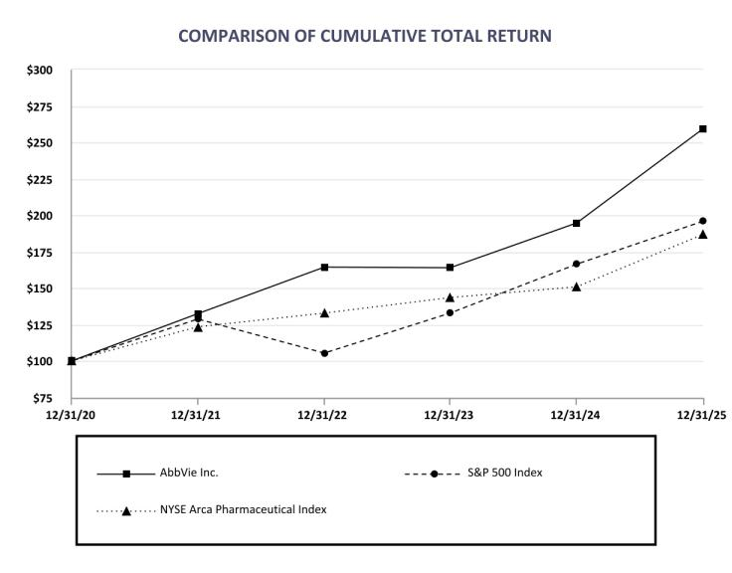

This performance graph is furnished and shall not be deemed "filed" with the SEC or subject to Section 18 of the Securities Exchange Act of 1934, nor shall it be deemed incorporated by reference in any of AbbVie's filings under the Securities Act of 1933, as amended.

2025 Form 10-K | | 32

Dividends

On October 31, 2025, AbbVie announced that its board of directors declared an increase in the company’s quarterly dividend from $1.64 per share to $1.73 per share, payable on February 17, 2026, to stockholders of record as of January 16, 2026. The timing, declaration, amount of and payment of any dividends by AbbVie in the future is within the discretion of its board of directors and will depend upon many factors, including AbbVie's financial condition, earnings, capital requirements of its operating subsidiaries, covenants associated with certain of AbbVie's debt service obligations, legal requirements, regulatory constraints, industry practice, ability to access capital markets and other factors deemed relevant by its board of directors. Moreover, if AbbVie determines to pay any dividend in the future, there can be no assurance that it will continue to pay such dividends or the amount of such dividends.

Issuer Purchases of Equity Securities

 |  |  |  |  |  | Total
 |  |  |  |  |  | Number of
 | Total |  |  |  |  | Shares (or Units) |  |  | Maximum Number (or
 | Total |  |  | Average |  | Purchased as Part |  |  | Maximum Number (or
 | Number |  |  |  |  | of Publicly |  |  | Approximate Dollar Value) of
 | of Shares |  |  | Price |  | Announced |  |  | Shares (or Units) that May
Period | (or Units) |  |  | Paid per Share |  | Plans or |  |  | Yet Be Purchased Under the
Period | Purchased |  |  | (or Unit) |  | Programs |  |  | Plans or Programs
October 1, 2025 - October 31, 2025 |  | 861 | (1) | $ | 228.89 | (1) | — | $ | 2,896,110,760
November 1, 2025 - November 30, 2025 |  | 691 | (1) | $ | 217.83 | (1) | — | $ | 2,896,110,760
December 1, 2025 - December 31, 2025 |  | 24,742 | (1) | $ | 224.39 | (1) | — | $ | 2,896,110,760
Total |  | 26,294 | (1) | $ | 224.36 | (1) | — | $ | 2,896,110,760

- In addition to AbbVie shares repurchased on the open market under a publicly announced program, if any, these shares also included the shares purchased on the open market for the benefit of participants in the AbbVie Employee Stock Purchase Plan – 861 in October; 691 in November; and 24,742 in December.

These shares do not include the shares surrendered to AbbVie to satisfy minimum tax withholding obligations in connection with the vesting or exercise of stock-based awards.

ITEM 6. [RESERVED]

33 | 2025 Form 10-K

ITEM 7. MANAGEMENT'S DISCUSSION AND ANALYSIS OF FINANCIAL CONDITION AND RESULTS OF OPERATIONS

The following is a discussion and analysis of the financial condition of AbbVie Inc. (AbbVie or the company). This commentary should be read in conjunction with the Consolidated Financial Statements and accompanying notes appearing in Item 8, "Financial Statements and Supplementary Data." This section of Form 10-K generally discusses 2025 and 2024 items and year-to-year comparisons between 2025 and 2024. Discussions of 2023 items and year-to-year comparisons between 2024 and 2023 that are not included in this Form 10-K can be found in “Management's Discussion and Analysis of Financial Condition and Results of Operations” in Part II, Item 7 of the Company’s Annual Report on Form 10-K for the fiscal year ended December 31, 2024.

EXECUTIVE OVERVIEW

Company Overview

AbbVie is a global, diversified research-based biopharmaceutical company positioned for success with a comprehensive product portfolio that has leadership positions across immunology, neuroscience, oncology and aesthetics. AbbVie uses its expertise, dedicated people and unique approach to innovation to develop and market advanced therapies that address some of the world’s most complex and serious diseases.

On February 13, 2025, the board of directors of AbbVie unanimously elected Chief Executive Officer (CEO) Robert A. Michael to succeed Richard A. Gonzalez as Chairman of the board of directors, effective July 1, 2025, at which time Mr. Gonzalez retired from the board.

AbbVie's products are generally sold worldwide directly to wholesalers, distributors, government agencies, health care facilities, specialty pharmacies and independent retailers from AbbVie-owned distribution centers and public warehouses. Certain products (including aesthetic products and devices) are also sold directly to physicians and other licensed healthcare providers. In the United States, AbbVie distributes pharmaceutical products principally through independent wholesale distributors, with some sales directly to retailers, pharmacies, patients or other customers. Outside the United States, AbbVie sells products primarily to wholesalers or through distributors, and depending on the market, works through largely centralized national payers systems to agree on reimbursement terms. Certain products are co-marketed or co-promoted with other companies. AbbVie operates as a single global business segment.

2026 Strategic Objectives

AbbVie's mission is to discover and develop innovative medicines and products that solve serious health issues today and address the medical challenges of tomorrow while achieving top-tier financial performance through outstanding execution. AbbVie intends to execute its strategy and advance its mission in a number of ways, including: (i) maximizing the benefits of a diversified revenue base with multiple long-term growth drivers; (ii) leveraging AbbVie's commercial strength and international infrastructure across therapeutic areas, ensuring strong commercial execution of new product launches as well as continued investment in key on-market products; (iii) continuing to invest in and expand its pipeline in support of opportunities across our core areas of immunology, neuroscience, oncology and aesthetics as well as new sources of growth such as obesity; (iv) generating substantial operating cash flows to support investments in innovative research and development and returning cash to shareholders via a strong and growing dividend while maintaining a strong investment grade credit rating. In addition, AbbVie anticipates several regulatory submissions, approvals and data readouts from key clinical trials in the next 12 months.

AbbVie expects to achieve its strategic objectives through:

- Maximizing revenue growth of our key on-market products, including Skyrizi, Rinvoq, Vraylar, Botox Therapeutic, Ubrelvy, Qulipta, Vyalev, Venclexta, Elahere, Botox Cosmetic and Juvederm Collection.

- Advancing our research and development pipeline by delivering late-stage pipeline milestones, achieving key proof-of-concept objectives across therapeutic areas and continuing to invest in key on-market product indication expansion.

- Maximizing the value of key acquisitions as well as continuing to invest in external innovation.

- The favorable impact of pipeline products and indications recently approved or currently under regulatory review where approval is expected in 2026. These products are described in greater detail in the section labeled "Research and Development" included as part of this Item 7.

2025 Form 10-K | | 34

2025 Financial Results

AbbVie's strategy has focused on delivering strong financial results, maximizing the benefits of a diversified revenue base, advancing and investing in its pipeline and returning value to shareholders while ensuring a strong, sustainable growth business over the long term. The company's financial performance in 2025 included delivering worldwide net revenues of $61.2 billion, operating earnings of $15.1 billion, diluted earnings per share of $2.36 and cash flows from operations of $19.0 billion. Worldwide net revenues increased by 9% on a reported and on a constant currency basis.

Financial results for 2025 also included the following costs: (i) $7.4 billion related to the amortization of intangible assets; (ii) $6.5 billion for the change in fair value of contingent consideration liabilities; (iii) $847 million related to intangible asset impairment; and (iv) $276 million of acquisition and integration expenses. Additionally, financial results reflected continued funding to support all stages of AbbVie’s pipeline assets and continued investment in AbbVie’s on-market brands.

Recent Events

Regulatory Environment

Subsequent to December 31, 2025, AbbVie announced a voluntary agreement with the U.S. government to further advance access and affordability of AbbVie’s products in the U.S. while protecting and investing in U.S. pharmaceutical innovation. AbbVie will provide low prices in Medicaid and expand affordable, direct-to-patient offerings. Additionally, AbbVie pledged $100 billion in U.S.-based research and development and capital investments, including manufacturing, over the next decade. Under this voluntary agreement, the U.S. government has agreed to provide AbbVie a three-year exemption from tariffs and future price mandates.

On July 4, 2025, the United States government signed into law the One Big Beautiful Bill Act of 2025 (2025 Act). Included within the 2025 Act are provisions that permanently extend certain expiring provisions of the 2017 Tax Cuts and Jobs Act, modify the international tax framework to reduce the tax rate on certain foreign earned income, restore the tax treatment of expensing for domestic research and development costs and bonus depreciation, and allow for full expensing of qualified production property. In addition, the legislation contains multiple effective dates and transition elections, with certain provisions effective in

2025 and others implemented through 2027. The 2025 Act also includes certain new health care provisions related to the orphan drug exclusion of the Inflation Reduction Act of 2022, and Medicaid, which have various effective dates. The new legislation had a favorable impact on cash tax payments in the current year.

The Inflation Reduction Act of 2022 has and will continue to have a significant impact on how drugs are covered and paid for under the Medicare program, including through the creation of financial penalties for drugs whose price increases outpace inflation, the redesign of Medicare Part D benefits to shift a greater portion of the costs to manufacturers, and through government price-setting for certain Medicare Part B and Part D drugs. In 2023, the U.S. Department of Health and Human Services, through Centers for Medicare and Medicaid Service, selected Imbruvica as one of 10 medicines subject to government-set prices in Medicare Part D beginning in 2026 and in 2025, selected Vraylar and Linzess as two of 15 medicines subject to government-set prices in Medicare Part D beginning in 2027. In January 2026, Botox was selected as one of 15 medicines subject to government-set prices in Medicare Parts B and D beginning in 2028. It is possible that more of our products, including products that generate substantial revenues, could be selected in future years, which could, among other things, accelerate revenue erosion prior to expiration of intellectual property protections. See Part I, Item 1 “Business – Regulation – Commercialization, Distribution and Manufacturing,” Part I, Item 1A “Risk Factors” and Note 7 to the Consolidated Financial Statements for additional information.

U.S. Capital Investment

In 2025, AbbVie announced the start of construction of a new active pharmaceutical ingredient facility in Illinois and an expansion of biologics manufacturing and research and development capacity in Massachusetts. In January 2026, AbbVie announced that it entered into an agreement to acquire a device manufacturing facility in Arizona. These projects are part of AbbVie's plan to increase capital investment in the U.S. to broadly support innovation and expand critical manufacturing capabilities and capacity.

Intellectual Property Protection and Regulatory Exclusivity

In September 2025, AbbVie announced the settlement of litigation with all generic manufacturers that filed abbreviated new drug applications with the U.S. Food and Drug Administration (FDA) for generic versions of upadacitinib tablets, which AbbVie markets as Rinvoq. Given the settlement and license agreements, which are subject to standard acceleration provisions, assuming pediatric exclusivity is granted, no generic entry for any Rinvoq tablets is expected prior to April 2037 in the United States.

35 | 2025 Form 10-K

Research and Development

Research and innovation are the cornerstones of AbbVie’s business as a global biopharmaceutical company. AbbVie's long-term success depends to a great extent on its ability to continue to discover and develop innovative products and acquire or collaborate on compounds currently in development by other biotechnology or pharmaceutical companies.

AbbVie’s pipeline currently includes approximately 90 compounds, devices or indications in development individually or under collaboration or license agreements. Of these programs, approximately 60 are in mid- and late-stage development. The company’s pipeline is focused on such important therapeutic areas as immunology, neuroscience, oncology and aesthetics and other specialties, including obesity.

The following sections summarize transitions of significant programs from mid-stage development to late-stage development as well as developments in significant late-stage and registrational programs.

AbbVie expects multiple mid-stage programs to transition into late-stage programs in the next 12 months.

Significant Programs and Developments

Immunology

Rinvoq

- In April 2025, AbbVie announced that the European Commission (EC) granted marketing authorization to Rinvoq for the treatment of giant cell arteritis (GCA) in adult patients.

- In April 2025, AbbVie announced that the U.S. FDA approved Rinvoq for the treatment of GCA in adult patients.

- In July 2025, AbbVie announced positive topline results from Study 2 of its Phase 3 UP-AA trial for Rinvoq as a monotherapy in adults and adolescents with severe alopecia areata (AA).

- In August 2025, AbbVie announced positive topline results from Study 1 of its Phase 3 UP-AA trial for Rinvoq as a monotherapy in adult and adolescent patients with severe AA.

- In October 2025, AbbVie announced that the U.S. FDA approved a supplemental New Drug Application (sNDA) that updates the indication statement for Rinvoq for the treatment of adults with moderately to severely active ulcerative colitis and moderately to severely active Crohn's disease. The updated indication allows the use of Rinvoq prior to the use of tumor necrosis factor (TNF) blocking agents in patients for whom use of these treatments is clinically inadvisable and who have received at least one approved systemic therapy.

- In October 2025, AbbVie announced positive topline results from the Phase 3b/4 head-to-head SELECT-SWITCH study evaluating the efficacy and safety of Rinvoq compared to Humira in adult patients with moderate to severe rheumatoid arthritis (RA), who had an inadequate response or intolerance to a single TNF inhibitor other than Humira. In the study, Rinvoq demonstrated superiority versus Humira in achieving low disease activity and remission.

- In October 2025, AbbVie announced positive topline results from two replicate Phase 3 studies evaluating the efficacy and safety of Rinvoq in adult and adolescent patients with non-segmental vitiligo.

- In November 2025, AbbVie submitted a marketing authorization application (MAA) to the European Medicines Agency (EMA) for Rinvoq for the treatment of adults and adolescents 12 years and older with severe AA.

- In February 2026, AbbVie announced the submission of applications for a new indication to the U.S. FDA and EMA for Rinvoq for the treatment of adult and adolescent patients with non-segmental vitiligo.

Neuroscience

Qulipta

- In February 2025, AbbVie initiated a Phase 3 clinical trial to evaluate Qulipta for the preventive treatment of menstrual migraine.

- In June 2025, AbbVie announced positive topline results from its Phase 3 TEMPLE head-to-head study evaluating the tolerability, safety and efficacy of Qulipta compared to the highest tolerated dose of topiramate in adult patients with a history of four or more migraine days per month.

2025 Form 10-K | | 36

- In December 2025, AbbVie announced results from the Phase 3 ECLIPSE study, evaluating the safety, efficacy and tolerability of Aquipta versus placebo for the acute treatment of migraine in adults. The study met its primary and key secondary endpoints, with Aquipta demonstrating superiority for achieving pain freedom at two hours after treatment of the first migraine attack.

- In December 2025, AbbVie announced the submission of an application for a new indication to the EMA for Aquipta for the acute treatment of adult patients with migraine.

Tavapadon

- In September 2025, AbbVie announced the submission of a New Drug Application (NDA) to the U.S. FDA for tavapadon, a novel selective dopamine D1/D5 receptor partial agonist, for the treatment of Parkinson's disease.

Oncology

Emrelis

- In May 2025, AbbVie announced that the U.S. FDA granted accelerated approval for Emrelis (telisotuzumab vedotin-tllv) for the treatment of adult patients with locally advanced or metastatic, non-squamous non-small cell lung cancer with high c-Met protein overexpression who have received a prior systemic therapy.

Venclexta

- In June 2025, AbbVie announced that the global Phase 3 VERONA trial evaluating Venclexta in combination with azacitidine in the treatment of newly diagnosed higher-risk myelodysplastic syndrome did not meet the primary endpoint of overall survival. No new safety signals were observed.

- In July 2025, AbbVie announced the submission of a sNDA to the U.S. FDA for the fixed-duration, all oral combination regimen of Venclexta and acalabrutinib in previously untreated patients with chronic lymphocytic leukemia (CLL). The submission is supported by positive results from the Phase 3 AMPLIFY trial which demonstrated that the combination regimen improved progression-free survival compared to standard chemoimmunotherapy in previously untreated patients with CLL.

Epkinly

- In May 2025, Genmab A/S (Genmab) announced positive topline results from the Phase 3 trial evaluating Epkinly plus rituximab and lenalidomide versus rituximab and lenalidomide alone in adult patients with relapsed or refractory (R/R) follicular lymphoma.

- In November 2025, AbbVie announced that the U.S. FDA approved Epkinly plus rituximab and lenalidomide for the treatment of adult patients with R/R follicular lymphoma.

- In January 2026, AbbVie announced topline results from the Phase 3 trial evaluating Epkinly compared to investigator's choice of chemoimmunotherapy in adult patients with R/R diffuse large B-cell lymphoma (DLBCL). The study demonstrated an improvement in progression free survival (PFS) but did not demonstrate a statistically significant improvement in overall survival (OS).

PVEK

- In September 2025, AbbVie announced the submission of a BLA to the U.S. FDA for approval of pivekimab sunirine (PVEK), an investigational antibody-drug conjugate (ADC), for treatment of blastic plasmacytoid dendritic cell neoplasm (BPDCN).

Aesthetics

TrenibotE

- In April 2025, AbbVie announced the submission of a BLA to the U.S. FDA for approval of trenibotulinumtoxinE (TrenibotE) for the treatment of moderate to severe glabellar lines. TrenibotE is a first-in-class botulinum neurotoxin serotype E characterized by a rapid onset of action as early as 8 hours after administration and short duration of effect of 2-3 weeks. If approved, TrenibotE will be the first neurotoxin of its kind available to patients.

37 | 2025 Form 10-K

Juvederm Collection

- In June 2025, AbbVie announced that the U.S. FDA accepted for review the supplemental premarket approval application for Skinvive by Juvederm to reduce neck lines for the improvement of neck appearance.

Other

Emblaveo

- In February 2025, AbbVie announced that the U.S. FDA approved Emblaveo (aztreonam and avibactam), as the first fixed-dose, intravenous, monobactam/β-lactamase inhibitor combination antibiotic to treat complicated intra-abdominal infections, including those caused by Gram-negative bacteria.

Mavyret

- In June 2025, AbbVie announced that the U.S. FDA approved a label expansion for Mavyret, an oral pangenotypic direct acting antiviral therapy. It is now approved for the treatment of adults and pediatric patients three years and older with acute or chronic hepatitis C virus infection.

2025 Form 10-K | | 38

RESULTS OF OPERATIONS

Net Revenues

The comparisons presented at constant currency rates reflect comparative local currency net revenues at the prior year's foreign exchange rates. This measure provides information on the change in net revenues assuming that foreign currency exchange rates had not changed between the prior and current periods. AbbVie believes that the non-GAAP measure of change in net revenues at constant currency rates, when used in conjunction with the GAAP measure of change in net revenues at actual currency rates, may provide a more complete understanding of the company's operations and can facilitate analysis of the company's results of operations, particularly in evaluating performance from one period to another.

 |  |  |  |  |  |  |  |  |  | Percent change
 |  |  |  |  |  |  |  | At actual currency rates |  |  |  |  | At constant currency rates
years ended (dollars in millions) |  |  | 2025 |  | 2024 |  | 2023 | 2025 | 2024 |  |  |  | 2025 | 2024
United States |  | $ | 46,603 | $ | 43,029 | $ | 41,883 |  | 8.3 % | 2.7 % |  |  | 8.3 % | 2.7 %
International |  |  | 14,557 |  | 13,305 |  | 12,435 |  | 9.4 % | 7.0 % |  |  | 9.2 % | 11.1 %
Net revenues |  | $ | 61,160 | $ | 56,334 | $ | 54,318 |  | 8.6 % | 3.7 % |  |  | 8.5 % | 4.6 %
39 | | 2025 Form 10-K

The following table details AbbVie's worldwide net revenues:

 |  |  |  |  |  |  |  |  | Percent change
 |  |  |  |  |  |  |  | At actual currency rates |  |  |  | At constant currency rates
years ended December 31 (dollars in millions) |  |  | 2025 |  | 2024 |  | 2023 | 2025 | 2024 |  |  | 2025 | 2024
Immunology
Skyrizi | United States | $ | 15,202 | $ | 10,086 | $ | 6,753 | 50.7 % | 49.3 % |  |  | 50.7 % | 49.3 %
 | International |  | 2,360 |  | 1,632 |  | 1,010 | 44.6 % | 61.6 % |  |  | 43.0 % | 65.4 %
 | Total | $ | 17,562 | $ | 11,718 | $ | 7,763 | 49.9 % | 50.9 % |  |  | 49.7 % | 51.4 %
Rinvoq | United States | $ | 5,940 | $ | 4,259 | $ | 2,824 | 39.5 % | 50.8 % |  |  | 39.5 % | 50.8 %
 | International |  | 2,364 |  | 1,712 |  | 1,145 | 38.0 % | 49.6 % |  |  | 37.1 % | 57.0 %
 | Total | $ | 8,304 | $ | 5,971 | $ | 3,969 | 39.1 % | 50.4 % |  |  | 38.8 % | 52.5 %
Humira | United States | $ | 3,062 | $ | 7,142 | $ | 12,160 | (57.1)% | (41.3)% |  |  | (57.1)% | (41.3)%
 | International |  | 1,478 |  | 1,851 |  | 2,244 | (20.2)% | (17.5)% |  |  | (19.5)% | (13.2)%
 | Total | $ | 4,540 | $ | 8,993 | $ | 14,404 | (49.5)% | (37.6)% |  |  | (49.4)% | (36.9)%
Neuroscience
Vraylar | United States | $ | 3,612 | $ | 3,260 | $ | 2,755 | 10.8 % | 18.4 % |  |  | 10.8 % | 18.4 %
 | International |  | 9 |  | 7 |  | 4 | 33.3 % | 57.8 % |  |  | 36.8 % | 58.6 %
 | Total | $ | 3,621 | $ | 3,267 | $ | 2,759 | 10.8 % | 18.4 % |  |  | 10.8 % | 18.4 %
Botox Therapeutic | United States | $ | 3,151 | $ | 2,718 | $ | 2,476 | 16.0 % | 9.8 % |  |  | 16.0 % | 9.8 %
 | International |  | 618 |  | 565 |  | 515 | 9.3 % | 9.8 % |  |  | 9.9 % | 14.0 %
 | Total | $ | 3,769 | $ | 3,283 | $ | 2,991 | 14.8 % | 9.8 % |  |  | 14.9 % | 10.5 %
Ubrelvy | United States | $ | 1,239 | $ | 981 | $ | 803 | 26.3 % | 22.1 % |  |  | 26.3 % | 22.1 %
 | International |  | 32 |  | 25 |  | 12 | 28.6 % | >100.0 % |  |  | 30.7 % | >100.0 %
 | Total | $ | 1,271 | $ | 1,006 | $ | 815 | 26.4 % | 23.4 % |  |  | 26.5 % | 23.4 %
Qulipta | United States | $ | 906 | $ | 628 | $ | 405 | 44.1 % | 55.3 % |  |  | 44.1 % | 55.3 %
 | International |  | 130 |  | 30 |  | 3 | >100.0 % | >100.0 % |  |  | >100.0 % | >100.0 %
 | Total | $ | 1,036 | $ | 658 | $ | 408 | 57.3 % | 61.3 % |  |  | 56.8 % | 61.3 %
Vyalev | United States | $ | 167 | $ | 1 | $ | — | >100.0 % | n/m |  |  | >100.0 % | n/m
 | International |  | 315 |  | 98 |  | 3 | >100.0 % | >100% |  |  | >100.0 % | >100%
 | Total | $ | 482 | $ | 99 | $ | 3 | >100.0 % | >100% |  |  | >100.0 % | >100%
Duodopa | United States | $ | 73 | $ | 96 | $ | 97 | (23.7)% | (1.8)% |  |  | (23.7)% | (1.8)%
 | International |  | 308 |  | 351 |  | 371 | (12.3)% | (5.3)% |  |  | (14.1)% | (5.4)%
 | Total | $ | 381 | $ | 447 | $ | 468 | (14.8)% | (4.6)% |  |  | (16.2)% | (4.7)%
Other Neuroscience | United States | $ | 192 | $ | 223 | $ | 254 | (13.9)% | (12.1)% |  |  | (13.9)% | (12.1)%
 | International |  | 15 |  | 16 |  | 19 | (0.4)% | (18.9)% |  |  | 2.8 % | (18.3)%
 | Total | $ | 207 | $ | 239 | $ | 273 | (13.0)% | (12.5)% |  |  | (12.8)% | (12.5)%
Oncology
Imbruvica | United States | $ | 2,048 | $ | 2,448 | $ | 2,665 | (16.4)% | (8.1)% |  |  | (16.4)% | (8.1)%
 | Collaboration revenues |  | 821 |  | 899 |  | 931 | (8.6)% | (3.5)% |  |  | (8.6)% | (3.5)%
 | Total | $ | 2,869 | $ | 3,347 | $ | 3,596 | (14.3)% | (6.9)% |  |  | (14.3)% | (6.9)%
Venclexta | United States | $ | 1,306 | $ | 1,234 | $ | 1,087 | 5.9 % | 13.5 % |  |  | 5.9 % | 13.5 %
 | International |  | 1,486 |  | 1,349 |  | 1,201 | 10.2 % | 12.3 % |  |  | 9.8 % | 18.0 %
 | Total | $ | 2,792 | $ | 2,583 | $ | 2,288 | 8.1 % | 12.9 % |  |  | 7.9 % | 15.9 %
Elahere | United States | $ | 607 | $ | 477 | $ | — | 27.2 % | n/m |  |  | 27.2 % | n/m
 | International |  | 83 |  | 2 |  | — | >100.0 % | n/m |  |  | >100.0 % | n/m
 | Total | $ | 690 | $ | 479 | $ | — | 44.0 % | n/m |  |  | 43.4 % | n/m
Epkinly | Collaboration revenues | $ | 181 | $ | 118 | $ | 28 | 52.9 % | >100.0 % |  |  | 52.9 % | >100.0 %
 | International |  | 90 |  | 28 |  | 3 | >100.0 % | >100.0 % |  |  | >100.0 % | >100.0 %
 | Total | $ | 271 | $ | 146 | $ | 31 | 85.5 % | >100.0 % |  |  | 85.0 % | >100.0 %
Other Oncology | United States | $ | 33 | $ | — | $ | — | n/m | n/m |  |  | n/m | n/m
Aesthetics
Botox Cosmetic | United States | $ | 1,504 | $ | 1,682 | $ | 1,670 | (10.5)% | 0.7 % |  |  | (10.5)% | 0.7 %
 | International |  | 1,098 |  | 1,038 |  | 1,012 | 5.7 % | 2.7 % |  |  | 6.2 % | 6.7 %
 | Total | $ | 2,602 | $ | 2,720 | $ | 2,682 | (4.3)% | 1.4 % |  |  | (4.1)% | 2.9 %
Juvederm Collection | United States | $ | 385 | $ | 469 | $ | 519 | (18.0)% | (9.6)% |  |  | (18.0)% | (9.6)%
 | International |  | 608 |  | 708 |  | 859 | (14.1)% | (17.6)% |  |  | (13.6)% | (13.4)%
 | Total | $ | 993 | $ | 1,177 | $ | 1,378 | (15.6)% | (14.6)% |  |  | (15.3)% | (12.0)%

2025 Form 10-K | | 40

Other Aesthetics | United States | $ | 1,101 | $ | 1,118 | $ | 1,060 | (1.5)% | 5.5 % | (1.5)% | 5.5 %
 | International |  | 164 |  | 161 |  | 174 | 1.8 % | (7.1)% | 2.7 % | (1.0)%
 | Total | $ | 1,265 | $ | 1,279 | $ | 1,234 | (1.1)% | 3.7 % | (1.0)% | 4.6 %
Eye Care
Ozurdex | United States | $ | 124 | $ | 138 | $ | 143 | (10.1)% | (4.1)% | (10.1)% | (4.1)%
 | International |  | 369 |  | 356 |  | 329 | 3.7 % | 8.3 % | 3.0 % | 10.7 %
 | Total | $ | 493 | $ | 494 | $ | 472 | (0.2)% | 4.5 % | (0.7)% | 6.2 %
Lumigan/Ganfort | United States | $ | 189 | $ | 187 | $ | 173 | 1.2 % | 7.5 % | 1.2 % | 7.5 %
 | International |  | 221 |  | 242 |  | 259 | (8.7)% | (6.4)% | (8.3)% | (3.9)%
 | Total | $ | 410 | $ | 429 | $ | 432 | (4.4)% | (0.9)% | (4.2)% | 0.6 %
Alphagan/Combigan | United States | $ | 53 | $ | 95 | $ | 121 | (43.3)% | (21.8)% | (43.3)% | (21.8)%
 | International |  | 144 |  | 153 |  | 151 | (6.3)% | 1.5 % | (4.6)% | 7.6 %
 | Total | $ | 197 | $ | 248 | $ | 272 | (20.4)% | (8.8)% | (19.4)% | (5.4)%
Other Eye Care | United States | $ | 588 | $ | 644 | $ | 815 | (8.7)% | (21.1)% | (8.7)% | (21.1)%
 | International |  | 421 |  | 427 |  | 424 | (1.4)% | 0.9 % | 0.5 % | 5.6 %
 | Total | $ | 1,009 | $ | 1,071 | $ | 1,239 | (5.8)% | (13.6)% | (5.0)% | (12.0)%
Other Key Products
Mavyret | United States | $ | 635 | $ | 595 | $ | 659 | 6.7 % | (9.7)% | 6.7 % | (9.7)%
 | International |  | 682 |  | 716 |  | 771 | (4.7)% | (7.2)% | (5.7)% | (4.5)%
 | Total | $ | 1,317 | $ | 1,311 | $ | 1,430 | 0.4 % | (8.3)% | (0.2)% | (6.9)%
Creon | United States | $ | 1,512 | $ | 1,383 | $ | 1,268 | 9.3 % | 9.1 % | 9.3 % | 9.1 %
Linzess/Constella | United States | $ | 864 | $ | 916 | $ | 1,073 | (5.7)% | (14.6)% | (5.7)% | (14.6)%
 | International |  | 43 |  | 38 |  | 35 | 13.6 % | 7.5 % | 13.3 % | 7.2 %
 | Total | $ | 907 | $ | 954 | $ | 1,108 | (4.9)% | (13.9)% | (4.9)% | (13.9)%
All other |  | $ | 2,627 | $ | 3,032 | $ | 3,035 | (13.3)% | — % | (12.8)% | 1.4 %
Total net revenues |  | $ | 61,160 | $ | 56,334 | $ | 54,318 | 8.6 % | 3.7 % | 8.5 % | 4.6 %

n/m – Not meaningful

The following discussion and analysis of AbbVie's net revenues by product is presented on a constant currency basis.

Net revenues for Skyrizi increased 50% in 2025 primarily driven by continued strong market share uptake as well as market growth across all indications.

Net revenues for Rinvoq increased 39% in 2025 primarily driven by continued strong market share uptake as well as market growth across all indications.

Net revenues for Humira decreased 49% in 2025 primarily driven by continued impact of direct biosimilar competition following the loss of exclusivity.

Net revenues for Vraylar increased 11% in 2025 primarily driven by continued market share uptake as well as market growth.

Net revenues for Botox Therapeutic increased 15% in 2025 primarily driven by market growth as well as continued market share uptake.

Net revenues for Ubrelvy increased 27% in 2025 primarily driven by continued market share uptake as well as market growth.

Net revenues for Qulipta increased 57% in 2025 primarily driven by continued strong market share uptake as well as market growth.

Net revenues for Imbruvica represent product revenues in the United States and collaboration revenues outside of the United States related to AbbVie's 50% share of Imbruvica profit. AbbVie's global Imbruvica revenues decreased 14% in 2025 primarily driven by decreased demand and unfavorable pricing in the United States as well as decreased collaboration revenues.

Net revenues for Venclexta increased 8% in 2025 primarily driven by increased demand, partially offset by unfavorable pricing.

Net revenues for Elahere increased 43% in 2025 primarily drive by increased demand and the favorable impact of a full period of Elahere results in 2025 compared to the prior year.

41 | 2025 Form 10-K

Net revenues for Botox Cosmetic decreased 4% in 2025. In the United States, Botox Cosmetic net revenues decreased 11% primarily driven by unfavorable pricing due to customer loyalty program changes, lower market share and decreased consumer demand, partially offset by the timing of customer inventory destocking in the prior year. Internationally, Botox Cosmetic net revenues increased 6% primarily driven by increased consumer demand across certain international markets, partially offset by unfavorable pricing.

Net revenues for Juvederm Collection decreased 15% in 2025 primarily driven by decreased consumer demand, partially offset by the timing of customer inventory destocking in the prior year.

Gross Margin

 |  |  |  |  |  |  | Percent change
years ended December 31 (dollars in millions) |  | 2025 |  | 2024 |  | 2023 | 2025 | 2024
Gross margin | $ | 42,956 | $ | 39,430 | $ | 33,903 | 9 % | 16 %
as a % of net revenues |  | 70 % |  | 70 % |  | 62 %

Gross margin as a percentage of net revenues in 2025 was flat compared to 2024. Gross margin percentage for 2025 was favorably impacted by increased leverage from net revenues growth, lower amortization of intangible assets and lower acquisition and integration costs offset by the unfavorable impact of intangible asset impairment charges of $847 million.

Selling, General and Administrative

 |  |  |  |  |  |  | Percent change
years ended December 31 (dollars in millions) |  | 2025 |  | 2024 |  | 2023 | 2025 | 2024
Selling, general and administrative | $ | 14,010 | $ | 14,752 | $ | 12,872 | (5)% | 15 %
as a % of net revenues |  | 23 % |  | 26 % |  | 24 %

Selling, general and administrative (SG&A) expenses as a percentage of net revenues decreased in 2025 compared to 2024. SG&A expense percentage for 2025 was favorably impacted by net leverage from revenue growth, lower litigation reserve charges and lower acquisition and integration costs.

Research and Development

 |  |  |  |  |  |  | Percent change
years ended December 31 (dollars in millions) |  | 2025 |  | 2024 |  | 2023 | 2025 | 2024
Research and development | $ | 9,096 | $ | 12,791 | $ | 7,675 | (29)% | 67 %
as a % of net revenues |  | 15 % |  | 23 % |  | 14 %

Research and development (R&D) expenses as a percentage of net revenues decreased in 2025 compared to 2024. R&D expense percentage for 2025 was favorably impacted by lower intangible asset impairment charges. Intangible asset impairment charges were $4.5 billion in 2024. R&D expenses other than intangible asset impairment charges increased to support all stages of the company's pipeline assets.

Acquired IPR&D and Milestones

years ended December 31 (in millions) |  | 2025 |  | 2024 |  | 2023
Upfront charges | $ | 4,808 | $ | 2,627 | $ | 582
Development milestones |  | 208 |  | 130 |  | 196
Acquired IPR&D and milestones | $ | 5,016 | $ | 2,757 | $ | 778

Acquired IPR&D and milestones expense in 2025 included upfront charges of $1.9 billion related to the acquisition of Capstan Therapeutics, Inc., $906 million related to the acquisition of Gilgamesh Pharmaceuticals, Inc., $700 million related to a license agreement with Ichnos Glenmark Innovation, Inc., $350 million related to a license agreement with Gubra A/S and $335 million related to an option-to-license agreement with ADARx Pharmaceuticals, Inc. Acquired IPR&D and milestones in 2024 included upfront charges of $1.4 billion related to the acquisition of Aliada Therapeutics Holdings, Inc. and $250 million related to the acquisition of Celsius Therapeutics, Inc. See Note 5 to the Consolidated Financial Statements for additional information.

2025 Form 10-K | | 42

Other Operating Income

Other operating income included a gain of $217 million in 2025 related to the termination of an R&D collaboration agreement with Calico Life Sciences LLC.

Other Non-Operating Expenses

years ended December 31 (in millions) |  | 2025 |  | 2024 |  | 2023
Interest expense | $ | 2,893 | $ | 2,808 | $ | 2,224
Interest income |  | (266) |  | (648) |  | (540)
Interest expense, net | $ | 2,627 | $ | 2,160 | $ | 1,684
Net foreign exchange loss | $ | 58 | $ | 21 | $ | 146
Other expense, net |  | 5,793 |  | 3,240 |  | 4,677

Interest expense in 2025 increased compared to 2024 primarily due to the impact of higher effective interest rates.

Interest income in 2025 decreased compared to 2024 primarily due to a lower average cash and equivalents balance.

Other expense, net included charges related to changes in fair value of contingent consideration liabilities of $ 6.5 billion in 2025 and $3.8 billion in 2024. The fair value of contingent consideration liabilities is impacted by the passage of time and multiple other inputs, including discount rates, the estimated amount of future sales of the acquired products and other market-based factors. In 2025, the change in fair value reflected higher estimated Skyrizi sales, the passage of time, lower discount rates and a longer estimated royalty period. In 2024, the change in fair value reflected higher estimated Skyrizi sales and the passage of time, partially offset by higher discount rates.

Income Tax Expense

The effective income tax rate was 36% in 2025, (15)% in 2024 and 22% in 2023. The effective income tax rate fluctuates year to year due to the allocation of the company’s taxable earnings among jurisdictions, as well as certain discrete factors and events in each year, including changes in tax law and business development activities. The effective income tax rates in 2025, 2024 and 2023 differed from the statutory tax rate principally due to the impact of foreign operations with lower income tax rates in locations outside the United States, the U.S. global minimum tax, changes in fair value of contingent consideration, tax audits and settlements, tax credits and incentives in the United States, Puerto Rico and other foreign tax jurisdictions, and business development activities. The effective income tax rate in 2025 was higher than 2024 primarily due to a one-time tax benefit associated with the closing of a three-year U.S. IRS examination in 2024, partially offset by decreases in unrecognized tax benefits, a decrease in the impact of acquisition costs related to certain business development activities and a decrease related to the impact of changes in fair value of contingent consideration.

The company's net earnings and cash flows could be affected by future tax policy and law changes in the jurisdictions in which we operate, including changes in tax law related to the projects undertaken by the Organization for Economic Cooperation and Development (OECD). These projects include a global minimum tax rate of 15%, referred to as "Pillar Two", and the creation of a new global system to tax income based on the location to which products are sold, referred to as "Pillar One." Numerous countries have agreed to a statement in support of the OECD model rules and European Union member states have agreed to implement Pillar Two. This implementation includes aspects of legislation that were effective starting in 2024.

In recent years, the OECD has issued Administrative Guidance, including the most recent side-by-side agreement released on January 5, 2026. The side-by-side agreement is intended to complement the OECD’s Pillar Two model rules with the addition of two new safe harbors that are aimed to provide clarity and reduce compliance complexity for eligible multinational companies. The Administrative Guidance generally requires further legislative action to be effective. These potential changes increase tax uncertainty and may impact income tax expense in future years. AbbVie will continue to monitor pending legislation and implementation by individual countries and evaluate the potential impact on the company's business in future periods.

43 | 2025 Form 10-K

FINANCIAL POSITION, LIQUIDITY AND CAPITAL RESOURCES

years ended December 31 (in millions) | 2025 |  | 2024 |  |  | 2023
Cash flows provided by (used in)
Operating activities | $ | 19,030 | $ | 18,806 | $ | 22,839
Investing activities |  | (6,643) |  | (20,820) |  | (2,009)
Financing activities |  | (12,724) |  | (5,211) |  | (17,222)

Operating cash flows in 2025 increased compared to the prior year primarily due to increased results from operations driven by higher net revenues, timing of working capital and lower acquisition-related cash expenses, partially offset by higher payments related to litigation matters and higher payments of contingent consideration liabilities. Operating cash flows also reflected AbbVie’s contributions to its defined benefit plans of $348 million in 2025 and $326 million in 2024.

Investing cash flows in 2025 included payments made for other acquisitions and investments, net of cash acquired of $5.2 billion and capital expenditures of $1.2 billion. Investing cash flows in 2024 included $18.5 billion cash consideration paid to acquire ImmunoGen, Inc. (ImmunoGen) and Cerevel Therapeutics Holdings, Inc. (Cerevel Therapeutics) offset by cash acquired of $952 million, net sales and maturities of investment securities of $482 million, payments made for other acquisitions and investments of $3.0 billion and capital expenditures of $974 million.

Financing cash flows in 2025 included the issuance of unsecured senior notes totaling $4.0 billion aggregate principal and $2.0 billion under the 364-day term loan credit agreement. Financing cash flows also included the repayment of $3.0 billion aggregate principal of 3.80% senior notes and $3.8 billion aggregate principal 3.60% senior notes.

Financing cash flows in 2024 included the issuance of unsecured senior notes totaling $15.0 billion aggregate principal which were used to finance the acquisitions of ImmunoGen and Cerevel Therapeutics. Additionally, financing cash flows included the issuance and repayment of $ 5.0 billion under the term loan credit agreement and repayments of $3.8 billion aggregate principal amount of 2.60% senior notes, €1.5 billion aggregate principal amount of 1.38% senior euro notes, €700 million aggregate principal amount of 1.25% senior euro notes, $1.0 billion aggregate principal amount of 3.85% senior notes, $99 million of secured term notes assumed from ImmunoGen in conjunction with the acquisition and settlement of $400 million aggregate amount of 2.5% convertible senior notes assumed from Cerevel Therapeutics. Additionally, the company refinanced its $2.0 billion floating rate three-year term loan. As part of the refinancing, the company repaid the existing $2.0 billion term loan due May 2025 and borrowed $2.0 billion under a new term loan due April 2027.

Financing cash flows also included cash dividend payments of $11.7 billion in 2025 and $11.0 billion in 2024. The increase in cash dividend payments was primarily driven by an increase of the dividend rate.

The company's stock repurchase authorization permits purchases of AbbVie shares from time to time in open-market or private transactions at management’s discretion. The program has no time limit and can be discontinued at any time. AbbVie repurchased 3 million shares for $606 million in 2025 and 7 million shares for $1.3 billion in 2024. AbbVie's remaining stock repurchase authorization was $2.9 billion as of December 31, 2025. On February 16, 2023, AbbVie's board of directors authorized a $5.0 billion increase to the existing stock repurchase authorization.

During 2025 and 2024, the company issued and redeemed commercial paper. The balance of commercial paper borrowings outstanding was $499 million as of December 31, 2025. There were no commercial paper borrowings outstanding as of December 31, 2024. AbbVie may issue additional commercial paper or retire commercial paper to meet liquidity requirements as needed.

Credit Risk

AbbVie monitors economic conditions, the creditworthiness of customers and government regulations and funding, both domestically and abroad. AbbVie regularly communicates with its customers regarding the status of receivable balances, including their payment plans and obtains positive confirmation of the validity of the receivables. AbbVie establishes an allowance for credit losses equal to the estimate of future losses over the contractual life of outstanding accounts receivable. AbbVie may also utilize factoring arrangements to mitigate credit risk, although the receivables included in such arrangements have historically not been a significant amount of total outstanding receivables.

Credit Facilities, Access to Capital and Credit Ratings

Credit Facilities

In January 2025, AbbVie entered into a new $3.0 billion five-year revolving credit facility that matures in January 2030 which is in addition to the existing $5.0 billion five-year revolving credit facility that matures in March 2028. The revolving

2025 Form 10-K | | 44

credit facilities are available to support AbbVie's commercial paper program and enable the company to borrow funds to meet liquidity requirements on an unsecured basis at variable interest rates and contain various covenants. At December 31, 2025, the company was in compliance with all covenants, and commitment fees under the revolving credit facilities were insignificant. No amounts were outstanding under the company's revolving credit facilities as of December 31, 2025 and December 31, 2024.

In April 2025, the company entered into a $4.0 billion 364-day term loan credit agreement. In May 2025, the company borrowed $2.0 billion under this term loan credit agreement which was outstanding and included in short-term borrowings on the consolidated balance sheet as of December 31, 2025.

In December 2023, in connection with the acquisitions of ImmunoGen and Cerevel Therapeutics, AbbVie entered into a $9.0 billion 364-day bridge credit agreement and $5.0 billion 364-day term loan credit agreement. In February 2024, AbbVie borrowed and repaid $5.0 billion under the term loan credit agreement. Subsequent to the $15.0 billion issuance of senior notes in February 2024, AbbVie terminated both the bridge and term loan credit agreements in the first quarter of 2024.

Access to Capital

The company intends to fund short-term and long-term financial obligations as they mature through cash on hand, future cash flows from operations or has the ability to issue additional debt. The company's ability to generate cash flows from operations, issue debt or enter into financing arrangements on acceptable terms could be adversely affected if there is a material decline in the demand for the company's products or in the solvency of its customers or suppliers, deterioration in the company's key financial ratios or credit ratings, or other material unfavorable changes in business conditions. At the current time, the company believes it has sufficient financial flexibility to issue debt, enter into other financing arrangements and attract long-term capital on acceptable terms to support the company's growth objectives.

Credit Ratings

In February 2026, Moody’s Investors Service upgraded AbbVie’s senior unsecured long -term credit rating to A2 with a stable outlook from A3 with a positive outlook and upgraded AbbVie’s short-term credit rating to Prime-1 from Prime-2. There were no other changes in the company’s credit ratings during the year ended December 31, 2025. Unfavorable changes to the ratings may have an adverse impact on future financing arrangements; however, they would not affect the company’s ability to draw on its credit facilities and would not result in an acceleration of scheduled maturities of any of the company’s outstanding debt.

Future Cash Requirements

Contractual Obligations

The following table summarizes AbbVie's estimated material contractual obligations as of December 31, 2025:

(in millions) |  | Total |  | Current |  | Long-term
Long-term debt, including current portion | $ | 64,503 | $ | 6,000 | $ | 58,503
Interest on long-term debt^{(a)} |  | 35,243 |  | 2,712 |  | 32,531
Contingent consideration liabilities^{(b)} |  | 25,374 |  | 3,455 |  | 21,919

- Includes estimated future interest payments on long-term debt. Interest payments on debt are calculated for future periods using forecasted interest rates in effect at the end of 2025. Projected interest payments include the related effects of interest rate swap agreements. Certain of these projected interest payments may differ in the future based on changes in floating interest rates or other factors or events. The projected interest payments only pertain to obligations and agreements outstanding at December 31, 2025. See Note 10 to the Consolidated Financial Statements for additional information regarding the company's debt instruments and Note 11 for additional information on the interest rate swap agreements outstanding at December 31, 2025.

- Includes contingent consideration liabilities which are recorded at fair value on the consolidated balance sheet. Potential contingent consideration payments that exceed the fair value recorded on the consolidated balance sheet are not included in the table of contractual obligations. See Note 11 to the Consolidated Financial Statements for additional information regarding these liabilities.

AbbVie enters into certain unconditional purchase obligations and other commitments in the normal course of business. There have been no changes to these commitments that would have a material impact on the company’s ability to meet either short-term or long-term future cash requirements.

45 | 2025 Form 10-K

Income Taxes

Future income tax cash requirements include a one-time transition tax liability on a mandatory deemed repatriation of previously untaxed earnings of foreign subsidiaries resulting from U.S. tax reform enacted in 2017. The one-time transition tax liability was $1.1 billion, which is classified as a current liability as of December 31, 2025.

Liabilities for unrecognized tax benefits totaled $5.6 billion as of December 31, 2025. It is not possible to reliably estimate the timing of the future cash outflows related to these liabilities. See Note 14 to the Consolidated Financial Statements for additional information on these unrecognized tax benefits.

Short-term Borrowings

Short-term borrowings included $2.0 billion of a 364-day term loan and $499 million of commercial paper, which are classified as current liabilities as of December 31, 2025. See Note 10 to the Consolidated Financial Statements for additional information regarding the company's short-term borrowings.

Quarterly Cash Dividend

On October 31, 2025, AbbVie announced that its board of directors declared an increase in the company’s quarterly dividend from $1.64 per share to $1.73 per share beginning with the dividend payable on February 17, 2026 to stockholders of record as of January 16, 2026. This reflects an increase of approximately 5.5% over the previous quarterly rate. The timing, declaration, amount of and payment of any dividends by AbbVie in the future is within the discretion of its board of directors and will depend upon many factors, including AbbVie's financial condition, earnings, capital requirements of its operating subsidiaries, covenants associated with certain of AbbVie's debt service obligations, legal requirements, regulatory constraints, industry practice, ability to access capital markets and other factors deemed relevant by its board of directors.

Collaborations, Licensing and Other Arrangements

AbbVie enters into collaborative, licensing and other arrangements with third parties that may require future milestone payments to third parties contingent upon the achievement of certain development, regulatory or commercial milestones. Individually, these arrangements are insignificant in any one annual reporting period. However, if milestones for multiple products covered by these arrangements happen to be reached in the same reporting period, the aggregate charge to expense could be material to the results of operations in that period. From a business perspective, the payments are viewed as positive because they signify that the product is successfully moving through development and is now generating or is more likely to generate future cash flows from product sales. It is not possible to predict with reasonable certainty whether these milestones will be achieved or the timing for achievement. See Note 5 to the Consolidated Financial Statements for additional information on these collaboration arrangements.

U.S. Research and Development and Capital Investment

Subsequent to December 31, 2025, AbbVie announced a voluntary agreement with the U.S. government to further advance access and affordability of AbbVie's products in the U.S. while protecting and investing in U.S. pharmaceutical innovation. Under this voluntary agreement, AbbVie pledged $100 billion in U.S.-based research and development and capital investment, including manufacturing, over the next decade.

CRITICAL ACCOUNTING POLICIES AND ESTIMATES

The preparation of financial statements in accordance with generally accepted accounting principles in the United States requires the use of estimates and assumptions that affect the reported amounts of assets and liabilities and the reported amounts of revenue and expenses. A summary of the company's significant accounting policies is included in Note 2 to the Consolidated Financial Statements. Certain of these policies are considered critical as these most significantly impact the company's financial condition and results of operations and require the most difficult, subjective, or complex judgments, often as a result of the need to make estimates about the effect of matters that are inherently uncertain. Actual results may vary from these estimates.

Revenue Recognition

AbbVie recognizes revenue when control of promised goods or services is transferred to the company’s customers, in an amount that reflects the consideration AbbVie expects to be entitled to in exchange for those goods or services. Sales, value add and other taxes collected concurrent with revenue-producing activities are excluded from revenue. AbbVie generates revenue primarily from product sales. For the majority of sales, the company transfers control, invoices the customer and recognizes revenue upon shipment to the customer.

2025 Form 10-K | | 46

Rebates

AbbVie provides rebates to pharmacy benefit managers, state government Medicaid programs, insurance companies that administer Medicare drug plans, wholesalers, group purchasing organizations and other government agencies and private entities.

Rebate and chargeback accruals are accounted for as variable consideration and are recorded as a reduction to revenue in the period the related product is sold. Provisions for rebates and chargebacks totaled $65.1 billion in 2025, $59.3 billion in 2024 and $56.8 billion in 2023. Rebate amounts are typically based upon the volume of purchases using contractual or statutory prices, which may vary by product and by payer. For each type of rebate, the factors used in the calculations of the accrual for that rebate include the identification of the products subject to the rebate, the applicable price terms and the estimated lag time between sale and payment of the rebate, which can be significant.

In order to establish its rebate and chargeback accruals, the company uses both internal and external data to estimate the level of inventory in the distribution channel and the rebate claims processing lag time for each type of rebate. To estimate the rebate percentage or net price, the company tracks sales by product and by customer or payer. The company evaluates inventory data reported by wholesalers, available prescription volume information, product pricing, historical experience and other factors in order to determine the adequacy of its reserves. AbbVie regularly monitors its reserves and records adjustments when rebate trends, rebate programs and contract terms, legislative changes, or other significant events indicate that a change in the reserve is appropriate. Historically, adjustments to rebate accruals have not been material to net earnings.

The following table is an analysis of the three largest accruals for rebates and chargebacks, which comprise approximately 94% of the total consolidated rebate and chargebacks recorded as reductions to revenues in 2025.
 | Medicaid |  |  | Managed
 | and |  |  | Managed |  | Wholesaler
(in millions) | Medicare |  |  | Care |  | Wholesaler
(in millions) | Rebates |  |  | Rebates |  | Chargebacks
Balance as of December 31, 2022 | $ | 5,198 | $ | 4,242 | $ | 1,143
Provisions |  | 15,153 |  | 23,978 |  | 14,191
Payments |  | (15,054) |  | (21,200) |  | (14,162)
Balance as of December 31, 2023 |  | 5,297 |  | 7,020 |  | 1,172
Provisions |  | 15,866 |  | 24,127 |  | 14,782
Payments |  | (13,756) |  | (25,622) |  | (14,797)
Balance as of December 31, 2024 |  | 7,407 |  | 5,525 |  | 1,157
Provisions |  | 21,283 |  | 22,307 |  | 17,710
Payments |  | (21,250) |  | (22,487) |  | (17,482)
Balance as of December 31, 2025 | $ | 7,440 | $ | 5,345 | $ | 1,385

Other Allowances

Other allowances include cash discounts, product returns, sales incentives and other adjustments, which are accounted for as variable consideration and are recorded as a reduction to revenue in the same period the related product is sold. Reserves for cash discounts and sales incentives are readily determinable because the company's experience of payment history is fairly consistent. Product returns can be reliably estimated based on the company's historical return experience. Cash discounts totaled $2.2 billion in 2025, $2.0 billion in 2024 and $2.0 billion in 2023.

Pension and Other Post-Employment Benefits

AbbVie engages outside actuaries to assist in the determination of the obligations and costs under the pension and other post-employment benefit plans that are direct obligations of AbbVie. The valuation of the funded status and the net periodic benefit cost for these plans are calculated using actuarial assumptions. The significant assumptions, which are reviewed annually, include the discount rate, the expected long-term rate of return on plan assets and the health care cost trend rates and are disclosed in Note 12 to the Consolidated Financial Statements.

The discount rate is selected based on current market rates on high-quality, fixed-income investments at December 31 each year. AbbVie employs a yield-curve approach for countries where a robust bond market exists. The yield curve is developed using high-quality bonds. The yield-curve approach reflects the plans' specific cash flows (i.e., duration) in calculating the benefit obligations by applying the corresponding individual spot rates along the yield curve. AbbVie reflects

47 | 2025 Form 10-K

the plans' specific cash flows and applies them to the corresponding individual spot rates along the yield curve in calculating the service cost and interest cost portions of expense. For certain plans, AbbVie reviews various indices such as corporate bond and government bond benchmarks to estimate the discount rate.

AbbVie's assumed discount rates have a significant effect on the amounts reported for defined benefit pension and other post-employment plans as of December 31, 2025. A 50 basis point change in the assumed discount rate would have had the following effects on AbbVie's calculation of net periodic benefit costs in 2026 and projected benefit obligations as of December 31, 2025:

 |  | 50 basis point
(in millions) (brackets denote a reduction) |  | Increase |  | Decrease
Defined benefit plans
Net periodic benefit cost | $ | (22) | $ | 48
Projected benefit obligation |  | (607) |  | 672
Other post-employment plans
Net periodic benefit cost | $ | (5) | $ | 6
Projected benefit obligation |  | (47) |  | 52

The expected long-term rate of return is based on the asset allocation, historical performance and the current view of expected future returns. AbbVie considers these inputs with a long-term focus to avoid short-term market influences. The current long-term rate of return on plan assets for each plan is supported by the historical performance of the trust's actual and target asset allocation. AbbVie's assumed expected long-term rate of return has a significant effect on the amounts reported for defined benefit pension plans as of December 31, 2025 and will be used in the calculation of net periodic benefit cost in 2026. A one percentage point change in assumed expected long-term rate of return on plan assets would increase or decrease the net period benefit cost of these plans in 2026 by $118 million.

The health care cost trend rate is selected by reviewing historical trends and current views on projected future health care cost increases. The current health care cost trend rate is supported by the historical trend experience of each plan. Assumed health care cost trend rates have a significant effect on the amounts reported for health care plans as of December 31, 2025 and will be used in the calculation of net periodic benefit cost in 2026.

Income Taxes

AbbVie accounts for income taxes under the asset and liability method. Provisions for federal, state and foreign income taxes are calculated on reported pre-tax earnings based on current tax laws. Deferred taxes are provided using enacted tax rates on the future tax consequences of temporary differences, which are the differences between the financial statement carrying amount of assets and liabilities and their respective tax bases and the tax benefits of carryforwards. A valuation allowance is established or maintained when, based on currently available information, it is more likely than not that all or a portion of a deferred tax asset will not be realized.

Litigation

The company is subject to contingencies, such as various claims, legal proceedings and investigations regarding product liability, intellectual property, commercial, securities and other matters that arise in the normal course of business. See Note 15 to the Consolidated Financial Statements for additional information. Loss contingency provisions are recorded for probable losses at management's best estimate of a loss, or when a best estimate cannot be made, a minimum loss contingency amount within a probable range is recorded. Accordingly, AbbVie is often initially unable to develop a best estimate of loss and therefore, the minimum amount, which could be zero, is recorded. As information becomes known, either the minimum loss amount is increased, resulting in additional loss provisions, or a best estimate can be made, also resulting in additional loss provisions. Occasionally, a best estimate amount is changed to a lower amount when events result in an expectation of a more favorable outcome than previously expected.

Valuation of Goodwill and Intangible Assets

AbbVie has acquired and may continue to acquire significant intangible assets in connection with business combinations that AbbVie records at fair value. Transactions involving the purchase or sale of intangible assets occur between companies in the pharmaceuticals industry and valuations are usually based on a discounted cash flow analysis incorporating the stage of completion. The discounted cash flow model requires assumptions about the timing and amount of future net cash flows, risk, cost of capital, terminal values and market participants. Each of these factors can significantly affect the value of the intangible asset. In-process research and development (IPR&D) acquired in a business combination is capitalized as an

2025 Form 10-K | | 48

indefinite-lived intangible asset until regulatory approval is obtained, at which time it is accounted for as a definite-lived asset and amortized over its estimated useful life, or discontinuation, at which point the intangible asset will be written off. IPR&D acquired in transactions that are not business combinations is expensed immediately, unless deemed to have an alternative future use. Milestone payments made to third parties subsequent to regulatory approval are capitalized and amortized over the remaining useful life.

AbbVie reviews the recoverability of definite-lived intangible assets whenever events or changes in circumstances indicate the carrying value of an asset may not be recoverable. Goodwill and indefinite-lived intangible assets are reviewed for impairment annually or when an event occurs that could result in an impairment. See Note 2 and Note 7 to the Consolidated Financial Statements for additional information.

Annually, the company tests its goodwill for impairment by first assessing qualitative factors to determine whether it is more likely than not that the fair value is less than its carrying amount. Some of the factors considered in the assessment include general macro-economic conditions, conditions specific to the industry and market, cost factors, the overall financial performance and whether there have been sustained declines in the company's share price. If the company concludes it is more likely than not that the fair value of the reporting unit is less than its carrying amount, a quantitative impairment test is performed. AbbVie tests indefinite-lived intangible assets for impairment by first assessing qualitative factors to determine whether it is more likely than not that the fair value is less than its carrying amount. If the company concludes it is more likely than not that the fair value is less than its carrying amount, a quantitative impairment test is performed.

For its quantitative impairment tests, the company uses an estimated future cash flow approach that requires significant judgment with respect to future volume, revenue and expense growth rates, changes in working capital use, the selection of an appropriate discount rate, asset groupings and other assumptions and estimates. The estimates and assumptions used are consistent with the company's business plans and a market participant's views. The use of alternative estimates and assumptions could increase or decrease projected cash flows and the estimated fair value of the related intangible assets. Future changes to these estimates and assumptions could have a material impact on the company's results of operations. Actual results may differ from the company's estimates.

Contingent Consideration

The fair value measurements of contingent consideration liabilities are determined as of the acquisition date based on significant unobservable inputs, including the discount rate, estimated probabilities and timing of achieving specified development, regulatory and commercial milestones and the estimated amount of future sales of the acquired products. Contingent consideration liabilities are revalued to fair value at each subsequent reporting date until the related contingency is resolved. The potential contingent consideration payments are estimated by applying a probability-weighted expected payment model for contingent milestone payments and a Monte Carlo simulation model for contingent royalty payments, which are then discounted to present value. Changes to the fair value of the contingent consideration liabilities can result from changes to one or a number of inputs, including discount rates, the probabilities of achieving the milestones, the time required to achieve the milestones and estimated future sales. Significant judgment is employed in determining the appropriateness of certain of these inputs, which are disclosed in Note 11 to the Consolidated Financial Statements. Changes to the inputs described above could have a material impact on the company's financial position and results of operations in any given period.

49 | 2025 Form 10-K

ITEM 7A. QUANTITATIVE AND QUALITATIVE DISCLOSURES ABOUT MARKET RISK

The company is exposed to risk that its earnings, cash flows and equity could be adversely impacted by changes in foreign exchange rates and interest rates. Certain derivative instruments are used when available on a cost-effective basis to hedge the company's underlying economic exposures. See Note 11 to the Consolidated Financial Statements for additional information regarding the company's financial instruments and hedging strategies.

Foreign Currency Risk

AbbVie's primary net foreign currency exposures are the Euro, Canadian dollar, Japanese yen and British pound. The following table reflects the total foreign currency forward exchange contracts outstanding at December 31, 2025 and 2024:

 |  |  | 2025 |  |  |  |  |  | 2024
 |  |  | Weighted average |  | Fair and carrying |  |  |  | Weighted average |  | Fair and carrying
as of December 31 (in millions) |  | Contract amount | Weighted average |  | value |  |  | Contract amount | Weighted average |  | value
as of December 31 (in millions) |  | Contract amount | exchange rate | receivable/(payable) |  |  |  | Contract amount | exchange rate | receivable/(payable)
Receive primarily U.S. dollars in exchange for the following currencies:
Euro | $ | 14,505 | 1.149 | $ | (443) |  | $ | 10,590 | 1.094 | $ | 183
Canadian dollar |  | 1,042 | 1.373 |  | (11) |  |  | 1,042 | 1.365 |  | 39
Japanese yen |  | 799 | 149.220 |  | 36 |  |  | 836 | 148.386 |  | 40
British pound |  | 560 | 1.336 |  | (2) |  |  | 461 | 1.271 |  | (1)
All other currencies |  | 2,662 | n/a |  | (38) |  |  | 2,308 | n/a |  | 17
Total | $ | 19,568 |  | $ | (458) |  | $ | 15,237 |  | $ | 278

The company estimates that a 10% appreciation in the underlying currencies being hedged from their levels against the U.S. dollar, with all other variables held constant, would decrease the fair value of foreign exchange forward contracts by $2.0 billion at December 31, 2025. If realized, this appreciation would negatively affect earnings over the remaining life of the contracts. However, gains and losses on the hedging instruments offset losses and gains on the hedged transactions and reduce the earnings and stockholders' equity volatility relating to foreign exchange. A 10% appreciation is believed to be a reasonably possible near-term change in foreign currencies.

As of December 31, 2025, the company has unsecured senior Euro notes outstanding, which are exposed to foreign currency risk. The company designated €3.1 billion aggregate principal amount of these foreign currency denominated notes as hedges of its net investments in certain foreign subsidiaries and affiliates. As a result, any foreign currency translation gains or losses related to the Euro notes will be included in accumulated other comprehensive loss. See Note 10 to the Consolidated Financial Statements for additional information regarding the senior Euro notes and Note 11 to the Consolidated Financial Statements for additional information regarding the net investment hedging program.

Interest Rate Risk

The company estimates that an increase in interest rates of 100 basis points would adversely impact the fair value of AbbVie's interest rate swap contracts by approximately $81 million at December 31, 2025. If realized, the fair value reduction would affect earnings over the remaining life of the contracts. The company estimates that an increase of 100 basis points in long-term interest rates would decrease the fair value of long-term debt by $4.5 billion at December 31, 2025. A 100 basis point change is believed to be a reasonably possible near-term change in interest rates.

2025 Form 10-K | | 50

ITEM 8. FINANCIAL STATEMENTS AND SUPPLEMENTARY DATA

Consolidated Financial Statements |  |  |  |  |  |  |  |  |  |  |  |  |  |  |  |  |  |  | Page
Consolidated Statements of Earnings |  |  |  |  |  |  |  |  |  |  |  |  |  |  |  |  |  |  | 52
Consolidated Statements of Comprehensive Income |  |  |  |  |  |  |  |  |  |  |  |  |  |  |  |  |  |  | 53
Consolidated Balance Sheets |  |  |  |  |  |  |  |  |  |  |  |  |  |  |  |  |  |  | 54
Consolidated Statements of Equity (Deficit) |  |  |  |  |  |  |  |  |  |  |  |  |  |  |  |  |  |  | 55
Consolidated Statements of Cash Flows |  |  |  |  |  |  |  |  |  |  |  |  |  |  |  |  |  |  | 56
Notes to Consolidated Financial Statements
Note 1 |  | Background |  |  |  |  |  |  |  |  |  |  |  |  |  |  |  |  | 57
Note 2 |  | Summary of Significant Accounting Policies |  |  |  |  |  |  |  |  |  |  |  |  |  |  |  |  | 57
Note 3 |  | Supplemental Financial Information |  |  |  |  |  |  |  |  |  |  |  |  |  |  |  |  | 62
Note 4 |  | Earnings Per Share |  |  |  |  |  |  |  |  |  |  |  |  |  |  |  |  | 63
Note 5 |  | Licensing, Acquisitions and Other Arrangements |  |  |  |  |  |  |  |  |  |  |  |  |  |  |  |  | 63
Note 6 |  | Collaborations |  |  |  |  |  |  |  |  |  |  |  |  |  |  |  |  | 69
Note 7 |  | Goodwill and Intangible Assets |  |  |  |  |  |  |  |  |  |  |  |  |  |  |  |  | 70
Note 8 |  | Restructuring Plans |  |  |  |  |  |  |  |  |  |  |  |  |  |  |  |  | 72
Note 9 |  | Leases |  |  |  |  |  |  |  |  |  |  |  |  |  |  |  |  | 73
Note 10 |  | Debt, Credit Facilities and Commitments and Contingencies |  |  |  |  |  |  |  |  |  |  |  |  |  |  |  |  | 75
Note 11 |  | Financial Instruments and Fair Value Measures |  |  |  |  |  |  |  |  |  |  |  |  |  |  |  |  | 77
Note 12 |  | Post-Employment Benefits |  |  |  |  |  |  |  |  |  |  |  |  |  |  |  |  | 83
Note 13 |  | Equity |  |  |  |  |  |  |  |  |  |  |  |  |  |  |  |  | 87
Note 14 |  | Income Taxes |  |  |  |  |  |  |  |  |  |  |  |  |  |  |  |  | 91
Note 15 |  | Legal Proceedings and Contingencies |  |  |  |  |  |  |  |  |  |  |  |  |  |  |  |  | 95
Note 16 |  | Segment and Geographic Area Information |  |  |  |  |  |  |  |  |  |  |  |  |  |  |  |  | 97
Note 17 |  | Fourth Quarter Financial Results (unaudited) |  |  |  |  |  |  |  |  |  |  |  |  |  |  |  |  | 99
Report of Independent Registered Public Accounting Firm (PCAOB ID: 42) |  |  |  |  |  |  |  |  |  |  |  |  |  |  |  |  |  |  | 100
51 | | 2025 Form 10-K

AbbVie Inc. and Subsidiaries

Consolidated Statements of Earnings

years ended December 31 (in millions, except per share data) |  | 2025 |  | 2024 |  | 2023
Net revenues | $ | 61,160 | $ | 56,334 | $ | 54,318
Cost of products sold |  | 18,204 |  | 16,904 |  | 20,415
Selling, general and administrative |  | 14,010 |  | 14,752 |  | 12,872
Research and development |  | 9,096 |  | 12,791 |  | 7,675
Acquired IPR&D and milestones |  | 5,016 |  | 2,757 |  | 778
Other operating income |  | (241) |  | (7) |  | (179)
Total operating costs and expenses |  | 46,085 |  | 47,197 |  | 41,561
Operating earnings |  | 15,075 |  | 9,137 |  | 12,757
Interest expense, net |  | 2,627 |  | 2,160 |  | 1,684
Net foreign exchange loss |  | 58 |  | 21 |  | 146
Other expense, net |  | 5,793 |  | 3,240 |  | 4,677
Earnings before income tax expense |  | 6,597 |  | 3,716 |  | 6,250
Income tax expense (benefit) |  | 2,364 |  | (570) |  | 1,377
Net earnings |  | 4,233 |  | 4,286 |  | 4,873
Net earnings attributable to noncontrolling interest |  | 7 |  | 8 |  | 10
Net earnings attributable to AbbVie Inc. | $ | 4,226 | $ | 4,278 | $ | 4,863
Per share data
Basic earnings per share attributable to AbbVie Inc. | $ | 2.37 | $ | 2.40 | $ | 2.73
Diluted earnings per share attributable to AbbVie Inc. | $ | 2.36 | $ | 2.39 | $ | 2.72
Weighted-average basic shares outstanding |  | 1,769 |  | 1,769 |  | 1,768
Weighted-average diluted shares outstanding |  | 1,773 |  | 1,773 |  | 1,773
 | The accompanying notes are an integral part of these consolidated financial statements.
 |  |  |  | 2025 Form 10-K | |  | 52

AbbVie Inc. and Subsidiaries

Consolidated Statements of Comprehensive Income

years ended December 31 (in millions) |  | 2025 |  | 2024 |  | 2023
Net earnings | $ | 4,233 | $ | 4,286 | $ | 4,873
Foreign currency translation adjustments, net of tax expense (benefit) of $63 in 2025, $(39) in 2024 and $15 in 2023 |  | 1,481 |  | (1,008) |  | 407
Net investment hedging activities, net of tax expense (benefit) of $(266) in 2025, $133 in 2024 and $(109) in 2023 |  | (971) |  | 484 |  | (399)
Pension and post-employment benefits, net of tax expense (benefit) of $98 in 2025, $206 in 2024 and $(6) in 2023 |  | 421 |  | 824 |  | (30)
Cash flow hedging activities, net of tax expense (benefit) of $(18) in 2025, $16 in 2024 and $(19) in 2023 |  | (150) |  | 80 |  | (84)
Other comprehensive income (loss) | $ | 781 | $ | 380 | $ | (106)
Comprehensive income |  | 5,014 |  | 4,666 |  | 4,767
Comprehensive income attributable to noncontrolling interest |  | 7 |  | 8 |  | 10
Comprehensive income attributable to AbbVie Inc. | $ | 5,007 | $ | 4,658 | $ | 4,757

The accompanying notes are an integral part of these consolidated financial statements.

53 | 2025 Form 10-K

AbbVie Inc. and Subsidiaries

Consolidated Balance Sheets

as of December 31 (in millions, except share data) |  | 2025 |  | 2024
Assets
Current assets
Cash and equivalents | $ | 5,229 | $ | 5,524
Short-term investments |  | 28 |  | 31
Accounts receivable, net |  | 12,589 |  | 10,919
Inventories |  | 4,951 |  | 4,181
Prepaid expenses and other |  | 6,265 |  | 4,927
Total current assets |  | 29,062 |  | 25,582
Investments |  | 268 |  | 279
Property and equipment, net |  | 5,628 |  | 5,134
Intangible assets, net |  | 52,641 |  | 60,068
Goodwill |  | 35,640 |  | 34,956
Other assets |  | 10,721 |  | 9,142
Total assets | $ | 133,960 | $ | 135,161
Liabilities and Equity
Current liabilities
Short-term borrowings | $ | 2,499 | $ | —
Current portion of long-term debt and finance lease obligations |  | 6,056 |  | 6,804
Accounts payable and accrued liabilities |  | 34,734 |  | 31,945
Total current liabilities |  | 43,289 |  | 38,749
Long-term debt and finance lease obligations |  | 58,941 |  | 60,340
Deferred income taxes |  | 2,389 |  | 2,579
Other long-term liabilities |  | 32,569 |  | 30,129
Commitments and contingencies
Stockholders' equity (deficit)
Common stock, $0.01 par value, 4,000,000,000 shares authorized, 1,838,678,628 shares issued as of December 31, 2025 and 1,831,594,494 as of |  | 18 |  | 18
December 31, 2024 |  | 18 |  | 18
Common stock held in treasury, at cost, 70,802,593 shares as of December 31, 2025 and 66,337,508 as of December 31, 2024 |  | (9,146) |  | (8,201)
Additional paid-in capital |  | 22,495 |  | 21,333
Accumulated deficit |  | (15,493) |  | (7,900)
Accumulated other comprehensive loss |  | (1,144) |  | (1,925)
Total stockholders' equity (deficit) |  | (3,270) |  | 3,325
Noncontrolling interest |  | 42 |  | 39
Total equity (deficit) |  | (3,228) |  | 3,364
Total liabilities and equity | $ | 133,960 | $ | 135,161
The accompanying notes are an integral part of these consolidated financial statements.
 |  | 2025 Form 10-K | |  | 54

AbbVie Inc. and Subsidiaries

Consolidated Statements of Equity (Deficit)

years ended December 31 (in millions) | Common shares |  | Common stock |  | Treasury stock |  | Additional paid-in |  | Retained earnings |  | Accumulated other |  | Noncontrolling interest |  | Total
years ended December 31 (in millions) | outstanding |  | Common stock |  | Treasury stock |  | capital |  | (accumulated deficit) |  | comprehensive loss |  | Noncontrolling interest |  | Total
Balance at December 31, 2022 | 1,769 | $ | 18 | $ | (4,594) | $ | 19,245 | $ | 4,784 | $ | (2,199) | $ | 33 | $ | 17,287
Net earnings attributable to AbbVie Inc. | — |  | — |  | — |  | — |  | 4,863 |  | — |  | — |  | 4,863
Other comprehensive loss, net of tax | — |  | — |  | — |  | — |  | — |  | (106) |  | — |  | (106)
Dividends declared | — |  | — |  | — |  | — |  | (10,647) |  | — |  | — |  | (10,647)
Purchases of treasury stock | (12) |  | — |  | (1,978) |  | — |  | — |  | — |  | — |  | (1,978)
Stock-based compensation plans and other | 9 |  | — |  | 39 |  | 935 |  | — |  | — |  | — |  | 974
Change in noncontrolling interest | — |  | — |  | — |  | — |  | — |  | — |  | 4 |  | 4
Balance at December 31, 2023 | 1,766 |  | 18 |  | (6,533) |  | 20,180 |  | (1,000) |  | (2,305) |  | 37 |  | 10,397
Net earnings attributable to AbbVie Inc. | — |  | — |  | — |  | — |  | 4,278 |  | — |  | — |  | 4,278
Other comprehensive income, net of tax | — |  | — |  | — |  | — |  | — |  | 380 |  | — |  | 380
Dividends declared | — |  | — |  | — |  | — |  | (11,178) |  | — |  | — |  | (11,178)
Purchases of treasury stock | (9) |  | — |  | (1,703) |  | — |  | — |  | — |  | — |  | (1,703)
Stock-based compensation plans and other | 8 |  | — |  | 35 |  | 1,153 |  | — |  | — |  | — |  | 1,188
Change in noncontrolling interest | — |  | — |  | — |  | — |  | — |  | — |  | 2 |  | 2
Balance at December 31, 2024 | 1,765 |  | 18 |  | (8,201) |  | 21,333 |  | (7,900) |  | (1,925) |  | 39 |  | 3,364
Net earnings attributable to AbbVie Inc. | — |  | — |  | — |  | — |  | 4,226 |  | — |  | — |  | 4,226
Other comprehensive income, net of tax | — |  | — |  | — |  | — |  | — |  | 781 |  | — |  | 781
Dividends declared | — |  | — |  | — |  | — |  | (11,819) |  | — |  | — |  | (11,819)
Purchases of treasury stock | (5) |  | — |  | (980) |  | — |  | — |  | — |  | — |  | (980)
Stock-based compensation plans and other | 8 |  | — |  | 35 |  | 1,162 |  | — |  | — |  | — |  | 1,197
Change in noncontrolling interest | — |  | — |  | — |  | — |  | — |  | — |  | 3 |  | 3
Balance at December 31, 2025 | 1,768 | $ | 18 | $ | (9,146) | $ | 22,495 | $ | (15,493) | $ | (1,144) | $ | 42 | $ | (3,228)

The accompanying notes are an integral part of these consolidated financial statements.

55 | 2025 Form 10-K

AbbVie Inc. and Subsidiaries

Consolidated Statements of Cash Flows

years ended December 31 (in millions) (brackets denote cash outflows) |  | 2025 |  | 2024 |  | 2023
Cash flows from operating activities
Net earnings | $ | 4,233 | $ | 4,286 | $ | 4,873
Adjustments to reconcile net earnings to net cash from operating activities:
Depreciation |  | 762 |  | 764 |  | 752
Amortization of intangible assets |  | 7,377 |  | 7,622 |  | 7,946
Deferred income taxes |  | (492) |  | (1,449) |  | (2,889)
Change in fair value of contingent consideration liabilities |  | 6,495 |  | 3,771 |  | 5,128
Payments of contingent consideration liabilities |  | (2,865) |  | (1,995) |  | (870)
Stock-based compensation |  | 955 |  | 911 |  | 747
Acquired IPR&D and milestones |  | 5,016 |  | 2,757 |  | 778
Non-cash litigation reserve adjustments, net of cash payments |  | (933) |  | 508 |  | (443)
Impairment of intangible assets |  | 847 |  | 4,476 |  | 4,229
Other, net |  | (3) |  | (63) |  | (225)
Changes in operating assets and liabilities, net of acquisitions:
Accounts receivable |  | (1,490) |  | 207 |  | 66
Inventories |  | (234) |  | (319) |  | (417)
Prepaid expenses and other assets |  | (827) |  | 361 |  | (188)
Accounts payable and other liabilities |  | 951 |  | 177 |  | 3,840
Income tax assets and liabilities, net |  | (762) |  | (3,208) |  | (488)
Cash flows from operating activities |  | 19,030 |  | 18,806 |  | 22,839
Cash flows from investing activities
Acquisition of businesses, net of cash acquired |  | (204) |  | (17,493) |  | —
Other acquisitions and investments, net of cash acquired |  | (5,237) |  | (3,024) |  | (1,223)
Acquisitions of property and equipment |  | (1,214) |  | (974) |  | (777)
Purchases of investment securities |  | (35) |  | (73) |  | (77)
Sales and maturities of investment securities |  | 76 |  | 555 |  | 55
Other, net |  | (29) |  | 189 |  | 13
Cash flows from investing activities |  | (6,643) |  | (20,820) |  | (2,009)
Cash flows from financing activities
Net change in commercial paper borrowings with original maturities of three months or less |  | 499 |  | — |  | —
Proceeds from issuance of other short-term borrowings |  | 4,798 |  | 5,008 |  | —
Repayments of other short-term borrowings |  | (2,798) |  | (5,008) |  | —
Proceeds from issuance of long-term debt |  | 3,994 |  | 16,963 |  | —
Repayments of long-term debt and finance lease obligations |  | (6,797) |  | (9,613) |  | (4,149)
Debt issuance costs |  | (23) |  | (99) |  | (38)
Dividends paid |  | (11,657) |  | (11,025) |  | (10,539)
Purchases of treasury stock |  | (980) |  | (1,708) |  | (1,972)
Proceeds from the exercise of stock options |  | 172 |  | 214 |  | 180
Payments of contingent consideration liabilities |  | — |  | — |  | (752)
Other, net |  | 68 |  | 57 |  | 48
Cash flows from financing activities |  | (12,724) |  | (5,211) |  | (17,222)
Effect of exchange rate changes on cash and equivalents |  | 42 |  | (65) |  | 5
Net change in cash and equivalents |  | (295) |  | (7,290) |  | 3,613
Cash and equivalents, beginning of year |  | 5,524 |  | 12,814 |  | 9,201
Cash and equivalents, end of year | $ | 5,229 | $ | 5,524 | $ | 12,814
Other supplemental information
Interest paid, net of portion capitalized | $ | 3,002 | $ | 2,811 | $ | 2,469

The accompanying notes are an integral part of these consolidated financial statements.

2025 Form 10-K | | 56

AbbVie Inc. and Subsidiaries

Notes to Consolidated Financial Statements

Note 1 Background

Background

The principal business of AbbVie Inc. (AbbVie or the company) is the discovery, development, manufacturing and sale of a broad line of therapies that address some of the world's most complex and serious diseases. AbbVie's products are generally sold worldwide directly to wholesalers, distributors, government agencies, health care facilities, specialty pharmacies and independent retailers from AbbVie-owned distribution centers and public warehouses. Certain products (including aesthetic products and devices) are also sold directly to physicians and other licensed healthcare providers. In the United States, AbbVie distributes pharmaceutical products principally through independent wholesale distributors, with some sales directly to retailers, pharmacies, patients or other customers. Outside the United States, AbbVie sells products primarily to wholesalers or through distributors, and depending on the market, works through largely centralized national payers systems to agree on reimbursement terms.

AbbVie was incorporated in Delaware on April 10, 2012. On January 1, 2013, AbbVie became an independent, publicly-traded company as a result of the distribution by Abbott Laboratories (Abbott) of 100% of the outstanding common stock of AbbVie to Abbott's shareholders.

Note 2 Summary of Significant Accounting Policies

Use of Estimates

The consolidated financial statements have been prepared in accordance with U.S. generally accepted accounting principles (GAAP) and necessarily include amounts based on estimates and assumptions by management. Actual results could differ from those amounts. Significant estimates include amounts for rebates, pension and other post-employment benefits, income taxes, litigation, valuation of goodwill, intangible assets and contingent consideration liabilities.

Basis of Consolidation

The consolidated financial statements include the accounts of AbbVie and all of its subsidiaries in which a controlling interest is maintained. Controlling interest is determined by majority ownership interest and the absence of substantive third-party participating rights or, in the case of variable interest entities, where AbbVie is determined to be the primary beneficiary. Investments in companies over which AbbVie has a significant influence but not a controlling interest are accounted for using the equity method with AbbVie's share of earnings or losses reported in other expense, net in the consolidated statements of earnings. Intercompany balances and transactions are eliminated. Certain reclassifications have been made to conform the prior period consolidated financial statements to the current period presentation.

Revenue Recognition

AbbVie recognizes revenue when control of promised goods or services is transferred to the company’s customers, in an amount that reflects the consideration AbbVie expects to be entitled to in exchange for those goods or services. Sales, value add and other taxes collected concurrent with revenue-producing activities are excluded from revenue. AbbVie generates revenue primarily from product sales. For the majority of sales, the company transfers control, invoices the customer and recognizes revenue upon shipment to the customer. The company recognizes shipping and handling costs as an expense in cost of products sold when the company transfers control to the customer. Payment terms vary depending on the type and location of the customer, are based on customary commercial terms and are generally less than one year. AbbVie does not adjust revenue for the effects of a significant financing component for contracts where AbbVie expects the period between the transfer of the good or service and collection to be one year or less.

Cash discounts, rebates and chargebacks, sales incentives, product returns and certain other adjustments are accounted for as variable consideration. Provisions for variable consideration are based on current pricing, executed contracts, government pricing legislation and historical data and are provided for in the period the related revenues are recorded. Rebate amounts are typically based upon the volume of purchases using contractual or statutory prices, which may vary by product and by payer. For each type of rebate, factors used in the calculation of the accrual include the identification of the products subject to the rebate, the applicable price terms and the estimated lag time between sale and payment of the rebate, which can be significant.

57 | 2025 Form 10-K

In addition to revenue from contracts with customers, the company also recognizes certain collaboration revenues. See Note 6 for additional information related to the collaborations with Janssen Biotech, Inc.

and its affiliates (Janssen) and Genentech, Inc. (Genentech). Additionally, see Note 16 for disaggregation of revenue by product and geography.

Research and Development Expenses

Internal research and development (R&D) costs are expensed as incurred. Clinical trial costs incurred by third parties are expensed as the contracted work is performed.

Acquired IPR&D and Milestones Expenses

In an asset acquisition, payments incurred prior to regulatory approval to acquire rights to in-process R&D projects are expensed as acquired IPR&D and milestones expense in the consolidated statements of earnings unless the project has an alternative future use. These costs include upfront and development milestone payments related to R&D collaborations, licensing arrangements, or other asset acquisitions that provide rights to develop, manufacture and/or sell pharmaceutical products. Where contingent development milestone payments are due to third parties, prior to regulatory approval, the payment obligations are expensed when the milestone results are achieved. Regulatory and commercial milestone payments made to third parties subsequent to regulatory approval are capitalized as intangible assets and amortized to cost of products sold over the remaining useful life of the related product.

Business Combinations

AbbVie utilizes the acquisition method of accounting for business combinations. This method requires, among other things, that results of operations of acquired companies are included in AbbVie's results of operations beginning on the acquisition date and that assets acquired and liabilities assumed are recognized at fair value as of the acquisition date. Any excess of the fair value of consideration transferred over the fair value of the net assets acquired is recognized as goodwill. Contingent consideration liabilities are recognized at the estimated fair value on the acquisition date. Subsequent changes to the fair value of contingent consideration liabilities are recognized in other expense, net in the consolidated statements of earnings. The fair value of assets acquired and liabilities assumed in certain cases may be subject to revision based on the final determination of fair value during a period of time not to exceed 12 months from the acquisition date. Legal costs, due diligence costs, business valuation costs and all other business acquisition costs are expensed when incurred.

In a business combination, the fair value of IPR&D projects acquired is capitalized and accounted for as indefinite-lived intangible assets until the underlying project receives regulatory approval, at which point the intangible asset will be accounted for as a definite-lived intangible asset, or discontinuation, at which point the intangible asset will be written off. R&D costs incurred by the company after the acquisition are expensed to R&D in the consolidated statements of earnings when incurred.

Collaborations and Other Arrangements

The company enters into collaborative agreements with third parties to develop and commercialize drug candidates. Collaborative activities may include joint research and development and commercialization of new products. AbbVie generally receives certain licensing rights under these arrangements. These collaborations often require upfront payments and may include additional milestone, R&D cost sharing, royalty or profit share payments, contingent upon the occurrence of certain future events linked to the success of the asset in development and commercialization. Upfront payments associated with collaborative arrangements and subsequent payments made to the partner for the achievement of development milestones prior to regulatory approval are expensed to acquired IPR&D and milestones expense in the consolidated statements of earnings. Regulatory and commercial milestone payments made to the partner subsequent to regulatory approval are capitalized as intangible assets and amortized to cost of products sold over the estimated useful life of the related asset. Royalties are expensed to cost of products sold in the consolidated statements of earnings when incurred.

Advertising

Costs associated with advertising are expensed as incurred and are included in selling, general and administrative (SG&A) expense in the consolidated statements of earnings. Advertising expenses were $2.1 billion in 2025, $2.1 billion in 2024 and $2.2 billion in 2023.

Pension and Other Post-Employment Benefits

AbbVie records annual expenses relating to its defined benefit pension and other post-employment benefit plans based on calculations which utilize various actuarial assumptions including discount rates, rates of return on assets, compensation increases, turnover rates and health care cost trend rates. AbbVie reviews its actuarial assumptions on an annual basis and makes modifications to the assumptions based on current rates and trends. Actuarial gains and losses are deferred in

2025 Form 10-K | | 58

accumulated other comprehensive income (loss) (AOCI), net of tax and are amortized over the remaining service attribution periods of the employees under the corridor method. Differences between the expected long-term return on plan assets and the actual annual return are generally amortized to net periodic benefit cost over a five-year period.

Income Taxes

Income taxes are accounted for under the asset and liability method. Provisions for federal, state and foreign income taxes are calculated on reported pre-tax earnings based on current tax laws. Deferred taxes are provided using enacted tax rates on the future tax consequences of temporary differences, which are the differences between the financial statement carrying amounts of assets and liabilities and their respective tax bases and the tax benefits of carryforwards. A valuation allowance is established or maintained when, based on currently available information, it is more likely than not that all or a portion of a deferred tax asset will not be realized.

Cash and Equivalents

Cash and equivalents include money market funds and time deposits with original maturities of three months or less.

Investments

Investments consist primarily of equity securities, held-to-maturity debt securities, marketable debt securities and time deposits. Investments in equity securities that have readily determinable fair values are recorded at fair value. Investments in equity securities that do not have readily determinable fair values are recorded at cost and are remeasured to fair value based on certain observable price changes or impairment events as they occur. Held-to-maturity debt securities are recorded at cost. Gains or losses on investments are included in other expense, net in the consolidated statements of earnings. Investments in marketable debt securities are classified as available-for-sale and are recorded at fair value with any unrealized holding gains or losses, net of tax, included in AOCI on the consolidated balance sheets until realized, at which time the gains or losses are recognized in earnings.

AbbVie periodically assesses its marketable debt securities for impairment and credit losses. When a decline in the fair value of marketable debt security is due to credit related factors, an allowance for credit losses is recorded with a corresponding charge to other expense, net in the consolidated statements of earnings. When AbbVie determines that a non-credit related impairment has occurred, the amortized cost basis of the investment, net of allowance for credit losses, is written down with a charge to other expense, net in the consolidated statements of earnings and an available-for-sale investment's unrealized loss is reclassified from AOCI to other expense, net in the consolidated statements of earnings. Realized gains and losses on sales of investments are computed using the first-in, first-out method adjusted for any impairments and credit losses that were recorded in net earnings.

Accounts Receivable

Accounts receivable are stated at amortized cost less allowance for credit losses. The allowance for credit losses reflects the best estimate of future losses over the contractual life of outstanding accounts receivable and is determined on the basis of historical experience, specific allowances for known troubled accounts, other currently available information including customer financial condition and both current and forecasted economic conditions.

Inventories

Inventories are valued at the lower of cost (first-in, first-out basis) or market. Cost includes material and conversion costs. Inventories consisted of the following:

as of December 31 (in millions) |  |  | 2025 |  | 2024
Finished goods |  | $ | 1,580 | $ | 1,173
Work-in-process |  |  | 2,287 |  | 1,951
Raw materials |  |  | 1,084 |  | 1,057
Inventories |  | $ | 4,951 | $ | 4,181
59 | | 2025 Form 10-K

Property and Equipment, Net

as of December 31 (in millions) |  | 2025 |  | 2024
Land | $ | 287 | $ | 284
Buildings |  | 3,057 |  | 2,895
Equipment |  | 8,785 |  | 7,995
Construction in progress |  | 1,401 |  | 1,093
Property and equipment, gross |  | 13,530 |  | 12,267
Less accumulated depreciation |  | (7,902) |  | (7,133)
Property and equipment, net | $ | 5,628 | $ | 5,134

Depreciation for property and equipment is recorded on a straight-line basis over the estimated useful lives of the assets (10 to 50 years for buildings and 2 to 25 years for equipment). Depreciation expense was $762 million in 2025, $764 million in 2024 and $752 million in 2023.

Leases

Short-term leases with a term of 12 months or less are not recorded on the balance sheet. For leases commencing or modified in 2019 or later, AbbVie does not separate lease components from non-lease components.

The company records lease liabilities based on the present value of lease payments over the lease term. AbbVie generally uses an incremental borrowing rate to discount its lease liabilities, as the rate implicit in the lease is typically not readily determinable. Certain lease agreements include renewal options that are under the company's control. AbbVie includes optional renewal periods in the lease term only when it is reasonably certain that AbbVie will exercise its option.

Variable lease payments include payments to lessors for taxes, maintenance, insurance and other operating costs as well as payments that are adjusted based on an index or rate. The company's lease agreements do not contain any significant residual value guarantees or restrictive covenants.

Litigation and Contingencies

Loss contingency provisions are recorded when it is probable that a liability has been incurred and the amount of the liability can be reasonably estimated based on existing information. When a best estimate cannot be made, the minimum loss contingency amount in a probable range is recorded. Legal fees are expensed as incurred. AbbVie accrues for product liability claims on an undiscounted basis. The liabilities are evaluated quarterly and adjusted if necessary as additional information becomes available. Receivables for insurance recoveries for product liability claims, if any, are recorded as assets on an undiscounted basis when it is probable that a recovery will be realized.

Goodwill and Intangible Assets

Intangible assets acquired in a business combination are recorded at fair value using a discounted cash flow model. The discounted cash flow model requires assumptions about the timing and amount of future net cash flows, risk, the cost of capital and terminal values of market participants. Definite-lived intangibles are amortized over their estimated useful lives using the estimated pattern of economic benefit. AbbVie reviews the recoverability of definite-lived intangible assets whenever events or changes in circumstances indicate the carrying value of an asset may not be recoverable. AbbVie first compares the projected undiscounted cash flows to be generated by the asset to its carrying value. If the undiscounted cash flows of an intangible asset are less than the carrying value, the intangible asset is written down to its fair value. Where cash flows cannot be identified for an individual asset, the review is applied at the lowest level for which cash flows are largely independent of the cash flows of other assets and liabilities.

Goodwill and indefinite-lived assets are not amortized but are subject to an impairment review annually and more frequently when indicators of impairment exist. An impairment of goodwill could occur if the carrying amount of a reporting unit exceeded the fair value of that reporting unit. An impairment of indefinite-lived intangible assets would occur if the fair value of the intangible asset is less than the carrying value.

The company tests its goodwill for impairment by first assessing qualitative factors to determine whether it is more likely than not that the fair value is less than its carrying amount. If the company concludes it is more likely than not that the fair value of the reporting unit is less than its carrying amount, a quantitative impairment test is performed. AbbVie tests indefinite-lived intangible assets for impairment by first assessing qualitative factors to determine whether it is more likely than not that the fair value is less than its carrying amount. If the company concludes it is more likely than not that the fair

2025 Form 10-K | | 60

value is less than its carrying amount, a quantitative impairment test is performed. For its quantitative impairment tests, the company uses an estimated future cash flow approach that requires significant judgment with respect to future volume, revenue and expense growth rates, changes in working capital use, the selection of an appropriate discount rate, asset groupings and other assumptions and estimates. The estimates and assumptions used are consistent with the company's business plans and a market participant's views. The use of alternative estimates and assumptions could increase or decrease projected cash flows and the estimated fair value of the related intangible assets. Future changes to these estimates and assumptions could have a material impact on the company's results of operations. Actual results may differ from the company's estimates.

Foreign Currency Translation

Foreign subsidiary earnings are translated into U.S. dollars using average exchange rates. The net assets of foreign subsidiaries are translated into U.S. dollars using period-end exchange rates. The U.S. dollar effects that arise from translating the net assets of these subsidiaries at changing rates are recognized in other comprehensive income (loss) in the consolidated statements of comprehensive income. The net assets of subsidiaries in highly inflationary economies are remeasured as if the functional currency were the reporting currency. The remeasurement is recognized in net foreign exchange loss in the consolidated statements of earnings.

Derivatives

All derivative instruments are recognized as either assets or liabilities at fair value on the consolidated balance sheets and are classified as current or long-term based on the scheduled maturity of the instrument.

For derivatives formally designated as hedges, the company assesses at inception and quarterly thereafter whether the hedging derivatives are highly effective in offsetting changes in the fair value or cash flows of the hedged item. The changes in fair value of a derivative designated as a fair value hedge and of the hedged item attributable to the hedged risk are recognized in earnings immediately. The effective portions of changes in the fair value of a derivative designated as a cash flow hedge are reported in AOCI and are subsequently recognized in earnings consistent with the underlying hedged item. If it is determined that a derivative is no longer highly effective as a hedge, the company discontinues hedge accounting prospectively. If a hedged forecasted transaction becomes probable of not occurring, any gains or losses are reclassified from AOCI to earnings. Derivatives that are not designated as hedges are adjusted to fair value through current earnings.

The company also uses derivative instruments or foreign currency denominated debt to hedge its net investments in certain foreign subsidiaries and affiliates. Realized and unrealized gains and losses from these hedges are included in AOCI.

Derivative cash flows, with the exception of net investment hedges, are principally classified in the operating section of the consolidated statements of cash flows, consistent with the underlying hedged item.

Cash flows related to net investment hedges are classified in the investing section of the consolidated statements of cash flows.

Recent Accounting Pronouncements

Recent Accounting Pronouncements Not Yet Adopted

ASU No. 2024-03

In November 2024, the Financial Accounting Standards Board (FASB) issued Accounting Standards Update (ASU) No. 2024-03, Income Statement-Reporting Comprehensive Income-Expense Disaggregation Disclosures (Subtopic 220-40). The standard requires further disaggregation of relevant expense captions in a separate note to the financial statements. The standard is effective for AbbVie starting in annual periods in 2027 and interim periods beginning in 2028, with early adoption permitted. AbbVie is currently assessing the impact of adopting this guidance on its consolidated financial statements.

Recently Adopted Accounting Pronouncements

ASU No. 2023-09

In December 2023, the FASB issued ASU No. 2023-09, Income Taxes (Topic 740). The standard requires disaggregation of the effective tax rate reconciliation into standard categories, enhances disclosure of income taxes paid, and modifies other income tax-related disclosures. AbbVie adopted the standard in the fourth quarter of 2025 on a prospective basis. The adoption did not have a material impact on its consolidated financial statements. See Note 14 for additional information.

61 | 2025 Form 10-K

Note 3 Supplemental Financial Information

Interest Expense, Net

years ended December 31 (in millions) |  | 2025 |  | 2024 |  | 2023
Interest expense | $ | 2,893 | $ | 2,808 | $ | 2,224
Interest income |  | (266) |  | (648) |  | (540)
Interest expense, net | $ | 2,627 | $ | 2,160 | $ | 1,684
Accounts Payable and Accrued Liabilities
as of December 31 (in millions) |  |  |  | 2025 |  | 2024
Sales rebates |  |  | $ | 14,572 | $ | 14,304
Accounts payable |  |  |  | 3,592 |  | 2,945
Current portion of contingent consideration liabilities |  |  |  | 3,455 |  | 2,589
Dividends payable |  |  |  | 3,099 |  | 2,936
Salaries, wages and commissions |  |  |  | 2,219 |  | 1,986
Royalty and license arrangements |  |  |  | 453 |  | 527
Other |  |  |  | 7,344 |  | 6,658
Accounts payable and accrued liabilities |  |  | $ | 34,734 | $ | 31,945
Other Long-Term Liabilities
as of December 31 (in millions) |  |  |  | 2025 |  | 2024
Contingent consideration liabilities |  |  | $ | 21,919 | $ | 19,077
Liabilities for unrecognized tax benefits |  |  |  | 5,573 |  | 5,049
Pension and other post-employment benefits |  |  |  | 1,410 |  | 1,234
Income taxes payable |  |  |  | 364 |  | 1,261
Other |  |  |  | 3,303 |  | 3,508
Other long-term liabilities |  |  | $ | 32,569 | $ | 30,129

2025 Form 10-K | | 62

Note 4 Earnings Per Share

AbbVie grants certain restricted stock units (RSUs) that are considered to be participating securities. Due to the presence of participating securities, AbbVie calculates earnings per share (EPS) using the more dilutive of the treasury stock or the two-class method. For all periods presented, the two-class method was more dilutive.

The following table summarizes the impact of the two-class method:

 |  |  | Years ended December 31,
(in millions, except per share data) |  | 2025 |  | 2024 |  | 2023
Basic EPS
Net earnings attributable to AbbVie Inc. | $ | 4,226 | $ | 4,278 | $ | 4,863
Earnings allocated to participating securities |  | 40 |  | 40 |  | 43
Earnings available to common shareholders | $ | 4,186 | $ | 4,238 | $ | 4,820
Weighted average basic shares of common stock outstanding |  | 1,769 |  | 1,769 |  | 1,768
Basic earnings per share attributable to AbbVie Inc. | $ | 2.37 | $ | 2.40 | $ | 2.73
Diluted EPS
Net earnings attributable to AbbVie Inc. | $ | 4,226 | $ | 4,278 | $ | 4,863
Earnings allocated to participating securities |  | 40 |  | 40 |  | 43
Earnings available to common shareholders | $ | 4,186 | $ | 4,238 | $ | 4,820
Weighted average shares of common stock outstanding |  | 1,769 |  | 1,769 |  | 1,768
Effect of dilutive securities |  | 4 |  | 4 |  | 5
Weighted average diluted shares of common stock outstanding |  | 1,773 |  | 1,773 |  | 1,773
Diluted earnings per share attributable to AbbVie Inc. | $ | 2.36 | $ | 2.39 | $ | 2.72

Certain shares issuable under stock-based compensation plans were excluded from the computation of EPS because the effect would have been antidilutive. The number of common shares excluded was insignificant for all periods presented.

Note 5 Licensing, Acquisitions and Other Arrangements

Acquisition of Nimble Therapeutics, Inc.

On January 23, 2025, AbbVie completed its acquisition of Nimble Therapeutics, Inc. (Nimble). Nimble is a biotechnology company dedicated to delivering on the promise of oral peptide therapeutics and its lead asset, an investigational oral peptide IL23R inhibitor in development for the treatment of psoriasis. The aggregate purchase price of $288 million was comprised of a $210 million upfront cash payment and $78 million for the acquisition date fair value of contingent consideration liabilities, for which AbbVie may owe up to $130 million in future payments upon achievement of certain development milestones. The transaction was accounted for as a business combination using the acquisition method of accounting. The acquisition method requires, among other things, that assets acquired and liabilities assumed in a business combination be recognized at their fair values as of the acquisition date. As of the acquisition date, AbbVie acquired $118 million of intangible assets and the acquisition resulted in the recognition of $170 million of goodwill. Goodwill was calculated as the excess of the consideration transferred over the fair value of net assets recognized and represents the future economic benefits arising from other assets acquired that could not be individually identified and separately recognized, including expected synergies related to enhancement of AbbVie’s existing immunology discovery capabilities and development efforts. The goodwill is not deductible for tax purposes. Other assets acquired and liabilities assumed were insignificant.

Acquisition of Cerevel Therapeutics Holdings, Inc.

On August 1, 2024, AbbVie completed its acquisition of Cerevel Therapeutics Holdings, Inc. (Cerevel Therapeutics). Cerevel Therapeutics is a clinical-stage biotechnology company focused on the discovery and development of differentiated therapies for neuroscience diseases. Cerevel Therapeutics neuroscience pipeline included multiple clinical-stage and preclinical candidates with the potential to treat several diseases including schizophrenia, Parkinson's disease and mood disorders. Under the terms of the agreement, AbbVie acquired all outstanding shares of Cerevel Therapeutics for $45.00 per

63 | 2025 Form 10-K

share in cash. The total fair value of the consideration transferred to owners of Cerevel Therapeutics common stock was $8.7 billion ($8.3 billion, net of cash acquired).

The acquisition of Cerevel Therapeutics was accounted for as a business combination using the acquisition method of accounting. The acquisition method requires, among other things, that assets acquired and liabilities assumed in a business combination be recognized at their fair values as of the acquisition date. The valuation of assets acquired and liabilities assumed was finalized during the three months ended March 31, 2025.

The following table summarizes the final fair value of assets acquired and liabilities assumed as of the acquisition date:

(in millions)

Assets acquired and liabilities assumed
Cash and equivalents | $ | 361
Short-term investments |  | 382
Prepaid expenses and other current assets |  | 9
Property and equipment, net |  | 25
Investments |  | 121
Intangible assets, net |  | 8,100
Other noncurrent assets |  | 31
Current portion of long-term debt |  | (400)
Accounts payable and accrued liabilities |  | (100)
Long-term debt |  | (246)
Deferred income taxes |  | (1,292)
Other long-term liabilities |  | (31)
Total identifiable net assets |  | 6,960
Goodwill |  | 1,702
Total assets acquired and liabilities assumed | $ | 8,662

Intangible assets relate to $8.1 billion of acquired in-process research and development (IPR&D) associated with products that have not yet received regulatory approval. The estimated fair values of identifiable intangible assets were determined using the "income approach" which is a valuation technique that provides an estimate of the fair value of an asset based on market participant expectations of the cash flows an asset would generate over its remaining useful life. Some of the more significant assumptions inherent in the development of these asset valuations include the estimated net cash flows for each year for each asset or product, the appropriate discount rate necessary to measure the risk inherent in each future cash flow stream, the life cycle of each asset, the potential regulatory and commercial success risk, competitive trends impacting the asset and each cash flow stream, as well as other factors.

The current portion of long-term debt assumed by AbbVie consists of $345 million aggregate principal of 2.5% convertible senior notes due 2027. Upon acquisition, the convertible senior notes became callable and note holders could redeem the convertible senior notes for cash at a premium. As of the acquisition date, the convertible senior notes were recognized as current portion of long-term debt on the consolidated balance sheets at an aggregate fair value of $400 million. Following the acquisition date, the company repaid the convertible senior notes and there were no amounts outstanding as of December 31, 2024.

Long-term debt assumed by AbbVie relates to funding agreements entered into by Cerevel Therapeutics prior to the acquisition. Under the agreements, Cerevel Therapeutics received funding to support development of tavapadon and agreed to repay regulatory milestones, sales milestones and royalties contingent upon approval of tavapadon by the U.S. Food and Drug Administration (FDA). The funding agreements were accounted for as financing arrangements and the fair value of the related financing liability was $246 million as of the acquisition date. The estimated fair value of the financing liability was determined using a probability-weighted expected payment model for regulatory milestone payments and a Monte Carlo simulation model for sales milestones and royalty payments, which are then discounted to present value. Assumptions inherent in the development of fair value include discount rates, estimated probabilities and timing of achieving milestones and estimated amounts of future sales. See Note 10 and Note 11 for additional information.

2025 Form 10-K | | 64

Goodwill was calculated as the excess of the consideration transferred over the fair value of net assets recognized and represents the future economic benefits arising from other assets acquired that could not be individually identified and separately recognized. Specifically, the goodwill recognized from the acquisition of Cerevel Therapeutics represents expected synergies, including the ability to: (i) expand AbbVie’s neuroscience pipeline, (ii) leverage AbbVie’s commercial, regulatory and clinical expertise to maximize Cerevel Therapeutic’s assets and (iii) enhance AbbVie’s existing neuroscience discovery capabilities. The goodwill is not deductible for tax purposes.

AbbVie also assumed a licensing agreement entered into by Cerevel Therapeutics with Pfizer Inc. (Pfizer) prior to the acquisition. Under the agreement, Cerevel Therapeutics was granted an exclusive global license under certain Pfizer patent rights to develop, manufacture and commercialize compounds included in Cerevel Therapeutic’s pipeline. AbbVie could make additional payments of up to $1.6 billion upon achievement of certain regulatory and commercial milestones for all programs. Additionally, AbbVie will pay tiered royalties on net revenues.

Following the acquisition date, the operating results of Cerevel Therapeutics have been included in the consolidated financial statements. For the period from the acquisition date through December 31, 2024, operating losses attributable to Cerevel Therapeutics were $4.9 billion, inclusive of an intangible asset impairment charge of $4.5 billion related to emraclidine. See Note 7 for additional information. Operating losses attributable to Cerevel Therapeutics also included $161 million of cash-settled, post-closing expense for Cerevel Therapeutics employee incentive awards. AbbVie issued 0.3 million RSUs to holders of Cerevel Therapeutics equity awards based on a conversion factor described in the transaction agreement. Stock compensation expense related to RSUs issued at the acquisition date was not significant.

Acquisition-related expenses, which were comprised primarily of regulatory, financial advisory and legal fees, totaled $44 million for the year ended December 31, 2024 and were included in SG&A expense in the consolidated statements of earnings.

Acquisition of ImmunoGen, Inc.

On February 12, 2024, AbbVie completed its acquisition of ImmunoGen, Inc. (ImmunoGen). ImmunoGen is a commercial-stage biotechnology company focused on the discovery, development and commercialization of antibody-drug conjugates (ADC) for cancer patients. ImmunoGen's oncology portfolio includes its flagship cancer therapy Elahere, a first-in-class ADC approved for platinum-resistant ovarian cancer, and a pipeline of promising next-generation ADC's targeting hematologic malignancies and solid tumors. The combination accelerated AbbVie’s entry into the solid tumor space and strengthened its oncology pipeline. Under the terms of the agreement, AbbVie acquired all outstanding shares of ImmunoGen for $31.26 per share in cash. The total fair value of the consideration transferred to owners of ImmunoGen common stock was $9.8 billion ($9.2 billion, net of cash acquired).

The acquisition of ImmunoGen was accounted for as a business combination using the acquisition method of accounting. The acquisition method requires, among other things, that assets acquired and liabilities assumed in a business combination be recognized at their fair values as of the acquisition date. The valuation of assets acquired and liabilities assumed was finalized during the three months ended December 31, 2024.

65 | 2025 Form 10-K

The following table summarizes the final fair value of assets acquired and liabilities assumed as of the acquisition date:

(in millions)

Assets acquired and liabilities assumed
Cash and equivalents | $ | 591
Accounts receivable |  | 171
Inventories |  | 211
Prepaid expenses and other current assets |  | 40
Property and equipment, net |  | 7
Intangible assets, net
Developed product rights |  | 7,200
License agreements |  | 125
Acquired in-process research and development |  | 1,280
Other noncurrent assets |  | 273
Current portion of long-term debt |  | (99)
Accounts payable and accrued liabilities |  | (312)
Deferred income taxes |  | (899)
Other long-term liabilities |  | (47)
Total identifiable net assets |  | 8,541
Goodwill |  | 1,249
Total assets acquired and liabilities assumed | $ | 9,790

The fair value step-up adjustment to inventories of $179 million was amortized to cost of products sold when the inventory was sold to customers during the year ended December 31, 2024.

Intangible assets relate to $7.3 billion of definite-lived intangible assets and $1.3 billion of acquired IPR&D associated with products that have not yet received regulatory approval. The acquired definite-lived intangible assets consist of developed product rights and license agreements and are being amortized over a weighted-average estimated useful life of approximately 12 years using the estimated pattern of economic benefit. The estimated fair values of identifiable intangible assets were determined using the "income approach" which is a valuation technique that provides an estimate of the fair value of an asset based on market participant expectations of the cash flows an asset would generate over its remaining useful life. Some of the more significant assumptions inherent in the development of these asset valuations include the estimated net cash flows for each year for each asset or product, the appropriate discount rate necessary to measure the risk inherent in each future cash flow stream, the life cycle of each asset, the potential regulatory and commercial success risk, competitive trends impacting the asset and each cash flow stream, as well as other factors.

Other noncurrent assets primarily consist of $250 million of deferred tax assets.

The current portion of long-term debt assumed by AbbVie was repaid concurrent with the acquisition at the fair value of $99 million. See Note 10 for additional information.

Goodwill was calculated as the excess of the consideration transferred over the fair value of net assets recognized and represents the future economic benefits arising from other assets acquired that could not be individually identified and separately recognized. Specifically, the goodwill recognized from the acquisition of ImmunoGen represents expected synergies including, the ability to: (i) expand AbbVie’s product portfolio as well as the potential to increase revenue from future growth platforms, (ii) accelerate AbbVie’s clinical and commercial presence in the solid tumor space within oncology, (iii) leverage the respective strengths of each company, and (iv) enhance AbbVie’s existing ADC development efforts. The goodwill is not deductible for tax purposes.

Following the acquisition date, the operating results of ImmunoGen have been included in the consolidated financial statements. For the period from the acquisition date through December 31, 2024, net revenues attributable to ImmunoGen were $578 million and operating losses attributable to ImmunoGen were $682 million, inclusive of $349 million of cash-settled, post-closing expense for ImmunoGen employee incentive awards, $179 million of inventory fair value step-up amortization and $157 million of intangible asset amortization. AbbVie also issued 0.3 million RSUs to holders of ImmunoGen equity awards based on a conversion factor described in the transaction agreement. Stock compensation expense related to RSUs issued at the acquisition date was not significant.

2025 Form 10-K | | 66

Acquisition-related expenses, which were comprised primarily of regulatory, financial advisory and legal fees, totaled $59 million for the year ended December 31, 2024 and were included in SG&A expense in the consolidated statements of earnings.

Pro Forma Financial Information

The following table presents the unaudited pro forma combined results of AbbVie, ImmunoGen and Cerevel Therapeutics for 2024 and 2023 as if the acquisitions of ImmunoGen and Cerevel Therapeutics had occurred on January 1, 2023:

years ended December 31 (in millions) |  | 2024 |  | 2023
Net revenues | $ | 56,389 | $ | 54,691
Net earnings |  | 4,564 |  | 2,862

The unaudited pro forma combined financial information was prepared using the acquisition method of accounting and was based on the historical financial information of AbbVie, ImmunoGen and Cerevel Therapeutics. In order to reflect the occurrence of the acquisitions on January 1, 2023 as required, the unaudited pro forma financial information includes adjustments to reflect incremental amortization expense to be incurred based on the fair values of the identifiable intangible assets acquired; the incremental cost of products sold related to the fair value adjustments associated with acquisition date inventory; the additional interest expense associated with the issuance of debt to finance the acquisition; and the reclassification of acquisition-related costs incurred during the year ended December 31, 2024 to the year ended December 31, 2023. The unaudited pro forma financial information is not necessarily indicative of what the consolidated results of operations would have been had the acquisitions been completed on January 1, 2023. In addition, the unaudited pro forma financial information is not a projection of future results of operations of the combined company nor does it reflect the expected realization of any synergies or cost savings associated with the acquisitions.

Other Licensing & Acquisitions Activity

Cash outflows related to other acquisitions and investments, net of cash acquired totaled $5.2 billion in 2025, $3.0 billion in 2024 and $1.2 billion in 2023.

The following table summarizes acquired IPR&D and milestone expense:

years ended December 31 (in millions) |  | 2025 |  | 2024 |  | 2023
Upfront charges | $ | 4,808 | $ | 2,627 | $ | 582
Development milestones |  | 208 |  | 130 |  | 196
Acquired IPR&D and milestones | $ | 5,016 | $ | 2,757 | $ | 778

RemeGen Co., Ltd.

Subsequent to December 31, 2025, AbbVie announced that it entered into a license agreement with RemeGen Co., Ltd. (RemeGen). Under the terms of the agreement, AbbVie will make an upfront payment of $650 million and receive an exclusive global license excluding China to develop, manufacture and commercialize RC148, a novel investigational Programmed Cell Death-1 (PD-1)/Vascular Endothelial Growth Factor (VEGF)-targeted bispecific antibody in development for the treatment of multiple advanced solid tumors. AbbVie could make additional payments of up to $5.0 billion upon achievement of certain development, regulatory and commercial milestones and pay tiered royalties. The transaction is expected to close in 2026, subject to regulatory approvals and other customary closing conditions.

Gilgamesh Pharmaceuticals, Inc.

In October 2025, AbbVie completed its previously announced acquisition of Gilgamesh Pharmaceuticals, Inc. (Gilgamesh), including its lead program bretisilocin (GM-2505). GM-2505, renamed ABBV-2505, is a short-acting serotonin (5-HT)2A receptor agonist and 5-HT releaser in development for the treatment of major depressive disorder. As part of the transaction, Gilgamesh spun off a new independent entity that will operate under the name Gilgamesh Pharma Inc. to retain its employees and other programs, including an existing option-to-license agreement with AbbVie which remains in effect. Under the terms of the agreement, AbbVie made an upfront cash payment of $906 million to acquire all outstanding equity of Gilgamesh and the transaction was accounted for as an asset acquisition as the lead program represented substantially all of the fair value of the gross assets acquired. The upfront cash payment was recorded in acquired IPR&D and milestones expense in the consolidated statement of earnings in the fourth quarter of 2025. AbbVie could make additional payments of up to $300 million upon achievement of development milestones.

67 | 2025 Form 10-K

Ichnos Glenmark Innovation, Inc.

In September 2025, AbbVie entered into a license agreement with Ichnos Glenmark Innovation, Inc. (IGI). Under the terms of the agreement, AbbVie received an exclusive license to develop, manufacture and commercialize ISB-2001 (ABBV-2001), a tri-specific T-cell engager in development for the treatment of multiple myeloma across North America, Europe, Japan and Greater China. The upfront payment of $700 million was recorded in acquired IPR&D and milestones expense in the consolidated statement of earnings in the third quarter of 2025. AbbVie could make additional payments of up to $1.2 billion upon achievement of certain development, regulatory and commercial milestones and pay tiered royalties.

Capstan Therapeutics, Inc.

In August 2025, AbbVie acquired Capstan Therapeutics, Inc. (Capstan), including its lead program CPTX2309 (ABBV-619), a potential first-in-class in vivo targeted lipid nanoparticle (tLNP) anti-CD19 CAR-T therapy candidate in development for the treatment of B cell-mediated autoimmune diseases. Under the terms of the agreement, AbbVie paid cash consideration of $2.1 billion ($1.9 billion, net of cash acquired) to acquire all outstanding equity of Capstan and the transaction was accounted for as an asset acquisition as the lead program represented substantially all of the fair value of the gross assets acquired. The cash consideration of $1.9 billion, net of cash acquired, was recognized in acquired IPR&D and milestones expense in the consolidated statement of earnings in the third quarter of 2025. In connection with the transaction, AbbVie also recorded $187 million of cash-settled, post-closing expense for Capstan employee incentive and compensation awards in the consolidated statement of earnings in the third quarter of 2025.

ADARx Pharmaceuticals, Inc.

In May 2025, AbbVie entered into a license option agreement with ADARx Pharmaceuticals, Inc. (ADARx). Under the terms of the agreement, AbbVie received exclusive options to global license rights to develop and commercialize ADARx’s small interfering RNA (siRNA) therapeutics across multiple disease areas, including neuroscience, immunology and oncology. Under the terms of the agreement, AbbVie made an upfront payment of $ 335 million which was recognized in acquired IPR&D and milestones expense in the consolidated statement of earnings in the second quarter of 2025. AbbVie could make additional payments of up to $385 million for option fees and option exercise payments, up to $7.5 billion upon achievement of certain development, regulatory and commercial milestones and pay tiered royalties.

Gubra A/S

In April 2025, AbbVie entered into a licensing agreement with Gubra A/S. Under the terms of the agreement, AbbVie received an exclusive global license to develop and commercialize GUB014295 (ABBV-295), a long-acting amylin analog in development for the treatment of obesity. Under the terms of the agreement, AbbVie made an upfront payment of $350 million which was recognized in acquired IPR&D and milestones expense in the consolidated statement of earnings in the second quarter of 2025. AbbVie could make additional payments of up to $1.9 billion upon achievement of certain development, regulatory and commercial milestones and pay tiered royalties.

Aliada Therapeutics Holdings, Inc.

In December 2024, AbbVie acquired Aliada Therapeutics Holdings, Inc. (Aliada) including its lead program ALIA-1758 (ABBV-1758) and accounted for the transaction as an asset acquisition as the lead program represented substantially all of the fair value of the gross assets acquired. ABBV-1758 is an anti-pyroglutamate amyloid beta (3pE-Aβ) antibody in development for the treatment of Alzheimer’s Disease. Under the terms of the agreement, AbbVie made an upfront cash payment of approximately $1.4 billion to acquire all outstanding equity of Aliada which was recorded in acquired IPR&D and milestones expense in the consolidated statement of earnings in the fourth quarter of 2024.

Celsius Therapeutics, Inc.

In June 2024, AbbVie acquired Celsius Therapeutics, Inc. (Celsius Therapeutics) including its lead pipeline asset CEL383 (ABBV-8736). Celsius Therapeutics is a clinical-stage biotechnology company focused on the discovery and development of precision medicine in inflammatory bowel disease. The transaction was accounted for as an asset acquisition as the lead pipeline asset represented substantially all of the fair value of the gross assets acquired. The upfront payment of $250 million was recorded in acquired IPR&D and milestones expense in the consolidated statement of earnings in the second quarter of 2024.

Other Arrangements

In addition to the significant arrangements described above, AbbVie entered into several other arrangements resulting in charges related to upfront payments of $602 million in 2025, $975 million in 2024 and $582 million in 2023. In connection

2025 Form 10-K | | 68

with the other individually insignificant early-stage arrangements entered into in 2025, AbbVie could make additional payments of up to $6.9 billion upon the achievement of certain development, regulatory and commercial milestones.

Note 6 Collaborations

The company has ongoing transactions with other entities through collaboration agreements. The following represent the significant collaboration agreements impacting 2025, 2024 and 2023.

Collaboration with Janssen Biotech, Inc.

In December 2011, Pharmacyclics, a wholly-owned subsidiary of AbbVie, entered into a worldwide collaboration and license agreement with Janssen, one of the Janssen Pharmaceutical companies of Johnson & Johnson, for the joint development and commercialization of Imbruvica, a novel, orally active, selective covalent inhibitor of Bruton's tyrosine kinase and certain compounds structurally related to Imbruvica, for oncology and other indications, excluding all immune and inflammatory mediated diseases or conditions and all psychiatric or psychological diseases or conditions, in the United States and outside the United States.

The collaboration provides Janssen with an exclusive license to commercialize Imbruvica outside of the United States and co-exclusively with AbbVie in the United States. Both parties are responsible for the development, manufacturing and marketing of any products generated as a result of the collaboration. The collaboration has no set duration or specific expiration date and provides for potential future development, regulatory and approval milestone payments of up to $200 million to AbbVie. The collaboration also includes a cost sharing arrangement for associated collaboration activities. Except in certain cases, Janssen is responsible for approximately 60% of collaboration development costs and AbbVie is responsible for the remaining 40% of collaboration development costs.

In the United States, both parties have co-exclusive rights to commercialize the products; however, AbbVie is the principal in the end-customer product sales. AbbVie and Janssen share pre-tax profits and losses equally from the commercialization of products. Sales of Imbruvica are included in AbbVie's net revenues. Janssen's share of profits is included in AbbVie's cost of products sold. Other costs incurred under the collaboration are reported in their respective expense line items, net of Janssen's share.

Outside the United States, Janssen is responsible for and has exclusive rights to commercialize Imbruvica. AbbVie and Janssen share pre-tax profits and losses equally from the commercialization of products. AbbVie's share of profits is included in AbbVie's net revenues. Other costs incurred under the collaboration are reported in their respective expense line items, net of Janssen's share.

The following table shows the profit and cost sharing relationship between Janssen and AbbVie:

years ended December 31 (in millions) |  | 2025 |  | 2024 |  | 2023
United States - Janssen's share of profits (included in cost of products sold) | $ | 954 | $ | 1,140 | $ | 1,245
International - AbbVie's share of profits (included in net revenues) |  | 821 |  | 899 |  | 931
Global - AbbVie's share of other costs (included in respective line items) |  | 101 |  | 162 |  | 228

AbbVie’s receivable from Janssen, included in accounts receivable, net, was $218 million at December 31, 2025 and $237 million at December 31, 2024. AbbVie’s payable to Janssen, included in accounts payable and accrued liabilities, was $189 million at December 31, 2025 and $282 million at December 31, 2024.

Collaboration with Genentech, Inc.

AbbVie and Genentech, a member of the Roche Group, are parties to a collaboration and license agreement executed in 2007 to jointly research, develop and commercialize human therapeutic products containing BCL-2 inhibitors and certain other compound inhibitors which included Venclexta, a BCL-2 inhibitor used to treat certain hematological malignancies. AbbVie shares equally with Genentech all pre-tax profits and losses from the development and commercialization of Venclexta in the United States. AbbVie pays royalties on Venclexta net revenues outside the United States.

AbbVie manufactures and distributes Venclexta globally and is the principal in the end-customer product sales. Sales of Venclexta are included in AbbVie's net revenues. Genentech's share of United States profits is included in AbbVie's cost of products sold. AbbVie records sales and marketing costs associated with the United States collaboration as part of SG&A expenses and global development costs as part of R&D expenses, net of Genentech’s share. Royalties paid for Venclexta revenues outside the United States are also included in AbbVie’s cost of products sold.

69 | 2025 Form 10-K

The following table shows the profit and cost sharing relationship between Genentech and AbbVie:

years ended December 31 (in millions) |  | 2025 |  | 2024 |  | 2023
Genentech's share of profits, including royalties (included in cost of products sold) | $ | 1,064 | $ | 990 | $ | 869
AbbVie's share of sales and marketing costs from U.S. collaboration (included in SG&A) |  | 28 |  | 29 |  | 41
AbbVie's share of development costs (included in R&D) |  | 63 |  | 84 |  | 109
Note 7 Goodwill and Intangible Assets
Goodwill
The following table summarizes the changes in the carrying amount of goodwill:
(in millions)
Balance as of December 31, 2023 |  |  |  |  | $ | 32,293
Additions^{(a)} |  |  |  |  |  | 2,951
Foreign currency translation adjustments and other |  |  |  |  |  | (288)
Balance as of December 31, 2024 |  |  |  |  |  | 34,956
Additions^{(b)} |  |  |  |  |  | 170
Foreign currency translation adjustments and other |  |  |  |  |  | 514
Balance as of December 31, 2025 |  |  |  |  | $ | 35,640

- Goodwill additions related to the acquisitions of ImmunoGen and Cerevel Therapeutics (see Note 5).

- Goodwill additions related to the acquisition of Nimble (see Note 5).

The company performs its annual goodwill impairment assessment in the third quarter, or earlier if impairment indicators exist. As of December 31, 2025 and 2024, there were no accumulated goodwill impairment losses.

2025 Form 10-K | | 70

Intangible Assets, Net

The following table summarizes intangible assets:

 |  |  |  | 2025 |  |  |  |  |  |  | 2024
 |  | Gross |  | Accumulated |  | Net |  |  | Gross |  | Accumulated |  | Net
as of December 31 (in millions) |  | carrying |  | Accumulated |  | carrying |  |  | carrying |  | Accumulated |  | carrying
as of December 31 (in millions) |  | amount |  | amortization |  | amount |  |  | amount |  | amortization |  | amount
Definite-lived intangible assets
Developed product rights | $ | 81,239 | $ | (34,849) | $ | 46,390 |  | $ | 81,428 | $ | (28,253) | $ | 53,175
License agreements |  | 8,353 |  | (7,383) |  | 970 |  |  | 8,315 |  | (6,624) |  | 1,691
Total definite-lived intangible assets |  | 89,592 |  | (42,232) |  | 47,360 |  |  | 89,743 |  | (34,877) |  | 54,866
Indefinite-lived intangible assets |  | 5,281 |  | — |  | 5,281 |  |  | 5,202 |  | — |  | 5,202
Total intangible assets, net | $ | 94,873 | $ | (42,232) | $ | 52,641 |  | $ | 94,945 | $ | (34,877) | $ | 60,068

Definite-Lived Intangible Assets

In the third quarter of 2025, the company made a decision to discontinue development and commercialization of Resonic, a rapid acoustic pulse device for long-term improvement in the appearance of cellulite. The company also made a decision to reduce current sales and marketing investment related to Durysta, an on-market eye care product to treat elevated intraocular pressure in open-angle glaucoma and ocular hypertension. Each of these strategic decisions contributed to decreases in the estimated future cash flows for the respective products and represented triggering events that required an evaluation of the underlying definite-lived intangible assets for impairment. For Resonic, the evaluation resulted in a full impairment of both the gross and net carrying amount of $407 million. For Durysta, the company utilized a discounted cash flow analysis to estimate the fair value of $271 million, which was lower than the carrying value of $711 million and resulted in a partial impairment of both the gross and net carrying amount. Based on the revised cash flows, the company recorded pre-tax impairment charges of $847 million in cost of products sold in the consolidated statement of earnings for the third quarter of 2025.

In the fourth quarter of 2023, the company made a decision to reduce current sales and marketing investment related to both CoolSculpting, a body contouring technology for aesthetic nonsurgical fat reduction, and Liletta, an on-market women’s health product. Each of these strategic decisions contributed to significant decreases in the estimated future cash flows for the respective products and represented triggering events that required an evaluation of the underlying definite-lived intangible assets for impairment. The company used a discounted cash flow analysis for both products. For CoolSculpting, the fair value of $290 million was lower than the carrying value of $1.3 billion resulting in a partial impairment of both the gross and net carrying amount. For Liletta, the fair value of $241 million was lower than the carrying value of $561 million resulting in a partial impairment of both the gross and net carrying amount. Based on the revised cash flows, the company recorded a pre-tax impairment charge of $1.4 billion to costs of products sold in the consolidated statement of earnings for the fourth quarter of 2023.

In the third quarter of 2023, as part of the Inflation Reduction Act of 2022, the company’s oncology product Imbruvica sold in the U.S. was included on the list of products subject to government-set prices by CMS. The selection resulted in a significant decrease in the estimated future cash flows for the product and represented a triggering event which required the company to evaluate the underlying definite-lived intangible asset for impairment. The company utilized a discounted cash flow analysis to determine the fair value of $1.9 billion, which was lower than the carrying value of $4.0 billion and resulted in a partial impairment of both the gross and net carrying amount as of August 29, 2023. Based on the revised cash flows, the company recorded a pre-tax impairment charge of $2.1 billion to cost of products sold in the consolidated statement of earnings for the third quarter of 2023.

Fair value measurements for the above evaluations were based on Level 3 inputs including estimated net revenues, cost of products sold, R&D costs, selling and marketing costs and discount rate.

71 | 2025 Form 10-K

Definite-lived intangible assets are amortized over their estimated useful lives, which range between 1 to 19 years with an average of 12 years for developed product rights and 11 years for license agreements. Amortization expense was $7.4 billion in 2025, $7.6 billion in 2024 and $ 7.9 billion in 2023 and was included in cost of products sold in the consolidated statements of earnings. The anticipated annual amortization expense for definite-lived intangible assets recorded as of December 31, 2025 is as follows:

(in billions) | 2026 |  | 2027 |  | 2028 |  | 2029 |  |  | 2030
Anticipated annual amortization expense | $ | 6.7 | $ | 6.1 | $ | 6.2 | $ | 5.7 | $ | 4.5

Indefinite-Lived Intangible Assets

Indefinite-lived intangible assets represent acquired IPR&D associated with products that have not yet received regulatory approval.

The company performs its annual impairment assessment of indefinite-lived intangible assets in the third quarter, or earlier if impairment indicators exist.

During the fourth quarter of 2024, the company announced that its two Phase 2 EMPOWER trials investigating emraclidine as a once-daily, oral monotherapy treatment for adults with schizophrenia who are

experiencing an acute exacerbation of psychotic symptoms, did not meet their primary endpoint of showing a statistically significant reduction (improvement) in the change from baseline in the Positive and

Negative Syndrome Scale total score compared to the placebo group at week 6. The results of these trials represented a triggering event which required the company to evaluate the underlying indefinite-lived

intangible asset for impairment which resulted in a significant decrease in the estimated future cash flows for the product. The company utilized a discounted cash flow analysis to determine the fair value of

$2.4 billion, which was lower than the carrying value of $6.9 billion and resulted in a partial impairment of the intangible asset carrying amount as of November 11, 2024. The fair value measurement was based on

Level 3 inputs including estimated net revenues, cost of products sold, R&D costs, selling and marketing costs and discount rates. Based on the revised cash flows, the company recorded a pre-tax impairment

charge of $4.5 billion to research and development expense in the consolidated statement of earnings for the fourth quarter of 2024.

During the first quarter of 2023, the company made a decision to revise the research and development plan for AGN-151607, a novel investigational neurotoxin for the prevention of postoperative atrial fibrillation in cardiac surgery patients. This decision contributed to a delay in the estimated timing of regulatory approval as well as a significant decrease in estimated future cash flows of the product and represented a triggering event which required the company to evaluate the underlying indefinite-lived intangible asset for impairment. The company utilized a discounted cash flow analysis to estimate the fair value which was below the carrying value of the intangible asset. Based on the revised cash flows, the company recorded a pre-tax impairment charge of $630 million to research and development expense in the consolidated statement of earnings for the first quarter of 2023.

Note 8 Restructuring Plans

AbbVie continuously evaluates its operations to identify opportunities to optimize its manufacturing and R&D operations, commercial infrastructure and administrative costs and to respond to changes in its business environment. As a result, AbbVie management periodically approves individual restructuring plans to achieve these objectives. In 2025, 2024 and 2023, no such plans were individually significant. Restructuring charges recorded were $ 282 million in 2025, $189 million in 2024 and $132 million in 2023 and were primarily related to employee severance and contractual obligations. These charges were recorded in cost of products sold, R&D expense and SG&A expense in the consolidated statements of earnings based on the classification of the affected employees or the related operations.

2025 Form 10-K | | 72

The following table summarizes the cash activity in the restructuring reserve for 2025, 2024 and 2023:

(in millions)

Accrued balance as of December 31, 2022 | $ | 176
Charges |  | 107
Payments and other adjustments |  | (87)
Accrued balance as of December 31, 2023 |  | 196
Charges |  | 168
Payments and other adjustments |  | (128)
Accrued balance as of December 31, 2024 |  | 236
Charges |  | 166
Payments and other adjustments |  | (88)
Accrued balance as of December 31, 2025 | $ | 314

Allergan Integration Plan

Following the closing of the Allergan acquisition, AbbVie implemented an integration plan designed to reduce costs, integrate and optimize the combined organization and incurred total cumulative charges of $2.5 billion through 2023. These costs consisted of severance and employee benefit costs (cash severance, non-cash severance, including accelerated equity award compensation expense, retention and other termination benefits) and other integration expenses. The Allergan integration plan was substantially complete as of December 31, 2023 and the remaining accrual as of December 31, 2025 is insignificant.

The following table summarizes the charges associated with the Allergan acquisition integration plan:

year ended December 31 (in millions) |  | 2023
Cost of products sold | $ | 89
Research and development |  | 7
Selling, general and administrative |  | 192
Total charges | $ | 288

Note 9 Leases

AbbVie's lease portfolio primarily consists of real estate properties, vehicles and equipment. The following table summarizes the amounts and location of operating and finance leases on the consolidated balance sheets:

as of December 31 (in millions) |  | Balance sheet caption |  | 2025 |  | 2024
Assets
Operating |  | Other assets | $ | 737 | $ | 723
Finance |  | Property and equipment, net |  | 44 |  | 33
Total lease assets |  |  | $ | 781 | $ | 756
Liabilities
Operating
Current |  | Accounts payable and accrued liabilities | $ | 194 | $ | 178
Noncurrent |  | Other long-term liabilities |  | 689 |  | 697
Finance
Current |  | Current portion of long-term debt and finance lease obligations |  | 19 |  | 17
Noncurrent |  | Long-term debt and finance lease obligations |  | 22 |  | 23
Total lease liabilities |  |  | $ | 924 | $ | 915
73 | | 2025 Form 10-K

The following table summarizes the lease costs recognized in the consolidated statements of earnings:

years ended December 31 (in millions) |  | 2025 |  | 2024 |  | 2023
Operating lease cost | $ | 213 | $ | 196 | $ | 189
Short-term lease cost |  | 75 |  | 65 |  | 28
Variable lease cost |  | 104 |  | 86 |  | 88
Total lease cost | $ | 392 | $ | 347 | $ | 305
Sublease income and finance lease costs were insignificant in 2025, 2024 and 2023.
The following table presents the weighted-average remaining lease term and weighted-average discount rate for operating and finance leases:
years ended December 31 |  | 2025 |  | 2024 |  | 2023
Weighted-average remaining lease term (years)
Operating |  | 6 |  | 7 |  | 7
Finance |  | 4 |  | 5 |  | 3
Weighted-average discount rate
Operating |  | 3.5 % |  | 3.3 % |  | 3.0 %
Finance |  | 4.3 % |  | 4.2 % |  | 3.6 %
The following table presents supplementary cash flow information regarding the company's leases:
years ended December 31 (in millions) |  | 2025 |  | 2024 |  | 2023
Cash paid for amounts included in the measurement of lease liabilities
Operating cash flows from operating leases | $ | 230 | $ | 204 | $ | 214
Right-of-use assets obtained in exchange for new operating lease liabilities |  | 212 |  | 159 |  | 173
Finance lease cash flows were insignificant in 2025, 2024 and 2023.
The following table summarizes the future maturities of AbbVie's operating and finance lease liabilities as of December 31, 2025:
(in millions) |  | Operating |  | Finance |  | Total^{(a)}
(in millions) |  | leases |  | leases
2026 | $ | 224 | $ | 21 | $ | 245
2027 |  | 187 |  | 11 |  | 198
2028 |  | 157 |  | 7 |  | 164
2029 |  | 133 |  | 3 |  | 136
2030 |  | 100 |  | — |  | 100
Thereafter |  | 184 |  | 2 |  | 186
Total lease payments |  | 985 |  | 44 |  | 1,029
Less: Interest |  | 102 |  | 3 |  | 105
Present value of lease liabilities | $ | 883 | $ | 41 | $ | 924
(a) Lease payments recognized as part of lease liabilities for optional renewal periods are insignificant.
 |  |  |  | 2025 Form 10-K | |  | 74

Note 10 Debt, Credit Facilities and Commitments and Contingencies

The following table summarizes long-term debt:

as of December 31 (dollars in millions) | 2025 Effective |  | 2025 | 2024 Effective | 2024
as of December 31 (dollars in millions) | interest rate (a) |  | 2025 | interest rate (a) | 2024
3.60-3.80% aggregate notes due 2025 | 2.09-3.66% | $ | — | 2.09-3.66% $ | 6,771
2.95% senior notes due 2026 | 3.02 % |  | 4,000 | 3.02 % | 4,000
3.20% senior notes due 2026 | 3.28 % |  | 2,000 | 3.28 % | 2,000
4.549% term loan due 2027 | 4.61 % |  | 2,000 | 4.61 % | 2,000
0.75% senior euro notes due 2027 (€750 principal) | 0.86 % |  | 880 | 0.86 % | 778
4.80% senior notes due 2027 | 4.93 % |  | 2,250 | 4.93 % | 2,250
4.25% senior notes due 2028 | 4.38 % |  | 1,750 | 4.38 % | 1,750
4.65% senior notes due 2028 | 4.78 % |  | 1,250 | — | —
2.125% senior euro notes due 2028 (€750 principal) | 2.18 % |  | 880 | 2.18 % | 778
2.625% senior euro notes due 2028 (€500 principal) | 1.20 % |  | 586 | 1.20 % | 519
3.20% senior notes due 2029 | 3.25 % |  | 5,500 | 3.25 % | 5,500
2.125% senior euro notes due 2029 (€550 principal) | 1.19 % |  | 645 | 1.19 % | 570
4.80% senior notes due 2029 | 4.91 % |  | 2,500 | 4.91 % | 2,500
4.875% senior notes due 2030 | 4.96 % |  | 1,000 | — | —
1.25% senior euro notes due 2031 (€650 principal) | 1.30 % |  | 761 | 1.30 % | 674
4.95% senior notes due 2031 | 5.02 % |  | 2,000 | 5.02 % | 2,000
5.05% senior notes due 2034 | 5.13 % |  | 3,000 | 5.13 % | 3,000
4.55% senior notes due 2035 | 3.52 % |  | 1,789 | 3.52 % | 1,789
4.50% senior notes due 2035 | 4.58 % |  | 2,500 | 4.58 % | 2,500
5.20% senior notes due 2035 | 5.26 % |  | 1,000 | — | —
4.30% senior notes due 2036 | 4.37 % |  | 1,000 | 4.37 % | 1,000
4.05% senior notes due 2039 | 4.11 % |  | 4,000 | 4.11 % | 4,000
4.40% senior notes due 2042 | 4.46 % |  | 2,600 | 4.46 % | 2,600
4.625% senior notes due 2042 | 4.00 % |  | 457 | 4.00 % | 457
4.85% senior notes due 2044 | 4.11 % |  | 1,074 | 4.11 % | 1,074
5.35% senior notes due 2044 | 5.39 % |  | 750 | 5.39 % | 750
4.70% senior notes due 2045 | 4.73 % |  | 2,700 | 4.73 % | 2,700
4.75% senior notes due 2045 | 4.20 % |  | 881 | 4.20 % | 881
4.45% senior notes due 2046 | 4.50 % |  | 2,000 | 4.50 % | 2,000
4.875% senior notes due 2048 | 4.94 % |  | 1,750 | 4.94 % | 1,750
4.25% senior notes due 2049 | 4.29 % |  | 5,750 | 4.29 % | 5,750
5.40% senior notes due 2054 | 5.44 % |  | 3,000 | 5.44 % | 3,000
5.60% senior notes due 2055 | 5.64 % |  | 750 | — | —
5.50% senior notes due 2064 | 5.53 % |  | 1,500 | 5.53 % | 1,500
Fair value hedges |  |  | (47) |  | (224)
Unamortized bond discounts |  |  | (122) |  | (130)
Unamortized deferred financing costs |  |  | (259) |  | (266)
Unamortized bond premiums |  |  | 503 |  | 555
Financing liability |  |  | 378 |  | 328
Other |  |  | 41 |  | 40
Total long-term debt and finance lease obligations |  |  | 64,997 |  | 67,144
Current portion |  |  | 6,056 |  | 6,804
Noncurrent portion |  | $ | 58,941 | $ | 60,340

(a) Excludes the effect of any related interest rate swaps.

75 | 2025 Form 10-K

Senior notes are redeemable prior to maturity at a redemption price equal to the principal amount plus a make-whole premium and AbbVie may redeem these debt securities at par generally between one and six months prior to maturity. At December 31, 2025, the company was in compliance with its senior note covenants and term loan covenants.

Maturities of Long-Term Debt

as of and for the years ending December 31 (in millions)

2026 | $ | 6,000
2027 |  | 5,130
2028 |  | 4,466
2029 |  | 8,645
2030 |  | 1,000
Thereafter |  | 39,262
Total long-term debt |  | 64,503
Fair value hedges, unamortized bond premiums/discounts, deferred financing costs, finance lease obligations and financing liability |  | 494
Total long-term debt and finance lease obligations | $ | 64,997

Issuance and Repayment of Long-Term Debt

In 2025, the company issued $4.0 billion aggregate principal amount of unsecured senior notes. The notes are unsecured, unsubordinated obligations of AbbVie and will rank equally in right of payment with all of AbbVie’s existing and future unsecured, unsubordinated indebtedness, liabilities and other obligations. AbbVie may redeem the fixed-rate senior notes prior to maturity at a redemption price equal to the greater of the principal amount or the sum of present values of the remaining scheduled payments of principal and interest plus a make-whole premium. AbbVie may also redeem the fixed-rate senior notes at par between one and six months prior to maturity. The company also repaid $3.0 billion aggregate principal amount of 3.80% senior notes and $3.8 billion aggregate principal amount of 3.60% senior notes at maturity.

In 2024, the company repaid $3.8 billion aggregate principal amount of 2.60% senior notes, €1.5 billion aggregate principal amount of 1.38% senior euro notes, €700 million aggregate principal amount of

1.25% senior euro notes and $1.0 billion aggregate principal amount of 3.85% senior notes. During the quarter ended December 31, 2024, the company refinanced its $2.0 billion floating rate three-year term loan.

As part of the refinancing, the company repaid the existing $2.0 billion term loan due May 2025 and borrowed $2.0 billion under a new term loan due April 2027 at a fixed rate of 4.549%. These term notes rank

equally with all other unsecured and unsubordinated indebtedness of the company. AbbVie may redeem the fixed-rate term notes between fifteen and twenty-one months at a redemption price equal to the notional

amount plus one percent make whole amount and can be redeemed at par after twenty-one months. All other significant terms of the loan remained unchanged after the refinancing.

Financing Related to ImmunoGen and Cerevel Therapeutics Acquisitions

In connection with the acquisitions of ImmunoGen and Cerevel Therapeutics, in February 2024, the company issued $15.0 billion aggregate principal amount of unsecured senior notes. The notes are unsecured, unsubordinated obligations of AbbVie and will rank equally in right of payment with all of AbbVie’s existing and future unsecured, unsubordinated indebtedness, liabilities and other obligations. AbbVie may redeem the fixed-rate senior notes prior to maturity at a redemption price equal to the greater of the principal amount or the sum of present values of the remaining scheduled payments of principal and interest on the fixed-rate senior notes to be redeemed plus a make-whole premium. AbbVie may also redeem the fixed-rate senior notes at par between one and six months prior to maturity. In connection with the offering, debt issuance costs incurred totaled $99 million and debt discounts totaled $37 million, which are being amortized over the respective terms of the notes to interest expense, net in the consolidated statements of earnings.

AbbVie used the net proceeds received from the issuance of the notes to finance the acquisition of ImmunoGen, repay its term-loan, repay commercial paper borrowings, pay fees and expenses in respect of the foregoing, finance general corporate purposes and, together with cash on hand, fund AbbVie’s acquisition of Cerevel Therapeutics. See Note 5 for additional information.

In December 2023, AbbVie entered into a $9.0 billion 364-day bridge credit agreement and $5.0 billion 364-day term loan credit agreement. In February 2024, AbbVie borrowed and repaid $5.0 billion under the term loan credit agreement. Interest charged on this borrowing was based on Secured Overnight Financing Rate Reference Rate (SOFR) +0.975% with an effective interest rate of 6.29%. Subsequent to the $15.0 billion issuance of senior notes, AbbVie terminated both the bridge

2025 Form 10-K | | 76

and term loan credit agreements in the first quarter of 2024. In February 2024, concurrent with the ImmunoGen acquisition, the company assumed and repaid an ImmunoGen senior secured term loan at a fair value of $99 million.

In connection with the acquisition of Cerevel Therapeutics, the company assumed $345 million aggregate principal of 2.5% convertible senior notes due 2027. Upon acquisition, the convertible senior notes became callable and note holders could redeem the convertible senior notes for cash at a premium. As of the acquisition date, the convertible senior notes were recognized as current portion of long-term debt on the consolidated balance sheets at an aggregate fair value of $400 million. Following the acquisition date, the company repaid the convertible senior notes and there were no amounts outstanding as of December 31, 2024.

The company also assumed funding agreements entered into by Cerevel Therapeutics prior to the acquisition. Under the agreements, Cerevel Therapeutics received funding to support development of tavapadon and agreed to repay regulatory milestones, sales milestones and royalties contingent upon approval of tavapadon by the U.S. FDA. In addition, upon acquisition the company has the option to satisfy payment obligations early by making a payment equal to the amount of funding provided to Cerevel Therapeutics plus a variable premium. In all circumstances, total repayments under the funding agreements will not exceed $531 million in aggregate. The funding agreements were accounted for as financing arrangements and the fair value of the related financing liability was $246 million as of the acquisition date. In conjunction with the funding agreements, AbbVie also assumed security agreements entered into by Cerevel Therapeutics prior to the acquisition pursuant to which Cerevel Therapeutics granted the funding investors a security interest in the assets material to the development and commercialization of tavapadon in the United States.

Short-Term Borrowings

Short-term borrowings included commercial paper borrowings of $499 million as of December 31, 2025. There were no commercial paper borrowings outstanding as of December 31, 2024. The weighted average interest rate on commercial paper borrowings was 4.46% for the twelve months ended December 31, 2025 and 4.91% for the twelve months ended December 31, 2024.

In April 2025, the company entered into a $4.0 billion 364-day term loan credit agreement. In May 2025, the company borrowed $2.0 billion under this term loan credit agreement which was outstanding and included in short-term borrowings on the consolidated balance sheet as of December 31, 2025. Borrowings under the term loan bear interest at adjusted SOFR +0.7%. The term loan may be prepaid without penalty upon prior notice and contains covenants, all of which the company was in compliance with as of December 31, 2025.

In January 2025, AbbVie entered into a new $3.0 billion five-year revolving credit facility that matures in January 2030 which is in addition to the existing $5.0 billion five-year revolving credit facility that matures in March 2028. The revolving credit facilities are available to support AbbVie's commercial paper program and enable the company to borrow funds to meet the liquidity requirements on an unsecured basis at variable interest rates and contain various covenants. At December 31, 2025, the company was in compliance with all covenants, and commitment fees under the revolving credit facilities were insignificant. No amounts were outstanding under the company's revolving credit facilities as of December 31, 2025 and December 31, 2024.

Contingencies and Guarantees

In connection with the separation, AbbVie has indemnified Abbott for all liabilities resulting from the operation of AbbVie's business other than income tax liabilities with respect to periods prior to the distribution date and other liabilities as agreed to by AbbVie and Abbott. AbbVie has no material exposures to off-balance sheet arrangements and no special-purpose entities. In the ordinary course of business, AbbVie has periodically entered into third-party agreements, such as the assignment of product rights, which have resulted in AbbVie becoming secondarily liable for obligations for which AbbVie had previously been primarily liable. Based upon past experience, the likelihood of payments under these agreements is remote.

Note 11 Financial Instruments and Fair Value Measures

Risk Management Policy

The company is exposed to foreign currency exchange rate and interest rate risks related to its business operations. AbbVie's hedging policy attempts to manage these risks to an acceptable level based on the company's judgment of the appropriate trade-off between risk, opportunity and costs. The company uses derivative and nonderivative instruments to reduce its exposure to foreign currency exchange rates. AbbVie also periodically enters into interest rate swaps in which the company agrees to exchange, at specified intervals, the difference between fixed and floating interest amounts calculated by reference to an agreed-upon notional amount. Derivative instruments are not used for trading purposes or to manage

77 | 2025 Form 10-K

exposure to changes in interest rates for investment securities, and none of the company's outstanding derivative instruments contain credit risk related contingent features; collateral is generally not required.

Financial Instruments

Various AbbVie foreign subsidiaries enter into foreign currency forward exchange contracts to manage exposures to changes in foreign exchange rates for anticipated intercompany transactions denominated in a currency other than the functional currency of the local entity. These contracts, with notional amounts totaling $ 2.5 billion at December 31, 2025 and $1.9 billion at December 31, 2024, are designated as cash flow hedges and are recorded at fair value. The durations of these forward exchange contracts were generally less than 24 months. Accumulated gains and losses as of December 31, 2025 are reclassified from AOCI and included in cost of products sold at the time the products are sold, generally not exceeding six months from the date of settlement.

The company also enters into foreign currency forward exchange contracts to manage its exposure to foreign currency denominated debt, trade payables, receivables and intercompany loans. These contracts are not designated as hedges and are recorded at fair value. Resulting gains or losses are recognized in net foreign exchange loss in the consolidated statements of earnings and are generally offset by losses or gains on the foreign currency exposure being managed. These contracts had notional amounts totaling $9.2 billion at December 31, 2025 and $5.9 billion at December 31, 2024.

The company also uses foreign currency forward exchange contracts or foreign currency denominated debt to hedge its net investments in certain foreign subsidiaries and affiliates. The company had an aggregate principal amount of senior Euro notes designated as net investment hedges of €3.1 billion at December 31, 2025 and December 31, 2024. In addition, the company had foreign currency forward exchange contracts designated as net investment hedges with notional amounts totaling €6.5 billion, SEK1.4 billion, CAD500 million and CHF80 million at December 31, 2025 and €6.2 billion, SEK1.4 billion, CAD500 million and CHF50 million at December 31, 2024. The company uses the spot method of assessing hedge effectiveness for derivative instruments designated as net investment hedges. Realized and unrealized gains and losses from these hedges are included in AOCI and the initial fair value of hedge components excluded from the assessment of effectiveness is recognized in interest expense, net over the life of the hedging instrument.

The company is a party to interest rate swap contracts designated as fair value hedges with notional amounts totaling $1.8 billion at December 31, 2025 and $3.5 billion at December 31, 2024. The effect of the hedge contracts is to change a fixed-rate interest obligation to a floating rate for that portion of the debt. AbbVie records the contracts at fair value and adjusts the carrying amount of the fixed-rate debt by an offsetting amount.

No amounts are excluded from the assessment of effectiveness for cash flow hedges or fair value hedges.

The following table summarizes the amounts and location of AbbVie's derivative instruments on the consolidated balance sheets:

 | Fair value - |  |  |  |  | Fair value -
 | Derivatives in asset position |  |  |  |  | Derivatives in liability position
as of December 31 (in millions) | Balance sheet caption | 2025 |  | 2024 |  | Balance sheet caption | 2025 |  | 2024
Foreign currency forward exchange contracts
Designated as cash flow hedges | Prepaid expenses and other $ | 35 | $ | 119 |  | Accounts payable and accrued liabilities $ | 51 | $ | 5
Designated as cash flow hedges | Other assets | 1 |  | — |  | Other long-term liabilities | — |  | —
Designated as net investment hedges | Prepaid expenses and other | — |  | 4 |  | Accounts payable and accrued liabilities | 220 |  | —
Designated as net investment hedges | Other assets | — |  | 148 |  | Other long-term liabilities | 228 |  | —
Not designated as hedges | Prepaid expenses and other | 25 |  | 42 |  | Accounts payable and accrued liabilities | 20 |  | 30
Interest rate swap contracts
Designated as fair value hedges | Prepaid expenses and other | — |  | — |  | Accounts payable and accrued liabilities | 21 |  | —
Designated as fair value hedges | Other assets | 30 |  | — |  | Other long-term liabilities | — |  | 231
Total derivatives | $ | 91 | $ | 313 |  | $ | 540 | $ | 266

While certain derivatives are subject to netting arrangements with the company's counterparties, the company does not offset derivative assets and liabilities within the consolidated balance sheets.

2025 Form 10-K | | 78

The following table presents the pre-tax amounts of gains (losses) from derivative instruments recognized in other comprehensive income (loss):

years ended in December 31 (in millions) |  | 2025 |  | 2024 |  | 2023
Foreign currency forward exchange contracts
Designated as cash flow hedges | $ | (81) | $ | 192 | $ | (2)
Designated as net investment hedges |  | (674) |  | 435 |  | (144)
Other |  | — |  | — |  | (6)

Assuming market rates remain constant through contract maturities, the company expects to reclassify pre-tax losses of $19 million into cost of products sold for foreign currency cash flow hedges and pre-tax gains of $21 million into interest expense, net for other cash flow hedges during the next 12 months.

Related to AbbVie’s non-derivative, foreign currency denominated debt designated as net investment hedges, the company recognized in other comprehensive income (loss) pre-tax losses of $418 million in 2025, pre-tax gains of $305 million in 2024 and pre-tax losses of $252 million in 2023.

The following table summarizes the pre-tax amounts and location of derivative instrument net gains (losses) recognized in the consolidated statements of earnings, including the net gains (losses) reclassified out of AOCI into net earnings. See Note 13 for the amount of net gains (losses) reclassified out of AOCI.

years ended December 31 (in millions) | Statement of earnings caption | 2025 | 2024 |  |  | 2023
Foreign currency forward exchange contracts
Designated as cash flow hedges | Cost of products sold $ | 66 | $ | 73 | $ | 77
Designated as net investment hedges | Interest expense, net | 145 |  | 123 |  | 112
Not designated as hedges | Net foreign exchange loss | (31) |  | 6 |  | 33
Interest rate swap contracts
Designated as fair value hedges | Interest expense, net | 134 |  | 62 |  | 98
Debt designated as hedged item in fair value hedges | Interest expense, net | (134) |  | (62) |  | (98)
Other | Interest expense, net | 21 |  | 23 |  | 18

Fair Value Measures

The fair value hierarchy consists of the following three levels:

- Level 1—Valuations based on unadjusted quoted prices in active markets for identical assets that the company has the ability to access;

- Level 2—Valuations based on quoted prices for similar instruments in active markets, quoted prices for identical or similar instruments in markets that are not active and model-based valuations in which all significant inputs are observable in the market; and

- Level 3—Valuations using significant inputs that are unobservable in the market and include the use of judgment by the company's management about the assumptions market participants would use in pricing the asset or liability.

79 | 2025 Form 10-K

The following table summarizes the bases used to measure certain assets and liabilities carried at fair value on a recurring basis on the consolidated balance sheet as of December 31, 2025 and

December 31, 2024:

 |  |  |  | December 31, 2025
 |  |  |  | Basis of fair value measurement
(in millions) |  | Total |  | Level 1 |  | Level 2 |  | Level 3
Assets
Cash and equivalents | $ | 5,229 | $ | 4,868 | $ | 361 | $ | —
Money market funds and time deposits |  | 10 |  | — |  | 10 |  | —
Debt securities |  | 24 |  | — |  | 24 |  | —
Equity securities |  | 103 |  | 62 |  | 41 |  | —
Interest rate swap contracts |  | 30 |  | — |  | 30 |  | —
Foreign currency contracts |  | 61 |  | — |  | 61 |  | —
Total assets | $ | 5,457 | $ | 4,930 | $ | 527 | $ | —
Liabilities
Interest rate swap contracts | $ | 21 | $ | — | $ | 21 | $ | —
Foreign currency contracts |  | 519 |  | — |  | 519 |  | —
Financing liability |  | 378 |  | — |  | — |  | 378
Contingent consideration |  | 25,374 |  | — |  | — |  | 25,374
Total liabilities | $ | 26,292 | $ | — | $ | 540 | $ | 25,752

December 31, 2024

 |  |  | Basis of fair value measurement
 | Total |  | Level 1 |  | Level 2 |  | Level 3
$ | 5,524 | $ | 5,179 | $ | 345 | $ | —
 | 10 |  | — |  | 10 |  | —
 | 33 |  | — |  | 33 |  | —
 | 98 |  | 70 |  | 28 |  | —
 | — |  | — |  | — |  | —
 | 313 |  | — |  | 313 |  | —
$ | 5,978 | $ | 5,249 | $ | 729 | $ | —
$ | 231 | $ | — | $ | 231 | $ | —
 | 35 |  | — |  | 35 |  | —
 | 328 |  | — |  | — |  | 328
 | 21,666 |  | — |  | — |  | 21,666
$ | 22,260 | $ | — | $ | 266 | $ | 21,994

Money market funds and time deposits are valued using relevant observable market inputs including quoted prices for similar assets and interest rate curves. Equity securities primarily consist of investments for which the fair values were determined by using the published market prices per unit multiplied by the number of units held, without consideration of transaction costs. The derivatives entered into by the company were valued using observable market inputs including published interest rate curves and both forward and spot prices for foreign currencies.

The financing liability is related to financing arrangements which the company elected to account for in accordance with the fair value option, as permitted under ASC 825 Financial Instruments. The fair value measurement of the financing liability was determined based on significant unobservable inputs. Potential payments are estimated by applying a probability-weighted expected payment model, which are then discounted to present value. Changes to the fair value of the financing liability can result from changes to one or a number of inputs, including discount rates, estimated probabilities and timing of achieving milestones and estimated amounts of future sales. The change in fair value recognized in net earnings is recorded in other expense, net in the consolidated statements of earnings and included a charge of $50 million in 2025 and $82 million in 2024. The change in fair value attributable to instrument-specific credit risk is recognized in other comprehensive income (loss) and were insignificant in 2025 and 2024.

The fair value measurements of the contingent consideration liabilities were determined based on significant unobservable inputs, including the discount rate, estimated probabilities and timing of achieving specified development, regulatory and commercial milestones and the estimated amount of future sales of the acquired products. The potential contingent consideration payments are estimated by applying a probability-weighted expected payment model for contingent milestone payments and a Monte Carlo simulation model for contingent royalty payments, which are then discounted to present value. Changes to the fair value of the contingent consideration liabilities can result from changes to one or a number of inputs, including discount rates, the probabilities of achieving the milestones, the time required to achieve the milestones and estimated future sales. Significant judgment is employed in determining the appropriateness of certain of these inputs. Changes to the inputs described above could have a material impact on the company's financial position and results of operations in any given period.

2025 Form 10-K | | 80

The fair value of the company's contingent consideration liabilities was calculated using the following significant unobservable inputs:

 | 2025 |  |  | 2024
years ended December 31 (in millions) | Range | Weighted Average^{(a)} |  | Range | Weighted Average^{(a)}
Discount rate | 3.7% - 4.8% | 4.0 % |  | 4.6% - 5.2% | 4.8 %
Probability of payment for royalties by indication | 100 % | 100 % |  | 100 % | 100 %
Projected year of payments | 2026 - 2037 | 2030 |  | 2025 - 2034 | 2029

- Unobservable inputs were weighted by the relative fair value of the contingent consideration liabilities.

There have been no transfers of assets or liabilities into or out of Level 3 of the fair value hierarchy. The following table presents the changes in fair value of contingent consideration liabilities which are measured using Level 3 inputs:

years ended December 31 (in millions) |  | 2025 |  | 2024 |  | 2023
Beginning balance | $ | 21,666 | $ | 19,890 | $ | 16,384
Additions^{(a)} |  | 78 |  | — |  | —
Change in fair value recognized in net earnings |  | 6,495 |  | 3,771 |  | 5,128
Payments |  | (2,865) |  | (1,995) |  | (1,622)
Ending balance | $ | 25,374 | $ | 21,666 | $ | 19,890

- Additions during the year ended December 31, 2025, represent contingent consideration liabilities related to the Nimble acquisition.

The change in fair value recognized in net earnings is recorded in other expense, net in the consolidated statements of earnings and included charges of $6.5 billion in 2025, $3.8 billion in 2024 and $5.1 billion in 2023. In 2025, the change in fair value reflected higher estimated Skyrizi sales, the passage of time, lower discount rates and a longer estimated royalty period. In 2024, the change in fair value reflected higher estimated Skyrizi sales and the passage of time, partially offset by higher discount rates. In 2023, the change in fair value reflected higher estimated Skyrizi sales, the passage of time and lower discount rates.

Contingent consideration payments of amounts up to the initial acquisition date fair value are classified as cash outflows from financing activities and payments of amounts in excess of the initial acquisition date fair value are classified as cash outflows from operating activities in the consolidated statements of cash flows.

81 | 2025 Form 10-K

Certain financial instruments are carried at historical cost or some basis other than fair value. The book value, fair value and bases used to measure the fair value of certain financial instruments as of

December 31, 2025 are shown in the table below:

 |  |  |  |  |  |  | Basis of fair value measurement
(in millions) |  | Book value |  | Fair value |  | Level 1 |  | Level 2 |  | Level 3
Liabilities
Short-term borrowings | $ | 2,499 | $ | 2,497 | $ | — | $ | 2,497 | $ | —
Current portion of long-term debt and finance lease obligations ^{(a)} |  | 6,016 |  | 5,985 |  | 5,965 |  | 20 |  | —
Long-term debt and finance lease obligations ^{(a)} |  | 58,650 |  | 55,822 |  | 53,381 |  | 2,441 |  | —
Total liabilities | $ | 67,165 | $ | 64,304 | $ | 59,346 | $ | 4,958 | $ | —

- Excludes the effects of fair value hedges and financing liability.

The book value, fair value and bases used to measure the fair value of certain financial instruments as of December 31, 2024 are shown in the table below:

 |  |  |  |  |  |  | Basis of fair value measurement
(in millions) |  | Book value |  | Fair value |  | Level 1 |  | Level 2 |  | Level 3
Liabilities
Current portion of long-term debt and finance lease obligations ^{(a)} | $ | 6,797 | $ | 6,767 | $ | 6,620 | $ | 147 | $ | —
Long-term debt and finance lease obligations ^{(a)} |  | 60,243 |  | 55,836 |  | 53,441 |  | 2,395 |  | —
Total liabilities | $ | 67,040 | $ | 62,603 | $ | 60,061 | $ | 2,542 | $ | —

- Excludes the effects of fair value hedges and financing liability.

AbbVie also holds investments in equity securities that do not have readily determinable fair values. The company records these investments at cost and remeasures them to fair value based on certain observable price changes or impairment events as they occur. The carrying amount of these investments was $159 million as of December 31, 2025 and $169 million as of December 31, 2024. No significant cumulative upward or downward adjustments have been recorded for these investments as of December 31, 2025.

Concentrations of Risk

Of total net accounts receivable, three U.S. wholesalers accounted for 84% as of December 31, 2025 and 81% as of December 31, 2024, and substantially all of AbbVie's pharmaceutical product net revenues in the United States were to these three wholesalers.

2025 Form 10-K | | 82

Note 12 Post-Employment Benefits

AbbVie sponsors various pension and other post-employment benefit plans, including defined benefit, defined contribution and termination indemnity plans, which cover most employees worldwide. In addition, AbbVie provides medical benefits, primarily to eligible retirees in the United States and Puerto Rico, through other post-retirement benefit plans. Net obligations for these plans have been recognized on the consolidated balance sheets as of December 31, 2025 and 2024.

The following table summarizes benefit plan information for the global AbbVie-sponsored defined benefit and other post-employment plans:

 |  | Defined benefit plans |  |  |  |  | Other post-employment plans
as of and for the years ended December 31 (in millions) |  | 2025 |  | 2024 |  |  | 2025 |  | 2024
Projected benefit obligations
Beginning of period | $ | 8,964 | $ | 9,544 |  | $ | 786 | $ | 796
Service cost |  | 264 |  | 286 |  |  | 40 |  | 43
Interest cost |  | 484 |  | 451 |  |  | 44 |  | 41
Actuarial (gain) loss |  | 124 |  | (855) |  |  | (12) |  | (62)
Benefits paid |  | (371) |  | (347) |  |  | (37) |  | (31)
Other, primarily foreign currency translation adjustments |  | 193 |  | (115) |  |  | 1 |  | (1)
End of period |  | 9,658 |  | 8,964 |  |  | 822 |  | 786
Fair value of plan assets
Beginning of period |  | 10,551 |  | 9,839 |  |  | — |  | —
Actual return on plan assets |  | 1,434 |  | 865 |  |  | — |  | —
Company contributions |  | 348 |  | 326 |  |  | 37 |  | 31
Benefits paid |  | (371) |  | (347) |  |  | (37) |  | (31)
Other, primarily foreign currency translation adjustments |  | 242 |  | (132) |  |  | — |  | —
End of period |  | 12,204 |  | 10,551 |  |  | — |  | —
Funded status, end of period | $ | 2,546 | $ | 1,587 |  | $ | (822) | $ | (786)
Amounts recognized on the consolidated balance sheets
Other assets | $ | 3,196 | $ | 2,097 |  | $ | — | $ | —
Accounts payable and accrued liabilities |  | (23) |  | (20) |  |  | (39) |  | (42)
Other long-term liabilities |  | (627) |  | (490) |  |  | (783) |  | (744)
Net asset (obligation) | $ | 2,546 | $ | 1,587 |  | $ | (822) | $ | (786)
Actuarial loss, net | $ | 770 | $ | 1,303 |  | $ | 181 | $ | 203
Prior service cost (credit) |  | 1 |  | 1 |  |  | (225) |  | (261)
Accumulated other comprehensive loss (income) | $ | 771 | $ | 1,304 |  | $ | (44) | $ | (58)

Related to international defined benefit plans the projected benefit obligations in the table above included $2.3 billion at December 31, 2025 and $2.2 billion at December 31, 2024.

For plans reflected in the table above, the accumulated benefit obligations were $8.7 billion at December 31, 2025 and $8.1 billion at December 31, 2024.

The 2025 actuarial loss of $124 million for qualified pension plans was primarily driven by experience losses, partially offset by higher discount rates. The 2024 actuarial gain of $855 million for qualified pension plans was primarily driven by higher discount rates.

83 | 2025 Form 10-K

Information For Pension Plans With An Accumulated Benefit Obligation In Excess Of Plan Assets

as of December 31 (in millions) |  |  |  | 2025 |  | 2024
Accumulated benefit obligation |  |  | $ | 647 | $ | 527
Fair value of plan assets |  |  |  | 99 |  | 94
Information For Pension Plans With A Projected Benefit Obligation In Excess Of Plan Assets
as of December 31 (in millions) |  |  |  | 2025 |  | 2024
Projected benefit obligation |  |  | $ | 749 | $ | 775
Fair value of plan assets |  |  |  | 99 |  | 265
Amounts Recognized in Other Comprehensive Income (Loss)
The following table summarizes the pre-tax losses (gains) included in other comprehensive income (loss):
years ended December 31 (in millions) |  | 2025 |  | 2024 |  | 2023
Defined benefit plans
Actuarial gain | $ | (478) | $ | (935) | $ | (16)
Amortization of prior service cost |  | — |  | — |  | (1)
Amortization of actuarial loss |  | (31) |  | (52) |  | (16)
Foreign exchange gain and other |  | (24) |  | — |  | (44)
Total gain | $ | (533) | $ | (987) | $ | (77)
Other post-employment plans
Actuarial loss (gain) | $ | (12) | $ | (62) | $ | 89
Amortization of prior service credit |  | 36 |  | 36 |  | 36
Amortization of actuarial loss |  | (10) |  | (17) |  | (12)
Total loss (gain) | $ | 14 | $ | (43) | $ | 113
Net Periodic Benefit Cost
years ended December 31 (in millions) |  | 2025 |  | 2024 |  | 2023
Defined benefit plans
Service cost | $ | 264 | $ | 286 | $ | 270
Interest cost |  | 484 |  | 451 |  | 432
Expected return on plan assets |  | (832) |  | (785) |  | (723)
Amortization of prior service cost |  | — |  | — |  | 1
Amortization of actuarial loss |  | 31 |  | 52 |  | 16
Net periodic benefit cost (credit) | $ | (53) | $ | 4 | $ | (4)
Other post-employment plans
Service cost | $ | 40 | $ | 43 | $ | 37
Interest cost |  | 44 |  | 41 |  | 37
Amortization of prior service credit |  | (36) |  | (36) |  | (36)
Amortization of actuarial loss |  | 10 |  | 17 |  | 12
Net periodic benefit cost | $ | 58 | $ | 65 | $ | 50
The components of net periodic benefit cost other than service cost are included in other expense, net in the consolidated statements of earnings.
 |  |  |  | 2025 Form 10-K | |  | 84

Weighted-Average Assumptions Used in Determining Benefit Obligations at the Measurement Date

as of December 31 |  | 2025 |  | 2024
Defined benefit plans
Discount rate |  |  | 5.5% | 5.4%
Rate of compensation increases |  |  | 4.1% | 4.4%
Cash balance interest crediting rate |  |  | 5.0% | 4.0%
Other post-employment plans
Discount rate |  |  | 5.6% | 5.7%
The assumptions used in calculating the December 31, 2025 measurement date benefit obligations will be used in the calculation of net periodic benefit cost in 2026.
Weighted-Average Assumptions Used in Determining Net Periodic Benefit Cost
years ended December 31 | 2025 | 2024 |  | 2023
Defined benefit plans
Discount rate for determining service cost |  | 5.4% | 4.8% | 5.0%
Discount rate for determining interest cost |  | 5.2% | 4.8% | 4.9%
Expected long-term rate of return on plan assets |  | 7.6% | 7.5% | 7.3%
Expected rate of change in compensation |  | 4.1% | 4.4% | 4.8%
Cash balance interest crediting rate |  | 4.0% | 4.4% | 2.7%
Other post-employment plans
Discount rate for determining service cost |  | 5.9% | 5.2% | 5.3%
Discount rate for determining interest cost |  | 5.5% | 4.9% | 5.1%

For the December 31, 2025 post-retirement health care obligations remeasurement, the company assumed a 6.6% pre-65 (2.2% post-65) annual rate of increase in the per capita cost of covered health care benefits. The pre-65 rate was assumed to decrease gradually to 4.5% (1.6% post-65) in 2035 and remain at that level thereafter. For purposes of measuring the 2025 post-retirement health care costs, the company assumed a 6.6% pre-65 (2.0% post-65) annual rate of increase in the per capita cost of covered health care benefits. The pre-65 rate was assumed to decrease gradually to 4.5% (1.8% post-65) for 2033 and remain at that level thereafter.

85 | 2025 Form 10-K

Defined Benefit Pension Plan Assets

 |  |  |  | December 31, 2025 |  |  |  |  |  |  |  |  | December 31, 2024
 |  |  |  | Basis of fair value measurement |  |  |  |  |  |  |  |  | Basis of fair value measurement
as of December 31 (in millions) |  | Total |  | Level 1 |  | Level 2 | Level 3 |  |  |  | Total |  | Level 1 |  | Level 2 |  | Level 3
Equities
U.S. large cap^{(a)} | $ | 1,376 | $ | 1,376 | $ | — | $ | — |  | $ | 1,131 | $ | 1,131 | $ | — | $ | —
U.S. mid cap^{(b)} |  | 130 |  | 130 |  | — |  | — |  |  | 176 |  | 176 |  | — |  | —
International^{(c)} |  | 573 |  | 573 |  | — |  | — |  |  | 408 |  | 408 |  | — |  | —
Fixed income securities
U.S. government^{(d)} |  | 405 |  | 6 |  | 399 |  | — |  |  | 414 |  | 18 |  | 396 |  | —
Corporate debt^{(d)} |  | 668 |  | 84 |  | 584 |  | — |  |  | 609 |  | 29 |  | 580 |  | —
Non-U.S. government^{(d)} |  | 447 |  | 146 |  | 301 |  | — |  |  | 346 |  | 183 |  | 163 |  | —
Other^{(d)} |  | 56 |  | 51 |  | 5 |  | — |  |  | 20 |  | 15 |  | 5 |  | —
Absolute return funds^{(e)} |  | 152 |  | 20 |  | 132 |  | — |  |  | 176 |  | 82 |  | 94 |  | —
Other^{(f)} |  | 468 |  | 467 |  | 1 |  | — |  |  | 351 |  | 350 |  | 1 |  | —
Total | $ | 4,275 | $ | 2,853 | $ | 1,422 | $ | — |  | $ | 3,631 | $ | 2,392 | $ | 1,239 | $ | —
Total assets measured at NAV |  | 7,929 |  |  |  |  |  |  |  |  | 6,920
Fair value of plan assets | $ | 12,204 |  |  |  |  |  |  |  | $ | 10,551

- A mix of index funds and actively managed equity accounts that are benchmarked to various large cap indices.

- A mix of index funds and actively managed equity accounts that are benchmarked to various mid cap indices.

- A mix of index funds and actively managed equity accounts that are benchmarked to various non-U.S. equity indices in both developed and emerging markets.

- Securities held by actively managed accounts, index funds and mutual funds.

- Primarily funds having global mandates with the flexibility to allocate capital broadly across a wide range of asset classes and strategies, including but not limited to equities, fixed income, commodities, financial futures, currencies and other securities, with objectives to outperform agreed upon benchmarks of specific return and volatility targets.

- Investments in cash and equivalents.

Equities and registered investment companies having quoted prices are valued at the published market prices. Fixed income securities that are valued using significant other observable inputs are quoted at prices obtained from independent financial service industry-recognized vendors. Investments held in pooled investment funds, common collective trusts or limited partnerships are valued at the net asset value (NAV) practical expedient to estimate fair value. The NAV is provided by the fund administrator and is based on the value of the underlying assets owned by the fund minus its liabilities.

The investment mix of equity securities, fixed income and other asset allocation strategies is based upon achieving a desired return, balancing higher return, more volatile equity securities and lower return, less volatile fixed income securities. Investment allocations are established for each plan and are generally made across a range of markets, industry sectors, capitalization sizes and in the case of fixed income securities, maturities and credit quality. The 2025 target investment allocation for the AbbVie Pension Plan was 62.5% in equity securities, 22.5% in fixed income securities and 15% in asset allocation strategies and other holdings. There are no known significant concentrations of risk in the plan assets of the AbbVie Pension Plan or of any other plans.

The expected return on plan assets assumption for each plan is based on management's expectations of long-term average rates of return to be achieved by the underlying investment portfolio. In establishing this assumption, management considers historical and expected returns for the asset classes in which the plans are invested, as well as current economic and capital market conditions.

2025 Form 10-K | | 86

Expected Benefit Payments

The following table summarizes total benefit payments expected to be paid to plan participants including payments funded from both plan and company assets:

years ending December 31 (in millions) | Defined |  |  | Other
years ending December 31 (in millions) | benefit plans |  |  | post-employment plans
2026 | $ | 396 | $ | 39
2027 |  | 422 |  | 43
2028 |  | 449 |  | 47
2029 |  | 482 |  | 51
2030 |  | 517 |  | 55
2031 to 2035 |  | 3,054 |  | 342

Defined Contribution Plan

AbbVie maintains defined contribution savings plans for the benefit of its eligible employees. The expense recognized for these plans was $504 million in 2025, $425 million in 2024 and $398 million in 2023.

AbbVie provides certain other post-employment benefits, primarily salary continuation arrangements, to qualifying employees and accrues for the related cost over the service lives of the employees.

Note 13 Equity

Stock-Based Compensation

In 2021, stockholders of the company approved the AbbVie Amended and Restated 2013 Incentive Stock Program (Amended Plan), which amends and restates the AbbVie 2013 Incentive Stock Program (2013 ISP). AbbVie grants stock-based awards to eligible employees pursuant to the Amended Plan, which provides for several different forms of benefits, including non-qualified stock options, RSUs and various performance-based awards. Under the Amended Plan, a total of 144 million shares of AbbVie common stock have been reserved for issuance as awards to AbbVie employees.

AbbVie measures compensation expense for stock-based awards based on the grant date fair value of the awards and the estimated number of awards that are expected to vest. Forfeitures are estimated based on historical experience at the time of grant and are revised in subsequent periods if actual forfeitures differ from those estimates. Compensation cost for stock-based awards is amortized over the service period, which could be shorter than the vesting period if an employee is retirement eligible. Retirement eligible employees generally are those who are age 55 or older and have at least 10 years of service.

Stock-based compensation expense is principally related to awards issued pursuant to the 2013 ISP and the Amended Plan and is summarized as follows:

years ended December 31 (in millions) |  |  | 2025 |  | 2024 |  | 2023
Cost of products sold |  | $ | 52 | $ | 55 | $ | 46
Research and development |  |  | 386 |  | 341 |  | 278
Selling, general and administrative |  |  | 517 |  | 515 |  | 423
Pre-tax compensation expense |  |  | 955 |  | 911 |  | 747
Tax benefit |  |  | (170) |  | (159) |  | (136)
After-tax compensation expense |  | $ | 785 | $ | 752 | $ | 611
 | Realized excess tax benefits associated with stock-based compensation totaled $58 million in 2025, $84 million in 2024 and $90 million in 2023.
87 | | 2025 Form 10-K

In addition to stock-based compensation expense included in the table above, in connection with the 2025 acquisition of Capstan and the 2024 acquisitions of ImmunoGen and Cerevel Therapeutics, AbbVie incurred cash-settled, post-closing expense for employee incentive awards, which is summarized in the table below:

years ended December 31 (in millions) |  | 2025 |  | 2024
Cost of products sold | $ | — $ |  | 36
Research and development |  | 28 |  | 184
Selling, general and administrative |  | 67 |  | 290
Total post-closing cash settled expense | $ | 95 | $ | 510

Stock Options

Stock options awarded to employees typically have a contractual term of 10 years and generally vest in one-third increments over a 3-year period. The exercise price is equal to at least 100% of the market value on the date of grant. The fair value is determined using the Black-Scholes model. The weighted-average grant-date fair values of stock options granted were $38.39 in 2025, $31.53 in 2024 and $29.89 in 2023.

The following table summarizes AbbVie stock option activity in 2025:

(options in thousands, aggregate intrinsic value in millions) | Options |  | Weighted- average | Weighted-average remaining |  | Aggregate intrinsic value
 | Options |  | exercise price | life (in years) |  | Aggregate intrinsic value
Outstanding at December 31, 2024 | 5,613 | $ | 117.48 | 5.6 | $ | 338
Granted | 561 |  | 192.86
Exercised | (1,684) |  | 102.87
Lapsed and forfeited | (119) |  | 128.13
Outstanding at December 31, 2025 | 4,371 | $ | 132.49 | 5.9 | $ | 420
Exercisable at December 31, 2025 | 3,175 | $ | 114.97 | 4.9 | $ | 360

The total intrinsic value of options exercised was $177 million in 2025, $202 million in 2024 and $189 million in 2023. The total fair value of options vested during 2025 was $19 million. As of December 31, 2025, $7 million of unrecognized compensation cost related to stock options is expected to be recognized as expense over approximately the next two years.

RSUs and Performance Shares

RSUs awarded to employees other than senior executives and other key employees generally vest in ratable increments over a three-year period. Recipients of these RSUs are entitled to receive dividend equivalents as dividends are declared and paid during the RSU vesting period.

The majority of the equity awards AbbVie grants to its senior executives and other key employees are performance-based. Equity awards granted to senior executives and other key employees consist of a combination of performance-vested RSUs and performance shares as well as non-qualified stock options described above. The performance-vested RSUs have the potential to vest in one-third increments during a three-year performance period and may be earned based on AbbVie’s return on invested capital (ROIC) performance relative to a defined peer group of pharmaceutical, biotech and life science companies. The recipient may receive one share of AbbVie common stock for each vested award. The performance shares have the potential to vest over a three-year performance period and may be earned based on AbbVie’s EPS achievement and AbbVie’s total stockholder return (TSR) (a market condition) relative to a defined peer group of pharmaceutical, biotech and life sciences companies. Dividend equivalents on performance-vested RSUs and performance shares accrue during the performance period and are payable at vesting only to the extent that shares are earned.

The weighted-average grant-date fair value of RSUs and performance shares generally is determined based on the number of shares/units granted and the quoted price of AbbVie’s common stock on the date of grant. The weighted-average grant-date fair values of performance shares with a TSR market condition are determined using the Monte Carlo simulation model.

2025 Form 10-K | | 88

The following table summarizes AbbVie RSU and performance share activity for 2025:

(share units in thousands) | Share units |  | Weighted-average grant date fair
(share units in thousands) | Share units |  | value
Outstanding at December 31, 2024 | 10,387 | $ | 159.52
Granted | 4,885 |  | 191.21
Vested | (5,244) |  | 154.24
Forfeited | (460) |  | 176.81
Outstanding at December 31, 2025 | 9,568 | $ | 177.76

The fair market value of RSUs and performance shares (as applicable) vested was $1.0 billion in 2025, $1.1 billion in 2024 and $1.0 billion in 2023.

In connection with the ImmunoGen and Cerevel Therapeutics acquisitions, AbbVie issued 0.6 million RSUs to holders of ImmunoGen and Cerevel Therapeutics equity awards based on a conversion factor described in each of the transaction agreements. See Note 5 for additional information regarding the ImmunoGen and Cerevel Therapeutics acquisitions.

As of December 31, 2025, $615 million of unrecognized compensation cost related to RSUs and performance shares is expected to be recognized as expense over approximately the next two years.

Cash Dividends

Cash dividends declared per common share totaled $6.65 in 2025, $6.29 in 2024 and $5.99 in 2023. The following table summarizes quarterly cash dividends declared during 2025, 2024 and 2023:

 | 2025 |  |  |  | 2024 |  |  |  | 2023
Date Declared | Payment Date | Dividend Per Share |  | Date Declared | Payment Date | Dividend Per Share |  | Date Declared | Payment Date | Dividend Per Share
10/31/25 | 02/17/26 | $1.73 |  | 10/30/24 | 02/14/25 | $1.64 |  | 10/26/23 | 02/15/24 | $1.55
09/05/25 | 11/14/25 | $1.64 |  | 09/06/24 | 11/15/24 | $1.55 |  | 09/08/23 | 11/15/23 | $1.48
06/20/25 | 08/15/25 | $1.64 |  | 06/21/24 | 08/15/24 | $1.55 |  | 06/22/23 | 08/15/23 | $1.48
02/13/25 | 05/15/25 | $1.64 |  | 02/15/24 | 05/15/24 | $1.55 |  | 02/16/23 | 05/15/23 | $1.48

Stock Repurchase Program

The company's stock repurchase authorization permits purchases of AbbVie shares from time to time in open-market or private transactions at management’s discretion. The program has no time limit and can be discontinued at any time. Shares repurchased under this program are recorded at acquisition cost, including related expenses and are available for general corporate purposes.

AbbVie repurchased 3 million shares for $606 million in 2025, 7 million shares for $ 1.3 billion in 2024 and 10 million shares for $1.6 billion in 2023. AbbVie's remaining stock repurchase authorization was $2.9 billion as of December 31, 2025. On February 16, 2023, AbbVie's board of directors authorized a $5.0 billion increase to the existing stock repurchase authorization.

89 | 2025 Form 10-K

Accumulated Other Comprehensive Loss

The following table summarizes the changes in each component of accumulated other comprehensive loss, net of tax, for 2025, 2024 and 2023:

 |  | Foreign currency |  | Net investment |  | Pension |  | Cash flow hedging
(in millions) (brackets denote losses) |  | translation |  | Net investment | and post-employment |  |  | Cash flow hedging |  | Total
(in millions) (brackets denote losses) |  | adjustments |  | hedging activities |  | benefits |  | activities |  | Total
Balance as of December 31, 2022 | $ | (1,513) | $ | 464 | $ | (1,458) | $ | 308 | $ | (2,199)
Other comprehensive income (loss) before reclassifications |  | 407 |  | (311) |  | (23) |  | (10) |  | 63
Net gains reclassified from accumulated other comprehensive loss |  | — |  | (88) |  | (7) |  | (74) |  | (169)
Net current-period other comprehensive income (loss) |  | 407 |  | (399) |  | (30) |  | (84) |  | (106)
Balance as of December 31, 2023 |  | (1,106) |  | 65 |  | (1,488) |  | 224 |  | (2,305)
Other comprehensive income (loss) before reclassifications |  | (1,008) |  | 580 |  | 799 |  | 155 |  | 526
Net losses (gains) reclassified from accumulated other comprehensive loss |  | — |  | (96) |  | 25 |  | (75) |  | (146)
Net current-period other comprehensive income (loss) |  | (1,008) |  | 484 |  | 824 |  | 80 |  | 380
Balance as of December 31, 2024 |  | (2,114) |  | 549 |  | (664) |  | 304 |  | (1,925)
Other comprehensive income (loss) before reclassifications |  | 1,481 |  | (857) |  | 419 |  | (83) |  | 960
Net losses (gains) reclassified from accumulated other comprehensive loss |  | — |  | (114) |  | 2 |  | (67) |  | (179)
Net current-period other comprehensive income (loss) |  | 1,481 |  | (971) |  | 421 |  | (150) |  | 781
Balance as of December 31, 2025 | $ | (633) | $ | (422) | $ | (243) | $ | 154 | $ | (1,144)

Other comprehensive income (loss) for 2025 included pension and post-employment benefit plan gains of $421 million primarily due to gains on plan assets and higher discount rates partially offset by experience losses. Other comprehensive income (loss) also included foreign currency translation adjustments totaling gains of $1.5 billion principally due to the impact of the strengthening of the Euro on the translation of the company's Euro-denominated assets and the offsetting impact of net investment hedging activities totaling losses of $971 million. Other comprehensive income (loss) for 2024 included pension and post-employment benefit plan gains of $824 million primarily due to actuarial gains driven by higher discount rates. Other comprehensive income (loss) for 2024 also included foreign currency translation adjustments totaling losses of $1.0 billion principally due to the impact of the weakening of the Euro on the translation of the company's Euro-denominated assets and the offsetting impact of net investment hedging activities totaling gains of $484 million. Other comprehensive income (loss) for 2023 included foreign currency translation adjustments totaling gains of $ 407 million principally due to the impact of the strengthening of the Euro on the translation of the company's Euro-denominated assets and the offsetting impact of net investment hedging activities totaling losses of $399 million.

2025 Form 10-K | | 90

The table below presents the impact on AbbVie's consolidated statements of earnings for significant amounts reclassified out of each component of accumulated other comprehensive loss:

years ended December 31 (in millions) (brackets denote gains) |  | 2025 |  | 2024 |  | 2023
Net investment hedging activities
Gains on derivative amount excluded from effectiveness testing^{(a)} | $ | (145) | $ | (123) | $ | (112)
Tax expense |  | 31 |  | 27 |  | 24
Total reclassifications, net of tax | $ | (114) | $ | (96) | $ | (88)
Pension and post-employment benefits
Amortization of actuarial losses (gains) and other^{(b)} | $ | 5 | $ | 33 | $ | (7)
Tax benefit |  | (3) |  | (8) |  | —
Total reclassifications, net of tax | $ | 2 | $ | 25 | $ | (7)
Cash flow hedging activities
Gains on foreign currency forward exchange contracts^{(c)} | $ | (66) | $ | (73) | $ | (77)
Other^{(d)} |  | (21) |  | (23) |  | (18)
Tax expense |  | 20 |  | 21 |  | 21
Total reclassifications, net of tax | $ | (67) | $ | (75) | $ | (74)

(a) Amounts are included in interest expense, net (see Note 11).

(b) Amounts are included in the computation of net periodic benefit cost (see Note 12).

(c) Amounts are included in cost of products sold (see Note 11).

(d) Amounts are included in net foreign exchange loss and interest expense, net (see Note 11).

Other

In addition to common stock, AbbVie's authorized capital includes 200 million shares of preferred stock, par value $0.01. As of December 31, 2025, no shares of preferred stock were issued or outstanding.

Note 14 Income Taxes

Earnings Before Income Tax Expense

years ended December 31 (in millions) | 2025 |  | 2024 |  |  | 2023
Domestic | $ | (3,540) | $ | (7,743) | $ | (3,475)
Foreign |  | 10,137 |  | 11,459 |  | 9,725
Total earnings before income tax expense | $ | 6,597 | $ | 3,716 | $ | 6,250
Income Tax Expense
years ended December 31 (in millions) | 2025 |  | 2024 |  |  | 2023
Current
Domestic | $ | 1,230 | $ | (331) | $ | 3,272
Foreign |  | 1,626 |  | 1,210 |  | 994
Total current taxes | $ | 2,856 | $ | 879 | $ | 4,266
Deferred
Domestic | $ | (61) | $ | (1,303) | $ | (2,324)
Foreign |  | (431) |  | (146) |  | (565)
Total deferred taxes | $ | (492) | $ | (1,449) | $ | (2,889)
Total income tax expense (benefit) | $ | 2,364 | $ | (570) | $ | 1,377

91 | 2025 Form 10-K

Effective Tax Rate Reconciliation

ASU 2023-09 was adopted on a prospective basis for the year ended December 31, 2025, accordingly the following table has been included which reconciles the U.S. federal statutory tax rate and expense to the effective tax rate:

year ended December 31 (dollars in millions, except for percentages) |  | 2025
Statutory tax rate | $ | 1,385 | 21.0 %
Foreign tax effects
Puerto Rico
Tax rate differential |  | 1,426 | 21.6
Impact from industrial development income |  | (2,989) | (45.3)
Other |  | (23) | (0.3)
Bermuda
Tax rate differential |  | 104 | 1.6
Valuation allowances |  | 286 | 4.3
Other |  | (14) | (0.2)
Ireland
Tax rate differential |  | (115) | (1.7)
Net operating loss utilization |  | 101 | 1.5
Other |  | (7) | (0.1)
Malta
Tax rate differential |  | (118) | (1.8)
Deduction on equity |  | (128) | (1.9)
Non-deductible items |  | 241 | 3.7
Other |  | 35 | 0.5
All other, net |  | 94 | 1.4
Effect of cross-border tax laws
Global intangible low-taxed income, net of foreign tax credit (FTC) |  | 1,114 | 16.9
U.S. tax impact of branch accounting, net of FTC |  | (149) | (2.3)
Other |  | 99 | 1.5
Tax credits |  | (142) | (2.2)
Unrecognized tax benefits |  | 654 | 9.9
Change in valuation allowances |  | (94) | (1.4)
Non-taxable and non-deductible acquisition costs |  | 649 | 9.8
All other, net |  | (45) | (0.7)
Effective tax rate | $ | 2,364 | 35.8 %
 |  | 2025 Form 10-K | | 92

As previously disclosed for the years ended December 31, 2024 and 2023, prior to the adoption of ASU 2023-09, the effective income tax rate differs from the statutory federal income tax rate as follows:

years ended December 31 | 2024 | 2023
Statutory tax rate | 21.0 % | 21.0 %
Effect of foreign operations | 7.6 | 8.0
U.S. tax credits | (5.4) | (3.1)
Stock-based compensation | (1.2) | (1.0)
Non-deductible expenses | 1.1 | 0.7
Tax law changes and related structuring | (0.3) | (3.8)
Tax audits, settlements and reserves | (51.4) | (1.1)
Acquisition costs | 13.4 | 0.2
All other, net | (0.1) | 1.1
Effective tax rate | (15.3)% | 22.0 %

The effective income tax rate fluctuates year to year due to the allocation of the company’s taxable earnings among jurisdictions, as well as certain discrete factors and events in each year, including changes in tax law and business development activities. The effective income tax rates in 2025, 2024 and 2023 differed from the statutory tax rate principally due to the impact of foreign operations with lower income tax rates in locations outside the United States, the U.S. global minimum tax, changes in fair value of contingent consideration, tax audits and settlements, tax credits and incentives in the United States, Puerto Rico and other foreign tax jurisdictions, and business development activities. The effective income tax rate in 2025 was higher than 2024 primarily due to a one-time tax benefit associated with the closing of a three-year U.S. IRS examination in 2024, partially offset by decreases in unrecognized tax benefits, a decrease in the impact of acquisition costs related to certain business development activities and a decrease related to the impact of changes in fair value of contingent consideration. The effective income tax rate in 2024 was lower than 2023 due to the closing of the U.S. IRS examination, partially offset by increases in unrecognized tax benefits pertaining to prior years.

The Tax Cuts and Jobs Act (2017 Act) was signed into law in December 2017, resulting in significant changes to the U.S. corporate tax system, including a one-time transition tax on a mandatory deemed repatriation of earnings of certain foreign subsidiaries that were previously untaxed. The 2017 Act also created a U.S. global minimum tax on certain foreign sourced earnings. The company’s accounting policy for the minimum tax on foreign sourced earnings is to report the tax effects on the basis that the minimum tax will be recognized in tax expense in the year it is incurred as a period expense.

On July 4, 2025, the United States government signed into law the One Big Beautiful Bill Act of 2025 (2025 Act). Included within the 2025 Act are provisions that permanently extend certain expiring provisions of the 2017 Act, modify the international tax framework to reduce the tax rate on certain foreign earned income, restore the tax treatment of expensing for domestic research and development costs and bonus depreciation, and allow for full expensing of qualified production property. In addition, the legislation contains multiple effective dates and transition elections, with certain provisions effective in 2025 and others implemented through 2027. The new legislation had a favorable impact on cash tax payments in the current year.

93 | 2025 Form 10-K

Income Taxes Paid

ASU 2023-09 was adopted on a prospective basis for the year ended December 31, 2025, accordingly the following table has been included which discloses the amount of income taxes paid (net of refunds)

disaggregated by jurisdiction:

year ended December 31 (in millions) |  |  |  | 2025
Domestic |  |  | $ | 2,185
Foreign
Ireland |  |  |  | 431
Puerto Rico |  |  |  | 297
Other |  |  |  | 713
Total foreign |  |  |  | 1,441
Income taxes paid |  |  | $ | 3,626
As previously disclosed and prior to the adoption of ASU 2023-09, income taxes paid totaled $4.1 billion and $4.7 billion for the years ended December 31, 2024 and 2023.
Deferred Tax Assets and Liabilities
as of December 31 (in millions) |  | 2025 |  | 2024
Deferred tax assets
Compensation and employee benefits | $ | 74 | $ | 215
Accruals and reserves |  | 1,133 |  | 1,253
Chargebacks and rebates |  | 1,482 |  | 1,354
Net operating losses and other carryforwards |  | 16,022 |  | 15,815
Other |  | 2,504 |  | 2,222
Total deferred tax assets |  | 21,215 |  | 20,859
Valuation allowances |  | (15,018) |  | (14,823)
Total net deferred tax assets |  | 6,197 |  | 6,036
Deferred tax liabilities
Excess of book basis over tax basis of intangible assets |  | (1,530) |  | (1,969)
Excess of book basis over tax basis in investments |  | (322) |  | (302)
Other |  | (630) |  | (718)
Total deferred tax liabilities |  | (2,482) |  | (2,989)
Net deferred tax assets | $ | 3,715 | $ | 3,047

The increase in deferred tax assets is primarily due to losses in other comprehensive income related to net investment hedges. The decrease in deferred tax liabilities is due to the amortization and impairment of intangible assets.

The company had valuation allowances of $15.0 billion as of December 31, 2025 and $14.8 billion as of December 31, 2024. These were principally related to foreign and state net operating losses and other credit carryforwards that are not expected to be realized.

As of December 31, 2025, the company had U.S. federal, state and foreign credit carryforwards of $614 million as well as U.S. federal, state and foreign net operating loss carryforwards of $38.4 billion, which will expire at various times through 2045. The company also had foreign loss carryforwards of $35.1 billion that have no expiration.

Unremitted foreign earnings subject to the 2017 Act’s transition tax are not considered indefinitely reinvested. Post-2017 earnings subject to the U.S. minimum tax on foreign sourced earnings or eligible for the 100% foreign dividends received deduction are also not considered indefinitely reinvested earnings. However, the company generally considers instances of outside basis differences in foreign subsidiaries that would incur additional U.S. tax upon reversal (e.g., capital gain distributions) to be permanent in duration. The unrecognized tax liability is not practicable to determine.

2025 Form 10-K | | 94

Unrecognized Tax Benefits

years ended December 31 (in millions) |  | 2025 |  | 2024 |  | 2023
Beginning balance | $ | 4,401 | $ | 5,762 | $ | 5,670
Increase due to current year tax positions |  | 337 |  | 173 |  | 129
Increase due to prior year tax positions |  | 20 |  | 454 |  | 109
Decrease due to prior year tax positions |  | (18) |  | (1,741) |  | (21)
Settlements |  | (222) |  | (284) |  | (86)
Increase due to acquisitions |  | 12 |  | 82 |  | —
Lapse of statutes of limitations |  | (25) |  | (45) |  | (39)
Ending balance | $ | 4,505 | $ | 4,401 | $ | 5,762

If recognized, the net amount of potential tax benefits that would impact the company's effective tax rate is $4.4 billion in 2025 and $4.3 billion in 2024. The "Increase due to current year tax positions" and "Increase due to prior year tax positions" in the table above include amounts related to federal, state and international tax items.

AbbVie recognizes interest and penalties related to income tax matters in income tax expense in the consolidated statements of earnings. AbbVie recognized a gross income tax expense of $315 million in 2025, a gross income tax benefit of $179 million in 2024 and a gross income tax expense of $430 million in 2023 for interest and penalties related to income tax matters. AbbVie had an accrual for the payment of gross interest and penalties of $1.7 billion at December 31, 2025, $1.4 billion at December 31, 2024 and $1.6 billion at December 31, 2023.

The company is routinely audited by the tax authorities in significant jurisdictions and various federal, state and foreign examinations are currently ongoing. All significant federal, state and international tax matters have been concluded for years before 2010. The company believes adequate provision has been made for all income tax uncertainties.

Note 15 Legal Proceedings and Contingencies

AbbVie is subject to contingencies, such as various claims, legal proceedings and investigations regarding product liability, intellectual property, commercial, securities and other matters that arise in the normal course of business. Loss contingency provisions are recorded for probable losses at management’s best estimate of a loss, or when a best estimate cannot be made, a minimum loss contingency amount within a probable range is recorded. The recorded accrual balance for litigation was approximately $1.6 billion as of December 31, 2025 and $ 2.5 billion as of December 31, 2024. For litigation matters discussed below for which a loss is probable or reasonably possible, the company is unable to estimate the possible loss or range of loss, if any, beyond the amounts accrued. Initiation of new legal proceedings or a change in the status of existing proceedings may result in a change in the estimated loss accrued by AbbVie. While it is not feasible to predict the outcome of all proceedings and exposures with certainty, management believes that their ultimate disposition should not have a material adverse effect on AbbVie’s consolidated financial position, results of operations or cash flows.

Subject to certain exceptions specified in the separation agreement by and between Abbott and AbbVie, AbbVie assumed the liability for, and control of, all pending and threatened legal matters related to its business, including liabilities for any claims or legal proceedings related to products that had been part of its business, but were discontinued prior to the distribution, as well as assumed or retained liabilities, and will indemnify Abbott for any liability arising out of or resulting from such assumed legal matters.

Antitrust Litigation

Lawsuits are pending against AbbVie and others generally alleging that the 2005 patent litigation settlement involving Niaspan entered into between Kos Pharmaceuticals, Inc. (a company acquired by Abbott in 2006 and presently a subsidiary of AbbVie) and a generic company violated federal and state antitrust laws and state unfair and deceptive trade practices and unjust enrichment laws. Plaintiffs generally seek monetary damages and/or injunctive relief and attorneys' fees. The lawsuits pending in federal court consist of six individual plaintiff lawsuits and a certified class action by Niaspan direct purchasers. The cases are pending in the United States District Court for the Eastern District of Pennsylvania for coordinated or consolidated pre-trial proceedings under the federal multi-district litigation (MDL) Rules as In re: Niaspan Antitrust Litigation, MDL No. 2460. In October 2016, the Orange County, California District Attorney’s Office filed a lawsuit on behalf of the State of California regarding the Niaspan patent litigation settlement in Orange County Superior Court, asserting a claim under the unfair competition provision of the California Business and Professions Code seeking injunctive relief, restitution, civil penalties and attorneys’ fees.

95 | 2025 Form 10-K

Government Proceedings

Lawsuits are pending against Allergan and several other manufacturers generally alleging that they improperly promoted and sold prescription opioid products. Approximately 335 lawsuits are pending against Allergan in federal and state courts. Most of the federal court lawsuits are consolidated for pre-trial purposes in the United States District Court for the Northern District of Ohio under the MDL rules as In re: National Prescription Opiate Litigation, MDL No. 2804. Approximately 25 of the lawsuits are pending in various state courts. The plaintiffs in these lawsuits, which include counties, cities, other municipal entities, Native American tribes, union trust funds and other third-party payors, private hospitals and personal injury claimants, generally seek compensatory and punitive damages. Of these approximately 335 lawsuits, approximately 20 of them are brought by counties, cities and other municipal entities, approximately 5 of which are in the process of being dismissed pursuant to the previously announced settlement.

In March 2023, AbbVie Inc. filed a petition in the United States Tax Court, AbbVie Inc. and Subsidiaries v. Commissioner of Internal Revenue. The petition disputed the Commissioner of Internal Revenue determination concerning a $572 million income tax benefit recorded in 2014 related to a payment made to a third party for the termination of a proposed business combination. In June 2025, the United States Tax Court granted AbbVie’s motion for summary judgment and denied the Commissioner of Internal Revenue’s cross-motion for summary judgment. The United States Tax Court ordered and decided that there is no deficiency in income tax due from AbbVie for the tax year 2014. In September 2025, the Commissioner of Internal Revenue appealed this decision. In February 2026, the Commissioner of Internal Revenue withdrew its appeal. As a result, the United States Tax Court’s decision stands and the matter is resolved.

Product Liability and General Litigation

In April 2023, a putative class action lawsuit, Camargo v. AbbVie Inc., was filed in the United States District Court for the Northern District of Illinois on behalf of Humira patients who paid for Humira based on its list price or who, after losing insurance coverage, discontinued Humira because they could not pay based on its list price, alleging that Humira’s list price is excessive in violation of multiple states’ unfair and deceptive trade practices statutes. The plaintiff generally seeks monetary damages, injunctive relief, and attorneys’ fees. In January 2026, the court granted AbbVie’s motion to dismiss, without prejudice.

Lawsuits are pending against various Allergan entities in the United States and other countries including Australia, Brazil, Canada and South Korea, in which plaintiffs generally allege that they developed, or may develop, breast implant-associated anaplastic large cell lymphoma (ALCL) or other injuries from Allergan’s Biocell textured breast implants, which were voluntarily withdrawn from worldwide markets in 2019. Approximately 150 ALCL lawsuits and 1,320 other lawsuits are coordinated for pre-trial purposes in the United States District Court for the District of New Jersey under the MDL rules as In re: Allergan Biocell Textured Breast Implant Product Liability Litigation, MDL No. 2921. Approximately 75 ALCL lawsuits and 470 other lawsuits are pending in various state courts. Approximately 70 ALCL and 1,080 other lawsuits are pending in other countries. In December 2025, the Amsterdam District Court dismissed all claims pending against Allergan and affiliated entities in the Netherlands, which dismissal is subject to appeal. Plaintiffs generally seek monetary damages, medical monitoring and attorneys’ fees.

In January 2025, a putative class action lawsuit, Sheet Metal Workers’ Health Plan of Southern California, Arizona and Nevada v. AbbVie Inc., was filed in the United States District Court for the Northern District of Illinois on behalf of third-party payors of Humira, alleging that AbbVie’s rebating practices are impairing biosimilar competition with Humira in violation of federal and state antitrust laws. The plaintiff generally seeks monetary damages, injunctive relief and attorneys' fees.

Intellectual Property Litigation

AbbVie Inc. is seeking to enforce patent rights related to ubrogepant (a drug sold under the trademark Ubrelvy). Litigation was filed in the United States District Court for the District of New Jersey in March 2024 against Aurobindo Pharma U.S.A., Inc., Aurobindo Pharma Limited, and Apitoria Pharma Private Limited; Zydus Pharmaceuticals (USA) Inc. and Zydus Lifesciences Limited; and Hetero USA Inc., Hetero Labs Limited Unit-III, and Hetero Labs Limited. AbbVie alleges defendants’ proposed generic ubrogepant products infringe certain patents and seeks declaratory and injunctive relief. Merck Sharp & Dohme LLC, which exclusively licenses certain patents to AbbVie, is a co-plaintiff in the litigation.

AbbVie is seeking to enforce patent rights related to atogepant (a drug sold under the trademark Qulipta). Litigation was filed in the United States District Court for the District of New Jersey in December 2025 and January 2026 against Apotex Inc.; Macleods Pharmaceuticals Ltd. and Macleods Pharma USA, Inc.; and Dr. Reddy’s Laboratories, Ltd. and Dr. Reddy’s Laboratories, Inc. AbbVie alleges defendants’ proposed generic atogepant products infringe certain patents and seeks declaratory and injunctive relief.

2025 Form 10-K | | 96

Note 16 Segment and Geographic Area Information

AbbVie operates as a single global business segment dedicated to the research and development, manufacturing, commercialization and sale of innovative medicines and therapies. This operating structure enables the Chief Executive Officer, as Chief Operating Decision Maker (CODM), to allocate resources and assess business performance on a global basis in order to achieve established long-term strategic goals. Consistent with this structure, a global research and development and supply chain organization is responsible for the discovery, manufacturing and supply of products. Commercial efforts that coordinate the marketing, sales and distribution of these products are organized by geographic region or therapeutic area. All of these activities are supported by a global corporate administrative staff. The determination of a single business segment is consistent with the consolidated financial information regularly reviewed by the CODM for purposes of assessing performance, allocating resources and planning and forecasting future periods.

The CODM regularly reviews net revenues, net earnings and significant segment expenses and uses net earnings as its principal measure of segment profit or loss. Net earnings and significant segment expenses reviewed by CODM are reported on the consolidated statement of earnings for the years ended December 31, 2025, 2024 and 2023. The CODM uses net earnings as its principal measure of segment profit or loss to compare past financial performance with current performance and analyze underlying business performance and trends. The CODM does not use segment assets to make decisions regarding resources; therefore, the total asset disclosure has not been included.

Substantially all of AbbVie's pharmaceutical product net revenues in the United States are to three wholesalers. Outside the United States, products are sold primarily to health care providers or through distributors, depending on the market served. The following tables detail AbbVie's worldwide net revenues:

years ended December 31 (in millions) |  |  | 2025 |  | 2024 |  | 2023
Immunology
Skyrizi | United States | $ | 15,202 | $ | 10,086 | $ | 6,753
 | International |  | 2,360 |  | 1,632 |  | 1,010
 | Total | $ | 17,562 | $ | 11,718 | $ | 7,763
Rinvoq | United States | $ | 5,940 | $ | 4,259 | $ | 2,824
 | International |  | 2,364 |  | 1,712 |  | 1,145
 | Total | $ | 8,304 | $ | 5,971 | $ | 3,969
Humira | United States | $ | 3,062 | $ | 7,142 | $ | 12,160
 | International |  | 1,478 |  | 1,851 |  | 2,244
 | Total | $ | 4,540 | $ | 8,993 | $ | 14,404
Neuroscience
Vraylar | United States | $ | 3,612 | $ | 3,260 | $ | 2,755
 | International |  | 9 |  | 7 |  | 4
 | Total | $ | 3,621 | $ | 3,267 | $ | 2,759
Botox Therapeutic | United States | $ | 3,151 | $ | 2,718 | $ | 2,476
 | International |  | 618 |  | 565 |  | 515
 | Total | $ | 3,769 | $ | 3,283 | $ | 2,991
Ubrelvy | United States | $ | 1,239 | $ | 981 | $ | 803
 | International |  | 32 |  | 25 |  | 12
 | Total | $ | 1,271 | $ | 1,006 | $ | 815
Qulipta | United States | $ | 906 | $ | 628 | $ | 405
 | International |  | 130 |  | 30 |  | 3
 | Total | $ | 1,036 | $ | 658 | $ | 408
Vyalev | United States | $ | 167 | $ | 1 | $ | —
 | International |  | 315 |  | 98 |  | 3
 | Total | $ | 482 | $ | 99 | $ | 3
Duodopa | United States | $ | 73 | $ | 96 | $ | 97
 | International |  | 308 |  | 351 |  | 371
 | Total | $ | 381 | $ | 447 | $ | 468

97 | 2025 Form 10-K

years ended December 31 (in millions) |  |  | 2025 |  | 2024 |  | 2023
Other Neuroscience | United States | $ | 192 | $ | 223 | $ | 254
 | International |  | 15 |  | 16 |  | 19
 | Total | $ | 207 | $ | 239 | $ | 273
Oncology
Imbruvica | United States | $ | 2,048 | $ | 2,448 | $ | 2,665
 | Collaboration revenues |  | 821 |  | 899 |  | 931
 | Total | $ | 2,869 | $ | 3,347 | $ | 3,596
Venclexta | United States | $ | 1,306 | $ | 1,234 | $ | 1,087
 | International |  | 1,486 |  | 1,349 |  | 1,201
 | Total | $ | 2,792 | $ | 2,583 | $ | 2,288
Elahere | United States | $ | 607 | $ | 477 | $ | —
 | International |  | 83 |  | 2 |  | —
 | Total | $ | 690 | $ | 479 | $ | —
Epkinly | Collaboration revenues | $ | 181 | $ | 118 | $ | 28
 | International |  | 90 |  | 28 |  | 3
 | Total | $ | 271 | $ | 146 | $ | 31
Other Oncology | United States | $ | 33 | $ | — | $ | —
Aesthetics
Botox Cosmetic | United States | $ | 1,504 | $ | 1,682 | $ | 1,670
 | International |  | 1,098 |  | 1,038 |  | 1,012
 | Total | $ | 2,602 | $ | 2,720 | $ | 2,682
Juvederm Collection | United States | $ | 385 | $ | 469 | $ | 519
 | International |  | 608 |  | 708 |  | 859
 | Total | $ | 993 | $ | 1,177 | $ | 1,378
Other Aesthetics | United States | $ | 1,101 | $ | 1,118 | $ | 1,060
 | International |  | 164 |  | 161 |  | 174
 | Total | $ | 1,265 | $ | 1,279 | $ | 1,234
Eye Care
Ozurdex | United States | $ | 124 | $ | 138 | $ | 143
 | International |  | 369 |  | 356 |  | 329
 | Total | $ | 493 | $ | 494 | $ | 472
Lumigan/Ganfort | United States | $ | 189 | $ | 187 | $ | 173
 | International |  | 221 |  | 242 |  | 259
 | Total | $ | 410 | $ | 429 | $ | 432
Alphagan/Combigan | United States | $ | 53 | $ | 95 | $ | 121
 | International |  | 144 |  | 153 |  | 151
 | Total | $ | 197 | $ | 248 | $ | 272
Other Eye Care | United States | $ | 588 | $ | 644 | $ | 815
 | International |  | 421 |  | 427 |  | 424
 | Total | $ | 1,009 | $ | 1,071 | $ | 1,239
Other Key Products
Mavyret | United States | $ | 635 | $ | 595 | $ | 659
 | International |  | 682 |  | 716 |  | 771
 | Total | $ | 1,317 | $ | 1,311 | $ | 1,430
Creon | United States | $ | 1,512 | $ | 1,383 | $ | 1,268
Linzess/Constella | United States | $ | 864 | $ | 916 | $ | 1,073
 | International |  | 43 |  | 38 |  | 35
 | Total | $ | 907 | $ | 954 | $ | 1,108
All other |  | $ | 2,627 | $ | 3,032 | $ | 3,035
Total net revenues |  | $ | 61,160 | $ | 56,334 | $ | 54,318
Net revenues to external customers by geographic area, based on product shipm
 |  |  |  |  | 2025 Form 10-K | |  | 98

ent destination, were as follows:

years ended December 31 (in millions) | 2025 |  | 2024 |  |  | 2023
United States | $ | 46,603 | $ | 43,029 | $ | 41,883
Germany |  | 1,738 |  | 1,465 |  | 1,266
Japan |  | 1,274 |  | 1,122 |  | 1,008
Canada |  | 1,222 |  | 1,088 |  | 1,076
China |  | 1,006 |  | 917 |  | 950
France |  | 806 |  | 776 |  | 780
United Kingdom |  | 626 |  | 522 |  | 417
Spain |  | 609 |  | 528 |  | 501
Italy |  | 580 |  | 511 |  | 484
Brazil |  | 478 |  | 464 |  | 439
Australia |  | 459 |  | 463 |  | 472
All other countries |  | 5,759 |  | 5,449 |  | 5,042
Total net revenues | $ | 61,160 | $ | 56,334 | $ | 54,318

See the following for additional information about certain income and expenses included in net earnings: intangible assets amortization expense (Note 7), intangible assets impairment expense (Note 7), change in fair value of contingent consideration (Note 11), interest income and expense (Note 3), depreciation expense (Note 2), litigation matters (Note 15), income tax expense (Note 14) and restructuring expense (Note 8).

Long-lived assets, consisting of property and equipment, net, by geographic area were as follows:

as of December 31 (in millions) |  | 2025 |  | 2024
United States | $ | 3,404 | $ | 3,331
Europe |  | 1,804 |  | 1,485
All other |  | 420 |  | 318
Total long-lived assets | $ | 5,628 | $ | 5,134

Note 17 Fourth Quarter Financial Results (unaudited)

quarter ended December 31 (in millions except per share data) |  |  | 2025
Net revenues |  | $ | 16,618
Gross margin |  |  | 12,066
Net earnings attributable to AbbVie Inc. |  |  | 1,816
Basic earnings per share attributable to AbbVie Inc. |  | $ | 1.02
Diluted earnings per share attributable to AbbVie Inc. |  | $ | 1.02
Cash dividends declared per common share |  | $ | 1.73
99 | | 2025 Form 10-K

Report of Independent Registered Public Accounting Firm

To the Stockholders and the Board of Directors of AbbVie Inc.

Opinion on the Financial Statements

We have audited the accompanying consolidated balance sheets of AbbVie Inc. and subsidiaries (the Company) as of December 31, 2025 and 2024, the related consolidated statements of earnings, comprehensive income, equity (deficit) and cash flows for each of the three years in the period ended December 31, 2025, and the related notes (collectively referred to as the “consolidated financial statements”). In our opinion, the consolidated financial statements present fairly, in all material respects, the financial position of the Company at December 31, 2025 and 2024, and the results of its operations and its cash flows for each of the three years in the period ended December 31, 2025, in conformity with U.S. generally accepted accounting principles.

We also have audited, in accordance with the standards of the Public Company Accounting Oversight Board (United States) (PCAOB), the Company's internal control over financial reporting as of December 31, 2025, based on criteria established in Internal Control—Integrated Framework issued by the Committee of Sponsoring Organizations of the Treadway Commission (2013 framework), and our report dated February 20, 2026 expressed an unqualified opinion thereon.

Basis for Opinion

These financial statements are the responsibility of the Company's management. Our responsibility is to express an opinion on the Company's financial statements based on our audits. We are a public accounting firm registered with the PCAOB and are required to be independent with respect to the Company in accordance with the U.S. federal securities laws and the applicable rules and regulations of the Securities and Exchange Commission and the PCAOB.

We conducted our audits in accordance with the standards of the PCAOB. Those standards require that we plan and perform the audit to obtain reasonable assurance about whether the financial statements are free of material misstatement, whether due to error or fraud. Our audits included performing procedures to assess the risks of material misstatement of the financial statements, whether due to error or fraud, and performing procedures that respond to those risks. Such procedures included examining, on a test basis, evidence regarding the amounts and disclosures in the financial statements. Our audits also included evaluating the accounting principles used and significant estimates made by management, as well as evaluating the overall presentation of the financial statements. We believe that our audits provide a reasonable basis for our opinion.

Critical Audit Matter

The critical audit matter communicated below is a matter arising from the current period audit of the financial statements that was communicated or required to be communicated to the audit committee and that: (1) relates to accounts or disclosures that are material to the financial statements and (2) involved our especially challenging, subjective or complex judgments. The communication of the critical audit matter does not alter in any way our opinion on the consolidated financial statements, taken as a whole, and we are not, by communicating the critical audit matter below, providing a separate opinion on the critical audit matter or on the accounts or disclosures to which it relates.

2025 Form 10-K | | 100

Sales rebate accruals for Medicaid, Medicare and managed care programs

Description of the Matter

As discussed in Note 2 to the consolidated financial statements under the caption “Revenue Recognition,” the Company established provisions for sales rebates in the same period the related product is sold. At December 31, 2025, the Company had $14,572 million in sales rebate accruals, a large portion of which were for rebates accrued for pharmacy benefit managers, state government Medicaid programs, insurance companies that administer Medicare drug plans and private entities for Medicaid, Medicare and managed care programs. In order to establish the rebate accruals, the Company estimated its rebates based on estimates and assumptions, including the determination of the related payer of the rebate based on sales trends, changes in rebate contracts which impacts the applicable price and rebate terms, and the corresponding lag in payment timing.

Auditing the Medicaid, Medicare and managed care sales rebate accruals was complex and required significant auditor judgment because the accruals consider multiple subjective and complex estimates and assumptions. In deriving these estimates and assumptions, the Company used both internal and external sources of information. Management supplemented its historical data analysis with qualitative adjustments based upon changes in rebate trends, rebate programs, contract terms, legislative changes, or other significant events which indicate a change in the reserve is appropriate.

How We Addressed the Matter in Our Audit

We obtained an understanding, evaluated the design and tested the operating effectiveness of controls over the Company’s sales rebate accruals for Medicaid, Medicare and managed care programs. This included testing controls over management’s review of the significant assumptions and other inputs used in the estimation of Medicaid, Medicare and managed care rebates, among others, including the significant assumptions discussed above. Specifically, we tested management’s controls to evaluate the sufficiency of its reserve estimates by comparing to actual rebates paid, controls over rebate validation and processing, and controls to ensure that the data used to evaluate and support the significant assumptions was complete and accurate.

To test the sales rebate accruals and assess the historical accuracy of management's estimate for Medicaid, Medicare and managed care programs, our audit procedures included independently calculating the sales rebate accruals based on historical payments and performing a hindsight analysis on the reserves recorded. Our testing of significant assumptions included corroborating management's estimate of the rebate claims processing lag time for each type of rebate. We evaluated the reasonableness of assumptions considering industry and economic trends, product profiles, and other regulatory factors. For Medicaid, we involved a specialist with an understanding of statutory reimbursement requirements to assess the consistency of the Company’s calculation methodologies with applicable government regulations and policy.

/s/ Ernst & Young LLP

We have served as the Company’s auditor since 2013.

Chicago, Illinois

February 20, 2026

101 | 2025 Form 10-K

ITEM 9. CHANGES IN AND DISAGREEMENTS WITH ACCOUNTANTS ON ACCOUNTING AND FINANCIAL DISCLOSURE

None.

ITEM 9A. CONTROLS AND PROCEDURES

Disclosure Controls and Procedures; Internal Control Over Financial Reporting

Evaluation of disclosure controls and procedures. The Chairman of the Board and Chief Executive Officer, Robert A. Michael, and the Chief Financial Officer, Scott T. Reents, evaluated the effectiveness of AbbVie's disclosure controls and procedures as of the end of the period covered by this report, and concluded that AbbVie's disclosure controls and procedures were effective to ensure that information AbbVie is required to disclose in the reports that it files or submits with the Securities and Exchange Commission under the Securities Exchange Act of 1934 is recorded, processed, summarized and reported, within the time periods specified in the Commission's rules and forms, and to ensure that information required to be disclosed by AbbVie in the reports that it files or submits under the Securities Exchange Act of 1934 is accumulated and communicated to AbbVie's management, including its principal executive officer and principal financial officer, as appropriate to allow timely decisions regarding required disclosure.

Changes in internal control over financial reporting. There were no changes in AbbVie's internal control over financial reporting (as defined in Rule 13a-15(f) under the Securities Exchange Act of 1934) that have materially affected, or are reasonably likely to materially affect, AbbVie's internal control over financial reporting during the quarter ended December 31, 2025.

Inherent limitations on effectiveness of controls. AbbVie's management, including its Chief Executive Officer and its Chief Financial Officer, do not expect that AbbVie's disclosure controls or internal control over financial reporting will prevent or detect all errors and all fraud. A control system, no matter how well designed and operated, can provide only reasonable, not absolute, assurance that the control system's objectives will be met. The design of a control system must reflect the fact that there are resource constraints, and the benefits of controls must be considered relative to their costs. Further, because of the inherent limitations in all control systems, no evaluation of controls can provide absolute assurance that misstatements due to error or fraud will not occur or that all control issues and instances of fraud, if any, have been detected. These inherent limitations include the realities that judgments in decision-making can be faulty and that breakdowns can occur because of simple error or mistake. Controls can also be circumvented by the individual acts of some persons, by collusion of two or more people, or by management override of the controls.

The design of any system of controls is based in part on certain assumptions about the likelihood of future events, and there can be no assurance that any design will succeed in achieving its stated goals under all potential future conditions. Projections of any evaluation of controls effectiveness to future periods are subject to risks. Over time, controls may become inadequate because of changes in conditions or deterioration in the degree of compliance with policies or procedures.

Management's annual report on internal control over financial reporting. Management of AbbVie is responsible for establishing and maintaining adequate internal control over financial reporting, as such term is defined in Rule 13a-15(f) under the Securities Exchange Act of 1934. AbbVie's internal control over financial reporting is designed to provide reasonable assurance regarding the reliability of financial reporting and the preparation of financial statements for external purposes in accordance with generally accepted accounting principles in the United States. However, all internal control systems, no matter how well designed, have inherent limitations. Therefore, even those systems determined to be effective can provide only reasonable assurance with respect to financial statement preparation and reporting.

Management assessed the effectiveness of AbbVie's internal control over financial reporting as of December 31, 2025. In making this assessment, management used the criteria set forth by the Committee of Sponsoring Organizations of the Treadway Commission (COSO) in Internal Control-Integrated Framework (2013 framework). Based on that assessment, management concluded that AbbVie maintained effective internal control over financial reporting as of December 31, 2025, based on the COSO criteria.

The effectiveness of AbbVie's internal control over financial reporting as of December 31, 2025 has been audited by Ernst & Young LLP, an independent registered public accounting firm, as stated in their attestation report below, which expresses an unqualified opinion on the effectiveness of AbbVie's internal control over financial reporting as of December 31, 2025.

Report of independent registered public accounting firm. The report of AbbVie's independent registered public accounting firm related to its assessment of the effectiveness of internal control over financial reporting is included below.

2025 Form 10-K | | 102

Report of Independent Registered Public Accounting Firm

To the Stockholders and the Board of Directors of AbbVie Inc.

Opinion on Internal Control Over Financial Reporting

We have audited AbbVie Inc. and subsidiaries' internal control over financial reporting as of December 31, 2025, based on criteria established in Internal Control—Integrated Framework issued by the Committee of Sponsoring Organizations of the Treadway Commission (2013 framework) (the COSO criteria). In our opinion, AbbVie Inc. and subsidiaries (the Company) maintained, in all material respects, effective internal control over financial reporting as of December 31, 2025, based on the COSO criteria.

We also have audited, in accordance with the standards of the Public Company Accounting Oversight Board (United States) (PCAOB), the consolidated balance sheets of the Company as of December 31, 2025 and 2024, the related consolidated statements of earnings, comprehensive income, equity (deficit) and cash flows for each of the three years in the period ended December 31, 2025, and the related notes and our report dated February 20, 2026 expressed an unqualified opinion thereon.

Basis for Opinion

The Company's management is responsible for maintaining effective internal control over financial reporting and for its assessment of the effectiveness of internal control over financial reporting included in the accompanying Management's annual report on internal control over financial reporting. Our responsibility is to express an opinion on the Company's internal control over financial reporting based on our audit. We are a public accounting firm registered with the PCAOB and are required to be independent with respect to the Company in accordance with the U.S. federal securities laws and the applicable rules and regulations of the Securities and Exchange Commission and the PCAOB.

We conducted our audit in accordance with the standards of the PCAOB. Those standards require that we plan and perform the audit to obtain reasonable assurance about whether effective internal control over financial reporting was maintained in all material respects.

Our audit included obtaining an understanding of internal control over financial reporting, assessing the risk that a material weakness exists, testing and evaluating the design and operating effectiveness of internal control based on the assessed risk, and performing such other procedures as we considered necessary in the circumstances. We believe that our audit provides a reasonable basis for our opinion.

Definition and Limitations of Internal Control Over Financial Reporting

A company's internal control over financial reporting is a process designed to provide reasonable assurance regarding the reliability of financial reporting and the preparation of financial statements for external purposes in accordance with generally accepted accounting principles. A company's internal control over financial reporting includes those policies and procedures that (1) pertain to the maintenance of records that, in reasonable detail, accurately and fairly reflect the transactions and dispositions of the assets of the company; (2) provide reasonable assurance that transactions are recorded as necessary to permit preparation of financial statements in accordance with generally accepted accounting principles, and that receipts and expenditures of the company are being made only in accordance with authorizations of management and directors of the company; and (3) provide reasonable assurance regarding prevention or timely detection of unauthorized acquisition, use, or disposition of the company's assets that could have a material effect on the financial statements.

Because of its inherent limitations, internal control over financial reporting may not prevent or detect misstatements. Also, projections of any evaluation of effectiveness to future periods are subject to the risk that controls may become inadequate because of changes in conditions, or that the degree of compliance with the policies or procedures may deteriorate.

/s/ Ernst & Young LLP

Chicago, Illinois

February 20, 2026

103 | 2025 Form 10-K

ITEM 9B. OTHER INFORMATION

During the three months ended December 31, 2025, no director or officer of the company adopted, modified or terminated a “Rule 10b5-1 trading arrangement” or “non-Rule 10b5-1 trading arrangement,” as each term is defined in Item 408(a) of Regulation S-K, except as provided below.

 |  |  |  | Aggregate Number of
 |  |  | Type of Trading | Shares to be Sold Pursuant | Duration of Trading
Name & Title | Action Taken | Date Adopted | Arrangement ⁽¹⁾ | to Trading Arrangement ⁽²⁾ | Arrangement⁽³⁾
Perry C. Siatis
Executive Vice President, |  |  | Rule 10b5-1 Trading | Up to 41,049 Shares to be
General Counsel and | Adoption | 11/18/2025 | Rule 10b5-1 Trading | Up to 41,049 Shares to be | 11/18/2026
Secretary | Adoption | 11/18/2025 | Arrangement | Sold | 11/18/2026

- Except as indicated by footnote, each trading arrangement marked as a "Rule 10b5-1 Trading Arrangement" is intended to satisfy the affirmative defense of Rule 10b5-1(c), as amended.

- The number of shares to be sold under each trading arrangement includes the maximum actual number of shares issuable under the applicable performance stock awards. The actual number of shares to be sold under the performance stock awards will depend on the achievement of applicable performance conditions under the awards and the number of shares withheld to satisfy tax obligations upon the vesting of the awards.

- Except as indicated by footnote, each trading arrangement permitted or permits transactions through and including the earlier to occur of (a) the completion of all sales or (b) the date listed in the table. Each trading arrangement marked as a “Rule 10b5-1 Trading Arrangement” only permitted or only permits transactions upon expiration of the applicable mandatory cooling-off period under the Rule.

ITEM 9C. DISCLOSURE REGARDING FOREIGN JURISDICTIONS THAT PREVENT INSPECTIONS

Not Applicable.

2025 Form 10-K | | 104

PART III

ITEM 10. DIRECTORS, EXECUTIVE OFFICERS AND CORPORATE GOVERNANCE

Incorporated herein by reference are "Information Concerning Director Nominees," "The Board of Directors and its Committees—Committees of the Board of Directors," "Communicating with the Board of Directors," "Deadlines for Notice of Stockholder Actions to be Considered at the 2026 Annual Meeting of Stockholders" and "Insider Trading Policy" to be included in the 2026 AbbVie Inc. Proxy Statement. The 2026 Definitive Proxy Statement will be filed on or about March 23, 2026. Also incorporated herein by reference is the text found in this Form 10-K under the caption, "Information about Our Executive Officers."

AbbVie's code of business conduct requires all its business activities to be conducted in compliance with all applicable laws, regulations and ethical principles and values. All directors, officers and employees of AbbVie are expected to understand and abide by the requirements of the code of business conduct applicable to them. AbbVie's code of business conduct is available in the corporate governance section of AbbVie's investor relations website at investors.abbvie.com.

Any waiver of the code of business conduct for directors or executive officers may be made only by AbbVie's audit committee. AbbVie will disclose any amendment to, or waiver from, a provision of the code of conduct for the principal executive officer, principal financial officer, principal accounting officer or controller, or persons performing similar functions, on its website within four business days following the date of the amendment or waiver. In addition, AbbVie will disclose any waiver from the code of business conduct for the other executive officers and for directors on the website.

AbbVie has a chief ethics and compliance officer who reports to the Executive Vice President, General Counsel and Secretary, to the public policy and sustainability committee, and to the full board of directors. The chief ethics and compliance officer is responsible for overseeing, administering and monitoring AbbVie's compliance program.

ITEM 11. EXECUTIVE COMPENSATION

The material to be included in the 2026 AbbVie Inc. Proxy Statement under the headings "Director Compensation," "Executive Compensation," and "Compensation Committee Report" is incorporated herein by reference. The 2026 Definitive Proxy Statement will be filed on or about March 23, 2026.

105 | 2025 Form 10-K

ITEM 12. SECURITY OWNERSHIP OF CERTAIN BENEFICIAL OWNERS AND MANAGEMENT AND RELATED STOCKHOLDER MATTERS

- Equity Compensation Plan Information.

The following table presents information as of December 31, 2025 about AbbVie's equity compensation plans under which AbbVie common stock has been authorized for issuance:

 | (a) |  |  | (c)
 | Number of |  |  | (c)
 | securities to be |  | (b) | Number of securities remaining
 | issued upon |  | (b) | available for
 | exercise of |  | Weighted- | future issuance under equity
 | outstanding |  | average exercise price of | compensation plans (excluding
 | options, |  | outstanding options, | securities
Plan Category | warrants and |  | warrants and | reflected in
Plan Category | rights (1) |  | rights (2) | column (a)) (3)
Equity compensation plans approved by security holders | 13,938,765 | $ | 132.49 | 49,917,374
Equity compensation plans not approved by security holders | — |  | — | —
Total | 13,938,765 | $ | 132.49 | 49,917,374

  - Includes 12,197 shares issuable under AbbVie's Incentive Stock Program pursuant to awards granted by Abbott and adjusted into AbbVie awards in connection with AbbVie's separation from Abbott.

  - The weighted-average exercise price does not include outstanding restricted stock units, restricted stock awards and performance shares that have no exercise price.

  - Excludes shares issuable upon the exercise of stock options and pursuant to other rights granted under the Stemcentrx 2011 Equity Incentive Plan, the ImmunoGen 2018 Equity Incentive Plan and the Cerevel Therapeutics 2020 Equity Incentive Plan. AbbVie assumed these incentive plans upon the consummation of acquisition of Stemcentrx, Inc., ImmunoGen Inc. and Cerevel Therapeutics Holdings, Inc. As of December 31, 2025, 15,271 options with a weighted-average exercise price of $20.09 remained outstanding under the Stemcentrx plan and 53,899 and 78,211 unvested restricted stock units remained outstanding under the ImmunoGen and Cerevel Therapeutics plans. No further awards will be granted under these plans.

- Information Concerning Security Ownership. Incorporated herein by reference is the material under the heading "Securities Ownership—Securities Ownership of Executive Officers and Directors" in the 2026 AbbVie Inc. Proxy Statement. The 2026 Definitive Proxy Statement will be filed on or about March 23, 2026.

ITEM 13. CERTAIN RELATIONSHIPS AND RELATED TRANSACTIONS, AND DIRECTOR INDEPENDENCE

The material to be included in the 2026 AbbVie Inc. Proxy Statement under the headings "The Board of Directors and its Committees," "Corporate Governance Materials," and "Procedures for Approval of Related Person Transactions" is incorporated herein by reference. The 2026 Definitive Proxy Statement will be filed on or about March 23, 2026.

ITEM 14. PRINCIPAL ACCOUNTING FEES AND SERVICES

The material to be included in the 2026 AbbVie Inc. Proxy Statement under the headings "Audit Fees and Non-Audit Fees" and "Policy on Audit Committee Pre-Approval of Audit and Permissible Non-Audit Services of the Independent Registered Public Accounting Firm" is incorporated herein by reference. The 2026 Definitive Proxy Statement will be filed on or about March 23, 2026.

2025 Form 10-K | | 106

PART IV

ITEM 15. EXHIBITS, FINANCIAL STATEMENT SCHEDULES

- Documents filed as part of this Form 10-K.

  - Financial Statements: See Item 8, "Financial Statements and Supplementary Data" for a list of financial statements.

  - Financial Statement Schedules: All schedules omitted are inapplicable or the information required is shown in the consolidated financial statements or notes thereto.

  - Exhibits Required by Item 601 of Regulation S-K: The information called for by this paragraph is set forth in Item 15(b) below.

- Exhibits:

Exhibit | Exhibit Description
Number | Exhibit Description
2.1 | *Transaction Agreement, dated as of June 25, 2019, between AbbVie Inc., Allergan plc and Venice Subsidiary, LLC (incorporated by reference to Exhibit 2.1 of the
 | company’s Current Report on Form 8-K filed on June 25, 2019).
2.2 | *Appendix III to the Rule 2.5 Announcement, dated as of June 25, 2019 (Conditions Appendix) (incorporated by reference to Exhibit 2.2 of the company’s Current
 | Report on Form 8-K filed on June 25, 2019).
2.3 | *Expenses Reimbursement Agreement, dated as of June 25, 2019, between AbbVie Inc. and Allergan plc (incorporated by reference to Exhibit 2.3 of the company’s
 | Current Report on Form 8-K filed on June 25, 2019).
2.4 | *Amendment to the Transaction Agreement, dated as of May 5, 2020, between AbbVie Inc., Allergan plc and Venice Subsidiary, LLC (incorporated by reference to
 | Exhibit 2.1 of the company’s Quarterly Report on Form 10-Q for the quarterly period ended March 31, 2020).
3.1 | *Amended and Restated Certificate of Incorporation of AbbVie Inc. (incorporated by reference to Exhibit 3.1 of the company's Current Report on Form 8-K filed on
 | January 2, 2013).
3.2 | *Third Amended and Restated By-Laws of AbbVie Inc. (incorporated by reference to Exhibit 3.1 of the company's Current Report on Form 8-K filed on September
 | 10, 2024).
4.1 | Description of the company’s securities registered pursuant to Section 12 of the Securities Exchange Act of 1934.
4.2 | *Indenture dated as of November 8, 2012 between AbbVie Inc. and U.S. Bank National Association (incorporated by reference to Exhibit 4.1 of Amendment No. 5 to
 | the company's Registration Statement on Form 10 filed on November 16, 2012).
4.3 | *Supplemental Indenture No. 1 dated as of November 8, 2012 among AbbVie Inc. and U.S. Bank National Association, including forms of notes (incorporated by
 | reference to Exhibit 4.2 of Amendment No. 5 to the company's Registration Statement on Form 10 filed on November 16, 2012).
4.4 | *Supplemental Indenture No. 2 dated May 14, 2015, between AbbVie Inc. and U.S. Bank National Association, as trustee, including forms of notes (incorporated by
 | reference to Exhibit 4.1 of the company's Current Report on Form 8-K filed on May 14, 2015).
4.5 | *Supplemental Indenture No. 3 dated May 12, 2016, between AbbVie Inc. and U.S. Bank National Association, as trustee, including forms of notes (incorporated by
 | reference to Exhibit 4.1 of the company’s Current Report on Form 8-K filed on May 12, 2016).
4.6 | *Supplemental Indenture No. 4, dated as of November 17, 2016, among AbbVie Inc., U.S. Bank National Association, as trustee, Elavon Financial Services DAC,
 | U.K. Branch, as paying agent and Elavon Financial Services DAC, as transfer agent and registrar, including forms of notes (incorporated by reference to Exhibit 4.1
 | of the company's Current Report on Form 8-K filed on November 17, 2016).
4.7 | *Supplemental Indenture No. 5, dated September 18, 2018, between AbbVie Inc. and U.S. Bank National Association, as trustee, including forms of notes
 | (incorporated by reference to Exhibit 4.2 of the company’s Current Report on Form 8-K filed on September 18, 2018).
107 | | 2025 Form 10-K

Exhibit
Number

Exhibit Description

4.8 *Supplemental Indenture No. 6, dated September 26, 2019, among AbbVie Inc., U.S. Bank National Association, as trustee, transfer agent and registrar, and Elavon Financial Services DAC, UK Branch, as paying agent, including forms of notes (incorporated by reference to Exhibit 4.2 of the company’s Current Report on Form 8-
K filed on September 26, 2019).

4.9 *Supplemental Indenture No. 7, dated November 21, 2019, by and between AbbVie Inc. and U.S. Bank National Association, as trustee, including forms of notes (incorporated by reference to Exhibit 4.2 of the company’s Current Report on Form 8-K filed on November 26, 2019).

4.10 *Supplemental Indenture No. 8, dated May 14, 2020, by and between AbbVie Inc. and U.S. Bank National Association, as trustee (incorporated by reference to Exhibit 4.2 of the company's Current Report on Form 8-K filed on May 14, 2020).

4.11 *Supplemental Indenture No. 9, dated May 14, 2020, among AbbVie Inc., U.S. Bank and National Association, as trustee, transfer agent and registrar, and Elavon Financial Services DAC, U.K. Branch, as paying agent (incorporated by reference to Exhibit 4.15 of the company's Current Report on Form 8-K filed on May 14,

2020).

4.12 *Supplemental Indenture No. 10, dated February 26, 2024, by and between AbbVie Inc. and U.S. Bank Trust Company, National Association, as trustee (incorporated by reference to Exhibit 4.2 of the company's Current Report on Form 8-K filed on February 26, 2024).

4.13 *Supplemental Indenture No. 11, dated February 26, 2025, by and between AbbVie Inc. and U.S. Bank Trust Company, National Association, as trustee (incorporated by reference to Exhibit 4.2 of the company's Current Report on Form 8-K filed on February 26, 2025).

4.14 *Agency Agreement, dated as of November 17, 2016, among AbbVie Inc., U.S. Bank National Association, as trustee, Elavon Financial Services DAC, U.K. Branch, as paying agent and Elavon Financial Services DAC, as transfer agent and registrar (incorporated by reference to Exhibit 4.2 of the company's Current Report on

Form 8-K filed on November 17, 2016).

4.15 *Agency Agreement, dated September 26, 2019, among AbbVie Inc., U.S. Bank National Association, as trustee, transfer agent and registrar, and Elavon Financial Services DAC, U.K. Branch, as paying agent (incorporated by reference to Exhibit 4.3 of the company’s Current Report on Form 8-K filed on September 26, 2019).

4.16 *Registration Rights Agreement, dated November 21, 2019, among AbbVie Inc. and Morgan Stanley & Co. LLC, BofA Securities, Inc. and Barclays Capital Inc. (acting for themselves and as representatives of the several initial purchasers) (incorporated by reference to Exhibit 4.13 of the company’s Current Report on Form

8-K filed on November 26, 2019).

4.17 *Agency Agreement, dated May 14, 2020, among AbbVie Inc., U.S. Bank National Association, as trustee, transfer agent and registrar, and Elavon Financial Services DAC, U.K. Branch, as paying agent and calculation agent (incorporated by reference to Exhibit 4.16 of the company’s Current Report on Form 8-K filed on

May 14, 2020).

4.18 *Registration Rights Agreement, dated May 14, 2020, among AbbVie Inc. and Morgan Stanley & Co. LLC, BofA Securities, Inc., Citigroup Global Markets Inc., BNP Paribas Securities Corp., HSBC Securities (USA) Inc., Mizuho Securities USA LLC and Wells Fargo Securities, LLC (incorporated by reference to Exhibit 4.23 of the

company’s Current Report on Form 8-K filed on May 14, 2020).

10.1 *AbbVie 2013 Amended and Restated Incentive Stock Program (incorporated by reference to Appendix C to the AbbVie Inc. Definitive Proxy Statement on Schedule 14A dated March 22, 2021).**

10.2 *Form of AbbVie Inc. Non-Employee Director Restricted Stock Unit ("RSU") Agreement (incorporated by reference to Exhibit 10.1 of the company's Quarterly Report on Form 10-Q for the quarterly period ended March 31, 2016).**

10.3 *Form of AbbVie Inc. Non-Employee Director RSU Agreement (incorporated by reference to Exhibit 10.1 of the company's Quarterly Report on Form 10-Q for the quarterly period ended March 31, 2017).**

10.4 *Form of AbbVie Inc. Non-Qualified Stock Option Agreement (incorporated by reference to Exhibit 10.2 of the company's Quarterly Report on Form 10-Q for the quarterly period ended March 31, 2017).**

10.5 *Form of AbbVie Inc. Non-Employee Director RSU Agreement (incorporated by reference to Exhibit 10.3 of the company’s Quarterly Report on Form 10-Q for the quarterly period ended March 31, 2018).**

10.6 *Form of AbbVie Inc. Non-Qualified Stock Option Agreement (incorporated by reference to Exhibit 10.4 of the company’s Quarterly Report on Form 10-Q for the quarterly period ended March 31, 2018).**

10.7 *Form of AbbVie Inc. Non-Employee Director RSU Agreement (incorporated by reference to Exhibit 10.3 of the company’s Quarterly Report on Form 10-Q for the quarterly period ended March 31, 2019).**

10.8 *Form of AbbVie Inc. Non-Qualified Stock Option Agreement (incorporated by reference to Exhibit 10.4 of the company’s Quarterly Report on Form 10-Q for the quarterly period ended March 31, 2019).**

2025 Form 10-K | | 108

Exhibit
Number

Exhibit Description

10.9 *Form of AbbVie Inc. Non-Employee Director RSU Agreement (incorporated by reference to Exhibit 10.3 of the company’s Quarterly Report on Form 10-Q for the quarterly period ended March 31, 2020).**

10.10 *Form of AbbVie Inc. Non-Qualified Stock Option Agreement (incorporated by reference to Exhibit 10.4 of the company’s Quarterly Report on Form 10-Q for the quarterly period ended March 31, 2020).**

10.11 *Amended and Restated Revolving Credit Agreement, dated as of August 27, 2019, among AbbVie Inc., the lenders and other parties party thereto and JPMorgan Chase Bank, N.A., as administrative agent (incorporated by reference to Exhibit 10.1 of the company’s Current Report on Form 8-K filed on August 30, 2019).

10.12 *364-Day Bridge Credit Agreement, dated as of June 25, 2019, among AbbVie Inc., Morgan Stanley Senior Funding, Inc. and the lenders party thereto (incorporated by reference to Exhibit 10.1 of the company’s Current Report on Form 8-K filed on June 25, 2019).

10.13 *Underwriting Agreement, dated September 17, 2019, among AbbVie Inc. and Morgan Stanley & Co. International plc, HSBC Bank plc and Merrill Lynch International (acting for themselves and as representatives of the several underwriters named therein) (incorporated by reference to Exhibit 1.1 of the company’s

Current Report on Form 8-K filed on September 23, 2019).

10.14 *Purchase Agreement, dated November 12, 2019, among AbbVie Inc. and Morgan Stanley & Co. LLC, BofA Securities, Inc. and Barclays Capital Inc. (acting for themselves and as representatives of the several initial purchasers named therein) (incorporated by reference to Exhibit 1.1 of the company’s Current Report on

Form 8-K filed on November 13, 2019).

10.15 *Form of AbbVie Inc. Non-Employee Director RSU Agreement (incorporated by reference to Exhibit 10.3 of the company’s Quarterly Report on Form 10-Q for the quarterly period ended March 31, 2021).**

10.16 *Form of AbbVie Inc. Non-Qualified Stock Option Agreement (incorporated by reference to Exhibit 10.4 of the company’s Quarterly Report on Form 10-Q for the quarterly period ended March 31, 2021).**

10.17 *AbbVie Performance Incentive Plan, as amended and restated (incorporated by reference to Exhibit 10.3 of the company's Annual Report on Form 10-K for the fiscal year ended December 31, 2021).**

10.18 *Amendment to the AbbVie Performance Incentive Plan, as amended and restated (incorporated by reference to Exhibit 10.1 of the company’s Quarterly Report on Form 10-Q for the quarterly period ended September 30, 2023).**

10.19 *AbbVie Supplemental Savings Plan, as amended and restated (incorporated by reference to Exhibit 10.6 of the company's Annual Report on Form 10-K for the fiscal year ended December 31, 2021).**

10.20 *Form of AbbVie Inc. Non-Employee Director RSU Agreement (incorporated by reference to Exhibit 10.3 of the company’s Quarterly Report on Form 10-Q for the quarterly period ended March 31, 2022).**

10.21 *Form of AbbVie Inc. Non-Qualified Stock Option Agreement (incorporated by reference to Exhibit 10.4 of the company’s Quarterly Report on Form 10-Q for the quarterly period ended March 31, 2022).**
10.22 *Form of AbbVie Inc. Performance-Vested Restricted Stock Unit Agreement (incorporated by reference to Exhibit 10.1 of the company’s Quarterly Report on Form
10-Q for the quarterly period ended March 31, 2023).**

10.23 *Form of AbbVie Inc. Performance Share Award Agreement (incorporated by reference to Exhibit 10.2 of the company’s Quarterly Report on Form 10-Q for the quarterly period ended March 31, 2023).**

10.24 *Form of AbbVie Inc. Non-Employee Director RSU Agreement (incorporated by reference to Exhibit 10.3 of the company’s Quarterly Report on Form 10-Q for the quarterly period ended March 31, 2023).**

10.25 *Form of AbbVie Inc. Non-Qualified Stock Option Agreement (incorporated by reference to Exhibit 10.4 of the company’s Quarterly Report on Form 10-Q for the quarterly period ended March 31, 2023).**

10.26 *Form of AbbVie Inc. Retention RSU Agreement – Ratable Vesting (incorporated by reference to Exhibit 10.5 of the company’s Quarterly Report on Form 10-Q for the quarterly period ended March 31, 2023).**
10.27 *Form of AbbVie Inc. Performance-Vested Restricted Stock Unit Agreement (incorporated by reference to Exhibit 10.1 of the company’s Quarterly Report on Form
10-Q for the quarterly period ended March 31, 2024).**

10.28 *Form of AbbVie Inc. Performance Share Award Agreement (incorporated by reference to Exhibit 10.2 of the company’s Quarterly Report on Form 10-Q for the quarterly period ended March 31, 2024).**

10.29 *Form of AbbVie Inc. Non-Employee Director RSU Agreement (incorporated by reference to Exhibit 10.3 of the company’s Quarterly Report on Form 10-Q for the quarterly period ended March 31, 2024).**

10.30 *Form of AbbVie Inc. Non-Qualified Stock Option Agreement (incorporated by reference to Exhibit 10.4 of the company’s Quarterly Report on Form 10-Q for the quarterly period ended March 31, 2024).**

109 | 2025 Form 10-K

Exhibit
Number

Exhibit Description

10.31 *Form of AbbVie Inc. Retention RSU Agreement - Ratable Vesting (incorporated by reference to Exhibit 10.5 of the company’s Quarterly Report on Form 10-Q for the quarterly period ended March 31, 2024).**
10.32 *Form of AbbVie Inc. Performance-Vested Restricted Stock Unit Agreement (incorporated by reference to Exhibit 10.1 of the company’s Quarterly Report on Form

10-Q for the quarterly period ended March 31, 2025).**

10.33 *Form of AbbVie Inc. Performance Share Award Agreement (incorporated by reference to Exhibit 10.2 of the company’s Quarterly Report on Form 10-Q for the quarterly period ended March 31, 2025).**

10.34 *Form of AbbVie Inc. Non-Employee Director RSU Agreement (incorporated by reference to Exhibit 10.3 of the company’s Quarterly Report on Form 10-Q for the quarterly period ended March 31, 2025).**

10.35 *Form of AbbVie Inc. Non-Qualified Stock Option Agreement (incorporated by reference to Exhibit 10.4 of the company’s Quarterly Report on Form 10-Q for the quarterly period ended March 31, 2025).**
10.36 *AbbVie Inc. Non-Employee Directors’ Fee Plan, as amended and restated (incorporated by reference to Exhibit 10.5 of the company’s Quarterly Report on Form
10-Q for the quarterly period ended March 31, 2025).**

10.37 *AbbVie Deferred Compensation Plan, as amended and restated (incorporated by reference to Exhibit 10.1 of the company's Quarterly Report on Form 10-Q for the quarterly period ended September 30, 2025).**

10.38 *AbbVie Supplemental Pension Plan, as amended and restated (incorporated by reference to Exhibit 10.2 of the company's Quarterly Report on Form 10-Q for the quarterly period ended September 30, 2025).**

10.39 *Form of Agreement Regarding Change in Control by and between AbbVie Inc. and its officers (incorporated by reference to Exhibit 10.1 to the company's Current Report on Form 8-K filed on October 14, 2022).**

19 Insider Trading Policy

21 Subsidiaries of AbbVie Inc.

23 Consent of Independent Registered Public Accounting Firm.

31.1 Certification of Chief Executive Officer Required by Rule 13a-14(a) (17 CFR 240.13a-14(a)).

31.2 Certification of Chief Financial Officer Required by Rule 13a-14(a) (17 CFR 240.13a-14(a)).

32.1 Certification of Chief Executive Officer Pursuant to 18 U.S.C. Section 1350, as adopted pursuant to Section 906 of the Sarbanes-Oxley Act of 2002.

32.2 Certification of Chief Financial Officer Pursuant to 18 U.S.C. Section 1350, as adopted pursuant to Section 906 of the Sarbanes-Oxley Act of 2002.

- *AbbVie Inc. Amended and Restated Clawback Policy (incorporated by reference to Exhibit 97 of the company’s Annual Report on Form 10-K for the fiscal year ended December 31, 2023).**

- The following financial statements and notes from the AbbVie Inc. Annual Report on Form 10-K for the year ended December 31, 2025 filed on February 20, 2026, formatted in Inline XBRL (eXtensible Business Reporting Language): (i) Consolidated Statements of Earnings; (ii) Consolidated Statements of Comprehensive Income; (iii) Consolidated Balance Sheets; (iv) Consolidated Statements of Equity (Deficit); (v) Consolidated Statements of Cash Flows; and (vi) the Notes to Consolidated Financial Statements.

- Cover Page Interactive Data File (the cover page from the AbbVie Inc. Annual Report on Form 10-K formatted as Inline XBRL and contained in Exhibit 101). The AbbVie Inc. 2026 Definitive Proxy Statement will be filed with the Securities and Exchange Commission under separate cover on or about March 23, 2026.

_________________________________________________________________________

- Incorporated herein by reference. Commission file number 001-35565.

- Denotes management contract or compensatory plan or arrangement required to be filed as an exhibit hereto.

Exhibits 32.1 and 32.2, above, are furnished herewith and should not be deemed to be "filed" under the Securities Exchange Act of 1934. AbbVie will furnish copies of any of the above exhibits to a stockholder upon written request to the Secretary, AbbVie Inc., 1 North Waukegan Road, North Chicago, Illinois 60064.

2025 Form 10-K | | 110

ITEM 16. FORM 10-K SUMMARY

None.

111 | 2025 Form 10-K

SIGNATURES

Pursuant to the requirements of Section 13 or 15(d) of the Securities Exchange Act of 1934, AbbVie Inc. has duly caused this report to be signed on its behalf by the undersigned, thereunto duly authorized.

AbbVie Inc.
By: | /s/ ROBERT A. MICHAEL
 | Name: | Robert A. Michael
 | Title: | Chairman of the Board and Chief Executive Officer
Date: | February 20, 2026

Pursuant to the requirements of the Securities Exchange Act of 1934, this report has been signed below by the following persons on behalf of AbbVie Inc. on February 20, 2026 in the capacities indicated below.

/s/ ROBERT A. MICHAEL
Robert A. Michael
Chairman of the Board and Chief Executive Officer
(Principal Executive Officer)

/s/ DAVID R. PURDUE
David R. Purdue
Senior Vice President, Controller
(Principal Accounting Officer)

/s/ ROXANNE S. AUSTIN
Roxanne S. Austin
Director of AbbVie Inc.

/s/ JENNIFER L. DAVIS
Jennifer L. Davis
Director of AbbVie Inc.

/s/ THOMAS C. FREYMAN
Thomas C. Freyman
Director of AbbVie Inc.

/s/ MELODY B. MEYER
Melody B. Meyer
Director of AbbVie Inc.

/s/ EDWARD J. RAPP
Edward J. Rapp
Director of AbbVie Inc.

/s/ FREDERICK H. WADDELL
Frederick H. Waddell
Director of AbbVie Inc.

/s/ SCOTT T. REENTS
Scott T. Reents
Executive Vice President, Chief Financial Officer
(Principal Financial Officer)

/s/ ROBERT J. ALPERN, M.D.
Robert J. Alpern, M.D.
Director of AbbVie Inc.

/s/ WILLIAM H.L. BURNSIDE
William H.L. Burnside
Director of AbbVie Inc.

/s/ THOMAS J. FALK
Thomas J. Falk
Director of AbbVie Inc.

/s/ BRETT J. HART
Brett J. Hart
Director of AbbVie Inc.

/s/ SUSAN E. QUAGGIN, M.D.
Susan E. Quaggin, M.D.
Director of AbbVie Inc.

/s/ REBECCA B. ROBERTS
Rebecca B. Roberts
Director of AbbVie Inc.

2025 Form 10-K | | 112

Exhibit 4.1

DESCRIPTION OF THE REGISTRANT’S SECURITIES REGISTERED PURSUANT TO SECTION 12 OF THE SECURITIES EXCHANGE ACT OF 1934

AbbVie Inc. (“AbbVie,” “we,” “us” and “our”) has the following classes of securities registered pursuant to Section 12 of the Securities Exchange Act of 1934, as amended (the "Exchange Act"): Common Stock, the 2023 Notes, the May 2024 Notes, the June 2024 Notes, the 2027 Notes, the 2.625% November 2028 Notes, the 2.125% November 2028 Notes, the 2029 Notes and the 2031 Notes (each as defined below).

DESCRIPTION OF CAPITAL STOCK

The following description of the material terms of our capital stock is a summary only and is qualified in its entirety by reference to the relevant provisions of the General Corporation Law of Delaware, as amended (the “DGCL”), our Amended and Restated Certificate of Incorporation (the “Certificate of Incorporation”) and our Amended and Restated By-laws (as amended, the “By-laws”). You should refer to the Certificate of Incorporation and the By-laws, both of which we have filed as an exhibit to our Annual Report on Form 10-K. In addition, you should refer to the DGCL, which may also affect the terms of our capital stock.

General

AbbVie is authorized to issue up to 4 billion shares of common stock, par value $ 0.01 per share (“Common Stock”), and 200 million shares of preferred stock, par value $0.01 per share (“Preferred Stock”), all of which shares of Preferred Stock are undesignated. AbbVie’s board of directors may establish the rights and preferences of the Preferred Stock from time to time. The Common Stock is listed on the New York Stock Exchange and the Chicago Stock Exchange under the symbol “ABBV.”

Common Stock

Voting Rights

Each holder of Common Stock is entitled to one vote for each share on all matters to be voted upon by the common stockholders, and there are no cumulative voting rights. Except as otherwise provided by law, the Certificate of Incorporation or the By-laws, in all matters other than the election of directors, the affirmative vote of a majority of the shares present in person or represented by proxy at the meeting and entitled to vote on the matter shall be the act of the stockholders.

Dividend Rights

Subject to any preferential rights of any outstanding Preferred Stock, holders of Common Stock are entitled to receive ratably the dividends, if any, as may be declared from time to time by its board of directors out of funds legally available for that purpose.

Liquidation Rights

If there is a liquidation, dissolution or winding up of AbbVie, holders of Common Stock would be entitled to a ratable distribution of its assets remaining after the payment in full of liabilities and any preferential rights of any then outstanding Preferred Stock.

Preemptive and Other Rights; Sinking Fund

Holders of Common Stock have no preemptive or conversion rights or other subscription rights, and there are no redemption or sinking fund provisions applicable to the common stock. The rights, preferences and privileges of the holders of Common Stock are subject to, and may be adversely affected by, the rights of the holders of shares of any series of Preferred Stock that AbbVie may designate and issue in the future.

Preferred Stock

Under the terms of the Certificate of Incorporation, our board of directors is authorized, subject to limitations prescribed by the DGCL and the Certificate of Incorporation, to issue up to 200 million shares of Preferred Stock in one or more series without further action by the holders of our Common Stock. Our board of directors has the discretion, subject to limitations prescribed by the DGCL and the Certificate of Incorporation, to determine the rights, preferences, privileges and restrictions, including voting rights, dividend rights, conversion rights, redemption privileges and liquidation preferences, of each series of Preferred Stock.

Anti-Takeover Effects of Various Provisions of Delaware Law and AbbVie’s Certificate of Incorporation and By-Laws

Provisions of the DGCL, the Certificate of Incorporation and the By-Laws could make it more difficult to acquire AbbVie by means of a tender offer, a proxy contest or otherwise, or to remove incumbent officers and directors. These provisions, summarized below, are expected to discourage certain types of coercive takeover practices and takeover bids that AbbVie’s board of directors may consider inadequate and to encourage persons seeking to acquire control of AbbVie to first negotiate with our board of directors.

Delaware Anti-Takeover Statute

AbbVie is subject to Section 203 of the DGCL, an anti-takeover statute. In general, Section 203 of the DGCL prohibits a publicly held Delaware corporation from engaging in a “business combination” with an “interested stockholder” for a period of three years following the time the person became an interested stockholder, unless the business combination or the acquisition of shares that resulted in a stockholder becoming an interested stockholder is approved in a prescribed manner. Generally, a “business combination” includes a merger, asset or stock sale, or other transaction resulting in a financial benefit to the interested stockholder. Generally, an “interested stockholder” is a person who, together with affiliates and associates, owns (or within three years prior to the determination of interested stockholder status did own) fifteen percent (15%) or more of a corporation’s voting stock. The existence of this provision would be expected to have an anti-takeover effect with respect to transactions not approved in advance by AbbVie’s board of directors, including discouraging attempts that might result in a premium over the market price for the shares of Common Stock held by AbbVie’s stockholders.

Board Structure

The Certificate of Incorporation and By-laws provide that AbbVie’s board of directors be divided into three classes. At any meeting of stockholders for the election of directors at which a quorum is present, the election will be determined by a majority of the votes cast by the stockholders entitled to vote in the election, with directors not receiving a majority of the votes cast required to tender their resignations for consideration by AbbVie’s board of directors, except that in the case of a contested election, the election will be determined by a plurality of the votes cast by the stockholders entitled to vote in the election. Under the classified board provisions, it would take at least two elections of directors for any individual or group to gain control of our board of directors. Accordingly, these provisions could discourage a third party from initiating a proxy contest, making a tender offer or otherwise attempting to gain control of AbbVie.

Removal of Directors

The By-laws provide that AbbVie’s stockholders may only remove its directors for cause.

Amendments to Certificate of Incorporation

The Certificate of Incorporation provides that the affirmative vote of the holders of at least eighty percent (80%) of AbbVie’s voting stock then outstanding is required to amend certain provisions relating to the number, term and removal of its directors, the filling of its board vacancies, the calling of special meetings of stockholders, stockholder action by written consent, and director and officer indemnification.

2

Amendments to By-Laws

The By-laws provide that they may be amended by AbbVie’s board of directors or by the affirmative vote of holders of a majority of AbbVie’s voting stock then outstanding, except that the affirmative vote of holders of at least eighty percent (80%) of AbbVie’s voting stock then outstanding is required to amend certain provisions relating to the number, term and removal of AbbVie’s directors, the filling of its board vacancies, the calling of special meetings of stockholders, stockholder action by written consent, and director and officer indemnification.

Size of Board and Vacancies

The By-laws provide that the number of directors on our board of directors will be fixed exclusively by its board of directors. Any vacancies created in its board of directors resulting from any increase in the authorized number of directors or the death, resignation, retirement, disqualification, removal from office or other cause will be filled by a majority of AbbVie’s board of directors then in office, even if less than a quorum is present, or by a sole remaining director. Any director appointed to fill a vacancy on AbbVie’s board of directors will be appointed for a term expiring at the next election of the class for which such director has been appointed, and until his or her successor has been elected and qualified.

Special Stockholder Meetings

The Certificate of Incorporation provides that only the chairman of AbbVie’s board of directors, its chief executive officer, any president or its board of directors pursuant to a resolution adopted by a majority of the entire board of directors may call special meetings of AbbVie stockholders. Stockholders may not call special stockholder meetings.

Stockholder Action by Written Consent

The Certificate of Incorporation provides that any action of AbbVie’s stockholders must be taken at an annual or special meeting of stockholders and may not be effected by written consent of the stockholders.

Requirements for Advance Notification of Stockholder Nominations and Proposals

The By-laws establish advance notice procedures with respect to stockholder proposals and nomination of candidates for election as directors other than nominations made by or at the direction of its board of directors or a committee of its board of directors.

No Cumulative Voting

The DGCL provides that stockholders are denied the right to cumulate votes in the election of directors unless the company’s certificate of incorporation provides otherwise. The Certificate of Incorporation does not provide for cumulative voting.

Authorized but Unissued Shares

Our authorized but unissued shares of Common Stock and Preferred Stock are available for future issuance without shareholder approval. The existence of authorized but unissued shares of Common Stock and Preferred Stock could discourage attempts by third parties to obtain control of AbbVie through a merger, tender offer, proxy contest or otherwise by making such attempts more difficult or more costly. For instance, our board of directors may be able to issue Preferred Stock with voting rights or conversion rights that, if exercised, could adversely affect the voting power of the holders of Common Stock.

3

Other Matters

Limitations on Liability, Indemnification of Officers and Directors, and Insurance

The DGCL authorizes corporations to limit or eliminate the personal liability of directors to corporations and their stockholders for monetary damages for breaches of directors’ fiduciary duties as directors, and the Certificate of Incorporation includes such an exculpation provision. The Certificate of Incorporation and By-Laws include provisions that indemnify, to the fullest extent allowable under the DGCL, the personal liability of directors or officers for monetary damages for actions taken as a director or officer of AbbVie, or for serving at AbbVie’s request as a director or officer or another position at another corporation or enterprise, as the case may be. The Certificate of Incorporation and Bylaws also provide that AbbVie must indemnify and advance reasonable expenses to its directors and officers, subject to an undertaking from the indemnified party as may be required under the DGCL. The By-laws expressly authorize AbbVie to carry directors’ and officers’ insurance to protect AbbVie, its directors, officers and certain employees for some liabilities.

The limitation of liability and indemnification provisions that are in the Certificate of Incorporation and By-laws may discourage stockholders from bringing a lawsuit against directors for breach of their fiduciary duty. These provisions may also have the effect of reducing the likelihood of derivative litigation against AbbVie’s directors and officers, even though such an action, if successful, might otherwise benefit AbbVie and its stockholders. However, these provisions do not limit or eliminate AbbVie’s rights, or those of any stockholder, to seek non-monetary relief such as injunction or rescission in the event of a breach of a director’s duty of care. The provisions also do not alter the liability of directors under the federal securities laws.

Exclusive Forum

The Certificate of Incorporation provides that unless the board of directors otherwise determines, the Court of Chancery of the State of Delaware will be the sole and exclusive forum for any derivative action or proceeding brought on behalf of AbbVie, any action asserting a claim of breach of a fiduciary duty owed by any director or officer of AbbVie to AbbVie or AbbVie’s stockholders, creditors or other constituents, any action asserting a claim against AbbVie or any director or officer of AbbVie arising pursuant to any provision of the DGCL or the Certificate of Incorporation or By-laws, or any action asserting a claim against AbbVie or any director or officer of AbbVie governed by the internal affairs doctrine. However, if the Court of Chancery of the State of Delaware dismisses any such action for lack of subject matter jurisdiction, the action may be brought in another court sitting in the State of Delaware. This exclusive forum provision is not intended to apply to any actions brought in federal court under the Securities Act of 1933, as amended, or under the Exchange Act.

4

DESCRIPTION OF NOTES

The following description of our 1.500% Senior Notes due 2023 (the “2023 Notes”), our 1.375% Senior Notes due 2024 (the “May 2024 Notes”), our 1.250% Senior Notes due 2024 (the “June 2024 Notes”), our 0.750% Senior Notes due 2027 (the “2027 Notes”), our 2.625% Senior Notes due 2028 (the “2.625% November 2028 Notes”), our 2.125% Senior Notes due 2028 (the “2.125% November 2028 Notes”), our 2.125% Senior Notes due 2029 (the “2029 Notes”) and our 1.250% Senior Notes due 2031 (the “2031 Notes,” and together with the 2023 Notes, the May 2024 Notes, the June 2024 Notes, the 2027 Notes, the

2.625% November 2028 Notes, the 2.125% November 2028 Notes and the 2029 Notes, the “Notes”) is a summary and does not purport to be complete and is subject to, and is qualified in its entirety by reference to, all the provisions of the Notes and the Indenture, dated as of November 8, 2012, between AbbVie and U.S. Bank National Association, as trustee (the “Trustee”) (the “Base Indenture”), as supplemented, in the case of the May 2024 Notes and the 2.125% November 2028 Notes, by Supplemental Indenture No. 4, dated as of November 17, 2016, among AbbVie, the Trustee, Elavon Financial Services DAC, U.K. Branch, as paying agent (the “London Paying Agent”), and Elavon Financial Services DAC, as transfer agent and registrar (“Supplemental Indenture No. 4”), as supplemented, in the case of the 2027 Notes and the 2031 Notes, by Supplemental Indenture No. 6, dated as of September 26, 2019, among AbbVie, the Trustee, U.S. Bank National Association, as transfer agent and registrar (the “Registrar”), and the London Paying Agent (“Supplemental Indenture No. 6”), and as supplemented, in the case of the 2023 Notes, the June 2024 Notes, the 2.625% November 2028 Notes and the 2029 Notes, by Supplemental Indenture No. 9, dated as of May 14, 2020, among AbbVie, the Trustee, the Registrar and the London Paying Agent (“Supplemental Indenture No. 9”), which are incorporated by reference as exhibits to our Annual Report on Form 10-K, including the definitions of certain terms therein and those terms made part thereof by the Trust Indenture Act of 1939, as amended (the “Trust Indenture Act”). The Base Indenture, together with Supplemental Indenture No. 4, Supplemental Indenture No. 6 or Supplemental Indenture No. 9, as applicable, is herein referred to as the “Indenture.” We encourage you to read the Indenture for additional information. In this description all references to “AbbVie,” “we,” “our” and “us” mean AbbVie Inc. only.

General

AbbVie issued €409,028,000 aggregate principal amount of 2023 Notes on November 19, 2020. The 2023 Notes will mature on November 15, 2023. Interest on the 2023 Notes accrues at the rate of 1.500% per annum.

AbbVie issued €1,450,000,000 aggregate principal amount of May 2024 Notes on November 17, 2016. The May 2024 Notes will mature on May 17, 2024. Interest on the May 2024 Notes accrues at the rate of 1.375% per annum.

AbbVie issued €577,719,000 aggregate principal amount of June 2024 Notes on November 19, 2020. The June 2024 Notes will mature on June 1, 2024. Interest on the June 2024 Notes accrues at the rate of 1.250% per annum.

AbbVie issued €750,000,000 aggregate principal amount of 2027 Notes on September 26, 2019. The 2027 Notes will mature on November 18, 2027. Interest on the 2027 Notes accrues at the rate of 0.750% per annum.

AbbVie issued € 427,793,000 aggregate principal amount of 2.625% November 2028 Notes on November 19, 2020. The 2.625% November 2028 Notes will mature on November 15, 2028. Interest on the 2.625% November 2028 Notes accrues at the rate of 2.625% per annum.

AbbVie issued € 750,000,000 aggregate principal amount of 2.125% November 2028 Notes on November 17, 2016. The 2.125% November 2028 Notes will mature on November 17, 2028. Interest on the 2.125% November 2028 Notes accrues at the rate of 2.125% per annum.

AbbVie issued €506,088,000 aggregate principal amount of 2029 Notes on November 19, 2020. The 2029 Notes will mature on June 1, 2029. Interest on the 2029 Notes accrues at the rate of 2.125% per

annum.

5

AbbVie issued €650,000,000 aggregate principal amount of 2031 Notes on September 26, 2019. The 2031 Notes will mature on November 18, 2031. Interest on the 2031 Notes accrues at the rate of 1.250% per annum.

The Notes were issued in fully registered form only in denominations of €100,000 and integral multiples of €1,000 in excess thereof.

In the future, AbbVie may, without the consent of the holders, increase the principal amounts of any series of Notes. The Notes of each series and any additional Notes of such series subsequently issued under the Indenture will be treated as a single series or class for all purposes under the Indenture, including, without limitation, waivers, amendments and redemptions, provided that if any such additional Notes are not fungible with the existing Notes for United States federal income tax purposes, such additional Notes will have a separate CUSIP number.

The Indenture limits neither the amount of debt that AbbVie may issue under the Indenture, nor the amount of other debt or securities that AbbVie or any of its subsidiaries may issue. AbbVie may issue debt securities under the Indenture from time to time in one or more series, each in an amount authorized prior to issuance. Other than the restrictions contained in the Indenture on secured debt and sale/leaseback transactions described below under “Certain Covenants of AbbVie,” and the restrictions described below under “Consolidation, Merger and Sale of Assets,” the Indenture does not contain any covenants or other provisions designed to protect holders of the debt securities in the event AbbVie participates in a highly leveraged transaction. In addition, the Indenture does not limit AbbVie’s ability to guarantee any indebtedness of its subsidiaries or any other person.

Interest

Interest is payable in arrears on (i) June 1 of each year for the June 2024 Notes and the 2029 Notes, (ii) November 15 of each year for the 2023 Notes and the 2.625% November 2028 Notes, (iii) May 17 of each year for the May 2024 Notes, (iv) November 17 of each year for the 2.125% November 2028 Notes and (v) November 18 of each year for the 2027 Notes and the 2031 Notes, to the persons in whose names the Notes are registered at the close of business on the date that is (i) in the case of Notes represented by a global note in registered form (“Global Note”), the clearing system business day (which, for these purposes, is a day on which Euroclear SA/NV (“Euroclear”) and Clearstream Banking S.A. (“Clearstream, Luxembourg”) settle payments in euro) immediately prior to the relevant interest payment date and (ii) in all other cases, 15 calendar days prior to the relevant interest payment date (whether or not a business day) (such day, the “Record Date”).

Interest on the Notes shall be determined on the basis of the actual number of days in the period for which interest is being calculated, and including the last date on which interest was paid or duly provided for on the Notes, but excluding the next following interest payment date. This payment convention is referred to as ACTUAL/ACTUAL (ICMA) as defined in the rulebook of the International Capital Market Association.

Unless otherwise indicated, the term “business day” means any day, other than a Saturday or Sunday, (i) which is not a day on which banking institutions in The City of New York or London are authorized or required by law or executive order to close and (ii) on which the Trans-European Automated Realtime Gross Settlement Express Transfer system, or the TARGET2 system, or any successor thereto, operates.

Optional Redemption

At any time prior to the Par Call Date applicable to the 2027 Notes and the 2031 Notes, AbbVie may redeem some or all of the Notes of such series at its option, in each case, at AbbVie’s option, at a redemption price equal to the greater of:

- 100% of the principal amount of the Notes of that series to be redeemed; and

- the sum of the present values of the remaining scheduled payments (through the Par Call Date with respect to such Notes assuming for such purpose that such Notes matured on the applicable

6

Par Call Date) of principal and interest on the Notes to be redeemed (exclusive of interest accrued to the date of redemption) discounted to the date of redemption on an annual basis (ACTUAL/ACTUAL (ICMA)) at the applicable Comparable Government Bond Rate (as defined below) plus 25 basis points for the 2027 Notes and 30 basis points for the 2031 Notes.

At any time prior to the Par Call Date applicable to the 2023 Notes, the May 2024 Notes, the June 2024 Notes, the 2.625% November 2028 Notes, the 2.125% November 2028 Notes and the 2029 Notes, AbbVie may redeem some or all of the Notes of such series at its option, in each case, at AbbVie’s option, at a redemption price equal to the greater of:

- 100% of the principal amount of the Notes of that series to be redeemed; and

- the sum of the present values of the remaining scheduled payments of principal and interest on the Notes to be redeemed (exclusive of interest accrued to the date of redemption) discounted to the date of redemption on an annual basis (ACTUAL/ACTUAL (ICMA)) at the applicable Comparable Government Bond Rate (as defined below) plus 25 basis points for the 2023 Notes, the May 2024 Notes and the June 2024 Notes, 35 basis points for the 2.625% November 2028 Notes and 30 basis points for the 2.125% November 2028 Notes and the 2029 Notes.

In each case, AbbVie will pay accrued and unpaid interest on the principal amount being redeemed to, but excluding, the date of redemption.

In addition, at any time on or after the Par Call Date applicable to a series of Notes, AbbVie may redeem some or all of the Notes of such series, at its option, in each case at a redemption price equal to 100% of the principal amount of the Notes of that series to be redeemed, plus, in each case, accrued and unpaid interest on the principal amount being redeemed to, but excluding, the date of redemption.

For purposes of the foregoing discussion of optional redemption, the following definitions are applicable:

“Comparable Government Bond” means, in relation to any Comparable Government Bond Rate calculation, at the discretion of an independent investment bank selected by us, a bond that is a direct obligation of the Federal Republic of Germany (“German government bond”), whose maturity is closest to the maturity of the notes, or if such independent investment bank in its discretion determines that such similar bond is not in issue, such other German government bond as such independent investment bank may, with the advice of three brokers of, and/or market makers in, German government bonds selected by us, determine to be appropriate for determining the Comparable Government Bond Rate.

“Comparable Government Bond Rate” means the yield to maturity, expressed as a percentage (rounded to three decimal places, with 0.0005 being rounded upwards), on the third business day prior to the date fixed for redemption, of the Comparable Government Bond on the basis of the middle market price of the Comparable Government Bond prevailing at 11:00 a.m. (London time) on such business day as determined by an independent investment bank selected by us.

“Par Call Date” means (i) with respect to the 2023 Notes, October 15, 2023 (one month prior to the maturity date of the 2023 Notes), (ii) with respect to the May 2024 Notes, February 17, 2024 (three months prior to the maturity date of the May 2024 Notes), (iii) with respect to the June 2024 Notes, March 1, 2024 (three months prior to the maturity date of the June 2024 Notes), (iv) with respect to the 2027 Notes, August 18, 2027 (three months prior to the maturity date of the 2027 Notes), (v) with respect to the 2.625% November 2028 Notes, August 15, 2028 (three months prior to the maturity date of the 2.625% November 2028 Notes), (vi) with respect to the 2.125% November 2028 Notes, August 17, 2028 (three months prior to the maturity date of the 2.125% November 2028 Notes), (vii) with respect to the 2029 Notes, March 1, 2029 (three months prior to the maturity date of the 2029 Notes) and (viii) with respect to the 2031 Notes, August 18, 2031 (three months prior to the maturity date of the 2031 Notes).

7

In the case of the May 2024 Notes, the 2027 Notes, the 2.125% November 2028 Notes and the 2031 Notes, the notice of redemption will be mailed at least 30 but not more than 60 days before the redemption date (i) in the case of Notes represented by a Global Note, to and through Euroclear or Clearstream, Luxembourg for communication by them to the holders of interests in the Notes, or (ii) in the case of notes in definitive form (“Definitive Notes”), to each holder of record of the Notes to be redeemed at its registered address.

In the case of the 2023 Notes, the June 2024 Notes, the 2.625% November 2028 Notes and the 2029 Notes, the notice of redemption will be mailed at least 15 but not more than 60 days before the redemption date (i) in the case of Notes represented by a Global Note, to and through Euroclear or Clearstream, Luxembourg for communication by them to the holders of interests in the Notes, or (ii) in the case of Definitive Notes, to each holder of record of the Notes to be redeemed at its registered address.

The notice of redemption for the Notes will state, among other things, the series and amount of Notes to be redeemed, the redemption date, the redemption price and the place or places that payment will be made upon presentation and surrender of Notes to be redeemed.

Any redemption or notice of redemption in the case of the 2023 Notes, the June 2024 Notes, the 2.625% November 2028 Notes and the 2029 Notes may, at AbbVie’s discretion, be subject to one or more conditions precedent, and, at AbbVie’s discretion, the redemption date may be delayed until such time as any or all such conditions shall be satisfied. AbbVie shall provide written notice to the Trustee prior to the close of business two business days prior to the redemption date if any such redemption has been rescinded or delayed, and upon receipt the Trustee shall provide such notice to each holder of the 2023 Notes, the June 2024 Notes, the 2.625% November 2028 Notes and the 2029 Notes, as applicable, in the same manner in which the notice of redemption was given.

Unless AbbVie defaults in the payment of the redemption price, interest will cease to accrue on any Notes that have been called for redemption at the redemption date. If fewer than all of the Notes of a series are to be redeemed at any time, (i) in the case of Notes represented by a Global Note, the Notes will be selected in accordance with the rules of Euroclear and/or Clearstream, Luxembourg (to be reflected in the records of Euroclear and Clearstream, Luxembourg as either a pool factor or a reduction in nominal amount, at their discretion), or (ii) in the case of Definitive Notes, the Trustee will select (in the case of the May 2024 Notes, the 2027 Notes, the 2.125% November 2028 Notes and the 2031 Notes, not more than 45 days prior to the redemption date, and in the case of the 2023 Notes, the June 2024 Notes, the 2.625% November 2028 Notes and the 2029 Notes, not more than 30 days prior to the redemption date), the particular Notes or portions thereof for redemption from the outstanding Notes not previously redeemed by random lot.

Payment of Additional Amounts

AbbVie will, subject to the exceptions and limitations set forth below, pay as additional interest on each series of the Notes such additional amounts as are necessary in order that the net amount of the principal of, and premium, if any, and interest on such Notes received by a beneficial owner who is not a U.S. person (as defined below), after withholding or deduction for any future tax, assessment or other governmental charge imposed by the United States or a taxing authority in the United States, will not be less than the amount provided in the Notes to be then due and payable; provided, however, that the foregoing obligation to pay additional amounts shall not apply:

- to any tax, assessment or other governmental charge that would not have been imposed but for the holder (or the beneficial owner for whose benefit such holder holds such Note), or a fiduciary, settlor, beneficiary, member or shareholder of the holder if the holder is an estate, trust, partnership or corporation, or a person holding a power over an estate or trust administered by a fiduciary holder, being considered as:

  - being or having been engaged in a trade or business in the United States or having or having had a permanent establishment in the United States;

8

  - having a current or former connection with the United States (other than a connection arising solely as a result of the ownership of the Notes or the receipt of any payment or the enforcement of any rights thereunder), including being or having been a citizen or resident of the United States;

  - being or having been a personal holding company, a passive foreign investment company or a controlled foreign corporation for U.S. federal income tax purposes or a corporation that has accumulated earnings to avoid U.S. federal income tax;

  - being or having been a “10-percent shareholder” of AbbVie as defined in section 871(h)(3) of the U.S. Internal Revenue Code of 1986, as amended (the “Code”), or any successor provision; or

  - being a bank receiving payments on an extension of credit made pursuant to a loan agreement entered into in the ordinary course of its trade or business;

- to any holder that is not the sole beneficial owner of the Notes, or a portion of the Notes, or that is a fiduciary, partnership or limited liability company, but only to the extent that a beneficial owner with respect to the holder, a beneficiary or settlor with respect to the fiduciary, or a beneficial owner or member of the partnership or limited liability company would not have been entitled to the payment of an additional amount had the beneficiary, settlor, beneficial owner or member received directly its beneficial or distributive share of the payment;

- to any tax, assessment or other governmental charge that would not have been imposed but for the failure of the holder or beneficial owner or any other person to comply with certification, identification or information reporting requirements concerning the nationality, residence, identity or connection with the United States of the holder or beneficial owner of the Notes, if compliance is required by statute, by regulation of the United States or any taxing authority therein or by an applicable income tax treaty to which the United States is a party as a precondition to exemption from such tax, assessment or other governmental charge;

- to any tax, assessment or other governmental charge that is imposed otherwise than by withholding by AbbVie or a paying agent from the payment;

- to any tax, assessment or other governmental charge that would not have been imposed but for a change in law, regulation, or administrative or judicial interpretation that becomes effective more than 15 days after the payment becomes due or is duly provided for, whichever occurs later;

- to any estate, inheritance, gift, sales, excise, transfer, wealth, capital gains or personal property tax or similar tax, assessment or other governmental charge;

- to any tax, assessment or other governmental charge required to be withheld by any paying agent from any payment of principal of or interest on any Note, if such payment can be made without such withholding by at least one other paying agent;

- to any tax, assessment or other governmental charge that would not have been imposed but for the presentation by the holder of any Note, where presentation is required, for payment on a date more than 30 days after the date on which payment became due and payable or the date on which payment thereof is duly provided for, whichever occurs later;

- to any tax, assessment or other governmental charge that would not have been imposed or withheld but for the beneficial owner being a bank (i) purchasing the Notes in the ordinary course of its lending business or (ii) that is neither (A) buying the Notes for investment purposes

9

only nor (B) buying the Notes for resale to a third-party that either is not a bank or holding the Notes for investment purposes only;

- to any tax, assessment or other governmental charge imposed under Sections 1471 through 1474 of the Code (or any amended or successor provisions), any current or future regulations or official interpretations thereof, any agreement entered into pursuant to Section 1471(b) of the Code, any intergovernmental agreement entered into in connection with the implementation of such sections of the Code or any fiscal or regulatory legislation, rules or practices adopted pursuant to any such intergovernmental agreement; or

- in the case of any combination of items (1), (2), (3), (4), (5), (6), (7), (8), (9) and (10).

The Notes are subject in all cases to any tax, fiscal or other law or regulation or administrative or judicial interpretation applicable to the Notes. Except as specifically provided under this heading “— Payment of Additional Amounts,” AbbVie is not required to make any payment for any tax, assessment or other governmental charge imposed by any government or a political subdivision or taxing authority of or in any government or political subdivision.

As used under this heading “—Payment of Additional Amounts” and under the heading “—Redemption for Tax Reasons”, the term “United States” means the United States of America, the states of the United States, and the District of Columbia, and the term “U.S. person” means any individual who is a citizen or resident of the United States for U.S. federal income tax purposes, a corporation, partnership or other entity created or organized in or under the laws of the United States, any state of the United States or the District of Columbia, or any estate or trust the income of which is subject to U.S. federal income taxation regardless of its source.

Redemption for Tax Reasons

If, as a result of any change in, or amendment to, the laws (or any regulations or rulings promulgated under the laws) of the United States (or any taxing authority in the United States), or any change in, or amendment to, an official position or judicial precedent regarding the application or interpretation of such laws, regulations or rulings, which change or amendment is announced or becomes effective on or after (i) in the case of the May 2024 Notes, the 2027 Notes, the 2.125% November 2028 Notes and the 2031 Notes, the initial issuance of such series of Notes and (ii) in the case of the 2023 Notes, the June 2024 Notes, the 2.625% November 2028 Notes and the 2029 Notes, October 25, 2019, AbbVie becomes or, based upon a written opinion of independent counsel selected by it, will become obligated to pay additional amounts as described under the heading “—Payment of Additional Amounts” with respect to such series of Notes, then AbbVie may at any time at its option redeem, in whole, but not in part, the Notes of such series on not less than 30 nor more than 60 days’ prior notice, (i) in the case of Notes represented by a Global Note, to and through Euroclear or Clearstream, Luxembourg for communication by them to the holders of interests in the Notes to be so redeemed, or (ii) in the case of Definitive Notes, to each holder of record of the Notes to be redeemed at its registered address, at a redemption price equal to 100% of their principal amount plus accrued and unpaid interest to the redemption date.

Open Market Purchases

AbbVie or any of its affiliates may at any time and from time to time purchase Notes in the open market or otherwise.

Sinking Fund

There is no provision for a sinking fund for any of the Notes.

10

Ranking

The Notes are unsecured, unsubordinated obligations of AbbVie and:

- rank equally in right of payment with all of AbbVie’s existing and future unsecured, unsubordinated indebtedness, liabilities and other obligations;

- rank senior in right of payment to all of AbbVie’s future indebtedness that is subordinated to the Notes;

- are effectively subordinated in right of payment to all of AbbVie’s existing and future secured indebtedness, to the extent of the value of the assets securing such indebtedness; and

- are structurally subordinated in right of payment to all existing and future indebtedness, liabilities and other obligations of AbbVie’s subsidiaries.

Issuance in Euro

All payments of principal of, and premium, if any, and interest on, the Notes, including payments made upon any redemption of the Notes, are payable in euro. If, on or after the date of the initial issuance of the Notes, we are unable to obtain euro in amounts sufficient to make a required payment under the Notes due to the imposition of exchange controls or other circumstances beyond our control (including the dissolution of the European Monetary Union) or if the euro is no longer being used by the then member states of the European Monetary Union that have adopted the euro as their currency or for the settlement of transactions by public institutions of or within the international banking community, then all payments in respect of the Notes will be made in U.S. dollars until the euro is again available to us or so used. In such circumstances, the amount payable on any date in euro will be converted into U.S. dollars at the rate mandated by the U.S. Federal Reserve Board as of the close of business on the second business day prior to the relevant payment date or, in the event the U.S. Federal Reserve Board has not mandated a rate of conversion, on the basis of the then most recent U.S. dollar/euro exchange rate available on or prior to the second business day prior to the relevant payment date as determined by us in our sole discretion. Any payment in respect of the Notes so made in U.S. dollar will not constitute an Event of Default under the Notes or the Indenture. Neither the Trustee nor the London Paying Agent shall have any responsibility for any calculation or conversion in connection with the foregoing.

Certain Covenants of AbbVie

Restrictions on Secured Debt

If AbbVie or any Domestic Subsidiary incurs, issues, assumes or guarantees any indebtedness for borrowed money represented by notes, bonds, debentures or other similar evidences of indebtedness for borrowed money (called “Debt”) and that Debt is secured by a Mortgage on any Principal Domestic Property or any shares of stock or Debt of any Domestic Subsidiary, AbbVie will secure, or cause its Domestic Subsidiary to secure, the Notes equally and ratably with, or prior to, such secured Debt, so long as such secured Debt shall be so secured, unless, after giving effect thereto, the aggregate amount of all such secured Debt, plus all Attributable Debt in respect of Sale and Leaseback Transactions involving Principal Domestic Properties (other than Sale and Leaseback Transactions permitted pursuant to the second bullet under the heading “Restrictions on Sale and Leasebacks” below), would not exceed 15% of AbbVie’s Consolidated Net Assets. This restriction does not apply to, and there shall be excluded from secured Debt in any computation under this restriction, Debt secured by:

- Mortgages on property of, or on any shares of stock or Debt of, any Person existing at the time such Person becomes a Domestic Subsidiary;

- Mortgages in favor of AbbVie or any Subsidiary thereof;

11

- Mortgages on property of AbbVie or a Domestic Subsidiary in favor of the United States of America or any State thereof, or any department, agency or instrumentality or political subdivision of the United States of America or any State thereof, or in favor of any other country, or any political subdivision thereof, to secure partial, progress, advance or other payments pursuant to any contract or statute;

- Mortgages on property, shares of stock or Debt existing at the time of acquisition thereof (including acquisition through merger or consolidation);

- Mortgages to secure the payment of all or any part of the cost of acquisition, construction, development or improvement of the underlying property, or to secure debt incurred to provide funds for any such purpose, provided that the commitment of the creditor to extend the credit secured by any such Mortgage shall have been obtained not later than 365 days after the later of (a) the completion of the acquisition, construction, development or improvement of such property or (b) the placing in operation of such property;

- with respect to each series of Notes, Mortgages existing on the first date on which a Note of such series was authenticated by the Trustee under the Indenture;

- Mortgages incurred in connection with pollution control, industrial revenue or similar financings;

- Mortgages created in substitution of or as replacements for any Mortgages referred to in the foregoing list, inclusive, provided that, based on a good faith determination of an officer of AbbVie, the property encumbered under any such substitute or replacement Mortgage is substantially similar in nature to the property encumbered by the otherwise permitted Mortgage which is being replaced; and

- any extension, renewal or replacement (or successive extensions, renewals or replacements), as a whole or in part, of any Debt secured by any Mortgage referred to in the foregoing list, inclusive, provided that (i) such extension, renewal or replacement Mortgage shall be limited to all or a part of the same property, shares of stock or debt that secured the Mortgage extended, renewed or replaced (plus improvements on such property, and plus any property relating to a specific project, the completion of which is funded pursuant to clause (ii)(b) below), and (ii) the Debt secured by such Mortgage at such time is not increased (other than (a) by an amount equal to any related financing costs (including, but not limited to, the accrued interest and premium, if any, on the Debt being refinanced) and (b) where an additional principal amount of Debt is incurred to provide funds for the completion of a specific project that is subject to a Mortgage securing the Debt being extended, refinanced or renewed, by an amount equal to such additional principal amount).

Restrictions on Sales and Leasebacks

Neither AbbVie nor any Domestic Subsidiary may enter into any Sale and Leaseback Transaction unless either:

- AbbVie or such Domestic Subsidiary could incur Debt secured by a Mortgage under the restrictions described above under “Restrictions on Secured Debt” on the Principal Domestic Property to be leased back in an amount equal to the Attributable Debt with respect to such Sale and Leaseback Transaction without equally and ratably securing the Notes; or

- AbbVie, within 180 days after the sale or transfer by AbbVie or by any such Domestic Subsidiary, applies to the retirement of AbbVie’s Funded Debt, an amount equal to the greater of (1) the net proceeds of the sale of the Principal Domestic Property sold and leased back pursuant to such arrangement; or (2) the fair market value of the Principal Domestic Property so sold and leased

12

back at the time of entering into such arrangements (as determined by any two of the following: the chairman of the board of AbbVie, its chief executive officer, an executive vice president, a senior vice president or a vice president, and the chief financial officer, the treasurer or an assistant treasurer), subject to credits for certain voluntary retirements of Funded Debt.

Certain Definitions

The following are the meanings of terms that are important in understanding the restrictive covenants of AbbVie:

- “Attributable Debt” means (except as otherwise provided in this paragraph), as to any particular lease under which any Person is at the time liable for a term of more than 12 months, at any date as of which the amount thereof is to be determined (the “Determination Date”), the total net amount of rent required to be paid by such Person under such lease during the remaining term thereof (excluding any subsequent renewal or other extension options held by the lessee), discounted from the respective due dates thereof to the Determination Date at the rate of 8% per annum, compounded monthly. The net amount of rent required to be paid under any such lease for any such period shall be the aggregate amount of the rent payable by the lessee with respect to such period after excluding amounts required to be paid on account of maintenance and repairs, services, insurance, taxes, assessments, water rates and similar charges and contingent rents (such as those based on sales or monetary inflation). If any lease is terminable by the lessee upon the payment of a penalty, if under the terms of the lease the termination right is not exercisable until after the Determination Date, and if the amount of such penalty discounted to the Determination Date at the rate of 8% per annum compounded monthly is less than the net amount of rentals payable after the time as of which such termination could occur (the “Termination Time”) discounted to the Determination Date at the rate of 8% per annum compounded monthly, then such discounted penalty amount shall be used instead of such discounted amount of net rentals payable after the Termination Time in calculating the Attributable Debt for such lease. If any lease is terminable by the lessee upon the payment of a penalty, if such termination right is exercisable on the Determination Date, and if the amount of the net rentals payable under such lease after the Determination Date discounted to the Determination Date at the rate of 8% per annum compounded monthly is greater than the amount of such penalty, the “Attributable Debt” for such lease as of such Determination Date shall be equal to the amount of such penalty.

- “Consolidated Net Assets” means the aggregate amount of assets (less applicable reserves and other properly deductible items) after deducting therefrom all current liabilities, as set forth on the consolidated balance sheet of AbbVie and its consolidated Subsidiaries prepared as of the end of a fiscal quarter in accordance with generally accepted accounting principles, which AbbVie shall have most recently filed with the Securities and Exchange Commission or otherwise distributed to its shareholders prior to the time as of which “Consolidated Net Assets” shall be determined (which calculation shall give pro forma effect to any acquisition by or disposition of assets of AbbVie or any of its Subsidiaries involving the payment or receipt by AbbVie or any of its Subsidiaries, as applicable, of consideration (whether in the form of cash or non-cash consideration) in excess of $500,000,000 that has occurred since the end of such fiscal quarter, as if such acquisition or disposition had occurred on the last day of such fiscal quarter).

- “Domestic Subsidiary” means any Subsidiary of AbbVie that transacts substantially all of its business or maintains substantially all of its property within the United States of America (excluding its territories and possessions and Puerto Rico); provided, however, that the term shall not include any Subsidiary which (1) is engaged primarily in the financing of operations outside of the United States of America or in leasing personal property or financing inventory, receivables or other property or (2) does not own a Principal Domestic Property.

13

- “Funded Debt” means indebtedness of AbbVie (other than the Notes or indebtedness subordinated in right of payment to the Notes) or indebtedness of a wholly-owned Domestic Subsidiary for borrowed money, having a stated maturity more than 12 months from the date of application of Sale and Leaseback Transaction proceeds or which is extendible at the option of the obligor thereon to a date more than 12 months from the date of such application.

- “Mortgage” means any mortgage, pledge, lien, security interest, conditional sale or other title retention agreement or other similar encumbrance.

- “Person” means any individual, partnership, corporation (including a business trust), joint stock company, trust, unincorporated association, joint venture, limited liability company or other entity, or a government or any political subdivision or agency thereof.

- “Principal Domestic Property” means any building, structure or other facility, together with the land upon which it is erected and fixtures comprising a part thereof, used primarily for manufacturing, processing, research, warehousing or distribution and located in the United States of America (excluding its territories and possessions and Puerto Rico), owned or leased by AbbVie or any Domestic Subsidiary and having a net book value which, on the date the determination as to whether a property is a Principal Domestic Property is being made, exceeds 2% of Consolidated Net Assets of AbbVie other than any such building, structure or other facility or a portion thereof (i) which is an air or water pollution control facility financed by State or local governmental obligations or (ii) which the chairman of the board, chief executive officer, an executive vice president, a senior vice president or a vice president and the chief financial officer, treasurer or assistant treasurer of AbbVie determine in good faith, at any time on or prior to such date, is not of material importance to the total business conducted, or assets owned, by AbbVie and its Subsidiaries as an entirety.

- “Sale and Leaseback Transaction” means any arrangement with any bank, insurance company or other lender or investor (not including AbbVie or any Subsidiary) or to which any such lender or investor is a party, providing for the leasing by AbbVie or any Domestic Subsidiary for a period, including renewals, in excess of three years of any Principal Domestic Property which has been or is to be sold or transferred, more than 180 days after the acquisition thereof or the completion of construction and commencement of full operation thereof, by AbbVie or any Domestic Subsidiary to such lender or investor or to any person to whom funds have been or are to be advanced by such lender or investor on the security of such Principal Domestic Property.

- “Subsidiary” means any Person which is a corporation, partnership, joint venture, limited liability company, trust or estate, and of which AbbVie directly or indirectly owns or controls stock or other interests, which under ordinary circumstances (not dependent upon the happening of a contingency) has the voting power to elect a majority of the board of directors, managers, trustees or equivalent of such Person; provided, however, that the term shall not include any such Person if and for so long as (i) such Person does not own a Principal Domestic Property and (ii) the chairman of the board, chief executive officer, an executive vice president, a senior vice president or a vice president and the chief financial officer, treasurer or assistant treasurer of AbbVie determine in good faith at least annually that the existing aggregate investments by AbbVie and its Domestic Subsidiaries (including all guarantees and other extensions of credit) in such Person are not of material importance to the total business conducted, or assets owned, by AbbVie and its Subsidiaries, as an entirety.

- “Trustee” means the Person named as the “Trustee” in the Indenture until a successor Trustee shall have become such pursuant to the applicable provisions of the Indenture, and thereafter “Trustee” shall mean or include each Person who is then a Trustee under the Indenture, and if at any time there is more than one such Person, “Trustee” as used with respect to the Notes of any series shall mean the Trustee with respect to the Notes of that series.

14

Consolidation, Merger and Sale of Assets

AbbVie shall not consolidate with or merge into any other Person or convey, transfer or lease its properties and assets substantially as an entirety to any Person, unless:

- the Person formed by such consolidation or into which AbbVie is merged or the Person which acquires by conveyance or transfer, or which leases, AbbVie’s properties and assets substantially as an entirety shall be a corporation, limited liability company or partnership, shall be organized and validly existing under the laws of the United States of America, any State thereof or the District of Columbia and shall expressly assume AbbVie’s obligations on the Notes under a supplemental indenture;

- immediately after giving effect to such transaction and treating any indebtedness which becomes an obligation of AbbVie or a Subsidiary as a result of such transaction as having been incurred by AbbVie or such Subsidiary at the time of such transaction, no event of default, and no event which, after notice or lapse of time or both, would become an event of default, shall have happened and be continuing;

- if, as a result of any such consolidation or merger or such conveyance, transfer or lease, AbbVie’s properties or assets would become subject to a mortgage, pledge, lien, security interest or other encumbrance which would not be permitted by the Indenture, AbbVie or such successor Person, as the case may be, shall take such steps as shall be necessary to effectively secure the Notes equally and ratably with, or prior to, all indebtedness secured thereby; and

- AbbVie has delivered to the Trustee an officers’ certificate and an opinion of counsel stating compliance with these provisions.

Upon any consolidation of AbbVie with, or merger of AbbVie into, any other Person or any conveyance, transfer or lease of the properties and assets of AbbVie substantially as an entirety in accordance with the above provisions, the successor Person formed by such consolidation or into which AbbVie is merged or to which such conveyance, transfer or lease is made shall succeed to, and be substituted for, and may exercise every right and power of, AbbVie under the Indenture with the same effect as if such successor Person had been named in the Indenture, and thereafter, except in the case of a lease, the predecessor Person shall be relieved of all obligations and covenants under the Indenture and the Notes.

Events of Default

The Indenture defines an event of default with respect to any series of Notes as being:

- failure to pay interest or premium on that series of Notes when due, continued for a period of 30 days;

- failure to pay the principal on that series of Notes when due;

- failure to perform, or breach, under any other covenant or warranty applicable to that series of Notes and not otherwise specifically dealt with in the definition of “event of default,” continued for a period of 90 days after the giving of written notice to AbbVie by the Trustee or to AbbVie and the Trustee by holders of at least 25% in principal amount of outstanding Notes of that series (provided that, in the case of the 2023 Notes, the June 2024 Notes, the 2027 Notes, the 2.625% November 2028 Notes, the 2029 Notes and the 2031 Notes, such notice may not be given with respect to any action taken, and reported publicly or to holders of the 2023 Notes, the June 2024 Notes, the 2027 Notes, the 2.625% November 2028 Notes, the 2029 Notes or the 2031 Notes, as applicable, more than two years prior to such notice); or

15

- specified events of bankruptcy, insolvency or reorganization of AbbVie.

The Trustee is required to give holders of the particular series of Notes written notice of a default with respect to that series as and to the extent provided by the Trust Indenture Act. In the case of any default of the character described above in clause (3) of the immediately preceding paragraph, no such notice to holders must be given until at least 60 days after the occurrence of that default.

AbbVie is required annually to deliver to the Trustee a certificate stating whether or not the signers have any knowledge of any default by AbbVie in its performance and observance of any terms, provisions and conditions of the Indenture.

In case an event of default (other than an event of default involving an event of bankruptcy, insolvency or reorganization of AbbVie) shall occur and be continuing with respect to any series of Notes, the Trustee or the holders of not less than 25% in principal amount of the particular series of Notes then outstanding may declare the principal amount of such series of Notes to be immediately due and payable. If an event of default relating to any event of bankruptcy, insolvency or reorganization of AbbVie occurs, the principal of all the Notes then outstanding will become immediately due and payable without any action on the part of the Trustee or any holder. The holders of a majority in principal amount of the outstanding series of Notes affected by the default may in some cases rescind this accelerated payment requirement. Depending on the terms of AbbVie’s other indebtedness, an event of default in respect of the Notes may give rise to cross defaults on its other indebtedness.

Any past default with respect to a series of Notes may be waived on behalf of all holders of that series of Notes by at least a majority in principal amount of the holders of the outstanding Notes of that series, except a default:

- in the payment of the principal of or any premium or interest on that series of Notes; or

- in respect of a covenant or provision which under the Indenture cannot be modified or amended without the consent of the holder of each outstanding Note of that series affected.

Any default that is so waived will cease to exist and any event of default arising from that default will be deemed to be cured and shall cease to exist for every purpose under the Indenture, but no such waiver will extend to any subsequent or other default or impair any right consequent thereon.

A holder of Notes of any series is able to pursue any remedy under the Indenture only if:

- such holder has previously given written notice to the Trustee of a continuing event of default with respect to that series of Notes;

- the holders of not less than 25% in principal amount of the outstanding Notes of that series shall have made written request to the Trustee to institute proceedings in respect of such event of default in its own name as Trustee under the Indenture;

- such holders or holders making the request have offered to the Trustee reasonable indemnity against the costs, expenses and liabilities to be incurred in compliance with such request;

- the Trustee for 60 days after its receipt of such notice, request and offer of indemnity has failed to institute any such proceeding; and

- during that 60-day period, the holders of a majority in principal amount of that series of Notes do not give the Trustee a direction inconsistent with such request.

Holders of Notes, however, are entitled at any time to bring a lawsuit for the payment of principal and interest due on their Notes on or after its due date.

16

Any time period in the Indenture to cure any actual or alleged default or event of default with respect to the 2023 Notes, the June 2024 Notes, the 2027 Notes, the 2.625% November 2028 Notes, the 2029 Notes or the 2031 Notes may be extended or stayed by a court of competent jurisdiction.

Modification of the Indenture

AbbVie and the Trustee may modify the Indenture or any supplemental indenture without the consent of the holders of the Notes for one or more of the following purposes:

- to evidence the succession of another Person to AbbVie and the assumption by any such successor of the obligations of AbbVie in the Indenture or any supplemental indenture, and in the Notes;

- to add to the covenants of AbbVie for the benefit of the holders of all or any series of Notes or to surrender any right or power conferred upon AbbVie by the Indenture or any supplemental indenture;

- to add any additional events of default for the benefit of holders of all or any series of Notes;

- to add to or change any of the provisions of the Indenture or any supplemental indenture to such extent as shall be necessary to permit or facilitate the issuance of debt securities in certain other forms;

- to add to, change or eliminate any of the provisions of the Indenture or any supplemental indenture in respect of one or more series of Notes, provided that any such addition, change or elimination

(i) shall neither (A) apply to any Note of any series created prior to the execution of such supplemental indenture affecting such modification and entitled to the benefit of such provision nor (B) modify the rights of the holder of any such Note with respect to such provision or (ii) shall become effective only when there is no such Note outstanding;

- to secure the Notes pursuant to the requirements of the Indenture or the requirements of any supplemental indenture or to otherwise provide any security for, or add any guarantees of or additional obligors on, the Notes of all or any series;

- to establish the form or terms of Notes of any series in accordance with the terms of the Indenture;

- to supplement any of the provisions of the Indenture to such extent as shall be necessary to permit or facilitate the defeasance and discharge of a particular series of Notes in accordance with the provisions in the Indenture;

- to evidence and provide for the acceptance of the appointment of a successor trustee with respect to the Notes of one or more series and to add to or change any of the provisions of the Indenture or any supplemental indenture as shall be necessary to provide for or facilitate the administration of the trusts under the Indenture or such supplemental indenture by more than one trustee pursuant to the requirements set forth in the Indenture; or

- to cure any ambiguity or to correct or supplement any provision of the Indenture or any supplemental indenture which may be defective or inconsistent with any other provision in the Indenture or any supplemental indenture, or to make any other provisions with respect to matters or questions arising under the Indenture or any supplemental indenture as shall not adversely affect the interests of the holders of any series of Notes in any material respect.

17

AbbVie and the Trustee may otherwise modify the Indenture or any supplemental indenture with the consent of the holders of not less than a majority in principal amount of each series of Notes affected for the purpose of adding any provisions to or changing in any manner or eliminating any of the provisions of the Indenture or of modifying in any manner the rights of the holders of Notes of such series under the Indenture or any supplemental indentures. However, without the consent of the holder of each outstanding Note affected by such modification, no modification may:

- change the stated maturity of the principal of, or any installment of principal of or interest thereon, or reduce the principal amount thereof or the rate of interest thereon or any premium payable upon the redemption thereof, or change any place of payment where, or the coin or currency in which, such Notes or any premium or interest thereon is payable, or impair the right to institute suit for the enforcement of any such payment on or after the stated maturity thereof (or, in the case of redemption, on or after the redemption date);

- reduce the percentage in principal amount of the Notes of any series, the consent of whose holders is required in the Indenture for consent for any waiver of compliance with certain provisions of the Indenture or certain defaults under the Indenture and their consequences; or

- modify the provisions set forth in the two bullets above or the paragraph immediately preceding the two bullets above or modify provisions relating to the waiver of past defaults or the waiver of certain covenants in the Indenture, in each case, other than to increase the percentage in principal amount of the Notes required to modify such provisions or to provide that certain other provisions of the Indenture cannot be modified or waived without the consent of the holder of each outstanding Note affected by such modification.

Defeasance and Covenant Defeasance

The Indenture provides that, at AbbVie’s option, AbbVie:

- will be discharged from any and all obligations in respect of the Notes of a series, except for certain obligations set forth in the Indenture that survive such discharge (“legal defeasance”); or

- may omit to comply with certain restrictive covenants of the Indenture, including those described under “Certain Covenants of AbbVie” and “Consolidation, Merger and Sale of Assets,” and the occurrence of an event described in clause (3) under “Events of Default” with respect to any such covenants will no longer be an event of default (“covenant defeasance”);

in each case, if

- AbbVie irrevocably deposits or causes to be deposited with the Trustee, as trust funds in trust for the purpose of making the following payments, specifically pledged as security for, and dedicated solely to, the benefit of the holders of such Notes, in money in an amount, euro-denominated government instruments, which through the scheduled payment of principal and interest in respect thereof in accordance with their terms will provide, not later than one day before the due date of any payment, money in an amount, or a combination thereof, sufficient, without reinvestment, in the opinion of a nationally recognized firm of independent public accountants to pay and discharge all the principal of and premium, if any, and interest on the Notes of that series on the dates such payments are due, which may include one or more redemption dates that AbbVie designates, in accordance with the terms of the Notes of that series;

- no event of default or event which with notice or lapse of time, or both, would become an event of default with respect to Notes of such series shall have occurred and be continuing on the date of such deposit or insofar as an event of default resulting from certain events involving AbbVie’s bankruptcy or insolvency are concerned, at any time during the period ending on the 121st day

18

after such date of the deposit or, if longer, ending on the day following the expiration of the longest preference period applicable to AbbVie in respect of such deposit (it being understood that this condition will not be deemed satisfied until the expiration of such period);

- such defeasance will not cause the Trustee to have a conflicting interest with respect to any of AbbVie’s securities or result in the trust arising from such deposit to constitute, unless it is qualified as, a regulated investment company under the Investment Company Act of 1940, as amended;

- the defeasance will not result in a breach or violation of, or constitute a default under, the Indenture or any other agreement or instrument to which AbbVie is a party or by which AbbVie is bound;

- AbbVie has delivered an opinion of counsel to the effect that the beneficial owners of Notes will not recognize income, gain or loss for federal income tax purposes as a result of the defeasance and will be subject to federal income tax in the same manner as if the defeasance had not occurred, which opinion of counsel, in the case of legal defeasance, must refer to and be based upon a published ruling of the Internal Revenue Service, a private ruling of the Internal Revenue Service addressed to AbbVie, or otherwise a change in applicable federal income tax law occurring after the date of the Indenture; and

- AbbVie shall have delivered an officer’s certificate and an opinion of counsel stating that the conditions to such defeasance set forth in the Indenture have been complied with.

If AbbVie fails to comply with its remaining obligations under the Indenture after a covenant defeasance with respect to the Notes of any series and the Notes of such series are declared due and payable because of the occurrence of any event of default, the amount of money and euro-denominated government instruments on deposit with the Trustee may be insufficient to pay amounts due on the Notes of that series at the time of the acceleration resulting from the event of default. AbbVie will, however, remain liable for those payments.

Satisfaction and Discharge

The Indenture will be discharged and will cease to be of further effect (except as to any surviving rights of registration of transfer or exchange of Notes, as expressly provided for in the Indenture) as to all outstanding Notes of any series when:

- either (a) all the Notes of such series theretofore authenticated and delivered (except lost, stolen or destroyed Notes which have been replaced or paid and Notes for whose payment money has theretofore been deposited in trust or segregated and held in trust by AbbVie and thereafter repaid to it or discharged from such trust) have been delivered to the Trustee for cancellation or (b) all of the Notes of such series not theretofore delivered to the Trustee for cancellation (i) have become due and payable, (ii) will become due and payable at their stated maturity within one year or (iii) if redeemable at AbbVie’s option, are to be called for redemption within one year under arrangements satisfactory to the Trustee for the giving of notice of redemption by the Trustee in the name, and at the expense, of AbbVie, and AbbVie has irrevocably deposited or caused to be deposited with the Trustee funds in an amount sufficient to pay and discharge the entire indebtedness on the Notes of such series not theretofore delivered to the Trustee for cancellation, for principal of, premium, if any, and interest on the Notes of such series to the date of such deposit (in the case of Notes which have become due and payable), or to their stated maturity or the redemption date, as the case may be (provided that in connection with any discharge relating to any redemption that requires the payment of a premium, the amount deposited shall be sufficient for purposes of the Indenture to the extent that an amount is deposited with the Trustee equal to the premium calculated as of the date of the notice of redemption, with any deficit as of the redemption date only required to be deposited with the

19

Trustee on or prior to the redemption date), together with irrevocable instructions from AbbVie directing the Trustee to apply such funds to the payment thereof at maturity or redemption, as the case may be;

- AbbVie has paid or caused to be paid all other sums payable under the Indenture in respect of such series of Notes; and

- AbbVie has delivered to the Trustee an officers’ certificate and an opinion of counsel, each stating that all conditions precedent under the Indenture relating to the satisfaction and discharge of the Indenture with respect to such series of Notes have been complied with.

Governing Law

The Indenture and the Notes are governed by the laws of the State of New York.

The Trustee

U.S. Bank National Association is named as the “Trustee” under the Indenture. U.S. Bank National Association and its affiliates perform certain commercial banking services for some of AbbVie’s affiliates for which they receive customary fees.

The Trustee is obligated to exercise any of its powers under the Indenture at the request or direction of any of the holders of any Notes pursuant to the Indenture only after those holders have offered the Trustee reasonable security or indemnity against the costs, expenses and liabilities which might be incurred by the Trustee in compliance with such request or direction.

In considering the interests of holders of the Notes while any relevant Global Notes are held on behalf of Euroclear and Clearstream, Luxembourg, the Trustee may have regard to any information provided to it by such clearing systems as to the identity (either individually or by category) of their accountholders and may consider such interests as if such accountholders were holders of the relevant Global Notes and interests therein.

Payment and Paying Agents

AbbVie makes payments on the Notes in euro at the office of the Trustee, the London Paying Agent or any paying agent AbbVie designates (which paying agent may include AbbVie). At its option, AbbVie may make payments of interest by (1) check mailed to the address of the Person entitled thereto as such address shall appear in the security register or (2) wire transfer as directed by the holder of any Note, in immediately available funds to an account maintained by the applicable depository or its nominee with respect to a Global Note, and to the holder of any Note or its nominee with respect to a Definitive Note; provided further that in the case of a Definitive Note (x) the holder thereof shall have provided written wiring instructions to the London Paying Agent on or before the related Record Date and (y) if appropriate instructions for any such wire transfer are not received by the related Record Date, then such payment shall be made by check mailed to the address of such holder specified in the security register. AbbVie will make interest payments to the holder in whose name the Note is registered at the close of business on the Record Date for the interest payment.

All payments of any amounts paid to or to the order of the nominee for a common depositary for Euroclear and Clearstream, Luxembourg shall be valid and, to the extent of the sums so paid, effectual to satisfy and discharge the liability of AbbVie for the moneys payable on the Notes.

AbbVie has designated the London Paying Agent as its paying agent for payments on Notes. AbbVie may at any time designate additional paying agents or rescind the designation of any paying agent or approve a change in the office through which any paying agent acts.

20

The Trustee or London Paying Agent, as applicable, will repay to AbbVie on AbbVie’s written request any funds they hold for payments on the Notes that remain unclaimed for two years after the date upon which that payment has become due. After repayment to AbbVie, holders entitled to those funds must look only to it for payment.

Exchange, Registration and Transfer

Notes of any series may be exchangeable for other Notes of the same series with the same total principal amount and the same terms but in different authorized denominations in accordance with the Indenture. Holders may present registered Notes for registration of transfer at the office of the security registrar. The security registrar will effect the transfer or exchange when it is satisfied with the documents of title and identity of the person making the request.

AbbVie has appointed the Trustee as security registrar for the 2023 Notes, the June 2024 Notes, the 2027 Notes, the 2.625% November 2028 Notes, the 2029 Notes and the 2031 Notes and the London Paying Agent as the security registrar for the May 2024 Notes and the 2.125% November 2028 Notes. AbbVie may at any time designate additional security registrars for any series of Notes or rescind the designation of any security registrar or approve a change in the location through which any security registrar acts. AbbVie is required to maintain an office or agency for transfers and exchanges in each place of payment. No service charge will be made for any registration of transfer or exchange of the Notes, but we or the security registrar may require payment of a sum sufficient to cover any transfer tax, assessments, or similar governmental charge payable in connection therewith (other than as set forth in the Indenture).

Neither AbbVie nor the security registrar is or will be required to register the transfer of or exchange of any Note:

- during a period beginning at the opening of business 15 days before the day of the mailing of a notice of redemption of Notes of that series selected for redemption and ending at the close of business on the day of such mailing; or

- so selected for redemption in whole or in part, except the unredeemed portion of any Note being redeemed in part.

21

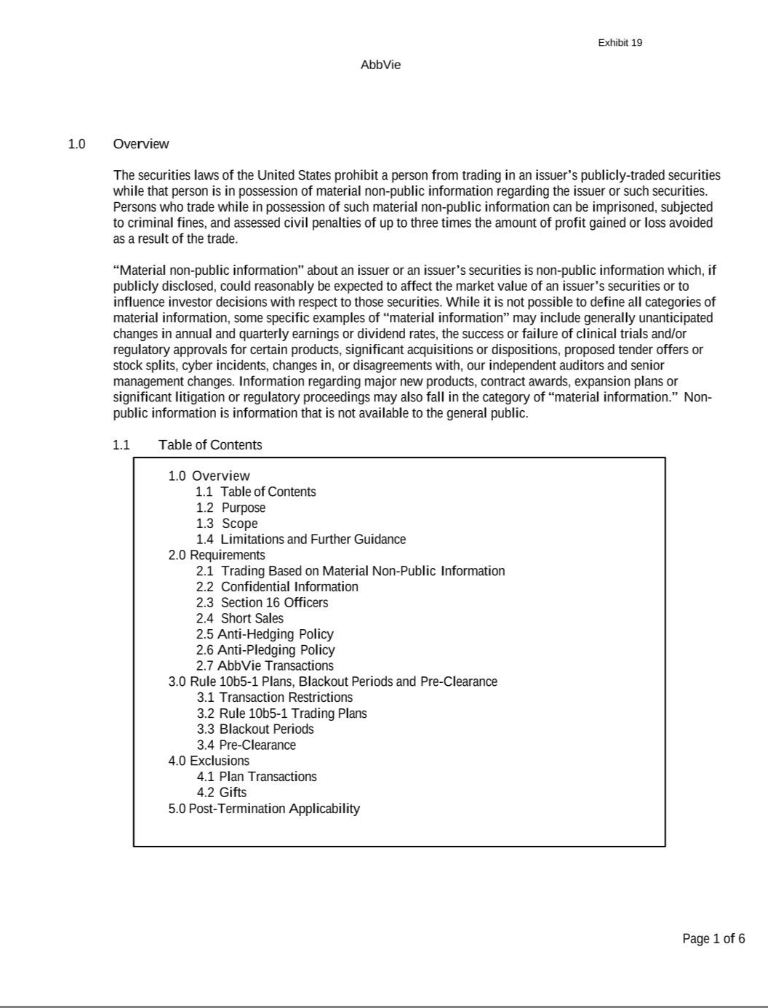

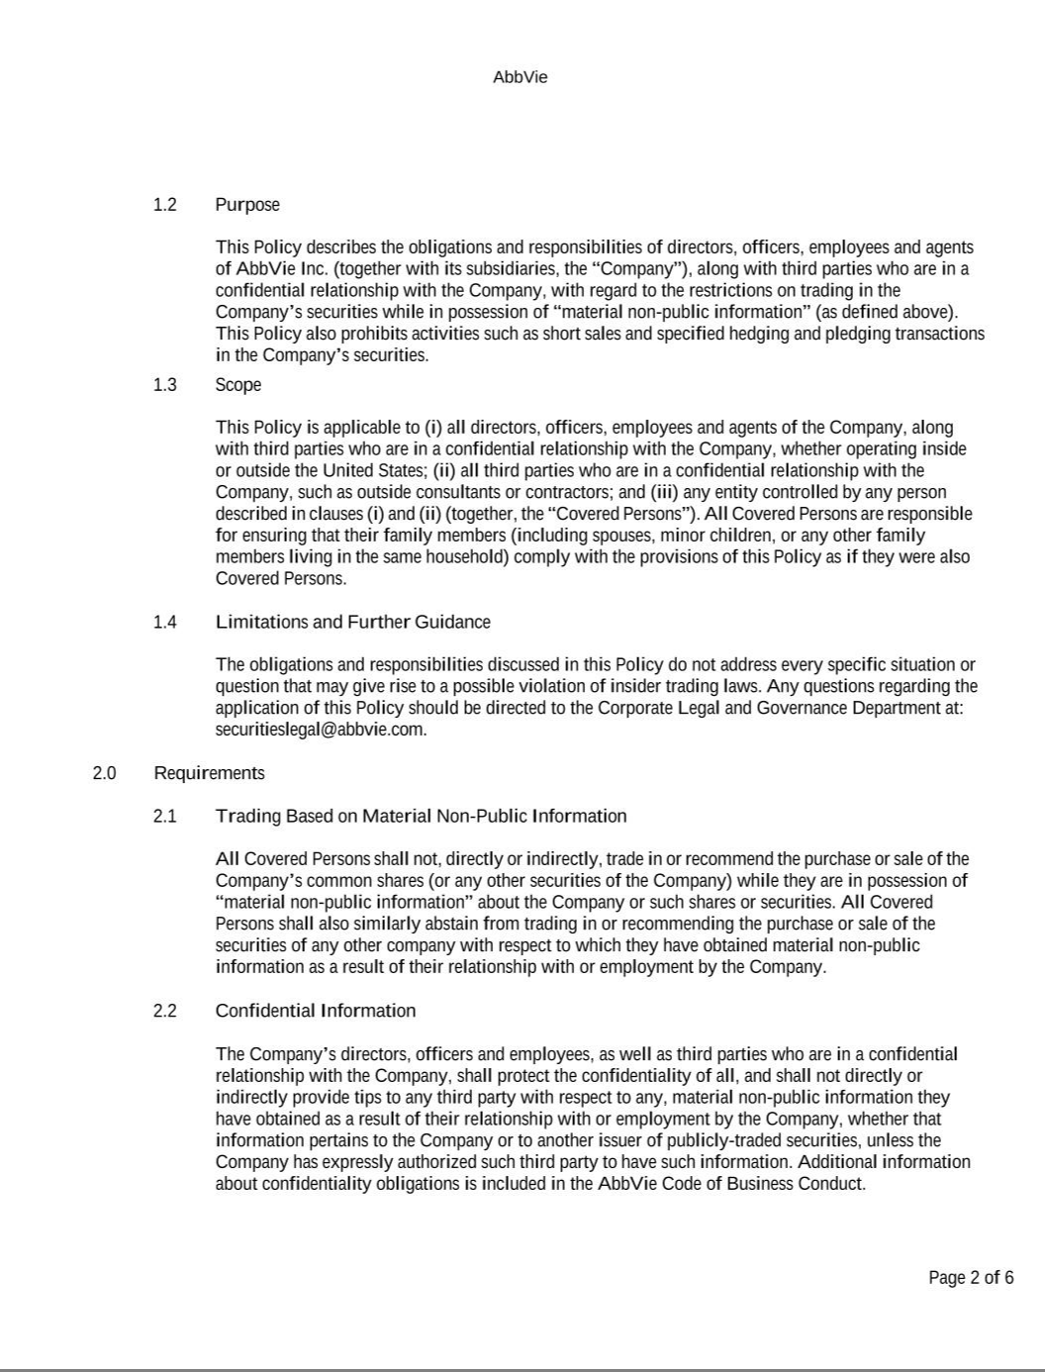

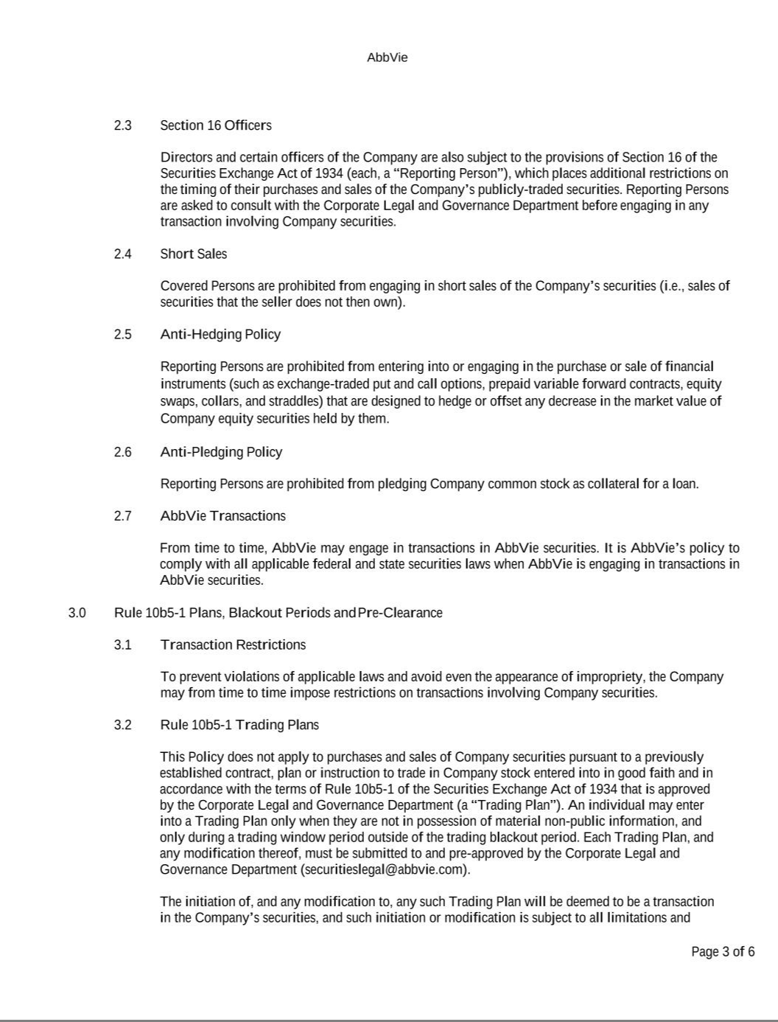

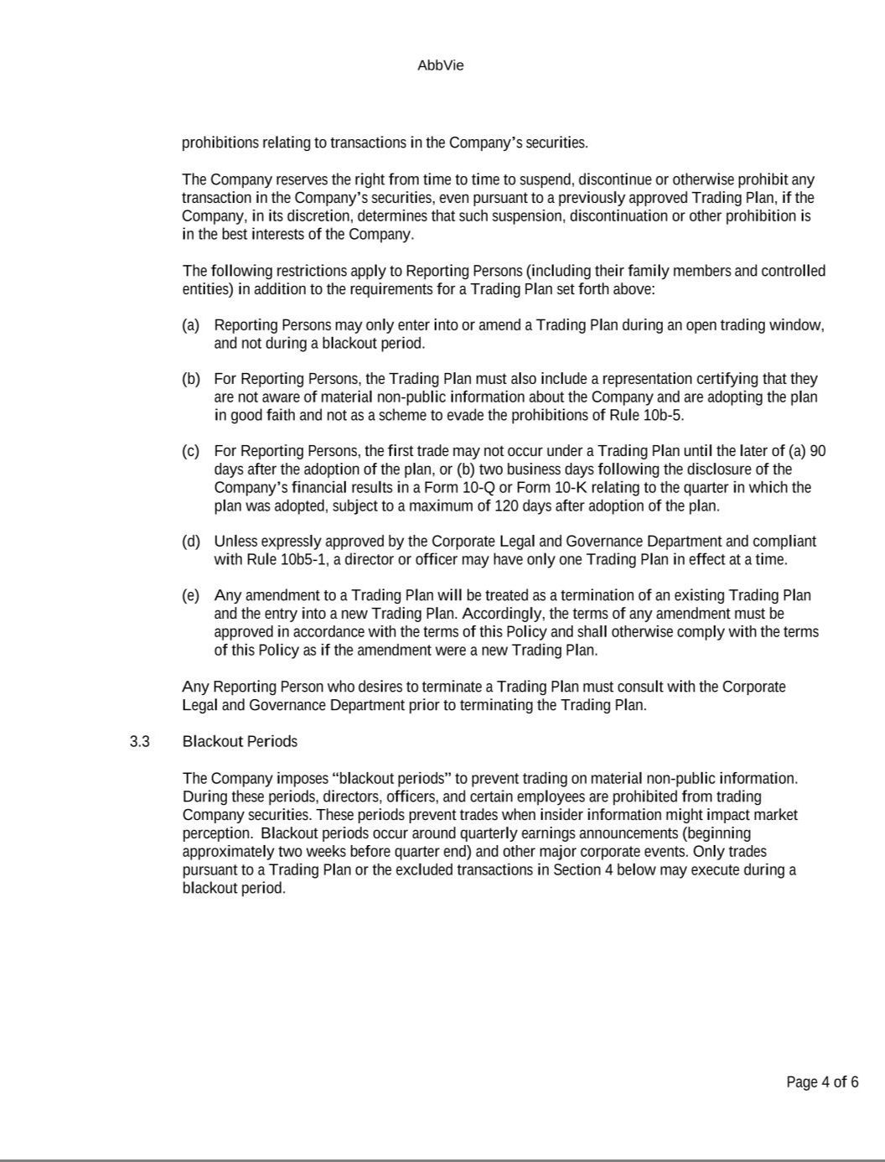

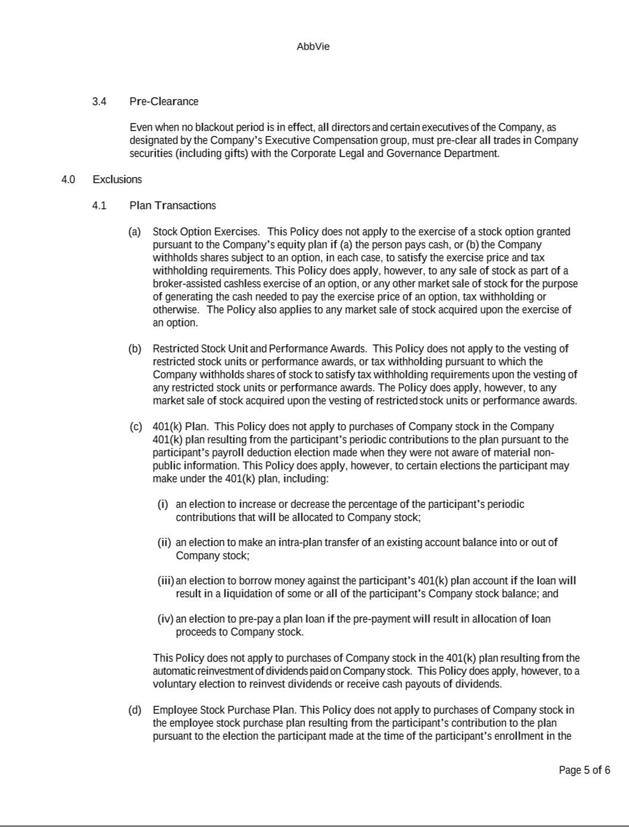

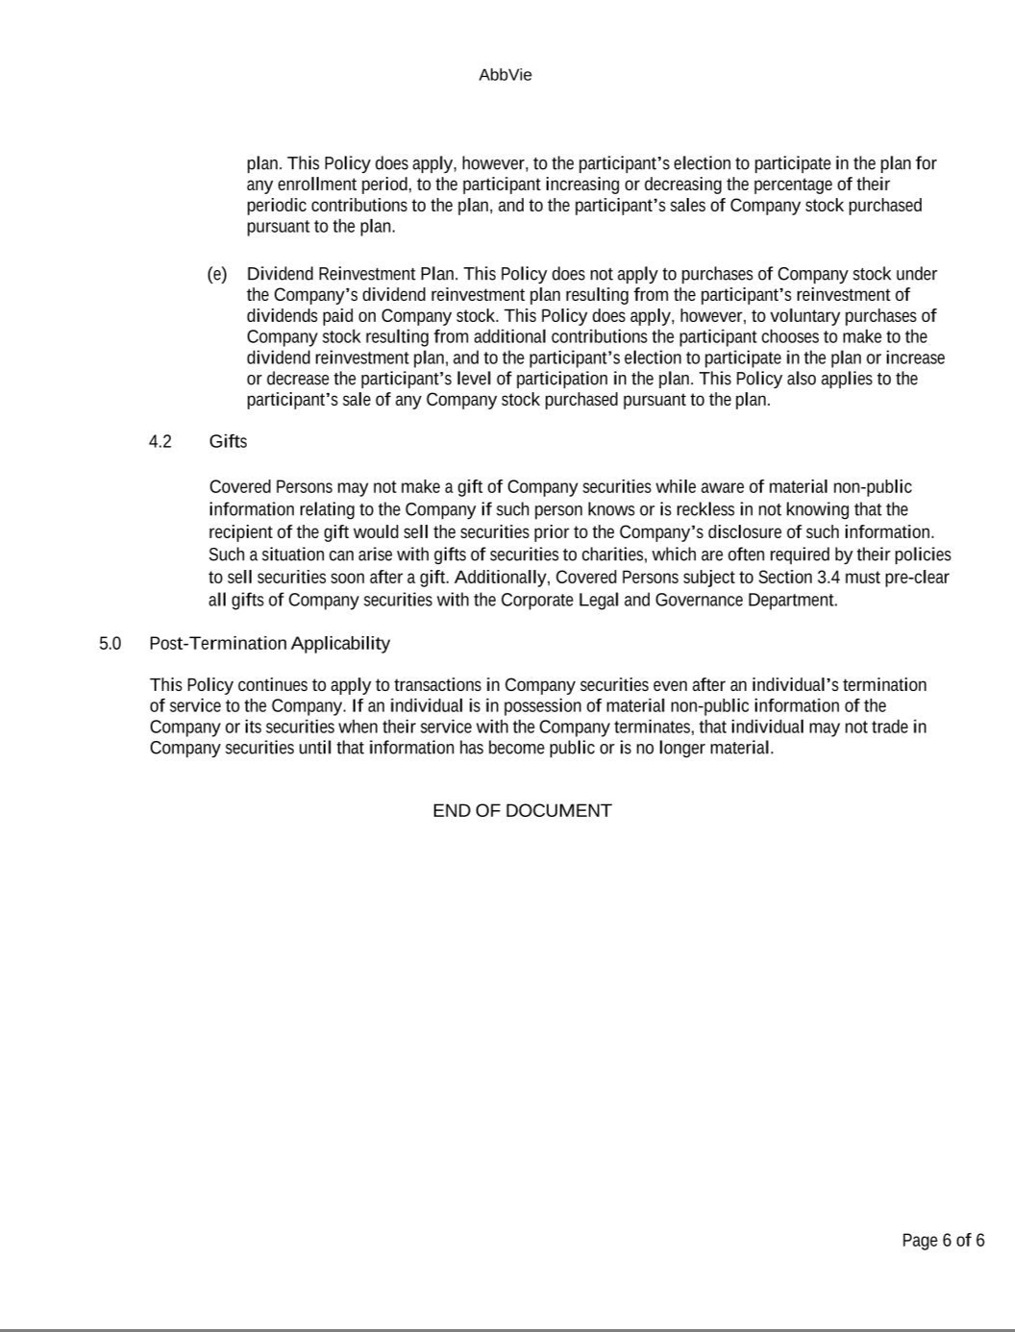

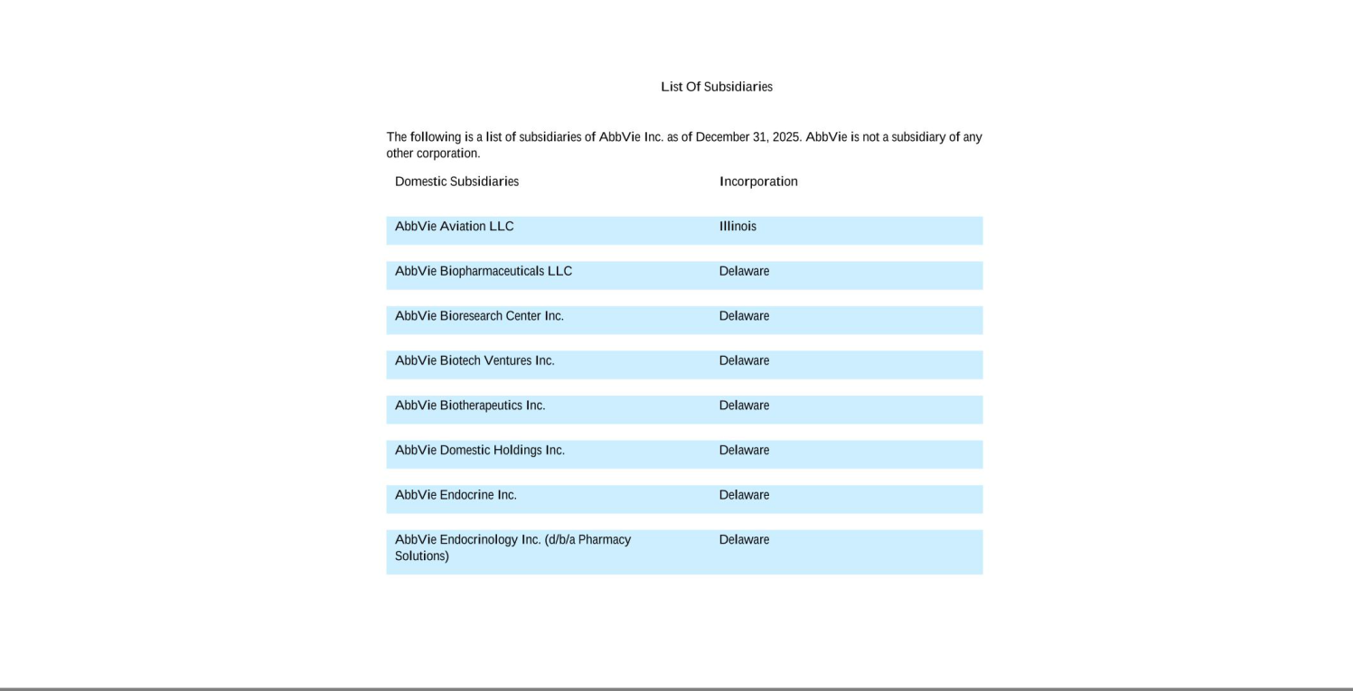

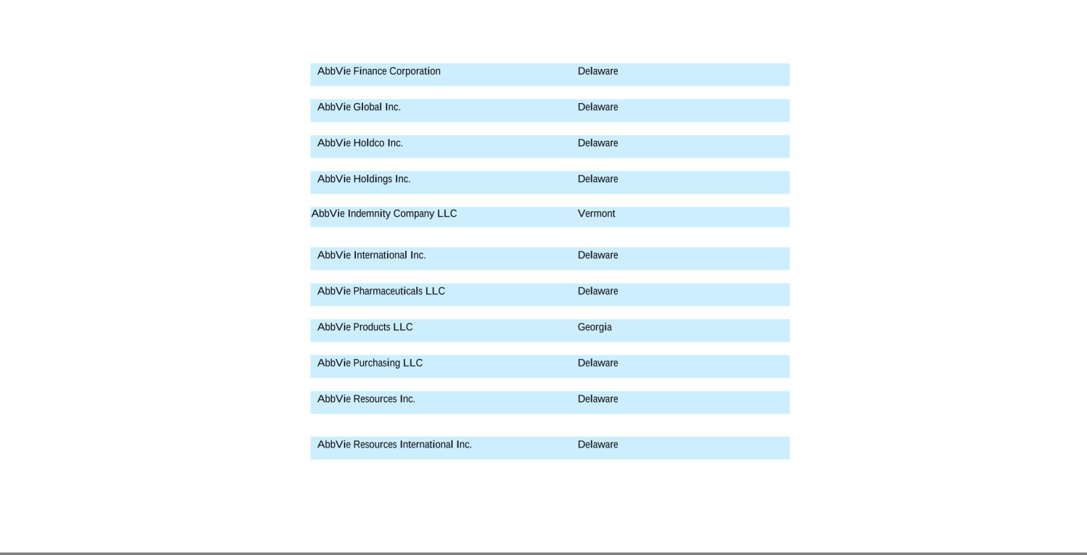

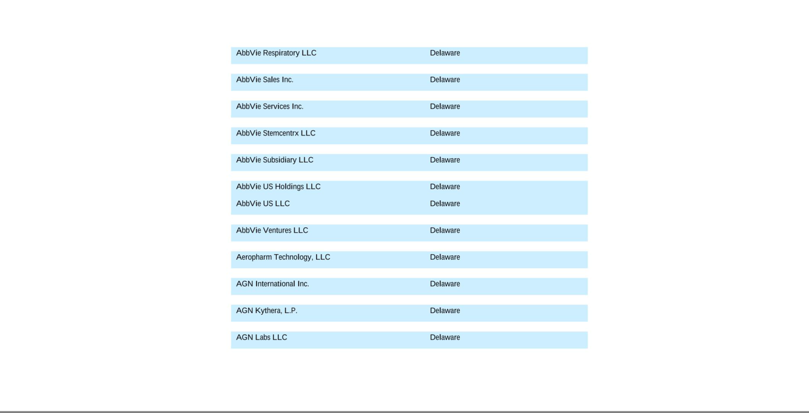

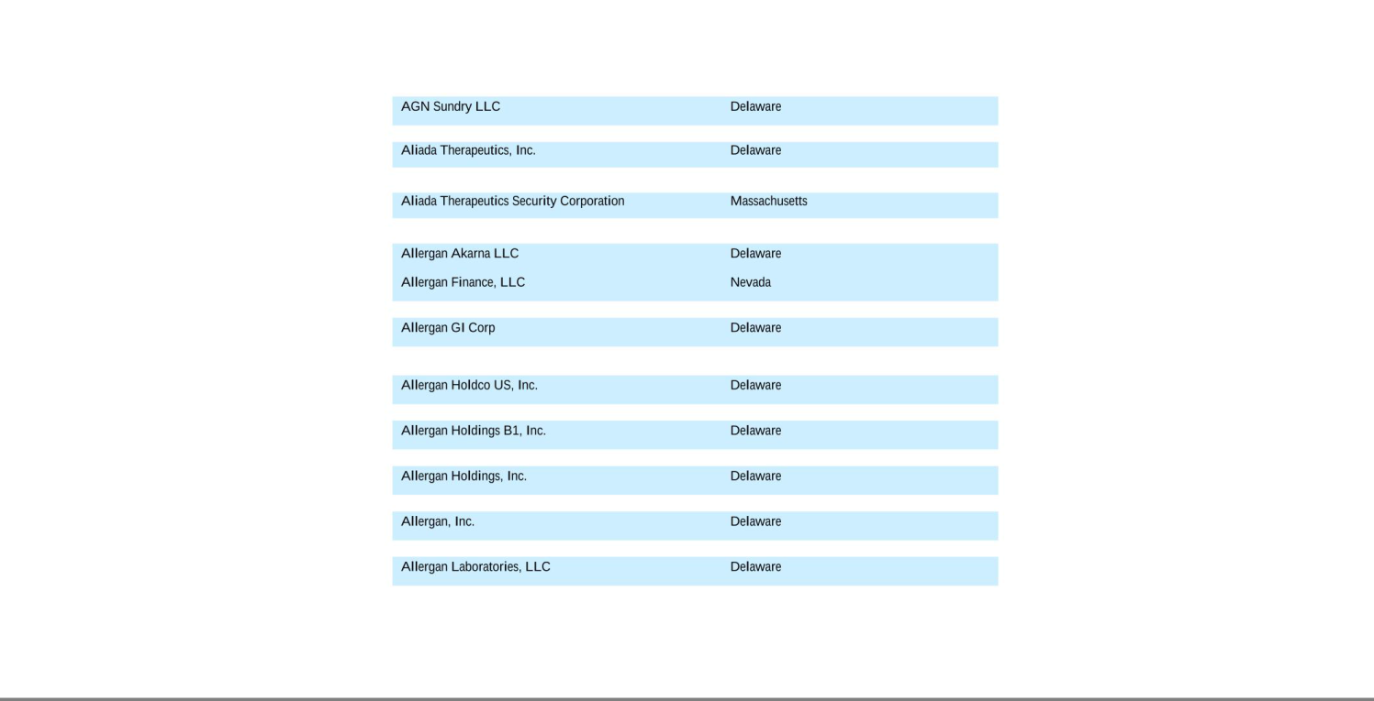

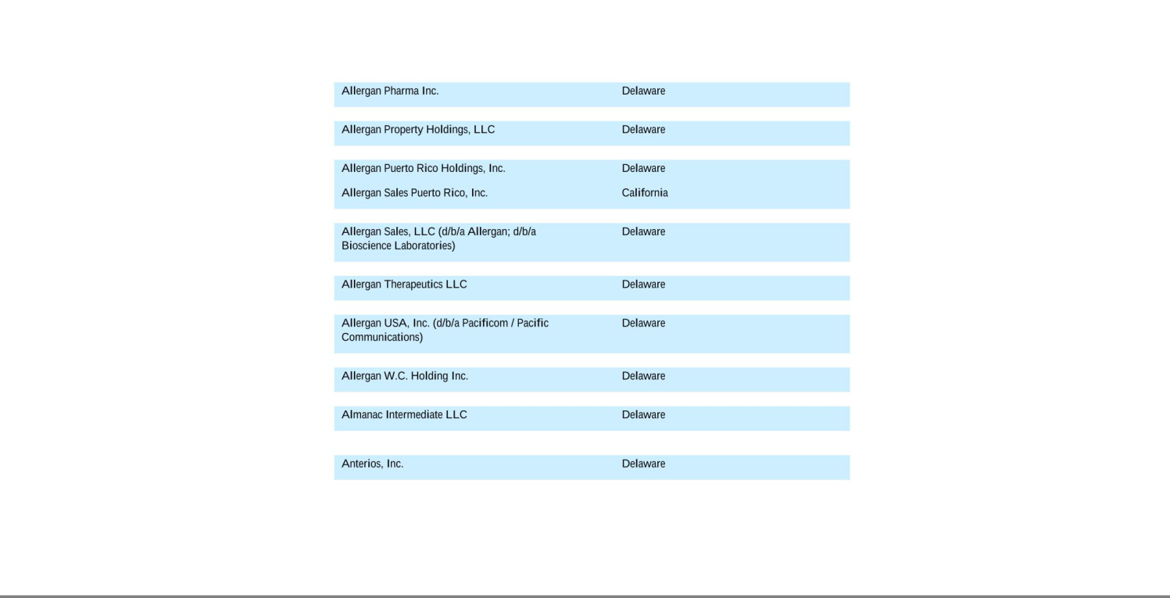

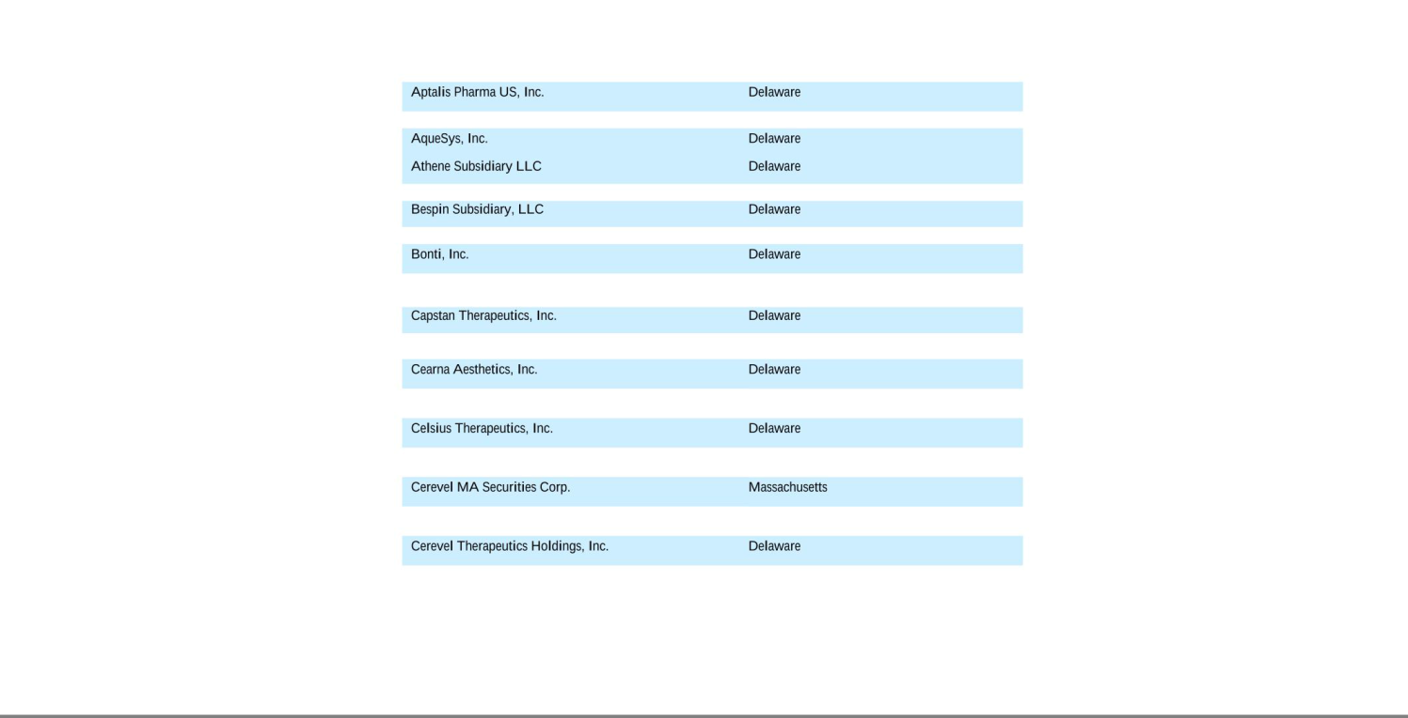

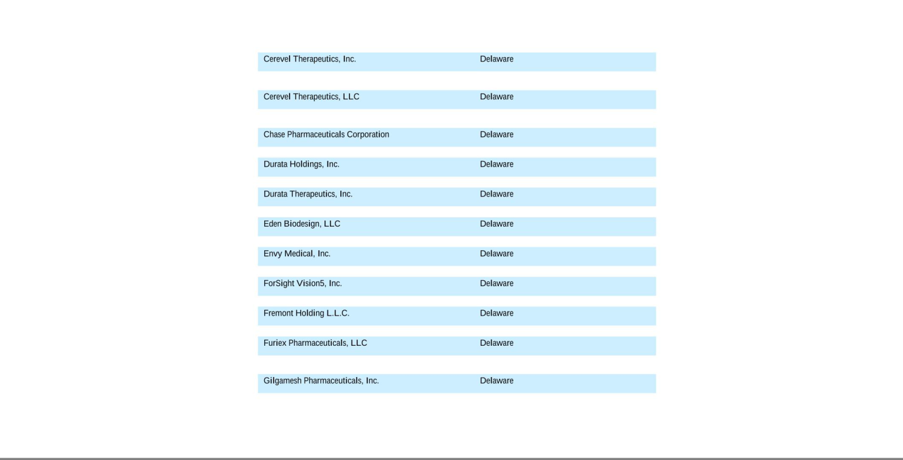

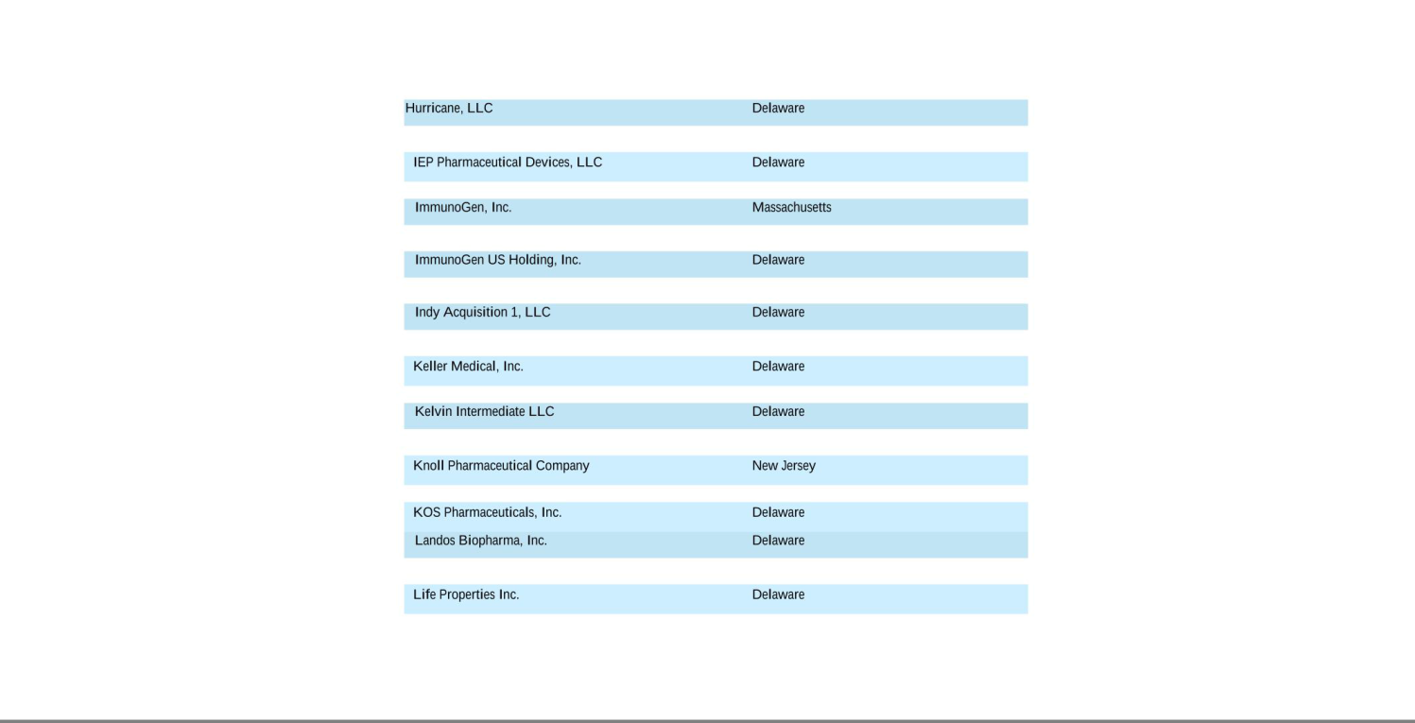

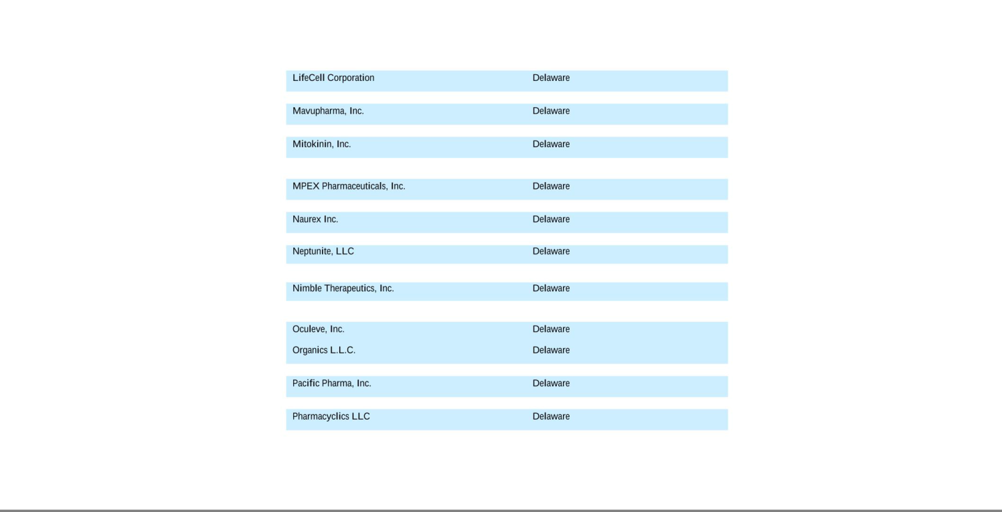

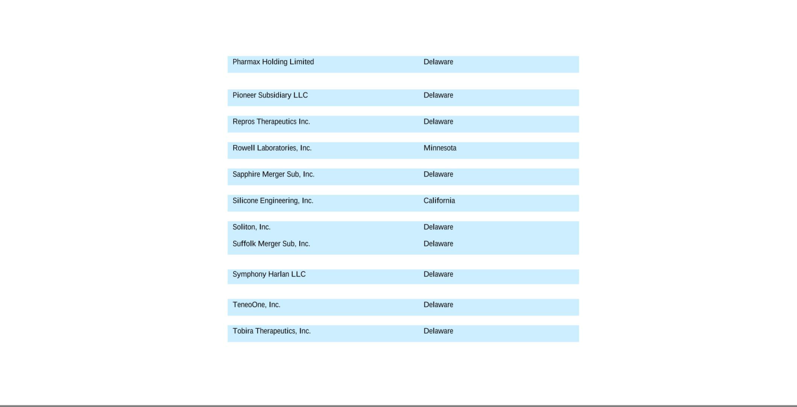

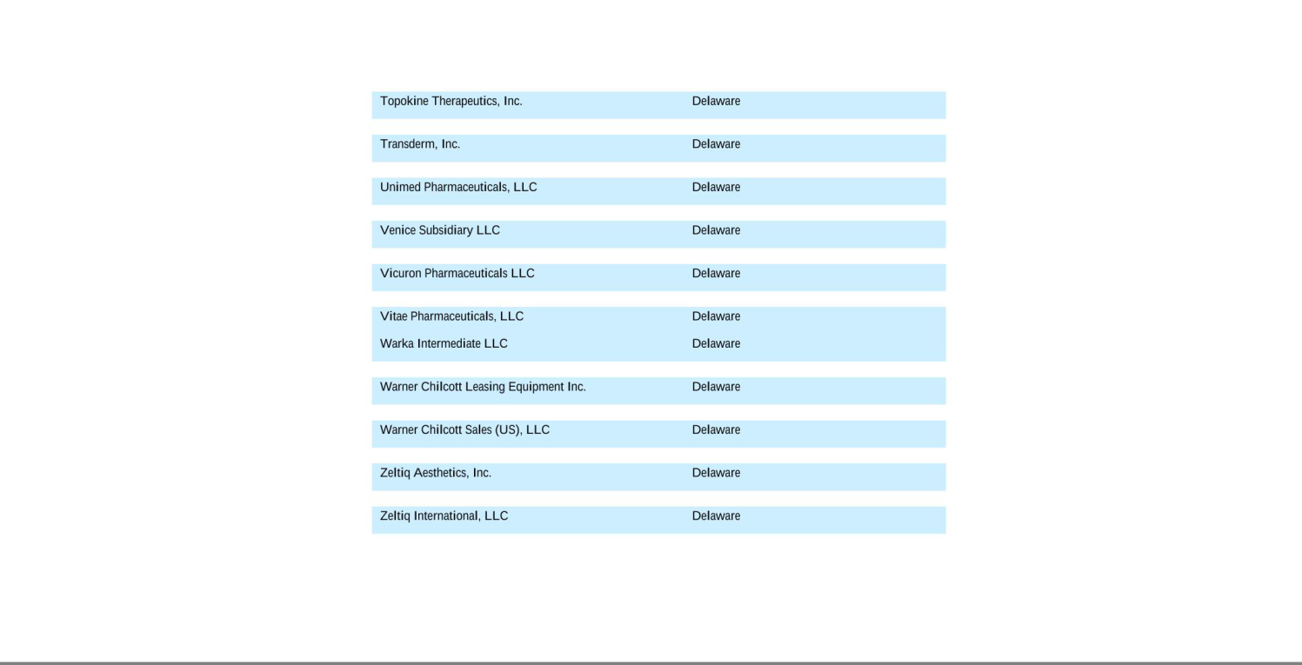

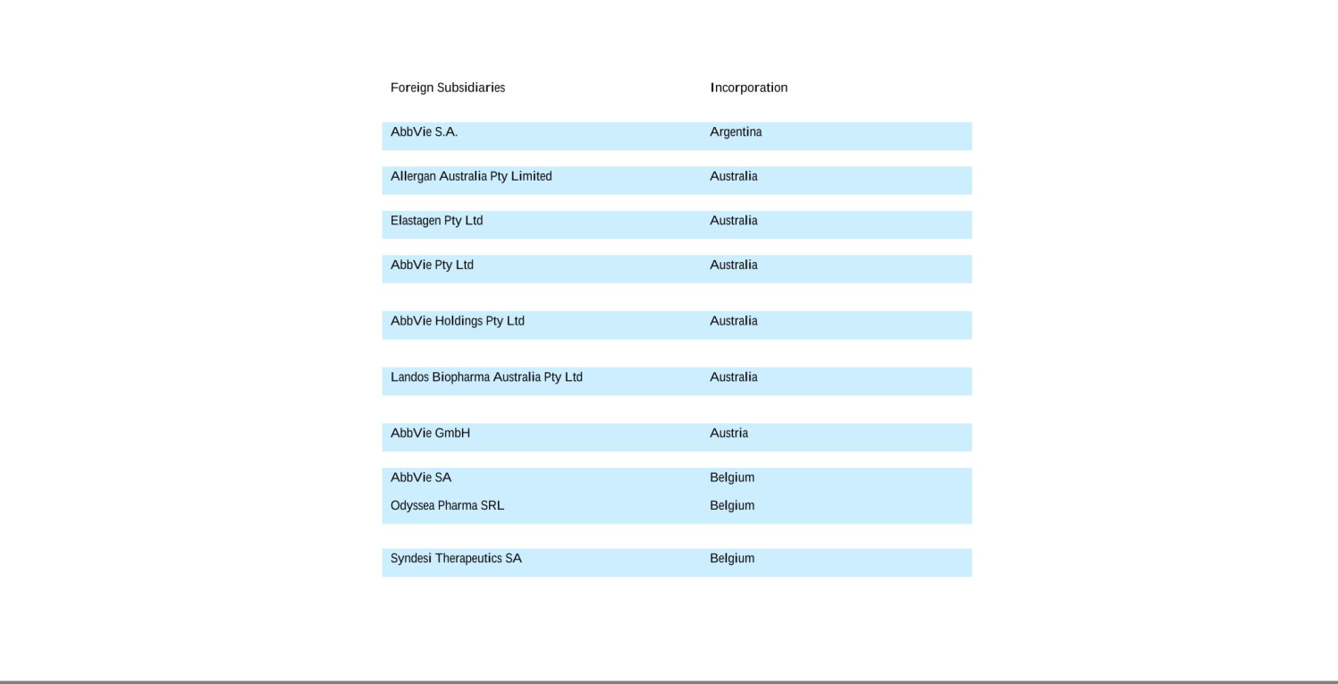

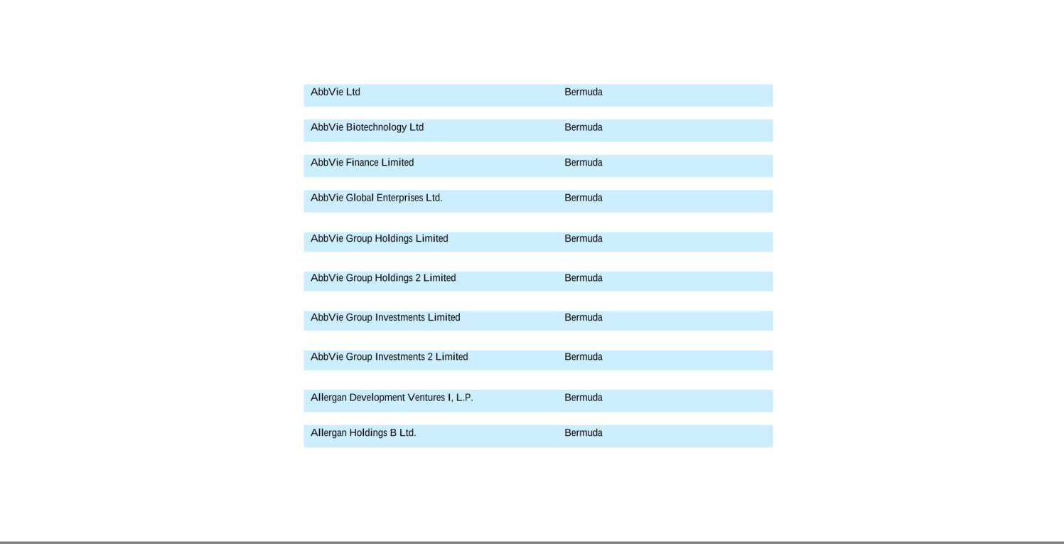

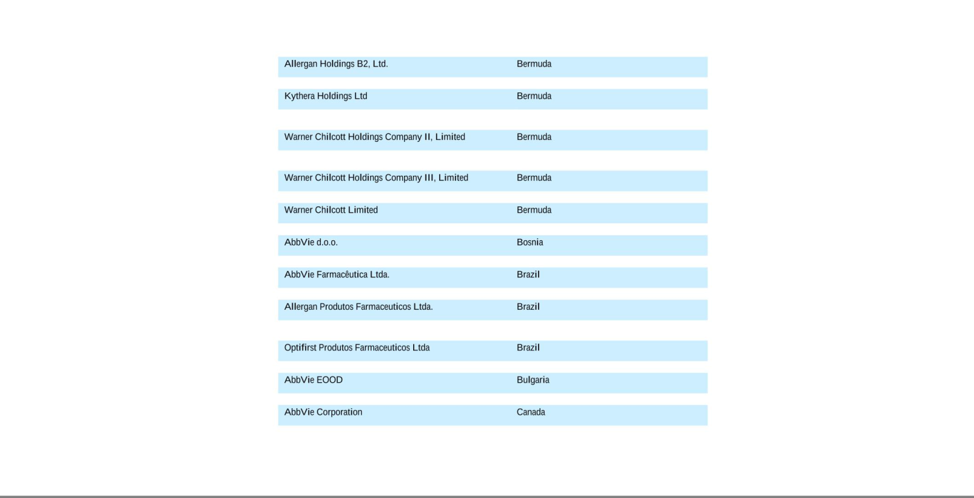

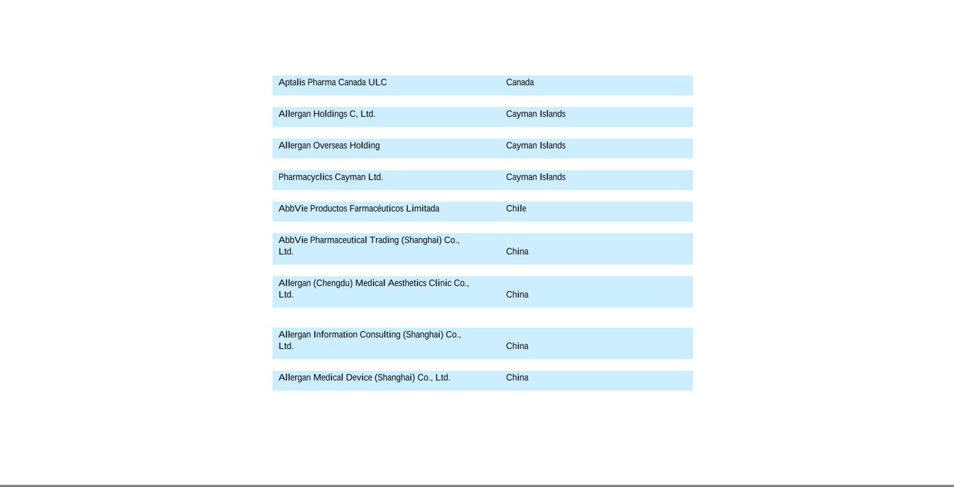

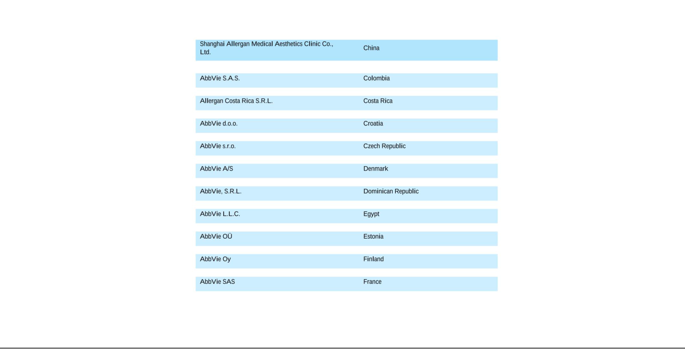

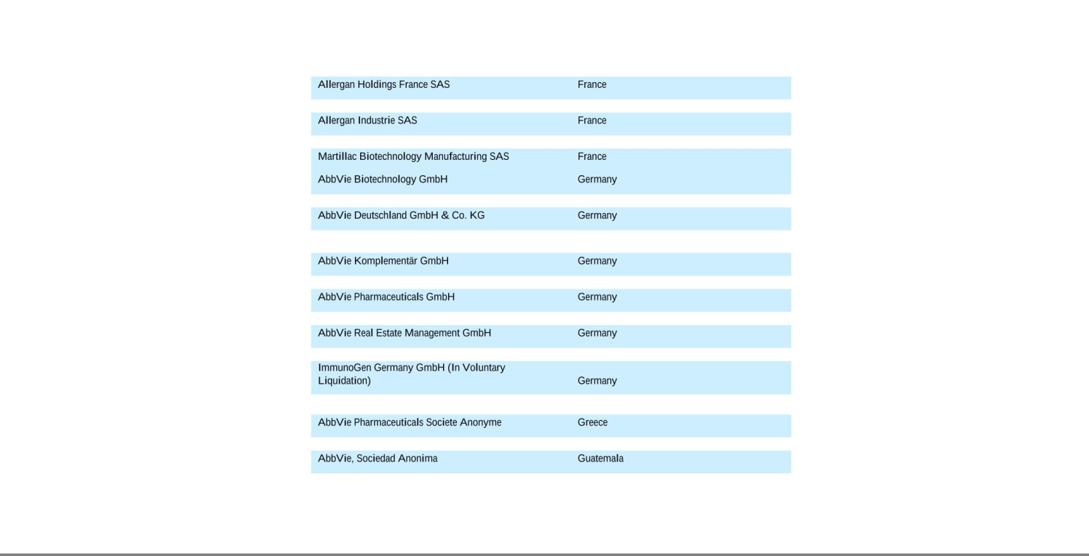

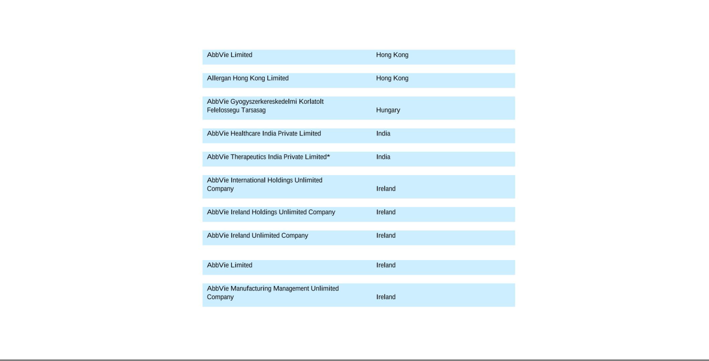

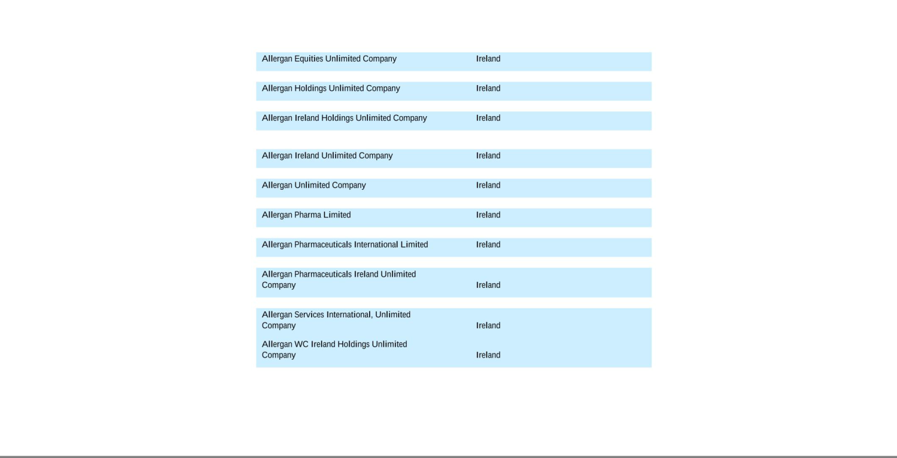

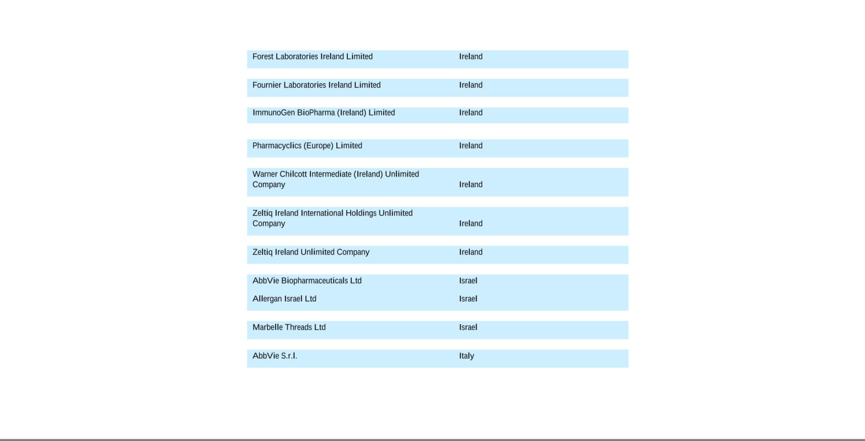

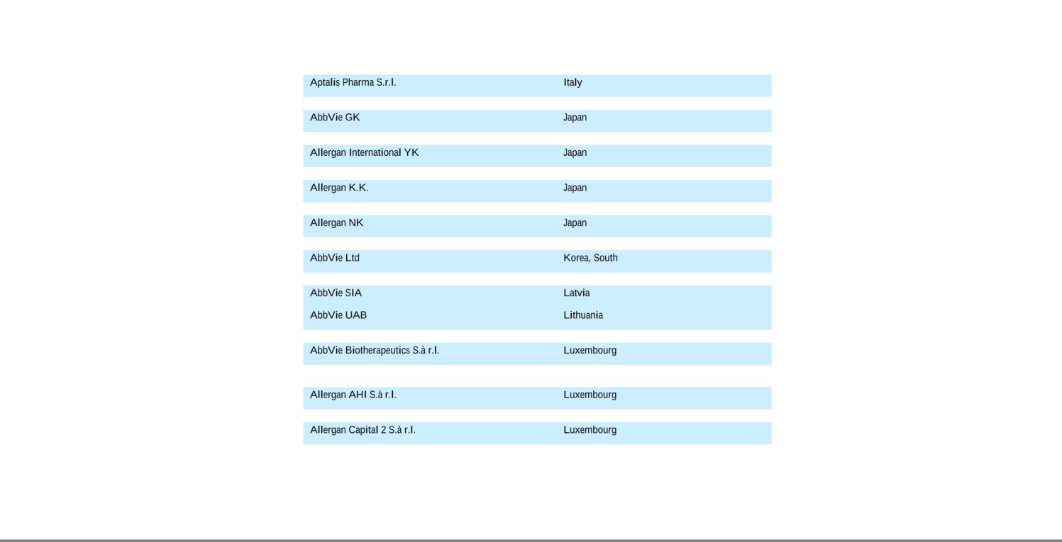

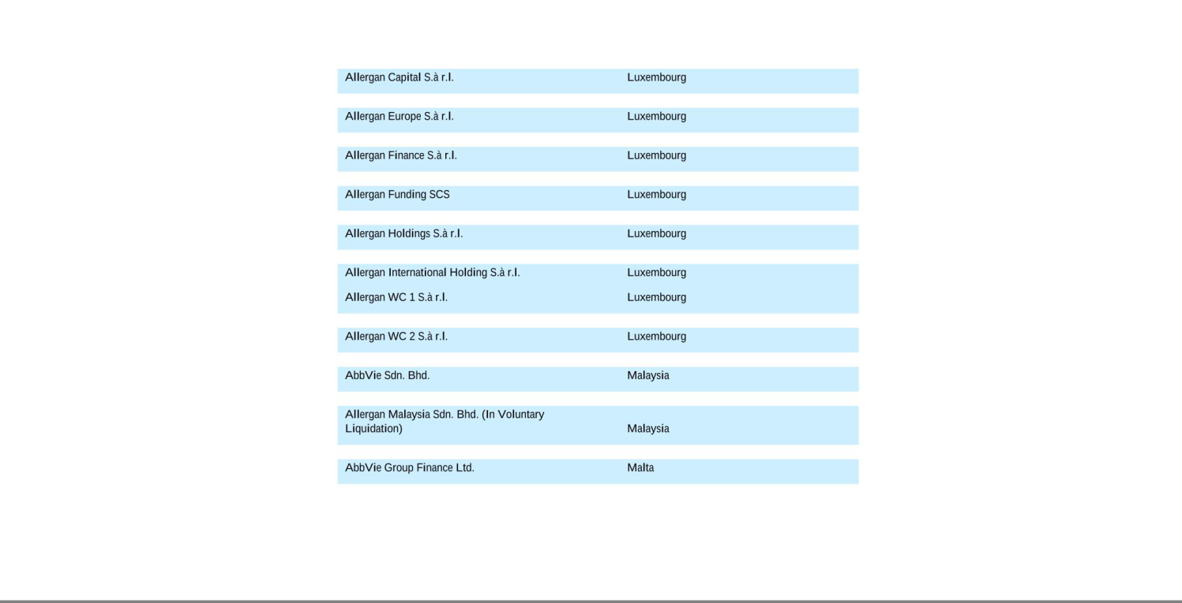

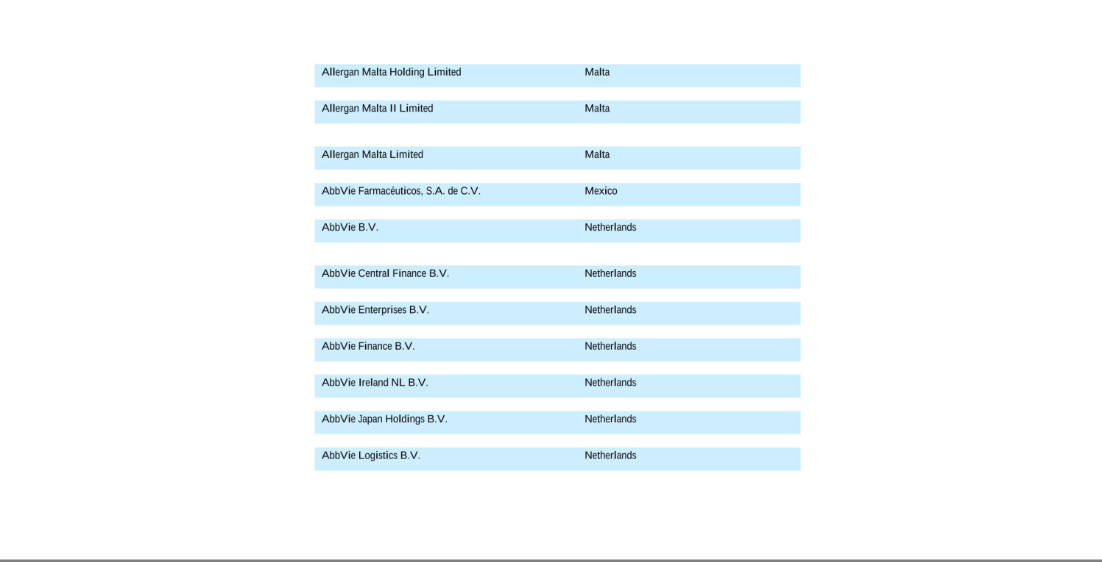

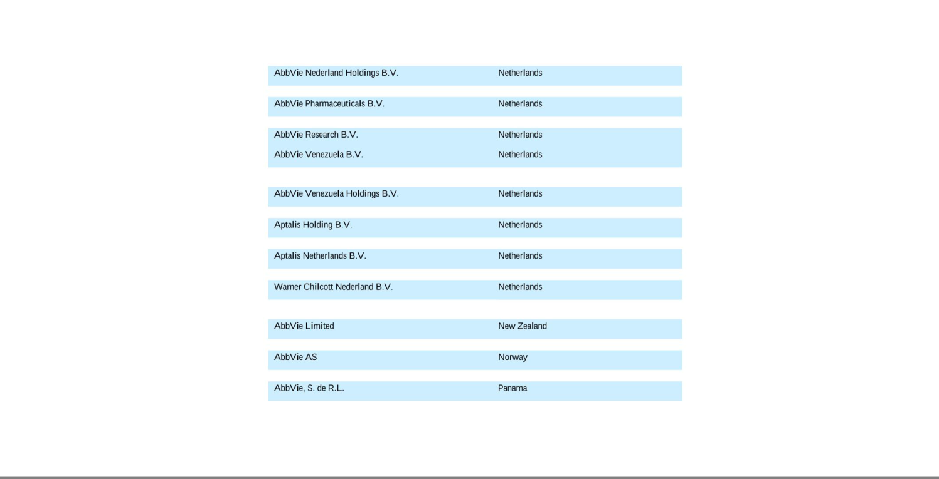

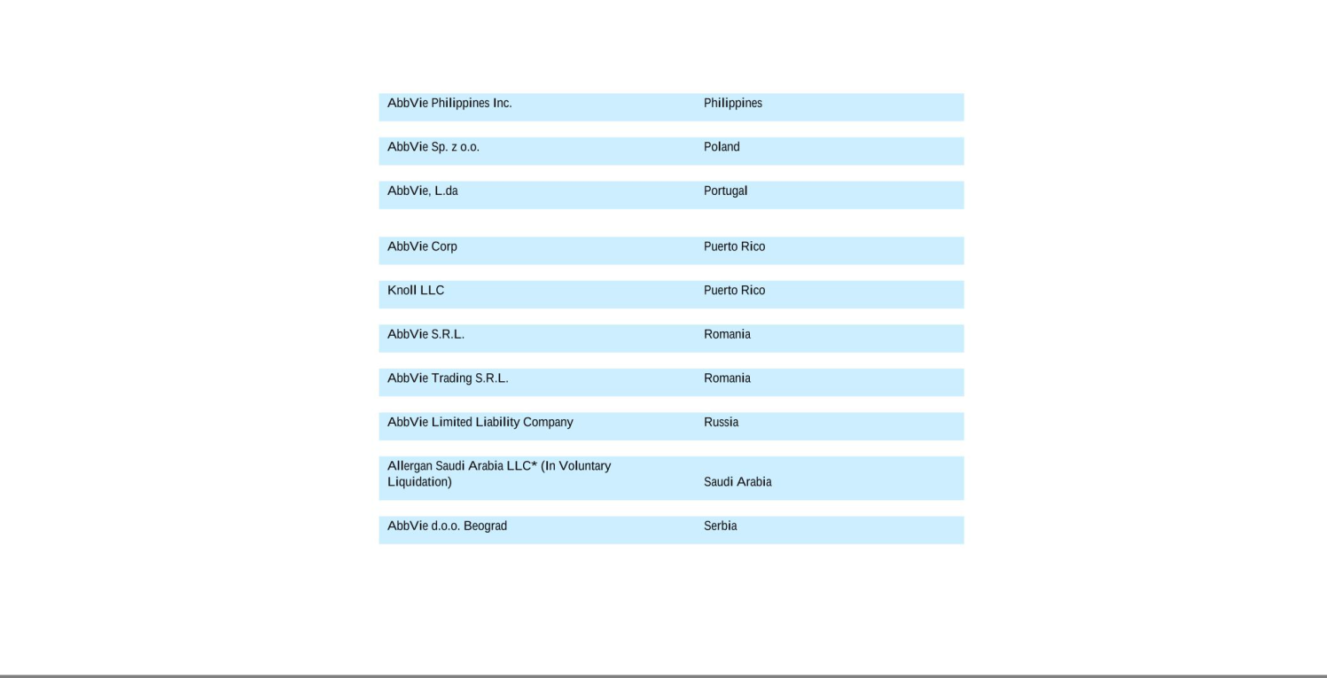

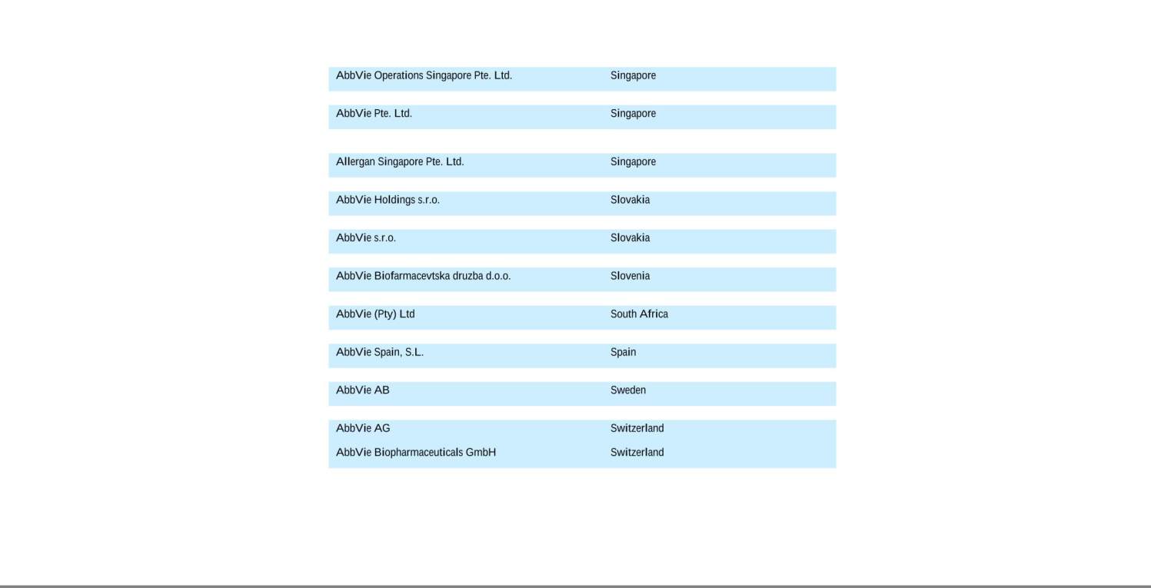

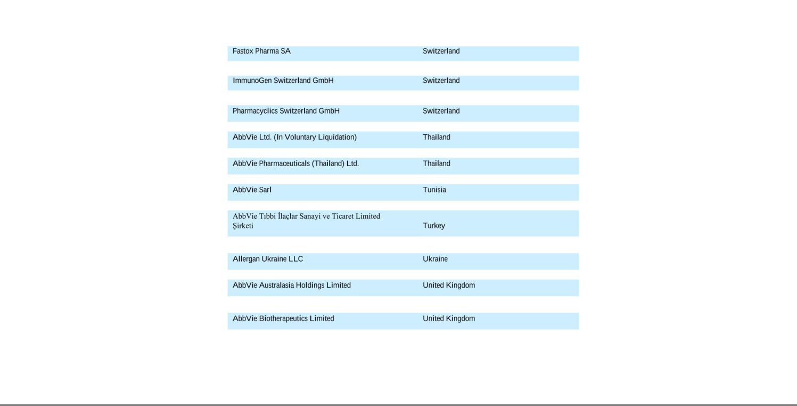

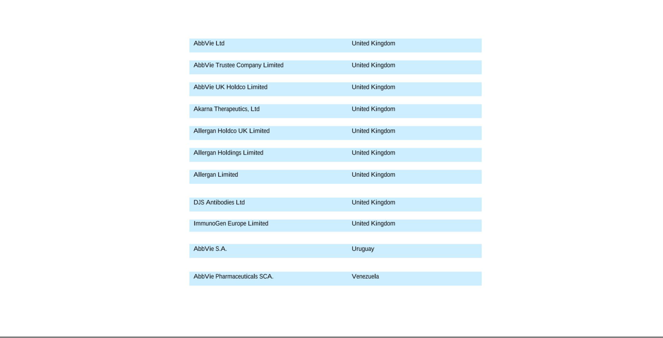

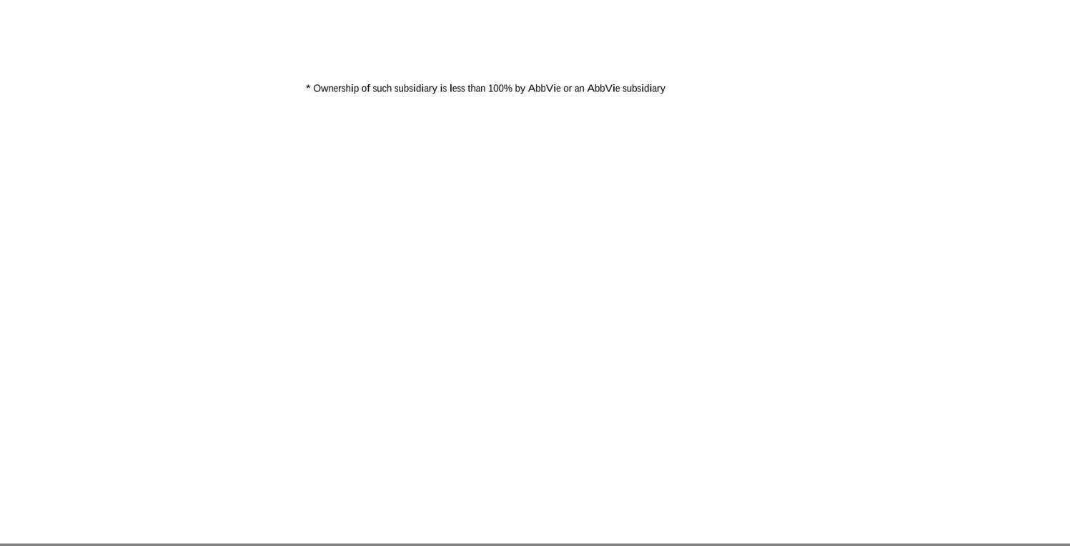

Exhibit 23

Consent of Independent Registered Public Accounting Firm

We consent to the incorporation by reference in the following Registration Statements:

- Registration Statements (Form S-8 No. 333-185561, Form S-3 No. 333-207422, and Form S-8 No. 333-222107) pertaining to the AbbVie 2013 Incentive Stock Program,

- Registration Statement (Form S-8 No. 333-185562) pertaining to the AbbVie 2013 Employee Stock Purchase Plan for Non-U.S. Employees,

- Registration Statements (Form S-8 No. 333-185563 and Form S-8 No. 333-222105) pertaining to the AbbVie Deferred Compensation Plan,

- Registration Statement (Form S-8 No. 333-185564 and Form S-8 No. 333-282982) pertaining to the AbbVie Savings Program,

- Registration Statement (Form S-8 No. 333-204466) pertaining to the Pharmacyclics, Inc. 2014 Equity Incentive Award Plan,

- Registration Statement (Form S-8 No. 333-212067) pertaining to the Stemcentrx 2011 Equity Incentive Plan,

- Registration Statement (Form S-3 No. 333-238302) pertaining to common stock of AbbVie Inc.,

- Registration Statement (Form S-8 No. 333-256045) pertaining to the AbbVie Amended and Restated 2013 Incentive Stock Program,

- Registration Statement (Form S-8 No. 333-268192 and Form S-8 No. 333-282981) pertaining to the AbbVie Deferred Compensation Plan and the AbbVie Deferred Compensation Plan Plus,

- Registration Statement (Form S-8 No. 333-277293) pertaining to the ImmunoGen, Inc. Amended and Restated 2018 Employee, Director and Consultant Equity Incentive Plan and the ImmunoGen, Inc. Inducement Equity Incentive Plan, As Amended,

- Registration Statement (Form S-8 No. 333-281545) pertaining to the Cerevel Therapeutics Holdings, Inc. 2020 Equity Incentive Plan,

- Registration Statement (Form S-3 No. 333-262908) pertaining to debt securities of AbbVie Inc., and

- Registration Statement (Form S-3 No. 333-284980) pertaining to debt securities of AbbVie Inc.;

of our reports dated February 20, 2026, with respect to the consolidated financial statements of AbbVie Inc. and subsidiaries and the effectiveness of internal control over financial reporting of AbbVie Inc. and subsidiaries included in this Annual Report (Form 10-K) of AbbVie Inc. and subsidiaries for the year ended December 31, 2025.

/s/ Ernst & Young LLP

Chicago, Illinois

February 20, 2026

Exhibit 31.1

Certification of Chief Executive Officer

Required by Rule 13a-14(a) (17 CFR 240.13a-14(a))

I, Robert A. Michael, certify that:

- I have reviewed this annual report on Form 10-K of AbbVie Inc.;

- Based on my knowledge, this report does not contain any untrue statement of a material fact or omit to state a material fact necessary to make the statements made, in light of the circumstances under which such statements were made, not misleading with respect to the period covered by this report;

- Based on my knowledge, the financial statements, and other financial information included in this report, fairly present in all material respects the financial condition, results of operations and cash flows of AbbVie as of, and for, the periods presented in this report;

- AbbVie’s other certifying officer and I are responsible for establishing and maintaining disclosure controls and procedures (as defined in Exchange Act Rules 13a-15(e) and 15d-15(e)) and internal control over financial reporting (as defined in Exchange Act Rules 13a-15(f) and 15d-15(f)) for AbbVie and have:

  - Designed such disclosure controls and procedures, or caused such disclosure controls and procedures to be designed under our supervision, to ensure that material information relating to AbbVie, including its consolidated subsidiaries, is made known to us by others within those entities, particularly during the period in which this report is being prepared;

  - Designed such internal control over financial reporting, or caused such internal control over financial reporting to be designed under our supervision, to provide reasonable assurance regarding the reliability of financial reporting and the preparation of financial statements for external purposes in accordance with generally accepted accounting principles;

  - Evaluated the effectiveness of AbbVie’s disclosure controls and procedures and presented in this report our conclusions about the effectiveness of the disclosure controls and procedures, as of the end of the period covered by this report based on such evaluation; and

  - Disclosed in this report any change in AbbVie’s internal control over financial reporting that occurred during AbbVie’s most recent fiscal quarter that has materially affected, or is reasonably likely to materially affect, AbbVie’s internal control over financial reporting; and

- AbbVie’s other certifying officer and I have disclosed, based on our most recent evaluation of internal control over financial reporting, to AbbVie’s auditors and the audit committee of AbbVie’s board of directors:

  - All significant deficiencies and material weaknesses in the design or operation of internal control over financial reporting which are reasonably likely to adversely affect AbbVie’s ability to record, process, summarize and report financial information; and

  - Any fraud, whether or not material, that involves management or other employees who have a significant role in AbbVie’s internal control over financial reporting.

Date: February 20, 2026 /s/ Robert A. Michael

Robert A. Michael, Chairman of the Board and Chief Executive Officer

Exhibit 31.2

Certification of Chief Financial Officer

Required by Rule 13a-14(a) (17 CFR 240.13a-14(a))

I, Scott T. Reents, certify that:

- I have reviewed this annual report on Form 10-K of AbbVie Inc.;

- Based on my knowledge, this report does not contain any untrue statement of a material fact or omit to state a material fact necessary to make the statements made, in light of the circumstances under which such statements were made, not misleading with respect to the period covered by this report;

- Based on my knowledge, the financial statements, and other financial information included in this report, fairly present in all material respects the financial condition, results of operations and cash flows of AbbVie as of, and for, the periods presented in this report;

- AbbVie’s other certifying officer and I are responsible for establishing and maintaining disclosure controls and procedures (as defined in Exchange Act Rules 13a-15(e) and 15d-15(e)) and internal control over financial reporting (as defined in Exchange Act Rules 13a-15(f) and 15d-15(f)) for AbbVie and have:

  - Designed such disclosure controls and procedures, or caused such disclosure controls and procedures to be designed under our supervision, to ensure that material information relating to AbbVie, including its consolidated subsidiaries, is made known to us by others within those entities, particularly during the period in which this report is being prepared;

  - Designed such internal control over financial reporting, or caused such internal control over financial reporting to be designed under our supervision, to provide reasonable assurance regarding the reliability of financial reporting and the preparation of financial statements for external purposes in accordance with generally accepted accounting principles;

  - Evaluated the effectiveness of AbbVie’s disclosure controls and procedures and presented in this report our conclusions about the effectiveness of the disclosure controls and procedures, as of the end of the period covered by this report based on such evaluation; and

  - Disclosed in this report any change in AbbVie’s internal control over financial reporting that occurred during AbbVie’s most recent fiscal quarter that has materially affected, or is reasonably likely to materially affect, AbbVie’s internal control over financial reporting; and

- AbbVie’s other certifying officer and I have disclosed, based on our most recent evaluation of internal control over financial reporting, to AbbVie’s auditors and the audit committee of AbbVie’s board of directors:

  - All significant deficiencies and material weaknesses in the design or operation of internal control over financial reporting which are reasonably likely to adversely affect AbbVie’s ability to record, process, summarize and report financial information; and

  - Any fraud, whether or not material, that involves management or other employees who have a significant role in AbbVie’s internal control over financial reporting.

Date: February 20, 2026 /s/ Scott T. Reents

Scott T. Reents, Executive Vice President, Chief Financial Officer

Exhibit 32.1

Certification Pursuant To

18 U.S.C. Section 1350

As Adopted Pursuant To

Section 906 of the Sarbanes-Oxley Act of 2002

In connection with the Annual Report of AbbVie Inc. (the “Company”) on Form 10-K for the period ended December 31, 2025 as filed with the Securities and Exchange Commission (the “Report”), I, Robert A. Michael, Chairman of the Board and Chief Executive Officer of the Company, certify, pursuant to 18 U.S.C. § 1350, as adopted pursuant to § 906 of the Sarbanes-Oxley Act of 2002, that:

- The Report fully complies with the requirements of section 13(a) or 15(d) of the Securities Exchange Act of 1934; and

- The information contained in the Report fairly presents, in all material respects, the financial condition and results of operations of the Company.

/s/ Robert A. Michael

Robert A. Michael

Chairman of the Board and Chief Executive Officer

February 20, 2026

A signed original of this written statement required by Section 906 has been provided to AbbVie Inc. and will be retained by AbbVie Inc. and furnished to the Securities and Exchange Commission or its staff upon request.

Exhibit 32.2

Certification Pursuant To

18 U.S.C. Section 1350

As Adopted Pursuant To

Section 906 of the Sarbanes-Oxley Act of 2002

In connection with the Annual Report of AbbVie Inc. (the “Company”) on Form 10-K for the period ended December 31, 2025 as filed with the Securities and Exchange Commission (the “Report”), I, Scott T.

Reents, Executive Vice President, Chief Financial Officer of the Company, certify, pursuant to 18 U.S.C. § 1350, as adopted pursuant to § 906 of the Sarbanes-Oxley Act of 2002, that:

- The Report fully complies with the requirements of section 13(a) or 15(d) of the Securities Exchange Act of 1934; and

- The information contained in the Report fairly presents, in all material respects, the financial condition and results of operations of the Company.

/s/ Scott T. Reents

Scott T. Reents

Executive Vice President, Chief Financial Officer

February 20, 2026

A signed original of this written statement required by Section 906 has been provided to AbbVie Inc. and will be retained by AbbVie Inc. and furnished to the Securities and Exchange Commission or its staff upon request.

