 |  |  |  | UNITED STATES
 |  |  | SECURITIES AND EXCHANGE COMMISSION
 |  |  |  | WASHINGTON, D. C. 20549
 |  |  |  | FORM 10-K
(MARK ONE)
☒ | ANNUAL REPORT PURSUANT TO SECTION 13 OR 15(d) OF THE SECURITIES EXCHANGE ACT OF 1934
For the fscal year ended December 31, 2022
☐ |  |  |  | OR
☐ | TRANSITION REPORT PURSUANT TO SECTION 13 OR 15(d) OF THE SECURITIES EXCHANGE ACT OF 1934
For the transiton period from |  | to
 |  |  |  | Commission fle number 001-35565
 |  |  |  | AbbVie Inc.
 |  |  | (Exact name of registrant as specifed in its charter)
 | Delaware |  |  |  | 32-0375147
(State or other jurisdicton of |  |  |  |  | (I.R.S. employer
incorporaton or organizaton) |  |  |  |  | identfcaton number)


1 North Waukegan Road
North Chicago, Illinois 60064-6400
(847) 932-7900
(Address, including zip code, and telephone number of principal executve ofces)

Securites Registered Pursuant to Secton 12(b) of the Act:
Title of Each Class |  | Trading Symbol(s) |  | Name of Each Exchange on Which Registered
Common Stock, par value $0.01 per share |  | ABBV |  | New York Stock Exchange
 |  |  |  | Chicago Stock Exchange
1.500% Senior Notes due 2023 |  | ABBV23B |  | New York Stock Exchange
1.375% Senior Notes due 2024 |  | ABBV24 |  | New York Stock Exchange
1.250% Senior Notes due 2024 |  | ABBV24B |  | New York Stock Exchange
0.750% Senior Notes due 2027 |  | ABBV27 |  | New York Stock Exchange
2.125% Senior Notes due 2028 |  | ABBV28 |  | New York Stock Exchange
2.625% Senior Notes due 2028 |  | ABBV28B |  | New York Stock Exchange
2.125% Senior Notes due 2029 |  | ABBV29 |  | New York Stock Exchange
1.250% Senior Notes due 2031 |  | ABBV31 |  | New York Stock Exchange

Indicate by check mark if the registrant is a well-known seasoned issuer, as defned in Rule 405 of the Securites Act.

Yes ☒ No ☐

Indicate by check mark if the registrant is not required to fle reports pursuant to Secton 13 or 15(d) of the Act.

Yes ☐ No ☒

Indicate by check mark whether the registrant (1) has fled all reports required to be fled by Secton 13 or 15(d) of the Securites Exchange Act of 1934 during the preceding 12 months (or for such shorter period that the registrant was required to fle such reports) and (2) has been subject to such fling requirements for the past 90 days.

Yes ☒ No ☐

Indicate by check mark whether the registrant has submited electronically every Interactve Data File required to be submited pursuant to Rule 405 of Regulaton S-T during the preceding 12 months (or for such shorter period that the registrant was required to submit such fles).

Yes ☒ No ☐

Indicate by check mark whether the registrant is a large accelerated fler, an accelerated fler, a non-accelerated fler, or a smaller reportng company. See the defnitons of "large accelerated fler," "accelerated fler" and "smaller reportng company" in Rule 12b-2 of the Exchange Act.

Large Accelerated Filer ☒ | Accelerated Filer ☐
Non-Accelerated Filer ☐ | Smaller reportng company ☐
 | Emerging growth company ☐

If an emerging growth company, indicate by check mark if the registrant has elected not to use the extended transiton period for complying with any new or revised fnancial accountng standards provided pursuant to Secton 13(a) of the Exchange Act. ☐

Indicate by check mark whether the registrant has fled a report on and atestaton to its management’s assessment of the efectveness of its internal control over fnancial reportng under Secton 404(b) of the Sarbanes-Oxley Act (15 U.S.C. 7262(b)) by the registered public accountng frm that prepared or issued its audit report. ☒

If securites are registered pursuant to Secton 12(b) of the Act, indicate by checkmark whether the fnancial statements of the registrant included in the fling refect the correcton of an error to previously issued fnancial statements. ☐

Indicate by check mark whether any of those error correctons are restatements that required a recovery analysis of incentve-based compensaton received by any of the registrant’s executve ofcers during the relevant recovery period pursuant to §240.10D-1(b). ☐

Indicate by check mark whether the registrant is a shell company (as defned in Rule 12b-2 of the Act).

Yes ☐ No ☒

The aggregate market value of the 1,751,453,358 shares of votng stock held by non-afliates of the registrant, computed by reference to the closing price as reported on the New York Stock Exchange, as of the last business day of AbbVie Inc.'s most recently completed second fscal quarter (June 30, 2022), was $268,252,598,311. AbbVie has no non-votng common equity.

Number of common shares outstanding as of January 31, 2023: 1,769,399,971

DOCUMENTS INCORPORATED BY REFERENCE

Portons of the 2023 AbbVie Inc. Proxy Statement are incorporated by reference into Part III. The Defnitve Proxy Statement will be fled on or about March 20, 2023.

 |  |  |  |  |  |  |  |  |  |  |  |  |  |  |  |  |  |  |  |  |  |  | ABBVIE INC.
 |  |  |  |  |  |  |  |  |  |  |  |  |  |  |  |  |  |  |  |  |  |  | FORM 10-K
 |  |  |  |  |  |  |  |  |  |  |  |  |  |  |  |  |  |  | FOR THE YEAR ENDED DECEMBER 31, 2022
 |  |  |  |  |  |  |  |  |  |  |  |  |  |  |  |  |  |  |  |  |  | TABLE OF CONTENTS
 |  |  |  |  |  |  |  |  |  |  |  |  |  |  |  |  |  |  |  |  |  |  |  |  |  |  |  |  |  |  |  | Page No.
 | PART I
 | Item 1. |  |  |  |  |  | BUSINESS |  |  |  |  |  |  |  |  |  |  |  |  |  |  |  |  |  |  |  |  |  |  |  |  | 1
 | Item 1A. |  |  |  |  |  |  | RISK FACTORS |  |  |  |  |  |  |  |  |  |  |  |  |  |  |  |  |  |  |  |  |  |  |  | 13
 | Item 1B. |  |  |  |  |  |  | UNRESOLVED STAFF COMMENTS |  |  |  |  |  |  |  |  |  |  |  |  |  |  |  |  |  |  |  |  |  |  |  | 25
 | Item 2. |  |  |  |  |  |  | PROPERTIES |  |  |  |  |  |  |  |  |  |  |  |  |  |  |  |  |  |  |  |  |  |  |  | 25
 | Item 3. |  |  |  |  |  | LEGAL PROCEEDINGS |  |  |  |  |  |  |  |  |  |  |  |  |  |  |  |  |  |  |  |  |  |  |  |  | 26
 | Item 4. |  |  |  |  |  | MINE SAFETY DISCLOSURES |  |  |  |  |  |  |  |  |  |  |  |  |  |  |  |  |  |  |  |  |  |  |  |  | 26
 |  |  |  |  |  |  |  | INFORMATION ABOUT OUR EXECUTIVE OFFICERS |  |  |  |  |  |  |  |  |  |  |  |  |  |  |  |  |  |  |  |  |  |  |  | 27
 | PART II
 | Item 5. |  |  |  |  |  | MARKET FOR REGISTRANT’S COMMON EQUITY, RELATED STOCKHOLDER MATTERS AND ISSUER PURCHASES OF EQUITY SECURITIES |  |  |  |  |  |  |  |  |  |  |  |  |  |  |  |  |  |  |  |  |  |  |  |  | 29
 | Item 6. |  |  |  |  |  | [RESERVED] |  |  |  |  |  |  |  |  |  |  |  |  |  |  |  |  |  |  |  |  |  |  |  |  | 31
 | Item 7. |  |  |  |  |  | MANAGEMENT’S DISCUSSION AND ANALYSIS OF FINANCIAL CONDITION AND RESULTS OF OPERATIONS |  |  |  |  |  |  |  |  |  |  |  |  |  |  |  |  |  |  |  |  |  |  |  |  | 32
 | Item 7A. |  |  |  |  |  |  | QUANTITATIVE AND QUALITATIVE DISCLOSURES ABOUT MARKET RISK |  |  |  |  |  |  |  |  |  |  |  |  |  |  |  |  |  |  |  |  |  |  |  | 48
 | Item 8. |  |  |  |  |  |  | FINANCIAL STATEMENTS AND SUPPLEMENTARY DATA |  |  |  |  |  |  |  |  |  |  |  |  |  |  |  |  |  |  |  |  |  |  |  | 49
 | Item 9. |  |  |  |  |  | CHANGES IN AND DISAGREEMENTS WITH ACCOUNTANTS ON ACCOUNTING AND FINANCIAL DISCLOSURE |  |  |  |  |  |  |  |  |  |  |  |  |  |  |  |  |  |  |  |  |  |  |  |  | 101
 | Item 9A. |  |  |  |  |  |  | CONTROLS AND PROCEDURES |  |  |  |  |  |  |  |  |  |  |  |  |  |  |  |  |  |  |  |  |  |  |  | 101
 | Item 9B. |  |  |  |  |  |  | OTHER INFORMATION |  |  |  |  |  |  |  |  |  |  |  |  |  |  |  |  |  |  |  |  |  |  |  | 103
 | Item 9C. |  |  |  |  |  |  | DISCLOSURE REGARDING FOREIGN JURISDICTIONS THAT PREVENT INSPECTIONS |  |  |  |  |  |  |  |  |  |  |  |  |  |  |  |  |  |  |  |  |  |  |  | 103
 | PART III
 | Item 10. |  |  |  |  |  |  | DIRECTORS, EXECUTIVE OFFICERS AND CORPORATE GOVERNANCE |  |  |  |  |  |  |  |  |  |  |  |  |  |  |  |  |  |  |  |  |  |  |  | 104
 | Item 11. |  |  |  |  |  |  | EXECUTIVE COMPENSATION |  |  |  |  |  |  |  |  |  |  |  |  |  |  |  |  |  |  |  |  |  |  |  | 104
 | Item 12. |  |  |  |  |  |  | SECURITY OWNERSHIP OF CERTAIN BENEFICIAL OWNERS AND MANAGEMENT AND RELATED STOCKHOLDER MATTERS |  |  |  |  |  |  |  |  |  |  |  |  |  |  |  |  |  |  |  |  |  |  |  | 105
 | Item 13. |  |  |  |  |  |  | CERTAIN RELATIONSHIPS AND RELATED TRANSACTIONS, AND DIRECTOR INDEPENDENCE |  |  |  |  |  |  |  |  |  |  |  |  |  |  |  |  |  |  |  |  |  |  |  | 105
 | Item 14. |  |  |  |  |  |  | PRINCIPAL ACCOUNTING FEES AND SERVICES |  |  |  |  |  |  |  |  |  |  |  |  |  |  |  |  |  |  |  |  |  |  |  | 105
 | PART IV
 | Item 15. |  |  |  |  |  |  | EXHIBITS, FINANCIAL STATEMENT SCHEDULES |  |  |  |  |  |  |  |  |  |  |  |  |  |  |  |  |  |  |  |  |  |  |  | 106
 | Item 16. |  |  |  |  |  |  | FORM 10-K SUMMARY |  |  |  |  |  |  |  |  |  |  |  |  |  |  |  |  |  |  |  |  |  |  |  | 110
 |  |  |  |  |  |  |  | SIGNATURES |  |  |  |  |  |  |  |  |  |  |  |  |  |  |  |  |  |  |  |  |  |  |  | 111

PART I

ITEM 1. BUSINESS

Overview

AbbVie or "the company" refer to AbbVie Inc., or AbbVie Inc. and its consolidated subsidiaries, as the context requires. AbbVie is a global, diversifed research-based biopharmaceutcal company positoned for success with a comprehensive product portolio that has leadership positons across immunology, oncology, aesthetcs, neuroscience and eye care. AbbVie uses its expertse, dedicated people and unique approach to innovaton to develop and market advanced therapies that address some of the world’s most complex and serious diseases. AbbVie was incorporated in Delaware on April 10, 2012. On January 1, 2013, AbbVie became an independent, publicly-traded company as a result of the distributon by Abbot Laboratories (Abbot) of 100% of the outstanding common stock of AbbVie to Abbot's shareholders.

Segments

AbbVie operates as a single global business segment dedicated to the research and development, manufacturing, commercializaton and sale of innovatve medicines and therapies. This operatng structure enables the Chief Executve Ofcer, as chief operatng decision maker (CODM), to allocate resources and assess business performance on a global basis in order to achieve established long-term strategic goals. Consistent with this structure, a global research and development and supply chain organizaton is responsible for the discovery, development, manufacturing and supply of products. Commercial eforts that coordinate the marketng, sales and distributon of these products are organized by geographic region or therapeutc area. All of these actvites are supported by a global corporate administratve staf. The determinaton of a single business segment is consistent with the consolidated fnancial informaton regularly reviewed by the CODM for purposes of assessing performance, allocatng resources and planning and forecastng future periods. See Note 16, "Segment and Geographic Area Informaton" to the Consolidated Financial Statements included under Item 8, "Financial Statements and Supplementary Data" and the sales informaton related to AbbVie's key products and geographies included under Item 7, "Management's Discussion and Analysis of Financial Conditon and Results of Operatons."

Products

AbbVie's portolio of products includes a broad line of therapies that address some of the world's most complex and serious diseases.

Immunology products. AbbVie maintains an extensive immunology portolio across rheumatology, dermatology and gastroenterology. AbbVie's immunology products address unmet needs for patents with autoimmune diseases. These products are:

Humira. Humira (adalimumab) is a biologic therapy administered as a subcutaneous injecton. It is approved to treat the following autoimmune diseases in the United States, Canada and
Mexico (collectvely, North America) and in the European Union:

 | Conditon | Principal Markets
 | Rheumatoid arthrits (moderate to severe) | North America, European Union
 | Psoriatc arthrits | North America, European Union
 | Ankylosing spondylits | North America, European Union
 | Adult Crohn's disease (moderate to severe) | North America, European Union
 | Plaque psoriasis (moderate to severe chronic) | North America, European Union
 | Juvenile idiopathic arthrits (moderate to severe polyartcular) | North America, European Union
 | Ulceratve colits (moderate to severe) | North America, European Union
 | Axial spondyloarthropathy | European Union
 | Pediatric Crohn's disease (moderate to severe) | North America, European Union
 | Hidradenits suppuratva (moderate to severe) | North America, European Union
 | Pediatric enthesits-related arthrits | European Union
 | Non-infectous intermediate, posterior and panuveits | North America, European Union
 | Pediatric ulceratve colits (moderate to severe) | U.S., Canada, European Union
 | Pediatric uveits | North America, European Union
1 | | 2022 Form 10-K

Humira is also approved in Japan for the treatment of intestnal Behçet's disease and pyoderma gangrenosum.

Humira is sold in numerous other markets worldwide, including Japan, China, Brazil and Australia, and accounted for approximately 37% of AbbVie's total net revenues in 2022.

Skyrizi. Skyrizi (risankizumab) is an interleukin-23 (IL-23) inhibitor that selectvely blocks IL-23 by binding to its p19 subunit. It is a biologic therapy approved to treat the following autoimmune diseases in North America, the European Union and Japan:

Conditon | Principal Markets
Plaque psoriasis (moderate to severe) | North America, European Union, Japan
Psoriatc arthrits | U.S., European Union
Adult Crohn's disease (moderate to severe) | U.S., Canada, European Union

Skyrizi is also approved in Japan for the treatment of plaque psoriasis, psoriatc arthrits, erythrodermic psoriasis in patents who have an inadequate response to conventonal therapies, and for inducton and maintenance in moderately to severely actve Crohn's disease.

Skyrizi is approved in multple countries globally, including the United States, Canada and the European Union, for the treatment of moderate to severe plaque psoriasis in adults who are candidates for systemic therapy or phototherapy. In psoriatc disease (psoriasis or psoriatc arthrits) Skyrizi is administered as a quarterly subcutaneous injecton following two inducton doses. When administered for Crohn’s disease, Skyrizi is given in three inducton doses via IV infusion, followed by subcutaneous injecton via an on-body injector every eight weeks.

Rinvoq. Rinvoq (upadacitnib) is an oral, once-daily selectve and reversible JAK inhibitor that is approved to treat the following infammatory diseases in North America, the European Union and Japan:

Conditon | Principal Markets
Rheumatoid arthrits (moderate to severe) | North America, European Union, Japan
Psoriatc arthrits | U.S., Canada, European Union, Japan
Ankylosing spondylits | U.S., European Union
Atopic dermatts (moderate to severe) | U.S., Canada, European Union, Japan
Axial spondyloarthropathy | U.S., European Union
Ulceratve colits | U.S., European Union

In the United States, Rinvoq is indicated for both the treatment of moderate to severe actve rheumatoid arthrits, for actve psoriatc arthrits, for moderately to severely actve ulceratve colits, for actve ankylosing spondylits and for actve non-radiographic axial spondyloarthrits in adult patents who have an inadequate response or intolerance to one or more TNF blockers. It is also indicated for the treatment of moderate to severe atopic dermatts in adults and children 12 years of age and older whose disease is not adequately controlled with other systemic drug products, including biologics, or when use of those therapies are inadvisable.

In the European Union, Rinvoq is indicated for the treatment of moderate to severe rheumatoid arthrits in adults, for actve psoriatc arthrits in adults who have an inadequate response or intolerance to disease-modifying ant-rheumatc medicines (DMARDs), and for actve axial spondyloarthrits in adults. It is also indicated for the treatment of moderate to severe atopic dermatts in adults and children 12 years of age and older, and for moderately to severely actve ulceratve colits in adults.

Oncology products. AbbVie’s oncology products target some of the most complex and difcult-to-treat cancers. These products are:

Imbruvica. Imbruvica (ibrutnib) is an oral, once-daily therapy that inhibits a protein called Bruton's tyrosine kinase. Imbruvica was one of the frst medicines to receive a United States Food and Drug Administraton (FDA) approval afer being granted a Breakthrough Therapy Designaton and is one of the few therapies to receive four separate designatons. Imbruvica currently is approved for the treatment of adult patents with blood cancers such as chronic lymphocytc leukemia (CLL), as well as certain forms of non-Hodgkin lymphoma. Imbruvica is approved in adult and pediatric patents one year and older with chronic graf versus host disease afer failure of one or more lines of systemic therapy.

Venclexta/Venclyxto. Venclexta (venetoclax) is a B-cell lymphoma 2 (BCL-2) inhibitor used to treat hematological malignancies. Venclexta is approved by the FDA for adults with CLL or small lymphocytc lymphoma. In additon, Venclexta

2022 Form 10-K | | 2

is approved in combinaton with azacitdine, or decitabine, or low-dose cytarabine to treat adults with newly-diagnosed acute myeloid leukemia who are 75 years of age or older or have other medical conditons that prevent the use of standard chemotherapy.

Aesthetcs products. AbbVie’s Aesthetcs portolio consists of facial injectables, plastcs and regeneratve medicine, body contouring and skincare products, which hold market-leading positons in the U.S. and in key markets around the world. These products are:

Botox Cosmetc. Botox Cosmetc is an acetylcholine release inhibitor and a neuromuscular blocking agent indicated for treatment in three areas: temporary improvement in the appearance of moderate to severe glabellar lines (frown lines between the eyebrows), moderate to severe crow's feet and moderate to severe forehead lines in adults. Having received its inital FDA approval in 2002, Botox Cosmetc is now approved for use in all major markets around the world.

The Juvederm Collecton of Fillers. The Juvederm Collecton of Fillers is a portolio of hyaluronic acid-based dermal fllers with a variety of approved indicatons in the U.S. and in other major markets around the world to augment or treat volume loss in the cheeks, chin, lips and lower face.

Other aesthetcs. Other aesthetcs products include, but are not limited to, Alloderm regeneratve dermal tssue, Coolsculptng body contouring technology, Natrelle breast implants, the SkinMedica skincare line, Latsse eyelash soluton and DiamondGlow dermabrasion technology.

Neuroscience products. AbbVie’s neuroscience products address some of the most difcult-to-treat neurologic diseases. These products are:

Botox Therapeutc. Botox Therapeutc (onabotulinumtoxinA injecton) is an acetylcholine release inhibitor and a neuromuscular blocking agent that is injected into muscle tssue. In the United States, it is approved to treat numerous indicatons, including chronic migraine, overactve bladder in adults who have an inadequate response to an antcholinergic medicaton, and urinary incontnence due to detrusor overactvity associated with a neurologic conditon in adults who have an inadequate response to an antcholinergic medicaton. In additon, Botox Therapeutc is approved to treat spastcity in patents two years of age and older, cervical dystonia in adults, as well as other conditons. Botox is marketed in other countries around the world and licenses will vary. Botox Therapeutc is marketed by GSK in Japan.

Vraylar. Vraylar (cariprazine) is a dopamine D3-preferring D3/D2 receptor partal agonist and a 5-HT1A receptor partal agonist. Vraylar is indicated for acute and maintenance treatment of schizophrenia in adults, acute treatment of manic or mixed episodes associated with bipolar disorder in adults, acute treatment of depressive episodes associated with bipolar I disorder in adults and as an adjunctve treatment in major depressive disorder.

Duopa and Duodopa (carbidopa and levodopa). AbbVie's levodopa-carbidopa intestnal gel for the treatment of advanced Parkinson's disease is marketed as Duopa in the United States and as Duodopa outside of the United States.

Ubrelvy. Ubrelvy (ubrogepant) is a calcitonin gene-related peptde receptor antagonist indicated for the acute treatment of migraine with or without aura in adults. Ubrelvy is commercialized in the United States, Israel, Saudi Arabia, United Arab Emirates and has been approved in Canada.

Qulipta. Qulipta (atogepant) is a calcitonin gene-related peptde receptor antagonist indicated for the preventve treatment of episodic migraine in adults. Qulipta is commercialized in the United States and has recently been approved for use in Canada.

Eye care products. AbbVie’s eye care products address unmet needs and new approaches to help preserve and protect patents’ vision. These products are:

Lumigan/Ganfort. Lumigan (bimatoprost ophthalmic soluton) 0.01% is a once daily, topical prostaglandin analog indicated for the reducton of elevated intraocular pressure (IOP) in patents with open angle glaucoma (OAG) or ocular hypertension (OHT). Ganfort is a once daily topical fxed combinaton of bimatoprost 0.03% and tmolol 0.5% for the reducton of IOP in adult patents with OAG or OHT. Lumigan is sold in the United States and numerous markets around the world, while Ganfort is approved in the European Union and some markets in South America, the Middle East and Asia.

Alphagan/Combigan. Alphagan (brimonidine tartrate ophthalmic soluton) is an alpha-adrenergic receptor agonist indicated for the reducton of elevated IOP in patents with open-angle glaucoma or ocular hypertension. Combigan (brimonidine tartrate/tmolol maleate ophthalmic soluton) is approved for reducing elevated IOP in patents with glaucoma who require additonal or adjunctve IOP-lowering therapy. Both Alphagan and Combigan are available for sale in the United States and numerous markets around the world.

₃ | 2022 Form 10-K

Restasis. Restasis is a calcineurin inhibitor immunosuppressant indicated to increase tear producton in patents whose tear producton is presumed to be suppressed due to ocular infammaton associated with keratoconjunctvits sicca. Restasis is approved in the United States and a number of other markets in South America, the Middle East and Asia.

Other eye care. Other eye care products include Ozurdex, Refresh/Optve, Xen and Durysta.

Other key products. AbbVie’s other key products include, among other things, treatments for patents with hepatts C virus (HCV), metabolic and hormone products that target a number of conditons, including exocrine pancreatc insufciency and hypothyroidism, as well as endocrinology products for the palliatve treatment of advanced prostate cancer, treatment of endometriosis and central precocious puberty and for the preoperatve treatment of patents with anemia caused by uterine fbroids. These products are:

Mavyret/Maviret. Mavyret (glecaprevir/pibrentasvir) is approved in the United States and European Union (Maviret) for the treatment of adult and pediatric patents (12 years and older or weighing at least 45 kilograms) with chronic HCV genotype 1-6 infecton without cirrhosis and with compensated cirrhosis (Child-Pugh A). It is also indicated for the treatment of adult and pediatric patents (12 years and older or weighing at least 45 kilograms) with HCV genotype 1 infecton, who previously have been treated with a regimen containing an HCV NS5A inhibitor or an NS3/4A protease inhibitor, but not both. It is an 8-week, pan-genotypic treatment for patents without cirrhosis and following the EXPEDITION-8 study, also in patents with compensated cirrhosis who are new to treatment.

Creon. Creon (pancrelipase) is a pancreatc enzyme therapy for exocrine pancreatc insufciency, a conditon that occurs in patents with cystc fbrosis, chronic pancreatts and several other conditons.

Lupron. Lupron (leuprolide acetate), which is also marketed as Lucrin and Lupron Depot, is a product for the palliatve treatment of advanced prostate cancer, treatment of endometriosis and central precocious puberty and for the preoperatve treatment of patents with anemia caused by uterine fbroids. Lupron is approved for daily subcutaneous injecton and one-month, three-month, four-month and six-month intramuscular injecton.

Linzess/Constella. Linzess (linaclotde) is a once-daily guanylate cyclase-C agonist used in adults to treat irritable bowel syndrome with constpaton (IBS‑C) and chronic idiopathic constpaton.

The product is marketed as Linzess in the United States and as Constella outside of the United States.

Synthroid. Synthroid (levothyroxine sodium tablets, USP) is used in the treatment of hypothyroidism.

AbbVie has the rights to sell Creon and Synthroid only in the United States.

Marketng, Sales and Distributon Capabilites

AbbVie utlizes a combinaton of dedicated commercial resources, regional commercial resources and distributorships to market, sell and distribute its products worldwide. AbbVie directs its primary marketng eforts toward securing the prescripton, or recommendaton, of its brand of products by physicians, external experts and other health care providers. Managed care providers (for example, health maintenance organizatons and pharmacy beneft managers), hospitals and state and federal government agencies (for example, State Medicaid programs, the United States Department of Veterans Afairs and the United States Department of Defense) are also important customers. AbbVie also markets directly to consumers themselves, although in the United States many of the company's products must be sold pursuant to a prescripton. Outside of the United States, AbbVie focuses its promotonal and market access eforts on external experts, payers, physicians and health systems. AbbVie also provides patent support programs closely related to its products.

AbbVie's products are generally sold worldwide directly to wholesalers, distributors, government agencies, health care facilites, specialty pharmacies and independent retailers from AbbVie-owned distributon centers and public warehouses. Certain products (including aesthetc products and devices) are also sold directly to physicians and other licensed healthcare providers. Although AbbVie's business does not have signifcant seasonality, AbbVie's product revenues may be afected by end customer and retail buying paterns, fuctuatons in wholesaler inventory levels and other factors.

In the United States, AbbVie distributes pharmaceutcal products principally through independent wholesale distributors, with some sales directly to retailers, pharmacies, patents or other customers. In 2022, three wholesale distributors (McKesson Corporaton, Cardinal Health, Inc. and AmerisourceBergen Corporaton) accounted for substantally all of AbbVie's pharmaceutcal product sales in the United States. No individual wholesaler accounted for greater than 39% of AbbVie's 2022 gross revenues in the United States. Outside the United States, AbbVie sells products primarily to wholesalers or through distributors, and depending on the market works through largely centralized natonal payers system to agree on reimbursement terms.

2022 Form 10-K | | 4

Certain products are co-marketed or co-promoted with other companies. AbbVie has no single customer that, if the customer were lost, would have a material adverse efect on the company's business. No material porton of AbbVie's business is subject to renegotaton of profts or terminaton of contracts at the electon of the government. Orders are generally flled on a current basis and order backlog is not material to AbbVie's business.

Competton

The markets for AbbVie's products are highly compettve. AbbVie competes with other research-based pharmaceutcals and biotechnology companies that discover, manufacture, market and sell proprietary pharmaceutcal products, therapies and biologics. For example, AbbVie's immunology products compete with ant-TNF products, JAK inhibitors and other compettve products intended to treat a number of disease states, and AbbVie's oncology products compete with BTK inhibitors. In additon, in the past few years, a number of other companies have started to develop, have successfully developed and/or are currently marketng products that are being positoned as compettors to Botox. The search for technological innovatons in pharmaceutcal products is a signifcant aspect of competton. The introducton of new products by compettors and changes in medical practces and procedures can result in product obsolescence. Price is also a compettve factor. In additon, the substtuton of generic and biosimilar pharmaceutcal products for branded pharmaceutcal products creates compettve pressures on AbbVie's products that do not have patent protecton. New products or treatments brought to market by AbbVie’s compettors could cause revenues for AbbVie’s products to decrease due to price reductons and sales volume decreases.

Biosimilars. Competton for AbbVie’s biologic products is afected by the approval of follow-on biologics, also known as “biosimilars.” Biologics have added major therapeutc optons for the treatment of many diseases, including some for which therapies were unavailable or inadequate. The cost of developing and producing biologic therapies is typically dramatcally higher than for small molecule medicatons, and many biologic medicatons are used for ongoing treatment of chronic diseases, such as rheumatoid arthrits or infammatory bowel disease, or for the treatment of previously untreatable cancer. Signifcant investments in biologics infrastructure and manufacturing are necessary to produce biologic products.

Humira is now facing direct biosimilar competton in Europe, the United States and other countries, and AbbVie will contnue to face compettve pressure from these biologics and from orally administered products.

In the United States, the FDA regulates biologics under the Federal Food, Drug, and Cosmetc Act (the FFDCA), the Public Health Service Act (PHSA) and the regulatons implementng these statutes. The enactment of federal health care reform legislaton in March 2010 provided a pathway for approval of biosimilars under the PHSA, but the approval process for, and science behind, biosimilars is complex. Approval by the FDA is dependent upon many factors, including a showing that the biosimilar is "highly similar" to the original product and has no clinically meaningful diferences from the original product in terms of safety, purity and potency. The types of data that could ordinarily be required in an applicaton to show similarity may include analytcal data, bioequivalence studies and studies to demonstrate chemical similarity, animal studies (including toxicity studies) and clinical studies.

Furthermore, the law provides that only a biosimilar product that is determined to be "interchangeable" will be considered by the FDA as substtutable for the original biologic product without the interventon of the health care provider who prescribed the original biologic product. To prove that a biosimilar product is interchangeable, the applicant must demonstrate that the product can be expected to produce the same clinical results as the original biologic product in any given patent, and if the product is administered more than once in a patent, that safety risks and potental for diminished efcacy of alternatng or switching between the use of the interchangeable biosimilar biologic product and the original biologic product is no greater than the risk of using the original biologic product without switching. The law contnues to be interpreted and implemented by the FDA. As a result, its full ultmate impact, implementaton and meaning remains subject to uncertainty.

Intellectual Property Protecton and Regulatory Exclusivity

Generally, upon approval, products may be enttled to certain kinds of exclusivity under applicable intellectual property and regulatory regimes. AbbVie’s intellectual property is materially valuable to the company, and AbbVie seeks patent protecton, where available, in all signifcant markets and/or countries for each product in development. In the United States, the expiraton date for patents is 20 years afer the fling date. Given that patents relatng to pharmaceutcal products are ofen obtained early in the development process and given the amount of tme needed to complete clinical trials and other development actvites required for regulatory approval, the length of tme between product launch and patent expiraton is signifcantly less than 20 years. The Drug Price Competton and Patent Term Restoraton Act of 1984 (commonly known as the Hatch-Waxman Act) permits a patent holder to seek a patent extension, commonly called a “patent term restoraton,” for patents on products (or processes for making the product) regulated by the FFDCA. The length of the patent extension is roughly based on 50 percent of the period of tme from the fling of an Investgatonal New Drug Applicaton (NDA) for a

₅ | 2022 Form 10-K

compound to the submission of the NDA for such compound, plus 100 percent of the tme period from NDA submission to regulatory approval. The extension, however, cannot exceed fve years and the patent term remaining afer regulatory approval cannot exceed 14 years. Biological products licensed under the PHSA are similarly eligible for terms of patent restoraton.

Pharmaceutcal products may be enttled to other forms of legal or regulatory exclusivity upon approval. The scope, length and requirements for each of these exclusivites vary both in the United States and in other jurisdictons. In the United States, if the FDA approves a conventonal drug product that contains an actve ingredient not previously approved, the product is typically enttled to fve years of non-patent regulatory exclusivity. Specifc conditons of use approved for individual products may also be enttled to three years of exclusivity if approval was based on the FDA’s reliance on new clinical studies essental to approval submited by the NDA applicant. If the NDA applicant studies the product for use by children, the FDA may grant pediatric exclusivity, which extends by 180 days all existng exclusivites (patent and regulatory) related to the product. For products that are either used to treat conditons that afict a relatvely small populaton or for which there is not a reasonable expectaton that the research and development costs will be recovered, the FDA may designate the pharmaceutcal as an orphan drug and grant it seven years of exclusivity. Other types of regulatory exclusivity may also be available, such as Generatng New Antbiotc Incentves Now (GAIN) exclusivity, which can provide new antbiotc or new antfungal drugs an additonal fve years of exclusivity to be added to certain exclusivites already provided for by law.

Applicable laws and regulatons dictate the scope of any exclusivity to which a product or partcular characteristcs of a product is enttled upon approval in any partcular country. In certain instances, regulatory exclusivity may ofer protecton where patent protecton is no longer available or for a period of tme in excess of patent protecton. It is not possible to estmate for each product in development the total period and scope of exclusivity to which it may become enttled untl regulatory approval is obtained or sometmes even later. However, given the length of tme required to complete clinical development of a pharmaceutcal product, the periods of exclusivity that might be achieved in any individual case would not generally be expected to exceed a minimum of three years and a maximum of 14 years. These estmates do not consider other factors, such as the difculty of recreatng the manufacturing process for a partcular product or other proprietary knowledge that may delay the introducton of a generic or other follow-on product afer the expiraton of applicable patent and other regulatory exclusivity periods.

Biologics may be enttled to exclusivity under the Biologics Price Competton and Innovaton Act, which was passed on March 23, 2010 as Title VII to the Patent Protecton and Afordable Care Act. The law provides a pathway for approval of biosimilars following the expiraton of 12 years of regulatory exclusivity for the innovator biologic and a potental additonal 180 day-extension term for conductng pediatric studies. Biologics are also eligible for orphan drug exclusivity, as discussed above. The law also includes an extensive process for the innovator biologic and biosimilar manufacturer to litgate patent infringement, validity and enforceability. The European Union has also created a pathway for approval of biosimilars and has published guidelines for approval of certain biosimilar products. The more complex nature of biologics and biosimilar products has led to close regulatory scrutny over follow-on biosimilar products, which can reduce the efect of biosimilars on sales of the innovator biologic as compared to the sales erosion caused by generic versions of small molecule pharmaceutcal products.

AbbVie owns or has licensed rights to a substantal number of patents and patent applicatons. AbbVie licenses or owns a patent portolio of thousands of patent families, each of which includes United States patent applicatons and/or issued patents and may also contain the non-United States counterparts to these patents and applicatons.

These patents and applicatons, including various patents that expire during the period 2023 to the early 2040s, in aggregate are believed to be of material importance in the operaton of AbbVie’s business. However, AbbVie believes that no single patent, license, trademark (or related group of patents, licenses, or trademarks), except for those related to adalimumab (which is sold under the trademark Humira), are material in relaton to the company’s business as a whole. AbbVie has entered into setlement and license agreements with several adalimumab biosimilar manufacturers. Under the agreements, the licenses in the United States begin in 2023 and the licenses in Europe began in 2018.

In additon, the following patents, licenses and trademarks are signifcant: those related to ibrutnib (which is sold under the trademark Imbruvica), those related to risankizumab (which is sold under the trademark Skyrizi) and those related to upadacitnib (which is sold under the trademark Rinvoq). The United States compositon of mater patent covering ibrutnib is expected to expire in 2027, with pediatric regulatory exclusivity then extending untl May 2028. However, no generic entry for any ibrutnib product is expected prior to March 30, 2032. The United States compositon of mater patent covering risankizumab is expected to expire in 2033. And the United States compositon of mater patent covering upadacitnib is expected to expire in 2033.

AbbVie may rely, in some circumstances, on trade secrets to protect its technology. AbbVie seeks to protect its technology and product candidates, in part, by confdentality agreements with its employees, consultants, advisors,

2022 Form 10-K | | 6

contractors and collaborators. These agreements may be breached and AbbVie may not have adequate remedies for any breach. In additon, AbbVie’s trade secrets may otherwise become known or be independently discovered by compettors. To the extent that AbbVie’s employees, consultants, advisors, contractors and collaborators use intellectual property owned by others in their work for the company, disputes may arise as to the rights in related or resultng know-how and inventons.

Licensing, Acquisitons and Other Arrangements

In additon to its independent eforts to develop and market products, AbbVie enters into arrangements such as acquisitons, opton-to-acquire agreements, licensing arrangements, opton-to-license arrangements, strategic alliances, co-promoton arrangements, co-development and co-marketng agreements and joint ventures. The acquisitons and opton-to-acquire agreements typically include, among other terms and conditons, non-refundable purchase price payments or opton fees, opton exercise payments, milestones or earn-outs and other customary terms and obligatons. The licensing and other arrangements typically include, among other terms and conditons, non-refundable upfront license fees, opton fees and opton exercise payments, milestone payments and royalty and/or proft sharing obligatons. See Note 5, "Licensing, Acquisitons and Other Arrangements—Other Licensing & Acquisitons Actvity," to the Consolidated Financial Statements included under Item 8, "Financial Statements and Supplementary Data."

Third Party Agreements

AbbVie has agreements with third partes for process development, product distributon, analytcal services and manufacturing of certain products. AbbVie procures certain products and services from a limited number of suppliers and, in some cases, a single supply source. In additon, AbbVie has agreements with third partes for actve pharmaceutcal ingredient and product manufacturing, formulaton and development services, fll, fnish and packaging services, transportaton and distributon and logistcs services for certain products. AbbVie does not believe that these manufacturing-related agreements are material because AbbVie's business is not substantally dependent on any individual agreement. In most cases, AbbVie maintains alternate supply relatonships that it can utlize without undue disrupton of its manufacturing processes if a third party fails to perform its contractual obligatons. AbbVie seeks to maintain sufcient inventory of product to minimize the impact of any supply disrupton.

AbbVie is also party to certain collaboratons and other arrangements, as discussed in Note 5, "Licensing, Acquisitons and Other Arrangements—Other Licensing & Acquisitons Actvity," to the Consolidated Financial Statements included under Item 8, "Financial Statements and Supplementary Data."

Sources and Availability of Raw Materials

AbbVie purchases, in the ordinary course of business, raw materials and supplies essental to its operatons from numerous suppliers around the world. In additon, certain medical devices and components necessary for the manufacture of AbbVie products are provided by unafliated third party suppliers. Despite the disrupton to the global supply chain caused by COVID-19, AbbVie has contnued to supply patents with no material supply impact, except for the previously-disclosed supply issues impactng Lupron. Given the general increased global volatlity due to the pandemic, AbbVie is monitoring and taking actons to mitgate potental supply shortages which may impact the fulfllment of product demand.

Research and Development Actvites

AbbVie makes a signifcant investment in research and development and has numerous compounds (and complementary devices) in clinical development, including potental treatments for complex, life-threatening diseases. AbbVie's ability to discover and develop new compounds is enhanced by the company's use of integrated discovery and development project teams, which include chemists, biologists, physicians and pharmacologists who work on the same compounds as a team. AbbVie also partners with third partes, such as biotechnology companies, other pharmaceutcal companies and academic insttutons to identfy and prioritze promising new treatments that complement and enhance AbbVie’s existng portolio. AbbVie also supplements its research and development eforts with acquisitons.

The research and development process generally begins with discovery research which focuses on the identfcaton of a molecule that has a desired efect against a given disease. If preclinical testng of an identfed compound proves successful, the compound moves into clinical development which generally includes the following phases:

- Phase 1— involves the frst human tests in a small number of healthy volunteers or patents to assess safety, tolerability and doses for later phases.

- Phase 2— tests diferent doses of the drug in a disease state in order to assess efcacy.

- Phase 3— tests a drug that demonstrates favorable results in the earlier phases in a signifcantly larger patent populaton to further demonstrate efcacy and safety in order to meet requirements to enable global approval.

₇ | 2022 Form 10-K

Preclinical data and clinical trials from all of the development phases provide the data required to prepare and submit an NDA, a Biological License Applicaton (BLA) or other submission for regulatory approval to the FDA or similar government agencies outside the United States. The specifc requirements (e.g., scope of clinical trials) for obtaining regulatory approval vary across diferent countries and geographic regions.

The research and development process from discovery through a new drug launch typically takes 8 to 12 years and can be even longer. The research and development of new pharmaceutcal products has a signifcant amount of inherent uncertainty. There is no guarantee when, or if, a molecule will receive the regulatory approval required to launch a new drug or indicaton.

In additon to the development of new products, delivery devices and new formulatons, research and development projects also may include Phase 4 trials, sometmes called post-marketng studies. For such projects, clinical trials are designed and conducted to collect additonal data regarding, among other parameters, the benefts and risks of an approved drug.

Regulaton—Discovery and Clinical Development

United States. Securing approval to market a new pharmaceutcal product in the United States requires substantal efort and fnancial resources and takes several years to complete. The applicant must complete preclinical tests and submit protocols to the FDA before commencing clinical trials. Clinical trials are intended to establish the safety and efcacy of the pharmaceutcal product and typically are conducted in sequental phases, although the phases may overlap or be combined. If the required clinical testng is successful, the results are submited to the FDA in the form of an NDA or BLA requestng approval to market the product for one or more indicatons. The FDA reviews an NDA or BLA to determine whether a product is safe and efectve for its intended use and whether its manufacturing is compliant with current Good Manufacturing Practces (cGMP).

Compliance with regulatory requirements is assured through periodic, announced or unannounced inspectons by the FDA and other regulatory authorites, and these inspectons associated with clinical development may include the sponsor, investgator sites, laboratories, hospitals and manufacturing facilites of AbbVie's subcontractors or other third-party manufacturers. Failure to comply with applicable regulatory requirements can result in enforcement acton by the FDA, including rejecton of an NDA or BLA.

Even if an NDA or a BLA receives approval, the applicant must comply with post-approval requirements. For example, holders of an approval must report adverse reactons, provide updated safety and efcacy informaton and comply with requirements concerning advertsing and promotonal materials and actvites. Also, quality control and manufacturing procedures must contnue to conform to cGMP afer approval, and certain changes to the manufacturing procedures and fnished product must be submited and approved by the FDA prior to implementaton. The FDA periodically inspects manufacturing facilites to assess compliance with cGMP, which imposes extensive procedural and record keeping requirements. In additon, as a conditon of approval, the FDA may require post-marketng testng and surveillance to further assess and monitor the product's safety or efcacy afer commercializaton, which may require additonal clinical trials, patent registries, observatonal data or additonal work on chemistry, manufacturing and controls. Any post-approval regulatory obligatons, and the cost of complying with such obligatons, could expand in the future. Further, the FDA contnues to regulate product labeling, and prohibits the promoton of products for unapproved or “of-label” uses along with other labeling restrictons.

Outside the United States. AbbVie is subject to similar regulatory requirements outside the United States for approval and marketng of pharmaceutcal products. AbbVie must obtain approval of a clinical trial applicaton or product from applicable supervising regulatory authorites before it can commence clinical trials or marketng of the product in target markets. The approval requirements and process for each country can vary, and the tme required to obtain approval may be longer or shorter than that required for FDA approval in the United States. For example, AbbVie may submit marketng authorizatons in the European Union under either a centralized or decentralized procedure. The centralized procedure is mandatory for the approval of biotechnology products and many pharmaceutcal products and provides for a single marketng authorizaton that is valid for all European Union member states. Under the centralized procedure, a single marketng authorizaton applicaton is submited to the European Medicines Agency. Afer the agency evaluates the applicaton, it makes a recommendaton to the European Commission, which then makes the fnal determinaton on whether to approve the applicaton. The decentralized procedure provides for mutual recogniton of individual natonal approval decisions and is available for products that are not subject to the centralized procedure.

In Japan, applicatons for approval of a new product are made through the Pharmaceutcal and Medical Devices Agency (PMDA). Japan-specifc trials and/or bridging studies to demonstrate that the non-Japanese clinical data applies to Japanese patents may be required. Afer completng a comprehensive review, the PMDA reports to the Ministry of Health, Labour and Welfare, which then approves or denies the applicaton.

2022 Form 10-K | | 8

Similarly, applicatons for a new product in China are submited to the Center for Drug Evaluaton of the Natonal Medical Products Administraton for technical review and approval of a product for marketng in China. Clinical data in Chinese subjects are usually required to support approval in China, requiring the inclusion of China in global pivotal studies, or a separate China/Asian clinical trial.

The regulatory process in many emerging markets contnues to evolve. Many emerging markets, including those in Asia, generally require regulatory approval to have been obtained in a large developed market (such as the United States or Europe) before the country will begin or complete its regulatory review process. Similar to the requirements in Japan and China, certain countries (notably South Korea, Taiwan, India and Russia) also generally require that clinical studies that include data from patents in those countries be conducted in order to support local regulatory approval.

The requirements governing the conduct of clinical trials and product licensing also vary. In additon, post-approval regulatory obligatons such as adverse event reportng and cGMP compliance generally apply and may vary by country. For example, afer a marketng authorizaton has been granted in the European Union, periodic safety reports must be submited and other pharmacovigilance measures may be required (such as Risk Management Plans).

Regulaton—Commercializaton, Distributon and Manufacturing

The manufacturing, marketng, sale, promoton and distributon of AbbVie's products are subject to comprehensive government regulaton. Government regulaton by various natonal, regional, federal, state and local agencies, both in the United States and other countries, addresses (among other maters) inspecton of, and controls over, research and laboratory procedures, clinical investgatons, product approvals and manufacturing, labeling, packaging, marketng and promoton, pricing and reimbursement, sampling, distributon, quality control, post-marketng surveillance, record keeping, storage and disposal practces. AbbVie's operatons are also afected by trade regulatons in many countries that limit the import of raw materials and fnished products and by laws and regulatons that seek to prevent corrupton and bribery in the marketplace (including the United States Foreign Corrupt Practces Act and the United Kingdom Bribery Act, which provide guidance on corporate interactons with government ofcials) and require safeguards for the protecton of personal data. In additon, AbbVie is subject to laws and regulatons pertaining to health care fraud and abuse, including state and federal ant-kickback and false claims laws in the United States. Prescripton drug manufacturers such as AbbVie are also subject to taxes, as well as applicaton, product, user and other fees.

Compliance with these laws and regulatons is costly and materially afects AbbVie's business. Among other efects, health care regulatons substantally increase the tme, difculty and costs incurred in obtaining and maintaining approval to market newly developed and existng products. AbbVie expects compliance with these regulatons to contnue to require signifcant technical expertse and capital investment to ensure compliance. Failure to comply can delay the release of a new product or result in regulatory and enforcement actons, the seizure or recall of a product, the suspension or revocaton of the authority necessary for a product's producton and sale and other civil or criminal sanctons, including fnes and penaltes.

In additon to regulatory initatves, AbbVie's business can be afected by ongoing studies of the utlizaton, safety, efcacy and outcomes of health care products and their components that are regularly conducted by industry partcipants, government agencies and others. These studies can lead to updates to the data regarding utlizaton, safety and efcacy of previously marketed products. In some cases, these studies have resulted, and may in the future result, in the discontnuance of, or limitatons on, marketng of such products domestcally or worldwide, and may give rise to claims for damages from persons who believe they have been injured as a result of their use.

Access to human health care products contnues to be a subject of oversight, investgaton and acton by governmental agencies, legislatve bodies and private organizatons in the United States and other countries. A major focus is cost containment. Eforts to reduce health care costs are also being made in the private sector, notably by health care payers and providers, which have insttuted various cost reducton and containment measures. AbbVie expects insurers and providers to contnue atempts to reduce the cost of health care products. Outside the United States, many countries control the price of health care products directly or indirectly, through reimbursement, payment, pricing, coverage limitatons, or compulsory licensing. Politcal and budgetary pressures in the United States and in other countries may also heighten the scope and severity of pricing pressures on AbbVie's products for the foreseeable future.

United States. Specifcally, U.S. federal laws require pharmaceutcal manufacturers to pay certain statutorily-prescribed rebates to state Medicaid programs on prescripton drugs reimbursed under state Medicaid plans, and the eforts by states to seek additonal rebates may afect AbbVie's business. Similarly, the Veterans Health Care Act of 1992, as a prerequisite to partcipaton in Medicaid and other federal health care programs, requires that manufacturers extend additonal discounts on pharmaceutcal products to various federal agencies, including the United States Department of Veterans Afairs, Department of Defense and Public Health Service enttes and insttutons. In additon, recent legislatve changes would require similarly discounted prices to be ofered to TRICARE program benefciaries. The Veterans Health Care

₉ | 2022 Form 10-K

Act of 1992 also established the 340B drug discount program, which requires pharmaceutcal manufacturers to provide products at reduced prices to various designated health care enttes and facilites.

In the United States, most states also have generic substtuton legislaton requiring or permitng a dispensing pharmacist to substtute a diferent manufacturer's generic version of a pharmaceutcal product for the one prescribed. In additon, the federal government follows a diagnosis-related group (DRG) payment system for certain insttutonal services provided under Medicare or Medicaid and has implemented a prospectve payment system (PPS) for services delivered in hospital outpatent, nursing home and home health setngs. DRG and PPS enttle a health care facility to a fxed reimbursement based on the diagnosis and/or procedure rather than actual costs incurred in patent treatment, thereby increasing the incentve for the facility to limit or control expenditures for many health care products. Medicare reimburses Part B drugs based on average sales price plus a certain percentage to account for physician administraton costs, which have been reduced in the hospital outpatent setng. Medicare enters into contracts with private plans to negotate prices for most patent-administered medicine delivered under Part D.

Under the Patent Protecton and Afordable Care Act and the Health Care and Educaton Reconciliaton Act (together, the Afordable Care Act), AbbVie pays a fee related to its pharmaceutcals sales to government programs. In additon, AbbVie provides a discount of 70% for branded prescripton drugs sold to patents who fall into the Medicare Part D coverage gap, or "donut hole."

The Afordable Care Act also includes provisions known as the Physician Payments Sunshine Act, which require manufacturers of drugs and biologics covered under Medicare and Medicaid to record any transfers of value to physicians and teaching hospitals and to report this data to the Centers for Medicare and Medicaid Services for subsequent public disclosure. Similar reportng requirements have also been enacted on the state level in the United States, and an increasing number of countries worldwide either have adopted or are considering similar laws requiring disclosure of interactons with health care professionals. Failure to report appropriate data may result in civil or criminal fnes and/or penaltes.

European Union. The European Union has adopted directves and other legislaton governing labeling, advertsing, distributon, supply, pharmacovigilance and marketng of pharmaceutcal products. Such legislaton provides mandatory standards throughout the European Union and permits member states to supplement these standards with additonal regulatons. European governments also regulate pharmaceutcal product prices through their control of natonal health care systems that fund a large part of the cost of such products to consumers. As a result, patents are unlikely to use a pharmaceutcal product that is not reimbursed by the government. In many European countries, the government either regulates the pricing of a new product at launch or subsequent launch through direct price controls or reference pricing. In recent years, many countries have also imposed new or additonal cost containment measures on pharmaceutcal products. Diferences between natonal pricing regimes create price diferentals within the European Union that can lead to signifcant parallel trade in pharmaceutcal products.

Most governments also promote generic substtuton by mandatng or permitng a pharmacist to substtute a diferent manufacturer's generic version of a pharmaceutcal product for the one prescribed and by permitng or mandatng that health care professionals prescribe generic versions in certain circumstances. Many governments are also following a similar path for biosimilar therapies. In additon, governments use reimbursement lists to limit the pharmaceutcal products that are eligible for reimbursement by natonal health care systems.

Japan. In Japan, the Natonal Health Insurance system maintains a Drug Price List specifying which pharmaceutcal products are eligible for reimbursement, and the Ministry of Health, Labour and Welfare sets the prices of the products on this list. The government generally introduces price cut rounds every other year and also mandates price decreases for specifc products. New products judged innovatve or useful, that are indicated for pediatric use, or that target orphan or small populaton diseases, however, may be eligible for a pricing premium. The government has also promoted the use of generics, where available.

Emerging Markets. Many emerging markets take steps to reduce pharmaceutcal product prices, in some cases through direct price controls and in others through the promoton of generic/biosimilar alternatves to branded pharmaceutcals.

Since AbbVie markets its products worldwide, certain products of a local nature and variatons of product lines must also meet other local regulatory requirements. Certain additonal risks are inherent in conductng business outside the United States, including price and currency exchange controls, changes in currency exchange rates, limitatons on partcipaton in local enterprises, expropriaton, natonalizaton and other governmental acton.

2022 Form 10-K | | 10

Regulaton – Medical Devices

Medical devices are subject to regulaton by the FDA, state agencies and foreign government health authorites. FDA regulatons, as well as various U.S. federal and state laws, govern the development, clinical testng, manufacturing, labeling, record keeping and marketng of medical device products agencies in the United States. AbbVie’s medical device product candidates, including AbbVie’s breast implants, must undergo rigorous clinical testng and an extensive government regulatory clearance or approval process prior to sale in the United States and other countries. The lengthy process of clinical development and submissions for clearance or approval, and the contnuing need for compliance with applicable laws and regulatons, require the expenditure of substantal resources. Regulatory clearance or approval, when and if obtained, may be limited in scope, and may signifcantly limit the indicated uses for which a product may be marketed. Cleared or approved products and their manufacturers are subject to ongoing review, and discovery of previously unknown problems with products may result in restrictons on their manufacture, sale and/or use or require their withdrawal from the market.

United States. AbbVie’s medical device products are subject to extensive regulaton by the FDA in the United States. Unless an exempton applies, each medical device AbbVie markets in the United States must have a 510(k) clearance or a Premarket Approval Applicaton (PMA) in accordance with the FFDCA and its implementng regulatons. The FDA classifes medical devices into one of three classes, depending on the degree of risk associated with each medical device and the extent of controls that are needed to ensure safety and efectveness. Devices deemed to pose a lower risk are placed in either Class I or Class II, and devices deemed by the FDA to pose the greatest risk, such as life-sustaining, life-supportng or implantable devices, or a device deemed to be not substantally equivalent to a previously cleared 510(k) device, are placed in Class III. In general, a Class III device cannot be marketed in the United States unless the FDA approves the device afer submission of a PMA, and any changes to the device subsequent to inital FDA approval must also be reviewed and approved by the FDA. The majority of AbbVie’s medical device products, including AbbVie’s breast implants, are regulated as Class III medical devices. A Class III device may have signifcant additonal obligatons imposed in its conditons of approval, and the tme in which it takes to obtain approval can be long. Compliance with regulatory requirements is assured through periodic, unannounced facility inspectons by the FDA and other regulatory authorites, and these inspectons may include the manufacturing facilites of AbbVie’s subcontractors or other third-party manufacturers. Failure to comply with applicable regulatory requirements can result in enforcement acton by the FDA, which may include any of the following sanctons: warning leters or unttled leters; fnes, injunctons and civil penaltes; recall or seizure of AbbVie’ products; operatng restrictons, partal suspension or total shutdown of producton; refusing AbbVie’ request for 510(k) clearance or PMA approval of new products; withdrawing 510(k) clearance or PMA approvals that are already granted; and criminal prosecuton.

A clinical trial is almost always required to support a PMA applicaton and is sometmes required for a 510(k) premarket notfcaton. Clinical trials generally require submission of an applicaton for an investgatonal device exempton (IDE), which must be supported by appropriate data, such as animal and laboratory testng results, showing that it is safe to test the device in humans and that the testng protocol is scientfcally sound. A study sponsor must obtain approval for its IDE from the FDA, and it must also obtain approval of its study from the Insttutonal Review Board overseeing the trial. The results of clinical testng may not be sufcient to obtain approval of the investgatonal device.

Once a device is approved, the manufacture and distributon of the device remains subject to contnuing regulaton by the FDA, including Quality System Regulaton requirements, which involve design, testng, control, documentaton and other quality assurance procedures during the manufacturing process. Medical device manufacturers and their subcontractors are required to register their establishments and list their manufactured devices with the FDA and are subject to periodic unannounced inspectons by the FDA and certain state agencies for compliance with regulatory requirements. Manufacturers must also report to the FDA if their devices may have caused or contributed to a death or serious injury or malfunctoned in a way that could likely cause or contribute to a death or serious injury, or if the manufacturer conducts a feld correcton or product recall or removal to reduce a risk to health posed by a device or to remedy a violaton of the FFDCA that may present a health risk. Further, the FDA contnues to regulate device labeling, and prohibits the promoton of products for unapproved or “of-label” uses along with other labeling restrictons.

European Union. Medical device products that are marketed in the European Union must comply with the requirements of the Medical Device Regulaton (the MDR), which came into efect in May 2021. The MDR provides for regulatory oversight with respect to the design, manufacture, clinical trials, labeling and adverse event reportng for medical devices to ensure that medical devices marketed in the European Union are safe and efectve for their intended uses. Medical devices that comply with the MDR are enttled to bear a Conformité Européenne marking evidencing such compliance and may be marketed in the European Union. Failure to comply with these domestc and internatonal regulatory requirements could afect AbbVie’s ability to market and sell AbbVie’s products in these countries.

₁₁ | 2022 Form 10-K

Environmental Maters

AbbVie believes that its operatons comply in all material respects with applicable laws and regulatons concerning environmental protecton. Regulatons under federal and state environmental laws impose stringent limitatons on emissions and discharges to the environment from various manufacturing operatons. AbbVie's capital expenditures for polluton control in 2022 were approximately $12 million and operatng expenditures were approximately $35 million. In 2023, capital expenditures for polluton control are estmated to be approximately $9 million and operatng expenditures are estmated to be approximately $37 million.

Abbot was identfed as one of many potentally responsible partes in investgatons and/or remediatons at several locatons in the United States, including Puerto Rico, under the Comprehensive Environmental Response, Compensaton and Liability Act, commonly known as Superfund. Some of these locatons were transferred to AbbVie in connecton with the separaton and distributon, and AbbVie has become a party to these investgatons and remediatons. Abbot was also engaged in remediaton at several other sites, some of which have been transferred to AbbVie in connecton with the separaton and distributon, in cooperaton with the Environmental Protecton Agency or similar agencies. While it is not feasible to predict with certainty the fnal costs related to those investgatons and remediaton actvites, AbbVie believes that such costs, together with other expenditures to maintain compliance with applicable laws and regulatons concerning environmental protecton, should not have a material adverse efect on the company's fnancial positon, cash fows, or results of operatons.

Employees

AbbVie employed approximately 50,000 employees in over 70 countries as of January 31, 2023. Outside the United States, some of AbbVie's employees are represented by unions or works councils. AbbVie believes that it has good relatons with its employees.

Human Capital Management

Atractng, retaining and providing meaningful growth and development opportunites to AbbVie's employees is critcal to the company's success in making a remarkable impact on people’s lives around the world. AbbVie leverages numerous resources to identfy and enhance strategic and leadership capability, foster employee engagement and create a culture where diverse talent is productve and engaged. AbbVie invests in its employees through compettve compensaton, benefts and employee support programs and ofers best-in-class development and leadership opportunites. AbbVie has developed a deep talent base through ongoing investment in functonal and leadership training and by sourcing world-class external talent, ensuring a sustainable talent pipeline. AbbVie contnuously cultvates and enhances its working culture and embraces equality, diversity and inclusion as fundamental to the company's mission.

Atractng and Developing Talent. Atractng and developing high-performing talent is essental to AbbVie’s contnued success. AbbVie implements detailed talent atracton strategies, with an emphasis on STEM skill sets, a diverse talent base and other critcal skillsets, including drug discovery, clinical development, market access and business development. AbbVie has also invested in integrated inclusive practces across the end-to-end hiring process and introduced Inclusive Recruitment Live Trainings, as a requirement for all people leaders and recruiters. AbbVie also invests in compettve compensaton and benefts programs. In additon to ofering a comprehensive suite of benefts ranging from medical and dental coverage to retrement, disability and life insurance programs, AbbVie also provides health promoton programs, mental health awareness campaigns and employee assistance programs in several countries, fnancial wellness support, on-site health screenings and immunizatons in several countries and on-site ftness and rehabilitaton centers. In 2022, AbbVie launched on-site health care clinics at certain locatons, ofering convenient and afordable access to quality healthcare, fu shots and vaccines. In additon, the AbbVie Employee Assistance Fund (a part of the AbbVie Foundaton) supports two programs for global employees: the AbbVie Possibilites Scholarship for children of employees, which is an annual merit-based scholarship for use at accredited colleges, universites or vocatonal-technical schools; and the Employee Relief Program, which is fnancial assistance to support short term needs of employees when faced with large-scale disasters (e.g. a hurricane), individual disasters (e.g. a home fre) or fnancial hardship (e.g. the death of a spouse). Finally, AbbVie empowers managers and their teams with tools, tps and guidelines on efectvely managing workloads, managing teams from a distance and supportng fexible work practces. In 2022, we implemented "Where We Work", AbbVie's hybrid work model, ofering eligible employees predictable fexibility.

New AbbVie employees are given a tailored onboarding experience for faster integraton and to support performance. One of AbbVie's mentorship programs allows employees to self-nominate as mentors or mentees and facilitates meaningful relatonships supportng employees’ career and development goals.

2022 Form 10-K | | 12

AbbVie also provides structured, broad-based development opportunites, focusing on high-performance skills and leadership training. AbbVie's talent philosophy holds leaders accountable for building a high-performing organizaton, and the company provides development opportunites for all levels of leadership. AbbVie's Learn, Develop, Perform program ofers year-long, self-directed leadership educaton, supplemented with tools and resources, and leverages leaders as role models and teachers. In additon, a foundatonal success factor to AbbVie's leadership pipeline is the company's Professional Development Programs, which atract graduates, postgraduates and post-doctoral talent to partcipate in formal development programs lastng up to three years, with the objectve of strengthening functonal and leadership capabilites.

Culture. AbbVie’s shared values of transforming lives, actng with integrity, driving innovaton, embracing diversity and inclusion and serving the community form the core of the company's culture. AbbVie artculates the behaviors associated with these values in the Ways We Work, a core set of working behaviors that emphasize how the company achieves results is equally as important as achieving them. The Ways We Work are designed to ensure that every AbbVie employee is aware of the company's cultural expectatons. AbbVie integrates the Ways We Work into all talent processes, forming the basis for assessing performance, prioritzing development and ultmately rewarding employees. AbbVie believes its culture creates strong engagement, which is measured regularly through a confdental, third-party all-employee survey, and this engagement supports AbbVie’s mission of making a remarkable impact on people’s lives.

Equity, Equality, Diversity & Inclusion (EED&I). A cornerstone of AbbVie’s human capital management approach is to prioritze fostering an inclusive and diverse workforce. Recently, AbbVie adopted a fve-year Equality, Diversity & Inclusion roadmap that defnes key global focus areas, objectves and associated initatves, and includes implementaton plans organized by business functon and geography. AbbVie’s senior leaders have adopted formal goals aligned with executng this strategy. In recent years, AbbVie's board of directors has prioritzed oversight of AbbVie's response to the U.S. racial justce movement, including overseeing internal programs designed to ensure that AbbVie is atractng, retaining and developing diverse talent. Through December 2022, women represented 52 percent of management positons globally and in the United States, 37 percent of AbbVie's workforce was comprised of members of historically underrepresented populatons, an increase from 2021. Further, AbbVie is commited to pay equity and conducts pay equity analyses annually. A critcal component of AbbVie's strategy is to instll an inclusive mindset in all AbbVie leaders and employees, so the company contnues to realize the full value of its diverse workforce from recruitment through retrement. AbbVie's Employee Resource Groups also help the company nurture an inclusive culture by building community and creatng connectons and opportunites for mentoring, professional development, talent atracton and networking. In 2021, AbbVie reiterated its commitment to racial equality and social justce by, among other things, expanding its employee matching program to $3-to-$1 for donatons to civil rights nonprofts fostering racial equity and by reafrming its commitment to clinical trial diversity. Additonal informaton about AbbVie's eforts on racial equality and social justce is provided on the company's website at: htps://abbvie.com/our-company/equality-inclusion-diversity/our-commitment-to-racial-justce.html.

Internet Informaton

Copies of AbbVie's Annual Reports on Form 10-K, Quarterly Reports on Form 10-Q, Current Reports on Form 8-K and amendments to those reports fled or furnished pursuant to Secton 13(a) or 15(d) of the Securites Exchange Act of 1934 are available free of charge through AbbVie's investor relatons website (investors.abbvie.com) as soon as reasonably practcable afer AbbVie electronically fles the material with, or furnishes it to, the Securites and Exchange Commission (SEC).

AbbVie's corporate governance guidelines, outline of directorship qualifcatons, code of business conduct and the charters of AbbVie's audit commitee, compensaton commitee, nominatons and governance commitee and public policy commitee are all available on AbbVie's investor relatons website (investors.abbvie.com).

ITEM 1A. RISK FACTORS

You should carefully consider the following risks and other informaton in this Form 10-K in evaluatng AbbVie and AbbVie's common stock. Any of the following risks could materially and adversely afect AbbVie's results of operatons, fnancial conditon or cash fows. The risk factors generally have been separated into two groups: risks related to AbbVie's business and risks related to AbbVie's common stock. Based on the informaton currently known to it, AbbVie believes that the following informaton identfes the most signifcant risk factors afectng it in each of these categories of risks. However, the risks and uncertaintes AbbVie faces are not limited to those set forth in the risk factors described below and may not be in order of importance or probability of occurrence. Additonal risks and uncertaintes not presently known to AbbVie or that AbbVie currently believes to be immaterial may also adversely afect its business. In additon, past fnancial performance may not be a reliable indicator of future performance and historical trends should not be used to antcipate results or trends in future periods.

₁₃ | 2022 Form 10-K

If any of the following risks and uncertaintes develops into actual events, these events could have a material adverse efect on AbbVie's business, results of operatons, fnancial conditon or cash fows. In such case, the trading price of AbbVie's common stock could decline.

Risks Related to AbbVie's Business

The expiraton or loss of patent protecton and licenses, including the loss of exclusivity for Humira and increased competton from biosimilars, may adversely afect AbbVie's revenues and operatng earnings.

AbbVie relies on patent, trademark and other intellectual property protecton in the discovery, development, manufacturing and sale of its products. In partcular, patent protecton is, in the aggregate, important in AbbVie's marketng of pharmaceutcal products in the United States and most major markets outside of the United States. Patents covering AbbVie products normally provide market exclusivity, which is important for the proftability of many of AbbVie's products.

As patents for certain of its products expire, AbbVie could face competton from lower priced generic or biosimilar products. The expiraton or loss of patent protecton for a product typically is followed promptly by substtutes that may signifcantly reduce sales for that product in a short amount of tme. If AbbVie's compettve positon is compromised because of generics, biosimilars or otherwise, it could have a material adverse efect on AbbVie's business and results of operatons. In additon, proposals emerge from tme to tme for legislaton to further encourage the early and rapid approval of generic drugs or biosimilars. Any such proposals that are enacted into law could increase the impact of generic competton.

Large pharmaceutcal companies and generics manufacturers of pharmaceutcal products contnue to expand into the biotechnology feld and form partnerships to pursue biosimilars. Companies have developed and are developing biosimilars that compete with AbbVie’s biologic products, including Humira. As compettors obtain marketng approval for biosimilars referencing AbbVie’s biologic products, AbbVie’s products may become subject to competton from such biosimilars, with the atendant compettve pressure and consequences. Expiraton of or successful challenges to AbbVie’s applicable patent rights could also trigger competton from other products, assuming any relevant exclusivity period has expired. As a result, AbbVie could face increased litgaton and administratve proceedings with respect to the validity and/or scope of patents relatng to its biologic products.

For example, Humira accounted for approximately 37% of AbbVie's total net revenues in 2022. Humira is facing competton from biosimilar products in the United States beginning in 2023 due to the loss of exclusivity, which AbbVie antcipates will cause a signifcant decline in Humira's revenue and could adversely afect AbbVie’s revenues and operatng earnings.

AbbVie's principal patents and trademarks are described in greater detail in Item 1, "Business—Intellectual Property Protecton and Regulatory Exclusivity" and Item 7, "Management's Discussion and Analysis of Financial Conditon and Results of Operatons—Results of Operatons," and litgaton regarding these patents is described in Item 3, "Legal Proceedings."

AbbVie's major products could lose patent protecton earlier than expected, which could adversely afect AbbVie's revenues and operatng earnings.

A signifcant porton of AbbVie's revenue and operatng earnings are derived from several major products. Third partes or government authorites may challenge or seek to invalidate or circumvent AbbVie's patents and patent applicatons. For example, manufacturers of generic pharmaceutcal products fle, and may contnue to fle, Abbreviated New Drug Applicatons with the FDA seeking to market generic forms of AbbVie's products prior to the expiraton of relevant patents owned or licensed by AbbVie by assertng that the patents are invalid, unenforceable and/or not infringed. In additon, pettoners have fled, and may contnue to fle, challenges to the validity of AbbVie's patents under the 2011 Leahy-Smith America Invents Act, which created inter partes review and post grant review procedures for challenging patent validity in administratve proceedings at the United States Patent and Trademark Ofce.

Although most of the challenges to AbbVie's intellectual property have come from other businesses, governments may also challenge intellectual property rights. For example, court decisions and potental legislaton relatng to patents, such as legislaton regarding biosimilars, and other regulatory initatves may result in further erosion of intellectual property protecton. In additon, certain governments outside the United States have indicated that compulsory licenses to patents may be sought to further their domestc policies or on the basis of natonal emergencies, such as HIV/AIDS. If triggered, compulsory licenses may diminish or eliminate sales and profts from those jurisdictons and negatvely afect AbbVie's results of operatons.

AbbVie normally responds to challenges by vigorously defending its patents, including by fling patent infringement lawsuits. Patent litgaton, administratve proceedings and other challenges to AbbVie's patents are costly and unpredictable and may deprive AbbVie of market exclusivity for a patented product. To the extent AbbVie's intellectual property is

2022 Form 10-K | | 14

successfully challenged, circumvented or weakened, or to the extent such intellectual property does not allow AbbVie to compete efectvely, AbbVie's business will sufer. To the extent that countries do not enforce AbbVie's intellectual property rights or require compulsory licensing of AbbVie's intellectual property, AbbVie's revenues and operatng earnings will be reduced.

A third party's intellectual property may prevent AbbVie from selling its products or have a material adverse efect on AbbVie's proftability and fnancial conditon.

Third partes may claim that an AbbVie product infringes upon their intellectual property. In additon, in its pursuit of valid business opportunites, AbbVie may be required to challenge intellectual property rights held by others that it believes were improperly granted. Resolving an intellectual property infringement or other claim can be costly and tme consuming and may require AbbVie to enter into license agreements. AbbVie cannot guarantee that it would be able to obtain license agreements on commercially reasonable terms. A successful claim of patent or other intellectual property infringement could subject AbbVie to signifcant damages or an injuncton preventng the manufacture, sale, or use of the afected AbbVie product or products. Any of these events could have a material adverse efect on AbbVie's proftability and fnancial conditon.

AbbVie's research and development eforts may not succeed in developing and marketng commercially successful products and technologies, which may cause its revenues and proftability to decline.

To remain compettve, AbbVie must contnue to launch new products and new indicatons and/or brand extensions for existng products. Such launches must generate revenue sufcient both to cover its substantal research and development costs and to replace revenues of proftable products that are lost to or displaced by competng products or therapies. Failure to do so would have a material adverse efect on AbbVie's revenue and proftability. Accordingly, AbbVie commits substantal efort, funds and other resources to research and development and must make ongoing substantal expenditures without any assurance that its eforts will be commercially successful. A high rate of failure in the biopharmaceutcal industry is inherent in the research and development of new products, and failure can occur at any point in the research and development process, including afer signifcant funds have been invested. Products that appear promising in development may fail to reach the market for numerous reasons, including failure to demonstrate efectveness, safety concerns, superior safety or efcacy of competng therapies, failure to achieve positve clinical or pre-clinical outcomes beyond the current standards of care, inability to obtain necessary regulatory approvals or delays in the approval of new products and new indicatons, limited scope of approved uses, excessive costs to manufacture or the failure to obtain or maintain intellectual property rights, or infringement of the intellectual property rights of others.

Decisions about research studies made early in the development process of a pharmaceutcal product candidate can afect the marketng strategy once such candidate receives approval. More detailed studies may demonstrate additonal benefts that can help in the marketng, but they also consume tme and resources and may delay submitng the pharmaceutcal product candidate for regulatory approval. AbbVie cannot guarantee that a proper balance of speed and testng will be made with respect to each pharmaceutcal product candidate or that decisions in this area would not adversely afect AbbVie's results of operatons.

Even if AbbVie successfully develops and markets new products or enhancements to its existng products, they may be quickly rendered obsolete by changing clinical preferences, changing industry standards, or compettors' innovatons. AbbVie's innovatons may not be accepted quickly in the marketplace because of existng clinical practces or uncertainty over third-party reimbursement. AbbVie cannot state with certainty when or whether any of its products under development will be launched, whether it will be able to develop, license, or otherwise acquire compounds or products, or whether any products will be commercially successful. Failure to launch successful new products or new indicatons for existng products may cause AbbVie's products to become obsolete, causing AbbVie's revenues and operatng results to sufer.

AbbVie is subject to cost-containment eforts and pricing pressures that could cause a reducton in revenues and operatng earnings, and changes in the terms of rebate and chargeback programs, which are common in the pharmaceutcals industry, could have a material adverse efect on AbbVie's operatons.

Cost-containment eforts by governments and private organizatons are described in greater detail in Item 1, "Business—Regulaton—Commercializaton, Distributon and Manufacturing." To the extent these cost containment eforts are not ofset by greater demand, increased patent access to health care, or other factors, AbbVie's revenues and operatng earnings will be reduced. In the United States, the European Union and other countries, AbbVie's business has experienced downward pressure on product pricing, and this pressure could increase in the future.

AbbVie is subject to increasing public and legislatve pressure with respect to pharmaceutcal pricing. In the United States, practces of managed care groups, and insttutonal and governmental purchasers, as well as federal laws and regulatons related to Medicare and Medicaid, contribute to pricing pressures. In partcular, the Infaton Reducton Act of

₁₅ | 2022 Form 10-K

2022 requires (i) the government to negotate prices for select high expenditure Medicare Part D drugs (prices efectve beginning in 2026) and Part B drugs (prices efectve beginning in 2028), (ii) manufacturers to pay a rebate for Medicare Part B and Part D drugs when prices for those drugs increase faster than infaton beginning in 2022 for Part D and 2023 for Part B, and (iii) a Medicare Part D redesign replacing the current coverage gap provisions and establishing a $2,000 cap for out-of-pocket costs for Medicare benefciaries beginning in 2025, with manufacturers being responsible for 10% of costs up to the $2,000 cap and 20% afer that cap is reached. The Infaton Reducton Act is to be implemented through forthcoming agency acton, the outcome of which cannot be reasonably determined with certainty. Additonally, changes to U.S. tax laws now require (i) a 15% minimum tax generally applied to U.S. corporatons on adjusted fnancial statement income beginning in 2023 and

- a non-deductble 1% excise tax provision on net stock repurchases, to be applied to repurchases beginning in 2023. AbbVie contnues to evaluate the impact that the Infaton Reducton Act may have on the company. The potental for contnuing changes to the health care system in the United States and the increased purchasing power of enttes that negotate on behalf of Medicare, Medicaid and private sector benefciaries may result in additonal pricing pressures.

In major markets worldwide, governments play a signifcant role in funding health care services and determining the pricing and reimbursement of pharmaceutcal products. Consequently, in those markets, AbbVie is subject to government decision-making and budgetary actons with respect to its products. In partcular, many European countries have ongoing government-mandated price reductons for many pharmaceutcal products, and AbbVie antcipates contnuing pricing pressures in Europe. Diferences between countries' pricing regulatons could lead to third-party cross-border trading in AbbVie's products that results in a reducton in revenues and operatng earnings.

Rebates related to government programs, such as fee-for-service Medicaid or Medicaid managed care programs, arise from laws and regulatons. AbbVie cannot predict with certainty if additonal government initatves to contain health care costs or other factors could lead to new or modifed regulatory requirements that include higher or incremental rebates or discounts. Other rebate and discount programs arise from contractual agreements with private payers. Various factors, including market factors and the ability of private payers to control patent access to products, may provide payers the leverage to negotate higher or additonal rebates or discounts that could have a material adverse efect on AbbVie's operatons.

A porton of AbbVie's near-term pharmaceutcal pipeline relies on collaboratons with third partes, which may adversely afect the development and sale of its products.

AbbVie depends on alliances and joint ventures with pharmaceutcal and biotechnology companies for a porton of the products in its near-term pharmaceutcal pipeline. Failures by these partes to meet their contractual, regulatory, or other obligatons to AbbVie, or any disrupton in the relatonships between AbbVie and these third partes, could have an adverse efect on AbbVie's pharmaceutcal pipeline and business. In additon, AbbVie's collaboratve relatonships for research and development extend for many years and may give rise to disputes regarding the relatve rights, obligatons and revenues of AbbVie and its collaboraton partners, including the ownership of intellectual property and associated rights and obligatons. This could result in the loss of intellectual property rights or protecton, delay the development and sale of potental pharmaceutcal products, afect the efectve sale and delivery of AbbVie's commercialized products and lead to lengthy and expensive litgaton, administratve proceedings or arbitraton.

Biologics carry unique risks and uncertaintes, which could have a negatve impact on AbbVie's business and results of operatons.

The successful discovery, development, manufacturing and sale of biologics is a long, expensive and uncertain process. There are unique risks and uncertaintes with biologics. For example, access to and supply of necessary biological materials, such as cell lines, may be limited and current governmental regulatons restrict access to and regulate the transport and use of such materials. In additon, the development, manufacturing and sale of biologics is subject to regulatons that are ofen more complex and extensive than the regulatons applicable to other pharmaceutcal products. As a result, manufacturing biologics, especially in large quanttes, is ofen complex and may require the use of innovatve technologies. Such manufacturing also requires facilites specifcally designed and validated for this purpose and sophistcated quality assurance and quality control procedures. Biologics are also frequently costly to manufacture because producton inputs are derived from living animal or plant material, and some biologics cannot be made synthetcally. Failure to successfully discover, develop, manufacture and sell biologics—including Humira and Skyrizi —could have a negatve impact on AbbVie's business and results of operatons.

New products and technological advances by AbbVie's compettors may negatvely afect AbbVie's results of operatons.

AbbVie competes with other research-based pharmaceutcal and biotechnology companies that research, develop, manufacture, market and sell proprietary pharmaceutcal products and biologics. For example, Humira competes with ant-

2022 Form 10-K | | 16

TNF products and other compettve products intended to treat a number of disease states and Mavyret/Maviret competes with other available hepatts C treatment optons. In additon, in the past few years, a number of other companies have started to develop, have successfully developed and/or are currently marketng products that are being positoned as compettors to Botox. All of these compettors may introduce new products or develop technological advances that compete with AbbVie’s products in therapeutc areas such as immunology, hematologic oncology, aesthetcs, neuroscience and eye care. In additon, as AbbVie products lose exclusivity, competton surrounding such products will increase and generic and biosimilar products will increasingly penetrate the markets. AbbVie cannot predict with certainty the tming or impact of the introducton by compettors of new products or technological advances. Such competng products may be safer, more efectve, more efectvely marketed or sold, have lower prices or beter insurance coverage or reimbursement levels, or have superior performance features than AbbVie’s products, and this may negatvely impact AbbVie’s business and results of operatons.

The manufacture of many of AbbVie's products is a highly exactng and complex process, and if AbbVie or one of its suppliers encounters problems manufacturing AbbVie's products, AbbVie's business could sufer.

The manufacture of many of AbbVie's products is a highly exactng and complex process, due in part to strict regulatory requirements. Problems may arise during manufacturing for a variety of reasons, including equipment malfuncton, failure to follow specifc protocols and procedures, problems with raw materials, delays related to the constructon of new facilites or the expansion of existng facilites, including those intended to support future demand for AbbVie's products, changes in manufacturing producton sites and limits to manufacturing capacity due to regulatory requirements, changes in the types of products produced, physical limitatons that could inhibit contnuous supply, man-made or natural disasters and environmental factors. If problems arise during the producton of a batch of product, such batch of product may have to be discarded and AbbVie may experience product shortages or incur added expenses. This could, among other things, lead to increased costs, lost revenue, damage to customer relatons, tme and expense spent investgatng the cause and, depending on the cause, similar losses with respect to other batches or products. If problems are not discovered before the product is released to the market, recall and product liability costs may also be incurred.

AbbVie uses raw materials and components in its pharmaceutcal and biologic manufacturing processes, including those sourced from single suppliers, and an interrupton in the supply of those raw materials and components could adversely afect AbbVie's business and results of operatons.

AbbVie uses raw materials and components in its pharmaceutcal and biologic manufacturing processes that may be sourced from single suppliers. The failure of AbbVie's suppliers, and partcularly its single-source suppliers, to fulfll their contractual obligatons in a tmely manner or as a result of regulatory noncompliance or physical disrupton at a manufacturing site may impair AbbVie's ability to deliver its products to customers on a tmely and compettve basis, which could adversely afect AbbVie's business and results of operatons. Increases in demand on any of AbbVie's suppliers could result in delays and disruptons in the manufacturing, distributon and sale of its products and/or product shortages, leading to lost revenue. Finding an alternatve supplier could take a signifcant amount of tme and involve signifcant expense due to the nature of the products and the need to obtain regulatory approvals. AbbVie cannot guarantee that it will be able to reach agreement with alternatve providers or that regulatory authorites would approve AbbVie's use of such alternatves. Business interrupton insurance may not provide adequate compensaton in the case of a failure by a supplier.

Certain aspects of AbbVie’s operatons are highly dependent upon third party service providers.

AbbVie relies on suppliers, vendors and other third party service providers to research, develop, manufacture, commercialize, promote and sell its products. Reliance on third party manufacturers reduces AbbVie’s oversight and control of the manufacturing process. Some of these third party providers are subject to legal and regulatory requirements, privacy and security risks and market risks of their own. The failure of a critcal third party service provider to meet its obligatons could have a material adverse impact on AbbVie’s operatons and results. If any third party service providers have violated or are alleged to have violated any laws or regulatons during the performance of their obligatons to AbbVie, it is possible that AbbVie could sufer fnancial and reputatonal harm or other negatve outcomes, including possible legal consequences.

Signifcant safety or efcacy issues could arise for AbbVie's products, which could have a material adverse efect on AbbVie's revenues and fnancial conditon.

Pharmaceutcal products receive regulatory approval based on data obtained in controlled clinical trials of limited duraton. Following regulatory approval, these products will be used over longer periods of tme in many patents. Additonal, and perhaps more extensive, studies may also be conducted, which may be sponsored by AbbVie but could also be sponsored by compettors, insurance companies, government insttutons, scientsts, investgators or other interested partes. If new safety or efcacy issues are reported or if new scientfc informaton becomes available (including results of post-marketng Phase 4 trials), or if governments change standards regarding safety, efcacy or labeling, AbbVie may be required to amend

₁₇ | 2022 Form 10-K

the conditons of use for a product. For example, AbbVie may voluntarily provide or be required to provide updated informaton on a product's label or narrow its approved indicaton, either of which could reduce the product's market acceptance. If safety or efcacy issues with an AbbVie product arise, sales of the product could be halted by AbbVie or by regulatory authorites and regulatory acton could be taken by such regulatory authorites. Safety or efcacy issues afectng suppliers' or compettors' products also may reduce the market acceptance of similar AbbVie products.

New data about AbbVie's products, or products similar to its products, could negatvely impact demand for AbbVie's products due to actual or perceived safety issues or uncertainty regarding efcacy and, in some cases, could result in product withdrawal. Furthermore, new data and informaton, including informaton about product misuse, may lead government agencies, professional societes, practce management groups or organizatons involved with various diseases to publish guidelines or recommendatons related to the use of AbbVie's products or the use of related therapies or place restrictons on sales. Such guidelines or recommendatons may lead to lower sales of AbbVie's products.

AbbVie is subject to product liability claims and other lawsuits that may adversely afect its business, results of operatons and reputaton.

In the ordinary course of business, AbbVie is the subject of product liability claims and lawsuits alleging that AbbVie's current or historical products or the products of other companies that it promotes have resulted or could result in an unsafe conditon for or injury to patents. For example, lawsuits are pending against Allergan, AbbVie’s subsidiary, and certain of its former ofcers alleging they made misrepresentatons and omissions regarding Allergan’s textured breast implants. Product liability claims and lawsuits and safety alerts or product recalls, regardless of their ultmate outcome, may have a material adverse efect on AbbVie's business, results of operatons and reputaton and on its ability to atract and retain customers. Consequences may also include additonal costs, a decrease in market share for the product in queston, lower revenue and exposure to other claims. AbbVie evaluates its risks and has determined that the cost of obtaining product liability insurance outweighs the likely benefts of the coverage that is available and, as such, AbbVie's product liability losses are self-insured.

AbbVie is also the subject of other claims, legal proceedings and investgatons in the ordinary course of business, which relate to intellectual property, commercial, securites and other maters. Adverse outcomes in such claims, legal proceedings and investgatons may also adversely afect AbbVie’s business, results of operatons and reputaton. For example, Allergan was named as a defendant in approximately 3,000 maters relatng to the promoton and sale of prescripton opioid pain relievers. Allergan recently agreed to a natonwide setlement to resolve such maters, which will provide for up to $2.02 billion to help support state and local eforts to address opioid-related issues in the United States, among other things. However, AbbVie cannot guarantee that the conditons to such setlement will be satsfed, or that additonal suits will not be fled. See Note 15, "Legal Proceedings and Contngencies" to the Consolidated Financial Statements included under Item 8, "Financial Statements and Supplementary Data." AbbVie cannot predict with certainty the outcome of these proceedings.

AbbVie is subject to governmental regulatons, and it can be costly to comply with these regulatons and to develop compliant products and processes.

AbbVie's products are subject to rigorous regulaton by numerous internatonal, supranatonal, federal and state authorites, as described in Item 1, "Business—Regulaton—Discovery and Clinical Development,” “Business—Regulaton—Commercializaton, Distributon and Manufacturing,” and “Business—Regulaton—Medical Devices.” The process of obtaining regulatory approvals to market a pharmaceutcal product can be costly and tme consuming, and approvals may not be granted for future products, or additonal indicatons or uses of existng products, on a tmely basis, if at all. Delays in the receipt of, or failure to obtain approvals for, future products, or new indicatons and uses, could result in delayed realizaton of product revenues, reducton in revenues and substantal additonal costs.

The U.S. healthcare industry, in partcular, is highly regulated and subject to frequent and substantal regulatory changes. It is expected that the U.S. healthcare industry will contnue to be subject to increasing regulaton as well as politcal and legal acton, as future proposals to reform the healthcare system are considered by the executve branch, Congress and state legislatures. AbbVie cannot predict with certainty when additonal changes in the healthcare industry in general, or the pharmaceutcal industry in partcular, will occur, or what the impact of such changes may be. For example, the Infaton Reducton Act is to be implemented through forthcoming agency acton, the outcome of which cannot be reasonably determined with certainty.

In additon, AbbVie cannot guarantee that it will remain compliant with applicable regulatory requirements once approval has been obtained for a product. These requirements include, among other things, regulatons regarding manufacturing practces, product labeling and advertsing and post-marketng reportng, including adverse event reports and feld alerts due to manufacturing quality concerns. AbbVie must incur expense and spend tme and efort to ensure compliance with these complex regulatons.

2022 Form 10-K | | 18

Possible regulatory actons could result in substantal modifcatons to AbbVie's business practces and operatons; refunds, recalls or seizures of AbbVie's products; a total or partal shutdown of producton in one or more of AbbVie's or its suppliers' facilites while AbbVie or its supplier remedies the alleged violaton; the inability to obtain future approvals; and withdrawals or suspensions of current products from the market. Any of these events could disrupt AbbVie's business and have a material adverse efect on its business and results of operatons.

Laws and regulatons afectng government beneft programs could impose new obligatons on AbbVie, require it to change its business practces, and restrict its operatons.

The health care industry is subject to federal, state and internatonal laws and regulatons pertaining to government beneft program reimbursements, rebates, price reportng and regulaton and health care fraud and abuse. In the United States, these laws include ant-kickback and false claims laws, the Medicaid Rebate Statute, the Veterans Health Care Act, the U.S. Physician Payments Sunshine Act, the TRICARE program, the government pricing rules applicable to the Medicaid, Medicare Part B, 340B Drug Pricing Program and individual state laws relatng to pricing and sales and marketng practces. Violatons of such laws and regulatons may be punishable by criminal and/or civil sanctons, including, in some instances, substantal fnes, imprisonment and exclusion from partcipaton in federal and state health care programs, including Medicare, Medicaid and Veterans Administraton health programs. Such violatons may also lead to product recalls and seizures, interrupton of producton leading to product shortages, import bans or denials of import certfcatons, delays or denials in the approvals of new products or supplemental approvals of current products pending resoluton of the issues, and reputatonal harm, any of which would adversely afect AbbVie's business. These laws and regulatons are broad in scope and are subject to change and evolving interpretatons, which could require AbbVie to incur substantal costs associated with compliance or to alter one or more of its sales or marketng practces. In additon, violatons of these laws and regulatons, or allegatons of such violatons, could impose new obligatons on AbbVie, require it to change its business practces and restrict its operatons.

Public health outbreaks, epidemics or pandemics, such as the coronavirus (COVID-19), have had, and could in the future have, an adverse impact on AbbVie’s operatons and fnancial conditon.

Public health outbreaks, epidemics or pandemics have had, and could in the future have, an adverse impact on AbbVie’s operatons and fnancial conditon. The pandemic caused by the novel strain of coronavirus (COVID-19) caused many countries, including the United States, to declare natonal emergencies and implement preventve measures such as travel bans and shelter in place or total lock-down orders. The contnuaton or re-implementaton of these bans and orders remains uncertain. The COVID-19 pandemic caused AbbVie to modify certain of its business practces, and AbbVie may take further actons as may be required by government authorites or as AbbVie determines are in the best interests of AbbVie’s employees, patents, customers and business partners.

While the impact of COVID-19 on AbbVie’s operatons, including, among others, its manufacturing and supply chain, sales and marketng, commercial and clinical trial operatons, to date was not material, AbbVie experienced lower new patent starts in certain products and markets. The impact of COVID-19 and other public health outbreaks on AbbVie over the long-term is uncertain and cannot be predicted with confdence. The extent of the adverse impact of COVID-19 or any other public health outbreak on AbbVie’s operatons will depend on the extent and severity of the contnued spread of the disease globally, the tming and nature of actons taken to respond to it and the resultng economic consequences. Ultmately, eforts to mitgate the impact of COVID-19 or any other public health outbreak may not completely prevent AbbVie's business from being adversely afected and future impacts remain uncertain.

The internatonal nature of AbbVie's business subjects it to additonal business risks that may cause its revenue and proftability to decline.

AbbVie's business is subject to risks associated with doing business internatonally, including in emerging markets. Net revenues outside of the United States made up approximately 21% of
AbbVie's total net revenues in 2022. The risks associated with AbbVie's operatons outside the United States include:

- fuctuatons in currency exchange rates;

- changes in medical reimbursement policies and programs and pricing restrictons;

- multple legal and regulatory requirements that are subject to change and that could restrict AbbVie's ability to manufacture, market and sell its products;

- difering local product preferences and product requirements;

- trade protecton measures and import or export licensing requirements;

₁₉ | 2022 Form 10-K

- internatonal trade disruptons or disputes;

- difculty in establishing, stafng and managing operatons;

- difering labor regulatons;

- potentally negatve consequences from changes in or interpretatons of tax laws;

- politcal and economic instability, including as a result of the COVID-19 pandemic;

- sovereign debt issues;

- price and currency exchange controls, limitatons on partcipaton in local enterprises, expropriaton, natonalizaton and other governmental acton and regulaton;

- infaton, recession and fuctuatons in interest rates;

- restrictons on transfers of funds;

- potental deterioraton in the economic positon and credit quality of certain non-U.S. countries; and

- potental penaltes or other adverse consequences for violatons of ant-corrupton, ant-bribery and other similar laws and regulatons, including the United States Foreign Corrupt Practces Act and the United Kingdom Bribery Act.

In partcular, in February 2022, armed confict escalated between Russia and Ukraine. In response thereto, the United States and other North Atlantc Treaty Organizatons member states, as well as certain non-member states, announced targeted economic sanctons, embargoes and export controls on Russia and Belarus. Although AbbVie is contnuing to supply essental pharmaceutcal products in Russia for humanitarian reasons while working to maintain compliance with evolving internatonal sanctons, it has suspended operatons for all aesthetcs products in Russia. AbbVie's operatons in Russia, Belarus and Ukraine are not signifcant. However, it is not possible to predict with certainty the contnued consequences of this confict, which, in additon to sanctons, have included regional instability, geopolitcal shifs and adverse efects on macroeconomic conditons, currency exchange rates and fnancial markets. Any such consequences could have an adverse impact on AbbVie's business and results of operatons.

If AbbVie does not efectvely and proftably commercialize its products, AbbVie's revenues and fnancial conditon could be adversely afected.

AbbVie must efectvely and proftably commercialize its principal products by creatng and meetng contnued market demand; achieving market acceptance and generatng product sales; ensuring that the actve pharmaceutcal ingredient(s) for a product and the fnished product are manufactured in sufcient quanttes and in compliance with requirements of the FDA and similar foreign regulatory agencies and with acceptable quality and pricing to meet commercial demand; and ensuring that the entre supply chain efciently and consistently delivers AbbVie's products to its customers. The commercializaton of AbbVie products may not be successful due to, among other things, unexpected challenges from compettors, new safety issues or concerns being reported that may impact or narrow approved indicatons, the relatve price of AbbVie's product as compared to alternatve treatment optons and changes to a product's label that further restrict its marketng. If the commercializaton of AbbVie's principal products is unsuccessful, AbbVie's revenues and fnancial conditon could be adversely afected.

AbbVie may acquire other businesses, license rights to technologies or products, form alliances, or dispose of assets, which could cause it to incur signifcant expenses and could negatvely afect proftability.

AbbVie may pursue acquisitons, technology licensing arrangements, joint ventures and strategic alliances, or dispose of some of its assets, as part of its business strategy. AbbVie may not complete these transactons in a tmely manner, on a cost-efectve basis, or at all, and may not realize the expected benefts. If AbbVie is successful in making an acquisiton, the products and technologies that are acquired may not be successful or may require signifcantly greater resources and investments than originally antcipated. AbbVie may not be able to integrate acquisitons successfully into its existng business and could incur or assume signifcant debt and unknown or contngent liabilites. AbbVie could also experience negatve efects on its reported results of operatons from acquisiton or dispositon-related charges, amortzaton of expenses related to intangibles and charges for impairment of long-term assets. These efects could cause a deterioraton of AbbVie's credit ratng and result in increased borrowing costs and interest expense.

Additonally, changes in AbbVie's structure, operatons, revenues, costs, or efciency resultng from major transactons such as acquisitons, divesttures, mergers, alliances, joint ventures, restructurings or other strategic initatves, may result in

2022 Form 10-K | | 20

greater than expected costs, may take longer than expected to complete or encounter other difcultes, including the need for regulatory approval where appropriate.

AbbVie is dependent on wholesale distributors for distributon of its products in the United States and, accordingly, its business and results of operatons could be adversely afected if they encounter fnancial or other difcultes.

In 2022, three wholesale distributors (McKesson Corporaton, Cardinal Health, Inc. and AmerisourceBergen Corporaton) accounted for substantally all of AbbVie's pharmaceutcal product sales in the United States. If one of its signifcant wholesale distributors encounters fnancial or other difcultes, such distributor may decrease the amount of business that it does with AbbVie, and AbbVie may be unable to collect all the amounts that the distributor owes it on a tmely basis or at all, which could adversely afect AbbVie's business and results of operatons.

AbbVie has debt obligatons that could adversely afect its business and its ability to meet its obligatons.

The amount of debt that AbbVie has incurred and intends to incur could have important consequences to AbbVie and its investors. These consequences include, among other things, requiring a porton of AbbVie's cash fow from operatons to make interest payments on this debt and reducing the cash fow available to fund capital expenditures and other corporate purposes and to grow AbbVie's business. To the extent AbbVie incurs additonal indebtedness or interest rates increase, these risks could increase further. In additon, AbbVie's cash fow from operatons may not be sufcient to repay all of the outstanding debt as it becomes due, and AbbVie may not be able to borrow money, sell assets, or otherwise raise funds on acceptable terms, or at all, to refnance its debt.

AbbVie may need additonal fnancing in the future to meet its capital needs or to make opportunistc acquisitons, and such fnancing may not be available on favorable terms, if at all.

AbbVie may need additonal fnancing in the future to meet its capital needs or to make opportunistc acquisitons. For example, it may need to increase its investment in research and development actvites. The capital and credit markets may experience extreme volatlity and disrupton, which may lead to uncertainty and liquidity issues for both borrowers and investors, and AbbVie may be unable to obtain any desired additonal fnancing on terms favorable to it, if at all. If AbbVie loses its investment grade credit ratng or adequate funds are not available on acceptable terms, AbbVie may be unable to fund its expansion, successfully develop or enhance products, or respond to compettve pressures, any of which could negatvely afect AbbVie's business. If AbbVie raises additonal funds by issuing debt or entering into credit facilites, it may be subject to limitatons on its operatons due to restrictve covenants. Failure to comply with these covenants could adversely afect AbbVie's business.

AbbVie depends on informaton technology and a failure of, or signifcant disrupton to, those systems could have a material adverse efect on AbbVie's business.

AbbVie relies on sophistcated sofware applicatons and complex informaton technology systems to operate its business, which may be vulnerable to malicious intrusion, random atack, loss of data privacy, disrupton, degradaton or breakdown. Data privacy or security breaches by employees or others may in the future result in the failure of critcal business operatons. Such breaches may cause sensitve data, including intellectual property, trade secrets or personal informaton belonging to AbbVie, its patents, customers or business partners, to be exposed to unauthorized persons or to the public. To date, neither AbbVie’s business nor operatons have been materially impacted by such incidents. Although AbbVie has invested in the protecton of its data and informaton technology and monitors its systems on an ongoing basis, there can be no assurance that such eforts will prevent material breakdowns or breaches in AbbVie's informaton technology systems that could have a material adverse efect on AbbVie's business. Such adverse consequences could include loss of revenue or the loss of critcal or sensitve informaton from AbbVie’s or third-party providers’ databases or IT systems and could also result in legal, fnancial, reputatonal or business harm to AbbVie and potentally substantal remediaton costs. In additon, while AbbVie maintains cyber insurance, it cannot guarantee that such insurance will be sufcient to cover the fnancial, legal, business or reputatonal losses that may result from an interrupton or breach of AbbVie systems.

AbbVie’s balances of intangible assets, including developed product rights and goodwill acquired, are subject to impairment testng and may result in impairment charges, which may adversely afect AbbVie’s results of operatons and fnancial conditon.

A signifcant amount of AbbVie’s total assets is related to acquired intangibles and goodwill. As of December 31, 2022, the carrying value of AbbVie’s developed product rights and other intangible assets was $67.4 billion and the carrying value of AbbVie’s goodwill was $32.2 billion.

AbbVie’s developed product rights are stated at cost, less accumulated amortzaton. AbbVie determines original fair value and amortzaton periods for developed product rights based on its assessment of various factors impactng estmated

₂₁ | 2022 Form 10-K

useful lives and cash fows of the acquired products. Signifcant adverse changes to any of these factors require AbbVie to perform an impairment test on the afected asset and, if evidence of impairment exists, require AbbVie to take an impairment charge with respect to the asset. For assets that are not impaired, AbbVie may adjust the remaining useful lives. Such a charge could adversely afect AbbVie’s results of operatons and fnancial conditon.

AbbVie’s other signifcant intangible assets include in-process research and development (IPR&D) intangible projects, acquired in recent business combinatons, which are indefnite-lived intangible assets. For IPR&D assets, the risk of failure is signifcant, and there can be no certainty that these assets ultmately will yield successful products. AbbVie's ability to realize value on these signifcant investments is ofen contngent upon, among other things, regulatory approvals and market conditons. As such, IPR&D assets may become impaired and/or be writen of at some point in the future if the associated research and development efort is abandoned or is curtailed.

Goodwill and AbbVie’s IPR&D intangible assets are tested for impairment annually, or when events occur, or circumstances change that could potentally reduce the fair value of the reportng unit or intangible asset. Impairment testng compares the fair value of the reportng unit or intangible asset to its carrying amount. A goodwill or IPR&D impairment, if any, would be recorded in operatng income and could have a material adverse efect on AbbVie’s results of operatons and fnancial conditon.

Failure to atract, develop and retain highly qualifed personnel could afect AbbVie’s ability to successfully develop and commercialize products.

AbbVie’s success is largely dependent on its contnued ability to atract, develop and retain diverse, highly qualifed scientfc, technical and management personnel, as well as personnel with expertse in clinical research and development, governmental regulaton and commercializaton. Competton for qualifed personnel in the biopharmaceutcal feld is intense and increasing. AbbVie cannot be sure that it will be able to atract and retain quality personnel or that the costs of doing so will not materially increase.

The illegal distributon and sale by third partes of counterfeit or unregistered versions of AbbVie products could have a material adverse impact on its reputaton, business and results of operatons.

Third partes may illegally obtain, distribute, and sell counterfeit or illegally diverted from their intended market versions of AbbVie products. These versions of product would not meet AbbVie's rigorous manufacturing, testng, distributon and quality standards. A patent who receives a counterfeit, stolen, or diverted drug may be at risk for a number of dangerous health consequences. The prevalence of counterfeit/diverted medicines is an industry-wide issue due to a variety of factors, including the adopton of e-commerce, which increased during the COVID-19 pandemic, greatly enhancing consumers' ability to obtain prescriptons and other medical treatments via the internet in lieu of traditonal brick and mortar pharmacies. This can expose patents to greater risks as the internet is a preferred vehicle for dangerous counterfeit/diverted product ofers and scams because of the anonymity it afords. AbbVie's reputaton and business could sufer harm as a result of counterfeit or diverted drugs sold under its brand name which may also result in reduced revenues that could negatvely afect our results of operaton.

Other factors can have a material adverse efect on AbbVie's proftability and fnancial conditon.

Many other factors can afect AbbVie's results of operatons, cash fows and fnancial conditon, including:

- changes in or interpretatons of laws and regulatons, including changes in accountng standards, taxaton requirements, product marketng applicaton standards, data privacy laws, partcularly in the European Union and the United States and environmental laws;

- diferences between the fair value measurement of assets and liabilites and their actual value, partcularly for pension and post-employment benefts, stock-based compensaton, intangibles and goodwill; and for contngent liabilites such as litgaton and contngent consideraton, the absence of a recorded amount, or an amount recorded at the minimum, compared to the actual amount;

- changes in the rate of infaton (including the cost of raw materials, commodites and supplies), interest rates, market value of AbbVie's equity investments and the performance of investments held by it or its employee beneft trusts;

- changes in the creditworthiness of counterpartes that transact business with or provide services to AbbVie or its employee beneft trusts;

- environmental liabilites in connecton with AbbVie’s manufacturing processes and distributon logistcs, including the handling of hazardous materials;

2022 Form 10-K | | 22

- changes in the ability of third partes that provide informaton technology, accountng, human resources, payroll and other outsourced services to AbbVie to meet their contractual obligatons to AbbVie;

- the failure, or perceived failure, of achieving environmental, social and governance objectves;

- informaton loss or damage to AbbVie's reputaton, brand, image or goodwill due to increased use of social media platorms;

- business interruptons stemming from natural disasters, such as climate change, earthquakes, hurricanes, fooding, fres, or eforts taken by third partes to prevent or mitgate such disasters; and

- changes in business, economic and politcal conditons, including: war, politcal instability, terrorist atacks, the threat of future terrorist actvity and related military acton; natural disasters; the cost and availability of insurance due to any of the foregoing events; labor disputes, strikes, slow-downs, or other forms of labor or union actvity; and pressure from third-party interest groups.

Risks Related to AbbVie's Common Stock

AbbVie cannot guarantee the tming, amount, or payment of dividends on its common stock or the repurchase of its common stock.

Although AbbVie expects to pay regular cash dividends, the tming, declaraton, amount and payment of future dividends to stockholders will fall within the discreton of AbbVie's board of directors. The board's decisions regarding the payment of dividends will depend on many factors, such as AbbVie's fnancial conditon, earnings, capital requirements, debt service obligatons, industry practce, legal requirements, regulatory constraints and other factors that the board deems relevant. For more informaton, see Item 5, "Market for Registrant's Common Equity, Related Stockholder Maters and Issuer Purchases of Equity Securites." AbbVie's ability to pay dividends and repurchase shares under its share repurchase program will depend on its ongoing ability to generate cash from operatons and access capital markets. AbbVie cannot guarantee that it will contnue to pay a dividend in the future.

An AbbVie stockholder's percentage of ownership in AbbVie may be diluted in the future.

In the future, a stockholder's percentage ownership in AbbVie may be diluted because of equity issuances for capital market transactons, equity awards that AbbVie will be grantng to AbbVie's directors, ofcers and employees, acquisitons or other purposes. AbbVie's employees have optons to purchase shares of its common stock as a result of conversion of their Abbot stock optons (in whole or in part) to AbbVie stock optons. AbbVie antcipates its compensaton commitee will grant additonal stock optons or other stock-based awards to its employees. Such awards will have a dilutve efect on AbbVie's earnings per share, which could adversely afect the market price of AbbVie's common stock. From tme to tme, AbbVie will issue additonal optons or other stock-based awards to its employees under AbbVie's employee benefts plans.

In additon, AbbVie's amended and restated certfcate of incorporaton authorizes AbbVie to issue, without the approval of AbbVie's stockholders, one or more classes or series of preferred stock having such designaton, powers, preferences and relatve, partcipatng, optonal and other special rights, including preferences over AbbVie's common stock respectng dividends and distributons, as AbbVie's board of directors generally may determine. The terms of one or more classes or series of preferred stock could dilute the votng power or reduce the value of AbbVie's common stock. For example, AbbVie could grant the holders of preferred stock the right to elect some number of AbbVie's directors in all events or on the happening of specifed events or the right to veto specifed transactons. Similarly, the repurchase or redempton rights or liquidaton preferences AbbVie could assign to holders of preferred stock could afect the residual value of the common stock.

Certain provisions in AbbVie's amended and restated certfcate of incorporaton and amended and restated by-laws, and of Delaware law, may prevent or delay an acquisiton of AbbVie, which could decrease the trading price of AbbVie's common stock.

AbbVie's amended and restated certfcate of incorporaton and amended and restated by-laws contain, and Delaware law contains, provisions that are intended to deter coercive takeover practces and inadequate takeover bids by encouraging prospectve acquirors to negotate with AbbVie's board of directors rather than to atempt a hostle takeover. These provisions include, among others:

- the inability of AbbVie's stockholders to call a special meetng;

- the division of AbbVie's board of directors into three classes of directors, with each class serving a staggered three-year term;

₂₃ | 2022 Form 10-K

- a provision that stockholders may only remove directors for cause;

- the ability of AbbVie's directors, and not stockholders, to fll vacancies on AbbVie's board of directors; and

- the requirement that the afrmatve vote of stockholders holding at least 80% of AbbVie's votng stock is required to amend certain provisions in AbbVie's amended and restated certfcate of incorporaton and AbbVie's amended and restated by-laws relatng to the number, term and electon of AbbVie's directors, the flling of board vacancies, the calling of special meetngs of stockholders and director and ofcer indemnifcaton provisions.

In additon, Secton 203 of the Delaware General Corporaton Law provides that, subject to limited exceptons, persons that acquire, or are afliated with a person that acquires, more than 15% of the outstanding votng stock of a Delaware corporaton shall not engage in any business combinaton with that corporaton, including by merger, consolidaton or acquisitons of additonal shares, for a three-year period following the date on which that person or its afliates becomes the holder of more than 15% of the corporaton's outstanding votng stock.

AbbVie believes these provisions protect its stockholders from coercive or otherwise unfair takeover tactcs by requiring potental acquirors to negotate with AbbVie's board of directors and by providing AbbVie's board of directors with more tme to assess any acquisiton proposal. These provisions are not intended to make the company immune from takeovers. However, these provisions apply even if the ofer may be considered benefcial by some stockholders and could delay or prevent an acquisiton that AbbVie's board of directors determines is not in the best interests of AbbVie and AbbVie's stockholders. These provisions may also prevent or discourage atempts to remove and replace incumbent directors.

2022 Form 10-K | | 24

CAUTIONARY STATEMENT REGARDING FORWARD-LOOKING STATEMENTS

This Annual Report on Form 10-K contains certain forward-looking statements regarding business strategies, market potental, future fnancial performance and other maters. The words "believe," "expect," "antcipate," "project" and similar expressions and uses of future or conditonal verbs, generally identfy "forward looking statements," which speak only as of the date the statements were made. The maters discussed in these forward-looking statements are subject to risks, uncertaintes and other factors that could cause actual results to difer materially from those expressed or implied in the forward-looking statements. In partcular, informaton included under Item 1, "Business," Item 1A, "Risk Factors," and Item 7, "Management's Discussion and Analysis of Financial Conditon and Results of Operatons" contain forward looking statements. Where, in any forward looking statement, an expectaton or belief as to future results or events is expressed or implied, such expectaton or belief is based on the current plans and expectatons of AbbVie management and expressed in good faith and believed to have a reasonable basis, but there can be no assurance that the expectaton or belief will result or be achieved or accomplished. Factors that could cause actual results or events to difer materially from those antcipated include, but are not limited to, the maters described under Item 1A, "Risk Factors" and Item 7, "Management's Discussion and Analysis of Financial Conditon and Results of Operatons." AbbVie does not undertake, and specifcally declines, any obligaton to update the forward-looking statements included in this Annual Report on Form 10-K to refect events or circumstances afer the date hereof, unless AbbVie is required by applicable securites law to do so.

ITEM 1B. UNRESOLVED STAFF COMMENTS

None.

ITEM 2. PROPERTIES

AbbVie's corporate ofces are located at 1 North Waukegan Road, North Chicago, Illinois 60064-6400. As of December 31, 2022, AbbVie owns or leases approximately 637 facilites worldwide, containing an aggregate of approximately 19 million square feet of foor space dedicated to producton, distributon and administraton. AbbVie's signifcant manufacturing facilites are in the following locatons:

United States | Outside the United States
Abbot Park, Illinois* | Campoverde di Aprilia, Italy
Barceloneta, Puerto Rico | Clonshaugh, Ireland
Branchburg, New Jersey* | La Aurora, Costa Rica
Campbell, California | Ludwigshafen, Germany
Cincinnat, Ohio | Pringy, France
Dublin, California* | Singapore*
Irvine, California | Sligo, Ireland
North Chicago, Illinois | Westport, Ireland*
Waco, Texas
Worcester, Massachusets*
Wyandote, Michigan*
_______________________________________________________________________________
* Leased property.

AbbVie believes its facilites are suitable and provide adequate producton capacity for its current and projected operatons. There are no material encumbrances on AbbVie's owned propertes.

In the United States, including Puerto Rico, AbbVie has two central distributon centers. AbbVie also has research and development facilites in the United States located at: Abbot Park, Illinois; Branchburg, New Jersey; Cambridge, Massachusets; Irvine, California; Madison, New Jersey; North Chicago, Illinois; Pleasanton, California; Santa Cruz, California; South San Francisco, California; and Worcester, Massachusets. Outside the United States, AbbVie's principal research and development facilites are located in Ludwigshafen, Germany.

₂₅ | 2022 Form 10-K

ITEM 3. LEGAL PROCEEDINGS

Informaton pertaining to legal proceedings is provided in Note 15, "Legal Proceedings and Contngencies" to the Consolidated Financial Statements included under Item 8, "Financial Statements and Supplementary Data," and is incorporated by reference herein.

ITEM 4. MINE SAFETY DISCLOSURES

Not applicable.

2022 Form 10-K | | 26

 |  | INFORMATION ABOUT OUR EXECUTIVE OFFICERS
The following table lists AbbVie's executve ofcers:
Name | Age | Positon
Richard A. Gonzalez | 69 | Chairman of the Board and Chief Executve Ofcer
Robert A. Michael | 52 | Vice Chairman and President
Scot T. Reents | 55 | Executve Vice President, Chief Financial Ofcer
Timothy J. Richmond | 56 | Executve Vice President, Chief Human Resources Ofcer
Azita Saleki-Gerhardt, Ph.D. | 59 | Executve Vice President, Operatons
Perry C. Siats | 48 | Executve Vice President, General Counsel and Secretary
Jefrey R. Stewart | 54 | Executve Vice President, Chief Commercial Ofcer
Thomas J. Hudson, M.D. | 61 | Senior Vice President, Research & Development and Chief Scientfc Ofcer
Elaine K. Sorg | 56 | Senior Vice President, AbbVie and President, U.S. Commercial Operatons
Carrie Strom | 45 | Senior Vice President, AbbVie and President, Global Allergan Aesthetcs
Brian L. Durkin | 62 | Vice President, Controller

_______________________________________________________________________________

Mr. Gonzalez is the Chairman and Chief Executve Ofcer of AbbVie. He served as Abbot’s Executve Vice President of the Pharmaceutcal Products Group from July 2010 to December 2012, and was responsible for Abbot’s worldwide pharmaceutcal business, including commercial operatons, research and development and manufacturing. He also served as President, Abbot Ventures Inc., Abbot’s medical technology investment arm, from 2009 to 2011. Mr. Gonzalez joined Abbot in 1977 and held various management positons. He was frst appointed as an AbbVie corporate ofcer in December 2012.

Mr. Michael is AbbVie’s Vice Chairman and President. Mr. Michael previously served as Vice Chairman, Finance and Commercial Operatons and Chief Financial Ofcer from June 2021 to June 2022, as Executve Vice President, Chief Financial Ofcer from 2019 to 2021, as Senior Vice President, Chief Financial Ofcer from 2018 to 2019 and as Vice President, Controller from 2017 to 2018. He served as AbbVie’s Vice President, Treasurer from 2015 to 2016, as Vice President, Controller, Commercial Operatons from 2013 to 2015 and Vice President, Financial Planning and Analysis from 2012 to 2013. At Abbot, Mr. Michael served as Division Controller, Nutriton Supply Chain from 2010 to 2012. Mr. Michael joined Abbot in 1993 and was frst appointed as an AbbVie corporate ofcer in March 2017.

Mr. Reents is AbbVie’s Executve Vice President, Chief Financial Ofcer. He previously served as Senior Vice President, Chief Financial Ofcer from June 2022 to November 2022, as Vice President, Tax and Treasury from 2019 to June 2022, and as Vice President, Tax from 2013 to 2019. Mr. Reents joined Abbot in 2008 and was frst appointed as an AbbVie corporate ofcer in June 2022.

Mr. Richmond is AbbVie’s Executve Vice President, Chief Human Resources Ofcer. He served as Senior Vice President, Human Resources from 2013 to 2018. Mr. Richmond served as Abbot’s Divisional Vice President of Compensaton & Benefts from 2008 to 2012, as Group Vice President of Talent and Rewards from 2007 to 2008 and as Divisional Vice President of Talent Acquisiton from 2006 to 2007. Mr. Richmond joined Abbot in 2006 and was frst appointed as an AbbVie corporate ofcer in December 2012.

Dr. Saleki-Gerhardt is AbbVie’s Executve Vice President, Operatons. She served as Senior Vice President, Operatons from 2013 to 2018. Dr. Saleki-Gerhardt served as Abbot’s Vice President, Pharmaceutcals Manufacturing and Supply from 2011 to 2012, and as Divisional Vice President, Quality Assurance, Global Pharmaceutcal Operatons from 2008 to 2011. Dr. Saleki-Gerhardt joined Abbot in 1993 and was frst appointed as an AbbVie corporate ofcer in December 2012. She serves on the board of Entegris Inc.

Mr. Siats is AbbVie’s Executve Vice President, General Counsel and Secretary. Mr. Siats previously served as Senior Vice President, Deputy General Counsel from September 2021 untl October 2022. From 2013 untl 2021, Mr. Siats also served in various roles including as Senior Vice President, Legal and Chief Ethics and Compliance Ofcer; Senior Vice President of Legal Transactons and R&D/Alliance Management and Chief Ethics and Compliance Ofcer; and Vice President, Biologic Strategic Development and Legal Regulatory. Mr. Siats joined Abbot in 2005 and was frst appointed as an AbbVie corporate ofcer in October 2022.

Mr. Stewart is AbbVie’s Executve Vice President, Chief Commercial Ofcer. He previously served as Senior Vice President, U.S. Commercial Operatons from 2018 to 2020 and as AbbVie’s President, Commercial Operatons from 2013 to

₂₇ | 2022 Form 10-K

2018. Prior to AbbVie’s separaton from Abbot, he served as Vice President, Abbot Proprietary Pharmaceutcal Division, United States. Mr. Stewart joined Abbot in 1992 and was frst appointed as an AbbVie corporate ofcer in December 2018.

Dr. Hudson is AbbVie's Senior Vice President, Research & Development and Chief Scientfc Ofcer. He previously served as Vice President, Head of Oncology Discovery and Early Development from 2016 to 2019. Prior to joining AbbVie, Dr. Hudson served at the Ontario Insttute for Cancer Research as President and Scientfc Director. He also previously served as Founder and Director of the McGill University and Genome Quebec Innovaton Centre and Assistant Director of the Whitehead/MIT Center for Genome Research. Dr. Hudson was frst appointed as an AbbVie corporate ofcer in July 2019.

Ms. Sorg is AbbVie’s Senior Vice President, AbbVie, and President U.S. Commercial Operatons. She previously served as AbbVie’s President, U.S. Immunology and Patent Services from 2019 to
2020 and as Vice President, Immunology and Oncology from 2016 to 2018. She served as Vice President, Immunology prior to AbbVie’s separaton from Abbot and untl 2016 at AbbVie. Ms. Sorg joined Abbot in 2012 and was frst appointed as an AbbVie corporate ofcer in November 2020. Prior to joining Abbot, Ms. Sorg served in management roles at Eli Lilly and Company for 23 years.

Ms. Strom is AbbVie’s Senior Vice President, AbbVie, and President, Global Allergan Aesthetcs, responsible for the worldwide operatons of the aesthetcs franchise. She was appointed to the
positon upon AbbVie’s acquisiton of Allergan in 2020 and was frst appointed as an AbbVie corporate ofcer in May 2020. At Allergan, Ms. Strom previously served as Senior Vice President, U.S. Medical Aesthetcs from 2018 to 2020. She joined Allergan in 2011.

Mr. Durkin is AbbVie’s Vice President, Controller. Mr. Durkin previously served as Vice President, Internal Audit from 2016 to 2018. Prior to joining AbbVie, he served as Vice President of Finance and Division Controller for Abbot’s Vision Care business from 2009 to 2016 and Controller Pharmaceutcal Research and Development from 2005 to 2009. Mr. Durkin joined Abbot in 1986 and was frst appointed as an AbbVie corporate ofcer in October 2018.

The executve ofcers of AbbVie are elected annually by the board of directors. All other ofcers are elected by the board or appointed by the Chairman of the Board. All ofcers are either elected at the frst meetng of the board of directors held afer the annual stockholder meetng or appointed by the Chairman of the Board afer that board meetng. Each ofcer holds ofce untl a successor has been duly elected or appointed and qualifed or untl the ofcer's death, resignaton, or removal. There are no family relatonships between any of the executve ofcers listed above.

2022 Form 10-K | | 28

PART II

ITEM 5. MARKET FOR REGISTRANT'S COMMON EQUITY, RELATED STOCKHOLDER MATTERS AND ISSUER PURCHASES OF EQUITY SECURITIES

Principal Market

The principal market for AbbVie's common stock is the New York Stock Exchange (Symbol: ABBV). AbbVie's common stock is also listed on the Chicago Stock Exchange and traded on various regional and electronic exchanges.

Stockholders

There were 44,487 stockholders of record of AbbVie common stock as of January 31, 2023.

Performance Graph

The following graph compares the cumulatve total returns of AbbVie, the S&P 500 Index and the NYSE Arca Pharmaceutcals Index for the period from December 31, 2017 through December 31,

2022. This graph assumes $100 was invested in AbbVie common stock and each index on December 31, 2017 and also assumes the reinvestment of dividends. The stock price performance on the following graph is not necessarily indicatve of future stock price performance.
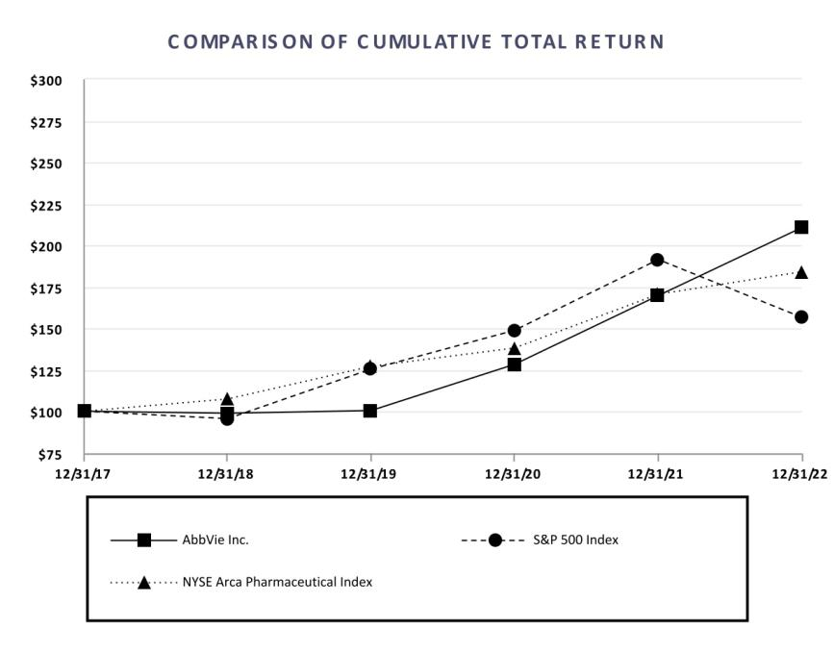

This performance graph is furnished and shall not be deemed "fled" with the SEC or subject to Secton 18 of the Securites Exchange Act of 1934, nor shall it be deemed incorporated by reference in any of AbbVie's flings under the Securites Act of 1933, as amended.

₂₉ | 2022 Form 10-K

Dividends

On October 28, 2022, AbbVie's board of directors declared an increase in the quarterly cash dividend from $1.41 per share to $1.48 per share, payable on February 15, 2023, to stockholders of record as of January 13, 2023. The tming, declaraton, amount of and payment of any dividends by AbbVie in the future is within the discreton of its board of directors and will depend upon many factors, including AbbVie's fnancial conditon, earnings, capital requirements of its operatng subsidiaries, covenants associated with certain of AbbVie's debt service obligatons, legal requirements, regulatory constraints, industry practce, ability to access capital markets and other factors deemed relevant by its board of directors. Moreover, if AbbVie determines to pay any dividend in the future, there can be no assurance that it will contnue to pay such dividends or the amount of such dividends.

Issuer Purchases of Equity Securites

 |  |  |  |  | Total
 |  |  |  |  | Number of
 |  |  |  |  | Shares (or Units)
 | Total |  | Average |  | Purchased as Part |  | Maximum Number (or
 | Number |  | Average |  | of Publicly |  | Approximate Dollar Value) of
 | of Shares |  | Price |  | Announced |  | Shares (or Units) that May
 | (or Units) |  | Paid per Share |  | Plans or |  | Yet Be Purchased Under the
Period | Purchased |  | (or Unit) |  | Programs |  | Plans or Programs
October 1, 2022 - October 31, 2022 | 926 ⁽¹⁾ | $ | 141.34 | (1) | — | $ | 1,393,714,917
November 1, 2022 - November 30, 2022 | 940 ⁽¹⁾ | $ | 146.61 | (1) | — | $ | 1,393,714,917
December 1, 2022 - December 31, 2022 | 26,019 ⁽¹⁾ | $ | 161.87 | (1) | — | $ | 1,393,714,917
Total | 27,885 ⁽¹⁾ | $ | 160.67 | (1) | — | $ | 1,393,714,917

- In additon to AbbVie shares repurchased on the open market under a publicly announced program, if any, these shares also included the shares purchased on the open market for the beneft of partcipants in the AbbVie Employee Stock Purchase Plan – 926 in October; 940 in November; and 26,019 in December.

These shares do not include the shares surrendered to AbbVie to satsfy minimum tax withholding obligatons in connecton with the vestng or exercise of stock-based awards.

2022 Form 10-K | | 30

ITEM 6. [RESERVED]

₃₁ | 2022 Form 10-K

ITEM 7. MANAGEMENT'S DISCUSSION AND ANALYSIS OF FINANCIAL CONDITION AND RESULTS OF OPERATIONS

The following is a discussion and analysis of the fnancial conditon of AbbVie Inc. (AbbVie or the company). This commentary should be read in conjuncton with the Consolidated Financial Statements and accompanying notes appearing in Item 8, "Financial Statements and Supplementary Data." This secton of Form 10-K generally discusses 2022 and 2021 items and year-to-year comparisons between 2022 and 2021. Discussions of 2020 items and year-to-year comparisons between 2021 and 2020 that are not included in this Form 10-K can be found in “Management's Discussion and Analysis of Financial Conditon and Results of Operatons” in Part II, Item 7 of the Company’s Annual Report on Form 10-K for the fscal year ended December 31, 2021.

EXECUTIVE OVERVIEW

Company Overview

AbbVie is a global, diversifed research-based biopharmaceutcal company positoned for success with a comprehensive product portolio that has leadership positons across immunology, oncology, aesthetcs, neuroscience and eye care. AbbVie uses its expertse, dedicated people and unique approach to innovaton to develop and market advanced therapies that address some of the world’s most complex and serious diseases.

AbbVie's products are generally sold worldwide directly to wholesalers, distributors, government agencies, health care facilites, specialty pharmacies and independent retailers from AbbVie-owned distributon centers and public warehouses. Certain products (including aesthetc products and devices) are also sold directly to physicians and other licensed healthcare providers. In the United States, AbbVie distributes pharmaceutcal products principally through independent wholesale distributors, with some sales directly to retailers, pharmacies, patents or other customers. Outside the United States, AbbVie sells products primarily to wholesalers or through distributors, and depending on the market works through largely centralized natonal payers system to agree on reimbursement terms. Certain products are co-marketed or co-promoted with other companies. AbbVie operates as a single global business segment and has approximately 50,000 employees.

2022 Financial Results

AbbVie's strategy has focused on delivering strong fnancial results, maximizing the benefts of the Allergan acquisiton, advancing and investng in its pipeline and returning value to shareholders while ensuring a strong, sustainable growth business over the long term. The company's fnancial performance in 2022 included delivering worldwide net revenues of $58.1 billion, operatng earnings of $18.1 billion, diluted earnings per share of $6.63 and cash fows from operatons of $24.9 billion. Worldwide net revenues increased by 3% on a reported basis and 5% on a constant currency basis, refectng growth across its immunology, neuroscience and aesthetcs portolios.

Diluted earnings per share in 2022 was $6.63 and included the following afer-tax costs: (i) $6.4 billion related to the amortzaton of intangible assets; (ii) $2.8 billion for the change in fair value of contngent consideraton liabilites; (iii) $2.0 billion for charges related to litgaton maters; (iv) $766 million of acquisiton and integraton expenses; and (v) $604 million related to intangible asset impairment. These costs were partally ofset by an afer-tax gain of $126 million related to the divestture of Pylera and a beneft of $26 million related to certain tax items. Additonally, fnancial results refected contnued funding to support all stages of AbbVie’s pipeline assets and contnued investment in AbbVie’s on-market brands.

Following the closing of the Allergan acquisiton in 2020, AbbVie implemented an integraton plan designed to reduce costs, integrate and optmize the combined organizaton. As a result of the successful executon of the integraton plan, AbbVie realized $2.5 billion of annual cost synergies in 2022.

To achieve these integraton objectves, AbbVie incurred total cumulatve charges of $2.3 billion through 2022. These costs consisted of severance and employee beneft costs (cash severance, non-cash severance, including accelerated equity award compensaton expense, retenton and other terminaton benefts) and other integraton expenses.

2022 Form 10-K | | 32

Recent Global Events

Russia/Ukraine

In response to the military confict between Russia and Ukraine, the United States and other North Atlantc Treaty Organizaton member states, as well as certain non-member states, announced targeted economic sanctons and export controls on Russia and Belarus. These include restrictons on the export and transfer of products containing certain toxins, including Botox, to Russia and Belarus. However, AbbVie is not prohibited to contnue the sale of essental pharmaceutcal products to help ensure patents receive an uninterrupted supply of their medicines. In March 2022, AbbVie announced the suspension of operatons for all aesthetcs products in Russia. In April 2022, AbbVie also announced that all profts from the sales of essental medicines in Russia will be donated to support direct humanitarian relief eforts in Ukraine. While the company’s operatons in Russia, Belarus and Ukraine are not signifcant, if the confict escalates and results in broader economic and politcal concerns, AbbVie’s business could be adversely impacted.

Impact of the Coronavirus Disease 2019 (COVID-19)

In response to COVID-19, AbbVie contnues to closely manage manufacturing and supply chain resources around the world to help ensure that patents contnue to receive an uninterrupted supply of their medicines. Clinical trial sites are being monitored locally to protect the safety of study partcipants, staf and employees. While the impact of COVID-19 on AbbVie's operatons to date has not been material, AbbVie contnues to experience lower new patent starts in certain products and markets. AbbVie expects this mater could contnue to negatvely impact its results of operatons throughout the duraton of the pandemic.

The extent to which COVID-19 may impact AbbVie's fnancial conditon and results of operatons remains uncertain and is dependent on numerous evolving factors, including the measures being taken by authorites to mitgate against the spread of COVID-19, the emergence of new variants and the efectveness of vaccines and therapeutcs.

2023 Strategic Objectves

AbbVie's mission is to discover and develop innovatve medicines and products that solve serious health issues today and address the medical challenges of tomorrow while achieving top-ter fnancial performance through outstanding executon. AbbVie intends to execute its strategy and advance its mission in a number of ways, including: (i) maximizing the benefts of a diversifed revenue base with multple long-term growth drivers; (ii) leveraging AbbVie's commercial strength and internatonal infrastructure across therapeutc areas and ensuring strong commercial executon of new product launches; (iii) contnuing to invest in and expand its pipeline in support of opportunites in immunology, oncology, aesthetcs, neuroscience and eye care as well as contnued investment in key on-market products; (iv) generatng substantal operatng cash fows to support investment in innovatve research and development, and return cash to shareholders via a strong and growing dividend while also reducing debt. In additon, AbbVie antcipates several regulatory submissions and data readouts from key clinical trials in the next 12 months.

AbbVie expects to achieve its strategic objectves through:

- Skyrizi and Rinvoq revenue growth driven by increasing market share and indicaton expansion.

- Advancing our hematologic oncology portolio by increasing Venclexta market share and new indicatons, strong commercial executon of new product launches and efectvely managing market and compettve challenges impactng Imbruvica.

- Contnuing investment in the global expansion of aesthetcs and increasing market penetraton of Botox and Juvederm Collecton.

- Neuroscience revenue growth driven by Vraylar, Botox Therapeutc, Ubrelvy and Qulipta.

- Maximizing AbbVie's existng eye care portolio.

- Efectvely managing the impact of Humira biosimilar erosion.

- The favorable impact of pipeline products and indicatons recently approved or currently under regulatory review where approval is expected in 2023. These products are described in greater detail in the secton labeled "Research and Development" included as part of this Item 7.

₃₃ | 2022 Form 10-K

Research and Development

Research and innovaton are the cornerstones of AbbVie's business as a global biopharmaceutcal company. AbbVie's long-term success depends to a great extent on its ability to contnue to discover and develop innovatve products and acquire or collaborate on compounds currently in development by other biotechnology or pharmaceutcal companies.

AbbVie's pipeline currently includes over 80 compounds, devices or indicatons in development individually or under collaboraton or license agreements and is focused on such important specialtes as immunology, oncology, aesthetcs, neuroscience and eye care. Of these programs, approximately 50 are in mid- and late-stage development.

The following sectons summarize transitons of signifcant programs from mid-stage development to late-stage development as well as developments in signifcant late-stage and registraton programs. AbbVie expects multple mid-stage programs to transiton into late-stage programs in the next 12 months.

Signifcant Programs and Developments

Immunology

Skyrizi

- In January 2022, AbbVie announced that the U.S. Food and Drug Administraton (FDA) approved Skyrizi for the treatment of adults with actve psoriatc arthrits.

- In June 2022, AbbVie announced that the FDA approved Skyrizi for the treatment of adults with moderately to severely actve Crohn’s disease.

- In November 2022, AbbVie announced that the European Commission (EC) approved Skyrizi for the treatment of adults with moderately to severely actve Crohn's disease who have had inadequate response, lost response or were intolerant to conventonal or biologic therapy.

Rinvoq

- In January 2022, AbbVie announced that the FDA approved Rinvoq for the treatment of moderate to severe atopic dermatts in adults and children 12 years of age and older whose disease did not respond to previous treatment and is not well controlled with other pills or injectons, including biologic medicines, or when use of other pills or injectons is not recommended.

- In February 2022, AbbVie announced top-line results from its second Phase 3 inducton study, U-Excel, for Rinvoq in patents with moderate to severe Crohn’s disease who had an inadequate response or were intolerant to conventonal or biologic therapy met the primary and most key secondary endpoints.

- In March 2022, AbbVie announced that the FDA approved Rinvoq for the treatment of adults with moderately to severely actve ulceratve colits (UC) who have had an inadequate response or intolerance to one or more tumor necrosis factor (TNF) blockers.

- In April 2022, AbbVie announced that the FDA approved Rinvoq for the treatment of adults with actve ankylosing spondylits who have had an inadequate response or intolerance to one or more TNF blockers.

- In May 2022, AbbVie announced positve top-line results from U-ENDURE, a Phase 3 maintenance study for Rinvoq in adult patents with moderate to severe Crohn's disease who had an inadequate response or were intolerant to a conventonal or biologic therapy. The results showed that more patents treated with Rinvoq achieved the co-primary and secondary endpoints at one year compared to placebo.

- In July 2022, AbbVie announced that the EC approved Rinvoq for the treatment of adults with moderately to severely actve UC who have had an inadequate response, lost response or were intolerant to either conventonal therapy or a biologic agent.

- In July 2022, AbbVie announced its submission of a supplemental New Drug Applicaton (sNDA) to the FDA and a marketng authorizaton applicaton (MAA) to the EMA for Rinvoq for the treatment of adult patents with moderately to severely actve Crohn’s disease.

- In July 2022, AbbVie announced that the EC approved Rinvoq for the treatment of adult patents with actve non-radiographic axial spondyloarthrits (nr-axSpA).

2022 Form 10-K | | 34

- In October 2022, AbbVie announced that the FDA approved Rinvoq for the treatment of adults with actve nr-axSpA with objectve signs of infammaton who have had an inadequate response or intolerance to TNF blocker therapy.

- In November 2022, AbbVie announced that the EMA's Commitee for Medical Products for Human Use (CHMP) adopted an opinion following a review of the beneft-risk of medicines within the JAK inhibitor class for the treatment of infammatory diseases, including Rinvoq. Confrming the recommendaton from the Pharmacovigilance Risk Assessment Commitee (PRAC), the CHMP did not recommend changes to the current Rinvoq indicaton statements and recommended updates to dosage and special warnings for all JAK inhibitor products indicated for the treatment of infammatory diseases. These recommendatons will be forwarded to the EC, which is expected to issue a fnal decision.

Oncology

Teliso-V

- In January 2022, AbbVie announced that the FDA granted Breakthrough Therapy Designaton to investgatonal telisotuzumab vedotn (Teliso-V) for the treatment of patents with advanced/metastatc epidermal growth factor receptor wild type, nonsquamous non-small cell lung cancer with high levels of c-Met overexpression whose disease has progressed on or afer platnum-based therapy.

- In May 2022, AbbVie initated a Phase 3 clinical trial to evaluate Teliso-V versus docetaxel for the treatment of patents with previously treated c-Met overexpressing, epidermal growth factor receptor wild type, advanced/metastatc non-squamous non-small cell lung cancer.

Epcoritamab

- In March 2022, Genmab A/S (Genmab) announced that the FDA granted orphan-drug designaton to the investgatonal medicine, epcoritamab (DuoBody-CD3xCD20), for the treatment of follicular lymphoma. Genmab and AbbVie are co-developing epcoritamab and will share commercial responsibilites in the U.S. and Japan, with AbbVie responsible for further global commercializaton.

- In June 2022, AbbVie and Genmab announced primary results from the large B-cell lymphoma expansion cohort in the EPCORE NHL-1 phase 2 clinical trial evaluatng epcoritamab, an investgatonal subcutaneous bispecifc antbody. In this study, epcoritamab demonstrated efcacy with durable responses in patents who had previously received at least two prior lines of ant-lymphoma therapy including chimeric antgen receptor T-cell therapy.

- In September 2022, AbbVie and Genmab submited a biological license applicaton (BLA) to the FDA for epcoritamab for the treatment of patents with relapsed/refractory large B-cell lymphoma.

- In October 2022, AbbVie and Genmab submited an MAA to the EMA for epcoritamab for the treatment of patents with relapsed/refractory difuse large B-cell lymphoma.

- In October 2022, AbbVie initated a Phase 3 clinical trial to evaluate epcoritamab in combinaton with rituximab and lenalidomide compared to rituximab and lenalidomide in patents with relapsed or refractory follicular lymphoma.

- In November 2022, AbbVie announced that the FDA has accepted for priority review the BLA for epcoritamab for the treatment of relapsed/refractory large B-cell lymphoma.

Imbruvica

- In August 2022, AbbVie announced that the FDA approved the use of Imbruvica for the treatment of pediatric patents one year and older with chronic graf versus host disease afer failure of one or more lines of systemic therapy.

- In August 2022, the Natonal Comprehensive Cancer Network (NCCN) in the United States issued updated guidelines for the management of chronic lymphocytc leukemia (CLL) re-categorizing Imbruvica from “Preferred Regimen” to “Other Recommended Regimen”.

₃₅ | 2022 Form 10-K

Aesthetcs

Juvederm Collecton

- In February 2022, AbbVie announced that the FDA approved Juvederm Volbella XC for improvement of infraorbital hollows in adults over the age of 21.

- In August 2022, AbbVie announced that the FDA approved Juvederm Volux XC for the improvement of jawline defniton in adults over the age of 21 with moderate to severe loss of jawline defniton.

BoNTE

- In March 2022, AbbVie initated three Phase 3 clinical trials to evaluate the efcacy and safety of BoNTE (AGN-151586) for the treatment of glabellar lines.

- In December 2022, AbbVie announced that the FDA approved Vraylar as an adjunctve therapy to antdepressants for the treatment of major depressive disorder in adults. Qulipta

- In March 2022, AbbVie announced results from the Phase 3 PROGRESS trial for Qulipta in the preventve treatment of chronic migraine in adults met the primary endpoint and resulted in signifcant improvements in all secondary endpoints afer adjustment for multple comparisons.

- In June 2022, AbbVie submited an sNDA to the FDA for Qulipta for the preventatve treatment of chronic migraine in adults.

- In July 2022, AbbVie submited an MAA to the EMA for Qulipta for the prophylactc treatment of migraine in adult patents who have at least four migraine days per month.

- In May 2022, AbbVie submited a New Drug Applicaton to the FDA for ABBV-951 (foscarbidopa/foslevodopa) for the treatment of motor fuctuatons in patents with advanced Parkinson's disease.

2022 Form 10-K | | 36

RESULTS OF OPERATIONS

Net Revenues

The comparisons presented at constant currency rates refect comparatve local currency net revenues at the prior year's foreign exchange rates. This measure provides informaton on the change in net revenues assuming that foreign currency exchange rates had not changed between the prior and current periods. AbbVie believes that the non-GAAP measure of change in net revenues at constant currency rates, when used in conjuncton with the GAAP measure of change in net revenues at actual currency rates, may provide a more complete understanding of the company's operatons and can facilitate analysis of the company's results of operatons, partcularly in evaluatng performance from one period to another.

 |  |  |  |  |  |  |  | Percent change
 |  |  |  |  |  |  | At actual currency rates |  |  |  | At constant currency rates
years ended (dollars in millions) |  | 2022 |  | 2021 |  | 2020
years ended (dollars in millions) |  | 2022 |  | 2021 |  | 2020 | 2022 | 2021 |  |  | 2022 | 2021
United States | $ | 45,713 | $ | 43,510 | $ | 34,879 | 5.1 % | 24.7 % |  |  | 5.1 % | 24.7 %
Internatonal |  | 12,341 |  | 12,687 |  | 10,925 | (2.7)% | 16.1 % |  |  | 5.5 % | 12.6 %
Net revenues | $ | 58,054 | $ | 56,197 | $ | 45,804 | 3.3 % | 22.7 % |  |  | 5.1 % | 21.9 %

₃₇ | 2022 Form 10-K

The following table details AbbVie's worldwide net revenues:

 |  |  |  |  |  |  |  |  | Percent change
 |  |  |  |  |  |  |  | At actual currency rates |  |  |  | At constant currency rates
years ended December 31 (dollars in millions) |  |  | 2022 |  | 2021 |  | 2020
 |  |  | 2022 |  | 2021 |  | 2020 | 2022 | 2021 |  |  | 2022 | 2021
Immunology
Humira | United States | $ | 18,619 | $ | 17,330 | $ | 16,112 | 7.4 % | 7.6 % |  |  | 7.4 % | 7.6 %
 | Internatonal |  | 2,618 |  | 3,364 |  | 3,720 | (22.2)% | (9.6)% |  |  | (14.9)% | (12.8)%
 | Total | $ | 21,237 | $ | 20,694 | $ | 19,832 | 2.6 % | 4.3 % |  |  | 3.8 % | 3.7 %
Skyrizi | United States | $ | 4,484 | $ | 2,486 | $ | 1,385 | 80.4 % | 79.6 % |  |  | 80.4 % | 79.6 %
 | Internatonal |  | 681 |  | 453 |  | 205 | 50.4 % | >100.0 % |  |  | 67.1 % | >100.0 %
 | Total | $ | 5,165 | $ | 2,939 | $ | 1,590 | 75.7 % | 84.9 % |  |  | 78.3 % | 84.0 %
Rinvoq | United States | $ | 1,794 | $ | 1,271 | $ | 653 | 41.2 % | 94.8 % |  |  | 41.2 % | 94.8 %
 | Internatonal |  | 728 |  | 380 |  | 78 | 91.4 % | >100.0 % |  |  | >100.0 % | >100.0 %
 | Total | $ | 2,522 | $ | 1,651 | $ | 731 | 52.8 % | >100.0 % |  |  | 58.1 % | >100.0 %
Hematologic Oncology
Imbruvica | United States | $ | 3,426 | $ | 4,321 | $ | 4,305 | (20.7)% | 0.4 % |  |  | (20.7)% | 0.4 %
 | Collaboraton revenues |  | 1,142 |  | 1,087 |  | 1,009 | 5.1 % | 7.7 % |  |  | 5.1 % | 7.7 %
 | Total | $ | 4,568 | $ | 5,408 | $ | 5,314 | (15.5)% | 1.8 % |  |  | (15.5)% | 1.8 %
Venclexta | United States | $ | 1,009 | $ | 934 | $ | 804 | 8.0 % | 16.1 % |  |  | 8.0 % | 16.1 %
 | Internatonal |  | 1,000 |  | 886 |  | 533 | 12.9 % | 66.2 % |  |  | 24.6 % | 60.9 %
 | Total | $ | 2,009 | $ | 1,820 | $ | 1,337 | 10.4 % | 36.1 % |  |  | 16.1 % | 34.0 %
Aesthetcs
Botox Cosmetc ^{(a)} | United States | $ | 1,654 | $ | 1,424 | $ | 687 | 16.2 % | >100.0 % |  |  | 16.2 % | >100.0 %
 | Internatonal |  | 961 |  | 808 |  | 425 | 18.9 % | 90.0 % |  |  | 28.8 % | 83.9 %
 | Total | $ | 2,615 | $ | 2,232 | $ | 1,112 | 17.2 % | >100.0 % |  |  | 20.8 % | 98.4 %
Juvederm Collecton ^{(a)} | United States | $ | 548 | $ | 658 | $ | 318 | (16.7)% | >100.0 % |  |  | (16.7)% | >100.0 %
 | Internatonal |  | 880 |  | 877 |  | 400 | 0.3 % | >100.0 % |  |  | 8.9 % | >100.0 %
 | Total | $ | 1,428 | $ | 1,535 | $ | 718 | (7.0)% | >100.0 % |  |  | (2.1)% | >100.0 %
Other Aesthetcs ^{(a)} | United States | $ | 1,122 | $ | 1,268 | $ | 666 | (11.5)% | 90.2 % |  |  | (11.5)% | 90.2 %
 | Internatonal |  | 168 |  | 198 |  | 94 | (14.9)% | >100.0 % |  |  | (8.3)% | >100.0 %
 | Total | $ | 1,290 | $ | 1,466 | $ | 760 | (12.0)% | 93.0 % |  |  | (11.1)% | 91.9 %
Neuroscience
Botox Therapeutc ^{(a)} | United States | $ | 2,255 | $ | 2,012 | $ | 1,155 | 12.1 % | 74.3 % |  |  | 12.1 % | 74.3 %
 | Internatonal |  | 464 |  | 439 |  | 232 | 5.6 % | 89.0 % |  |  | 15.3 % | 78.8 %
 | Total | $ | 2,719 | $ | 2,451 | $ | 1,387 | 10.9 % | 76.7 % |  |  | 12.6 % | 75.0 %
Vraylar ^{(a)} | United States | $ | 2,037 | $ | 1,728 | $ | 951 | 17.9 % | 81.7 % |  |  | 17.9 % | 81.7 %
 | Internatonal |  | 1 |  | — |  | — | n/m | n/m |  |  | n/m | n/m
 | Total | $ | 2,038 | $ | 1,728 | $ | 951 | 17.9 % | 81.7 % |  |  | 17.9 % | 81.7 %
Duodopa | United States | $ | 95 | $ | 102 | $ | 103 | (6.7)% | (1.0)% |  |  | (6.7)% | (1.0)%
 | Internatonal |  | 363 |  | 409 |  | 391 | (11.3)% | 4.6 % |  |  | (0.8)% | (0.1)%
 | Total | $ | 458 | $ | 511 | $ | 494 | (10.4)% | 3.4 % |  |  | (2.0)% | (0.3)%
Ubrelvy ^{(a)} | United States | $ | 680 | $ | 552 | $ | 125 | 23.2 % | >100.0 % |  |  | 23.2 % | >100.0 %
Qulipta | United States | $ | 158 | $ | — | $ | — | >100.0 % | n/m |  |  | >100.0 % | n/m
Other Neuroscience ^{(a)} | United States | $ | 456 | $ | 667 | $ | 528 | (30.5)% | 26.3 % |  |  | (30.5)% | 26.3 %
 | Internatonal |  | 19 |  | 18 |  | 11 | 4.8 % | 77.4 % |  |  | 9.0 % | 64.7 %
 | Total | $ | 475 | $ | 685 | $ | 539 | (29.6)% | 27.2 % |  |  | (29.5)% | 27.0 %

2022 Form 10-K | | 38

 |  |  |  |  |  |  |  |  | Percent change
 |  |  |  |  |  |  |  | At actual currency rates |  |  |  | At constant currency rates
years ended December 31 (dollars in millions) |  |  | 2022 |  | 2021 |  | 2020
 |  |  | 2022 |  | 2021 |  | 2020 | 2022 | 2021 |  |  | 2022 | 2021
Eye Care
Lumigan/Ganfort ^{(a)} | United States | $ | 242 | $ | 273 | $ | 165 | (11.0)% | 64.7 % |  |  | (11.0)% | 64.7 %
 | Internatonal |  | 272 |  | 306 |  | 213 | (11.3)% | 44.1 % |  |  | (3.0)% | 38.1 %
 | Total | $ | 514 | $ | 579 | $ | 378 | (11.2)% | 53.1 % |  |  | (6.8)% | 49.7 %
Alphagan/Combigan ^{(a)} | United States | $ | 202 | $ | 373 | $ | 223 | (45.8)% | 66.5 % |  |  | (45.8)% | 66.5 %
 | Internatonal |  | 144 |  | 156 |  | 103 | (7.9)% | 52.5 % |  |  | 2.5 % | 50.6 %
 | Total | $ | 346 | $ | 529 | $ | 326 | (34.6)% | 62.1 % |  |  | (31.5)% | 61.5 %
Restasis ^{(a)} | United States | $ | 621 | $ | 1,234 | $ | 755 | (49.6)% | 63.3 % |  |  | (49.6)% | 63.3 %
 | Internatonal |  | 45 |  | 56 |  | 32 | (20.2)% | 75.3 % |  |  | (13.8)% | 80.1 %
 | Total | $ | 666 | $ | 1,290 | $ | 787 | (48.3)% | 63.8 % |  |  | (48.0)% | 64.0 %
Other Eye Care ^{(a)} | United States | $ | 538 | $ | 523 | $ | 305 | 2.3 % | 72.7 % |  |  | 2.3 % | 72.7 %
 | Internatonal |  | 637 |  | 646 |  | 388 | (1.2)% | 66.1 % |  |  | 8.7 % | 61.0 %
 | Total | $ | 1,175 | $ | 1,169 | $ | 693 | 0.4 % | 69.0 % |  |  | 5.9 % | 66.1 %
Other Key Products
Mavyret | United States | $ | 755 | $ | 754 | $ | 785 | 0.2 % | (4.0)% |  |  | 0.2 % | (4.0)%
 | Internatonal |  | 786 |  | 956 |  | 1,045 | (17.8)% | (8.5)% |  |  | (8.5)% | (10.8)%
 | Total | $ | 1,541 | $ | 1,710 | $ | 1,830 | (9.9)% | (6.5)% |  |  | (4.7)% | (7.8)%
Creon | United States | $ | 1,278 | $ | 1,191 | $ | 1,114 | 7.3 % | 6.9 % |  |  | 7.3 % | 6.9 %
Linzess/Constella ^{(a)} | United States | $ | 1,003 | $ | 1,006 | $ | 649 | (0.4)% | 55.1 % |  |  | (0.4)% | 55.1 %
 | Internatonal |  | 32 |  | 32 |  | 18 | 0.3 % | 77.3 % |  |  | 7.6 % | 66.4 %
 | Total | $ | 1,035 | $ | 1,038 | $ | 667 | (0.3)% | 55.7 % |  |  | (0.1)% | 55.4 %
All other |  | $ | 4,137 | $ | 5,019 | $ | 5,119 | (17.6)% | (2.0)% |  |  | (16.3)% | (2.8)%
Total net revenues |  | $ | 58,054 | $ | 56,197 | $ | 45,804 | 3.3 % | 22.7 % |  |  | 5.1 % | 21.9 %

n/m – Not meaningful

- Net revenues include Allergan product revenues afer the acquisiton closing date of May 8, 2020.

The following discussion and analysis of AbbVie's net revenues by product is presented on a constant currency basis.

Global Humira sales increased 4% in 2022 primarily driven by market growth across therapeutc categories, partally ofset by direct biosimilar competton in internatonal markets. In the United States, Humira sales increased 7% in 2022 primarily driven by market growth across all indicatons and favorable pricing. This increase was partally ofset by a lower market share following the corresponding market share gains of Skyrizi and Rinvoq. Internatonally, Humira revenues decreased 15% in 2022 primarily driven by direct biosimilar competton. On January 31, 2023, Humira lost exclusivity in the United States. Following this loss of exclusivity, AbbVie expects direct biosimilar competton and Humira net revenues to decline in the United States. AbbVie contnues to pursue strategies to maintain broad formulary access of Humira and manage the impact of biosimilar erosion.

Net revenues for Skyrizi increased 78% in 2022 primarily driven by contnued strong volume and market share uptake since launch as a treatment for plaque psoriasis as well as market growth. Net revenues were also favorably impacted by recent regulatory approvals and expansion of Skyrizi for the treatment of psoriatc arthrits and Crohn’s disease.

Net revenues for Rinvoq increased 58% in 2022 primarily driven by contnued strong volume and market share uptake since launch for the treatment of moderate to severe rheumatoid arthrits as well as market growth. Net revenues were also favorably impacted by recent regulatory approvals and expansion of Rinvoq for the treatment of psoriatc arthrits, atopic dermatts, ankylosing spondylits, ulceratve colits and non-radiographic axial spondyloarthrits.

Net revenues for Imbruvica represent product revenues in the United States and collaboraton revenues outside of the United States related to AbbVie's 50% share of Imbruvica proft. AbbVie's global Imbruvica revenues decreased 16% in 2022 as a result of decreased market demand and lower market share in the United States. The decrease in net revenues was also partally ofset by increased collaboraton revenues.

Net revenues for Venclexta increased 16% in 2022 primarily due to contnued expansion of Venclexta for the treatment of patents with CLL and acute myeloid leukemia.

₃₉ | 2022 Form 10-K

Net revenues for Botox Cosmetc increased 21% in 2022 due to sustained consumer demand in the United States, which was moderated in the second half of the year by economic pressures impactng consumer discretonary spending, and increased investment in key internatonal markets.

Net revenues for Juvederm Collecton decreased 2% in 2022 due to economic pressures impactng consumer discretonary spending and increased pricing promotons to support the market.
Internatonal net revenues increased by 9% due to increased investment in key markets, partally ofset by the suspension of aesthetc operatons in Russia and the impact of COVID-19 in China.

Net revenues for Botox Therapeutc increased 13% in 2022 due to market growth.

Net revenues for Vraylar increased 18% in 2022 due to higher market share and market growth.

Net revenues for Ubrelvy increased 23% in 2022 primarily due to increased market share uptake since launch, partally ofset by unfavorable pricing.

Net revenues for Qulipta increased greater than 100% in 2022 due to strong volume and market share uptake since launch for the preventatve treatment of episodic migraine in adults.

Net revenues for Mavyret decreased 5% in 2022 due to the contnued disrupton of global hepatts C virus markets due to the COVID-19 pandemic.

Gross Margin

 |  |  |  |  |  |  | Percent change
years ended December 31 (dollars in millions) |  | 2022 |  | 2021 |  | 2020
years ended December 31 (dollars in millions) |  | 2022 |  | 2021 |  | 2020 | 2022 | 2021
Gross margin | $ | 40,640 | $ | 38,751 | $ | 30,417 | 5 % | 27 %
as a percent of net revenues |  | 70 % |  | 69 % |  | 66 %

Gross margin as a percentage of net revenues in 2022 increased compared to 2021. Gross margin percentage for 2022 was favorably impacted by changes in product mix, partally ofset by an intangible asset impairment charge of $770 million.

Selling, General and Administratve

 |  |  |  |  |  |  | Percent change
years ended December 31 (dollars in millions) |  | 2022 |  | 2021 |  | 2020
years ended December 31 (dollars in millions) |  | 2022 |  | 2021 |  | 2020 | 2022 | 2021
Selling, general and administratve | $ | 15,260 | $ | 12,349 | $ | 11,299 | 24 % | 9 %
as a percent of net revenues |  | 26 % |  | 22 % |  | 25 %

Selling, general and administratve (SG&A) expenses as a percentage of net revenues increased in 2022 compared to the prior year primarily due to the unfavorable impact of litgaton reserve charges of $2.5 billion, partally ofset by leverage from revenue growth and increased synergies realized.

Research and Development and Acquired IPR&D and Milestones

 |  |  |  |  |  |  | Percent change
years ended December 31 (dollars in millions) |  | 2022 |  | 2021 |  | 2020
years ended December 31 (dollars in millions) |  | 2022 |  | 2021 |  | 2020 | 2022 | 2021
Research and development | $ | 6,510 | $ | 6,922 | $ | 6,379 | (6)% | 9 %
as a percent of net revenues |  | 11 % |  | 12 % |  | 14 %
Acquired IPR&D and milestones | $ | 697 | $ | 1,124 | $ | 1,376 | (38)% | (18)%

R&D expenses as a percentage of net revenues decreased in 2022 compared to 2021. R&D expense percentage for 2022 was favorably impacted by increased scale of the combined company and synergies realized, the purchase of priority review vouchers from third partes in the prior year as well as lower integraton costs related to the acquisiton of Allergan.

Acquired IPR&D and milestones expense represents upfront and subsequent development milestone payments incurred prior to regulatory approval to acquire rights to in-process R&D projects through R&D collaboratons, licensing arrangements or other asset acquisitons. Acquired IPR&D and milestones expense in 2022 included a charge of $130 million related to acquiring Syndesi Therapeutcs SA, charges related to other upfront payments totaling $315 million and development milestones of $252 million. Acquired IPR&D and milestones expense in 2021 included a charge of $400 million related to exercising the company's exclusive right to acquire TeneoOne, a charge of $370 million related to a collaboraton

2022 Form 10-K | | 40

agreement with REGENXBIO Inc, charges related to other upfront payments totaling $192 million and development milestones of $162 million. See Note 5 to the Consolidated Financial Statements for additonal informaton.

Other Operatng Expense, Net

Other operatng expense, net in 2022 included a one-tme charge of $229 million related to an asset divested as part of the Allergan acquisiton, partally ofset by $172 million of income related to the sale of worldwide commercial rights of a mature brand Pylera. Other operatng expense, net in 2021 included a $500 million charge related to the extension of the Calico Life Sciences LLC collaboraton. See Note 5 to the Consolidated Financial Statements for additonal informaton.

Other Non-Operatng Expenses

years ended December 31 (in millions) |  | 2022 |  | 2021 |  | 2020
Interest expense | $ | 2,230 | $ | 2,423 | $ | 2,454
Interest income |  | (186) |  | (39) |  | (174)
Interest expense, net | $ | 2,044 | $ | 2,384 | $ | 2,280
Net foreign exchange loss | $ | 148 | $ | 51 | $ | 71
Other expense, net |  | 2,448 |  | 2,500 |  | 5,614

Interest expense in 2022 decreased compared to 2021 primarily due to a lower average debt balance as a result of deleveraging, partally ofset by the impact of higher interest rates.

Interest income in 2022 increased compared to 2021 primarily due to the impact of higher interest rates.

Other expense, net included charges related to changes in fair value of contngent consideraton liabilites of $2.8 billion in 2022 and $2.7 billion in 2021. The fair value of contngent consideraton liabilites is impacted by the passage of tme and multple other inputs, including the probability of success of achieving regulatory/commercial milestones, discount rates, the estmated amount of future sales of the acquired products and other market-based factors. In 2022, the change in fair value refected higher estmated Skyrizi sales driven by stronger market share uptake and the passage of tme, partally ofset by higher discount rates. In 2021, the change in fair value refected higher estmated Skyrizi sales driven by stronger market share uptake, favorable clinical trial results and the passage of tme, partally ofset by higher discount rates.

Income Tax Expense

The efectve income tax rate was 12% in 2022, 11% in 2021 and negatve 36% in 2020. The efectve income tax rates difered from the U.S. statutory tax rate of 21% principally due to the impact of foreign operatons which refects the impact of lower income tax rates in locatons outside the United States, tax incentves in Puerto Rico and other foreign tax jurisdictons, business development actvites and changes in fair value of contngent consideraton. The efectve tax rates for these periods also refected the beneft from U.S. tax credits principally related to research and development credits, the orphan drug tax credit and Puerto Rico excise tax credits. The Puerto Rico tax credits relate to excise tax on certain products manufactured in Puerto Rico. The tax is levied on gross inventory purchases from enttes in Puerto Rico and is included in cost of products sold in the consolidated statements of earnings. The majority of the tax is creditable for U.S. income tax purposes. In 2022, Puerto Rico enacted Act 52-2002 (the “Puerto Rico Act”) allowing for a transiton from a Puerto Rico excise tax levied on gross inventory purchases to an income-based tax beginning in 2023. The company completed the transiton requirements of the Puerto Rico Act in 2022, resultng in the remeasurement of certain deferred tax assets and liabilites based on income tax rates at which they are expected to reverse in the future. The net tax beneft from the remeasurement of deferred taxes related to the Puerto Rico Act was $323 million.

FINANCIAL POSITION, LIQUIDITY AND CAPITAL RESOURCES

years ended December 31 (in millions) |  | 2022 |  | 2021 |  | 2020
Cash fows provided by (used in)
Operatng actvites | $ | 24,943 | $ | 22,777 | $ | 17,588
Investng actvites |  | (623) |  | (2,344) |  | (37,557)
Financing actvites |  | (24,803) |  | (19,039) |  | (11,501)

Operatng cash fows in 2022 increased from 2021 primarily due to improved results of operatons resultng from revenue growth and lower income tax payments, partally ofset by the tming of working capital. Operatng cash fows also refected AbbVie’s contributons to its defned beneft plans of $357 million in 2022 and $376 million in 2021.

₄₁ | 2022 Form 10-K

Investng cash fows in 2022 included payments made for capital expenditures of $695 million, other acquisitons and investments of $539 million, $255 million cash consideraton paid to acquire DJS Antbodies Ltd ofset by cash acquired and net sales and maturites of investments securites totaling $92 million. Investment cash fows in 2021 included $535 million cash consideraton paid to acquire Soliton, Inc. ofset by cash acquired, payments made for other acquisitons and investments of $1.4 billion, capital expenditures of $787 million and net purchases of investment securites totaling $21 million.

Financing cash fows in 2022 included repayment of $3.1 billion aggregate principal amount of the company's 2.9% senior notes, $3.0 billion aggregate principal amount of the company's 2.3% senior notes, $2.9 billion aggregate principal amount of the company's 3.45% senior notes, $1.7 billion aggregate principal amount of the company's 3.25% senior notes, $1.0 billion aggregate principal amount of the company’s 3.2% senior notes and $750 million aggregate principal amount of the company's foatng rate senior notes. Additonally fnancing cash fows included repayment of a $2.0 billion foatng term loan due May 2025 and issuance of a new $2.0 billion foatng rate term loan as part of the term loan refnancing in February 2022. Subsequent to December 31, 2022, the company repaid a $1.0 billion foatng rate three-year term loan that was scheduled to mature in May 2023.

Financing cash fows in 2021 included early repayments of $1.8 billion aggregate principal amount of the company's 2.3% principal notes, $1.2 billion aggregate principal amount of the company's 5.0% senior notes and €750 million aggregate principal amount of the company's 0.5% senior Euro notes. Financing cash fows also included repayment of $750 million aggregate principal amount of foatng rate senior notes, $1.3 billion aggregate principal amount of 3.375% senior notes, $1.8 billion aggregate principal amount of 2.15% senior notes and $750 million aggregate principal amount of foatng rate senior notes at maturity. Additonally, fnancing cash fows included repayment of a $1.0 billion foatng rate term loan due May 2023 and issuance of a new $1.0 billion foatng rate term loan as part of the term loan refnancing in September 2021.

Financing cash fows also included cash dividend payments of $10.0 billion in 2022 and $9.3 billion in 2021. The increase in cash dividend payments was primarily driven by an increase of the dividend rate.

The company's stock repurchase authorizaton permits purchases of AbbVie shares from tme to tme in open-market or private transactons at management’s discreton. The program has no tme limit and can be discontnued at any tme. AbbVie repurchased 8 million shares for $1.1 billion in 2022 and 6 million shares for $670 million in 2021. AbbVie's remaining stock repurchase authorizaton was $1.4 billion as of December 31, 2022. On February 16, 2023, AbbVie's board of directors authorized a $5.0 billion increase to the existng stock repurchase authorizaton.

No commercial paper borrowings were issued during 2022 or 2021 and there were no commercial paper borrowings outstanding as of December 31, 2022 or December 31, 2021. AbbVie may issue additonal commercial paper or retre commercial paper to meet liquidity requirements as needed.

Credit Risk

AbbVie monitors economic conditons, the creditworthiness of customers and government regulatons and funding, both domestcally and abroad. AbbVie regularly communicates with its customers regarding the status of receivable balances, including their payment plans and obtains positve confrmaton of the validity of the receivables. AbbVie establishes an allowance for credit losses equal to the estmate of future losses over the contractual life of outstanding accounts receivable. AbbVie may also utlize factoring arrangements to mitgate credit risk, although the receivables included in such arrangements have historically not been a signifcant amount of total outstanding receivables.

Credit Facility, Access to Capital and Credit Ratngs

Credit Facility

AbbVie currently has a $4.0 billion fve-year revolving credit facility that matures in August 2024. This credit facility enables the company to borrow funds on an unsecured basis at variable interest rates and contains various covenants. At December 31, 2022, the company was in compliance with all covenants, and commitment fees under the credit facility were insignifcant. No amounts were outstanding under the company's credit facility as of December 31, 2022 and December 31, 2021.

2022 Form 10-K | | 42

Access to Capital

The company intends to fund short-term and long-term fnancial obligatons as they mature through cash on hand, future cash fows from operatons or has the ability to issue additonal debt. The company's ability to generate cash fows from operatons, issue debt or enter into fnancing arrangements on acceptable terms could be adversely afected if there is a material decline in the demand for the company's products or in the solvency of its customers or suppliers, deterioraton in the company's key fnancial ratos or credit ratngs, or other material unfavorable changes in business conditons. At the current tme, the company believes it has sufcient fnancial fexibility to issue debt, enter into other fnancing arrangements and atract long-term capital on acceptable terms to support the company's growth objectves.

Credit Ratngs

In 2022, Moody’s Investors Service upgraded AbbVie's senior unsecured long-term credit ratng to Baa1 from Baa2, afrmed its Prime-2 short-term credit ratng and revised its outlook to positve from stable. In additon, Standard and Poor's Global Ratngs revised its outlook to positve from stable and afrmed its long-term issuer credit ratng of BBB+.

Unfavorable changes to the ratngs may have an adverse impact on future fnancing arrangements; however, they would not afect the company’s ability to draw on its credit facility and would not result in an acceleraton of scheduled maturites of any of the company’s outstanding debt.

Future Cash Requirements

Contractual Obligatons

The following table summarizes AbbVie's estmated material contractual obligatons as of December 31, 2022:

(in millions) |  | Total |  | Current |  | Long-term
Long-term debt, including current porton | $ | 63,128 | $ | 4,132 | $ | 58,996
Interest on long-term debt^{(a)} |  | 28,445 |  | 2,363 |  | 26,082
Contngent consideraton liabilites^{(b)} |  | 16,384 |  | 1,469 |  | 14,915

- Includes estmated future interest payments on long-term debt. Interest payments on debt are calculated for future periods using forecasted interest rates in efect at the end of 2022. Projected interest payments include the related efects of interest rate swap agreements. Certain of these projected interest payments may difer in the future based on changes in foatng interest rates or other factors or events. The projected interest payments only pertain to obligatons and agreements outstanding at December 31, 2022. See Note 10 to the Consolidated Financial Statements for additonal informaton regarding the company's debt instruments and Note 11 for additonal informaton on the interest rate swap agreements outstanding at December 31, 2022.

- Includes contngent consideraton liabilites which are recorded at fair value on the consolidated balance sheet. Potental contngent consideraton payments that exceed the fair value recorded on the consolidated balance sheet are not included in the table of contractual obligatons. See Note 11 to the Consolidated Financial Statements for additonal informaton regarding these liabilites.

AbbVie enters into certain unconditonal purchase obligatons and other commitments in the normal course of business. There have been no changes to these commitments that would have a material impact on the company’s ability to meet either short-term or long-term future cash requirements.

Income Taxes

Future income tax cash requirements include a one-tme transiton tax liability on a mandatory deemed repatriaton of previously untaxed earnings of foreign subsidiaries resultng from U.S. tax reform enacted in 2017. The one-tme transiton tax liability was $3.4 billion as of December 31, 2022 and is payable in four future annual installments.

Liabilites for unrecognized tax benefts totaled $6.5 billion as of December 31, 2022. It is not possible to reliably estmate the tming of the future cash outlows related to these liabilites. See Note 14 to the Consolidated Financial Statements for additonal informaton on these unrecognized tax benefts.

Quarterly Cash Dividend

On October 28, 2022, AbbVie announced that its board of directors declared an increase in the quarterly cash dividend from $1.41 per share to $1.48 per share beginning with the dividend payable on February 15, 2023, to stockholders of record as of January 13, 2023. This refects an increase of approximately 5.0% over the previous quarterly rate. The tming,

₄₃ | 2022 Form 10-K

declaraton, amount of and payment of any dividends by AbbVie in the future is within the discreton of its board of directors and will depend upon many factors, including AbbVie's fnancial conditon, earnings, capital requirements of its operatng subsidiaries, covenants associated with certain of AbbVie's debt service obligatons, legal requirements, regulatory constraints, industry practce, ability to access capital markets and other factors deemed relevant by its board of directors.

Collaboratons, Licensing and Other Arrangements

AbbVie enters into collaboratve, licensing and other arrangements with third partes that may require future milestone payments to third partes contngent upon the achievement of certain development, regulatory, or commercial milestones. Individually, these arrangements are insignifcant in any one annual reportng period. However, if milestones for multple products covered by these arrangements happen to be reached in the same reportng period, the aggregate charge to expense could be material to the results of operatons in that period. From a business perspectve, the payments are viewed as positve because they signify that the product is successfully moving through development and is now generatng or is more likely to generate future cash fows from product sales. It is not possible to predict with reasonable certainty whether these milestones will be achieved or the tming for achievement. See Note 5 to the Consolidated Financial Statements for additonal informaton on these collaboraton arrangements.

CRITICAL ACCOUNTING POLICIES AND ESTIMATES

The preparaton of fnancial statements in accordance with generally accepted accountng principles in the United States requires the use of estmates and assumptons that afect the reported amounts of assets and liabilites and the reported amounts of revenue and expenses. A summary of the company's signifcant accountng policies is included in Note 2 to the Consolidated Financial Statements. Certain of these policies are considered critcal as these most signifcantly impact the company's fnancial conditon and results of operatons and require the most difcult, subjectve, or complex judgments, ofen as a result of the need to make estmates about the efect of maters that are inherently uncertain. Actual results may vary from these estmates.

Revenue Recogniton

AbbVie recognizes revenue when control of promised goods or services is transferred to the company’s customers, in an amount that refects the consideraton AbbVie expects to be enttled to in exchange for those goods or services. Sales, value add and other taxes collected concurrent with revenue-producing actvites are excluded from revenue. AbbVie generates revenue primarily from product sales. For the majority of sales, the company transfers control, invoices the customer and recognizes revenue upon shipment to the customer.

Rebates

AbbVie provides rebates to pharmacy beneft managers, state government Medicaid programs, insurance companies that administer Medicare drug plans, wholesalers, group purchasing organizatons and other government agencies and private enttes.

Rebate and chargeback accruals are accounted for as variable consideraton and are recorded as a reducton to revenue in the period the related product is sold. Provisions for rebates and chargebacks totaled $41.4 billion in 2022, $33.9 billion in 2021 and $27.0 billion in 2020. Rebate amounts are typically based upon the volume of purchases using contractual or statutory prices, which may vary by product and by payer. For each type of rebate, the factors used in the calculatons of the accrual for that rebate include the identfcaton of the products subject to the rebate, the applicable price terms and the estmated lag tme between sale and payment of the rebate, which can be signifcant.

In order to establish its rebate and chargeback accruals, the company uses both internal and external data to estmate the level of inventory in the distributon channel and the rebate claims processing lag tme for each type of rebate. To estmate the rebate percentage or net price, the company tracks sales by product and by customer or payer. The company evaluates inventory data reported by wholesalers, available prescripton volume informaton, product pricing, historical experience and other factors in order to determine the adequacy of its reserves. AbbVie regularly monitors its reserves and records adjustments when rebate trends, rebate programs and contract terms, legislatve changes, or other signifcant events indicate that a change in the reserve is appropriate. Historically, adjustments to rebate accruals have not been material to net earnings.

2022 Form 10-K | | 44

The following table is an analysis of the three largest accruals for rebates and chargebacks, which comprise approximately 94% of the total consolidated rebate and chargebacks recorded as reductons to revenues in 2022. Remaining rebate provisions charged against gross revenues are not signifcant in the determinaton of operatng earnings.

 |  | Medicaid
 |  | and |  | Managed
(in millions) |  | Medicare |  | Care |  | Wholesaler
(in millions) |  | Rebates |  | Rebates |  | Chargebacks
Balance at December 31, 2019 | $ | 1,765 | $ | 1,936 | $ | 686
Additons^{(a)} |  | 1,266 |  | 649 |  | 71
Provisions |  | 6,715 |  | 8,656 |  | 8,677
Payments |  | (6,801) |  | (8,334) |  | (8,693)
Balance at December 31, 2020 |  | 2,945 |  | 2,907 |  | 741
Provisions |  | 9,622 |  | 11,306 |  | 11,286
Payments |  | (8,751) |  | (11,116) |  | (11,125)
Balance at December 31, 2021 |  | 3,816 |  | 3,097 |  | 902
Provisions |  | 11,713 |  | 14,119 |  | 13,070
Payments |  | (10,331) |  | (12,974) |  | (12,829)
Balance at December 31, 2022 | $ | 5,198 | $ | 4,242 | $ | 1,143

- Represents rebate accruals and chargeback allowances assumed in the Allergan acquisiton.

Other Allowances

Other allowances include cash discounts, product returns, sales incentves, and other adjustments, which are accounted for as variable consideraton and are recorded as a reducton to revenue in the same period the related product is sold. Reserves for cash discounts and sales incentves are readily determinable because the company's experience of payment history is fairly consistent. Product returns can be reliably estmated based on the company's historical return experience. Cash discounts totaled $1.8 billion in 2022, $1.6 billion in 2021 and $1.2 billion in 2020. Allowances other than cash discounts are not signifcant.

Pension and Other Post-Employment Benefts

AbbVie engages outside actuaries to assist in the determinaton of the obligatons and costs under the pension and other post-employment beneft plans that are direct obligatons of AbbVie. The valuaton of the funded status and the net periodic beneft cost for these plans are calculated using actuarial assumptons. The signifcant assumptons, which are reviewed annually, include the discount rate, the expected long-term rate of return on plan assets and the health care cost trend rates and are disclosed in Note 12 to the Consolidated Financial Statements.

The discount rate is selected based on current market rates on high-quality, fxed-income investments at December 31 each year. AbbVie employs a yield-curve approach for countries where a robust bond market exists. The yield curve is developed using high-quality bonds. The yield-curve approach refects the plans' specifc cash fows (i.e. duraton) in calculatng the beneft obligatons by applying the corresponding individual spot rates along the yield curve. AbbVie refects the plans' specifc cash fows and applies them to the corresponding individual spot rates along the yield curve in calculatng the service cost and interest cost portons of expense. For other countries, AbbVie reviews various indices such as corporate bond and government bond benchmarks to estmate the discount rate.

₄₅ | 2022 Form 10-K

AbbVie's assumed discount rates have a signifcant efect on the amounts reported for defned beneft pension and other post-employment plans as of December 31, 2022. A 50 basis point change in the assumed discount rate would have had the following efects on AbbVie's calculaton of net periodic beneft costs in 2023 and projected beneft obligatons as of December 31, 2022:

 |  | 50 basis point
(in millions) (brackets denote a reducton)
(in millions) (brackets denote a reducton) |  | Increase |  | Decrease
Defned beneft plans
Net periodic beneft cost | $ | (34) | $ | 57
Projected beneft obligaton |  | (612) |  | 687
Other post-employment plans
Net periodic beneft cost | $ | (5) | $ | 6
Projected beneft obligaton |  | (44) |  | 49

The expected long-term rate of return is based on the asset allocaton, historical performance and the current view of expected future returns. AbbVie considers these inputs with a long-term focus to avoid short-term market infuences. The current long-term rate of return on plan assets for each plan is supported by the historical performance of the trust's actual and target asset allocaton. AbbVie's assumed expected long-term rate of return has a signifcant efect on the amounts reported for defned beneft pension plans as of December 31, 2022 and will be used in the calculaton of net periodic beneft cost in 2023. A one percentage point change in assumed expected long-term rate of return on plan assets would increase or decrease the net period beneft cost of these plans in 2023 by $98 million.

The health care cost trend rate is selected by reviewing historical trends and current views on projected future health care cost increases. The current health care cost trend rate is supported by the historical trend experience of each plan. Assumed health care cost trend rates have a signifcant efect on the amounts reported for health care plans as of December 31, 2022 and will be used in the calculaton of net periodic beneft cost in 2023.

Income Taxes

AbbVie accounts for income taxes under the asset and liability method. Provisions for federal, state and foreign income taxes are calculated on reported pre-tax earnings based on current tax laws. Deferred taxes are provided using enacted tax rates on the future tax consequences of temporary diferences, which are the diferences between the fnancial statement carrying amount of assets and liabilites and their respectve tax bases and the tax benefts of carryforwards. A valuaton allowance is established or maintained when, based on currently available informaton, it is more likely than not that all or a porton of a deferred tax asset will not be realized.

Litgaton

The company is subject to contngencies, such as various claims, legal proceedings and investgatons regarding product liability, intellectual property, commercial, securites and other maters that arise in the normal course of business. See Note 15 to the Consolidated Financial Statements for additonal informaton. Loss contngency provisions are recorded for probable losses at management's best estmate of a loss, or when a best estmate cannot be made, a minimum loss contngency amount within a probable range is recorded. Accordingly, AbbVie is ofen initally unable to develop a best estmate of loss and therefore, the minimum amount, which could be zero, is recorded. As informaton becomes known, either the minimum loss amount is increased, resultng in additonal loss provisions, or a best estmate can be made, also resultng in additonal loss provisions. Occasionally, a best estmate amount is changed to a lower amount when events result in an expectaton of a more favorable outcome than previously expected.

Valuaton of Goodwill and Intangible Assets

AbbVie has acquired and may contnue to acquire signifcant intangible assets in connecton with business combinatons that AbbVie records at fair value. Transactons involving the purchase or sale of intangible assets occur between companies in the pharmaceutcals industry and valuatons are usually based on a discounted cash fow analysis incorporatng the stage of completon. The discounted cash fow model requires assumptons about the tming and amount of future net cash fows, risk, cost of capital, terminal values and market partcipants. Each of these factors can signifcantly afect the value of the intangible asset. In-process research and development (IPR&D) acquired in a business combinaton is capitalized as an indefnite-lived intangible asset untl regulatory approval is obtained, at which tme it is accounted for as a defnite-lived asset and amortzed over its estmated useful life, or discontnuaton, at which point the intangible asset will be writen of. IPR&D acquired in transactons that are not business combinatons is expensed immediately, unless deemed to have an alternatve

2022 Form 10-K | | 46

future use. Payments made to third partes subsequent to regulatory approval are capitalized and amortzed over the remaining useful life.

AbbVie reviews the recoverability of defnite-lived intangible assets whenever events or changes in circumstances indicate the carrying value of an asset may not be recoverable. Goodwill and indefnite-lived intangible assets are reviewed for impairment annually or when an event occurs that could result in an impairment. See Note 2 to the Consolidated Financial Statements for additonal informaton.

Annually, the company tests its goodwill for impairment by frst assessing qualitatve factors to determine whether it is more likely than not that the fair value is less than its carrying amount. Some of the factors considered in the assessment include general macro-economic conditons, conditons specifc to the industry and market, cost factors, the overall fnancial performance and whether there have been sustained declines in the company's share price. If the company concludes it is more likely than not that the fair value of the reportng unit is less than its carrying amount, a quanttatve impairment test is performed. AbbVie tests indefnite-lived intangible assets for impairment by frst assessing qualitatve factors to determine whether it is more likely than not that the fair value is less than its carrying amount. If the company concludes it is more likely than not that the fair value is less than its carrying amount, a quanttatve impairment test is performed.

For its quanttatve impairment tests, the company uses an estmated future cash fow approach that requires signifcant judgment with respect to future volume, revenue and expense growth rates, changes in working capital use, the selecton of an appropriate discount rate, asset groupings and other assumptons and estmates. The estmates and assumptons used are consistent with the company's business plans and a market partcipant's views. The use of alternatve estmates and assumptons could increase or decrease projected cash fows and the estmated fair value of the related intangible assets. Future changes to these estmates and assumptons could have a material impact on the company's results of operatons. Actual results may difer from the company's estmates.

Contngent Consideraton

The fair value measurements of contngent consideraton liabilites are determined as of the acquisiton date based on signifcant unobservable inputs, including the discount rate, estmated probabilites and tming of achieving specifed development, regulatory and commercial milestones and the estmated amount of future sales of the acquired products. Contngent consideraton liabilites are revalued to fair value at each subsequent reportng date untl the related contngency is resolved. The potental contngent consideraton payments are estmated by applying a probability-weighted expected payment model for contngent milestone payments and a Monte Carlo simulaton model for contngent royalty payments, which are then discounted to present value. Changes to the fair value of the contngent consideraton liabilites can result from changes to one or a number of inputs, including discount rates, the probabilites of achieving the milestones, the tme required to achieve the milestones and estmated future sales. Signifcant judgment is employed in determining the appropriateness of certain of these inputs, which are disclosed in Note 11 to the Consolidated Financial Statements. Changes to the inputs described above could have a material impact on the company's fnancial positon and results of operatons in any given period.

₄₇ | 2022 Form 10-K

ITEM 7A. QUANTITATIVE AND QUALITATIVE DISCLOSURES ABOUT MARKET RISK

The company is exposed to risk that its earnings, cash fows and equity could be adversely impacted by changes in foreign exchange rates and interest rates. Certain derivatve instruments are used when available on a cost-efectve basis to hedge the company's underlying economic exposures. See Note 11 to the Consolidated Financial Statements for additonal informaton regarding the company's fnancial instruments and hedging strategies.

Foreign Currency Risk

AbbVie's primary net foreign currency exposures are the Euro, Japanese yen, Canadian dollar, Chinese yuan and Britsh pound. The following table refects the total foreign currency forward exchange contracts outstanding at December 31, 2022 and 2021:

 |  |  | 2022 |  |  |  |  |  | 2021
 |  |  |  |  | Fair and carrying |  |  |  |  |  | Fair and carrying
as of December 31 (in millions) |  | Contract amount | Weighted average |  | value |  |  | Contract amount | Weighted average |  | value
as of December 31 (in millions) |  | Contract amount | exchange rate | receivable/(payable) |  |  |  | Contract amount | exchange rate | receivable/(payable)
Receive primarily U.S. dollars in exchange for the following currencies:
Euro | $ | 8,507 | 1.071 | $ | 9 |  | $ | 10,253 | 1.155 | $ | 195
Canadian dollar |  | 1,302 | 1.312 |  | 40 |  |  | 571 | 1.258 |  | 9
Britsh pound |  | 772 | 1.234 |  | (8) |  |  | 605 | 1.331 |  | 9
Chinese yuan |  | 596 | 7.024 |  | (5) |  |  | 673 | 6.400 |  | (1)
Japanese yen |  | 567 | 133.3 |  | (3) |  |  | 602 | 113.3 |  | 9
All other currencies |  | 1,954 | n/a |  | (2) |  |  | 1,549 | n/a |  | 5
Total | $ | 13,698 |  | $ | 31 |  | $ | 14,253 |  | $ | 226

The company estmates that a 10% appreciaton in the underlying currencies being hedged from their levels against the U.S. dollar, with all other variables held constant, would decrease the fair value of foreign exchange forward contracts by $1.4 billion at December 31, 2022. If realized, this appreciaton would negatvely afect earnings over the remaining life of the contracts. However, gains and losses on the hedging instruments ofset losses and gains on the hedged transactons and reduce the earnings and stockholders' equity volatlity relatng to foreign exchange. A 10% appreciaton is believed to be a reasonably possible near-term change in foreign currencies.

As of December 31, 2022, the company has €5.9 billion aggregate principal amount of unsecured senior Euro notes outstanding, which are exposed to foreign currency risk. The company designated these foreign currency denominated notes as hedges of its net investments in certain foreign subsidiaries and afliates. As a result, any foreign currency translaton gains or losses related to the Euro notes will be included in accumulated other comprehensive loss. See Note 10 to the Consolidated Financial Statements for additonal informaton regarding the senior Euro notes and Note 11 to the Consolidated Financial Statements for additonal informaton regarding the net investment hedging program.

Interest Rate Risk

The company estmates that an increase in interest rates of 100 basis points would adversely impact the fair value of AbbVie's interest rate swap contracts by approximately $155 million at December 31, 2022. If realized, the fair value reducton would afect earnings over the remaining life of the contracts. The company estmates that an increase of 100 basis points in long-term interest rates would decrease the fair value of long-term debt by $4.2 billion at December 31, 2022. A 100 basis point change is believed to be a reasonably possible near-term change in interest rates.

2022 Form 10-K | | 48

ITEM 8. FINANCIAL STATEMENTS AND SUPPLEMENTARY DATA

 |  |  |  |  |  |  |  |  |  |  |  |  |  |  |  |  |  |  |  |  |  |  | Page
Consolidated Financial Statements
Consolidated Statements of Earnings |  |  |  |  |  |  |  |  |  |  |  |  |  |  |  |  |  |  |  |  |  |  |  | 50
Consolidated Statements of Comprehensive Income |  |  |  |  |  |  |  |  |  |  |  |  |  |  |  |  |  |  |  |  |  |  |  | 51
Consolidated Balance Sheets |  |  |  |  |  |  |  |  |  |  |  |  |  |  |  |  |  |  |  |  |  |  |  | 52
Consolidated Statements of Equity |  |  |  |  |  |  |  |  |  |  |  |  |  |  |  |  |  |  |  |  |  |  | 53
Consolidated Statements of Cash Flows |  |  |  |  |  |  |  |  |  |  |  |  |  |  |  |  |  |  |  |  |  |  |  | 54
Notes to Consolidated Financial Statements
Note 1 |  |  | Background |  |  |  |  |  |  |  |  |  |  |  |  |  |  |  |  |  |  |  |  | 55
Note 2 |  |  | Summary of Signifcant Accountng Policies |  |  |  |  |  |  |  |  |  |  |  |  |  |  |  |  |  |  |  | 55
Note 3 |  |  | Supplemental Financial Informaton |  |  |  |  |  |  |  |  |  |  |  |  |  |  |  |  |  |  |  | 60
Note 4 |  |  | Earnings Per Share |  |  |  |  |  |  |  |  |  |  |  |  |  |  |  |  |  |  |  |  | 61
Note 5 |  |  | Licensing, Acquisitons and Other Arrangements |  |  |  |  |  |  |  |  |  |  |  |  |  |  |  |  |  |  |  | 62
Note 6 |  |  | Collaboratons |  |  |  |  |  |  |  |  |  |  |  |  |  |  |  |  |  |  |  | 66
Note 7 |  |  | Goodwill and Intangible Assets |  |  |  |  |  |  |  |  |  |  |  |  |  |  |  |  |  |  |  | 68
Note 8 |  |  | Integraton and Restructuring Plans |  |  |  |  |  |  |  |  |  |  |  |  |  |  |  |  |  |  |  | 69
Note 9 |  |  | Leases |  |  |  |  |  |  |  |  |  |  |  |  |  |  |  |  |  |  |  |  | 70
Note 10 |  |  | Debit, Credit Facilites and Commitments and Contngencies |  |  |  |  |  |  |  |  |  |  |  |  |  |  |  |  |  |  |  | 72
Note 11 |  |  | Financial Instruments and Fair Value Measures |  |  |  |  |  |  |  |  |  |  |  |  |  |  |  |  |  |  |  | 74
Note 12 |  |  | Post-Employment Benefts |  |  |  |  |  |  |  |  |  |  |  |  |  |  |  |  |  |  |  | 80
Note 13 |  |  | Equity |  |  |  |  |  |  |  |  |  |  |  |  |  |  |  |  |  |  |  | 85
Note 14 |  |  | Income Taxes |  |  |  |  |  |  |  |  |  |  |  |  |  |  |  |  |  |  |  | 90
Note 15 |  |  | Legal Proceedings and Contngencies |  |  |  |  |  |  |  |  |  |  |  |  |  |  |  |  |  |  |  | 92
Note 16 |  |  | Segment and Geographic Area Informaton |  |  |  |  |  |  |  |  |  |  |  |  |  |  |  |  |  |  |  | 94
Note 17 |  |  | Fourth Quarter Financial Results (unaudited) |  |  |  |  |  |  |  |  |  |  |  |  |  |  |  |  |  |  |  | 97
Report of Independent Registered Public Accounting Firm (PCAOB ID: 42) |  |  |  |  |  |  |  |  |  |  |  |  |  |  |  |  |  |  |  |  |  |  | 98

₄₉ | 2022 Form 10-K

AbbVie Inc. and Subsidiaries
Consolidated Statements of Earnings

 | years ended December 31 (in millions, except per share data) |  | 2022 |  | 2021 |  | 2020
 | Net revenues | $ | 58,054 | $ | 56,197 | $ | 45,804
 | Cost of products sold |  | 17,414 |  | 17,446 |  | 15,387
 | Selling, general and administratve |  | 15,260 |  | 12,349 |  | 11,299
 | Research and development |  | 6,510 |  | 6,922 |  | 6,379
 | Acquired IPR&D and milestones |  | 697 |  | 1,124 |  | 1,376
 | Other operatng expense, net |  | 56 |  | 432 |  | —
 | Total operatng costs and expenses |  | 39,937 |  | 38,273 |  | 34,441
 | Operatng earnings |  | 18,117 |  | 17,924 |  | 11,363
 | Interest expense, net |  | 2,044 |  | 2,384 |  | 2,280
 | Net foreign exchange loss |  | 148 |  | 51 |  | 71
 | Other expense, net |  | 2,448 |  | 2,500 |  | 5,614
 | Earnings before income tax expense |  | 13,477 |  | 12,989 |  | 3,398
 | Income tax expense (beneft) |  | 1,632 |  | 1,440 |  | (1,224)
 | Net earnings |  | 11,845 |  | 11,549 |  | 4,622
 | Net earnings atributable to noncontrolling interest |  | 9 |  | 7 |  | 6
 | Net earnings atributable to AbbVie Inc. | $ | 11,836 | $ | 11,542 | $ | 4,616
 | Per share data
 | Basic earnings per share atributable to AbbVie Inc. | $ | 6.65 | $ | 6.48 | $ | 2.73
 | Diluted earnings per share atributable to AbbVie Inc. | $ | 6.63 | $ | 6.45 | $ | 2.72
 | Weighted-average basic shares outstanding |  | 1,771 |  | 1,770 |  | 1,667
 | Weighted-average diluted shares outstanding |  | 1,778 |  | 1,777 |  | 1,673
 |  | The accompanying notes are an integral part of these consolidated fnancial statements.
 |  |  |  |  | 2022 Form 10-K | | | 50

AbbVie Inc. and Subsidiaries
Consolidated Statements of Comprehensive Income

years ended December 31 (in millions) |  | 2022 |  | 2021 |  | 2020
Net earnings | $ | 11,845 | $ | 11,549 | $ | 4,622
Foreign currency translaton adjustments, net of tax expense (beneft) of $(10) in 2022, $(35) in 2021 and $28 in 2020 |  | (943) |  | (1,153) |  | 1,511
Net investment hedging actvites, net of tax expense (beneft) of $152 in 2022, $193 in 2021 and $(221) in 2020 |  | 555 |  | 699 |  | (799)
Pension and post-employment benefts, net of tax expense (beneft) of $272 in 2022, $124 in 2021 and $(47) in 2020 |  | 1,088 |  | 521 |  | (102)
Cash fow hedging actvites, net of tax expense (beneft) of $5 in 2022, $20 in 2021 and $(23) in 2020 |  | — |  | 151 |  | (131)
Other comprehensive income | $ | 700 | $ | 218 | $ | 479
Comprehensive income |  | 12,545 |  | 11,767 |  | 5,101
Comprehensive income atributable to noncontrolling interest |  | 9 |  | 7 |  | 6
Comprehensive income atributable to AbbVie Inc. | $ | 12,536 | $ | 11,760 | $ | 5,095

The accompanying notes are an integral part of these consolidated fnancial statements.

₅₁ | 2022 Form 10-K

AbbVie Inc. and Subsidiaries
Consolidated Balance Sheets

 | as of December 31 (in millions, except share data) |  | 2022 |  | 2021
 | Assets
 | Current assets
 | Cash and equivalents | $ | 9,201 | $ | 9,746
 | Short-term investments |  | 28 |  | 84
 | Accounts receivable, net |  | 11,254 |  | 9,977
 | Inventories |  | 3,579 |  | 3,128
 | Prepaid expenses and other |  | 4,401 |  | 4,993
 | Total current assets |  | 28,463 |  | 27,928
 | Investments |  | 241 |  | 277
 | Property and equipment, net |  | 4,935 |  | 5,110
 | Intangible assets, net |  | 67,439 |  | 75,951
 | Goodwill |  | 32,156 |  | 32,379
 | Other assets |  | 5,571 |  | 4,884
 | Total assets | $ | 138,805 | $ | 146,529
 | Liabilites and Equity
 | Current liabilites
 | Short-term borrowings | $ | 1 | $ | 14
 | Current porton of long-term debt and fnance lease obligatons |  | 4,135 |  | 12,481
 | Accounts payable and accrued liabilites |  | 25,402 |  | 22,699
 | Total current liabilites |  | 29,538 |  | 35,194
 | Long-term debt and fnance lease obligatons |  | 59,135 |  | 64,189
 | Deferred income taxes |  | 2,190 |  | 3,009
 | Other long-term liabilites |  | 30,655 |  | 28,701
 | Commitments and contngencies
 | Stockholders' equity
 | Common stock, $0.01 par value, 4,000,000,000 shares authorized, 1,813,770,294 shares issued as of December 31, 2022 and 1,803,195,293 as of
 | December 31, 2021 |  | 18 |  | 18
 | Common stock held in treasury, at cost, 44,589,000 shares as of December 31, 2022 and 34,857,597 as of December 31, 2021 |  | (4,594) |  | (3,143)
 | Additonal paid-in capital |  | 19,245 |  | 18,305
 | Retained earnings |  | 4,784 |  | 3,127
 | Accumulated other comprehensive loss |  | (2,199) |  | (2,899)
 | Total stockholders' equity |  | 17,254 |  | 15,408
 | Noncontrolling interest |  | 33 |  | 28
 | Total equity |  | 17,287 |  | 15,436
 | Total liabilites and equity | $ | 138,805 | $ | 146,529
 | The accompanying notes are an integral part of these consolidated fnancial statements.
 |  |  | 2022 Form 10-K | | | 52

AbbVie Inc. and Subsidiaries
Consolidated Statements of Equity

years ended December 31 (in millions) | Common shares | Common stock |  | Treasury stock |  | Additonal paid-in |  |  | Retained |  | Accumulated other | Noncontrolling interest |  |  | Total
years ended December 31 (in millions) | outstanding |  |  |  |  |  | capital |  | earnings |  | comprehensive loss |  |  |  | Total
Balance at December 31, 2019 | 1,479 | $ | 18 | $ | (24,504) | $ | 15,193 | $ | 4,717 | $ | (3,596) | $ | — | $ | (8,172)
Net earnings atributable to AbbVie Inc. | — |  | — |  | — |  | — |  | 4,616 |  | — |  | — |  | 4,616
Other comprehensive income, net of tax | — |  | — |  | — |  | — |  | — |  | 479 |  | — |  | 479
Dividends declared | — |  | — |  | — |  | — |  | (8,278) |  | — |  | — |  | (8,278)
Common shares and equity awards issued for acquisiton of | 286 |  | — |  | 23,166 |  | 1,243 |  | — |  | — |  | — |  | 24,409
Allergan plc | 286 |  | — |  | 23,166 |  | 1,243 |  | — |  | — |  | — |  | 24,409
Purchases of treasury stock | (10) |  | — |  | (978) |  | — |  | — |  | — |  | — |  | (978)
Stock-based compensaton plans and other | 10 |  | — |  | 52 |  | 948 |  | — |  | — |  | — |  | 1,000
Change in noncontrolling interest | — |  | — |  | — |  | — |  | — |  | — |  | 21 |  | 21
Balance at December 31, 2020 | 1,765 |  | 18 |  | (2,264) |  | 17,384 |  | 1,055 |  | (3,117) |  | 21 |  | 13,097
Net earnings atributable to AbbVie Inc. | — |  | — |  | — |  | — |  | 11,542 |  | — |  | — |  | 11,542
Other comprehensive income, net of tax | — |  | — |  | — |  | — |  | — |  | 218 |  | — |  | 218
Dividends declared | — |  | — |  | — |  | — |  | (9,470) |  | — |  | — |  | (9,470)
Purchases of treasury stock | (8) |  | — |  | (934) |  | — |  | — |  | — |  | — |  | (934)
Stock-based compensaton plans and other | 11 |  | — |  | 55 |  | 921 |  | — |  | — |  | — |  | 976
Change in noncontrolling interest | — |  | — |  | — |  | — |  | — |  | — |  | 7 |  | 7
Balance at December 31, 2021 | 1,768 |  | 18 |  | (3,143) |  | 18,305 |  | 3,127 |  | (2,899) |  | 28 |  | 15,436
Net earnings atributable to AbbVie Inc. | — |  | — |  | — |  | — |  | 11,836 |  | — |  | — |  | 11,836
Other comprehensive income, net of tax | — |  | — |  | — |  | — |  | — |  | 700 |  | — |  | 700
Dividends declared | — |  | — |  | — |  | — |  | (10,179) |  | — |  | — |  | (10,179)
Purchases of treasury stock | (10) |  | — |  | (1,487) |  | — |  | — |  | — |  | — |  | (1,487)
Stock-based compensaton plans and other | 11 |  | — |  | 36 |  | 940 |  | — |  | — |  | — |  | 976
Change in noncontrolling interest | — |  | — |  | — |  | — |  | — |  | — |  | 5 |  | 5
Balance at December 31, 2022 | 1,769 | $ | 18 | $ | (4,594) | $ | 19,245 | $ | 4,784 | $ | (2,199) | $ | 33 | $ | 17,287

The accompanying notes are an integral part of these consolidated fnancial statements.

₅₃ | 2022 Form 10-K

AbbVie Inc. and Subsidiaries
Consolidated Statements of Cash Flows

years ended December 31 (in millions) (brackets denote cash outlows) | 2022 |  |  | 2021 |  | 2020
Cash fows from operatng actvites
Net earnings | $ | 11,845 | $ | 11,549 | $ | 4,622
Adjustments to reconcile net earnings to net cash from operatng actvites:
Depreciaton |  | 778 |  | 803 |  | 666
Amortzaton of intangible assets |  | 7,689 |  | 7,718 |  | 5,805
Deferred income taxes |  | (1,931) |  | (898) |  | (2,325)
Change in fair value of contngent consideraton liabilites |  | 2,761 |  | 2,679 |  | 5,753
Stock-based compensaton |  | 671 |  | 692 |  | 753
Acquired IPR&D and milestones |  | 697 |  | 1,124 |  | 1,376
Other charges related to collaboratons |  | — |  | 500 |  | —
Gain on divesttures |  | (172) |  | (68) |  | —
Non-cash litgaton reserve adjustments, net of cash payments |  | 2,243 |  | 163 |  | (31)
Impairment of intangible assets |  | 770 |  | 50 |  | —
Other, net |  | (150) |  | (213) |  | 863
Changes in operatng assets and liabilites, net of acquisitons:
Accounts receivable |  | (1,455) |  | (1,321) |  | (929)
Inventories |  | (686) |  | (142) |  | (40)
Prepaid expenses and other assets |  | (264) |  | (197) |  | 134
Accounts payable and other liabilites |  | 1,605 |  | 1,628 |  | 1,514
Income tax assets and liabilites, net |  | 542 |  | (1,290) |  | (573)
Cash fows from operatng actvites |  | 24,943 |  | 22,777 |  | 17,588
Cash fows from investng actvites
Acquisiton of businesses, net of cash acquired |  | (255) |  | (525) |  | (38,260)
Other acquisitons and investments |  | (539) |  | (1,377) |  | (1,350)
Acquisitons of property and equipment |  | (695) |  | (787) |  | (798)
Purchases of investment securites |  | (1,438) |  | (119) |  | (61)
Sales and maturites of investment securites |  | 1,530 |  | 98 |  | 1,525
Other, net |  | 774 |  | 366 |  | 1,387
Cash fows from investng actvites |  | (623) |  | (2,344) |  | (37,557)
Cash fows from fnancing actvites
Proceeds from issuance of long-term debt |  | 2,000 |  | 1,000 |  | 3,000
Repayments of long-term debt and fnance lease obligatons |  | (14,433) |  | (9,414) |  | (5,683)
Debt issuance costs |  | — |  | — |  | (20)
Dividends paid |  | (10,043) |  | (9,261) |  | (7,716)
Purchases of treasury stock |  | (1,487) |  | (934) |  | (978)
Proceeds from the exercise of stock optons |  | 262 |  | 244 |  | 209
Payments of contngent consideraton liabilites |  | (1,132) |  | (698) |  | (321)
Other, net |  | 30 |  | 24 |  | 8
Cash fows from fnancing actvites |  | (24,803) |  | (19,039) |  | (11,501)
Efect of exchange rate changes on cash and equivalents |  | (62) |  | (97) |  | (5)
Net change in cash and equivalents |  | (545) |  | 1,297 |  | (31,475)
Cash and equivalents, beginning of year |  | 9,746 |  | 8,449 |  | 39,924
Cash and equivalents, end of year | $ | 9,201 | $ | 9,746 | $ | 8,449
Other supplemental informaton
Interest paid, net of porton capitalized | $ | 2,546 | $ | 2,712 | $ | 2,619
Income taxes paid |  | 2,988 |  | 3,648 |  | 1,674
Supplemental schedule of non-cash investng and fnancing actvites
Issuance of common shares associated with acquisitons of businesses |  | — |  | — |  | 23,979
 | The accompanying notes are an integral part of these consolidated fnancial statements.

2022 Form 10-K | | 54

AbbVie Inc. and Subsidiaries
Notes to Consolidated Financial Statements

Note 1 Background

Background

The principal business of AbbVie Inc. (AbbVie or the company) is the discovery, development, manufacturing and sale of a broad line of therapies that address some of the world's most complex and serious diseases. AbbVie's products are generally sold worldwide directly to wholesalers, distributors, government agencies, health care facilites, specialty pharmacies and independent retailers from AbbVie-owned distributon centers and public warehouses. Certain products (including aesthetc products and devices) are also sold directly to physicians and other licensed healthcare providers. In the United States, AbbVie distributes pharmaceutcal products principally through independent wholesale distributors, with some sales directly to retailers, pharmacies, patents or other customers. Outside the United States, AbbVie sells products primarily to wholesalers or through distributors, and depending on the market works through largely centralized natonal payers system to agree on reimbursement terms.

AbbVie was incorporated in Delaware on April 10, 2012. On January 1, 2013, AbbVie became an independent, publicly-traded company as a result of the distributon by Abbot Laboratories (Abbot) of 100% of the outstanding common stock of AbbVie to Abbot's shareholders.

On May 8, 2020, AbbVie completed its acquisiton of Allergan plc (Allergan). Refer to Note 5 for additonal informaton regarding this acquisiton.

Note 2 Summary of Signifcant Accountng Policies

Use of Estmates

The consolidated fnancial statements have been prepared in accordance with U.S. generally accepted accountng principles (GAAP) and necessarily include amounts based on estmates and assumptons by management. Actual results could difer from those amounts. Signifcant estmates include amounts for rebates, pension and other post-employment benefts, income taxes, litgaton, valuaton of goodwill and intangible assets, contngent consideraton liabilites, fnancial instruments and inventory and accounts receivable exposures.

Basis of Consolidaton

The consolidated fnancial statements include the accounts of AbbVie and all of its subsidiaries in which a controlling interest is maintained. Controlling interest is determined by majority ownership interest and the absence of substantve third-party partcipatng rights or, in the case of variable interest enttes, where AbbVie is determined to be the primary benefciary. Investments in companies over which AbbVie has a signifcant infuence but not a controlling interest are accounted for using the equity method with AbbVie's share of earnings or losses reported in other expense, net in the consolidated statements of earnings. Intercompany balances and transactons are eliminated.

During 2022, AbbVie revised its classifcaton of development milestone expense associated with licensing and collaboraton arrangements in the consolidated statements of earnings. Milestone payments incurred prior to regulatory approval, which were previously included in research and development (R&D) expense, are now presented as acquired IPR&D and milestones expense in the consolidated statements of earnings. The reclassifcaton decreased R&D expense and increased acquired IPR&D and milestones expense by $162 million in 2021 and $178 million in 2020. The company believes this presentaton assists users of the fnancial statements to beter understand the total upfront and subsequent development milestone payments incurred to acquire in-process research and development projects. Prior periods have been reclassifed to conform to the current period presentaton. Certain other reclassifcatons have been made to conform the prior period consolidated fnancial statements to the current period presentaton.

Revenue Recogniton

AbbVie recognizes revenue when control of promised goods or services is transferred to the company’s customers, in an amount that refects the consideraton AbbVie expects to be enttled to in exchange for those goods or services. Sales, value add and other taxes collected concurrent with revenue-producing actvites are excluded from revenue. AbbVie generates revenue primarily from product sales. For the majority of sales, the company transfers control, invoices the customer and recognizes revenue upon shipment to the customer. The company recognizes shipping and handling costs as an

₅₅ | 2022 Form 10-K

expense in cost of products sold when the company transfers control to the customer. Payment terms vary depending on the type and locaton of the customer, are based on customary commercial terms and are generally less than one year. AbbVie does not adjust revenue for the efects of a signifcant fnancing component for contracts where AbbVie expects the period between the transfer of the good or service and collecton to be one year or less.

Cash discounts, rebates and chargebacks, sales incentves, product returns and certain other adjustments are accounted for as variable consideraton. Provisions for variable consideraton are based on current pricing, executed contracts, government pricing legislaton and historical data and are provided for in the period the related revenues are recorded. Rebate amounts are typically based upon the volume of purchases using contractual or statutory prices, which may vary by product and by payer. For each type of rebate, factors used in the calculaton of the accrual include the identfcaton of the products subject to the rebate, the applicable price terms and the estmated lag tme between sale and payment of the rebate, which can be signifcant.

In additon to revenue from contracts with customers, the company also recognizes certain collaboraton revenues. See Note 6 for additonal informaton related to the collaboratons with Janssen Biotech, Inc. and Genentech, Inc. Additonally, see Note 16 for disaggregaton of revenue by product and geography.

Research and Development Expenses

Internal R&D costs are expensed as incurred. Clinical trial costs incurred by third partes are expensed as the contracted work is performed.

Acquired IPR&D and Milestones Expenses

In an asset acquisiton, payments incurred prior to regulatory approval to acquire rights to in-process R&D projects are expensed as acquired IPR&D and milestones expense in the consolidated statements of earnings unless the project has an alternatve future use. These costs include upfront and development milestone payments related to R&D collaboratons, licensing arrangements, or other asset acquisitons that provide rights to develop, manufacture and/or sell pharmaceutcal products. Where contngent development milestone payments are due to third partes, prior to regulatory approval, the payment obligatons are expensed when the milestone results are achieved. Regulatory and commercial milestone payments made to third partes subsequent to regulatory approval are capitalized as intangible assets and amortzed to cost of products sold over the remaining useful life of the related product.

Business Combinatons

AbbVie utlizes the acquisiton method of accountng for business combinatons. This method requires, among other things, that results of operatons of acquired companies are included in AbbVie's results of operatons beginning on the acquisiton date and that assets acquired and liabilites assumed are recognized at fair value as of the acquisiton date. Any excess of the fair value of consideraton transferred over the fair value of the net assets acquired is recognized as goodwill. Contngent consideraton liabilites are recognized at the estmated fair value on the acquisiton date. Subsequent changes to the fair value of contngent consideraton liabilites are recognized in other expense, net in the consolidated statements of earnings. The fair value of assets acquired and liabilites assumed in certain cases may be subject to revision based on the fnal determinaton of fair value during a period of tme not to exceed 12 months from the acquisiton date. Legal costs, due diligence costs, business valuaton costs and all other business acquisiton costs are expensed when incurred.

In a business combinaton, the fair value of IPR&D projects acquired is capitalized and accounted for as indefnite-lived intangible assets untl the underlying project receives regulatory approval, at which point the intangible asset will be accounted for as a defnite-lived intangible asset, or discontnuaton, at which point the intangible asset will be writen of. R&D costs incurred by the company afer the acquisiton are expensed to R&D as incurred.

Collaboratons and Other Arrangements

The company enters into collaboratve agreements with third partes to develop and commercialize drug candidates. Collaboratve actvites may include joint research and development and commercializaton of new products. AbbVie generally receives certain licensing rights under these arrangements. These collaboratons ofen require upfront payments and may include additonal milestone, research and development cost sharing, royalty or proft share payments, contngent upon the occurrence of certain future events linked to the success of the asset in development and commercializaton. Upfront payments associated with collaboratve arrangements and subsequent payments made to the partner for the achievement of development milestones prior to regulatory approval are expensed to acquired IPR&D and milestones expense in the consolidated statements of earnings. Regulatory and commercial milestone payments made to the partner subsequent to regulatory approval are capitalized as intangible assets and amortzed to cost of products sold over the estmated useful life of the related asset. Royaltes are expensed to cost of products sold in the consolidated statements of earnings when incurred.

2022 Form 10-K | | 56

Advertsing

Costs associated with advertsing are expensed as incurred and are included in selling, general and administratve (SG&A) expense in the consolidated statements of earnings. Advertsing expenses were $2.0 billion in 2022, $2.1 billion in 2021 and $1.8 billion in 2020.

Pension and Other Post-Employment Benefts

AbbVie records annual expenses relatng to its defned beneft pension and other post-employment beneft plans based on calculatons which utlize various actuarial assumptons including discount rates, rates of return on assets, compensaton increases, turnover rates and health care cost trend rates. AbbVie reviews its actuarial assumptons on an annual basis and makes modifcatons to the assumptons based on current rates and trends. Actuarial gains and losses are deferred in accumulated other comprehensive income (loss) (AOCI), net of tax and are amortzed over the remaining service atributon periods of the employees under the corridor method. Diferences between the expected long-term return on plan assets and the actual annual return are generally amortzed to net periodic beneft cost over a fve-year period.

Income Taxes

Income taxes are accounted for under the asset and liability method. Provisions for federal, state and foreign income taxes are calculated on reported pre-tax earnings based on current tax laws. Deferred taxes are provided using enacted tax rates on the future tax consequences of temporary diferences, which are the diferences between the fnancial statement carrying amounts of assets and liabilites and their respectve tax bases and the tax benefts of carryforwards. A valuaton allowance is established or maintained when, based on currently available informaton, it is more likely than not that all or a porton of a deferred tax asset will not be realized.

Cash and Equivalents

Cash and equivalents include money market funds and tme deposits with original maturites of three months or less.

Investments

Investments consist primarily of equity securites, held-to-maturity debt securites, marketable debt securites and tme deposits. Investments in equity securites that have readily determinable fair values are recorded at fair value. Investments in equity securites that do not have readily determinable fair values are recorded at cost and are remeasured to fair value based on certain observable price changes or impairment events as they occur. Held-to-maturity debt securites are recorded at cost. Gains or losses on investments are included in other expense, net in the consolidated statements of earnings. Investments in marketable debt securites are classifed as available-for-sale and are recorded at fair value with any unrealized holding gains or losses, net of tax, included in AOCI on the consolidated balance sheets untl realized, at which tme the gains or losses are recognized in earnings.

AbbVie periodically assesses its marketable debt securites for impairment and credit losses. When a decline in fair value of marketable debt security is due to credit related factors, an allowance for credit losses is recorded with a corresponding charge to other expense, net in the consolidated statements of earnings. When AbbVie determines that a non-credit related impairment has occurred, the amortzed cost basis of the investment, net of allowance for credit losses, is writen down with a charge to other expense, net in the consolidated statements of earnings and an available-for-sale investment's unrealized loss is reclassifed from AOCI to other expense, net in the consolidated statements of earnings. Realized gains and losses on sales of investments are computed using the frst-in, frst-out method adjusted for any impairments and credit losses that were recorded in net earnings.

Accounts Receivable

Accounts receivable are stated at amortzed cost less allowance for credit losses. The allowance for credit losses refects the best estmate of future losses over the contractual life of outstanding accounts receivable and is determined on the basis of historical experience, specifc allowances for known troubled accounts, other currently available informaton including customer fnancial conditon and both current and forecasted economic conditons.

₅₇ | 2022 Form 10-K

Inventories

Inventories are valued at the lower of cost (frst-in, frst-out basis) or market. Cost includes material and conversion costs. Inventories consisted of the following:

as of December 31 (in millions) |  | 2022 |  | 2021
Finished goods | $ | 1,162 | $ | 932
Work-in-process |  | 1,417 |  | 1,193
Raw materials |  | 1,000 |  | 1,003
Inventories | $ | 3,579 | $ | 3,128
Property and Equipment
as of December 31 (in millions) |  | 2022 |  | 2021
Land | $ | 286 | $ | 287
Buildings |  | 2,737 |  | 2,791
Equipment |  | 7,107 |  | 6,850
Constructon in progress |  | 856 |  | 799
Property and equipment, gross |  | 10,986 |  | 10,727
Less accumulated depreciaton |  | (6,051) |  | (5,617)
Property and equipment, net | $ | 4,935 | $ | 5,110

Depreciaton for property and equipment is recorded on a straight-line basis over the estmated useful lives of the assets. The estmated useful life for buildings ranges from 10 to 50 years. Buildings include leasehold improvements which are amortzed over the lesser of the remainder of the lease term or the useful life of the leasehold improvement. The estmated useful life for equipment ranges from 2 to 25 years. Equipment includes certain computer sofware and sofware development costs incurred in connecton with developing or obtaining sofware for internal use and is amortzed over 3 to 10 years. Depreciaton expense was $778 million in 2022, $803 million in 2021 and $666 million in 2020.

Leases

Short-term leases with a term of 12 months or less are not recorded on the balance sheet. For leases commencing or modifed in 2019 or later, AbbVie does not separate lease components from non-lease components.

The company records lease liabilites based on the present value of lease payments over the lease term. AbbVie generally uses an incremental borrowing rate to discount its lease liabilites, as the rate implicit in the lease is typically not readily determinable. Certain lease agreements include renewal optons that are under the company's control. AbbVie includes optonal renewal periods in the lease term only when it is reasonably certain that AbbVie will exercise its opton.

Variable lease payments include payments to lessors for taxes, maintenance, insurance and other operatng costs as well as payments that are adjusted based on an index or rate. The company's lease agreements do not contain any signifcant residual value guarantees or restrictve covenants.

Litgaton and Contngencies

Loss contngency provisions are recorded when it is probable that a liability has been incurred and the amount of the liability can be reasonably estmated based on existng informaton. When a best estmate cannot be made, the minimum loss contngency amount in a probable range is recorded. Legal fees are expensed as incurred. AbbVie accrues for product liability claims on an undiscounted basis. The liabilites are evaluated quarterly and adjusted if necessary as additonal informaton becomes available. Receivables for insurance recoveries for product liability claims, if any, are recorded as assets on an undiscounted basis when it is probable that a recovery will be realized.

Goodwill and Intangible Assets

Intangible assets acquired in a business combinaton are recorded at fair value using a discounted cash fow model. The discounted cash fow model requires assumptons about the tming and amount of future net cash fows, risk, the cost of capital and terminal values of market partcipants. Defnite-lived intangibles are amortzed over their estmated useful lives using the estmated patern of economic beneft. AbbVie reviews the recoverability of defnite-lived intangible assets whenever events or changes in circumstances indicate the carrying value of an asset may not be recoverable. AbbVie frst compares the projected undiscounted cash fows to be generated by the asset to its carrying value. If the undiscounted cash

2022 Form 10-K | | 58

fows of an intangible asset are less than the carrying value, the intangible asset is writen down to its fair value. Where cash fows cannot be identfed for an individual asset, the review is applied at the lowest level for which cash fows are largely independent of the cash fows of other assets and liabilites.

Goodwill and indefnite-lived assets are not amortzed, but are subject to an impairment review annually and more frequently when indicators of impairment exist. An impairment of goodwill could occur if the carrying amount of a reportng unit exceeded the fair value of that reportng unit. An impairment of indefnite-lived intangible assets would occur if the fair value of the intangible asset is less than the carrying value.

The company tests its goodwill for impairment by frst assessing qualitatve factors to determine whether it is more likely than not that the fair value is less than its carrying amount. If the company concludes it is more likely than not that the fair value of the reportng unit is less than its carrying amount, a quanttatve impairment test is performed. AbbVie tests indefnite-lived intangible assets for impairment by frst assessing qualitatve factors to determine whether it is more likely than not that the fair value is less than its carrying amount. If the company concludes it is more likely than not that the fair value is less than its carrying amount, a quanttatve impairment test is performed. For its quanttatve impairment tests, the company uses an estmated future cash fow approach that requires signifcant judgment with respect to future volume, revenue and expense growth rates, changes in working capital use, the selecton of an appropriate discount rate, asset groupings and other assumptons and estmates. The estmates and assumptons used are consistent with the company's business plans and a market partcipant's views. The use of alternatve estmates and assumptons could increase or decrease projected cash fows and the estmated fair value of the related intangible assets. Future changes to these estmates and assumptons could have a material impact on the company's results of operatons. Actual results may difer from the company's estmates.

Foreign Currency Translaton

Foreign subsidiary earnings are translated into U.S. dollars using average exchange rates. The net assets of foreign subsidiaries are translated into U.S. dollars using period-end exchange rates. The U.S. dollar afects that arise from translatng the net assets of these subsidiaries at changing rates are recognized in other comprehensive income (loss) in the consolidated statements of comprehensive income. The net assets of subsidiaries in highly infatonary economies are remeasured as if the functonal currency were the reportng currency. The remeasurement is recognized in net foreign exchange loss in the consolidated statements of earnings.

Derivatves

All derivatve instruments are recognized as either assets or liabilites at fair value on the consolidated balance sheets and are classifed as current or long-term based on the scheduled maturity of the instrument.

For derivatves formally designated as hedges, the company assesses at incepton and quarterly thereafer whether the hedging derivatves are highly efectve in ofsetng changes in the fair value or cash fows of the hedged item. The changes in fair value of a derivatve designated as a fair value hedge and of the hedged item atributable to the hedged risk are recognized in earnings immediately. The efectve portons of changes in the fair value of a derivatve designated as a cash fow hedge are reported in AOCI and are subsequently recognized in earnings consistent with the underlying hedged item. If it is determined that a derivatve is no longer highly efectve as a hedge, the company discontnues hedge accountng prospectvely. If a hedged forecasted transacton becomes probable of not occurring, any gains or losses are reclassifed from AOCI to earnings. Derivatves that are not designated as hedges are adjusted to fair value through current earnings.

The company also uses derivatve instruments or foreign currency denominated debt to hedge its net investments in certain foreign subsidiaries and afliates. Realized and unrealized gains and losses from these hedges are included in AOCI.

Derivatve cash fows, with the excepton of net investment hedges, are principally classifed in the operatng secton of the consolidated statements of cash fows, consistent with the underlying hedged item. Cash fows related to net investment hedges are classifed in the investng secton of the consolidated statements of cash fows.

₅₉ | 2022 Form 10-K

Note 3 Supplemental Financial Informaton

Interest Expense, Net

years ended December 31 (in millions) |  | 2022 |  | 2021 |  | 2020
Interest expense | $ | 2,230 | $ | 2,423 | $ | 2,454
Interest income |  | (186) |  | (39) |  | (174)
Interest expense, net | $ | 2,044 | $ | 2,384 | $ | 2,280
Accounts Payable and Accrued Liabilites
as of December 31 (in millions) |  |  |  | 2022 |  | 2021
Sales rebates |  |  | $ | 10,717 | $ | 8,254
Dividends payable |  |  |  | 2,680 |  | 2,543
Accounts payable |  |  |  | 2,934 |  | 2,882
Current porton of contngent consideraton liabilites |  |  |  | 1,469 |  | 1,249
Salaries, wages and commissions |  |  |  | 1,371 |  | 1,785
Royalty and license arrangements |  |  |  | 412 |  | 661
Other |  |  |  | 5,819 |  | 5,325
Accounts payable and accrued liabilites |  |  | $ | 25,402 | $ | 22,699
Other Long-Term Liabilites
as of December 31 (in millions) |  |  |  | 2022 |  | 2021
Contngent consideraton liabilites |  |  | $ | 14,915 | $ | 13,638
Liabilites for unrecognized tax benefts |  |  |  | 6,502 |  | 5,970
Income taxes payable |  |  |  | 2,985 |  | 3,442
Pension and other post-employment benefts |  |  |  | 1,638 |  | 3,153
Other |  |  |  | 4,615 |  | 2,498
Other long-term liabilites |  |  | $ | 30,655 | $ | 28,701
 |  |  |  | 2022 Form 10-K | | | 60

Note 4 Earnings Per Share

AbbVie grants certain restricted stock units (RSUs) that are considered to be partcipatng securites. Due to the presence of partcipatng securites, AbbVie calculates earnings per share (EPS) using the more dilutve of the treasury stock or the two-class method. For all periods presented, the two-class method was more dilutve.

The following table summarizes the impact of the two-class method:

 |  |  | Years ended December 31,
(in millions, except per share data)
(in millions, except per share data) |  | 2022 |  | 2021 |  | 2020
Basic EPS
Net earnings atributable to AbbVie Inc. | $ | 11,836 | $ | 11,542 | $ | 4,616
Earnings allocated to partcipatng securites |  | 54 |  | 74 |  | 60
Earnings available to common shareholders | $ | 11,782 | $ | 11,468 | $ | 4,556
Weighted average basic shares of common stock outstanding |  | 1,771 |  | 1,770 |  | 1,667
Basic earnings per share atributable to AbbVie Inc. | $ | 6.65 | $ | 6.48 | $ | 2.73
Diluted EPS
Net earnings atributable to AbbVie Inc. | $ | 11,836 | $ | 11,542 | $ | 4,616
Earnings allocated to partcipatng securites |  | 54 |  | 74 |  | 60
Earnings available to common shareholders | $ | 11,782 | $ | 11,468 | $ | 4,556
Weighted average shares of common stock outstanding |  | 1,771 |  | 1,770 |  | 1,667
Efect of dilutve securites |  | 7 |  | 7 |  | 6
Weighted average diluted shares of common stock outstanding |  | 1,778 |  | 1,777 |  | 1,673
Diluted earnings per share atributable to AbbVie Inc. | $ | 6.63 | $ | 6.45 | $ | 2.72

Certain shares issuable under stock-based compensaton plans were excluded from the computaton of EPS because the efect would have been antdilutve. The number of common shares excluded was insignifcant for all periods presented.

₆₁ | 2022 Form 10-K

Note 5 Licensing, Acquisitons and Other Arrangements

Acquisiton of DJS Antbodies Ltd

In October 2022, AbbVie entered into an agreement to acquire DJS Antbodies Ltd (DJS) including its lead program DJS-002 and proprietary HEPTAD platorm. DJS-002 is an LPAR1 antagonist antbody currently in preclinical studies for the treatment of Idiopathic Pulmonary Fibrosis and other fbrotc diseases. HEPTAD platorm is a potental novel approach to antbody discovery with specifc capabilites targetng transmembrane protein targets. The aggregate purchase price of $287 million was comprised of a $255 million upfront cash payment and $32 million for the acquisiton date fair value of contngent consideraton liabilites, for which AbbVie may owe up to $95 million in future payments upon achievement of certain development milestones. The transacton was accounted for as a business combinaton using the acquisiton method of accountng. As of the acquisiton date, AbbVie acquired $233 million of intangible assets for in-process research and development, $22 million of intangible assets for developed product rights and $60 million of deferred tax liabilites. Other assets and liabilites assumed were insignifcant. The acquisiton resulted in the recogniton of $92 million of goodwill which is not deductble for tax purposes.

Acquisiton of Soliton, Inc.

In December 2021, AbbVie completed its previously announced acquisiton of Soliton, Inc. (Soliton). Soliton's RESONIC (Rapid Acoustc Pulse device) has U.S. Food and Drug Administraton (FDA) 510(k) clearance for the long-term improvement in the appearance of cellulite up to one year. The transacton was accounted for as a business combinaton using the acquisiton method of accountng. Total consideraton transferred allocated to the purchase price consisted of cash consideraton of $535 million paid to holders of Soliton common stock, equity-based awards and warrants. As of the transacton date, AbbVie acquired $407 million of intangible assets for developed product rights and assumed deferred tax liabilites totaling $63 million. Other assets and liabilites were insignifcant. The acquisiton resulted in the recogniton of $177 million of goodwill which is not deductble for tax purposes.

Acquisiton of Luminera

In October 2020, AbbVie entered into an agreement with Luminera, a privately held aesthetcs company based in Israel, to acquire Luminera's full dermal fller portolio and R&D pipeline including HArmonyCa, a dermal fller intended for facial sof tssue augmentaton. The aggregate accountng purchase price of $186 million was comprised of a $122 million upfront cash payment and $64 million for the acquisiton date fair value of contngent consideraton liabilites, for which AbbVie may owe up to $90 million in future payments upon achievement of certain commercial milestones. The agreement was accounted for as a business combinaton using the acquisiton method of accountng. As of the acquisiton date, AbbVie acquired $127 million of intangible assets for in-process research and development and $33 million of intangible assets for developed product rights. Other assets and liabilites assumed were insignifcant. The acquisiton resulted in the recogniton of $12 million of goodwill which is not deductble for tax purposes.

Acquisiton of Allergan

On May 8, 2020, AbbVie completed its acquisiton of all outstanding equity interests in Allergan in a cash and stock transacton. Allergan is a global pharmaceutcal leader focused on developing, manufacturing and commercializing branded pharmaceutcal, device, biologic, surgical and regeneratve medicine products for patents around the world. The combinaton created a diverse entty with leadership positons across immunology, hematologic oncology, aesthetcs, neuroscience and eye care. AbbVie's existng product portolio and pipeline is enhanced with numerous Allergan assets and Allergan's product portolio benefts from AbbVie's commercial strength, expertse and internatonal infrastructure. Under the terms of the acquisiton, each ordinary share of Allergan common stock was converted into the right to receive (i) $120.30 in cash and (ii) 0.8660 of a share of AbbVie common stock.

Total consideraton for the acquisiton of Allergan is summarized as follows:

(in millions)

Cash consideraton paid to Allergan shareholders ^{(a)} | $ | 39,675
Fair value of AbbVie common stock issued to Allergan shareholders ^{(b)} |  | 23,979
Fair value of AbbVie equity awards issued to Allergan equity award holders ^{(c)} |  | 430
Total consideraton | $ | 64,084

- Represents cash consideraton transferred of $120.30 per outstanding Allergan ordinary share based on 330 million Allergan ordinary shares outstanding at closing.

2022 Form 10-K | | 62

- Represents the acquisiton date fair value of 286 million shares of AbbVie common stock issued to Allergan shareholders based on the exchange rato of 0.8660 AbbVie shares for each outstanding Allergan ordinary share at the May 8, 2020, closing price of $83.96 per share.

- Represents the pre-acquisiton service porton of the fair value of 11 million AbbVie stock optons and 8 million RSUs issued to Allergan equity award holders.

The acquisiton of Allergan has been accounted for as a business combinaton using the acquisiton method of accountng. The acquisiton method requires, among other things, that assets acquired and liabilites assumed in a business combinaton be recognized at their fair values as of the acquisiton date. The valuaton of assets acquired and liabilites assumed was fnalized during the second quarter of 2021. Measurement period adjustments to the preliminary purchase price allocaton during 2021 included (i) an increase to intangible assets of $710 million; (ii) an increase to deferred income tax liabilites of $148 million; (iii) other individually insignifcant adjustments for a net increase to identfable net assets of $2 million; and (iv) a corresponding decrease to goodwill of $564 million. The measurement period adjustments primarily resulted from the completon of the valuaton of certain license agreement intangible assets based on facts and circumstances that existed as of the acquisiton date and did not result from intervening events subsequent to such date. These adjustments did not have a signifcant impact on AbbVie's results of operatons in 2021 and would not have had a signifcant impact on prior period results if these adjustments had been made as of the acquisiton date.

The following table summarizes the fnal fair value of assets acquired and liabilites assumed as of the acquisiton date:

(in millions)

Assets acquired and liabilites assumed
Cash and equivalents | $ | 1,537
Short-term investments |  | 1,421
Accounts receivable |  | 2,374
Inventories |  | 2,340
Prepaid expenses and other current assets |  | 1,982
Investments |  | 137
Property and equipment |  | 2,129
Intangible assets
Defnite-lived intangible assets |  | 68,190
In-process research and development |  | 1,600
Other noncurrent assets |  | 1,395
Short-term borrowings |  | (60)
Current porton of long-term debt and fnance lease obligatons |  | (1,899)
Accounts payable and accrued liabilites |  | (5,852)
Long-term debt and fnance lease obligatons |  | (18,937)
Deferred income taxes |  | (3,940)
Other long-term liabilites |  | (4,765)
Total identfable net assets |  | 47,652
Goodwill |  | 16,432
Total assets acquired and liabilites assumed | $ | 64,084

The fair value step-up adjustment to inventories of $1.2 billion was amortzed to cost of products sold when the inventory was sold to customers and was fully amortzed as of December 31, 2021.

Intangible assets relate to $68.2 billion of defnite-lived intangible assets and $1.6 billion of IPR&D. The acquired defnite-lived intangible assets consist of developed product rights and license agreements and are being amortzed over a weighted-average estmated useful life of approximately twelve years using the estmated patern of economic beneft. The estmated fair values of identfable intangible assets were determined using the "income approach" which is a valuaton technique that provides an estmate of the fair value of an asset based on market partcipant expectatons of the cash fows an asset would generate over its remaining useful life. Some of the more signifcant assumptons inherent in the development of these asset valuatons include the estmated net cash fows for each year for each asset or product, the appropriate discount rate necessary to measure the risk inherent in each future cash fow stream, the life cycle of each asset, the potental regulatory and commercial success risk, compettve trends impactng the asset and each cash fow stream, as well as other factors.

₆₃ | 2022 Form 10-K

The fair value of long-term debt was determined by quoted market prices as of the acquisiton date and the total purchase price adjustment of $1.3 billion is being amortzed as a reducton to interest expense, net over the lives of the related debt.

Goodwill was calculated as the excess of the consideraton transferred over the net assets recognized and represents the future economic benefts arising from the other assets acquired that could not be individually identfed and separately recognized. Specifcally, the goodwill recognized from the acquisiton of Allergan represents the value of additonal growth platorms and an expanded revenue base as well as antcipated operatonal synergies and cost savings from the creaton of a single combined global organizaton. The goodwill is not deductble for tax purposes.

Following the acquisiton date, the operatng results of Allergan have been included in the consolidated fnancial statements. For the period from the acquisiton date through December 31, 2020, net revenues atributable to Allergan were $10.3 billion and operatng losses atributable to Allergan were $1.1 billion, inclusive of $4.0 billion of intangible asset amortzaton and $1.2 billion of inventory fair value step-up amortzaton.

Acquisiton-related expenses, which were comprised primarily of regulatory, fnancial advisory and legal fees, totaled $781 million for the year ended December 31, 2020 which were included in SG&A expenses in the consolidated statements of earnings. In the fourth quarter of 2021, AbbVie recovered certain acquisiton-related regulatory fees totaling $401 million which was recorded as a reducton to SG&A expenses in the consolidated statement of earnings for the year ended December 31, 2021.

Pro Forma Financial Informaton

The following table presents the unaudited pro forma combined results of AbbVie and Allergan for 2020 as if the acquisiton of Allergan had occurred on January 1, 2019:

years ended December 31 (in millions) |  | 2020
Net revenues | $ | 50,521
Net earnings |  | 6,746

The unaudited pro forma combined fnancial informaton was prepared using the acquisiton method of accountng and was based on the historical fnancial informaton of AbbVie and Allergan. In order to refect the occurrence of the acquisiton on January 1, 2019 as required, the unaudited pro forma fnancial informaton includes adjustments to refect incremental amortzaton expense to be incurred based on the fnal fair values of the identfable intangible assets acquired; the incremental cost of products sold related to the fair value adjustments associated with acquisiton date inventory; the additonal interest expense associated with the issuance of debt to fnance the acquisiton; and the reclassifcaton of acquisiton-related costs incurred during the year ended December 31, 2020 to the year ended December 31, 2019. The unaudited pro forma fnancial informaton is not necessarily indicatve of what the consolidated results of operatons would have been had the acquisiton been completed on January 1, 2019. In additon, the unaudited pro forma fnancial informaton is not a projecton of future results of operatons of the combined company nor does it refect the expected realizaton of any synergies or cost savings associated with the acquisiton.

Other Licensing & Acquisitons Actvity

Cash outlows related to other acquisitons and investments totaled $539 million in 2022, $1.4 billion in 2021 and $1.4 billion in 2020. AbbVie recorded acquired IPR&D and milestones expense of $697 million in 2022, $1.1 billion in 2021 and $1.4 billion in 2020. Signifcant arrangements impactng 2022, 2021 and 2020, some of which require contngent milestone payments, are summarized below.

Syndesi Therapeutcs SA

In February 2022, AbbVie acquired Syndesi Therapeutcs SA and its portolio of novel modulators of the synaptc vesicle protein 2A, including its lead molecule SDI-118 and accounted for the transacton as an asset acquisiton. SDI-118 is a small molecule currently in Phase 1b studies, which is being evaluated to target nerve terminals to enhance synaptc efciency. Under the terms of the agreement, AbbVie made an upfront payment of $130 million which was recorded to acquired IPR&D and milestones expense in the consolidated statement of earnings in the frst quarter of 2022. The agreement also includes

2022 Form 10-K | | 64

additonal future payments of up to $870 million upon the achievement of certain development, regulatory and commercial milestones.

Juvise Pharmaceutcals

In June 2022, AbbVie and Laboratories Juvise Pharmaceutcals (Juvise) entered into an asset purchase agreement where Juvise acquired worldwide commercial rights of a mature brand Pylera, which is used for the treatment of peptc ulcers with an infecton by the bacterium Helicobacter pylori. The transacton was accounted for as the sale of an asset. Upon completon of the transacton, AbbVie received net cash proceeds of $215 million and recognized a pre-tax gain of $172 million which was recorded in other operatng income in the consolidated statement of earnings in the second quarter of 2022.

Calico Life Sciences LLC

In July 2021, AbbVie and Calico Life Sciences LLC (Calico) entered into an extension of their collaboraton to discover, develop and bring to market new therapies for patents with age-related diseases, including neurodegeneraton and cancer. This is the second collaboraton extension and builds on the partnership established in 2014 and extended in 2018. Under the terms of the agreement, AbbVie and Calico will each contribute an additonal $500 million, and the term is extended for an additonal three years. AbbVie’s contributon is payable in two equal installments beginning in 2023. Calico will be responsible for research and early development untl 2025 and will advance collaboraton projects into Phase 2a through 2030. Following completon of the Phase 2a studies, AbbVie will have the opton to exclusively license the collaboraton compounds. Upon exercise, AbbVie would be responsible for late-stage development and commercial actvites. Collaboraton costs and profts will be shared equally by both partes post opton exercise. During the third quarter of 2021, AbbVie recorded $500 million as other operatng expense in the consolidated statement of earnings related to its commitments under the agreement.

TeneoOne and TNB-383B

In September 2021, AbbVie acquired TeneoOne, an afliate of Teneobio, Inc., and TNB-383B, a BCMA-targetng immunotherapeutc for the potental treatment of relapsed or refractory multple myeloma (R/R MM). In February 2019, AbbVie and TeneoOne entered a strategic transacton to develop and commercialize TNB-383B, a bispecifc antbody that simultaneously targets BCMA and CD3 and is designed to direct the body's own immune system to target and kill BCMA-expressing tumor cells. AbbVie exercised its exclusive right to acquire TeneoOne and TNB-383B based on an interim analysis of an ongoing Phase 1 study and accounted for the transacton as an asset acquisiton. Under the terms of the agreement, AbbVie made an exercise payment of $400 million which was recorded to acquired IPR&D and milestones expense in the consolidated statement of earnings in the third quarter of 2021. The agreement also included additonal payments of up to $250 million upon the achievement of certain development, regulatory and commercial milestones.

REGENXBIO Inc.

In September 2021, AbbVie and REGENXBIO Inc. (REGENXBIO) entered into a collaboraton to develop and commercialize RGX-314, an investgatonal gene therapy for wet age-related macular degeneraton, diabetc retnopathy and other chronic retnal diseases. The collaboraton provides AbbVie with an exclusive global license to develop and commercialize RGX-314. REGENXBIO will be responsible for completon of ongoing trials, AbbVie and REGENXBIO will collaborate and share costs of additonal trials and AbbVie will lead the clinical development and commercializaton of RGX-314 globally. REGENXBIO and AbbVie will share equally in pre-tax profts from net revenues of RGX-314 in the U.S. and AbbVie will pay REGENXBIO tered royaltes on net revenues outside the U.S. Upon closing in the fourth quarter of 2021, AbbVie made an upfront payment of $370 million to exclusively license RGX-314 which was recorded to acquired IPR&D and milestones expense in the consolidated statement of earnings for the year ended December 31, 2022. The agreement also included additonal payments of up to $1.4 billion upon the achievement of certain development, regulatory and commercial milestones.

I-Mab Biopharma

In September 2020, AbbVie and I-Mab Biopharma (I-Mab) entered into a collaboraton agreement for the development and commercializaton of lemzoparlimab, an ant-CD47 monoclonal antbody internally discovered and developed by I-Mab for the treatment of multple cancers. Both companies will collaborate to design and conduct further global clinical trials to evaluate lemzoparlimab. The collaboraton provides AbbVie an exclusive global license, excluding greater China, to develop and commercialize lemzoparlimab. The companies will share manufacturing responsibilites with AbbVie being the primary manufacturer for global supply. The agreement also allows for potental collaboraton on future CD47-related therapeutc agents, subject to further licenses to explore each other's related programs in their respectve territories. The terms of the arrangement include an inital upfront payment of $180 million to exclusively license lemzoparlimab along with a milestone payment of $20 million based on the Phase I results, for a total of $200 million, which was recorded to acquired IPR&D and milestones expense in the consolidated statement of earnings in the fourth quarter of 2020 afer regulatory approval of the

₆₅ | 2022 Form 10-K

transacton. In additon, I-Mab will be eligible to receive up to $1.7 billion upon the achievement of certain clinical development, regulatory and commercial milestones, and AbbVie will pay tered royaltes from low-to-mid teen percentages on global net revenues outside of greater China.

Genmab A/S

In June 2020, AbbVie and Genmab A/S (Genmab) entered into a collaboraton agreement to jointly develop and commercialize three of Genmab's early-stage investgatonal bispecifc antbody therapeutcs and entered into a discovery research collaboraton for future diferentated antbody therapeutcs for the treatment of cancer. Under the terms of the agreement, Genmab granted AbbVie an exclusive license to its epcoritamab (DuoBody-CD3xCD20), DuoHexaBody-CD37 and DuoBody-CD3x5T4 programs. For epcoritamab, the companies will share commercial responsibilites in the U.S. and Japan, with AbbVie responsible for further global commercializaton. Genmab will record net revenues in the U.S. and Japan, and the partes will share equally in pre-tax profts from these sales. Genmab will receive tered royaltes on remaining global sales. For the discovery research partnership, Genmab will conduct Phase 1 studies for these programs and AbbVie retains the right to opt-in to program development. During 2020, AbbVie made an upfront payment of $750 million, which was recorded to acquired IPR&D and milestones expense in the consolidated statement of earnings. AbbVie could make additonal payments of up to $3.2 billion upon the achievement of certain development, regulatory and commercial milestones for all programs.

Other Arrangements

In additon to the signifcant arrangements described above, AbbVie entered into several other arrangements resultng in charges related to upfront payments of $315 million in 2022, $192 million in 2021 and $248 million in 2020. In connecton with the other individually insignifcant early-stage arrangements entered into in 2022, AbbVie could make additonal payments of up to $7.5 billion upon the achievement of certain development, regulatory and commercial milestones. Acquired IPR&D and milestones expense also included development milestones of $252 million in 2022, $162 million in 2021 and $178 million in 2020.

Note 6 Collaboratons

The company has ongoing transactons with other enttes through collaboraton agreements. The following represent the signifcant collaboraton agreements impactng 2022, 2021 and 2020.

Collaboraton with Janssen Biotech, Inc.

In December 2011, Pharmacyclics, a wholly-owned subsidiary of AbbVie, entered into a worldwide collaboraton and license agreement with Janssen Biotech, Inc. and its afliates (Janssen), one of the Janssen Pharmaceutcal companies of Johnson & Johnson, for the joint development and commercializaton of Imbruvica, a novel, orally actve, selectve covalent inhibitor of Bruton's tyrosine kinase and certain compounds structurally related to Imbruvica, for oncology and other indicatons, excluding all immune and infammatory mediated diseases or conditons and all psychiatric or psychological diseases or conditons, in the United States and outside the United States.

The collaboraton provides Janssen with an exclusive license to commercialize Imbruvica outside of the United States and co-exclusively with AbbVie in the United States. Both partes are responsible for the development, manufacturing and marketng of any products generated as a result of the collaboraton. The collaboraton has no set duraton or specifc expiraton date and provides for potental future development, regulatory and approval milestone payments of up to $200 million to AbbVie. The collaboraton also includes a cost sharing arrangement for associated collaboraton actvites. Except in certain cases, Janssen is responsible for approximately 60% of collaboraton development costs and AbbVie is responsible for the remaining 40% of collaboraton development costs.

2022 Form 10-K | | 66

In the United States, both partes have co-exclusive rights to commercialize the products; however, AbbVie is the principal in the end-customer product sales. AbbVie and Janssen share pre-tax profts and losses equally from the commercializaton of products. Sales of Imbruvica are included in AbbVie's net revenues. Janssen's share of profts is included in AbbVie's cost of products sold. Other costs incurred under the collaboraton are reported in their respectve expense line items, net of Janssen's share.

Outside the United States, Janssen is responsible for and has exclusive rights to commercialize Imbruvica. AbbVie and Janssen share pre-tax profts and losses equally from the commercializaton of products. AbbVie's share of profts is included in AbbVie's net revenues. Other costs incurred under the collaboraton are reported in their respectve expense line items, net of Janssen's share.

The following table shows the proft and cost sharing relatonship between Janssen and AbbVie:

years ended December 31 (in millions) |  | 2022 |  | 2021 |  | 2020
United States - Janssen's share of profts (included in cost of products sold) | $ | 1,607 | $ | 2,018 | $ | 2,012
Internatonal - AbbVie's share of profts (included in net revenues) |  | 1,142 |  | 1,087 |  | 1,009
Global - AbbVie's share of other costs (included in respectve line items) |  | 268 |  | 304 |  | 295

AbbVie’s receivable from Janssen, included in accounts receivable, net, was $295 million at December 31, 2022 and $294 million at December 31, 2021. AbbVie’s payable to Janssen, included in accounts payable and accrued liabilites, was $379 million at December 31, 2022 and $509 million at December 31, 2021.

Collaboraton with Genentech, Inc.

AbbVie and Genentech, Inc. (Genentech), a member of the Roche Group, are partes to a collaboraton and license agreement executed in 2007 to jointly research, develop and commercialize human therapeutc products containing BCL-2 inhibitors and certain other compound inhibitors which includes Venclexta, a BCL-2 inhibitor used to treat certain hematological malignancies. AbbVie shares equally with Genentech all pre-tax profts and losses from the development and commercializaton of Venclexta in the United States. AbbVie pays royaltes on Venclexta net revenues outside the United States.

AbbVie manufactures and distributes Venclexta globally and is the principal in the end-customer product sales. Sales of Venclexta are included in AbbVie's net revenues. Genentech's share of United States profts is included in AbbVie's cost of products sold. AbbVie records sales and marketng costs associated with the United States collaboraton as part of SG&A expenses and global development costs as part of R&D expenses, net of Genentech’s share. Royaltes paid for Venclexta revenues outside the United States are also included in AbbVie’s cost of products sold.

The following table shows the proft and cost sharing relatonship between Genentech and AbbVie:

years ended December 31 (in millions) |  | 2022 |  | 2021 |  |  | 2020
Genentech's share of profts, including royaltes (included in cost of products sold) |  | $ | 778 | $ | 703 | $ | 533
AbbVie's share of sales and marketng costs from U.S. collaboraton (included in SG&A) |  |  | 37 |  | 40 |  | 46
AbbVie's share of development costs (included in R&D) |  |  | 121 |  | 140 |  | 129
67 | | 2022 Form 10-K

Note 7 Goodwill and Intangible Assets

Goodwill

The following table summarizes the changes in the carrying amount of goodwill:

(in millions)

Balance as of December 31, 2020 | $ | 33,124
Additons^{(a)} |  | 177
Measurement period adjustments^{(b)} |  | (564)
Foreign currency translaton adjustments and other |  | (358)
Balance as of December 31, 2021 |  | 32,379
Additons^{(c)} |  | 92
Foreign currency translaton adjustments and other |  | (315)
Balance as of December 31, 2022 | $ | 32,156

- Goodwill additons related to the acquisiton of Soliton in the fourth quarter of 2021 (see Note 5).

- Measurement period adjustments recorded in 2021 related to the acquisiton of Allergan (see Note 5).

- Goodwill additons related to the acquisiton of DJS in the fourth quarter of 2022 (see Note 5).

The company performs its annual goodwill impairment assessment in the third quarter, or earlier if impairment indicators exist. As of December 31, 2022 and 2021, there were no accumulated goodwill impairment losses.

Intangible Assets, Net

The following table summarizes intangible assets:

 |  |  |  | 2022 |  |  |  |  |  |  | 2021
 |  | Gross |  |  |  | Net |  |  | Gross |  |  |  | Net
as of December 31 (in millions) |  | carrying |  | Accumulated |  | carrying |  |  | carrying |  | Accumulated |  | carrying
as of December 31 (in millions) |  | amount |  | amortzaton |  | amount |  |  | amount |  | amortzaton |  | amount
Defnite-lived intangible assets
Developed product rights | $ | 87,698 | $ | (25,003) | $ | 62,695 |  | $ | 88,945 | $ | (18,463) | $ | 70,482
License agreements |  | 8,474 |  | (4,642) |  | 3,832 |  |  | 8,487 |  | (3,688) |  | 4,799
Total defnite-lived intangible assets |  | 96,172 |  | (29,645) |  | 66,527 |  |  | 97,432 |  | (22,151) |  | 75,281
Indefnite-lived intangible assets |  | 912 |  | — |  | 912 |  |  | 670 |  | — |  | 670
Total intangible assets, net | $ | 97,084 | $ | (29,645) | $ | 67,439 |  | $ | 98,102 | $ | (22,151) | $ | 75,951

Defnite-Lived Intangible Assets

In September 2022, the company made a strategic decision to reduce ongoing sales and marketng investment related to Vuity, an on-market product to treat presbyopia. This strategic decision contributed to a signifcant decrease in the estmated future cash fows for the product and represented a triggering event which required the company to evaluate the underlying defnite lived-intangible asset for impairment. The company utlized a discounted cash fow analysis to estmate the fair value of the intangible asset resultng in a full impairment of both the gross and net carrying amount. Based on the revised cash fows, the company recorded a pre-tax impairment charge of $770 million to cost of products sold in the consolidated statement of earnings for the third quarter of 2022.

Defnite-lived intangible assets are amortzed over their estmated useful lives, which range between 1 to 16 years with an average of 12 years for developed product rights and 11 years for license agreements. Amortzaton expense was $7.7 billion in 2022, $7.7 billion in 2021 and $5.8 billion in 2020 and was included in cost of products sold in the consolidated statements of earnings. The antcipated annual amortzaton expense for defnite-lived intangible assets recorded as of December 31, 2022 is as follows:

(in billions) | 2023 |  |  | 2024 |  | 2025 | 2026 |  |  | 2027
Antcipated annual amortzaton expense | $ | 7.7 | $ | 7.9 | $ | 8.0 | $ | 7.3 | $ | 5.8
 |  |  |  |  |  |  | 2022 Form 10-K | | |  | 68

Indefnite-Lived Intangible Assets

Indefnite-lived intangible assets represent acquired IPR&D associated with products that have not yet received regulatory approval. Indefnite-lived intangible assets as of December 31, 2022 primarily relate to the acquisitons of Allergan and DJS.

The company performs its annual impairment assessment of indefnite-lived intangible assets in the third quarter, or earlier if impairment indicators exist.

Note 8 Integraton and Restructuring Plans

Allergan Integraton Plan

Following the closing of the Allergan acquisiton, AbbVie implemented an integraton plan designed to reduce costs, integrate and optmize the combined organizaton and incurred total cumulatve charges of $2.3 billion through 2022. These costs consisted of severance and employee beneft costs (cash severance, non-cash severance, including accelerated equity award compensaton expense, retenton and other terminaton benefts) and other integraton expenses.

The following table summarizes the charges (benefts) associated with the Allergan acquisiton integraton plan:

 |  | Severance and employee benefts |  |  |  |  |  |  |  |  | Other integraton
year ended December 31 (in millions)
year ended December 31 (in millions) |  | 2022 |  | 2021 |  | 2020 |  |  | 2022 |  | 2021 |  | 2020
Cost of products sold | $ | (4) | $ | 5 | $ | 109 |  | $ | 121 | $ | 127 | $ | 21
Research and development |  | — |  | — |  | 199 |  |  | 23 |  | 102 |  | 177
Selling, general and administratve |  | (4) |  | 64 |  | 388 |  |  | 403 |  | 289 |  | 237
Total charges (benefts) | $ | (8) | $ | 69 | $ | 696 |  | $ | 547 | $ | 518 | $ | 435
The following table summarizes the cash actvity in the recorded liability associated with the integraton plan:
year ended December 31 (in millions) |  |  |  |  |  |  |  |  |  | Severance and employee |  |  | Other integraton
year ended December 31 (in millions) |  |  |  |  |  |  |  |  |  |  | benefts |  | Other integraton
Charges |  |  |  |  |  |  |  |  |  | $ | 594 | $ | 435
Payments and other adjustments |  |  |  |  |  |  |  |  |  |  | (227) |  | (415)
Accrued balance as of December 31, 2020 |  |  |  |  |  |  |  |  |  |  | 367 |  | 20
Charges |  |  |  |  |  |  |  |  |  |  | 65 |  | 461
Payments and other adjustments |  |  |  |  |  |  |  |  |  |  | (210) |  | (448)
Accrued balance as of December 31, 2021 |  |  |  |  |  |  |  |  |  |  | 222 |  | 33
Charges (benefts) |  |  |  |  |  |  |  |  |  |  | (8) |  | 385
Payments and other adjustments |  |  |  |  |  |  |  |  |  |  | (116) |  | (409)
Accrued balance as of December 31, 2022 |  |  |  |  |  |  |  |  |  | $ | 98 | $ | 9

Other Restructuring

AbbVie contnuously evaluates its operatons to identfy opportunites to optmize its manufacturing and R&D operatons, commercial infrastructure and administratve costs and to respond to changes in its business environment. As a result, AbbVie management periodically approves individual restructuring plans to achieve these objectves. In 2022, 2021 and 2020, no such plans were individually signifcant. Restructuring charges recorded were $241 million in 2022, $59 million in 2021 and $60 million in 2020 and were primarily related to employee severance and contractual obligatons. These charges were recorded in cost of products sold, R&D expense and SG&A expenses in the consolidated statements of earnings based on the classifcaton of the afected employees or operatons.

₆₉ | 2022 Form 10-K

The following table summarizes the cash actvity in the restructuring reserve for 2022, 2021 and 2020:

(in millions)

Accrued balance as of December 31, 2019 | $ | 140
Restructuring charges |  | 58
Payments and other adjustments |  | (108)
Accrued balance as of December 31, 2020 |  | 90
Restructuring charges |  | 54
Payments and other adjustments |  | (111)
Accrued balance as of December 31, 2021 |  | 33
Restructuring charges |  | 193
Payments and other adjustments |  | (50)
Accrued balance as of December 31, 2022 | $ | 176

Note 9 Leases

AbbVie's lease portolio primarily consists of real estate propertes, vehicles and equipment. The following table summarizes the amounts and locaton of operatng and fnance leases on the consolidated balance sheets:

as of December 31 (in millions) | Balance sheet capton |  |  |  | 2022 |  | 2021
Assets
Operatng | Other assets |  |  | $ | 737 | $ | 762
Finance | Property and equipment, net |  |  |  | 25 |  | 33
Total lease assets |  |  |  | $ | 762 | $ | 795
Liabilites
Operatng
Current | Accounts payable and accrued liabilites |  |  | $ | 166 | $ | 178
Noncurrent | Other long-term liabilites |  |  |  | 754 |  | 713
Finance
Current | Current porton of long-term debt and fnance lease obligatons |  |  |  | 17 |  | 9
Noncurrent | Long-term debt and fnance lease obligatons |  |  |  | 17 |  | 25
Total lease liabilites |  |  |  | $ | 954 | $ | 925
The following table summarizes the lease costs recognized in the consolidated statements of earnings:
years ended December 31 (in millions) |  |  | 2022 |  | 2021 |  | 2020
Operatng lease cost |  | $ | 201 | $ | 226 | $ | 192
Short-term lease cost |  |  | 67 |  | 56 |  | 59
Variable lease cost |  |  | 71 |  | 71 |  | 60
Total lease cost |  | $ | 339 | $ | 353 | $ | 311

In December 2022, the company entered into an agreement to sublease a porton of its Madison, New Jersey ofce space through the end of the original lease maturity in 2030. As a result of this agreement, the company recognized an impairment loss on its right-of-use asset of $69 million and wrote-of the related leasehold improvements of $37 million. These losses were recorded to SG&A expense in the consolidated statements of earnings for the year ended December 31, 2022. The company used a discounted cash fows method to value the right-of-use asset to determine the impairment amount.

Sublease income and fnance lease costs were insignifcant in 2022, 2021 and 2020.

2022 Form 10-K | | 70

The following table presents the weighted-average remaining lease term and weighted-average discount rate for operatng and fnance leases:

years ended December 31 | 2022 |  | 2021 |  |  | 2020
Weighted-average remaining lease term (years)
Operatng |  | 8 |  | 7 |  | 8
Finance |  | 2 |  | 3 |  | 3
Weighted-average discount rate
Operatng |  | 2.6 % |  | 2.4 % |  | 2.5 %
Finance |  | 1.5 % |  | 1.1 % |  | 1.4 %
The following table presents supplementary cash fow informaton regarding the company's leases:
years ended December 31 (in millions) | 2022 |  | 2021 |  |  | 2020
Cash paid for amounts included in the measurement of lease liabilites
Operatng cash fows from operatng leases | $ | 212 | $ | 236 | $ | 185
Right-of-use assets obtained in exchange for new operatng lease liabilites |  | 235 |  | 66 |  | 692

Finance lease cash fows were insignifcant in 2022, 2021 and 2020. Right-of-use assets obtained in exchange for new operatng lease liabilites as of December 31, 2020 included $453 million of right-of-use assets acquired in the Allergan acquisiton.

The following table summarizes the future maturites of AbbVie's operatng and fnance lease liabilites as of December 31, 2022:

(in millions) | Operatng |  | Finance |  |  | Total ^{(a)}
(in millions) | leases |  | leases |  |  | Total ^{(a)}
2023 | $ | 185 | $ | 17 | $ | 202
2024 |  | 152 |  | 7 |  | 159
2025 |  | 130 |  | 5 |  | 135
2026 |  | 113 |  | 6 |  | 119
2027 |  | 90 |  | — |  | 90
Thereafer |  | 361 |  | — |  | 361
Total lease payments |  | 1,031 |  | 35 |  | 1,066
Less: Interest |  | 111 |  | 1 |  | 112
Present value of lease liabilites | $ | 920 | $ | 34 | $ | 954

- Lease payments recognized as part of lease liabilites for optonal renewal periods are insignifcant.

₇₁ | 2022 Form 10-K

Note 10 Debt, Credit Facilites and Commitments and Contngencies

The following table summarizes long-term debt:

as of December 31 (dollars in millions) | 2022 Efectve |  | 2022 | 2021 Efectve | 2021
as of December 31 (dollars in millions) | interest rate (a) |  | 2022 | interest rate (a) | 2021
2.30-3.45% aggregate notes due 2022 | 1.92-3.28% | $ | — | 0.99-3.45% $ | 12,428
3.75% senior notes due 2023 | 3.84 % |  | 1,250 | 3.84 % | 1,250
2.85% senior notes due 2023 | 2.91 % |  | 1,000 | 2.91 % | 1,000
Floatng rate term loans due 2023 | 2.45 % |  | 1,000 | 0.81 % | 1,000
1.50% senior euro notes due 2023 (€500 principal) | 0.49 % |  | 532 | 0.49 % | 567
2.80% senior notes due 2023 | 2.13 % |  | 350 | 2.13 % | 350
2.60% senior notes due 2024 | 2.69 % |  | 3,750 | 2.69 % | 3,750
1.375% senior euro notes due 2024 (€1,450 principal) | 1.46 % |  | 1,543 | 1.46 % | 1,643
3.85% senior notes due 2024 | 2.07 % |  | 1,032 | 2.07 % | 1,032
1.25% senior euro notes due 2024 (€700 principal) | 0.65 % |  | 745 | 0.65 % | 793
3.60% senior notes due 2025 | 3.66 % |  | 3,750 | 3.66 % | 3,750
3.80% senior notes due 2025 | 2.09 % |  | 3,021 | 2.09 % | 3,021
Floatng rate term loans due 2025 | 1.39 % |  | — | 1.36 % | 2,000
Floatng rate term loans due 2025 | 2.82 % |  | 2,000 | — | —
2.95% senior notes due 2026 | 3.02 % |  | 4,000 | 3.02 % | 4,000
3.20% senior notes due 2026 | 3.28 % |  | 2,000 | 3.28 % | 2,000
0.75% senior euro notes due 2027 (€750 principal) | 0.86 % |  | 798 | 0.86 % | 850
4.25% senior notes due 2028 | 4.38 % |  | 1,750 | 4.38 % | 1,750
2.125% senior euro notes due 2028 (€750 principal) | 2.18 % |  | 798 | 2.18 % | 850
2.625% senior euro notes due 2028 (€500 principal) | 1.20 % |  | 532 | 1.20 % | 567
3.20% senior notes due 2029 | 3.25 % |  | 5,500 | 3.25 % | 5,500
2.125% senior euro notes due 2029 (€550 principal) | 1.19 % |  | 585 | 1.19 % | 623
1.25% senior euro notes due 2031 (€650 principal) | 1.30 % |  | 691 | 1.30 % | 737
4.55% senior notes due 2035 | 3.52 % |  | 1,789 | 3.52 % | 1,789
4.50% senior notes due 2035 | 4.58 % |  | 2,500 | 4.58 % | 2,500
4.30% senior notes due 2036 | 4.37 % |  | 1,000 | 4.37 % | 1,000
4.05% senior notes due 2039 | 4.11 % |  | 4,000 | 4.11 % | 4,000
4.40% senior notes due 2042 | 4.46 % |  | 2,600 | 4.46 % | 2,600
4.625% senior notes due 2042 | 4.00 % |  | 457 | 4.00 % | 457
4.85% senior notes due 2044 | 4.11 % |  | 1,074 | 4.11 % | 1,074
4.70% senior notes due 2045 | 4.73 % |  | 2,700 | 4.73 % | 2,700
4.75% senior notes due 2045 | 4.20 % |  | 881 | 4.20 % | 881
4.45% senior notes due 2046 | 4.50 % |  | 2,000 | 4.50 % | 2,000
4.875% senior notes due 2048 | 4.94 % |  | 1,750 | 4.94 % | 1,750
4.25% senior notes due 2049 | 4.29 % |  | 5,750 | 4.29 % | 5,750
Fair value hedges |  |  | (346) |  | 102
Unamortzed bond discounts |  |  | (116) |  | (130)
Unamortzed deferred fnancing costs |  |  | (222) |  | (251)
Unamortzed bond premiums ^{(b)} |  |  | 793 |  | 954
Other |  |  | 33 |  | 33
Total long-term debt and fnance lease obligatons |  |  | 63,270 |  | 76,670
Current porton |  |  | 4,135 |  | 12,481
Noncurrent porton |  | $ | 59,135 | $ | 64,189

- Excludes the efect of any related interest rate swaps.

- Represents unamortzed purchase price adjustments of Allergan debt.

2022 Form 10-K | | 72

Senior notes and foatng rate term loans are redeemable prior to maturity at a redempton price equal to the principal amount plus a make-whole premium and AbbVie may redeem these debt securites at par generally between one and six months prior to maturity. At December 31, 2022, the company was in compliance with its senior note covenants and term loan covenants.

Maturites of Long-Term Debt

as of and for the years ending December 31 (in millions)

2023 | $ | 4,132
2024 |  | 7,070
2025 |  | 8,771
2026 |  | 6,000
2027 |  | 798
Thereafer |  | 36,357
Total obligatons and commitments |  | 63,128
Fair value hedges, unamortzed bond premiums/discounts, deferred fnancing costs and fnance lease obligatons |  | 142
Total long-term debt and fnance lease obligatons | $ | 63,270

Repayment and Issuance of Long-Term Debt

In 2022, the company repaid $2.9 billion aggregate principal amount of 3.450% senior notes, $1.7 billion aggregate principal amount of 3.25% senior notes, $1.0 billion aggregate principal amount of 3.2% senior notes. These repayments were made by exercising, under the terms of the notes ranging between 60 and 90-day early redemptons at 100% of the principal amount. During the quarter ended December 31, 2022, the company also paid $3.1 billion aggregate principal amount of 2.9% senior notes, $3.0 billion aggregate principal amount of 2.3% senior notes and $750 million aggregate principal amount of foatng rate senior notes at maturity. Additonally in 2022, the company refnanced its $2.0 billion foatng rate fve-year term loan. As part of the refnancing, the company repaid the existng $2.0 billion term loan due May 2025 and borrowed $2.0 billion under a new term loan at a lower foatng rate. All other signifcant terms of the loan, including the maturity date, remained unchanged afer the refnancing.

Subsequent to December 31, 2022, the company repaid a $1.0 billion foatng rate three-year term loan that was scheduled to mature in May 2023.

In 2021, the company repaid $1.8 billion aggregate principal amount of 2.3% senior notes, €750 million aggregate principal amount of 0.5% senior Euro notes and $1.2 billion aggregate principal amount of 5.0% senior notes. These repayments were made by exercising, under the terms of the notes, ranging between 30 and 90-day early redemptons at 100% of the principal amounts. The company also repaid $1.3 billion aggregate principal amount of 3.375% senior notes $1.8 billion aggregate principal amount of 2.15% senior notes and $1.5 billion aggregate principal amount of foatng rate senior notes at maturity. Additonally in 2021, the company refnanced its $1.0 billion foatng rate three-year term loan. As part of the refnancing, the company repaid the existng $1.0 billion term loan due May 2023 and borrowed $1.0 billion under a new term loan at a lower foatng rate. All other signifcant terms of the loan, including the maturity date, remained unchanged afer the refnancing.

Short-Term Borrowings

There were no commercial paper borrowings outstanding as of December 31, 2022 and December 31, 2021. No commercial paper borrowings were issued during 2022 or 2021. There were commercial paper borrowings issued during 2020 and the weighted-average interest rate was 1.8%. AbbVie currently has a $4.0 billion fve-year revolving credit facility that matures in August 2024. This credit facility enables the company to borrow funds on an unsecured basis at variable interest rates and contains various covenants, all of which the company was in compliance with as of December 31, 2022. Commitment fees under AbbVie's revolving credit facilites were insignifcant in 2022, 2021 and 2020. No amounts were outstanding under the company's credit facilites as of December 31, 2022 and December 31, 2021.

Contngencies and Guarantees

In connecton with the separaton, AbbVie has indemnifed Abbot for all liabilites resultng from the operaton of AbbVie's business other than income tax liabilites with respect to periods prior to the distributon date and other liabilites as agreed to by AbbVie and Abbot. AbbVie has no material exposures to of-balance sheet arrangements and no special-purpose enttes. In the ordinary course of business, AbbVie has periodically entered into third-party agreements, such as the assignment of product rights, which have resulted in AbbVie becoming secondarily liable for obligatons for which AbbVie had previously been primarily liable. Based upon past experience, the likelihood of payments under these agreements is remote.

₇₃ | 2022 Form 10-K

Note 11 Financial Instruments and Fair Value Measures

Risk Management Policy

The company is exposed to foreign currency exchange rate and interest rate risks related to its business operatons. AbbVie's hedging policy atempts to manage these risks to an acceptable level based on the company's judgment of the appropriate trade-of between risk, opportunity and costs. The company uses derivatve and nonderivatve instruments to reduce its exposure to foreign currency exchange rates. AbbVie also periodically enters into interest rate swaps in which the company agrees to exchange, at specifed intervals, the diference between fxed and foatng interest amounts calculated by reference to an agreed-upon notonal amount. Derivatve instruments are not used for trading purposes or to manage exposure to changes in interest rates for investment securites, and none of the company's outstanding derivatve instruments contain credit risk related contngent features; collateral is generally not required.

Financial Instruments

Various AbbVie foreign subsidiaries enter into foreign currency forward exchange contracts to manage exposures to changes in foreign exchange rates for antcipated intercompany transactons denominated in a currency other than the functonal currency of the local entty. These contracts, with notonal amounts totaling $1.7 billion at December 31, 2022 and $1.1 billion at December 31, 2021, are designated as cash fow hedges and are recorded at fair value. The duratons of these forward exchange contracts were generally less than 18 months. Accumulated gains and losses as of December 31, 2022 will be reclassifed from AOCI and included in cost of products sold at the tme the products are sold, generally not exceeding six months from the date of setlement.

In 2019, the company entered into treasury rate lock agreements with notonal amounts totaling $10.0 billion to hedge exposure to variability in future cash fows resultng from changes in interest rates related to the issuance of long-term debt in connecton with the acquisiton of Allergan. The treasury rate lock agreements were designated as cash fow hedges and recorded at fair value. The agreements were net setled upon issuance of the senior notes in 2019 and the resultng net gain was recognized in other comprehensive income. This gain is reclassifed to interest expense, net over the term of the related debt.

The company was a party to interest rate swap contracts designated as cash fow hedges that matured in November 2022, for which the notonal amount was $750 million at December 31, 2021. The efect of the hedge contracts was to change a foatng-rate interest obligaton to a fxed rate for that porton of the foatng-rate debt. Realized and unrealized gains or losses were included in AOCI and were reclassifed to interest expense, net over the lives of the foatng-rate debt.

The company also enters into foreign currency forward exchange contracts to manage its exposure to foreign currency denominated trade payables and receivables and intercompany loans. These contracts are not designated as hedges and are recorded at fair value. Resultng gains or losses are refected in net foreign exchange loss in the consolidated statements of earnings and are generally ofset by losses or gains on the foreign currency exposure being managed. These contracts had notonal amounts totaling $6.5 billion at December 31, 2022 and $8.2 billion at December 31, 2021.

The company also uses foreign currency forward exchange contracts or foreign currency denominated debt to hedge its net investments in certain foreign subsidiaries and afliates. The company had an aggregate principal amount of senior Euro notes designated as net investment hedges of €5.9 billion at December 31, 2022 and December 31, 2021. In additon, the company had foreign currency forward exchange contracts designated as net investment hedges with notonal amounts totaling €4.3 billion, SEK2.0 billion, CAD750 million and CHF90 million at December 31, 2022 and €4.3 billion at December 31, 2021. The company uses the spot method of assessing hedge efectveness for derivatve instruments designated as net investment hedges. Realized and unrealized gains and losses from these hedges are included in AOCI and the inital fair value of hedge components excluded from the assessment of efectveness is recognized in interest expense, net over the life of the hedging instrument.

The company is a party to interest rate swap contracts designated as fair value hedges with notonal amounts totaling $4.5 billion at December 31, 2022 and December 31, 2021. The efect of the hedge contracts is to change a fxed-rate interest obligaton to a foatng rate for that porton of the debt. AbbVie records the contracts at fair value and adjusts the carrying amount of the fxed-rate debt by an ofsetng amount.

No amounts are excluded from the assessment of efectveness for cash fow hedges or fair value hedges.

2022 Form 10-K | | 74

The following table summarizes the amounts and locaton of AbbVie's derivatve instruments on the consolidated balance sheets:

 | Fair value - |  |  |  |  | Fair value -
 | Derivatves in asset positon |  |  |  |  | Derivatves in liability positon
as of December 31 (in millions)
as of December 31 (in millions) | Balance sheet capton | 2022 |  | 2021 |  | Balance sheet capton | 2022 |  | 2021
Foreign currency forward exchange contracts
Designated as cash fow hedges | Prepaid expenses and other $ | 49 | $ | 51 |  | Accounts payable and accrued | 8 | $ | 2
 |  |  |  |  |  | liabilites $ | 8 | $ | 2
Designated as cash fow hedges | Other assets | 1 |  | — |  | Other long-term liabilites | — |  | —
Designated as net investment hedges | Prepaid expenses and other | 6 |  | 149 |  | Accounts payable and accrued | 36 |  | —
Designated as net investment hedges | Prepaid expenses and other | 6 |  | 149 |  | liabilites | 36 |  | —
Designated as net investment hedges | Other assets | 74 |  | 15 |  | Other long-term liabilites | 47 |  | —
Not designated as hedges | Prepaid expenses and other | 33 |  | 26 |  | Accounts payable and accrued | 41 |  | 13
Not designated as hedges | Prepaid expenses and other | 33 |  | 26 |  | liabilites | 41 |  | 13
Interest rate swap contracts
Designated as cash fow hedges | Prepaid expenses and other | — |  | — |  | Accounts payable and accrued | — |  | 7
Designated as cash fow hedges | Prepaid expenses and other | — |  |  |  | liabilites | — |  | 7
Designated as fair value hedges | Prepaid expenses and other | — |  | — |  | Accounts payable and accrued | 17 |  | —
Designated as fair value hedges | Prepaid expenses and other | — |  |  |  | liabilites | 17 |  | —
Designated as fair value hedges | Other assets | — |  | 26 |  | Other long-term liabilites | 375 |  | 15
Total derivatves | $ | 163 | $ | 267 |  | $ | 524 | $ | 37

While certain derivatves are subject to netng arrangements with the company's counterpartes, the company does not ofset derivatve assets and liabilites within the consolidated balance sheets.

The following table presents the pre-tax amounts of gains (losses) from derivatve instruments recognized in other comprehensive income:

years ended in December 31 (in millions) | 2022 |  | 2021 |  |  | 2020
Foreign currency forward exchange contracts
Designated as cash fow hedges | $ | 103 | $ | 82 | $ | (71)
Designated as net investment hedges |  | 395 |  | 341 |  | (95)
Interest rate swap contracts designated as cash fow hedges |  | 6 |  | 2 |  | (53)

Assuming market rates remain constant through contract maturites, the company expects to reclassify pre-tax gains of $86 million into cost of products sold for foreign currency cash fow hedges and pre-tax gains of $24 million into interest expense, net for treasury rate lock agreement cash fow hedges during the next 12 months.

Related to AbbVie’s non-derivatve, foreign currency denominated debt designated as net investment hedges, the company recognized in other comprehensive income pre-tax gains of $406 million in 2022, pre-tax gains of $577 million in 2021 and pre-tax losses of $907 million in 2020.

₇₅ | 2022 Form 10-K

The following table summarizes the pre-tax amounts and locaton of derivatve instrument net gains (losses) recognized in the consolidated statements of earnings, including the net gains (losses) reclassifed out of AOCI into net earnings. See Note 13 for the amount of net gains (losses) reclassifed out of AOCI.

years ended December 31 (in millions) | Statement of earnings capton | 2022 |  | 2021 |  | 2020
Foreign currency forward exchange contracts
Designated as cash fow hedges | Cost of products sold $ | 82 | $ | (87) | $ | 23
Designated as net investment hedges | Interest expense, net | 94 |  | 26 |  | 18
Not designated as hedges | Net foreign exchange loss | (156) |  | (100) |  | 58
Treasury rate lock agreements designated as cash fow hedges | Interest expense, net | 23 |  | 24 |  | 24
Interest rate swap contracts
Designated as cash fow hedges | Interest expense, net | (1) |  | (24) |  | (17)
Designated as fair value hedges | Interest expense, net | (402) |  | (127) |  | 365
Debt designated as hedged item in fair value hedges | Interest expense, net | 402 |  | 127 |  | (365)

Fair Value Measures

The fair value hierarchy consists of the following three levels:

- Level 1—Valuatons based on unadjusted quoted prices in actve markets for identcal assets that the company has the ability to access;

- Level 2—Valuatons based on quoted prices for similar instruments in actve markets, quoted prices for identcal or similar instruments in markets that are not actve and model-based valuatons in which all signifcant inputs are observable in the market; and

- Level 3—Valuatons using signifcant inputs that are unobservable in the market and include the use of judgment by the company's management about the assumptons market partcipants would use in pricing the asset or liability.

2022 Form 10-K | | 76

The following table summarizes the bases used to measure certain assets and liabilites carried at fair value on a recurring basis on the consolidated balance sheet as of December 31, 2022:

 |  |  |  |  | Basis of fair value measurement
 |  |  |  | Quoted prices in actve
 |  |  |  | markets for | Signifcant other observable |  |  | Signifcant unobservable
 |  |  |  | identcal assets |  | inputs |  | inputs
(in millions) |  | Total |  | (Level 1) |  | (Level 2) |  | (Level 3)
Assets
Cash and equivalents | $ | 9,201 | $ | 4,201 | $ | 5,000 | $ | —
Money market funds and tme deposits |  | 21 |  | — |  | 21 |  | —
Debt securites |  | 28 |  | — |  | 28 |  | —
Equity securites |  | 91 |  | 59 |  | 32 |  | —
Foreign currency contracts |  | 163 |  | — |  | 163 |  | —
Total assets | $ | 9,504 | $ | 4,260 | $ | 5,244 | $ | —
Liabilites
Interest rate swap contracts | $ | 392 | $ | — | $ | 392 | $ | —
Foreign currency contracts |  | 132 |  | — |  | 132 |  | —
Contngent consideraton |  | 16,384 |  | — |  | — |  | 16,384
Total liabilites | $ | 16,908 | $ | — | $ | 524 | $ | 16,384

The following table summarizes the bases used to measure certain assets and liabilites carried at fair value on a recurring basis on the consolidated balance sheet as of December 31, 2021:

 |  |  |  |  | Basis of fair value measurement
 |  |  |  | Quoted prices in actve | Signifcant other observable |  |  | Signifcant unobservable
(in millions) |  | Total | markets for identcal assets |  |  | inputs |  | inputs
(in millions) |  | Total |  | (Level 1) |  | (Level 2) |  | (Level 3)
Assets
Cash and equivalents | $ | 9,746 | $ | 4,451 | $ | 5,295 | $ | —
Money market funds and tme deposits |  | 45 |  | — |  | 45 |  | —
Debt securites |  | 46 |  | — |  | 46 |  | —
Equity securites |  | 121 |  | 100 |  | 21 |  | —
Interest rate swap contracts |  | 26 |  | — |  | 26 |  | —
Foreign currency contracts |  | 241 |  | — |  | 241 |  | —
Total assets | $ | 10,225 | $ | 4,551 | $ | 5,674 | $ | —
Liabilites
Interest rate swap contracts | $ | 22 | $ | — | $ | 22 | $ | —
Foreign currency contracts |  | 15 |  | — |  | 15 |  | —
Contngent consideraton |  | 14,887 |  | — |  | — |  | 14,887
Total liabilites | $ | 14,924 | $ | — | $ | 37 | $ | 14,887

Money market funds and tme deposits are valued using relevant observable market inputs including quoted prices for similar assets and interest rate curves. Equity securites primarily consist of investments for which the fair values were determined by using the published market prices per unit multplied by the number of units held, without consideraton of transacton costs. The derivatves entered into by the company were valued using observable market inputs including published interest rate curves and both forward and spot prices for foreign currencies.

The fair value measurements of the contngent consideraton liabilites were determined based on signifcant unobservable inputs, including the discount rate, estmated probabilites and tming of achieving specifed development, regulatory and commercial milestones and the estmated amount of future sales of the acquired products. The potental contngent consideraton payments are estmated by applying a probability-weighted expected payment model for contngent milestone payments and a Monte Carlo simulaton model for contngent royalty payments, which are then discounted to present value. Changes to the fair value of the contngent consideraton liabilites can result from changes to one or a number of inputs, including discount rates, the probabilites of achieving the milestones, the tme required to achieve the milestones

₇₇ | 2022 Form 10-K

and estmated future sales. Signifcant judgment is employed in determining the appropriateness of certain of these inputs. Changes to the inputs described above could have a material impact on the company's fnancial positon and results of operatons in any given period.

The fair value of the company's contngent consideraton liabilites was calculated using the following signifcant unobservable inputs:

 |  | 2022 |  |  | 2021
years ended December 31 (in millions)
years ended December 31 (in millions) | Range |  | Weighted Average^{(a)} |  | Range | Weighted Average^{(a)}
Discount rate | 4.7% - 5.1% |  | 4.8% |  | 0.2% - 2.6% | 1.7 %
Probability of payment for unachieved milestones | 100% | - 100% | 100% |  | 89% - 100% | 90 %
Probability of payment for royaltes by indicaton^{(b)} | 56% | - 100% | 99% |  | 56% - 100% | 96 %
Projected year of payments | 2023 - 2034 |  | 2028 |  | 2022 - 2034 | 2027

- Unobservable inputs were weighted by the relatve fair value of the contngent consideraton liabilites.

- Excluding approved indicatons, the estmated probability of payment was 56% at December 31, 2022 and ranged from 56% to 89% at December 31, 2021.

There have been no transfers of assets or liabilites into or out of Level 3 of the fair value hierarchy. The following table presents the changes in fair value of contngent consideraton liabilites which are measured using Level 3 inputs:

years ended December 31 (in millions) |  | 2022 |  | 2021 |  | 2020
Beginning balance | $ | 14,887 | $ | 12,997 | $ | 7,340
Additons^{(a)} |  | 32 |  | — |  | 225
Change in fair value recognized in net earnings |  | 2,761 |  | 2,679 |  | 5,753
Payments |  | (1,296) |  | (789) |  | (321)
Ending balance | $ | 16,384 | $ | 14,887 | $ | 12,997

- Additons during the year ended December 31, 2022, represent contngent consideraton liabilites assumed in the DJS acquisiton. Additons during the year ended December 31, 2020, represent contngent consideraton liabilites assumed in the Allergan and Luminera acquisitons (see Note 5).

The change in fair value recognized in net earnings is recorded in other expense, net in the consolidated statements of earnings and included charges of $2.8 billion in 2022, $2.7 billion in 2021 and $5.8 billion in 2020. In 2022, the change in fair value refected higher estmated Skyrizi sales driven by stronger market share uptake and the passage of tme, partally ofset by higher discount rates. In 2021, the change in fair value refected higher estmated Skyrizi sales driven by stronger market share uptake, favorable clinical trial results and the passage of tme, partally ofset by higher discount rates. In 2020, the change in fair value refected higher estmated Skyrizi sales driven by stronger market share uptake, lower discount rates, the passage of tme and favorable clinical trial results.

2022 Form 10-K | | 78

Certain fnancial instruments are carried at historical cost or some basis other than fair value. The book values, approximate fair values and bases used to measure the approximate fair values of certain fnancial instruments as of December 31, 2022 are shown in the table below:

 |  |  |  |  |  |  | Basis of fair value measurement
 |  |  |  |  |  | Quoted prices in actve
 |  |  |  |  |  | markets for identcal |  | Signifcant other | Signifcant unobservable
 |  |  |  |  |  | assets |  | observable inputs |  | inputs
(in millions) |  | Book value |  | Approximate fair values |  | (Level 1) |  | (Level 2) |  | (Level 3)
Liabilites
Short-term borrowings | $ | 1 | $ | 1 | $ | — | $ | 1 | $ | —
Current porton of long-term debt and fnance lease obligatons, excluding fair
value hedges |  | 4,152 |  | 4,121 |  | 3,930 |  | 191 |  | —
Long-term debt and fnance lease obligatons, excluding fair value hedges |  | 59,463 |  | 54,073 |  | 53,365 |  | 708 |  | —
Total liabilites | $ | 63,616 | $ | 58,195 | $ | 57,295 | $ | 900 | $ | —

The book values, approximate fair values and bases used to measure the approximate fair values of certain fnancial instruments as of December 31, 2021 are shown in the table below:

 |  |  |  |  |  |  | Basis of fair value measurement
 |  |  |  |  |  | Quoted prices in actve
 |  |  |  |  |  | markets for identcal |  | Signifcant other | Signifcant unobservable
 |  |  |  |  |  | assets |  | observable inputs |  | inputs
(in millions) |  | Book value |  | Approximate fair values |  | (Level 1) |  | (Level 2) |  | (Level 3)
Liabilites
Short-term borrowings | $ | 14 | $ | 14 | $ | — | $ | 14 | $ | —
Current porton of long-term debt and fnance lease obligatons, excluding fair
value hedges | $ | 12,455 | $ | 11,830 | $ | 11,329 | $ | 501 | $ | —
Long-term debt and fnance lease obligatons, excluding fair value hedges |  | 64,113 |  | 71,810 |  | 70,757 |  | 1,053 |  | —
Total liabilites | $ | 76,582 | $ | 83,654 | $ | 82,086 | $ | 1,568 | $ | —

AbbVie also holds investments in equity securites that do not have readily determinable fair values. The company records these investments at cost and remeasures them to fair value based on certain observable price changes or impairment events as they occur. The carrying amount of these investments was $129 million as of December 31, 2022 and $149 million as of December 31, 2021. No signifcant cumulatve upward or downward adjustments have been recorded for these investments as of December 31, 2022.

Concentratons of Risk

Of total net accounts receivable, three U.S. wholesalers accounted for 82% as of December 31, 2022 and 75% as of December 31, 2021, and substantally all of AbbVie's pharmaceutcal product net revenues in the United States were to these three wholesalers.

Humira (adalimumab) is AbbVie's single largest product and accounted for approximately 37% of AbbVie's total net revenues in 2022, 37% in 2021 and 43% in 2020.

₇₉ | 2022 Form 10-K

Note 12 Post-Employment Benefts

AbbVie sponsors various pension and other post-employment beneft plans, including defned beneft, defned contributon and terminaton indemnity plans, which cover most employees worldwide. In additon, AbbVie provides medical benefts, primarily to eligible retrees in the United States and Puerto Rico, through other post-retrement beneft plans. Net obligatons for these plans have been refected on the consolidated balance sheets as of December 31, 2022 and 2021.

The following table summarizes beneft plan informaton for the global AbbVie-sponsored defned beneft and other post-employment plans:

 |  | Defned beneft plans |  |  |  |  | Other post-employment plans
as of and for the years ended December 31 (in millions)
as of and for the years ended December 31 (in millions) |  | 2022 |  | 2021 |  |  | 2022 |  | 2021
Projected beneft obligatons
Beginning of period | $ | 12,006 | $ | 11,792 |  | $ | 850 | $ | 795
Service cost |  | 454 |  | 440 |  |  | 51 |  | 48
Interest cost |  | 297 |  | 237 |  |  | 23 |  | 19
Employee contributons |  | 1 |  | 2 |  |  | — |  | —
Amendments |  | — |  | — |  |  | (2) |  | —
Actuarial (gain) loss |  | (3,668) |  | (8) |  |  | (229) |  | 10
Benefts paid |  | (294) |  | (281) |  |  | (25) |  | (22)
Other, primarily foreign currency translaton adjustments |  | (208) |  | (176) |  |  | (1) |  | —
End of period |  | 8,588 |  | 12,006 |  |  | 667 |  | 850
Fair value of plan assets
Beginning of period |  | 10,655 |  | 9,702 |  |  | — |  | —
Actual return on plan assets |  | (2,031) |  | 1,000 |  |  | — |  | —
Company contributons |  | 357 |  | 376 |  |  | 25 |  | 22
Employee contributons |  | 1 |  | 2 |  |  | — |  | —
Benefts paid |  | (294) |  | (281) |  |  | (25) |  | (22)
Other, primarily foreign currency translaton adjustments |  | (216) |  | (144) |  |  | — |  | —
End of period |  | 8,472 |  | 10,655 |  |  | — |  | —
Funded status, end of period | $ | (116) | $ | (1,351) |  | $ | (667) | $ | (850)
Amounts recognized on the consolidated balance sheets
Other assets | $ | 896 | $ | 991 |  | $ | — | $ | —
Accounts payable and accrued liabilites |  | (14) |  | (13) |  |  | (27) |  | (26)
Other long-term liabilites |  | (998) |  | (2,329) |  |  | (640) |  | (824)
Net obligaton | $ | (116) | $ | (1,351) |  | $ | (667) | $ | (850)
Actuarial loss, net | $ | 2,365 | $ | 3,504 |  | $ | 205 | $ | 461
Prior service cost (credit) |  | 3 |  | 5 |  |  | (333) |  | (370)
Accumulated other comprehensive loss | $ | 2,368 | $ | 3,509 |  | $ | (128) | $ | 91

Related to internatonal defned beneft plans the projected beneft obligatons in the table above included $2.1 billion at December 31, 2022 and $3.2 billion at December 31, 2021.

For plans refected in the table above, the accumulated beneft obligatons were $7.7 billion at December 31, 2022 and $10.5 billion at December 31, 2021.

The 2022 actuarial gain of $3.7 billion for qualifed pension plans and actuarial gain of $229 million for other post-employment plans were primarily driven by an increase in the discount rate. The 2021 actuarial gain of $8 million for qualifed pension plans and actuarial loss of $10 million for other post-employment plans were primarily driven by an increase in the assumed discount rate ofset by change in demographic assumptons from 2020.

2022 Form 10-K | | 80

Informaton For Pension Plans With An Accumulated Beneft Obligaton In Excess Of Plan Assets

as of December 31 (in millions) |  | 2022 |  | 2021
Accumulated beneft obligaton | $ | 1,211 | $ | 6,395
Fair value of plan assets |  | 746 |  | 5,412
Informaton For Pension Plans With A Projected Beneft Obligaton In Excess Of Plan Assets
as of December 31 (in millions) |  | 2022 |  | 2021
Projected beneft obligaton | $ | 5,592 | $ | 7,788
Fair value of plan assets |  | 4,580 |  | 5,447

AbbVie's U.S. pension plan was modifed to close the plan to new entrants efectve January 1, 2022. In additon, a change to AbbVie's U.S. retree health beneft plan was approved in 2020 and communicated to employees and retrees in October 2020. Beginning in 2022, Medicare-eligible retrees and Medicare-eligible dependents choose health care coverage from insurance providers through a private Medicare exchange. AbbVie will contnue to provide fnancial support to Medicare-eligible retrees. This change to the U.S. retree health beneft plan decreased AbbVie's post-employment beneft obligaton and increased AbbVie's unrecognized prior service credit as of December 31, 2020 by $397 million.

₈₁ | 2022 Form 10-K

Amounts Recognized in Other Comprehensive Income

The following table summarizes the pre-tax losses (gains) included in other comprehensive income:

years ended December 31 (in millions) |  | 2022 |  | 2021 |  | 2020
Defned beneft plans
Actuarial loss (gain) | $ | (925) | $ | (345) | $ | 701
Amortzaton of prior service cost |  | (2) |  | (2) |  | (2)
Amortzaton of actuarial loss |  | (231) |  | (288) |  | (227)
Foreign exchange loss (gain) and other |  | 17 |  | (27) |  | 56
Total loss (gain) | $ | (1,141) | $ | (662) | $ | 528
Other post-employment plans
Actuarial loss (gain) | $ | (229) | $ | 10 | $ | 40
Prior service credit |  | (2) |  | — |  | (397)
Amortzaton of prior service credit |  | 38 |  | 39 |  | 4
Amortzaton of actuarial loss |  | (26) |  | (32) |  | (26)
Total loss (gain) | $ | (219) | $ | 17 | $ | (379)
Net Periodic Beneft Cost
years ended December 31 (in millions) |  | 2022 |  | 2021 |  | 2020
Defned beneft plans
Service cost | $ | 454 | $ | 440 | $ | 370
Interest cost |  | 297 |  | 237 |  | 264
Expected return on plan assets |  | (712) |  | (663) |  | (575)
Amortzaton of prior service cost |  | 2 |  | 2 |  | 2
Amortzaton of actuarial loss |  | 231 |  | 288 |  | 227
Net periodic beneft cost | $ | 272 | $ | 304 | $ | 288
Other post-employment plans
Service cost | $ | 51 | $ | 48 | $ | 42
Interest cost |  | 23 |  | 19 |  | 34
Amortzaton of prior service credit |  | (38) |  | (39) |  | (4)
Amortzaton of actuarial loss |  | 26 |  | 32 |  | 26
Net periodic beneft cost | $ | 62 | $ | 60 | $ | 98
The components of net periodic beneft cost other than service cost are included in other expense, net in the consolidated statements of earnings.
Weighted-Average Assumptons Used in Determining Beneft Obligatons at the Measurement Date
as of December 31 |  |  |  | 2022 |  | 2021
Defned beneft plans
Discount rate |  |  |  | 5.0 % |  | 2.8 %
Rate of compensaton increases |  |  |  | 5.5 % |  | 5.2 %
Cash balance interest creditng rate |  |  |  | 2.7 % |  | 2.7 %
Other post-employment plans
Discount rate |  |  |  | 5.3 % |  | 3.1 %

The assumptons used in calculatng the December 31, 2022 measurement date beneft obligatons will be used in the calculaton of net periodic beneft cost in 2023.

2022 Form 10-K | | 82

Weighted-Average Assumptons Used in Determining Net Periodic Beneft Cost

years ended December 31 | 2022 | 2021 | 2020
Defned beneft plans
Discount rate for determining service cost | 3.0 % | 2.6 % | 3.1 %
Discount rate for determining interest cost | 2.6 % | 2.2 % | 3.0 %
Expected long-term rate of return on plan assets | 7.1 % | 7.1 % | 7.1 %
Expected rate of change in compensaton | 5.2 % | 4.6 % | 4.6 %
Cash balance interest creditng rate | 2.7 % | 2.8 % | 2.8 %
Other post-employment plans
Discount rate for determining service cost | 3.3 % | 3.0 % | 3.7 %
Discount rate for determining interest cost | 2.7 % | 2.2 % | 3.2 %

For the December 31, 2022 post-retrement health care obligatons remeasurement, the company assumed a 6.2% pre-65 (2.0% post-65) annual rate of increase in the per capita cost of covered health care benefts. The pre-65 rate was assumed to decrease gradually to 4.5% (1.8% post-65) in 2030 and remain at that level thereafer. For purposes of measuring the 2022 post-retrement health care costs, the company assumed a 5.9% pre-65 (2.1% post-65) annual rate of increase in the per capita cost of covered health care benefts. The pre-65 rate was assumed to decrease gradually to 4.5% (1.8% post-65) for 2029 and remain at that level thereafer.

₈₃ | 2022 Form 10-K

Defned Beneft Pension Plan Assets

 |  |  |  |  |  | Basis of fair value measurement
 |  |  |  |  | Quoted prices in actve | Signifcant other observable |  |  | Signifcant unobservable
 |  |  |  |  | markets for identcal assets |  | inputs |  | inputs
as of December 31 (in millions) |  | 2022 |  |  | (Level 1) |  | (Level 2) |  | (Level 3)
Equites
U.S. large cap^{(a)} | $ | 949 | $ |  | 949 | $ | — | $ | —
U.S. mid cap^{(b)} |  | 157 |  |  | 157 |  | — |  | —
Internatonal^{(c)} |  | 327 |  |  | 327 |  | — |  | —
Fixed income securites
U.S. government securites^{(d)} |  | 237 |  |  | 69 |  | 168 |  | —
Corporate debt instruments^{(d)} |  | 680 |  |  | 144 |  | 536 |  | —
Non-U.S. government securites^{(d)} |  | 548 |  |  | 402 |  | 146 |  | —
Other^{(d)} |  | 84 |  |  | 81 |  | 3 |  | —
Absolute return funds^{(e)} |  | 91 |  |  | 4 |  | 87 |  | —
Real assets |  | 9 |  |  | 9 |  | — |  | —
Other^{(f)} |  | 278 |  |  | 277 |  | 1 |  | —
Total | $ | 3,360 | $ |  | 2,419 | $ | 941 | $ | —
Total assets measured at NAV |  | 5,112
Fair value of plan assets | $ | 8,472
 |  |  |  |  |  | Basis of fair value measurement
 |  |  |  |  | Quoted prices in actve | Signifcant other observable |  |  | Signifcant unobservable
as of December 31 (in millions) |  | 2021 |  |  | markets for identcal assets |  | inputs |  | inputs
as of December 31 (in millions) |  | 2021 |  |  | (Level 1) |  | (Level 2) |  | (Level 3)
Equites
U.S. large cap^{(a)} | $ | 1,428 | $ |  | 1,428 | $ | — | $ | —
U.S. mid cap^{(b)} |  | 198 |  |  | 198 |  | — |  | —
Internatonal^{(c)} |  | 458 |  |  | 458 |  | — |  | —
Fixed income securites
U.S. government securites^{(d)} |  | 228 |  |  | 95 |  | 133 |  | —
Corporate debt instruments^{(d)} |  | 945 |  |  | 179 |  | 766 |  | —
Non-U.S. government securites^{(d)} |  | 602 |  |  | 445 |  | 157 |  | —
Other^{(d)} |  | 273 |  |  | 268 |  | 5 |  | —
Absolute return funds^{(e)} |  | 100 |  |  | 5 |  | 95 |  | —
Real assets |  | 10 |  |  | 10 |  | — |  | —
Other^{(f)} |  | 261 |  |  | 216 |  | 45 |  | —
Total | $ | 4,503 | $ |  | 3,302 | $ | 1,201 | $ | —
Total assets measured at NAV |  | 6,152
Fair value of plan assets | $ | 10,655

- A mix of index funds and actvely managed equity accounts that are benchmarked to various large cap indices.

- A mix of index funds and actvely managed equity accounts that are benchmarked to various mid cap indices.

- A mix of index funds and actvely managed equity accounts that are benchmarked to various non-U.S. equity indices in both developed and emerging markets.

- Securites held by actvely managed accounts, index funds and mutual funds.

2022 Form 10-K | | 84

- Primarily funds having global mandates with the fexibility to allocate capital broadly across a wide range of asset classes and strategies, including but not limited to equites, fxed income, commodites, fnancial futures, currencies and other securites, with objectves to outperform agreed upon benchmarks of specifc return and volatlity targets.

- Investments in cash and cash equivalents.

Equites and registered investment companies having quoted prices are valued at the published market prices. Fixed income securites that are valued using signifcant other observable inputs are quoted at prices obtained from independent fnancial service industry-recognized vendors. Investments held in pooled investment funds, common collectve trusts or limited partnerships are valued at the net asset value (NAV) practcal expedient to estmate fair value. The NAV is provided by the fund administrator and is based on the value of the underlying assets owned by the fund minus its liabilites.

The investment mix of equity securites, fxed income and other asset allocaton strategies is based upon achieving a desired return, balancing higher return, more volatle equity securites and lower return, less volatle fxed income securites. Investment allocatons are established for each plan and are generally made across a range of markets, industry sectors, capitalizaton sizes and in the case of fxed income securites, maturites and credit quality. The 2022 target investment allocaton for the AbbVie Pension Plan was 62.5% in equity securites, 22.5% in fxed income securites and 15% in asset allocaton strategies and other holdings. There are no known signifcant concentratons of risk in the plan assets of the AbbVie Pension Plan or of any other plans.

The expected return on plan assets assumpton for each plan is based on management's expectatons of long-term average rates of return to be achieved by the underlying investment portolio. In establishing this assumpton, management considers historical and expected returns for the asset classes in which the plans are invested, as well as current economic and capital market conditons.

Expected Beneft Payments

The following table summarizes total beneft payments expected to be paid to plan partcipants including payments funded from both plan and company assets:

years ending December 31 (in millions) | Defned |  |  | Other
years ending December 31 (in millions) | beneft plans |  |  | post-employment plans
2023 | $ | 310 | $ | 28
2024 |  | 333 |  | 31
2025 |  | 355 |  | 34
2026 |  | 378 |  | 37
2027 |  | 404 |  | 39
2028 to 2032 |  | 2,427 |  | 244

Defned Contributon Plan

AbbVie maintains defned contributon savings plans for the beneft of its eligible employees. The expense recognized for these plans was $474 million in 2022, $267 million in 2021 and

$191 million in 2020. AbbVie provides certain other post-employment benefts, primarily salary contnuaton arrangements, to qualifying employees and accrues for the related cost over the service lives of the employees.

Note 13 Equity

Stock-Based Compensaton

In May 2021, stockholders of the company approved the AbbVie Amended and Restated 2013 Incentve Stock Program (the Amended Plan), which amends and restates the AbbVie 2013 Incentve Stock Program (2013 ISP). AbbVie grants stock-based awards to eligible employees pursuant to the Amended Plan, which provides for several diferent forms of benefts, including non-qualifed stock optons, RSUs and various performance-based awards. Under the Amended Plan, a total of 144 million shares of AbbVie common stock have been reserved for issuance as awards to AbbVie employees.

₈₅ | 2022 Form 10-K

AbbVie measures compensaton expense for stock-based awards based on the grant date fair value of the awards and the estmated number of awards that are expected to vest. Forfeitures are estmated based on historical experience at the tme of grant and are revised in subsequent periods if actual forfeitures difer from those estmates. Compensaton cost for stock-based awards is amortzed over the service period, which could be shorter than the vestng period if an employee is retrement eligible. Retrement eligible employees generally are those who are age 55 or older and have at least 10 years of service.

Stock-based compensaton expense is principally related to awards issued pursuant to the 2013 ISP and the Amended Plan and is summarized as follows:

years ended December 31 (in millions) |  | 2022 |  | 2021 |  | 2020
Cost of products sold | $ | 38 | $ | 46 | $ | 47
Research and development |  | 232 |  | 226 |  | 247
Selling, general and administratve |  | 401 |  | 420 |  | 459
Pre-tax compensaton expense |  | 671 |  | 692 |  | 753
Tax beneft |  | 122 |  | 126 |  | 131
Afer-tax compensaton expense | $ | 549 | $ | 566 | $ | 622

Realized excess tax benefts associated with stock-based compensaton totaled $116 million in 2022, $50 million in 2021 and $34 million in 2020.

Stock Optons

Stock optons awarded to employees typically have a contractual term of 10 years and generally vest in one-third increments over a three-year period. The exercise price is equal to at least 100% of the market value on the date of grant. The fair value is determined using the Black-Scholes model. The weighted-average grant-date fair values of stock optons granted were $22.83 in 2022, $16.28 in 2021 and $12.14 in 2020.

In connecton with the Allergan acquisiton, during the second quarter of 2020, AbbVie issued 11.2 million stock optons to holders of Allergan optons as a result of the conversion of such optons.

These optons were fair-valued using a latce valuaton model. Refer to Note 5 for additonal informaton regarding the Allergan acquisiton.

The following table summarizes AbbVie stock opton actvity in 2022:

(optons in thousands, aggregate intrinsic value in millions) | Optons |  | Weighted- average | Weighted-average remaining |  | Aggregate intrinsic value
(optons in thousands, aggregate intrinsic value in millions) | Optons |  | exercise price | life (in years) |  | Aggregate intrinsic value
Outstanding at December 31, 2021 | 12,374 | $ | 81.98 | 4.7 | $ | 661
Granted | 863 |  | 144.54
Exercised | (3,764) |  | 70.85
Lapsed and forfeited | (153) |  | 107.65
Outstanding at December 31, 2022 | 9,320 | $ | 91.84 | 4.8 | $ | 650
Exercisable at December 31, 2022 | 7,120 | $ | 84.54 | 3.7 | $ | 549

The total intrinsic value of optons exercised was $295 million in 2022, $239 million in 2021 and $186 million in 2020. The total fair value of optons vested during 2022 was $21 million. As of December 31, 2022, $6 million of unrecognized compensaton cost related to stock optons is expected to be recognized as expense over approximately the next two years.

RSUs and Performance Shares

RSUs awarded to employees other than senior executves and other key employees generally vest in ratable increments over a three or four-year period. Recipients of these RSUs are enttled to receive dividend equivalents as dividends are declared and paid during the RSU vestng period.

The majority of the equity awards AbbVie grants to its senior executves and other key employees are performance-based. Equity awards granted to senior executves and other key employees consist of a combinaton of performance-vested RSUs and performance shares as well as non-qualifed stock optons described above. The performance-vested RSUs have the potental to vest in one-third increments during a three-year performance period and may be earned based on AbbVie’s return on invested capital (ROIC) performance relatve to a defned peer group of pharmaceutcal, biotech and life science companies. The recipient may receive one share of AbbVie common stock for each vested award. The performance shares

2022 Form 10-K | | 86

have the potental to vest over a three-year performance period and may be earned based on AbbVie’s EPS achievement and AbbVie’s total stockholder return (TSR) (a market conditon) relatve to a defned peer group of pharmaceutcal, biotech and life sciences companies. Dividend equivalents on performance-vested RSUs and performance shares accrue during the performance period and are payable at vestng only to the extent that shares are earned.

The weighted-average grant-date fair value of RSUs and performance shares generally is determined based on the number of shares/units granted and the quoted price of AbbVie’s common stock on the date of grant. The weighted-average grant-date fair values of performance shares with a TSR market conditon are determined using the Monte Carlo simulaton model.

The following table summarizes AbbVie RSU and performance share actvity for 2022:

(share units in thousands) | Share units | Weighted-average grant date fair
(share units in thousands) | Share units |  | value
Outstanding at December 31, 2021 | 14,890 | $ | 94.93
Granted | 5,943 |  | 138.73
Vested | (6,958) |  | 89.31
Forfeited | (844) |  | 111.45
Outstanding at December 31, 2022 | 13,031 | $ | 116.84

The fair market value of RSUs and performance shares (as applicable) vested was $1.0 billion in 2022, $718 million in 2021 and $618 million in 2020.

In connecton with the Allergan acquisiton, during the second quarter of 2020, AbbVie issued 8.2 million RSUs to holders of Allergan equity awards based on a conversion factor described in the transacton agreement. Refer to Note 5 for additonal informaton regarding the Allergan acquisiton.

As of December 31, 2022, $578 million of unrecognized compensaton cost related to RSUs and performance shares is expected to be recognized as expense over approximately the next two
years.

Cash Dividends

Cash dividends declared per common share totaled $5.71 in 2022, $5.31 in 2021 and $4.84 in 2020. The following table summarizes quarterly cash dividends declared during 2022, 2021 and 2020:

 | 2022 |  |  |  | 2021 |  |  |  | 2020
Date Declared | Payment Date | Dividend Per Share |  | Date Declared | Payment Date | Dividend Per Share |  | Date Declared | Payment Date | Dividend Per Share
10/28/22 | 02/15/23 | $1.48 |  | 10/29/21 | 02/15/22 | $1.41 |  | 10/30/20 | 02/16/21 | $1.30
09/09/22 | 11/15/22 | $1.41 |  | 09/10/21 | 11/15/21 | $1.30 |  | 09/11/20 | 11/16/20 | $1.18
06/23/22 | 08/15/22 | $1.41 |  | 06/17/21 | 08/16/21 | $1.30 |  | 06/17/20 | 08/14/20 | $1.18
02/17/22 | 05/16/22 | $1.41 |  | 02/18/21 | 05/14/21 | $1.30 |  | 02/20/20 | 05/15/20 | $1.18

Stock Repurchase Program

The company's stock repurchase authorizaton permits purchases of AbbVie shares from tme to tme in open-market or private transactons at management’s discreton. The program has no tme limit and can be discontnued at any tme. Shares repurchased under these programs are recorded at acquisiton cost, including related expenses and are available for general corporate purposes.

AbbVie repurchased 8 million shares for $1.1 billion in 2022, 6 million shares for $670 million in 2021 and 8 million shares for $757 million in 2020. AbbVie's remaining stock repurchase authorizaton was $1.4 billion as of December 31, 2022. On February 16, 2023, AbbVie's board of directors authorized a $5.0 billion increase to the existng stock repurchase authorizaton.

₈₇ | 2022 Form 10-K

Accumulated Other Comprehensive Loss

The following table summarizes the changes in each component of accumulated other comprehensive loss, net of tax, for 2022, 2021 and 2020:

 |  | Foreign currency |  |  |  | Pension
(in millions) (brackets denote losses) |  | translaton |  | Net investment |  | and post- |  | Cash fow hedging |  | Total
(in millions) (brackets denote losses) |  | adjustments |  | hedging actvites | employment benefts |  |  | actvites |  | Total
Balance as of December 31, 2019 | $ | (928) | $ | 9 | $ | (2,965) | $ | 288 | $ | (3,596)
Other comprehensive income (loss) before reclassifcatons |  | 1,511 |  | (785) |  | (300) |  | (108) |  | 318
Net losses (gains) reclassifed from accumulated other comprehensive loss |  | — |  | (14) |  | 198 |  | (23) |  | 161
Net current-period other comprehensive income (loss) |  | 1,511 |  | (799) |  | (102) |  | (131) |  | 479
Balance as of December 31, 2020 |  | 583 |  | (790) |  | (3,067) |  | 157 |  | (3,117)
Other comprehensive income (loss) before reclassifcatons |  | (1,153) |  | 720 |  | 298 |  | 76 |  | (59)
Net losses (gains) reclassifed from accumulated other comprehensive loss |  | — |  | (21) |  | 223 |  | 75 |  | 277
Net current-period other comprehensive income (loss) |  | (1,153) |  | 699 |  | 521 |  | 151 |  | 218
Balance as of December 31, 2021 |  | (570) |  | (91) |  | (2,546) |  | 308 |  | (2,899)
Other comprehensive income (loss) before reclassifcatons |  | (943) |  | 629 |  | 915 |  | 91 |  | 692
Net losses (gains) reclassifed from accumulated other comprehensive loss |  | — |  | (74) |  | 173 |  | (91) |  | 8
Net current-period other comprehensive income (loss) |  | (943) |  | 555 |  | 1,088 |  | — |  | 700
Balance as of December 31, 2022 | $ | (1,513) | $ | 464 | $ | (1,458) | $ | 308 | $ | (2,199)

Other comprehensive income for 2022 included pension and post-employment beneft plan gains of $1.1 billion primarily due actuarial gains driven by higher discount rates partally ofset by losses on plan assets. Other comprehensive income for 2022 also included foreign currency translaton adjustments totaling losses of $943 million principally due to the impact of the weakening of the Euro on the translaton of the company’s Euro-denominated assets and the ofsetng impact of net investment hedging actvites totaling gains of $555 million. Other comprehensive income for 2021 included foreign currency translaton adjustments totaling losses of $1.2 billion principally due to the impact of the weakening of the Euro on the translaton of the company's Euro-denominated assets and the ofsetng impact of net investment hedging actvites totaling gains of $699 million. Other comprehensive income for 2020 included foreign currency translaton adjustments totaling gains of $1.5 billion principally due to the impact of the strengthening of the Euro on the translaton of the company's Euro-denominated assets and the ofsetng impact of net investment hedging actvites totaling losses of $799 million.

2022 Form 10-K | | 88

The table below presents the impact on AbbVie's consolidated statements of earnings for signifcant amounts reclassifed out of each component of accumulated other comprehensive loss:

years ended December 31 (in millions) (brackets denote gains) |  | 2022 |  | 2021 |  | 2020
Net investment hedging actvites
Gains on derivatve amount excluded from efectveness testng^{(a)} | $ | (94) | $ | (26) | $ | (18)
Tax expense |  | 20 |  | 5 |  | 4
Total reclassifcatons, net of tax | $ | (74) | $ | (21) | $ | (14)
Pension and post-employment benefts
Amortzaton of actuarial losses and other^{(b)} | $ | 221 | $ | 283 | $ | 251
Tax beneft |  | (48) |  | (60) |  | (53)
Total reclassifcatons, net of tax | $ | 173 | $ | 223 | $ | 198
Cash fow hedging actvites
Losses (gains) on foreign currency forward exchange contracts^{(c)} | $ | (82) | $ | 87 | $ | (23)
Gains on treasury rate lock agreements^{(a)} |  | (23) |  | (24) |  | (24)
Losses on interest rate swap contracts^{(a)} |  | 1 |  | 24 |  | 17
Tax expense (beneft) |  | 13 |  | (12) |  | 7
Total reclassifcatons, net of tax | $ | (91) | $ | 75 | $ | (23)

(a) Amounts are included in interest expense, net (see Note 11).

(b) Amounts are included in the computaton of net periodic beneft cost (see Note 12).

(c) Amounts are included in cost of products sold (see Note 11).

Other

In additon to common stock, AbbVie's authorized capital includes 200 million shares of preferred stock, par value $0.01. As of December 31, 2022, no shares of preferred stock were issued or outstanding.

₈₉ | 2022 Form 10-K

Note 14 Income Taxes

Earnings Before Income Tax Expense

years ended December 31 (in millions) |  | 2022 |  | 2021 |  | 2020
Domestc | $ | (4,608) | $ | (1,644) | $ | (4,467)
Foreign |  | 18,085 |  | 14,633 |  | 7,865
Total earnings before income tax expense | $ | 13,477 | $ | 12,989 | $ | 3,398
Income Tax Expense
years ended December 31 (in millions) |  | 2022 |  | 2021 |  | 2020
Current
Domestc | $ | 2,647 | $ | 1,987 | $ | 907
Foreign |  | 916 |  | 351 |  | 194
Total current taxes | $ | 3,563 | $ | 2,338 | $ | 1,101
Deferred
Domestc | $ | (1,512) | $ | (839) | $ | (58)
Foreign |  | (419) |  | (59) |  | (2,267)
Total deferred taxes | $ | (1,931) | $ | (898) | $ | (2,325)
Total income tax expense (beneft) | $ | 1,632 | $ | 1,440 | $ | (1,224)
Efectve Tax Rate Reconciliaton
years ended December 31 |  | 2022 |  | 2021 |  | 2020
Statutory tax rate |  | 21.0 % |  | 21.0 % |  | 21.0 %
Efect of foreign operatons |  | (4.4) |  | (5.4) |  | 2.4
U.S. tax credits |  | (2.8) |  | (2.8) |  | (10.6)
Impacts related to U.S. tax reform |  | — |  | — |  | (1.1)
Non-deductble expenses |  | 0.6 |  | 0.3 |  | 7.2
Tax law changes and related restructuring |  | (2.4) |  | (2.0) |  | (48.5)
Tax audits and setlements |  | 0.9 |  | (0.4) |  | (5.1)
All other, net |  | (0.8) |  | 0.4 |  | (1.3)
Efectve tax rate |  | 12.1 % |  | 11.1 % |  | (36.0)%

The efectve income tax rate fuctuates year to year due to the allocaton of the company's taxable earnings among jurisdictons, as well as certain discrete factors and events in each year, including changes in tax law, acquisitons and collaboratons. The efectve income tax rates in 2022, 2021 and 2020 difered from the statutory tax rate principally due to the impact of foreign operatons which refects the impact of lower income tax rates in locatons outside the United States, tax incentves in Puerto Rico and other foreign tax jurisdictons, business development actvites, changes in enacted tax rates and laws and related restructuring, tax audits and setlements and changes in fair value of contngent consideraton. The efectve tax rates for these periods also refected the beneft from U.S. tax credits principally related to research and development credits, the orphan drug tax credit and Puerto Rico excise tax credits. The Puerto Rico tax credits relate to excise tax on certain products manufactured in Puerto Rico. The tax is levied on gross inventory purchases from enttes in Puerto Rico and is included in cost of products sold in the consolidated statements of earnings. The majority of the tax is creditable for U.S. income tax purposes.

In 2022, Puerto Rico enacted Act 52-2002 (the Puerto Rico Act) allowing for a transiton from a Puerto Rico excise tax levied on gross inventory purchases to an income-based tax beginning in 2023. The company completed the transiton requirements of the Puerto Rico Act in 2022, resultng in the remeasurement of certain deferred tax assets and liabilites based on income tax rates at which they are expected to reverse in the future. The net tax beneft from the remeasurement of deferred taxes related to the Puerto Rico Act was $323 million.

The 2020 efectve income tax rate included the recogniton of a net tax beneft of $1.7 billion related to changes in tax laws and related restructuring, including certain intra-group transfers of intellectual property and deferred tax remeasurement.

2022 Form 10-K | | 90

The Tax Cuts and Jobs Act (the Act) was signed into law in December 2017, resultng in signifcant changes to the U.S. corporate tax system, including a one-tme transiton tax on a mandatory deemed repatriaton of earnings of certain foreign subsidiaries that were previously untaxed. The Act also created a minimum tax on certain foreign sourced earnings. The company’s accountng policy for the minimum tax on foreign sourced earnings is to report the tax efects on the basis that the minimum tax will be recognized in tax expense in the year it is incurred as a period expense.

Deferred Tax Assets and Liabilites

as of December 31 (in millions) |  | 2022 |  | 2021
Deferred tax assets
Compensaton and employee benefts | $ | 497 | $ | 937
Accruals and reserves |  | 1,023 |  | 667
Chargebacks and rebates |  | 991 |  | 837
Advance payments |  | 547 |  | 809
Net operatng losses and other carryforwards |  | 10,391 |  | 10,095
Other |  | 1,710 |  | 1,234
Total deferred tax assets |  | 15,159 |  | 14,579
Valuaton allowances |  | (9,627) |  | (9,391)
Total net deferred tax assets |  | 5,532 |  | 5,188
Deferred tax liabilites
Excess of book basis over tax basis of intangible assets |  | (3,590) |  | (4,711)
Excess of book basis over tax basis in investments |  | (340) |  | (308)
Other |  | (772) |  | (904)
Total deferred tax liabilites |  | (4,702) |  | (5,923)
Net deferred tax assets (liabilites) | $ | 830 | $ | (735)

The increase in net deferred tax assets is primarily related to capitalizaton of R&D expense and increases in accruals and reserves, ofset by a decrease in advance payments. The decrease in deferred tax liabilites is primarily related to amortzaton of intangible assets.

In connecton with the Allergan acquisiton, the company recorded adjustments within the measurement period in 2021 related to foreign net operatng losses and other credit carryforwards that are not expected to be realized. The adjustments refected an increase of $8.2 billion to deferred tax assets and an ofsetng increase to valuaton allowances, resultng in no net impact to deferred tax assets.

The company had valuaton allowances of $9.6 billion as of December 31, 2022 and $9.4 billion as of December 31, 2021. These were principally related to foreign and state net operatng losses and other credit carryforwards that are not expected to be realized.

As of December 31, 2022, the company had U.S. federal, state and foreign credit carryforwards of $355 million as well as U.S. federal, state and foreign net operatng loss carryforwards of $33.2 billion, which will expire at various tmes through 2042. The remaining U.S. federal and foreign loss carryforwards of $6.0 billion have no expiraton.

The Act signifcantly changed the tming and manner in which earnings of foreign subsidiaries are subject to U.S. tax. Therefore, unremited foreign earnings subject to the Act’s transiton tax are not considered indefnitely reinvested. Post-2017 earnings subject to the U.S. minimum tax on foreign sourced earnings or eligible for the 100 percent foreign dividends received deducton are also not considered indefnitely reinvested earnings. However, the company generally considers instances of outside basis diferences in foreign subsidiaries that would incur additonal U.S. tax upon reversal (e.g., capital gain distributon) to be permanent in duraton. The unrecognized tax liability is not practcable to determine.

₉₁ | 2022 Form 10-K

Unrecognized Tax Benefts

years ended December 31 (in millions) |  | 2022 |  | 2021 |  | 2020
Beginning balance | $ | 5,489 | $ | 5,264 | $ | 2,661
Increase due to acquisiton |  | — |  | — |  | 2,674
Increase due to current year tax positons |  | 88 |  | 208 |  | 91
Increase due to prior year tax positons |  | 243 |  | 137 |  | 59
Decrease due to prior year tax positons |  | (33) |  | (62) |  | (7)
Setlements |  | (7) |  | (24) |  | (141)
Lapse of statutes of limitatons |  | (110) |  | (34) |  | (73)
Ending balance | $ | 5,670 | $ | 5,489 | $ | 5,264

If recognized, the net amount of potental tax benefts that would impact the company's efectve tax rate is $5.5 billion in 2022 and $5.2 billion in 2021. The "Increase due to current year tax positons" and "Increase due to prior year tax positons" in the table above include amounts related to federal, state and internatonal tax items. "Increase due to acquisiton" in the table above includes amounts related to federal, state and internatonal tax items recorded in acquisiton accountng related to the Allergan acquisiton.

AbbVie recognizes interest and penaltes related to income tax maters in income tax expense in the consolidated statements of earnings. AbbVie recognized gross income tax expense of $339 million in 2022, $161 million in 2021 and $142 million in 2020, for interest and penaltes related to income tax maters. AbbVie had an accrual for the payment of gross interest and penaltes of $1.1 billion at December 31, 2022, $803 million at December 31, 2021 and $642 million at December 31, 2020.

The company is routnely audited by the tax authorites in signifcant jurisdictons and a number of audits are currently underway. It is reasonably possible during the next 12 months that uncertain tax positons may be setled, which could result in a decrease in the gross amount of unrecognized tax benefts. Due to the potental for resoluton of federal, state and foreign examinatons and the expiraton of various statutes of limitaton, the company's gross unrecognized tax benefts balance may change within the next 12 months up to $162 million. All signifcant federal, state, local and internatonal maters have been concluded for years through 2009. The company believes adequate provision has been made for all income tax uncertaintes.

Note 15 Legal Proceedings and Contngencies

AbbVie is subject to contngencies, such as various claims, legal proceedings and investgatons regarding product liability, intellectual property, commercial, securites and other maters that arise in the normal course of business. The most signifcant maters are described below. Loss contngency provisions are recorded for probable losses at management’s best estmate of a loss, or when a best estmate cannot be made, a minimum loss contngency amount within a probable range is recorded. For litgaton maters discussed below for which a loss is probable or reasonably possible, the company is unable to estmate the possible loss or range of loss, if any, beyond the amounts accrued. Initaton of new legal proceedings or a change in the status of existng proceedings may result in a change in the estmated loss accrued by AbbVie. While it is not feasible to predict the outcome of all proceedings and exposures with certainty, management believes that their ultmate dispositon should not have a material adverse efect on AbbVie’s consolidated fnancial positon, results of operatons or cash fows.

Subject to certain exceptons specifed in the separaton agreement by and between Abbot Laboratories (Abbot) and AbbVie, AbbVie assumed the liability for, and control of, all pending and threatened legal maters related to its business, including liabilites for any claims or legal proceedings related to products that had been part of its business, but were discontnued prior to the distributon, as well as assumed or retained liabilites, and will indemnify Abbot for any liability arising out of or resultng from such assumed legal maters.

Anttrust Litgaton

Lawsuits are pending against AbbVie and others generally alleging that the 2005 patent litgaton setlement involving Niaspan entered into between Kos Pharmaceutcals, Inc. (a company acquired by Abbot in 2006 and presently a subsidiary of AbbVie) and a generic company violates federal and state anttrust laws and state unfair and deceptve trade practces and unjust enrichment laws. Plaintfs generally seek monetary damages and/or injunctve relief and atorneys' fees. The lawsuits pending in federal court consist of four individual plaintf lawsuits and two consolidated purported class actons: one brought

2022 Form 10-K | | 92

by Niaspan direct purchasers and one brought by Niaspan end-payors. The cases are pending in the United States District Court for the Eastern District of Pennsylvania for coordinated or consolidated pre-trial proceedings under the MDL Rules as In re: Niaspan Anttrust Litgaton, MDL No. 2460. In August 2019, the court certfed a class of direct purchasers of Niaspan. In June 2020 and August 2021, the court denied the end-payors' moton to certfy a class. In October 2016, the Orange County, California District Atorney’s Ofce fled a lawsuit on behalf of the State of California regarding the Niaspan patent litgaton setlement in Orange County Superior Court, assertng a claim under the unfair competton provision of the California Business and Professions Code seeking injunctve relief, resttuton, civil penaltes and atorneys’ fees.

In August 2019, direct purchasers of AndroGel fled a lawsuit, King Drug Co. of Florence, Inc., et al. v. AbbVie Inc., et al., against AbbVie and others in the United States District Court for the Eastern District of Pennsylvania, alleging that 2006 patent litgaton setlements and related agreements by Solvay Pharmaceutcals, Inc. (a company Abbot acquired in February 2010 and now known as AbbVie Products LLC) with three generic companies violated federal anttrust law, and also alleging that 2011 patent litgaton by Abbot with two generic companies regarding AndroGel was sham litgaton and the setlements of those litgatons violated federal anttrust law. Plaintfs generally seek monetary damages and/or injunctve relief and atorneys’ fees. In November 2022, the State of Oregon fled a lawsuit in the Multnomah County, Oregon Circuit Court making similar allegatons regarding the 2011 patent litgaton with one of the generic companies.

Lawsuits are pending against Forest Laboratories, LLC, an AbbVie subsidiary, and others generally alleging that 2009 and 2010 patent litgaton setlements involving Namenda entered into between Forest and generic companies and other conduct by Forest involving Namenda, violated state anttrust, unfair and deceptve trade practces and unjust enrichment laws. Plaintfs generally seek monetary damages and/or injunctve relief and atorneys’ fees. The lawsuits, purported class actons fled by indirect purchasers of Namenda, are consolidated as In re: Namenda Indirect Purchaser Anttrust Litgaton in the United States District Court for the Southern District of New York. In November 2022, the partes reached an agreement to setle this mater that has received preliminary court approval.

Lawsuits are pending against Forest Laboratories, LLC and others generally alleging that 2012 and 2013 patent litgaton setlements involving Bystolic with six generic manufacturers violated federal and state anttrust laws and state unfair and deceptve trade practces and unjust enrichment laws. Plaintfs generally seek monetary damages and/or injunctve relief and atorneys’ fees. The lawsuits, purported class actons fled on behalf of direct and indirect purchasers of Bystolic, are consolidated as In re: Bystolic Anttrust Litgaton in the United States District Court for the Southern District of New York.

Government Proceedings

Lawsuits are pending against Allergan and several other manufacturers generally alleging that they improperly promoted and sold prescripton opioid products. Approximately 3,000 maters are pending against Allergan. Most of the federal court cases are consolidated for pre-trial purposes in the United States District Court for the Northern District of Ohio under the MDL rules as In re: Natonal Prescripton Opiate Litgaton, MDL No. 2804. Approximately 270 maters are pending in various state courts. The plaintfs in these cases, which include states, countes, cites, other municipal enttes, Natve American tribes, union trust funds and other third-party payors, private hospitals and personal injury claimants, generally seek compensatory and punitve damages. In November 2022, Allergan fnalized the terms of a setlement with state and local government enttes and Natve American tribes. That setlement is subject to certain conditons, including Allergan's determinaton that a sufcient number of government enttes elect to partcipate in the setlement. AbbVie recorded a charge of $2.1 billion to selling, general and administratve expense in the consolidated statement of earnings in the second quarter of 2022 related to this potental setlement.

Shareholder and Securites Litgaton

In June 2016, a lawsuit, Elliot Associates, L.P., et al. v. AbbVie Inc., was fled by fve investment funds against AbbVie in the Cook County, Illinois Circuit Court alleging that AbbVie made misrepresentatons and omissions in connecton with its proposed transacton with Shire. Similar lawsuits were fled between July 2017 and October 2019 against AbbVie and in some instances its chief executve ofcer in the same court by additonal investment funds. In September 2021, the Illinois court granted AbbVie's moton for summary judgment on all pending claims in all pending cases, dismissing them with prejudice. In November 2022, the Illinois appellate court afrmed summary judgment in AbbVie's favor and, in December 2022, that court denied plaintfs' petton for rehearing.

In October 2018, a federal securites lawsuit, Holwill v. AbbVie Inc., et al., was fled in the United States District Court for the Northern District of Illinois against AbbVie, its chief executve ofcer and former chief fnancial ofcer, alleging that reasons stated for Humira sales growth in fnancial flings between 2013 and 2018 were misleading because they omited alleged misconduct in connecton with Humira patent and reimbursement support services and other services and items of value that allegedly induced Humira prescriptons. In September 2021, the court granted plaintfs' moton to certfy a class. In May 2022, a shareholder derivatve lawsuit, Ranney v. Gonzalez, et al., was fled in Delaware Chancery Court, alleging that

₉₃ | 2022 Form 10-K

certain AbbVie directors and ofcers breached their fduciary dutes based on related allegatons. In December 2022, afer AbbVie and the director/ofcer defendants fled a moton to dismiss, the plaintf voluntarily dismissed the lawsuit with prejudice.

Lawsuits are pending against Allergan and certain of its current and former ofcers alleging they made misrepresentatons and omissions regarding Allergan's textured breast implants. The lawsuits, which were fled by Allergan shareholders, have been consolidated in the United States District Court for the Southern District of New York as In re: Allergan plc Securites Litgaton. The plaintfs generally seek compensatory damages and atorneys’ fees. In September 2019, the court partally granted Allergan's moton to dismiss. In September 2021, the court granted plaintfs' moton to certfy a class. In December 2022, the court granted Allergan's moton for summary judgment on the remaining claims, dismissing them with prejudice. Plaintfs are appealing the court's moton to dismiss and summary judgment rulings.

In April 2022, a federal securites lawsuit, Nakata v. AbbVie Inc., was fled in the United States District Court for the Northern District of Illinois against AbbVie and certain ofcers alleging misstatements regarding the potental efect that safety informaton about another company’s product would have on the Food and Drug Administraton’s approval and labeling for AbbVie’s Rinvoq. In May and July 2022, two shareholder derivatve lawsuits, Treppel Family Trust v. Gonzalez et al., and Katcher v. Gonzalez, et al., were fled in the same court, alleging that certain AbbVie directors and ofcers breached fduciary and other legal dutes based on related allegatons.

Product Liability and General Litgaton

In 2018, a qui tam lawsuit, U.S. ex rel. Silbersher v. Allergan Inc., et al., was fled in the United States District Court for the Northern District of California against several Allergan enttes and others, alleging that their conduct before the U.S. Patent Ofce resulted in false claims for payment being made to federal and state healthcare payors for Namenda XR and Namzaric. The plaintf-relator seeks damages and atorneys' fees under the federal False Claims Act and state law analogues. The federal government and state governments declined to intervene in the lawsuit. In August 2022, the United States Court of Appeals reversed the district court’s denial of Allergan’s moton to dismiss. The case has been remanded to the district court for further proceedings consistent with that ruling.

Intellectual Property Litgaton

Pharmacyclics LLC, a wholly owned subsidiary of AbbVie, is seeking to enforce its patent rights relatng to ibrutnib tablets (a drug Pharmacyclics sells under the trademark Imbruvica). Cases were fled in the United States District Court for the District of Delaware in March 2019 against Alvogen Pine Brook LLC and Natco Pharma Ltd. In August 2021, the court issued a decision holding all asserted patents infringed and valid. The judgment precludes Defendants from obtaining regulatory approval and launching untl the last patent expires in 2036. On August 30, 2021, Defendants appealed. On November 15, 2022, the Court of Appeals for the Federal Circuit afrmed the judgment. Janssen Biotech, Inc. which is in a global collaboraton with Pharmacyclics concerning the development and marketng of Imbruvica, is the co-plaintf in these suits.

AbbVie Inc. is seeking to enforce patent rights relatng to venetoclax (a drug sold under the trademark Venclexta). Litgaton was fled in the United States District Court for the District of Delaware in July 2020 against Dr. Reddy’s Laboratories, Ltd. and Dr. Reddy’s Laboratories, Inc.: and Alembic Pharmaceutcals Ltd., Alembic Pharmaceutcals, Inc., and Alembic Global Holdings SA. AbbVie alleges defendants’ proposed generic venetoclax products infringe certain patents and seeks declaratory and injunctve relief. Genentech, Inc., which is in a global collaboraton with AbbVie concerning the development and marketng of Venclexta, is the co-plaintf in this suit.

Note 16 Segment and Geographic Area Informaton

AbbVie operates as a single global business segment dedicated to the research and development, manufacturing, commercializaton and sale of innovatve medicines and therapies. This operatng structure enables the Chief Executve Ofcer, as chief operatng decision maker (CODM), to allocate resources and assess business performance on a global basis in order to achieve established long-term strategic goals. Consistent with this structure, a global research and development and supply chain organizaton is responsible for the discovery, manufacturing and supply of products. Commercial eforts that coordinate the marketng, sales and distributon of these products are organized by geographic region or therapeutc area. All of these actvites are supported by a global corporate administratve staf. The determinaton of a single business segment is consistent with the consolidated fnancial informaton regularly reviewed by the CODM for purposes of assessing performance, allocatng resources and planning and forecastng future periods.

2022 Form 10-K | | 94

Substantally all of AbbVie's net revenues in the United States are to three wholesalers. Outside the United States, products are sold primarily to health care providers or through distributors, depending on the market served. The following tables detail AbbVie's worldwide net revenues:

years ended December 31 (in millions) |  |  | 2022 |  | 2021 |  | 2020
Immunology
Humira | United States | $ | 18,619 | $ | 17,330 | $ | 16,112
 | Internatonal |  | 2,618 |  | 3,364 |  | 3,720
 | Total | $ | 21,237 | $ | 20,694 | $ | 19,832
Skyrizi | United States | $ | 4,484 | $ | 2,486 | $ | 1,385
 | Internatonal |  | 681 |  | 453 |  | 205
 | Total | $ | 5,165 | $ | 2,939 | $ | 1,590
Rinvoq | United States | $ | 1,794 | $ | 1,271 | $ | 653
 | Internatonal |  | 728 |  | 380 |  | 78
 | Total | $ | 2,522 | $ | 1,651 | $ | 731
Hematologic Oncology
Imbruvica | United States | $ | 3,426 | $ | 4,321 | $ | 4,305
 | Collaboraton revenues |  | 1,142 |  | 1,087 |  | 1,009
 | Total | $ | 4,568 | $ | 5,408 | $ | 5,314
Venclexta | United States | $ | 1,009 | $ | 934 | $ | 804
 | Internatonal |  | 1,000 |  | 886 |  | 533
 | Total | $ | 2,009 | $ | 1,820 | $ | 1,337
Aesthetcs
Botox Cosmetc ^{(a)} | United States | $ | 1,654 | $ | 1,424 | $ | 687
 | Internatonal |  | 961 |  | 808 |  | 425
 | Total | $ | 2,615 | $ | 2,232 | $ | 1,112
Juvederm Collecton ^{(a)} | United States | $ | 548 | $ | 658 | $ | 318
 | Internatonal |  | 880 |  | 877 |  | 400
 | Total | $ | 1,428 | $ | 1,535 | $ | 718
Other Aesthetcs ^{(a)} | United States | $ | 1,122 | $ | 1,268 | $ | 666
 | Internatonal |  | 168 |  | 198 |  | 94
 | Total | $ | 1,290 | $ | 1,466 | $ | 760
Neuroscience
Botox Therapeutc ^{(a)} | United States | $ | 2,255 | $ | 2,012 | $ | 1,155
 | Internatonal |  | 464 |  | 439 |  | 232
 | Total | $ | 2,719 | $ | 2,451 | $ | 1,387
Vraylar ^{(a)} | United States | $ | 2,037 | $ | 1,728 | $ | 951
 | Internatonal |  | 1 |  | — |  | —
 | Total | $ | 2,038 | $ | 1,728 | $ | 951
Duodopa | United States | $ | 95 | $ | 102 | $ | 103
 | Internatonal |  | 363 |  | 409 |  | 391
 | Total | $ | 458 | $ | 511 | $ | 494
Ubrelvy ^{(a)} | United States | $ | 680 | $ | 552 | $ | 125
Qulipta | United States | $ | 158 | $ | — | $ | —
Other Neuroscience ^{(a)} | United States | $ | 456 | $ | 667 | $ | 528
 | Internatonal |  | 19 |  | 18 |  | 11
 | Total | $ | 475 | $ | 685 | $ | 539

₉₅ | 2022 Form 10-K

years ended December 31 (in millions) |  |  | 2022 |  | 2021 |  | 2020
Eye Care
Lumigan/Ganfort ^{(a)} | United States | $ | 242 | $ | 273 | $ | 165
 | Internatonal |  | 272 |  | 306 |  | 213
 | Total | $ | 514 | $ | 579 | $ | 378
Alphagan/Combigan ^{(a)} | United States | $ | 202 | $ | 373 | $ | 223
 | Internatonal |  | 144 |  | 156 |  | 103
 | Total | $ | 346 | $ | 529 | $ | 326
Restasis ^{(a)} | United States | $ | 621 | $ | 1,234 | $ | 755
 | Internatonal |  | 45 |  | 56 |  | 32
 | Total | $ | 666 | $ | 1,290 | $ | 787
Other Eye Care ^{(a)} | United States | $ | 538 | $ | 523 | $ | 305
 | Internatonal |  | 637 |  | 646 |  | 388
 | Total | $ | 1,175 | $ | 1,169 | $ | 693
Other Key Products
Mavyret | United States | $ | 755 | $ | 754 | $ | 785
 | Internatonal |  | 786 |  | 956 |  | 1,045
 | Total | $ | 1,541 | $ | 1,710 | $ | 1,830
Creon | United States | $ | 1,278 | $ | 1,191 | $ | 1,114
Linzess/Constella ^{(a)} | United States | $ | 1,003 | $ | 1,006 | $ | 649
 | Internatonal |  | 32 |  | 32 |  | 18
 | Total | $ | 1,035 | $ | 1,038 | $ | 667
All other |  | $ | 4,137 | $ | 5,019 | $ | 5,119
Total net revenues |  | $ | 58,054 | $ | 56,197 | $ | 45,804

- Net revenues include Allergan product revenues afer the acquisiton closing date of May 8, 2020.

Net revenues to external customers by geographic area, based on product shipment destnaton, were as follows:

years ended December 31 (in millions) |  | 2022 |  | 2021 |  | 2020
United States | $ | 45,713 | $ | 43,510 | $ | 34,879
Germany |  | 1,340 |  | 1,223 |  | 1,049
Canada |  | 1,159 |  | 1,397 |  | 1,159
Japan |  | 956 |  | 1,090 |  | 1,198
China |  | 912 |  | 857 |  | 471
France |  | 787 |  | 936 |  | 797
Australia |  | 508 |  | 533 |  | 527
Spain |  | 506 |  | 519 |  | 453
United Kingdom |  | 462 |  | 497 |  | 509
Italy |  | 444 |  | 506 |  | 379
Brazil |  | 430 |  | 368 |  | 406
All other countries |  | 4,837 |  | 4,761 |  | 3,977
Total net revenues | $ | 58,054 | $ | 56,197 | $ | 45,804
Long-lived assets, primarily net property and equipment, by geographic area were as follows:
as of December 31 (in millions) |  |  |  | 2022 |  | 2021
United States and Puerto Rico |  |  | $ | 3,243 | $ | 3,369
Europe |  |  |  | 1,369 |  | 1,400
All other |  |  |  | 323 |  | 341
Total long-lived assets |  |  | $ | 4,935 | $ | 5,110
 |  |  |  | 2022 Form 10-K | | | 96

Note 17 Fourth Quarter Financial Results (unaudited)

quarter ended December 31 (in millions except per share data) |  |  | 2022
Net revenues |  | $ | 15,121
Gross margin |  |  | 10,951
Net earnings atributable to AbbVie Inc. |  |  | 2,473
Basic earnings per share atributable to AbbVie Inc. |  | $ | 1.39
Diluted earnings per share atributable to AbbVie Inc. |  | $ | 1.38
Cash dividends declared per common share |  | $ | 1.48
97 | | 2022 Form 10-K

Report of Independent Registered Public Accountng Firm

To the Stockholders and the Board of Directors of AbbVie Inc.

Opinion on the Financial Statements

We have audited the accompanying consolidated balance sheets of AbbVie Inc. and subsidiaries (the Company) as of December 31, 2022 and 2021, the related consolidated statements of earnings, comprehensive income, equity and cash fows for each of the three years in the period ended December 31, 2022, and the related notes (collectvely referred to as the “fnancial statements”). In our opinion, the fnancial statements present fairly, in all material respects, the fnancial positon of the Company at December 31, 2022 and 2021, and the results of its operatons and its cash fows for each of the three years in the period ended December 31, 2022, in conformity with U.S. generally accepted accountng principles.

We also have audited, in accordance with the standards of the Public Company Accountng Oversight Board (United States) (PCAOB), the Company's internal control over fnancial reportng as of December 31, 2022, based on criteria established in Internal Control-Integrated Framework issued by the Commitee of Sponsoring Organizatons of the Treadway Commission (2013 framework) and our report dated February 17, 2023 expressed an unqualifed opinion thereon.

Basis for Opinion

These fnancial statements are the responsibility of the Company's management. Our responsibility is to express an opinion on the Company's fnancial statements based on our audits. We are a public accountng frm registered with the PCAOB and are required to be independent with respect to the Company in accordance with the U.S. federal securites laws and the applicable rules and regulatons of the Securites and Exchange Commission and the PCAOB.

We conducted our audits in accordance with the standards of the PCAOB. Those standards require that we plan and perform the audit to obtain reasonable assurance about whether the fnancial statements are free of material misstatement, whether due to error or fraud. Our audits included performing procedures to assess the risks of material misstatement of the fnancial statements, whether due to error or fraud, and performing procedures that respond to those risks. Such procedures included examining, on a test basis, evidence regarding the amounts and disclosures in the fnancial statements. Our audits also included evaluatng the accountng principles used and signifcant estmates made by management, as well as evaluatng the overall presentaton of the fnancial statements. We believe that our audits provide a reasonable basis for our opinion.

Critcal Audit Maters

The critcal audit maters communicated below are maters arising from the current period audit of the fnancial statements that were communicated or required to be communicated to the audit commitee and that: (1) relate to accounts or disclosures that are material to the fnancial statements and (2) involved our especially challenging, subjectve or complex judgments. The communicaton of critcal audit maters does not alter in any way our opinion on the fnancial statements, taken as a whole, and we are not, by communicatng the critcal audit maters below, providing separate opinions on the critcal audit maters or on the accounts or disclosures to which they relate.

2022 Form 10-K | | 98

Sales rebate accruals for Medicaid, Medicare and managed care programs

Descripton of the Mater

As discussed in Note 2 to the consolidated fnancial statements under the capton “Revenue Recogniton,” the Company established provisions for sales rebates in the same period the related product is sold. At December 31, 2022, the Company had $10,717 million in sales rebate accruals, a large porton

of which were for rebates provided to pharmacy beneft managers, state government Medicaid programs, insurance companies that administer Medicare drug plans and private enttes for Medicaid, Medicare and managed care programs. In order to establish these sales rebate accruals, the Company estmated its rebates based upon the identfcaton of the products subject to a rebate, the applicable price and rebate terms and the
estmated lag tme between the sale and payment of the rebate.

Auditng the Medicaid, Medicare and managed care sales rebate accruals was complex and required signifcant auditor judgment because the accruals consider multple subjectve and complex estmates and assumptons. These estmates and assumptons included the estmated inventory in the

distributon channel, which impacts the lag tme between the sale to the customer and payment of the rebate, and the fnal payer related to product sales, which impacts the applicable price and rebate terms. In deriving these estmates and assumptons, the Company used both internal and external sources of informaton to estmate product in the distributon channels, payer mix, prescripton volumes and historical experience. Management

supplemented its historical data analysis with qualitatve adjustments based upon changes in rebate trends, rebate programs and contract terms, legislatve changes, or other signifcant events which indicate a change in the reserve is appropriate.

How We Addressed the Mater in Our Audit

We obtained an understanding, evaluated the design and tested the operatng efectveness of controls over the Company’s sales rebate accruals for Medicaid, Medicare and managed care programs. This included testng controls over management’s review of the signifcant assumptons and other

inputs used in the estmaton of Medicaid, Medicare and managed care rebates, among others, including the signifcant assumptons discussed above. The testng was inclusive of management’s controls to evaluate the accuracy of its reserve judgments to actual rebates paid, rebate validaton and processing, and controls to ensure that the data used to evaluate and support the signifcant assumptons was complete, accurate and, where applicable,
verifed to external data sources.

To test the sales rebate accruals for Medicaid, Medicare and managed care programs, our audit procedures included, among others, understanding and evaluatng the signifcant assumptons and underlying data used in management’s calculatons. Our testng of signifcant assumptons included

corroboraton to external data sources. We evaluated the reasonableness of assumptons considering industry and economic trends, product profles, and other regulatory factors. We assessed the historical accuracy of management’s estmates by comparing actual actvity to previous estmates and performed analytcal procedures, based on internal and external data sources, to evaluate the completeness of the reserves. For Medicaid, we involved a

specialist with an understanding of statutory reimbursement requirements to assess the consistency of the Company’s calculaton methodologies with applicable government regulatons and policy.

₉₉ | 2022 Form 10-K

Valuaton of contngent consideraton

Descripton of the Mater

As discussed in Note 2 to the consolidated fnancial statements under the capton “Business Combinatons” and in Note 11 under the capton “Fair Value Measures,” the Company recognized contngent consideraton liabilites at the estmated fair value on the acquisiton date in connecton with applying

the acquisiton method of accountng for business combinatons. Subsequent changes to the fair value of the contngent consideraton liabilites were recorded within the consolidated statement of earnings in the period of change. At December 31, 2022, the Company had $16,384 million in contngent consideraton liabilites, which represented a ‘Level 3’ fair value measurement in the fair value hierarchy due to the signifcant unobservable inputs used
in determining the fair value and the use of management judgment about the assumptons market partcipants would use in pricing the liabilites.

Auditng the valuaton of contngent consideraton liabilites was complex and required signifcant auditor judgment due to the use of a Monte Carlo simulaton model and the high degree of subjectvity in evaluatng certain assumptons required to estmate the fair value of contngent royalty

payments. In partcular, the fair value measurement was sensitve to the signifcant assumptons underlying the estmated amount of future sales of the acquired products. Management utlized its expertse within the industry, including commercial dynamics, trends and utlizaton, as well as knowledge of clinical development and regulatory approval processes to determine certain of these assumptons.

How We Addressed the Mater in Our Audit

We obtained an understanding, evaluated the design and tested the operatng efectveness of controls over the Company’s contngent consideraton liabilites process including, among others, management’s process to establish the signifcant assumptons and measure the liability. This included testng

controls over management’s review of the signifcant assumptons and other inputs used in the determinaton of fair value. The testng was inclusive of key management review controls to monitor and evaluate clinical development of the acquired products and estmated future sales, and controls to ensure that the data used to evaluate and support the signifcant assumptons was complete, accurate and, where applicable, verifed to external data
sources.

To test the estmated fair value of contngent consideraton liabilites, our audit procedures included, among others, inspectng the terms of the executed agreement, assessing the Monte Carlo simulaton model used and testng the key contractual inputs and signifcant assumptons discussed above. We

evaluated the assumptons and judgments considering observable industry and economic trends and standards, external data sources and regulatory factors. Estmated amounts of future sales were evaluated for reasonableness in relaton to internal and external analyses, clinical development progress and tmelines, probability of success benchmarks, and regulatory notces. Our procedures included evaluatng the data sources used by management in

determining its assumptons and, where necessary, included an evaluaton of available informaton that either corroborated or contradicted management’s conclusions. We involved a valuaton specialist to assess the Company’s Monte Carlo simulaton model and to perform corroboratve fair value calculatons.

/s/ Ernst & Young LLP

We have served as the Company’s auditor since 2013.

Chicago, Illinois

February 17, 2023

2022 Form 10-K | | 100

ITEM 9. CHANGES IN AND DISAGREEMENTS WITH ACCOUNTANTS ON ACCOUNTING AND FINANCIAL DISCLOSURE

None.

ITEM 9A. CONTROLS AND PROCEDURES

Disclosure Controls and Procedures; Internal Control Over Financial Reportng

Evaluaton of disclosure controls and procedures. The Chief Executve Ofcer, Richard A. Gonzalez, and the Chief Financial Ofcer, Scot T. Reents, evaluated the efectveness of AbbVie's disclosure controls and procedures as of the end of the period covered by this report, and concluded that AbbVie's disclosure controls and procedures were efectve to ensure that informaton AbbVie is required to disclose in the reports that it fles or submits with the Securites and Exchange Commission under the Securites Exchange Act of 1934 is recorded, processed, summarized and reported, within the tme periods specifed in the Commission's rules and forms, and to ensure that informaton required to be disclosed by AbbVie in the reports that it fles or submits under the Securites Exchange Act of 1934 is accumulated and communicated to AbbVie's management, including its principal executve ofcer and principal fnancial ofcer, as appropriate to allow tmely decisions regarding required disclosure.

Changes in internal control over fnancial reportng. There were no changes in AbbVie's internal control over fnancial reportng (as defned in Rule 13a-15(f) under the Securites Exchange Act of 1934) that have materially afected, or are reasonably likely to materially afect, AbbVie's internal control over fnancial reportng during the quarter ended December 31, 2022.

Inherent limitatons on efectveness of controls. AbbVie's management, including its Chief Executve Ofcer and its Chief Financial Ofcer, do not expect that AbbVie's disclosure controls or internal control over fnancial reportng will prevent or detect all errors and all fraud. A control system, no mater how well designed and operated, can provide only reasonable, not absolute, assurance that the control system's objectves will be met. The design of a control system must refect the fact that there are resource constraints, and the benefts of controls must be considered relatve to their costs. Further, because of the inherent limitatons in all control systems, no evaluaton of controls can provide absolute assurance that misstatements due to error or fraud will not occur or that all control issues and instances of fraud, if any, have been detected. These inherent limitatons include the realites that judgments in decision-making can be faulty and that breakdowns can occur because of simple error or mistake. Controls can also be circumvented by the individual acts of some persons, by collusion of two or more people, or by management override of the controls.

The design of any system of controls is based in part on certain assumptons about the likelihood of future events, and there can be no assurance that any design will succeed in achieving its stated goals under all potental future conditons. Projectons of any evaluaton of controls efectveness to future periods are subject to risks. Over tme, controls may become inadequate because of changes in conditons or deterioraton in the degree of compliance with policies or procedures.

Management's annual report on internal control over fnancial reportng. Management of AbbVie is responsible for establishing and maintaining adequate internal control over fnancial reportng, as such term is defned in Rule 13a-15(f) under the Securites Exchange Act of 1934. AbbVie's internal control over fnancial reportng is designed to provide reasonable assurance regarding the reliability of fnancial reportng and the preparaton of fnancial statements for external purposes in accordance with generally accepted accountng principles in the United States. However, all internal control systems, no mater how well designed, have inherent limitatons. Therefore, even those systems determined to be efectve can provide only reasonable assurance with respect to fnancial statement preparaton and reportng.

Management assessed the efectveness of AbbVie's internal control over fnancial reportng as of December 31, 2022. In making this assessment, management used the criteria set forth by the Commitee of Sponsoring Organizatons of the Treadway Commission (COSO) in Internal Control-Integrated Framework (2013 framework). Based on that assessment, management concluded that AbbVie maintained efectve internal control over fnancial reportng as of December 31, 2022, based on the COSO criteria.

The efectveness of AbbVie's internal control over fnancial reportng as of December 31, 2022 has been audited by Ernst & Young LLP, an independent registered public accountng frm, as stated in their atestaton report below, which expresses an unqualifed opinion on the efectveness of AbbVie's internal control over fnancial reportng as of December 31, 2022.

Report of independent registered public accountng frm. The report of AbbVie's independent registered public accountng frm related to its assessment of the efectveness of internal control over fnancial reportng is included below.

₁₀₁ | 2022 Form 10-K

Report of Independent Registered Public Accountng Firm

To the Stockholders and the Board of Directors of AbbVie Inc.

Opinion on Internal Control over Financial Reportng

We have audited AbbVie Inc. and subsidiaries' internal control over fnancial reportng as of December 31, 2022, based on criteria established in Internal Control—Integrated Framework issued by the Commitee of Sponsoring Organizatons of the Treadway Commission (2013 framework) (the COSO criteria). In our opinion, AbbVie Inc. and subsidiaries (the Company) maintained, in all material respects, efectve internal control over fnancial reportng as of December 31, 2022, based on the COSO criteria.

We also have audited, in accordance with the standards of the Public Company Accountng Oversight Board (United States) (PCAOB), the consolidated balance sheets of AbbVie Inc. and subsidiaries as of December 31, 2022 and 2021, the related consolidated statements of earnings, comprehensive income, equity and cash fows for each of the three years in the period ended December 31, 2022, and the related notes and our report dated February 17, 2023 expressed an unqualifed opinion thereon.

Basis for Opinion

The Company's management is responsible for maintaining efectve internal control over fnancial reportng and for its assessment of the efectveness of internal control over fnancial reportng included in the accompanying Management's Annual Report on Internal Control over Financial Reportng. Our responsibility is to express an opinion on the Company's internal control over fnancial reportng based on our audit. We are a public accountng frm registered with the PCAOB and are required to be independent with respect to the Company in accordance with the U.S. federal securites laws and the applicable rules and regulatons of the Securites and Exchange Commission and the PCAOB.

We conducted our audit in accordance with the standards of the PCAOB. Those standards require that we plan and perform the audit to obtain reasonable assurance about whether efectve internal control over fnancial reportng was maintained in all material respects.

Our audit included obtaining an understanding of internal control over fnancial reportng, assessing the risk that a material weakness exists, testng and evaluatng the design and operatng efectveness of internal control based on the assessed risk, and performing such other procedures as we considered necessary in the circumstances. We believe that our audit provides a reasonable basis for our opinion.

Defniton and Limitatons on Internal Control Over Financial Reportng

A company's internal control over fnancial reportng is a process designed to provide reasonable assurance regarding the reliability of fnancial reportng and the preparaton of fnancial statements for external purposes in accordance with generally accepted accountng principles. A company's internal control over fnancial reportng includes those policies and procedures that (1) pertain to the maintenance of records that, in reasonable detail, accurately and fairly refect the transactons and dispositons of the assets of the company; (2) provide reasonable assurance that transactons are recorded as necessary to permit preparaton of fnancial statements in accordance with generally accepted accountng principles, and that receipts and expenditures of the company are being made only in accordance with authorizatons of management and directors of the company; and (3) provide reasonable assurance regarding preventon or tmely detecton of unauthorized acquisiton, use, or dispositon of the company's assets that could have a material efect on the fnancial statements.

Because of its inherent limitatons, internal control over fnancial reportng may not prevent or detect misstatements. Also, projectons of any evaluaton of efectveness to future periods are subject to the risk that controls may become inadequate because of changes in conditons, or that the degree of compliance with the policies or procedures may deteriorate.

/s/ Ernst & Young LLP

Chicago, Illinois

February 17, 2023

2022 Form 10-K | | 102

ITEM 9B. OTHER INFORMATION

None.

ITEM 9C. DISCLOSURE REGARDING FOREIGN JURISDICTIONS THAT PREVENT INSPECTIONS

Not Applicable.

₁₀₃ | 2022 Form 10-K

PART III

ITEM 10. DIRECTORS, EXECUTIVE OFFICERS AND CORPORATE GOVERNANCE

Incorporated herein by reference are "Informaton Concerning Director Nominees," "The Board of Directors and its Commitees—Commitees of the Board of Directors," "Communicatng with the Board of Directors," and "Deadlines for Notce of Stockholder Actons to be Considered at the 2024 Annual Meetng of Stockholders" to be included in the 2023 AbbVie Inc. Proxy Statement. The 2023 Defnitve Proxy Statement will be fled on or about March 20, 2023. Also incorporated herein by reference is the text found in this Form 10-K under the capton, "Informaton about Our Executve Ofcers."

AbbVie's code of business conduct requires all its business actvites to be conducted in compliance with all applicable laws, regulatons and ethical principles and values. All directors, ofcers and employees of AbbVie are required to read, understand and abide by the requirements of the code of business conduct applicable to them. AbbVie's code of business conduct is available in the corporate governance secton of AbbVie's investor relatons website at www.abbvieinvestor.com.

Any waiver of the code of business conduct for directors or executve ofcers may be made only by AbbVie's audit commitee. AbbVie will disclose any amendment to, or waiver from, a provision of the code of conduct for the principal executve ofcer, principal fnancial ofcer, principal accountng ofcer or controller, or persons performing similar functons, on its website within four business days following the date of the amendment or waiver. In additon, AbbVie will disclose any waiver from the code of business conduct for the other executve ofcers and for directors on the website.

AbbVie has a chief ethics and compliance ofcer who reports to the Executve Vice President, General Counsel and Secretary and to the public policy commitee. The chief ethics and compliance ofcer is responsible for overseeing, administering and monitoring AbbVie's compliance program.

ITEM 11. EXECUTIVE COMPENSATION

The material to be included in the 2023 AbbVie Inc. Proxy Statement under the headings "Director Compensaton," "Executve Compensaton," and "Compensaton Commitee Report" is incorporated herein by reference. The 2023 Defnitve Proxy Statement will be fled on or about March 20, 2023.

2022 Form 10-K | | 104

ITEM 12. SECURITY OWNERSHIP OF CERTAIN BENEFICIAL OWNERS AND MANAGEMENT AND RELATED STOCKHOLDER MATTERS

- Equity Compensaton Plan Informaton.

The following table presents informaton as of December 31, 2022 about AbbVie's equity compensaton plans under which AbbVie common stock has been authorized for issuance:

 | (a)
 | Number of |  |  | (c)
 | securites to be |  |  | Number of securites remaining
 | issued upon |  | (b) | available for
 | exercise of |  | Weighted- | future issuance under equity
 | outstanding |  | average exercise price of | compensaton plans (excluding
 | optons, |  | outstanding optons, | securites
Plan Category | warrants and |  | warrants and | refected in
Plan Category | rights (1) |  | rights (2) | column (a)) (3)
Equity compensaton plans approved by security holders | 22,351,655 | $ | 91.84 | 67,365,289
Equity compensaton plans not approved by security holders | — |  | — | —
Total | 22,351,655 | $ | 91.84 | 67,365,289

  - Includes 34,879 shares issuable under AbbVie's Incentve Stock Program pursuant to awards granted by Abbot and adjusted into AbbVie awards in connecton with AbbVie's separaton from Abbot.

  - The weighted-average exercise price does not include outstanding restricted stock units, restricted stock awards and performance shares that have no exercise price.

  - Excludes shares issuable upon the exercise of stock optons and pursuant to other rights granted under the Stemcentrx 2011 Equity Incentve Plan, which was assumed by AbbVie upon the consummaton of its acquisiton of Stemcentrx, Inc. As of December 31, 2022, 41,212 optons remained outstanding under this plan. The optons have a weighted-average exercise price of $18.02. No further awards will be granted under this plan.

- Informaton Concerning Security Ownership. Incorporated herein by reference is the material under the heading "Securites Ownership—Securites Ownership of Executve Ofcers and Directors" in the 2023 AbbVie Inc. Proxy Statement. The 2023 Defnitve Proxy Statement will be fled on or about March 20, 2023.

ITEM 13. CERTAIN RELATIONSHIPS AND RELATED TRANSACTIONS, AND DIRECTOR INDEPENDENCE

The material to be included in the 2023 AbbVie Inc. Proxy Statement under the headings "The Board of Directors and its Commitees," "Corporate Governance Materials," and "Procedures for Approval of Related Person Transactons" is incorporated herein by reference. The 2023 Defnitve Proxy Statement will be fled on or about March 20, 2023.

ITEM 14. PRINCIPAL ACCOUNTING FEES AND SERVICES

The material to be included in the 2023 AbbVie Inc. Proxy Statement under the headings "Audit Fees and Non-Audit Fees" and "Policy on Audit Commitee Pre-Approval of Audit and Permissible Non-Audit Services of the Independent Registered Public Accountng Firm" is incorporated herein by reference. The 2023 Defnitve Proxy Statement will be fled on or about March 20, 2023.

₁₀₅ | 2022 Form 10-K

PART IV

ITEM 15. EXHIBITS, FINANCIAL STATEMENT SCHEDULES

- Documents fled as part of this Form 10-K.

  - Financial Statements: See Item 8, "Financial Statements and Supplementary Data" for a list of fnancial statements.

  - Financial Statement Schedules: All schedules omited are inapplicable or the informaton required is shown in the consolidated fnancial statements or notes thereto.

  - Exhibits Required by Item 601 of Regulaton S-K: The informaton called for by this paragraph is set forth in Item 15(b) below.

- Exhibits:

Exhibit | Exhibit Descripton
Number | Exhibit Descripton

2.1 *Transacton Agreement, dated as of June 25, 2019, between AbbVie Inc., Allergan plc and Venice Subsidiary, LLC (incorporated by reference to Exhibit 2.1 of the company’s Current Report on Form 8-K fled on June 25, 2019).

2.2 *Appendix III to the Rule 2.5 Announcement, dated as of June 25, 2019 (Conditons Appendix) (incorporated by reference to Exhibit 2.2 of the company’s Current Report on Form 8-K fled on June 25, 2019).

2.3 *Expenses Reimbursement Agreement, dated as of June 25, 2019, between AbbVie Inc. and Allergan plc (incorporated by reference to Exhibit 2.3 of the company’s Current Report on Form 8-K fled on June 25, 2019).

2.4 *Amendment to the Transacton Agreement, dated as of May 5, 2020, between AbbVie Inc., Allergan plc and Venice Subsidiary, LLC (incorporated by reference to Exhibit 2.1 of the company’s Quarterly Report on Form 10-Q for the quarterly period ended March 31, 2020).

3.1 *Amended and Restated Certfcate of Incorporaton of AbbVie Inc. (incorporated by reference to Exhibit 3.1 of the company's Current Report on Form 8-K fled on January 2, 2013).

3.2 *Second Amended and Restated By-Laws of AbbVie Inc. (incorporated by reference to Exhibit 3.1 of the company's Current Report on Form 8-K fled on October 14, 2022).

4.1 Descripton of the company’s securites registered pursuant to Secton 12 of the Securites Exchange Act of 1934.

4.2 *Indenture dated as of November 8, 2012 between AbbVie Inc. and U.S. Bank Natonal Associaton (incorporated by reference to Exhibit 4.1 of Amendment No. 5 to the company's Registraton Statement on Form 10 fled on November 16, 2012).

4.3 *Supplemental Indenture No. 1 dated as of November 8, 2012 among AbbVie Inc. and U.S. Bank Natonal Associaton, including forms of notes (incorporated by reference to Exhibit 4.2 of Amendment No. 5 to the company's Registraton Statement on Form 10 fled on November 16, 2012).

4.4 *Supplemental Indenture No. 2 dated May 14, 2015, between AbbVie Inc. and U.S. Bank Natonal Associaton, as trustee, including forms of notes (incorporated by reference to Exhibit 4.1 of the company's Current Report on Form 8-K fled on May 14, 2015).

4.5 *Supplemental Indenture No. 3 dated May 12, 2016, between AbbVie Inc. and U.S. Bank Natonal Associaton, as trustee, including forms of notes (incorporated by reference to Exhibit 4.1 of the company’s Current Report on Form 8-K fled on May 12, 2016).

4.6 *Supplemental Indenture No. 4, dated as of November 17, 2016, among AbbVie Inc., U.S. Bank Natonal Associaton, as trustee, Elavon Financial Services DAC, U.K. Branch, as paying agent and Elavon Financial Services DAC, as transfer agent and registrar, including forms of notes (incorporated by reference to Exhibit 4.1 of the company's Current Report on Form 8-K fled on November 17, 2016).

4.7 *Supplemental Indenture No. 5, dated September 18, 2018, between AbbVie Inc. and U.S. Bank Natonal Associaton, as trustee, including forms of notes (incorporated by reference to Exhibit 4.2 of the company’s Current Report on Form 8-K fled on September 18, 2018).

2022 Form 10-K | | 106

Exhibit
Number

Exhibit Descripton

4.8 *Supplemental Indenture No. 6, dated September 26, 2019, among AbbVie Inc., U.S. Bank Natonal Associaton, as trustee, transfer agent and registrar, and
Elavon Financial Services DAC, UK Branch, as paying agent, including forms of notes (incorporated by reference to Exhibit 4.2 of the company’s Current Report on Form 8-K fled on September 26, 2019).

4.9 *Supplemental Indenture No. 7, dated November 21, 2019, by and between AbbVie Inc. and U.S. Bank Natonal Associaton, as trustee, including forms of notes (incorporated by reference to Exhibit 4.2 of the company’s Current Report on Form 8-K fled on November 26, 2019).

4.10 *Supplemental Indenture No. 8, dated May 14, 2020, by and between AbbVie Inc. and U.S. Bank Natonal Associaton, as trustee (incorporated by reference to Exhibit 4.2 of the company's Current Report on Form 8-K fled on May 14, 2020).

4.11 *Supplemental Indenture No. 9, dated May 14, 2020, among AbbVie Inc., U.S. Bank and Natonal Associaton, as trustee, transfer agent and registrar, and Elavon Financial Services DAC, U.K. Branch, as paying agent (incorporated by reference to Exhibit 4.15 of the company's Current Report on Form 8-K fled on May 14, 2020).

4.12 *Agency Agreement, dated as of November 17, 2016, among AbbVie Inc., U.S. Bank Natonal Associaton, as trustee, Elavon Financial Services DAC, U.K. Branch, as paying agent and Elavon Financial Services DAC, as transfer agent and registrar (incorporated by reference to Exhibit 4.2 of the company's Current Report on Form 8-K fled on November 17, 2016).

4.13 *Agency Agreement, dated September 26, 2019, among AbbVie Inc., U.S. Bank Natonal Associaton, as trustee, transfer agent and registrar, and Elavon Financial Services DAC, U.K. Branch, as paying agent (incorporated by reference to Exhibit 4.3 of the company’s Current Report on Form 8-K fled on September 26, 2019).

4.14 *Registraton Rights Agreement, dated November 21, 2019, among AbbVie Inc. and Morgan Stanley & Co. LLC, BofA Securites, Inc. and Barclays Capital Inc. (actng for themselves and as representatves of the several inital purchasers) (incorporated by reference to Exhibit 4.13 of the company’s Current Report on Form 8-K fled on November 26, 2019).

4.15 *Agency Agreement, dated May 14, 2020, among AbbVie Inc., U.S. Bank Natonal Associaton, as trustee, transfer agent and registrar, and Elavon Financial Services DAC, U.K. Branch, as paying agent and calculaton agent (incorporated by reference to Exhibit 4.16 of the company’s Current Report on Form 8-K fled on May 14, 2020).

4.16 *Registraton Rights Agreement, dated May 14, 2020, among AbbVie Inc. and Morgan Stanley & Co. LLC, BofA Securites, Inc., Citgroup Global Markets Inc., BNP Paribas Securites Corp., HSBC Securites (USA) Inc., Mizuho Securites USA LLC and Wells Fargo Securites, LLC (incorporated by reference to Exhibit 4.23 of the company’s Current Report on Form 8-K fled on May 14, 2020).

10.1 *Form of Agreement Regarding Change in Control by and between AbbVie Inc. and its named executve ofcers (incorporated by reference to Exhibit 10.13 of Amendment No. 5 to the Company's Registraton Statement on Form 10 fled on November 16, 2012).**

10.2 *AbbVie 2013 Amended and Restated Incentve Stock Program (incorporated by reference to Appendix C to the AbbVie Inc. Defnitve Proxy Statement on Schedule 14A dated March 22, 2021).**

10.3 *AbbVie Deferred Compensaton Plan, as amended and restated (incorporated by reference to Exhibit 10.5 of the company's Annual Report on Form 10-K for the fscal year ended December 31, 2016).**

10.4 *AbbVie Deferred Compensaton Plan Plus (incorporated by reference to Exhibit 10.2 of the company's Quarterly Report on Form 10-Q for the quarterly period ended September 30, 2022).**

10.5 *Form of AbbVie Inc. Non-Qualifed Stock Opton Agreement (incorporated by reference to Exhibit 10.7 of the company's Quarterly Report on Form 10-Q for the quarterly period ended March 31, 2013).**

10.6 *Form of AbbVie Inc. Non-Employee Director Restricted Stock Unit Agreement (incorporated by reference to Exhibit 10.1 of the company's Quarterly Report on Form 10-Q for the quarterly period ended March 31, 2016).**

10.7 *Form of AbbVie Inc. Non-Qualifed Stock Opton Agreement (incorporated by reference to Exhibit 10.2 of the company's Quarterly Report on Form 10-Q for the quarterly period ended March 31, 2016).**

10.8 *Form of AbbVie Inc. Non-Employee Director Restricted Stock Unit Agreement (incorporated by reference to Exhibit 10.1 of the company's Quarterly Report on Form 10-Q for the quarterly period ended March 31, 2017).**

10.9 *Form of AbbVie Inc. Non-Qualifed Stock Opton Agreement (incorporated by reference to Exhibit 10.2 of the company's Quarterly Report on Form 10-Q for the quarterly period ended March 31, 2017).**

10.10 *Form of AbbVie Inc. Non-Employee Director RSU Agreement (US) (incorporated by reference to Exhibit 10.3 of the company’s Quarterly Report on Form
10-Q for the quarterly period ended March 31, 2018).**

₁₀₇ | 2022 Form 10-K

Exhibit | Exhibit Descripton
Number | Exhibit Descripton

10.11 *Form of AbbVie Inc. Non-Qualifed Stock Opton Agreement (incorporated by reference to Exhibit 10.4 of the company’s Quarterly Report on Form 10-Q for the quarterly period ended March 31, 2018).**

10.12 *Form of AbbVie Inc. Non-Employee Director RSU Agreement (US) (incorporated by reference to Exhibit 10.3 of the company’s Quarterly Report on Form
10-Q for the quarterly period ended March 31, 2019).**

10.13 *Form of AbbVie Inc. Non-Qualifed Stock Opton Agreement (incorporated by reference to Exhibit 10.4 of the company’s Quarterly Report on Form 10-Q for the quarterly period ended March 31, 2019).**

10.14 *Form of AbbVie Inc. Performance Share Award Agreement (incorporated by reference to Exhibit 10.2 of the company’s Quarterly Report on Form 10-Q for the quarterly period ended March 31, 2020).**

10.15 *Form of AbbVie Inc. Performance-Vested Restricted Stock Unit Agreement (incorporated by reference to Exhibit 10.1 of the company’s Quarterly Report on Form 10-Q for the quarterly period ended March 31, 2020).**

10.16 *Form of AbbVie Inc. Non-Employee Director RSU Agreement (US) (incorporated by reference to Exhibit 10.3 of the company’s Quarterly Report on Form
10-Q for the quarterly period ended March 31, 2020).**

10.17 *Form of AbbVie Inc. Non-Qualifed Stock Opton Agreement (incorporated by reference to Exhibit 10.4 of the company’s Quarterly Report on Form 10-Q for the quarterly period ended March 31, 2020).**

10.18 *Amended and Restated Revolving Credit Agreement, dated as of August 27, 2019, among AbbVie Inc., the lenders and other partes party thereto and JPMorgan Chase Bank, N.A., as administratve agent (incorporated by reference to Exhibit 10.1 of the company’s Current Report on Form 8-K fled on August 30, 2019).

10.19 *364-Day Bridge Credit Agreement, dated as of June 25, 2019, among AbbVie Inc., Morgan Stanley Senior Funding, Inc. and the lenders party thereto (incorporated by reference to Exhibit 10.1 of the company’s Current Report on Form 8-K fled on June 25, 2019).

10.20 *Underwritng Agreement, dated September 17, 2019, among AbbVie Inc. and Morgan Stanley & Co. Internatonal plc, HSBC Bank plc and Merrill Lynch Internatonal (actng for themselves and as representatves of the several underwriters named therein) (incorporated by reference to Exhibit 1.1 of the company’s Current Report on Form 8-K fled on September 23, 2019).

10.21 *Purchase Agreement, dated November 12, 2019, among AbbVie Inc. and Morgan Stanley & Co. LLC, BofA Securites, Inc. and Barclays Capital Inc. (actng for themselves and as representatves of the several inital purchasers named therein) (incorporated by reference to Exhibit 1.1 of the company’s Current Report on Form 8-K fled on November 13, 2019).

10.22 *Form of AbbVie Inc. Performance-Vested Restricted Stock Unit Agreement (incorporated by reference to Exhibit 10.1 of the company’s Quarterly Report on Form 10-Q for the quarterly period ended March 31, 2021). **

10.23 *Form of AbbVie Inc. Performance Share Award Agreement (incorporated by reference to Exhibit 10.2 of the company’s Quarterly Report on Form 10-Q for the quarterly period ended March 31, 2021).**

10.24 *Form of AbbVie Inc. Non-Employee Director RSU Agreement (US) (incorporated by reference to Exhibit 10.3 of the company’s Quarterly Report on Form
10-Q for the quarterly period ended March 31, 2021).**

10.25 *Form of AbbVie Inc. Non-Qualifed Stock Opton Agreement (incorporated by reference to Exhibit 10.4 of the company’s Quarterly Report on Form 10-Q for the quarterly period ended March 31, 2021).**

10.26 *Form of AbbVie Inc. Retenton RSU Agreement - Ratable Vestng (incorporated by reference to Exhibit 10.5 of the company’s Quarterly Report on Form 10-Q for the quarterly period ended March 31, 2021).**

10.27 *AbbVie Performance Incentve Plan, as amended and restated (incorporated by reference to Exhibit 10.3 of the company's Annual Report on Form 10-K for the fscal year ended December 31, 2021).**

10.28 *AbbVie Supplemental Pension Plan, as amended and restated (incorporated by reference to Exhibit 10.5 of the company's Annual Report on Form 10-K for the fscal year ended December 31, 2021).**

10.29 *AbbVie Supplemental Savings Plan, as amended and restated (incorporated by reference to Exhibit 10.6 of the company's Annual Report on Form 10-K for the fscal year ended December 31, 2021).**

10.30 *Form of AbbVie Inc. Performance-Vested Restricted Stock Unit Agreement (incorporated by reference to Exhibit 10.1 of the company’s Quarterly Report on Form 10-Q for the quarterly period ended March 31, 2022).**

10.31 *Form of AbbVie Inc. Performance Share Award Agreement (incorporated by reference to Exhibit 10.2 of the company’s Quarterly Report on Form 10-Q for the quarterly period ended March 31, 2022).**

10.32 *Form of AbbVie Inc. Non-Employee Director RSU Agreement (US) (incorporated by reference to Exhibit 10.3 of the company’s Quarterly Report on Form
10-Q for the quarterly period ended March 31, 2022).**

2022 Form 10-K | | 108

Exhibit | Exhibit Descripton
Number | Exhibit Descripton

10.33 *Form of AbbVie Inc. Non-Qualifed Stock Opton Agreement (incorporated by reference to Exhibit 10.4 of the company’s Quarterly Report on Form 10-Q for the quarterly period ended March 31, 2022).**

10.34 *Form of AbbVie Inc. Retenton RSU Agreement – Ratable Vestng (incorporated by reference to Exhibit 10.5 of the company’s Quarterly Report on Form
10-Q for the quarterly period ended March 31, 2022).**

10.35 *Form of AbbVie Inc. Retenton RSU Agreement – Clif Vestng with Dividend Equivalent Accrual (incorporated by reference to Exhibit 10.6 of the company’s Quarterly Report on Form 10-Q for the quarterly period ended March 31, 2022).**

10.36 *Form of AbbVie Non-Employee Directors’ Fee Plan, as amended and restated (incorporated by reference to Exhibit 10.6 of the company’s Quarterly Report on Form 10-Q for the quarterly period ended June 30, 2022).**

10.37 *AbbVie Deferred Compensaton Plan Plus (incorporated by reference to Exhibit 10.2 to the company's Quarterly Report on Form 10-Q for the quarterly period ended September 30, 2022).**

10.38 *Form of Agreement Regarding Change in Control by and between AbbVie Inc. and its named executve ofcers (incorporated by reference to Exhibit 10.1 to the company's Current Report on Form 8-K fled on October 14, 2022).**

21 Subsidiaries of AbbVie Inc.

23 Consent of Independent Registered Public Accountng Firm.

31.1 Certfcaton of Chief Executve Ofcer Required by Rule 13a-14(a) (17 CFR 240.13a-14(a)).

31.2 Certfcaton of Chief Financial Ofcer Required by Rule 13a-14(a) (17 CFR 240.13a-14(a)).

32.1 Certfcaton of Chief Executve Ofcer Pursuant to 18 U.S.C. Secton 1350, as adopted pursuant to Secton 906 of the Sarbanes-Oxley Act of 2002.

32.2 Certfcaton of Chief Financial Ofcer Pursuant to 18 U.S.C. Secton 1350, as adopted pursuant to Secton 906 of the Sarbanes-Oxley Act of 2002.

- The following fnancial statements and notes from the AbbVie Inc. Annual Report on Form 10-K for the year ended December 31, 2022 fled on February 17, 2023, formated in Inline XBRL (eXtensible Business Reportng Language): (i) Consolidated Statements of Earnings; (ii) Consolidated Statements of Comprehensive Income; (iii) Consolidated Balance Sheets; (iv) Consolidated Statements of Equity; (v) Consolidated Statements of Cash Flows; and (vi) the Notes to Consolidated Financial Statements.

- Cover Page Interactve Data File (the cover page from the AbbVie Inc. Annual Report on Form 10-K formated as Inline XBRL and contained in Exhibit 101). The AbbVie Inc. 2023 Defnitve Proxy Statement will be fled with the Securites and Exchange Commission under separate cover on or about March 20, 2023.

_______________________________________________________________________________

* Incorporated herein by reference. Commission fle number 001-35565.
** Denotes management contract or compensatory plan or arrangement required to be fled as an exhibit hereto.

Exhibits 32.1 and 32.2, above, are furnished herewith and should not be deemed to be "fled" under the Securites Exchange Act of 1934. AbbVie will furnish copies of any of the above exhibits to a stockholder upon writen request to the Secretary, AbbVie Inc., 1 North Waukegan Road, North Chicago, Illinois 60064.

₁₀₉ | 2022 Form 10-K

ITEM 16. FORM 10-K SUMMARY

None.

2022 Form 10-K | | 110

SIGNATURES

Pursuant to the requirements of Secton 13 or 15(d) of the Securites Exchange Act of 1934, AbbVie Inc. has duly caused this report to be signed on its behalf by the undersigned, thereunto duly authorized.

AbbVie Inc.
By: | /s/ RICHARD A. GONZALEZ
 | Name: | Richard A. Gonzalez
 | Title: | Chairman of the Board and
 |  | Chief Executve Ofcer
Date: | February 17, 2023

Pursuant to the requirements of the Securites Exchange Act of 1934, this report has been signed below by the following persons on behalf of AbbVie Inc. on February 17, 2023 in the capacites indicated below.

/s/ RICHARD A. GONZALEZ
Richard A. Gonzalez
Chairman of the Board and
Chief Executve Ofcer
(Principal Executve Ofcer)

/s/ BRIAN L. DURKIN
Brian L. Durkin
Vice President, Controller
(Principal Accountng Ofcer)

/s/ ROBERT J. ALPERN, M.D.
Robert J. Alpern, M.D.
Director of AbbVie Inc.

/s/ WILLIAM H.L. BURNSIDE
William H.L. Burnside
Director of AbbVie Inc.

/s/ BRETT J. HART
Bret J. Hart
Director of AbbVie Inc.

/s/ MELODY B. MEYER
Melody B. Meyer
Director of AbbVie Inc.

/s/ REBECCA B. ROBERTS
Rebecca B. Roberts
Director of AbbVie Inc.

/s/ FREDERICK H. WADDELL
Frederick H. Waddell
Director of AbbVie Inc.

/s/ SCOTT T. REENTS

Scot T. Reents
Executve Vice President, Chief Financial Ofcer
(Principal Financial Ofcer)

/s/ ROXANNE S. AUSTIN
Roxanne S. Austn
Director of AbbVie Inc.

/s/ THOMAS C. FREYMAN
Thomas C. Freyman
Director of AbbVie Inc.

/s/ EDWARD J. RAPP
Edward J. Rapp
Director of AbbVie Inc.

/s/ GLENN F. TILTON
Glenn F. Tilton
Director of AbbVie Inc.

₁₁₁ | 2022 Form 10-K

Exhibit 4.1

DESCRIPTION OF THE REGISTRANT’S SECURITIES REGISTERED PURSUANT TO SECTION 12 OF THE SECURITIES EXCHANGE ACT OF 1934

AbbVie Inc. (“AbbVie,” “we,” “us” and “our”) has the following classes of securites registered pursuant to Secton 12 of the Securites Exchange Act of 1934, as amended (the "Exchange Act"): Common Stock, the 2023 Notes, the May 2024 Notes, the June 2024 Notes, the 2027 Notes, the 2.625% November 2028 Notes, the 2.125% November 2028 Notes, the 2029 Notes and the 2031 Notes (each as defned below).

DESCRIPTION OF CAPITAL STOCK

The following descripton of the material terms of our capital stock is a summary only and is qualifed in its entrety by reference to the relevant provisions of the General Corporaton Law of Delaware, as amended (the “DGCL”), our Amended and Restated Certfcate of Incorporaton (the “Certfcate of Incorporaton”) and our Amended and Restated By-laws (as amended, the “By-laws”). You should refer to the Certfcate of Incorporaton and the By-laws, both of which we have fled as an exhibit to our Annual Report on Form 10-K. In additon, you should refer to the DGCL, which may also afect the terms of our capital stock.

General

AbbVie is authorized to issue up to 4 billion shares of common stock, par value $0.01 per share (“Common Stock”), and 200 million shares of preferred stock, par value $0.01 per share (“Preferred Stock”), all of which shares of Preferred Stock are undesignated. AbbVie’s board of directors may establish the rights and preferences of the Preferred Stock from tme to tme. The Common Stock is listed on the New York Stock Exchange and the Chicago Stock Exchange under the symbol “ABBV.”

Common Stock

Votng Rights

Each holder of Common Stock is enttled to one vote for each share on all maters to be voted upon by the common stockholders, and there are no cumulatve votng rights. Except as otherwise provided by law, the Certfcate of Incorporaton or the By-laws, in all maters other than the electon of directors, the afrmatve vote of a majority of the shares present in person or represented by proxy at the meetng and enttled to vote on the mater shall be the act of the stockholders.

Dividend Rights

Subject to any preferental rights of any outstanding Preferred Stock, holders of Common Stock are enttled to receive ratably the dividends, if any, as may be declared from tme to tme by its board of directors out of funds legally available for that purpose.

Liquidaton Rights

If there is a liquidaton, dissoluton or winding up of AbbVie, holders of Common Stock would be enttled to a ratable distributon of its assets remaining afer the payment in full of liabilites and any preferental rights of any then outstanding Preferred Stock.

Preemptve and Other Rights; Sinking Fund

Holders of Common Stock have no preemptve or conversion rights or other subscripton rights, and there are no redempton or sinking fund provisions applicable to the common stock. The rights, preferences and privileges of the holders of Common Stock are subject to, and may be adversely afected by, the rights of the holders of shares of any series of Preferred Stock that AbbVie may designate and issue in the future.

Preferred Stock

Under the terms of the Certfcate of Incorporaton, our board of directors is authorized, subject to limitatons prescribed by the DGCL and the Certfcate of Incorporaton, to issue up to 200 million shares of Preferred Stock in one or more series without further acton by the holders of our Common Stock. Our board of directors has the discreton, subject to limitatons prescribed by the DGCL and the Certfcate of Incorporaton, to determine the rights, preferences, privileges and restrictons, including votng rights, dividend rights, conversion rights, redempton privileges and liquidaton preferences, of each series of Preferred Stock.

Ant-Takeover Efects of Various Provisions of Delaware Law and AbbVie’s Certfcate of Incorporaton and By-Laws

Provisions of the DGCL, the Certfcate of Incorporaton and the By-Laws could make it more difcult to acquire AbbVie by means of a tender ofer, a proxy contest or otherwise, or to remove incumbent ofcers and directors. These provisions, summarized below, are expected to discourage certain types of coercive takeover practces and takeover bids that AbbVie’s board of directors may consider inadequate and to encourage persons seeking to acquire control of AbbVie to frst negotate with our board of directors.

Delaware Ant-Takeover Statute

AbbVie is subject to Secton 203 of the DGCL, an ant-takeover statute. In general, Secton 203 of the DGCL prohibits a publicly held Delaware corporaton from engaging in a “business combinaton” with an “interested stockholder” for a period of three years following the tme the person became an interested stockholder, unless the business combinaton or the acquisiton of shares that resulted in a stockholder becoming an interested stockholder is approved in a prescribed manner. Generally, a “business combinaton” includes a merger, asset or stock sale, or other transacton resultng in a fnancial beneft to the interested stockholder. Generally, an “interested stockholder” is a person who, together with afliates and associates, owns (or within three years prior to the determinaton of interested stockholder status did own) ffeen percent (15%) or more of a corporaton’s votng stock. The existence of this provision would be expected to have an ant-takeover efect with respect to transactons not approved in advance by AbbVie’s board of directors, including discouraging atempts that might result in a premium over the market price for the shares of Common Stock held by AbbVie’s stockholders.

Board Structure

The Certfcate of Incorporaton and By-laws provide that AbbVie’s board of directors be divided into three classes. At any meetng of stockholders for the electon of directors at which a quorum is present, the electon will be determined by a majority of the votes cast by the stockholders enttled to vote in the electon, with directors not receiving a majority of the votes cast required to tender their resignatons for consideraton by AbbVie’s board of directors, except that in the case of a contested electon, the electon will be determined by a plurality of the votes cast by the stockholders enttled to vote in the electon. Under the classifed board provisions, it would take at least two electons of directors for any individual or group to gain control of our board of directors. Accordingly, these provisions could discourage a third party from initatng a proxy contest, making a tender ofer or otherwise atemptng to gain control of AbbVie.

Removal of Directors

The By-laws provide that AbbVie’s stockholders may only remove its directors for cause.

Amendments to Certfcate of Incorporaton

The Certfcate of Incorporaton provides that the afrmatve vote of the holders of at least eighty percent (80%) of AbbVie’s votng stock then outstanding is required to amend certain provisions relatng to the number, term and removal of its directors, the flling of its board vacancies, the calling of special meetngs of stockholders, stockholder acton by writen consent, and director and ofcer indemnifcaton.

2

Amendments to By-Laws

The By-laws provide that they may be amended by AbbVie’s board of directors or by the afrmatve vote of holders of a majority of AbbVie’s votng stock then outstanding, except that the afrmatve vote of holders of at least eighty percent (80%) of AbbVie’s votng stock then outstanding is required to amend certain provisions relatng to the number, term and removal of AbbVie’s directors, the flling of its board vacancies, the calling of special meetngs of stockholders, stockholder acton by writen consent, and director and ofcer indemnifcaton.

Size of Board and Vacancies

The By-laws provide that the number of directors on our board of directors will be fxed exclusively by its board of directors. Any vacancies created in its board of directors resultng from any increase in the authorized number of directors or the death, resignaton, retrement, disqualifcaton, removal from ofce or other cause will be flled by a majority of AbbVie’s board of directors then in ofce, even if less than a quorum is present, or by a sole remaining director. Any director appointed to fll a vacancy on AbbVie’s board of directors will be appointed for a term expiring at the next electon of the class for which such director has been appointed, and untl his or her successor has been elected and qualifed.

Special Stockholder Meetngs

The Certfcate of Incorporaton provides that only the chairman of AbbVie’s board of directors, its chief executve ofcer, any president or its board of directors pursuant to a resoluton adopted by a majority of the entre board of directors may call special meetngs of AbbVie stockholders. Stockholders may not call special stockholder meetngs.

Stockholder Acton by Writen Consent

The Certfcate of Incorporaton provides that any acton of AbbVie’s stockholders must be taken at an annual or special meetng of stockholders and may not be efected by writen consent of the stockholders.

Requirements for Advance Notfcaton of Stockholder Nominatons and Proposals

The By-laws establish advance notce procedures with respect to stockholder proposals and nominaton of candidates for electon as directors other than nominatons made by or at the directon of its board of directors or a commitee of its board of directors.

No Cumulatve Votng

The DGCL provides that stockholders are denied the right to cumulate votes in the electon of directors unless the company’s certfcate of incorporaton provides otherwise. The Certfcate of Incorporaton does not provide for cumulatve votng.

Authorized but Unissued Shares

Our authorized but unissued shares of Common Stock and Preferred Stock are available for future issuance without shareholder approval. The existence of authorized but unissued shares of Common Stock and Preferred Stock could discourage atempts by third partes to obtain control of AbbVie through a merger, tender ofer, proxy contest or otherwise by making such atempts more difcult or more costly. For instance, our board of directors may be able to issue Preferred Stock with votng rights or conversion rights that, if exercised, could adversely afect the votng power of the holders of Common Stock.

3

Other Maters

Limitatons on Liability, Indemnifcaton of Ofcers and Directors, and Insurance

The DGCL authorizes corporatons to limit or eliminate the personal liability of directors to corporatons and their stockholders for monetary damages for breaches of directors’ fduciary dutes as directors, and the Certfcate of Incorporaton includes such an exculpaton provision. The Certfcate of Incorporaton and By-Laws include provisions that indemnify, to the fullest extent allowable under the DGCL, the personal liability of directors or ofcers for monetary damages for actons taken as a director or ofcer of AbbVie, or for serving at AbbVie’s request as a director or ofcer or another positon at another corporaton or enterprise, as the case may be. The Certfcate of Incorporaton and Bylaws also provide that AbbVie must indemnify and advance reasonable expenses to its directors and ofcers, subject to an undertaking from the indemnifed party as may be required under the DGCL. The By-laws expressly authorize AbbVie to carry directors’ and ofcers’ insurance to protect AbbVie, its directors, ofcers and certain employees for some liabilites.

The limitaton of liability and indemnifcaton provisions that are in the Certfcate of Incorporaton and By-laws may discourage stockholders from bringing a lawsuit against directors for breach of their fduciary duty. These provisions may also have the efect of reducing the likelihood of derivatve litgaton against AbbVie’s directors and ofcers, even though such an acton, if successful, might otherwise beneft AbbVie and its stockholders. However, these provisions do not limit or eliminate AbbVie’s rights, or those of any stockholder, to seek non-monetary relief such as injuncton or rescission in the event of a breach of a director’s duty of care. The provisions also do not alter the liability of directors under the federal securites laws.

Exclusive Forum

The Certfcate of Incorporaton provides that unless the board of directors otherwise determines, the Court of Chancery of the State of Delaware will be the sole and exclusive forum for any derivatve acton or proceeding brought on behalf of AbbVie, any acton assertng a claim of breach of a fduciary duty owed by any director or ofcer of AbbVie to AbbVie or AbbVie’s stockholders, creditors or other consttuents, any acton assertng a claim against AbbVie or any director or ofcer of AbbVie arising pursuant to any provision of the DGCL or the Certfcate of Incorporaton or By-laws, or any acton assertng a claim against AbbVie or any director or ofcer of AbbVie governed by the internal afairs doctrine. However, if the Court of Chancery of the State of Delaware dismisses any such acton for lack of subject mater jurisdicton, the acton may be brought in another court sitng in the State of Delaware. This exclusive forum provision is not intended to apply to any actons brought in federal court under the Securites Act of 1933, as amended, or under the Exchange Act.

4

DESCRIPTION OF NOTES

The following descripton of our 1.500% Senior Notes due 2023 (the “2023 Notes”), our 1.375% Senior Notes due 2024 (the “May 2024 Notes”), our 1.250% Senior Notes due 2024 (the “June 2024 Notes”), our 0.750% Senior Notes due 2027 (the “2027 Notes”), our 2.625% Senior Notes due 2028 (the “2.625% November 2028 Notes”), our 2.125% Senior Notes due 2028 (the “2.125% November 2028 Notes”), our 2.125% Senior Notes due 2029 (the “2029 Notes”) and our 1.250% Senior Notes due 2031 (the “2031 Notes,” and together with the 2023 Notes, the May 2024 Notes, the June 2024 Notes, the 2027 Notes, the 2.625% November 2028 Notes, the 2.125% November 2028 Notes and the 2029 Notes, the “Notes”) is a summary and does not purport to be complete and is subject to, and is qualifed in its entrety by reference to, all the provisions of the Notes and the Indenture, dated as of November 8, 2012, between AbbVie and U.S. Bank Natonal Associaton, as trustee (the “Trustee”) (the “Base Indenture”), as supplemented, in the case of the May 2024 Notes and the 2.125% November 2028 Notes, by Supplemental Indenture No. 4, dated as of November 17, 2016, among AbbVie, the Trustee, Elavon Financial Services DAC, U.K. Branch, as paying agent (the “London Paying Agent”), and Elavon Financial Services DAC, as transfer agent and registrar (“Supplemental Indenture No. 4”), as supplemented, in the case of the 2027 Notes and the 2031 Notes, by Supplemental Indenture No. 6, dated as of September 26, 2019, among AbbVie, the Trustee, U.S. Bank Natonal Associaton, as transfer agent and registrar (the “Registrar”), and the London Paying Agent (“Supplemental Indenture No. 6”), and as supplemented, in the case of the 2023 Notes, the June 2024 Notes, the 2.625% November 2028 Notes and the 2029 Notes, by Supplemental Indenture No. 9, dated as of May 14, 2020, among AbbVie, the Trustee, the Registrar and the London Paying Agent (“Supplemental Indenture No. 9”), which are incorporated by reference as exhibits to our Annual Report on Form 10-K, including the defnitons of certain terms therein and those terms made part thereof by the Trust Indenture Act of 1939, as amended (the “Trust Indenture Act”). The Base Indenture, together with Supplemental Indenture No. 4, Supplemental Indenture No. 6 or Supplemental Indenture No. 9, as applicable, is herein referred to as the “Indenture.” We encourage you to read the Indenture for additonal informaton. In this descripton all references to “AbbVie,” “we,” “our” and “us” mean AbbVie Inc. only.

General

AbbVie issued €409,028,000 aggregate principal amount of 2023 Notes on November 19, 2020. The 2023 Notes will mature on November 15, 2023. Interest on the 2023 Notes accrues at the rate of 1.500% per annum.

AbbVie issued €1,450,000,000 aggregate principal amount of May 2024 Notes on November 17, 2016. The May 2024 Notes will mature on May 17, 2024. Interest on the May 2024 Notes accrues at the rate of 1.375% per annum.

AbbVie issued €577,719,000 aggregate principal amount of June 2024 Notes on November 19, 2020. The June 2024 Notes will mature on June 1, 2024. Interest on the June 2024 Notes accrues at the rate of 1.250% per annum.

AbbVie issued €750,000,000 aggregate principal amount of 2027 Notes on September 26, 2019. The 2027 Notes will mature on November 18, 2027. Interest on the 2027 Notes accrues at the rate of 0.750% per annum.

AbbVie issued €427,793,000 aggregate principal amount of 2.625% November 2028 Notes on November 19, 2020. The 2.625% November 2028 Notes will mature on November 15, 2028.
Interest on the 2.625% November 2028 Notes accrues at the rate of 2.625% per annum.

AbbVie issued €750,000,000 aggregate principal amount of 2.125% November 2028 Notes on November 17, 2016. The 2.125% November 2028 Notes will mature on November 17, 2028.
Interest on the 2.125% November 2028 Notes accrues at the rate of 2.125% per annum.

AbbVie issued €506,088,000 aggregate principal amount of 2029 Notes on November 19, 2020. The 2029 Notes will mature on June 1, 2029. Interest on the 2029 Notes accrues at the rate of 2.125% per annum.

5

AbbVie issued €650,000,000 aggregate principal amount of 2031 Notes on September 26, 2019. The 2031 Notes will mature on November 18, 2031. Interest on the 2031 Notes accrues at the rate of 1.250% per annum.

The Notes were issued in fully registered form only in denominatons of €100,000 and integral multples of €1,000 in excess thereof.

In the future, AbbVie may, without the consent of the holders, increase the principal amounts of any series of Notes. The Notes of each series and any additonal Notes of such series subsequently issued under the Indenture will be treated as a single series or class for all purposes under the Indenture, including, without limitaton, waivers, amendments and redemptons, provided that if any such additonal Notes are not fungible with the existng Notes for United States federal income tax purposes, such additonal Notes will have a separate CUSIP number.

The Indenture limits neither the amount of debt that AbbVie may issue under the Indenture, nor the amount of other debt or securites that AbbVie or any of its subsidiaries may issue. AbbVie may issue debt securites under the Indenture from tme to tme in one or more series, each in an amount authorized prior to issuance. Other than the restrictons contained in the Indenture on secured debt and sale/leaseback transactons described below under “Certain Covenants of AbbVie,” and the restrictons described below under “Consolidaton, Merger and Sale of Assets,” the Indenture does not contain any covenants or other provisions designed to protect holders of the debt securites in the event AbbVie partcipates in a highly leveraged transacton. In additon, the Indenture does not limit AbbVie’s ability to guarantee any indebtedness of its subsidiaries or any other person.

Interest

Interest is payable in arrears on (i) June 1 of each year for the June 2024 Notes and the 2029 Notes, (ii) November 15 of each year for the 2023 Notes and the 2.625% November 2028 Notes, (iii) May 17 of each year for the May 2024 Notes, (iv) November 17 of each year for the 2.125% November 2028 Notes and (v) November 18 of each year for the 2027 Notes and the 2031 Notes, to the persons in whose names the Notes are registered at the close of business on the date that is (i) in the case of Notes represented by a global note in registered form (“Global Note”), the clearing system business day (which, for these purposes, is a day on which Euroclear SA/NV (“Euroclear”) and Clearstream Banking S.A. (“Clearstream, Luxembourg”) setle payments in euro) immediately prior to the relevant interest payment date and (ii) in all other cases, 15 calendar days prior to the relevant interest payment date (whether or not a business day) (such day, the “Record Date”).

Interest on the Notes shall be determined on the basis of the actual number of days in the period for which interest is being calculated, and including the last date on which interest was paid or duly provided for on the Notes, but excluding the next following interest payment date. This payment conventon is referred to as ACTUAL/ACTUAL (ICMA) as defned in the rulebook of the Internatonal Capital Market Associaton.

Unless otherwise indicated, the term “business day” means any day, other than a Saturday or Sunday, (i) which is not a day on which banking insttutons in The City of New York or London are authorized or required by law or executve order to close and (ii) on which the Trans-European Automated Realtme Gross Setlement Express Transfer system, or the TARGET2 system, or any successor thereto, operates.

Optonal Redempton

At any tme prior to the Par Call Date applicable to the 2027 Notes and the 2031 Notes, AbbVie may redeem some or all of the Notes of such series at its opton, in each case, at AbbVie’s opton, at a redempton price equal to the greater of:

- 100% of the principal amount of the Notes of that series to be redeemed; and

- the sum of the present values of the remaining scheduled payments (through the Par Call Date with respect to such Notes assuming for such purpose that such Notes matured on the applicable

6

Par Call Date) of principal and interest on the Notes to be redeemed (exclusive of interest accrued to the date of redempton) discounted to the date of redempton on an annual basis (ACTUAL/ACTUAL (ICMA)) at the applicable Comparable Government Bond Rate (as defned below) plus 25 basis points for the 2027 Notes and 30 basis points for the 2031 Notes.

At any tme prior to the Par Call Date applicable to the 2023 Notes, the May 2024 Notes, the June 2024 Notes, the 2.625% November 2028 Notes, the 2.125% November 2028 Notes and the 2029 Notes, AbbVie may redeem some or all of the Notes of such series at its opton, in each case, at AbbVie’s opton, at a redempton price equal to the greater of:

- 100% of the principal amount of the Notes of that series to be redeemed; and

- the sum of the present values of the remaining scheduled payments of principal and interest on the Notes to be redeemed (exclusive of interest accrued to the date of redempton) discounted to the date of redempton on an annual basis (ACTUAL/ACTUAL (ICMA)) at the applicable Comparable Government Bond Rate (as defned below) plus 25 basis points for the 2023 Notes, the May 2024 Notes and the June 2024 Notes, 35 basis points for the 2.625% November 2028 Notes and 30 basis points for the 2.125% November 2028 Notes and the 2029 Notes.

In each case, AbbVie will pay accrued and unpaid interest on the principal amount being redeemed to, but excluding, the date of redempton.

In additon, at any tme on or afer the Par Call Date applicable to a series of Notes, AbbVie may redeem some or all of the Notes of such series, at its opton, in each case at a redempton price equal to 100% of the principal amount of the Notes of that series to be redeemed, plus, in each case, accrued and unpaid interest on the principal amount being redeemed to, but excluding, the date of redempton.

For purposes of the foregoing discussion of optonal redempton, the following defnitons are applicable:

“Comparable Government Bond” means, in relaton to any Comparable Government Bond Rate calculaton, at the discreton of an independent investment bank selected by us, a bond that is a direct obligaton of the Federal Republic of Germany (“German government bond”), whose maturity is closest to the maturity of the notes, or if such independent investment bank in its discreton determines that such similar bond is not in issue, such other German government bond as such independent investment bank may, with the advice of three brokers of, and/or market makers in, German government bonds selected by us, determine to be appropriate for determining the Comparable Government Bond Rate.

“Comparable Government Bond Rate” means the yield to maturity, expressed as a percentage (rounded to three decimal places, with 0.0005 being rounded upwards), on the third business day prior to the date fxed for redempton, of the Comparable Government Bond on the basis of the middle market price of the Comparable Government Bond prevailing at 11:00 a.m. (London tme) on such business day as determined by an independent investment bank selected by us.

“Par Call Date” means (i) with respect to the 2023 Notes, October 15, 2023 (one month prior to the maturity date of the 2023 Notes), (ii) with respect to the May 2024 Notes, February 17, 2024 (three months prior to the maturity date of the May 2024 Notes), (iii) with respect to the June 2024 Notes, March 1, 2024 (three months prior to the maturity date of the June 2024 Notes), (iv) with respect to the 2027 Notes, August 18, 2027 (three months prior to the maturity date of the 2027 Notes), (v) with respect to the 2.625% November 2028 Notes, August 15, 2028 (three months prior to the maturity date of the 2.625% November 2028 Notes), (vi) with respect to the 2.125% November 2028 Notes, August 17, 2028 (three months prior to the maturity date of the 2.125% November 2028 Notes), (vii) with respect to the 2029 Notes, March 1, 2029 (three months prior to the maturity date of the 2029 Notes) and (viii) with respect to the 2031 Notes, August 18, 2031 (three months prior to the maturity date of the 2031 Notes).

7

In the case of the May 2024 Notes, the 2027 Notes, the 2.125% November 2028 Notes and the 2031 Notes, the notce of redempton will be mailed at least 30 but not more than 60 days before the redempton date (i) in the case of Notes represented by a Global Note, to and through Euroclear or Clearstream, Luxembourg for communicaton by them to the holders of interests in the Notes, or (ii) in the case of notes in defnitve form (“Defnitve Notes”), to each holder of record of the Notes to be redeemed at its registered address.

In the case of the 2023 Notes, the June 2024 Notes, the 2.625% November 2028 Notes and the 2029 Notes, the notce of redempton will be mailed at least 15 but not more than 60 days before the redempton date (i) in the case of Notes represented by a Global Note, to and through Euroclear or Clearstream, Luxembourg for communicaton by them to the holders of interests in the Notes, or (ii) in the case of Defnitve Notes, to each holder of record of the Notes to be redeemed at its registered address.

The notce of redempton for the Notes will state, among other things, the series and amount of Notes to be redeemed, the redempton date, the redempton price and the place or places that payment will be made upon presentaton and surrender of Notes to be redeemed.

Any redempton or notce of redempton in the case of the 2023 Notes, the June 2024 Notes, the 2.625% November 2028 Notes and the 2029 Notes may, at AbbVie’s discreton, be subject to one or more conditons precedent, and, at AbbVie’s discreton, the redempton date may be delayed untl such tme as any or all such conditons shall be satsfed. AbbVie shall provide writen notce to the Trustee prior to the close of business two business days prior to the redempton date if any such redempton has been rescinded or delayed, and upon receipt the Trustee shall provide such notce to each holder of the 2023 Notes, the June 2024 Notes, the 2.625% November 2028 Notes and the 2029 Notes, as applicable, in the same manner in which the notce of redempton was given.

Unless AbbVie defaults in the payment of the redempton price, interest will cease to accrue on any Notes that have been called for redempton at the redempton date. If fewer than all of the Notes of a series are to be redeemed at any tme, (i) in the case of Notes represented by a Global Note, the Notes will be selected in accordance with the rules of Euroclear and/or Clearstream, Luxembourg (to be refected in the records of Euroclear and Clearstream, Luxembourg as either a pool factor or a reducton in nominal amount, at their discreton), or (ii) in the case of Defnitve Notes, the Trustee will select (in the case of the May 2024 Notes, the 2027 Notes, the 2.125% November 2028 Notes and the 2031 Notes, not more than 45 days prior to the redempton date, and in the case of the 2023 Notes, the June 2024 Notes, the 2.625% November 2028 Notes and the 2029 Notes, not more than 30 days prior to the redempton date), the partcular Notes or portons thereof for redempton from the outstanding Notes not previously redeemed by random lot.

Payment of Additonal Amounts

AbbVie will, subject to the exceptons and limitatons set forth below, pay as additonal interest on each series of the Notes such additonal amounts as are necessary in order that the net amount of the principal of, and premium, if any, and interest on such Notes received by a benefcial owner who is not a U.S. person (as defned below), afer withholding or deducton for any future tax, assessment or other governmental charge imposed by the United States or a taxing authority in the United States, will not be less than the amount provided in the Notes to be then due and payable; provided, however, that the foregoing obligaton to pay additonal amounts shall not apply:

- to any tax, assessment or other governmental charge that would not have been imposed but for the holder (or the benefcial owner for whose beneft such holder holds such Note), or a fduciary, setlor, benefciary, member or shareholder of the holder if the holder is an estate, trust, partnership or corporaton, or a person holding a power over an estate or trust administered by a fduciary holder, being considered as:

  - being or having been engaged in a trade or business in the United States or having or having had a permanent establishment in the United States;

8

  - having a current or former connecton with the United States (other than a connecton arising solely as a result of the ownership of the Notes or the receipt of any payment or the enforcement of any rights thereunder), including being or having been a citzen or resident of the United States;

  - being or having been a personal holding company, a passive foreign investment company or a controlled foreign corporaton for U.S. federal income tax purposes or a corporaton that has accumulated earnings to avoid U.S. federal income tax;

  - being or having been a “10-percent shareholder” of AbbVie as defned in secton 871(h)(3) of the U.S. Internal Revenue Code of 1986, as amended (the “Code”), or any successor provision; or

  - being a bank receiving payments on an extension of credit made pursuant to a loan agreement entered into in the ordinary course of its trade or business;

- to any holder that is not the sole benefcial owner of the Notes, or a porton of the Notes, or that is a fduciary, partnership or limited liability company, but only to the extent that a benefcial owner with respect to the holder, a benefciary or setlor with respect to the fduciary, or a benefcial owner or member of the partnership or limited liability company would not have been enttled to the payment of an additonal amount had the benefciary, setlor, benefcial owner or member received directly its benefcial or distributve share of the payment;

- to any tax, assessment or other governmental charge that would not have been imposed but for the failure of the holder or benefcial owner or any other person to comply with certfcaton, identfcaton or informaton reportng requirements concerning the natonality, residence, identty or connecton with the United States of the holder or benefcial owner of the Notes, if compliance is required by statute, by regulaton of the United States or any taxing authority therein or by an applicable income tax treaty to which the United States is a party as a preconditon to exempton from such tax, assessment or other governmental charge;

- to any tax, assessment or other governmental charge that is imposed otherwise than by withholding by AbbVie or a paying agent from the payment;

- to any tax, assessment or other governmental charge that would not have been imposed but for a change in law, regulaton, or administratve or judicial interpretaton that becomes efectve more than 15 days afer the payment becomes due or is duly provided for, whichever occurs later;

- to any estate, inheritance, gif, sales, excise, transfer, wealth, capital gains or personal property tax or similar tax, assessment or other governmental charge;

- to any tax, assessment or other governmental charge required to be withheld by any paying agent from any payment of principal of or interest on any Note, if such payment can be made without such withholding by at least one other paying agent;

- to any tax, assessment or other governmental charge that would not have been imposed but for the presentaton by the holder of any Note, where presentaton is required, for payment on a date more than 30 days afer the date on which payment became due and payable or the date on which payment thereof is duly provided for, whichever occurs later;

- to any tax, assessment or other governmental charge that would not have been imposed or withheld but for the benefcial owner being a bank (i) purchasing the Notes in the ordinary course of its lending business or (ii) that is neither (A) buying the Notes for investment purposes

9

only nor (B) buying the Notes for resale to a third-party that either is not a bank or holding the Notes for investment purposes only;

- to any tax, assessment or other governmental charge imposed under Sectons 1471 through 1474 of the Code (or any amended or successor provisions), any current or future regulatons or ofcial interpretatons thereof, any agreement entered into pursuant to Secton 1471(b) of the Code, any intergovernmental agreement entered into in connecton with the implementaton of such sectons of the Code or any fscal or regulatory legislaton, rules or practces adopted pursuant to any such intergovernmental agreement; or

- in the case of any combinaton of items (1), (2), (3), (4), (5), (6), (7), (8), (9) and (10).

The Notes are subject in all cases to any tax, fscal or other law or regulaton or administratve or judicial interpretaton applicable to the Notes. Except as specifcally provided under this heading “—Payment of Additonal Amounts,” AbbVie is not required to make any payment for any tax, assessment or other governmental charge imposed by any government or a politcal subdivision or taxing authority of or in any government or politcal subdivision.

As used under this heading “—Payment of Additonal Amounts” and under the heading “—Redempton for Tax Reasons”, the term “United States” means the United States of America, the states of the United States, and the District of Columbia, and the term “U.S. person” means any individual who is a citzen or resident of the United States for U.S. federal income tax purposes, a corporaton, partnership or other entty created or organized in or under the laws of the United States, any state of the United States or the District of Columbia, or any estate or trust the income of which is subject to U.S. federal income taxaton regardless of its source.

Redempton for Tax Reasons

If, as a result of any change in, or amendment to, the laws (or any regulatons or rulings promulgated under the laws) of the United States (or any taxing authority in the United States), or any change in, or amendment to, an ofcial positon or judicial precedent regarding the applicaton or interpretaton of such laws, regulatons or rulings, which change or amendment is announced or becomes efectve on or afer (i) in the case of the May 2024 Notes, the 2027 Notes, the 2.125% November 2028 Notes and the 2031 Notes, the inital issuance of such series of Notes and (ii) in the case of the 2023 Notes, the June 2024 Notes, the 2.625% November 2028 Notes and the 2029 Notes, October 25, 2019, AbbVie becomes or, based upon a writen opinion of independent counsel selected by it, will become obligated to pay additonal amounts as described under the heading “—Payment of Additonal Amounts” with respect to such series of Notes, then AbbVie may at any tme at its opton redeem, in whole, but not in part, the Notes of such series on not less than 30 nor more than 60 days’ prior notce, (i) in the case of Notes represented by a Global Note, to and through Euroclear or Clearstream, Luxembourg for communicaton by them to the holders of interests in the Notes to be so redeemed, or (ii) in the case of Defnitve Notes, to each holder of record of the Notes to be redeemed at its registered address, at a redempton price equal to 100% of their principal amount plus accrued and unpaid interest to the redempton date.

Open Market Purchases

AbbVie or any of its afliates may at any tme and from tme to tme purchase Notes in the open market or otherwise.

Sinking Fund

There is no provision for a sinking fund for any of the Notes.

10

Ranking

The Notes are unsecured, unsubordinated obligatons of AbbVie and:

- rank equally in right of payment with all of AbbVie’s existng and future unsecured, unsubordinated indebtedness, liabilites and other obligatons;

- rank senior in right of payment to all of AbbVie’s future indebtedness that is subordinated to the Notes;

- are efectvely subordinated in right of payment to all of AbbVie’s existng and future secured indebtedness, to the extent of the value of the assets securing such indebtedness; and

- are structurally subordinated in right of payment to all existng and future indebtedness, liabilites and other obligatons of AbbVie’s subsidiaries.

Issuance in Euro

All payments of principal of, and premium, if any, and interest on, the Notes, including payments made upon any redempton of the Notes, are payable in euro. If, on or afer the date of the inital issuance of the Notes, we are unable to obtain euro in amounts sufcient to make a required payment under the Notes due to the impositon of exchange controls or other circumstances beyond our control (including the dissoluton of the European Monetary Union) or if the euro is no longer being used by the then member states of the European Monetary Union that have adopted the euro as their currency or for the setlement of transactons by public insttutons of or within the internatonal banking community, then all payments in respect of the Notes will be made in U.S. dollars untl the euro is again available to us or so used. In such circumstances, the amount payable on any date in euro will be converted into U.S. dollars at the rate mandated by the U.S. Federal Reserve Board as of the close of business on the second business day prior to the relevant payment date or, in the event the U.S. Federal Reserve Board has not mandated a rate of conversion, on the basis of the then most recent U.S. dollar/euro exchange rate available on or prior to the second business day prior to the relevant payment date as determined by us in our sole discreton. Any payment in respect of the Notes so made in U.S. dollar will not consttute an Event of Default under the Notes or the Indenture. Neither the Trustee nor the London Paying Agent shall have any responsibility for any calculaton or conversion in connecton with the foregoing.

Certain Covenants of AbbVie

Restrictons on Secured Debt

If AbbVie or any Domestc Subsidiary incurs, issues, assumes or guarantees any indebtedness for borrowed money represented by notes, bonds, debentures or other similar evidences of indebtedness for borrowed money (called “Debt”) and that Debt is secured by a Mortgage on any Principal Domestc Property or any shares of stock or Debt of any Domestc Subsidiary, AbbVie will secure, or cause its Domestc Subsidiary to secure, the Notes equally and ratably with, or prior to, such secured Debt, so long as such secured Debt shall be so secured, unless, afer giving efect thereto, the aggregate amount of all such secured Debt, plus all Atributable Debt in respect of Sale and Leaseback Transactons involving Principal Domestc Propertes (other than Sale and Leaseback Transactons permited pursuant to the second bullet under the heading “Restrictons on Sale and Leasebacks” below), would not exceed 15% of AbbVie’s Consolidated Net Assets. This restricton does not apply to, and there shall be excluded from secured Debt in any computaton under this restricton, Debt secured by:

- Mortgages on property of, or on any shares of stock or Debt of, any Person existng at the tme such Person becomes a Domestc Subsidiary;

- Mortgages in favor of AbbVie or any Subsidiary thereof;

11

- Mortgages on property of AbbVie or a Domestc Subsidiary in favor of the United States of America or any State thereof, or any department, agency or instrumentality or politcal subdivision of the United States of America or any State thereof, or in favor of any other country, or any politcal subdivision thereof, to secure partal, progress, advance or other payments pursuant to any contract or statute;

- Mortgages on property, shares of stock or Debt existng at the tme of acquisiton thereof (including acquisiton through merger or consolidaton);

- Mortgages to secure the payment of all or any part of the cost of acquisiton, constructon, development or improvement of the underlying property, or to secure debt incurred to provide funds for any such purpose, provided that the commitment of the creditor to extend the credit secured by any such Mortgage shall have been obtained not later than 365 days afer the later of (a) the completon of the acquisiton, constructon, development or improvement of such property or (b) the placing in operaton of such property;

- with respect to each series of Notes, Mortgages existng on the frst date on which a Note of such series was authentcated by the Trustee under the Indenture;

- Mortgages incurred in connecton with polluton control, industrial revenue or similar fnancings;

- Mortgages created in substtuton of or as replacements for any Mortgages referred to in the foregoing list, inclusive, provided that, based on a good faith determinaton of an ofcer of AbbVie, the property encumbered under any such substtute or replacement Mortgage is substantally similar in nature to the property encumbered by the otherwise permited Mortgage which is being replaced; and

- any extension, renewal or replacement (or successive extensions, renewals or replacements), as a whole or in part, of any Debt secured by any Mortgage referred to in the foregoing list, inclusive, provided that (i) such extension, renewal or replacement Mortgage shall be limited to all or a part of the same property, shares of stock or debt that secured the Mortgage extended, renewed or replaced (plus improvements on such property, and plus any property relatng to a specifc project, the completon of which is funded pursuant to clause (ii)(b) below), and (ii) the Debt secured by such Mortgage at such tme is not increased (other than (a) by an amount equal to any related fnancing costs (including, but not limited to, the accrued interest and premium, if any, on the Debt being refnanced) and (b) where an additonal principal amount of Debt is incurred to provide funds for the completon of a specifc project that is subject to a Mortgage securing the Debt being extended, refnanced or renewed, by an amount equal to such additonal principal amount).

Restrictons on Sales and Leasebacks

Neither AbbVie nor any Domestc Subsidiary may enter into any Sale and Leaseback Transacton unless either:

- AbbVie or such Domestc Subsidiary could incur Debt secured by a Mortgage under the restrictons described above under “Restrictons on Secured Debt” on the Principal Domestc Property to be leased back in an amount equal to the Atributable Debt with respect to such Sale and Leaseback Transacton without equally and ratably securing the Notes; or

- AbbVie, within 180 days afer the sale or transfer by AbbVie or by any such Domestc Subsidiary, applies to the retrement of AbbVie’s Funded Debt, an amount equal to the greater of

(1) the net proceeds of the sale of the Principal Domestc Property sold and leased back pursuant to such arrangement; or (2) the fair market value of the Principal Domestc Property so sold and leased

12

back at the tme of entering into such arrangements (as determined by any two of the following: the chairman of the board of AbbVie, its chief executve ofcer, an executve vice president, a senior vice president or a vice president, and the chief fnancial ofcer, the treasurer or an assistant treasurer), subject to credits for certain voluntary retrements of Funded Debt.

Certain Defnitons

The following are the meanings of terms that are important in understanding the restrictve covenants of AbbVie:

- “Atributable Debt” means (except as otherwise provided in this paragraph), as to any partcular lease under which any Person is at the tme liable for a term of more than 12 months, at any date as of which the amount thereof is to be determined (the “Determinaton Date”), the total net amount of rent required to be paid by such Person under such lease during the remaining term thereof (excluding any subsequent renewal or other extension optons held by the lessee), discounted from the respectve due dates thereof to the Determinaton Date at the rate of 8% per annum, compounded monthly. The net amount of rent required to be paid under any such lease for any such period shall be the aggregate amount of the rent payable by the lessee with respect to such period afer excluding amounts required to be paid on account of maintenance and repairs, services, insurance, taxes, assessments, water rates and similar charges and contngent rents (such as those based on sales or monetary infaton). If any lease is terminable by the lessee upon the payment of a penalty, if under the terms of the lease the terminaton right is not exercisable untl afer the Determinaton Date, and if the amount of such penalty discounted to the Determinaton Date at the rate of 8% per annum compounded monthly is less than the net amount of rentals payable afer the tme as of which such terminaton could occur (the “Terminaton Time”) discounted to the Determinaton Date at the rate of 8% per annum compounded monthly, then such discounted penalty amount shall be used instead of such discounted amount of net rentals payable afer the Terminaton Time in calculatng the Atributable Debt for such lease. If any lease is terminable by the lessee upon the payment of a penalty, if such terminaton right is exercisable on the Determinaton Date, and if the amount of the net rentals payable under such lease afer the Determinaton Date discounted to the Determinaton Date at the rate of 8% per annum compounded monthly is greater than the amount of such penalty, the “Atributable Debt” for such lease as of such Determinaton Date shall be equal to the amount of such penalty.

- “Consolidated Net Assets” means the aggregate amount of assets (less applicable reserves and other properly deductble items) afer deductng therefrom all current liabilites, as set forth on the consolidated balance sheet of AbbVie and its consolidated Subsidiaries prepared as of the end of a fscal quarter in accordance with generally accepted accountng principles, which AbbVie shall have most recently fled with the Securites and Exchange Commission or otherwise distributed to its shareholders prior to the tme as of which “Consolidated Net Assets” shall be determined (which calculaton shall give pro forma efect to any acquisiton by or dispositon of assets of AbbVie or any of its Subsidiaries involving the payment or receipt by AbbVie or any of its Subsidiaries, as applicable, of consideraton (whether in the form of cash or non-cash consideraton) in excess of $500,000,000 that has occurred since the end of such fscal quarter, as if such acquisiton or dispositon had occurred on the last day of such fscal quarter).

- “Domestc Subsidiary” means any Subsidiary of AbbVie that transacts substantally all of its business or maintains substantally all of its property within the United States of America (excluding its territories and possessions and Puerto Rico); provided, however, that the term shall not include any Subsidiary which (1) is engaged primarily in the fnancing of operatons outside of the United States of America or in leasing personal property or fnancing inventory, receivables or other property or (2) does not own a Principal Domestc Property.

13

- “Funded Debt” means indebtedness of AbbVie (other than the Notes or indebtedness subordinated in right of payment to the Notes) or indebtedness of a wholly-owned Domestc Subsidiary for borrowed money, having a stated maturity more than 12 months from the date of applicaton of Sale and Leaseback Transacton proceeds or which is extendible at the opton of the obligor thereon to a date more than 12 months from the date of such applicaton.

- “Mortgage” means any mortgage, pledge, lien, security interest, conditonal sale or other ttle retenton agreement or other similar encumbrance.

- “Person” means any individual, partnership, corporaton (including a business trust), joint stock company, trust, unincorporated associaton, joint venture, limited liability company or other entty, or a government or any politcal subdivision or agency thereof.

- “Principal Domestc Property” means any building, structure or other facility, together with the land upon which it is erected and fxtures comprising a part thereof, used primarily for manufacturing, processing, research, warehousing or distributon and located in the United States of America (excluding its territories and possessions and Puerto Rico), owned or leased by AbbVie or any Domestc Subsidiary and having a net book value which, on the date the determinaton as to whether a property is a Principal Domestc Property is being made, exceeds 2% of Consolidated Net Assets of AbbVie other than any such building, structure or other facility or a porton thereof (i) which is an air or water polluton control facility fnanced by State or local governmental obligatons or (ii) which the chairman of the board, chief executve ofcer, an executve vice president, a senior vice president or a vice president and the chief fnancial ofcer, treasurer or assistant treasurer of AbbVie determine in good faith, at any tme on or prior to such date, is not of material importance to the total business conducted, or assets owned, by AbbVie and its Subsidiaries as an entrety.

- “Sale and Leaseback Transacton” means any arrangement with any bank, insurance company or other lender or investor (not including AbbVie or any Subsidiary) or to which any such lender or investor is a party, providing for the leasing by AbbVie or any Domestc Subsidiary for a period, including renewals, in excess of three years of any Principal Domestc Property which has been or is to be sold or transferred, more than 180 days afer the acquisiton thereof or the completon of constructon and commencement of full operaton thereof, by AbbVie or any Domestc Subsidiary to such lender or investor or to any person to whom funds have been or are to be advanced by such lender or investor on the security of such Principal Domestc Property.

- “Subsidiary” means any Person which is a corporaton, partnership, joint venture, limited liability company, trust or estate, and of which AbbVie directly or indirectly owns or controls stock or other interests, which under ordinary circumstances (not dependent upon the happening of a contngency) has the votng power to elect a majority of the board of directors, managers, trustees or equivalent of such Person; provided, however, that the term shall not include any such Person if and for so long as (i) such Person does not own a Principal Domestc Property and (ii) the chairman of the board, chief executve ofcer, an executve vice president, a senior vice president or a vice president and the chief fnancial ofcer, treasurer or assistant treasurer of AbbVie determine in good faith at least annually that the existng aggregate investments by AbbVie and its Domestc Subsidiaries (including all guarantees and other extensions of credit) in such Person are not of material importance to the total business conducted, or assets owned, by AbbVie and its Subsidiaries, as an entrety.

- “Trustee” means the Person named as the “Trustee” in the Indenture untl a successor Trustee shall have become such pursuant to the applicable provisions of the Indenture, and thereafer “Trustee” shall mean or include each Person who is then a Trustee under the Indenture, and if at any tme there is more than one such Person, “Trustee” as used with respect to the Notes of any series shall mean the Trustee with respect to the Notes of that series.

14

Consolidaton, Merger and Sale of Assets

AbbVie shall not consolidate with or merge into any other Person or convey, transfer or lease its propertes and assets substantally as an entrety to any Person, unless:

- the Person formed by such consolidaton or into which AbbVie is merged or the Person which acquires by conveyance or transfer, or which leases, AbbVie’s propertes and assets substantally as an entrety shall be a corporaton, limited liability company or partnership, shall be organized and validly existng under the laws of the United States of America, any State thereof or the District of Columbia and shall expressly assume AbbVie’s obligatons on the Notes under a supplemental indenture;

- immediately afer giving efect to such transacton and treatng any indebtedness which becomes an obligaton of AbbVie or a Subsidiary as a result of such transacton as having been incurred by AbbVie or such Subsidiary at the tme of such transacton, no event of default, and no event which, afer notce or lapse of tme or both, would become an event of default, shall have happened and be contnuing;

- if, as a result of any such consolidaton or merger or such conveyance, transfer or lease, AbbVie’s propertes or assets would become subject to a mortgage, pledge, lien, security interest or other encumbrance which would not be permited by the Indenture, AbbVie or such successor Person, as the case may be, shall take such steps as shall be necessary to efectvely secure the Notes equally and ratably with, or prior to, all indebtedness secured thereby; and

- AbbVie has delivered to the Trustee an ofcers’ certfcate and an opinion of counsel statng compliance with these provisions.

Upon any consolidaton of AbbVie with, or merger of AbbVie into, any other Person or any conveyance, transfer or lease of the propertes and assets of AbbVie substantally as an entrety in accordance with the above provisions, the successor Person formed by such consolidaton or into which AbbVie is merged or to which such conveyance, transfer or lease is made shall succeed to, and be substtuted for, and may exercise every right and power of, AbbVie under the Indenture with the same efect as if such successor Person had been named in the Indenture, and thereafer, except in the case of a lease, the predecessor Person shall be relieved of all obligatons and covenants under the Indenture and the Notes.

Events of Default

The Indenture defnes an event of default with respect to any series of Notes as being:

- failure to pay interest or premium on that series of Notes when due, contnued for a period of 30 days;

- failure to pay the principal on that series of Notes when due;

- failure to perform, or breach, under any other covenant or warranty applicable to that series of Notes and not otherwise specifcally dealt with in the defniton of “event of default,” contnued for a period of 90 days afer the giving of writen notce to AbbVie by the Trustee or to AbbVie and the Trustee by holders of at least 25% in principal amount of outstanding Notes of that series (provided that, in the case of the 2023 Notes, the June 2024 Notes, the 2027 Notes, the 2.625% November 2028 Notes, the 2029 Notes and the 2031 Notes, such notce may not be given with respect to any acton taken, and reported publicly or to holders of the 2023 Notes, the June 2024 Notes, the 2027 Notes, the 2.625% November 2028 Notes, the 2029 Notes or the 2031 Notes, as applicable, more than two years prior to such notce); or

15

(4) specifed events of bankruptcy, insolvency or reorganizaton of AbbVie.

The Trustee is required to give holders of the partcular series of Notes writen notce of a default with respect to that series as and to the extent provided by the Trust Indenture Act. In the case of any default of the character described above in clause (3) of the immediately preceding paragraph, no such notce to holders must be given untl at least 60 days afer the occurrence of that default.

AbbVie is required annually to deliver to the Trustee a certfcate statng whether or not the signers have any knowledge of any default by AbbVie in its performance and observance of any terms, provisions and conditons of the Indenture.

In case an event of default (other than an event of default involving an event of bankruptcy, insolvency or reorganizaton of AbbVie) shall occur and be contnuing with respect to any series of Notes, the Trustee or the holders of not less than 25% in principal amount of the partcular series of Notes then outstanding may declare the principal amount of such series of Notes to be immediately due and payable. If an event of default relatng to any event of bankruptcy, insolvency or reorganizaton of AbbVie occurs, the principal of all the Notes then outstanding will become immediately due and payable without any acton on the part of the Trustee or any holder. The holders of a majority in principal amount of the outstanding series of Notes afected by the default may in some cases rescind this accelerated payment requirement. Depending on the terms of AbbVie’s other indebtedness, an event of default in respect of the Notes may give rise to cross defaults on its other indebtedness.

Any past default with respect to a series of Notes may be waived on behalf of all holders of that series of Notes by at least a majority in principal amount of the holders of the outstanding Notes of that series, except a default:

- in the payment of the principal of or any premium or interest on that series of Notes; or

- in respect of a covenant or provision which under the Indenture cannot be modifed or amended without the consent of the holder of each outstanding Note of that series afected.

Any default that is so waived will cease to exist and any event of default arising from that default will be deemed to be cured and shall cease to exist for every purpose under the Indenture, but no such waiver will extend to any subsequent or other default or impair any right consequent thereon.

A holder of Notes of any series is able to pursue any remedy under the Indenture only if:

- such holder has previously given writen notce to the Trustee of a contnuing event of default with respect to that series of Notes;

- the holders of not less than 25% in principal amount of the outstanding Notes of that series shall have made writen request to the Trustee to insttute proceedings in respect of such event of default in its own name as Trustee under the Indenture;

- such holders or holders making the request have ofered to the Trustee reasonable indemnity against the costs, expenses and liabilites to be incurred in compliance with such request;

- the Trustee for 60 days afer its receipt of such notce, request and ofer of indemnity has failed to insttute any such proceeding; and

- during that 60-day period, the holders of a majority in principal amount of that series of Notes do not give the Trustee a directon inconsistent with such request.

Holders of Notes, however, are enttled at any tme to bring a lawsuit for the payment of principal and interest due on their Notes on or afer its due date.

16

Any tme period in the Indenture to cure any actual or alleged default or event of default with respect to the 2023 Notes, the June 2024 Notes, the 2027 Notes, the 2.625% November 2028 Notes, the 2029 Notes or the 2031 Notes may be extended or stayed by a court of competent jurisdicton.

Modifcaton of the Indenture

AbbVie and the Trustee may modify the Indenture or any supplemental indenture without the consent of the holders of the Notes for one or more of the following purposes:

- to evidence the succession of another Person to AbbVie and the assumpton by any such successor of the obligatons of AbbVie in the Indenture or any supplemental indenture, and in the Notes;

- to add to the covenants of AbbVie for the beneft of the holders of all or any series of Notes or to surrender any right or power conferred upon AbbVie by the Indenture or any supplemental indenture;

- to add any additonal events of default for the beneft of holders of all or any series of Notes;

- to add to or change any of the provisions of the Indenture or any supplemental indenture to such extent as shall be necessary to permit or facilitate the issuance of debt securites in certain other forms;

- to add to, change or eliminate any of the provisions of the Indenture or any supplemental indenture in respect of one or more series of Notes, provided that any such additon, change or eliminaton (i) shall neither (A) apply to any Note of any series created prior to the executon of such supplemental indenture afectng such modifcaton and enttled to the beneft of such provision nor (B) modify the rights of the holder of any such Note with respect to such provision or (ii) shall become efectve only when there is no such Note outstanding;

- to secure the Notes pursuant to the requirements of the Indenture or the requirements of any supplemental indenture or to otherwise provide any security for, or add any guarantees of or additonal obligors on, the Notes of all or any series;

- to establish the form or terms of Notes of any series in accordance with the terms of the Indenture;

- to supplement any of the provisions of the Indenture to such extent as shall be necessary to permit or facilitate the defeasance and discharge of a partcular series of Notes in accordance with the provisions in the Indenture;

- to evidence and provide for the acceptance of the appointment of a successor trustee with respect to the Notes of one or more series and to add to or change any of the provisions of the Indenture or any supplemental indenture as shall be necessary to provide for or facilitate the administraton of the trusts under the Indenture or such supplemental indenture by more than one trustee pursuant to the requirements set forth in the Indenture; or

- to cure any ambiguity or to correct or supplement any provision of the Indenture or any supplemental indenture which may be defectve or inconsistent with any other provision in the Indenture or any supplemental indenture, or to make any other provisions with respect to maters or questons arising under the Indenture or any supplemental indenture as shall not adversely afect the interests of the holders of any series of Notes in any material respect.

17

AbbVie and the Trustee may otherwise modify the Indenture or any supplemental indenture with the consent of the holders of not less than a majority in principal amount of each series of Notes afected for the purpose of adding any provisions to or changing in any manner or eliminatng any of the provisions of the Indenture or of modifying in any manner the rights of the holders of Notes of such series under the Indenture or any supplemental indentures. However, without the consent of the holder of each outstanding Note afected by such modifcaton, no modifcaton may:

- change the stated maturity of the principal of, or any installment of principal of or interest thereon, or reduce the principal amount thereof or the rate of interest thereon or any premium payable upon the redempton thereof, or change any place of payment where, or the coin or currency in which, such Notes or any premium or interest thereon is payable, or impair the right to insttute suit for the enforcement of any such payment on or afer the stated maturity thereof (or, in the case of redempton, on or afer the redempton date);

- reduce the percentage in principal amount of the Notes of any series, the consent of whose holders is required in the Indenture for consent for any waiver of compliance with certain provisions of the Indenture or certain defaults under the Indenture and their consequences; or

- modify the provisions set forth in the two bullets above or the paragraph immediately preceding the two bullets above or modify provisions relatng to the waiver of past defaults or the waiver of certain covenants in the Indenture, in each case, other than to increase the percentage in principal amount of the Notes required to modify such provisions or to provide that certain other provisions of the Indenture cannot be modifed or waived without the consent of the holder of each outstanding Note afected by such modifcaton.

Defeasance and Covenant Defeasance

The Indenture provides that, at AbbVie’s opton, AbbVie:

- will be discharged from any and all obligatons in respect of the Notes of a series, except for certain obligatons set forth in the Indenture that survive such discharge (“legal defeasance”); or

- may omit to comply with certain restrictve covenants of the Indenture, including those described under “Certain Covenants of AbbVie” and “Consolidaton, Merger and Sale of Assets,” and the occurrence of an event described in clause (3) under “Events of Default” with respect to any such covenants will no longer be an event of default (“covenant defeasance”);

in each case, if

- AbbVie irrevocably deposits or causes to be deposited with the Trustee, as trust funds in trust for the purpose of making the following payments, specifcally pledged as security for, and dedicated solely to, the beneft of the holders of such Notes, in money in an amount, euro-denominated government instruments, which through the scheduled payment of principal and interest in respect thereof in accordance with their terms will provide, not later than one day before the due date of any payment, money in an amount, or a combinaton thereof, sufcient, without reinvestment, in the opinion of a natonally recognized frm of independent public accountants to pay and discharge all the principal of and premium, if any, and interest on the Notes of that series on the dates such payments are due, which may include one or more redempton dates that AbbVie designates, in accordance with the terms of the Notes of that series;

- no event of default or event which with notce or lapse of tme, or both, would become an event of default with respect to Notes of such series shall have occurred and be contnuing on the date of such deposit or insofar as an event of default resultng from certain events involving AbbVie’s bankruptcy or insolvency are concerned, at any tme during the period ending on the 121st day

18

afer such date of the deposit or, if longer, ending on the day following the expiraton of the longest preference period applicable to AbbVie in respect of such deposit (it being understood that this conditon will not be deemed satsfed untl the expiraton of such period);

- such defeasance will not cause the Trustee to have a confictng interest with respect to any of AbbVie’s securites or result in the trust arising from such deposit to consttute, unless it is qualifed as, a regulated investment company under the Investment Company Act of 1940, as amended;

- the defeasance will not result in a breach or violaton of, or consttute a default under, the Indenture or any other agreement or instrument to which AbbVie is a party or by which AbbVie is bound;

- AbbVie has delivered an opinion of counsel to the efect that the benefcial owners of Notes will not recognize income, gain or loss for federal income tax purposes as a result of the defeasance and will be subject to federal income tax in the same manner as if the defeasance had not occurred, which opinion of counsel, in the case of legal defeasance, must refer to and be based upon a published ruling of the Internal Revenue Service, a private ruling of the Internal Revenue Service addressed to AbbVie, or otherwise a change in applicable federal income tax law occurring afer the date of the Indenture; and

- AbbVie shall have delivered an ofcer’s certfcate and an opinion of counsel statng that the conditons to such defeasance set forth in the Indenture have been complied with.

If AbbVie fails to comply with its remaining obligatons under the Indenture afer a covenant defeasance with respect to the Notes of any series and the Notes of such series are declared due and payable because of the occurrence of any event of default, the amount of money and euro-denominated government instruments on deposit with the Trustee may be insufcient to pay amounts due on the Notes of that series at the tme of the acceleraton resultng from the event of default. AbbVie will, however, remain liable for those payments.

Satsfacton and Discharge

The Indenture will be discharged and will cease to be of further efect (except as to any surviving rights of registraton of transfer or exchange of Notes, as expressly provided for in the
Indenture) as to all outstanding Notes of any series when:

- either (a) all the Notes of such series theretofore authentcated and delivered (except lost, stolen or destroyed Notes which have been replaced or paid and Notes for whose payment money has theretofore been deposited in trust or segregated and held in trust by AbbVie and thereafer repaid to it or discharged from such trust) have been delivered to the Trustee for cancellaton or (b) all of the Notes of such series not theretofore delivered to the Trustee for cancellaton (i) have become due and payable, (ii) will become due and payable at their stated maturity within one year or (iii) if redeemable at AbbVie’s opton, are to be called for redempton within one year under arrangements satsfactory to the Trustee for the giving of notce of redempton by the Trustee in the name, and at the expense, of AbbVie, and AbbVie has irrevocably deposited or caused to be deposited with the Trustee funds in an amount sufcient to pay and discharge the entre indebtedness on the Notes of such series not theretofore delivered to the Trustee for cancellaton, for principal of, premium, if any, and interest on the Notes of such series to the date of such deposit (in the case of Notes which have become due and payable), or to their stated maturity or the redempton date, as the case may be (provided that in connecton with any discharge relatng to any redempton that requires the payment of a premium, the amount deposited shall be sufcient for purposes of the Indenture to the extent that an amount is deposited with the Trustee equal to the premium calculated as of the date of the notce of redempton, with any defcit as of the redempton date only required to be deposited with the

19

Trustee on or prior to the redempton date), together with irrevocable instructons from AbbVie directng the Trustee to apply such funds to the payment thereof at maturity or redempton, as the case may be;

- AbbVie has paid or caused to be paid all other sums payable under the Indenture in respect of such series of Notes; and

- AbbVie has delivered to the Trustee an ofcers’ certfcate and an opinion of counsel, each statng that all conditons precedent under the Indenture relatng to the satsfacton and discharge of the Indenture with respect to such series of Notes have been complied with.

Governing Law

The Indenture and the Notes are governed by the laws of the State of New York.

The Trustee

U.S. Bank Natonal Associaton is named as the “Trustee” under the Indenture. U.S. Bank Natonal Associaton and its afliates perform certain commercial banking services for some of AbbVie’s afliates for which they receive customary fees.

The Trustee is obligated to exercise any of its powers under the Indenture at the request or directon of any of the holders of any Notes pursuant to the Indenture only afer those holders have ofered the Trustee reasonable security or indemnity against the costs, expenses and liabilites which might be incurred by the Trustee in compliance with such request or directon.

In considering the interests of holders of the Notes while any relevant Global Notes are held on behalf of Euroclear and Clearstream, Luxembourg, the Trustee may have regard to any informaton provided to it by such clearing systems as to the identty (either individually or by category) of their accountholders and may consider such interests as if such accountholders were holders of the relevant Global Notes and interests therein.

Payment and Paying Agents

AbbVie makes payments on the Notes in euro at the ofce of the Trustee, the London Paying Agent or any paying agent AbbVie designates (which paying agent may include AbbVie). At its opton, AbbVie may make payments of interest by (1) check mailed to the address of the Person enttled thereto as such address shall appear in the security register or (2) wire transfer as directed by the holder of any Note, in immediately available funds to an account maintained by the applicable depository or its nominee with respect to a Global Note, and to the holder of any Note or its nominee with respect to a Defnitve Note; provided further that in the case of a Defnitve Note (x) the holder thereof shall have provided writen wiring instructons to the London Paying Agent on or before the related Record Date and (y) if appropriate instructons for any such wire transfer are not received by the related Record Date, then such payment shall be made by check mailed to the address of such holder specifed in the security register. AbbVie will make interest payments to the holder in whose name the Note is registered at the close of business on the Record Date for the interest payment.

All payments of any amounts paid to or to the order of the nominee for a common depositary for Euroclear and Clearstream, Luxembourg shall be valid and, to the extent of the sums so paid, efectual to satsfy and discharge the liability of AbbVie for the moneys payable on the Notes.

AbbVie has designated the London Paying Agent as its paying agent for payments on Notes. AbbVie may at any tme designate additonal paying agents or rescind the designaton of any paying agent or approve a change in the ofce through which any paying agent acts.

20

The Trustee or London Paying Agent, as applicable, will repay to AbbVie on AbbVie’s writen request any funds they hold for payments on the Notes that remain unclaimed for two years afer the date upon which that payment has become due. Afer repayment to AbbVie, holders enttled to those funds must look only to it for payment.

Exchange, Registraton and Transfer

Notes of any series may be exchangeable for other Notes of the same series with the same total principal amount and the same terms but in diferent authorized denominatons in accordance with the Indenture. Holders may present registered Notes for registraton of transfer at the ofce of the security registrar. The security registrar will efect the transfer or exchange when it is satsfed with the documents of ttle and identty of the person making the request.

AbbVie has appointed the Trustee as security registrar for the 2023 Notes, the June 2024 Notes, the 2027 Notes, the 2.625% November 2028 Notes, the 2029 Notes and the 2031 Notes and the London Paying Agent as the security registrar for the May 2024 Notes and the 2.125% November 2028 Notes. AbbVie may at any tme designate additonal security registrars for any series of Notes or rescind the designaton of any security registrar or approve a change in the locaton through which any security registrar acts. AbbVie is required to maintain an ofce or agency for transfers and exchanges in each place of payment. No service charge will be made for any registraton of transfer or exchange of the Notes, but we or the security registrar may require payment of a sum sufcient to cover any transfer tax, assessments, or similar governmental charge payable in connecton therewith (other than as set forth in the Indenture).

Neither AbbVie nor the security registrar is or will be required to register the transfer of or exchange of any Note:

- during a period beginning at the opening of business 15 days before the day of the mailing of a notce of redempton of Notes of that series selected for redempton and ending at the close of business on the day of such mailing; or

- so selected for redempton in whole or in part, except the unredeemed porton of any Note being redeemed in part.

21

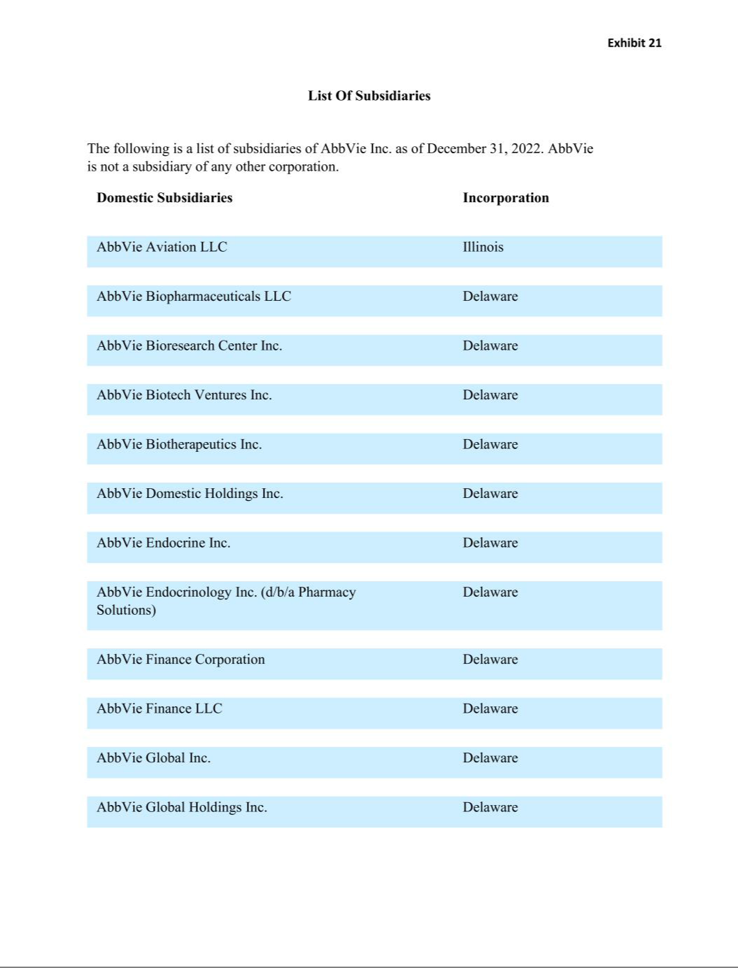

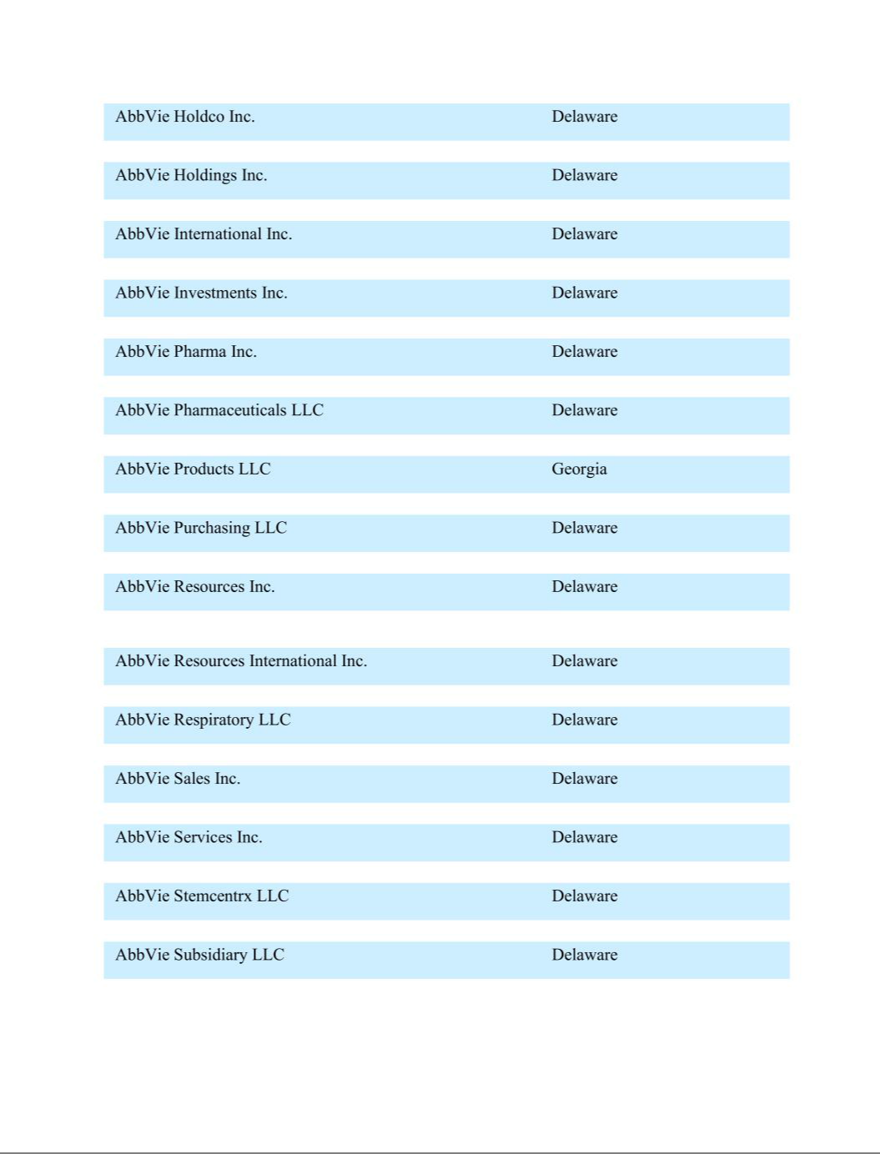

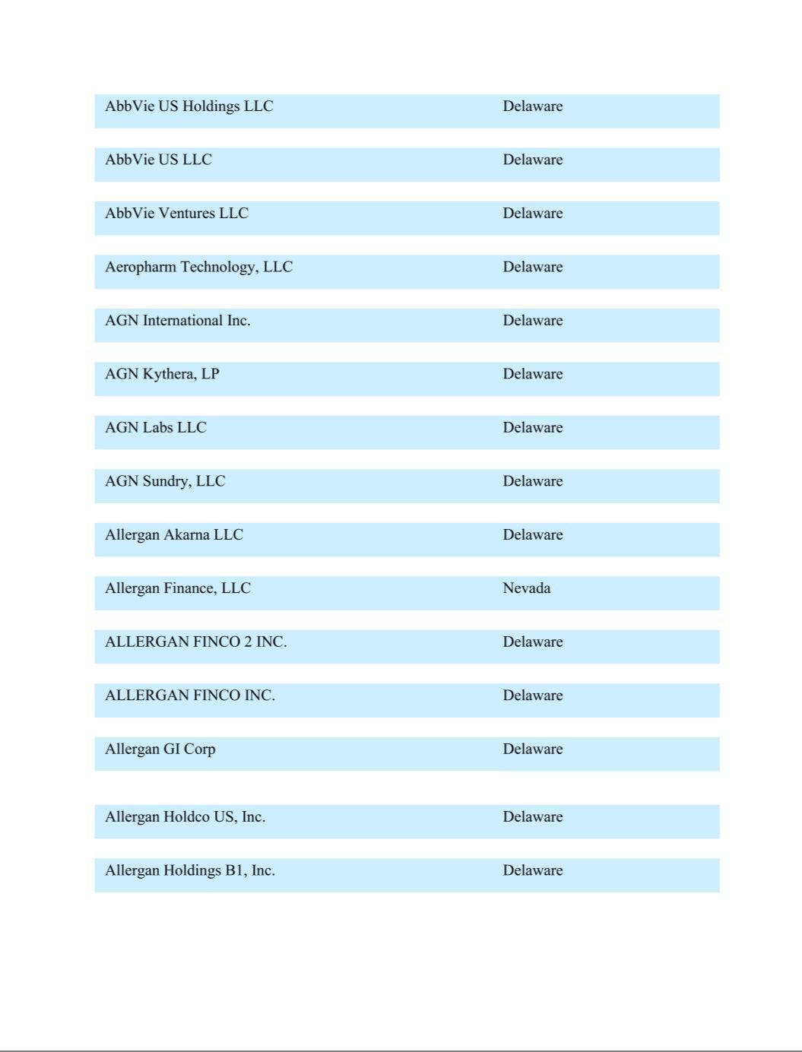

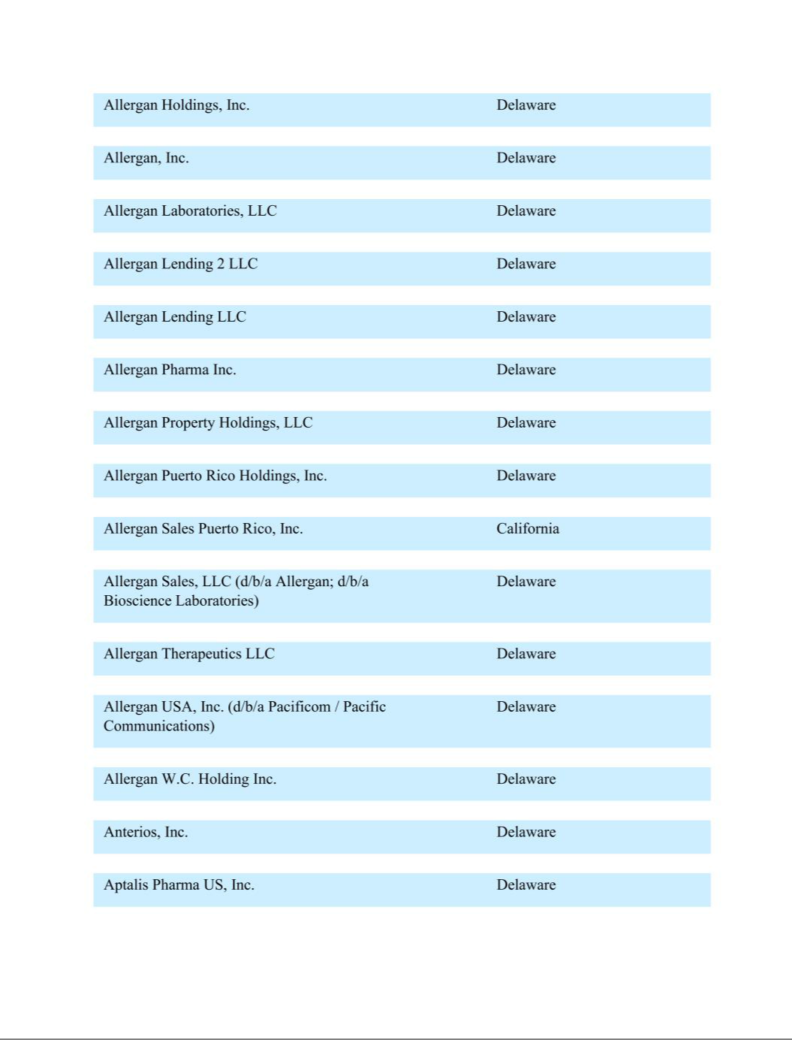

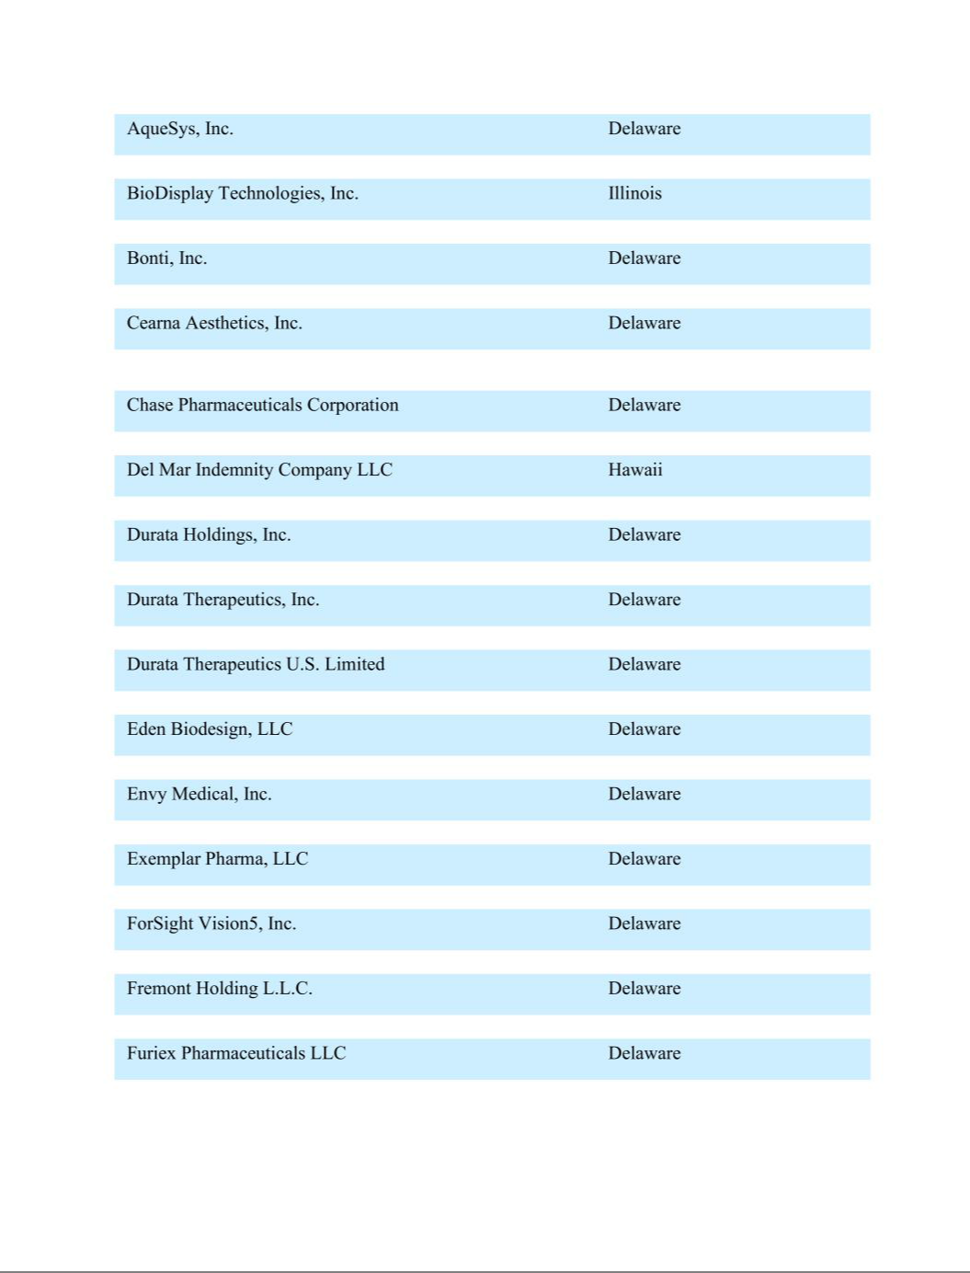

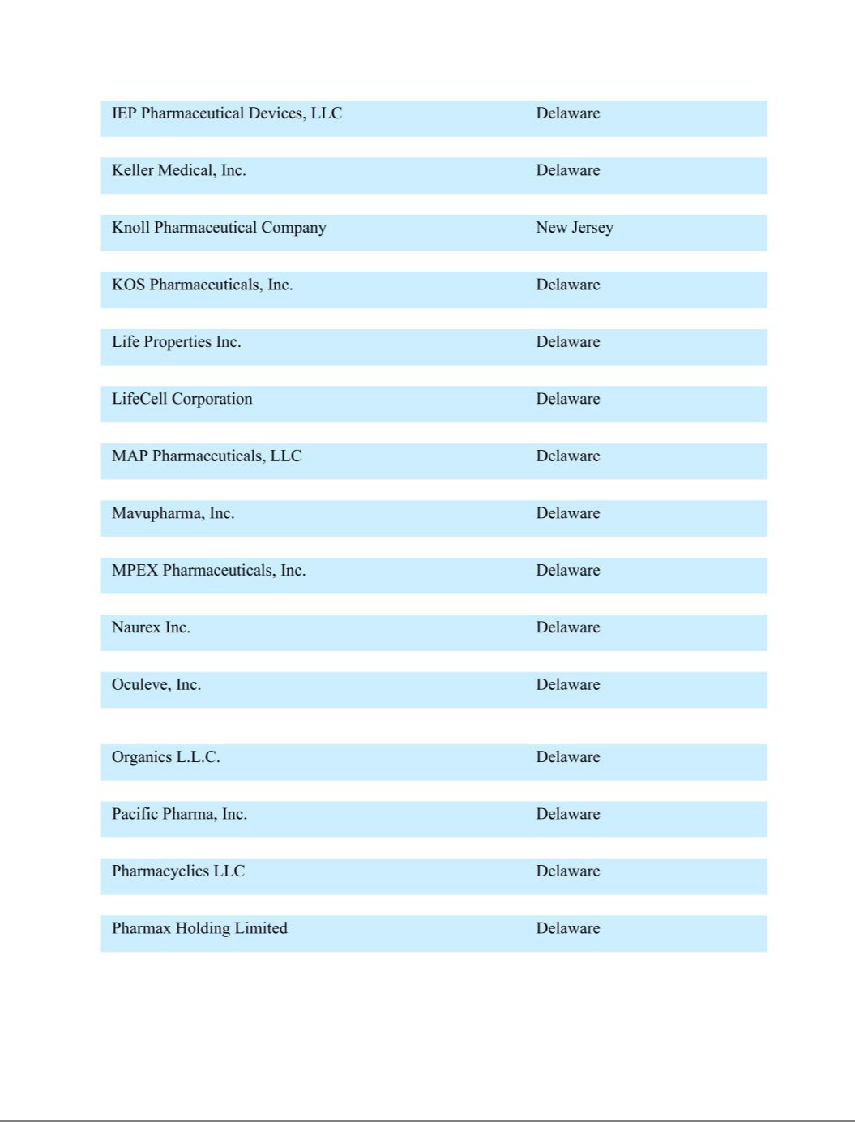

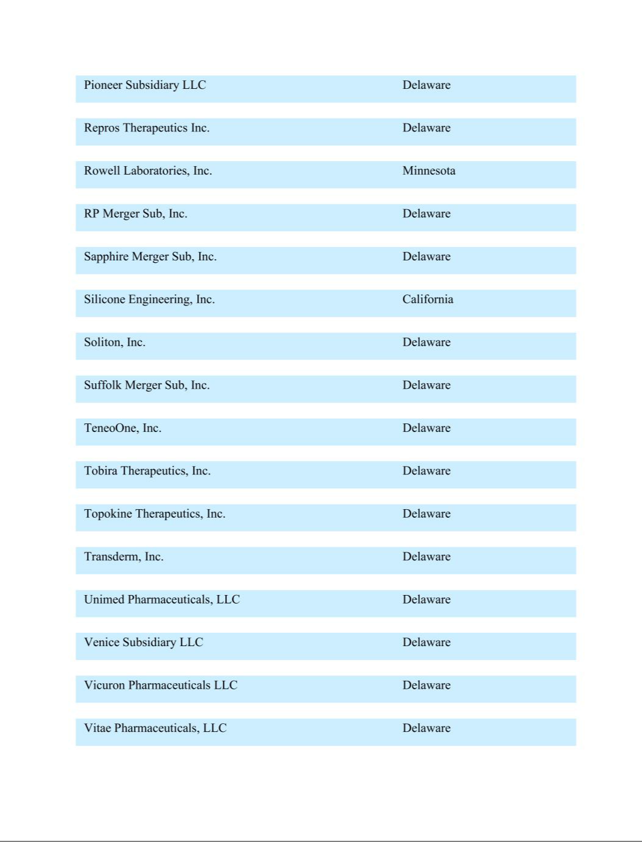

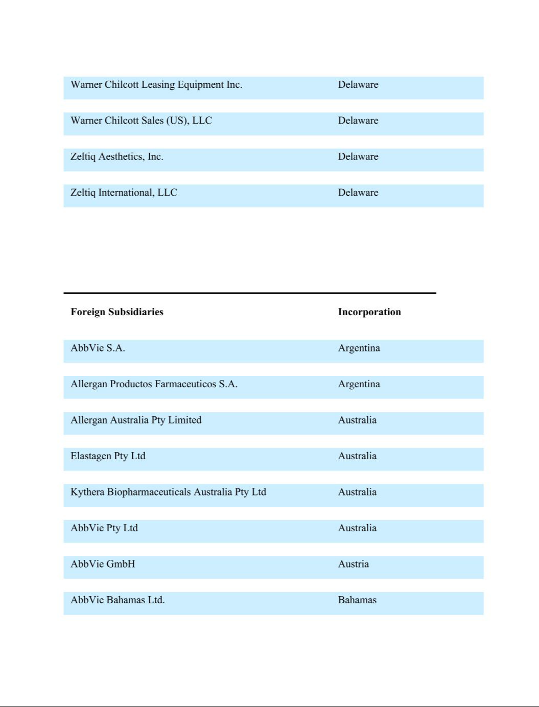

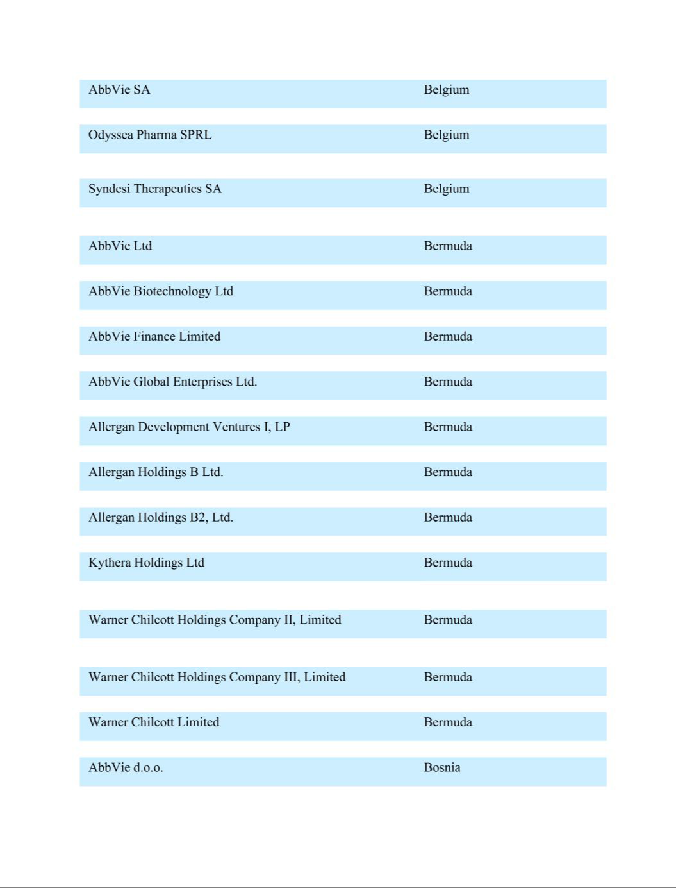

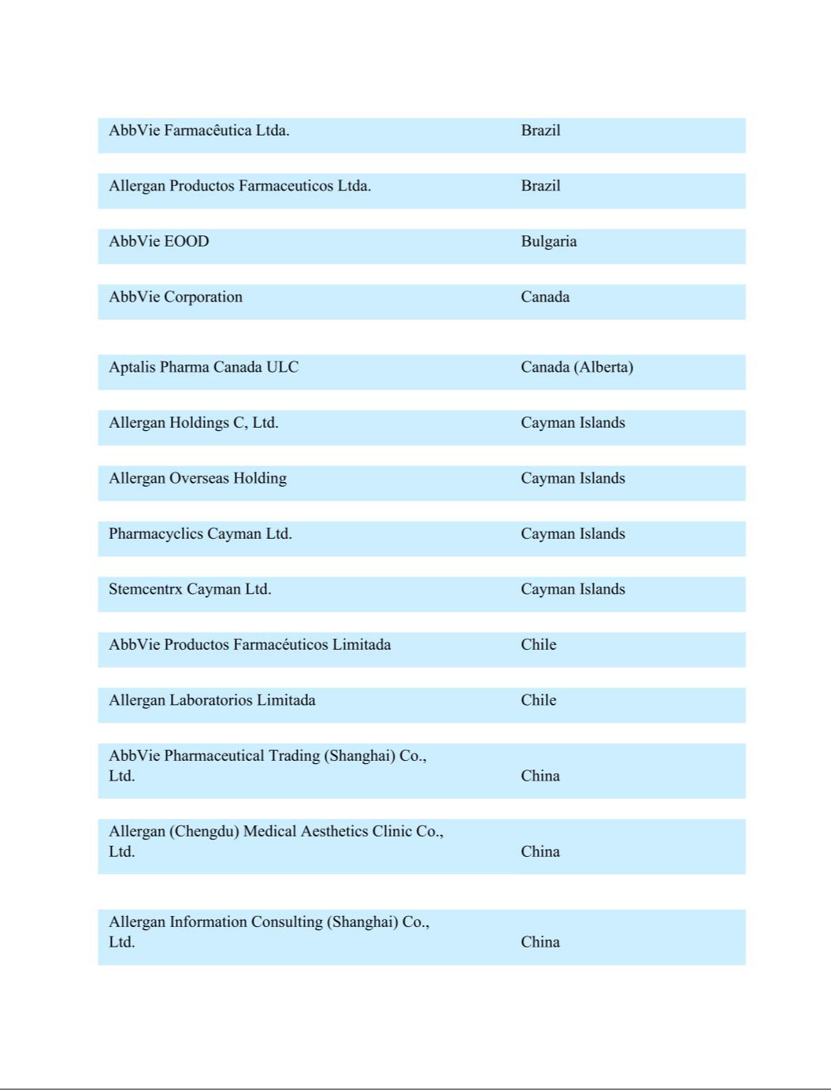

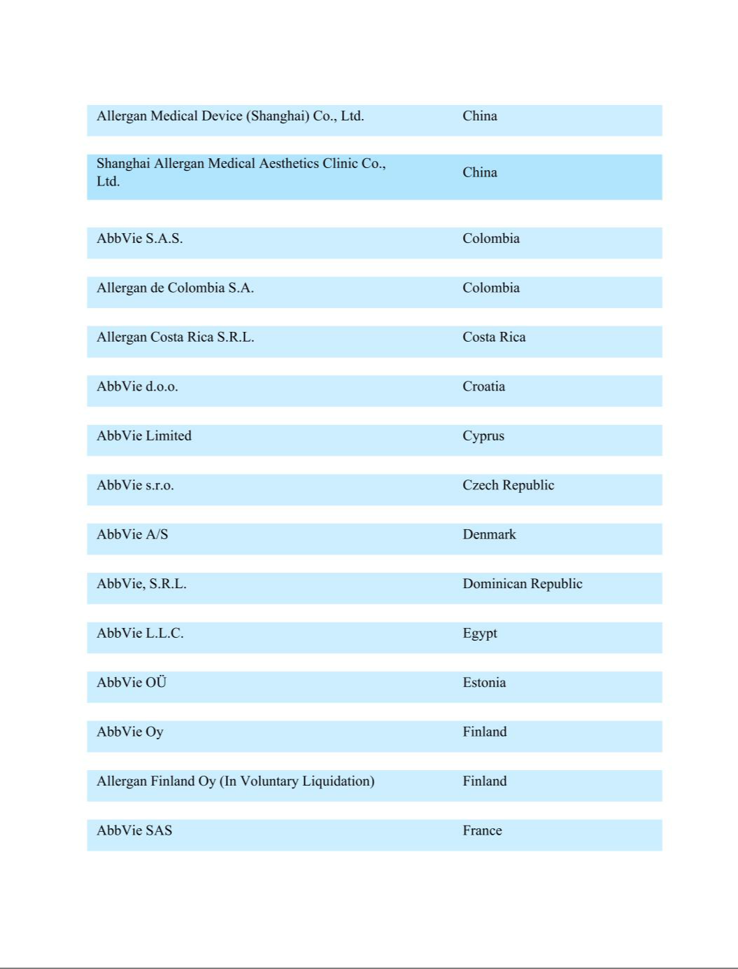

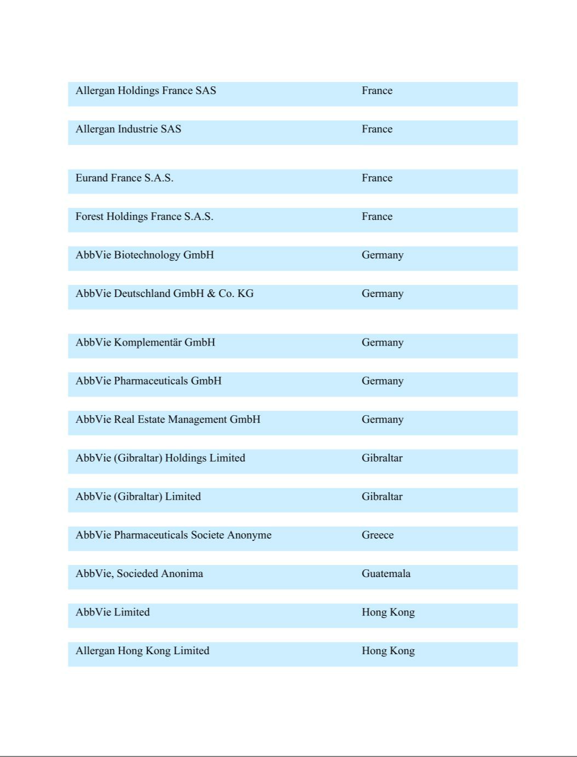

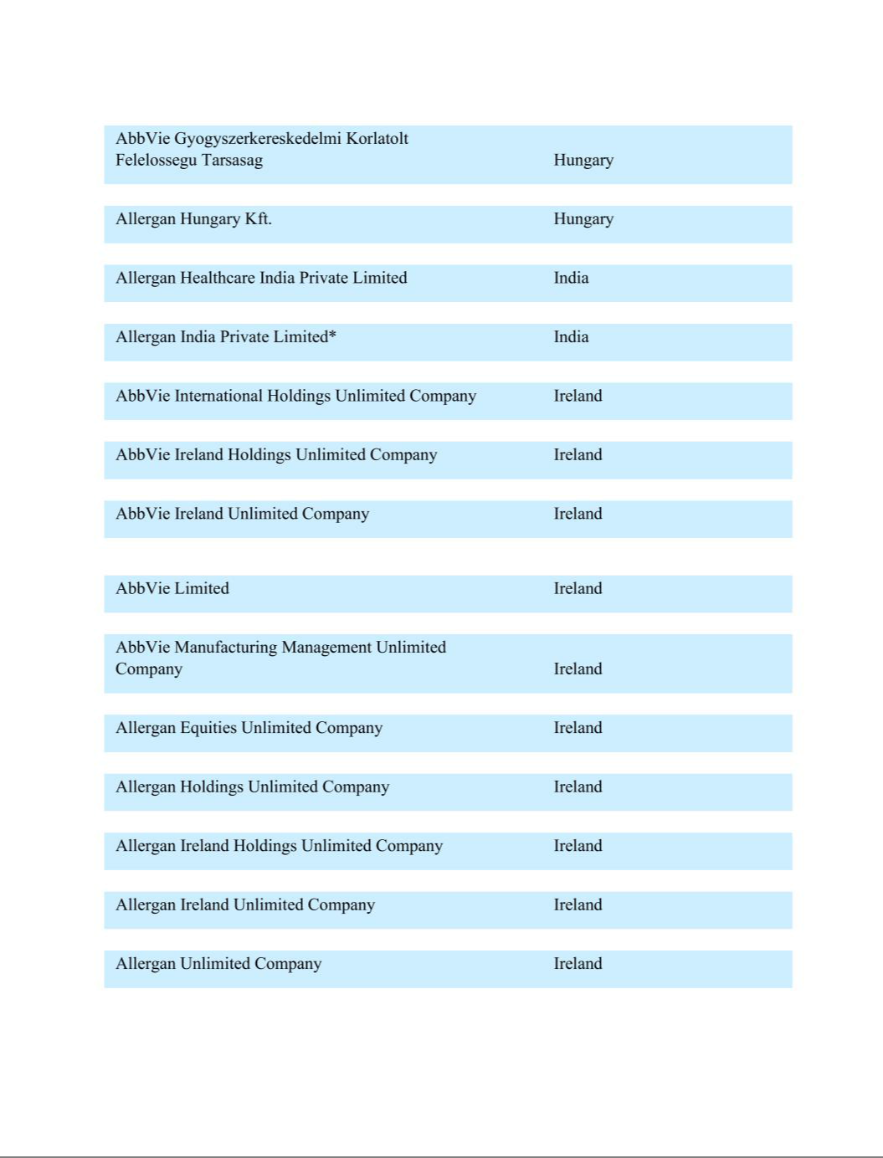

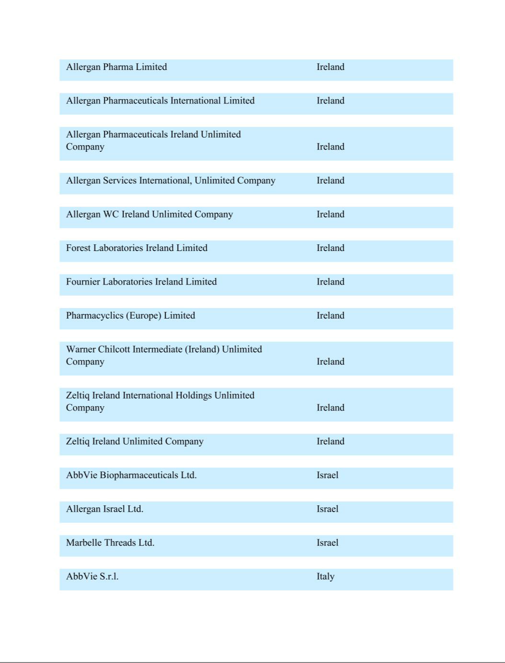

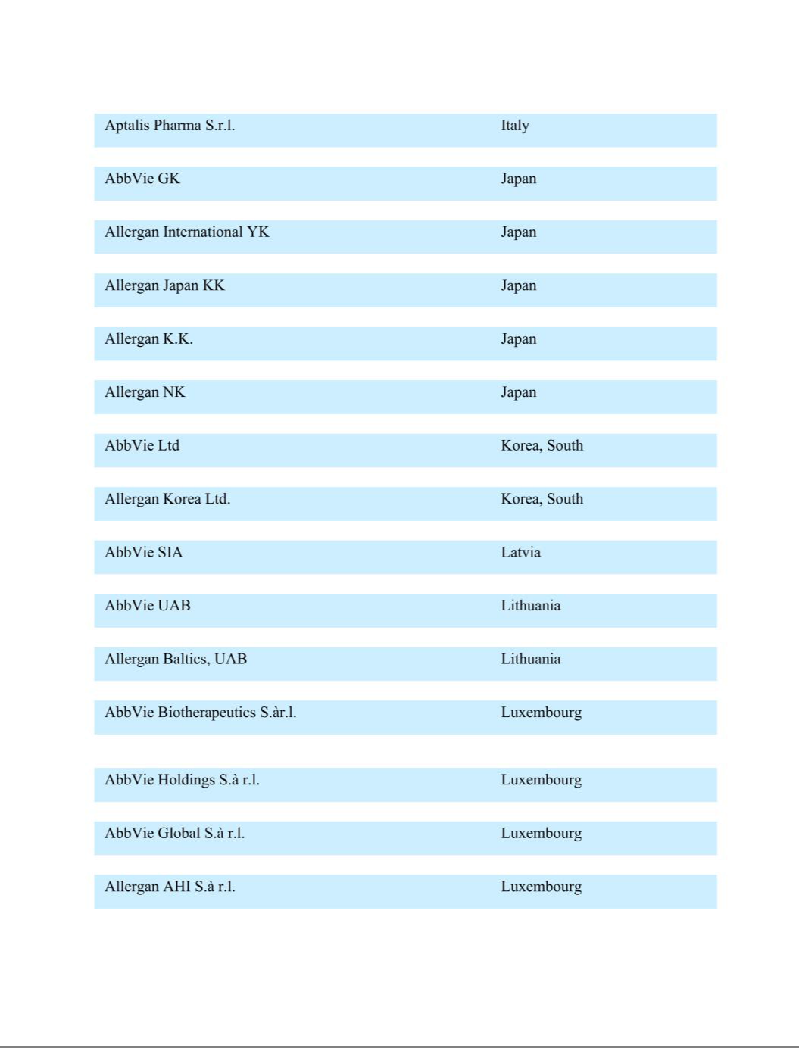

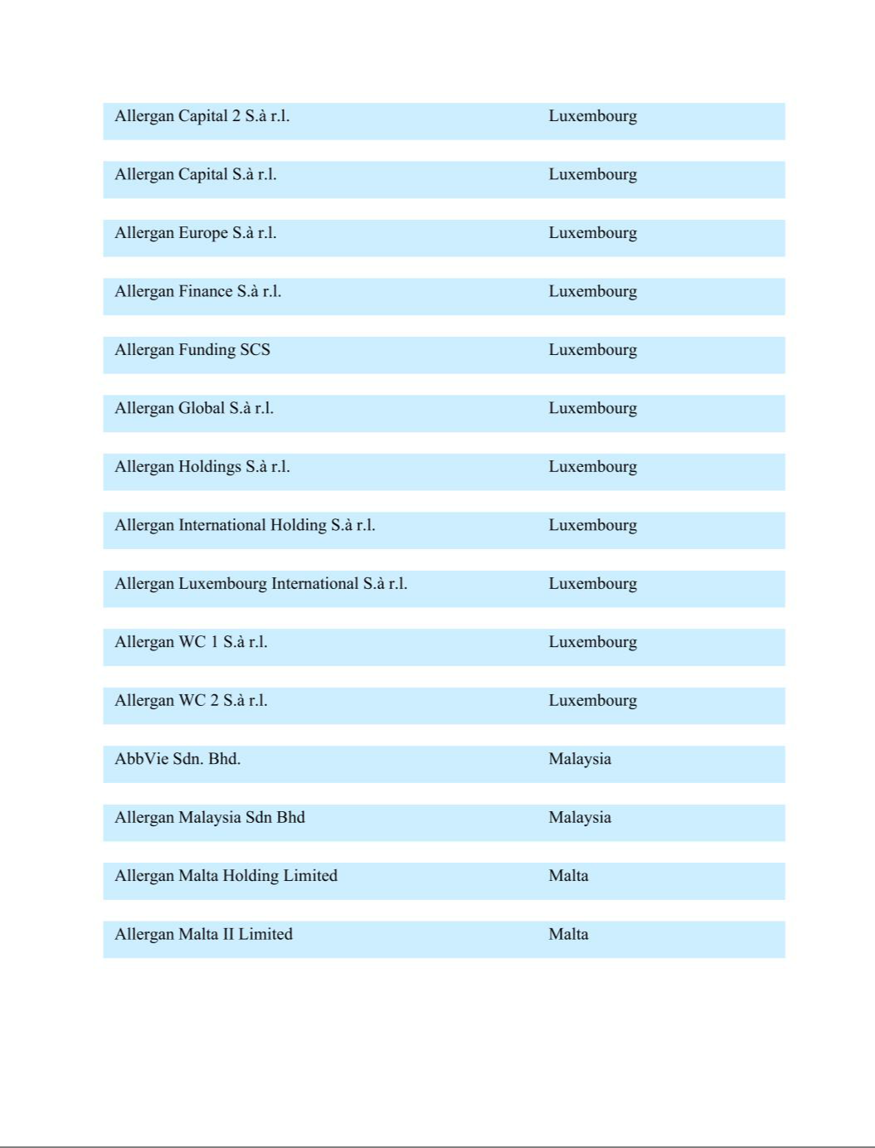

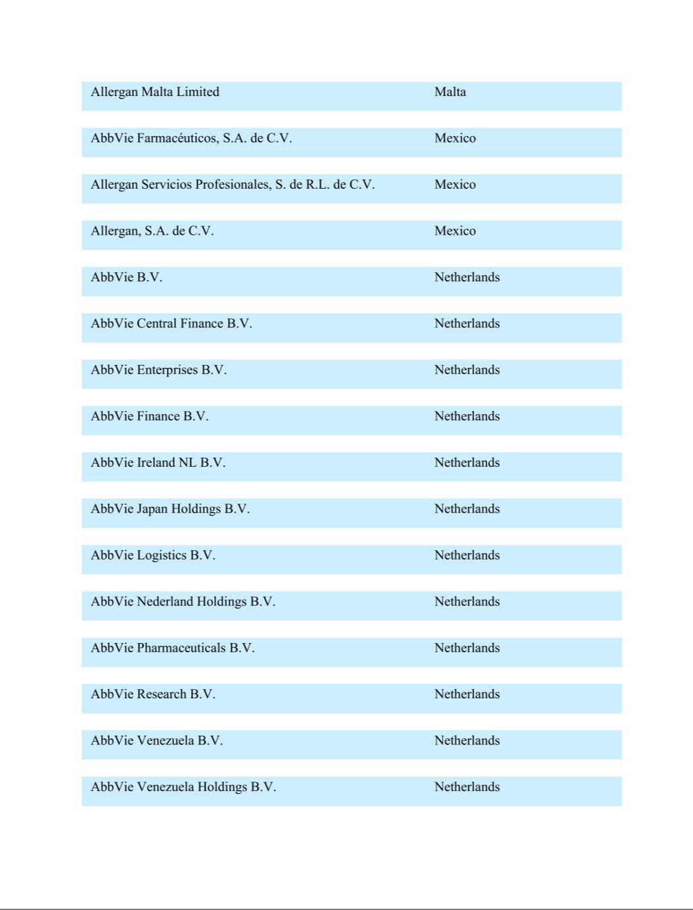

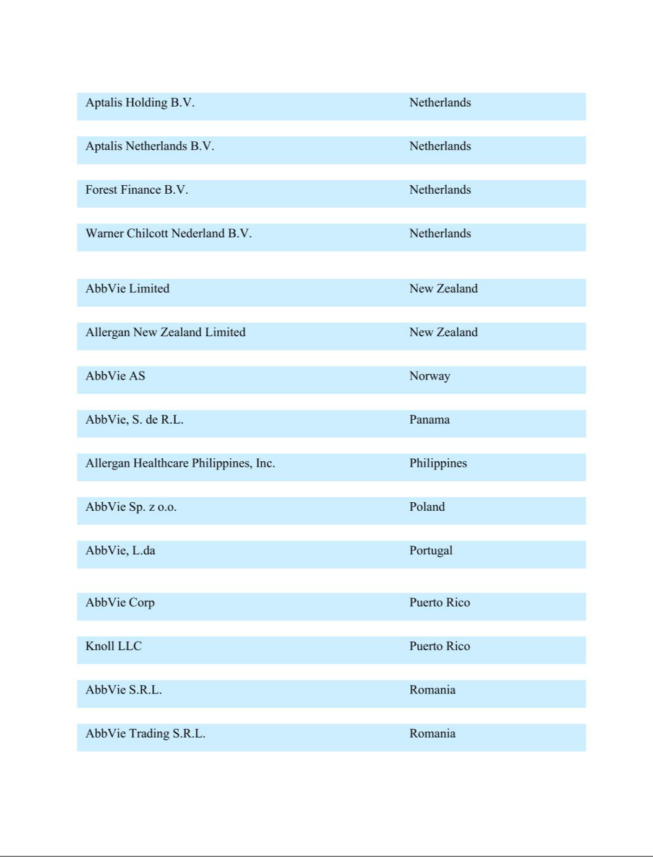

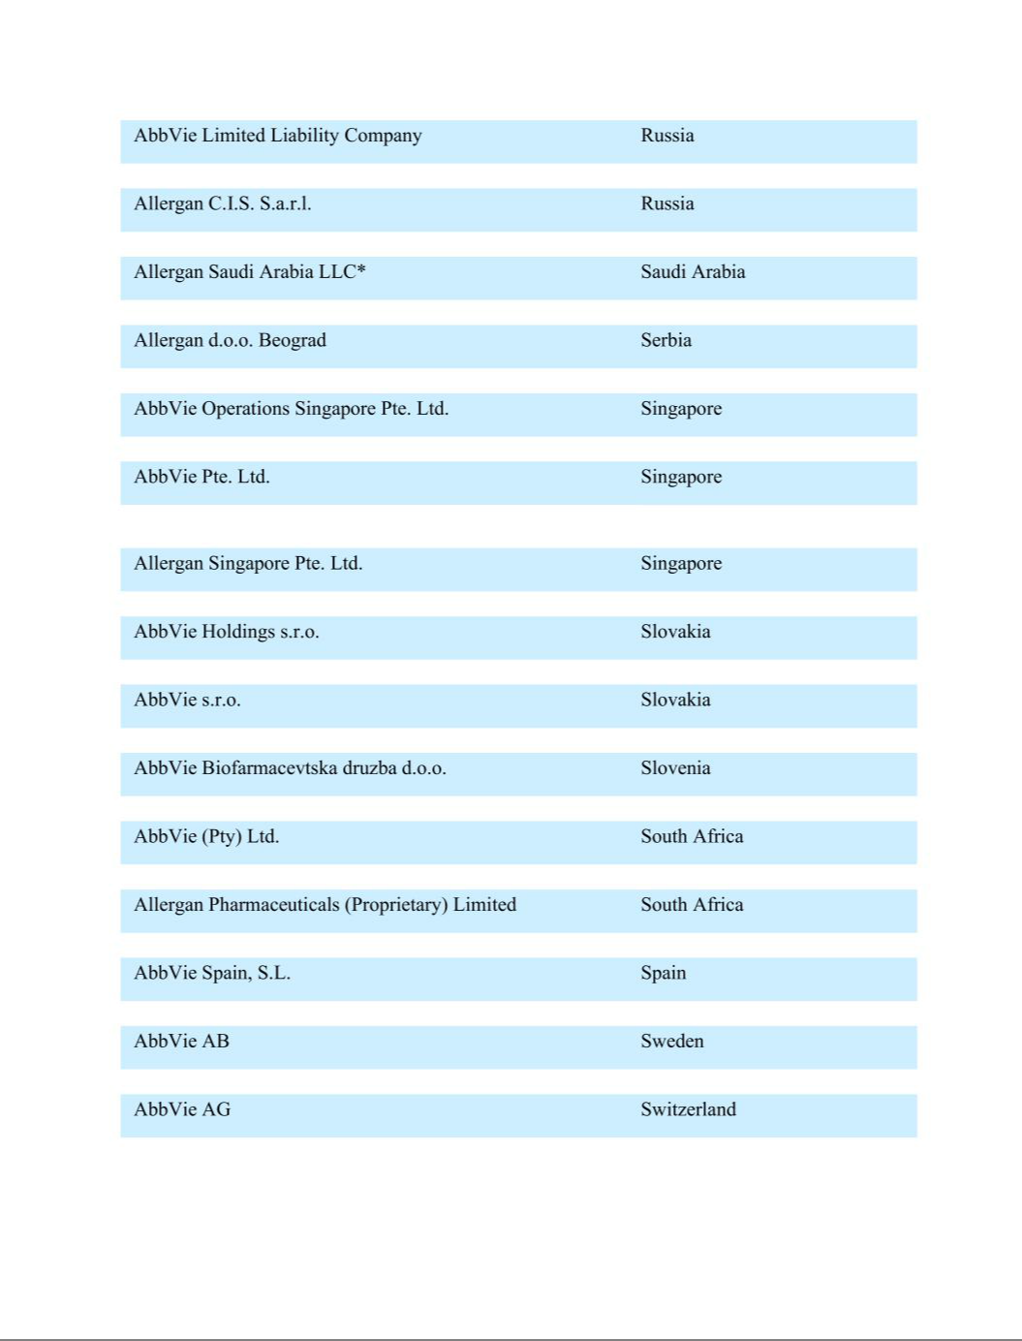

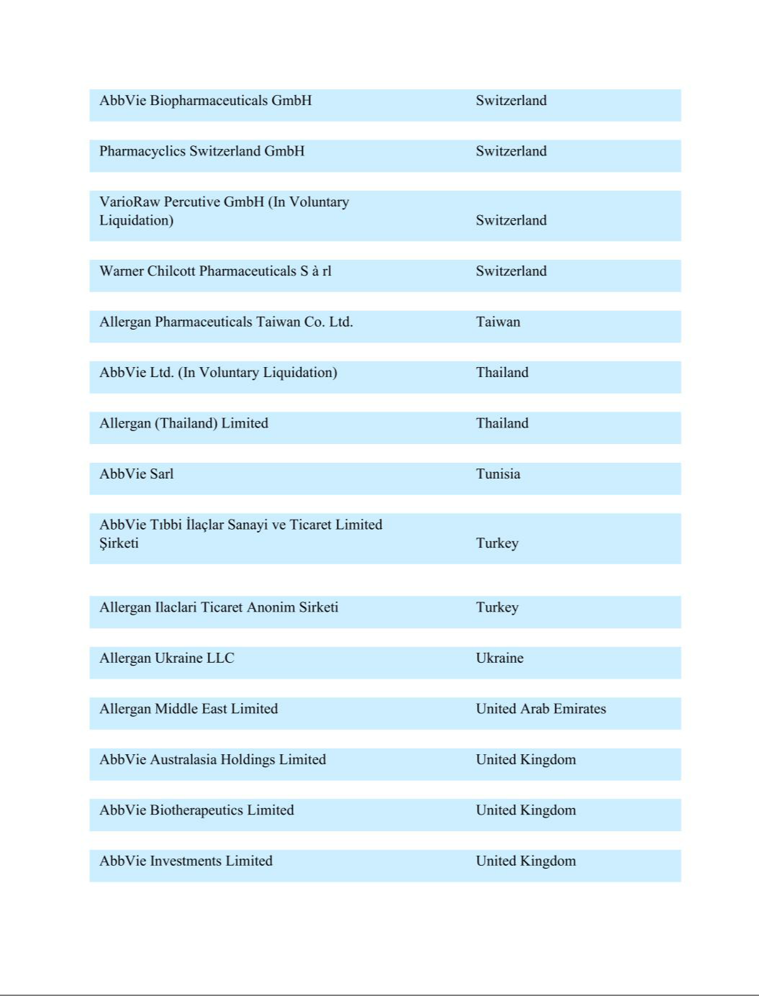

Exhibit 23

Consent of Independent Registered Public Accountng Firm

We consent to the incorporaton by reference in the following Registraton Statements:

- Registraton Statements (Form S-8 No. 333-185561, Form S-3 No. 333-207422, and Form S-8 No. 333-222107) pertaining to the AbbVie 2013 Incentve Stock Program,

- Registraton Statement (Form S-8 No. 333-185562) pertaining to the AbbVie 2013 Employee Stock Purchase Plan for Non-U.S. Employees,

- Registraton Statements (Form S-8 No. 333-185563 and Form S-8 No. 333-222105) pertaining to the AbbVie Deferred Compensaton Plan,

- Registraton Statement (Form S-8 No. 333-185564) pertaining to the AbbVie Savings Program,

- Registraton Statement (Form S-8 No. 333-204466) pertaining to the Pharmacyclics, Inc. 2014 Equity Incentve Awards Plan,

- Registraton Statement (Form S-8 No. 333-212067) pertaining to the Stemcentrx 2011 Equity Incentve Plan,

- Registraton Statement (Form S-3 No. 333-238302) pertaining to common stock of AbbVie Inc.,

- Registraton Statement (Form S-8 No. 333-239320) pertaining to the Allergan, Inc. Retrement 401(k) Plan,

- Registraton Statement (Form S-8 No. 333-256045) pertaining to the AbbVie Amended and Restated 2013 Incentve Stock Program, and

- Registraton Statement (Form S-8 No. 333-268192) pertaining to the AbbVie Deferred Compensaton Plan and the AbbVie Deferred Compensaton Plan Plus;

of our reports dated February 17, 2023, with respect to the consolidated fnancial statements of AbbVie Inc. and subsidiaries and the efectveness of internal control over fnancial reportng of AbbVie Inc. and subsidiaries included in this Annual Report (Form 10-K) of AbbVie Inc. and subsidiaries for the year ended December 31, 2022.

/s/ Ernst & Young LLP

Chicago, Illinois

February 17, 2023

Exhibit 31.1

Certfcaton of Chief Executve Ofcer
Required by Rule 13a-14(a) (17 CFR 240.13a-14(a))

I, Richard A. Gonzalez, certfy that:

- I have reviewed this annual report on Form 10-K of AbbVie Inc.;

- Based on my knowledge, this report does not contain any untrue statement of a material fact or omit to state a material fact necessary to make the statements made, in light of the circumstances under which such statements were made, not misleading with respect to the period covered by this report;

- Based on my knowledge, the fnancial statements, and other fnancial informaton included in this report, fairly present in all material respects the fnancial conditon, results of operatons and cash fows of AbbVie as of, and for, the periods presented in this report;

- AbbVie’s other certfying ofcer and I are responsible for establishing and maintaining disclosure controls and procedures (as defned in Exchange Act Rules 13a-15(e) and 15d-15(e)) and internal control over fnancial reportng (as defned in Exchange Act Rules 13a-15(f) and 15d-15(f)) for AbbVie and have:

  - Designed such disclosure controls and procedures, or caused such disclosure controls and procedures to be designed under our supervision, to ensure that material informaton relatng to AbbVie, including its consolidated subsidiaries, is made known to us by others within those enttes, partcularly during the period in which this report is being prepared;

  - Designed such internal control over fnancial reportng, or caused such internal control over fnancial reportng to be designed under our supervision, to provide reasonable assurance regarding the reliability of fnancial reportng and the preparaton of fnancial statements for external purposes in accordance with generally accepted accountng principles;

  - Evaluated the efectveness of AbbVie’s disclosure controls and procedures and presented in this report our conclusions about the efectveness of the disclosure controls and procedures, as of the end of the period covered by this report based on such evaluaton; and

  - Disclosed in this report any change in AbbVie’s internal control over fnancial reportng that occurred during AbbVie’s most recent fscal quarter that has materially afected, or is reasonably likely to materially afect, AbbVie’s internal control over fnancial reportng; and

- AbbVie’s other certfying ofcer and I have disclosed, based on our most recent evaluaton of internal control over fnancial reportng, to AbbVie’s auditors and the audit commitee of AbbVie’s board of directors:

  - All signifcant defciencies and material weaknesses in the design or operaton of internal control over fnancial reportng which are reasonably likely to adversely afect AbbVie’s ability to record, process, summarize and report fnancial informaton; and

  - Any fraud, whether or not material, that involves management or other employees who have a signifcant role in AbbVie’s internal control over fnancial reportng.

Date: February 17, 2023 /s/ Richard A. Gonzalez
Richard A. Gonzalez, Chairman of the Board
and Chief Executve Ofcer

Exhibit 31.2

Certfcaton of Chief Financial Ofcer
Required by Rule 13a-14(a) (17 CFR 240.13a-14(a))

I, Scot T. Reents, certfy that:

- I have reviewed this annual report on Form 10-K of AbbVie Inc.;

- Based on my knowledge, this report does not contain any untrue statement of a material fact or omit to state a material fact necessary to make the statements made, in light of the circumstances under which such statements were made, not misleading with respect to the period covered by this report;

- Based on my knowledge, the fnancial statements, and other fnancial informaton included in this report, fairly present in all material respects the fnancial conditon, results of operatons and cash fows of AbbVie as of, and for, the periods presented in this report;

- AbbVie’s other certfying ofcer and I are responsible for establishing and maintaining disclosure controls and procedures (as defned in Exchange Act Rules 13a-15(e) and 15d-15(e)) and internal control over fnancial reportng (as defned in Exchange Act Rules 13a-15(f) and 15d-15(f)) for AbbVie and have:

  - Designed such disclosure controls and procedures, or caused such disclosure controls and procedures to be designed under our supervision, to ensure that material informaton relatng to AbbVie, including its consolidated subsidiaries, is made known to us by others within those enttes, partcularly during the period in which this report is being prepared;

  - Designed such internal control over fnancial reportng, or caused such internal control over fnancial reportng to be designed under our supervision, to provide reasonable assurance regarding the reliability of fnancial reportng and the preparaton of fnancial statements for external purposes in accordance with generally accepted accountng principles;

  - Evaluated the efectveness of AbbVie’s disclosure controls and procedures and presented in this report our conclusions about the efectveness of the disclosure controls and procedures, as of the end of the period covered by this report based on such evaluaton; and

  - Disclosed in this report any change in AbbVie’s internal control over fnancial reportng that occurred during AbbVie’s most recent fscal quarter that has materially afected, or is reasonably likely to materially afect, AbbVie’s internal control over fnancial reportng; and

- AbbVie’s other certfying ofcer and I have disclosed, based on our most recent evaluaton of internal control over fnancial reportng, to AbbVie’s auditors and the audit commitee of AbbVie’s board of directors:

  - All signifcant defciencies and material weaknesses in the design or operaton of internal control over fnancial reportng which are reasonably likely to adversely afect AbbVie’s ability to record, process, summarize and report fnancial informaton; and

  - Any fraud, whether or not material, that involves management or other employees who have a signifcant role in AbbVie’s internal control over fnancial reportng.

Date: February 17, 2023 ^{/s/ Scot T. Reents}
Scot T. Reents, Executve Vice President, Chief Financial Ofcer

Exhibit 32.1

Certfcaton Pursuant To
18 U.S.C. Secton 1350
As Adopted Pursuant To
Secton 906 of the Sarbanes-Oxley Act of 2002

In connecton with the Annual Report of AbbVie Inc. (the “Company”) on Form 10-K for the period ended December 31, 2022 as fled with the Securites and Exchange Commission (the “Report”), I, Richard A. Gonzalez, Chairman of the Board and Chief Executve Ofcer of the Company, certfy, pursuant to 18 U.S.C. § 1350, as adopted pursuant to § 906 of the Sarbanes-Oxley Act of 2002, that:

- The Report fully complies with the requirements of secton 13(a) or 15(d) of the Securites Exchange Act of 1934; and

- The informaton contained in the Report fairly presents, in all material respects, the fnancial conditon and results of operatons of the Company.

/s/ Richard A. Gonzalez

Richard A. Gonzalez
Chairman of the Board and
Chief Executve Ofcer

February 17, 2023

A signed original of this writen statement required by Secton 906 has been provided to AbbVie Inc. and will be retained by AbbVie Inc. and furnished to the Securites and Exchange Commission or its staf upon request.

Exhibit 32.2

Certfcaton Pursuant To
18 U.S.C. Secton 1350
As Adopted Pursuant To
Secton 906 of the Sarbanes-Oxley Act of 2002

In connecton with the Annual Report of AbbVie Inc. (the “Company”) on Form 10-K for the period ended December 31, 2022 as fled with the Securites and Exchange Commission (the “Report”), I, Scot T. Reents, Executve Vice President, Chief Financial Ofcer of the Company, certfy, pursuant to 18 U.S.C. § 1350, as adopted pursuant to § 906 of the Sarbanes-Oxley Act of 2002, that:

- The Report fully complies with the requirements of secton 13(a) or 15(d) of the Securites Exchange Act of 1934; and

- The informaton contained in the Report fairly presents, in all material respects, the fnancial conditon and results of operatons of the Company.

/s/ Scot T. Reents
Scot T. Reents
Executve Vice President, Chief Financial Ofcer

February 17, 2023

A signed original of this writen statement required by Secton 906 has been provided to AbbVie Inc. and will be retained by AbbVie Inc. and furnished to the Securites and Exchange Commission or its staf upon request.

